<!---Part 1---->

Name: Mike Simister
ID: 10095107

Name Brendan Petras
ID: 10137098

<!---Part 2---->
Note: We were unsure if we were supposed to get the cycles for the entire loop ie Time from begin of loop till
end of loop. Or, if we were supposed to get the clock cycles for the procadd and sysAdd calls explicitly, ie
within the loop. When we got the cycles within the loop(s) not surprisingly there were fewer of them. For the procadd
call, there were ~110 cycles for the entire loop, and 27 within the loop.

Also of note, we used code from a university webpage to aquire the Time Stamp Counter, credit is given below and in our code
http://www.cs.wm.edu/~kearns/001lab.d/rdtsc.html

<!---Part 3---->
kos/src/include/syscalls.h
kos/src/kernel/syscalls.cc
kos/src/ulib/libKOS.cc
kos/src/main/InitProcess.cc
kos/src/user/syscall_test.cc
kos/src/user/isEven.cc

and associtated *.o files

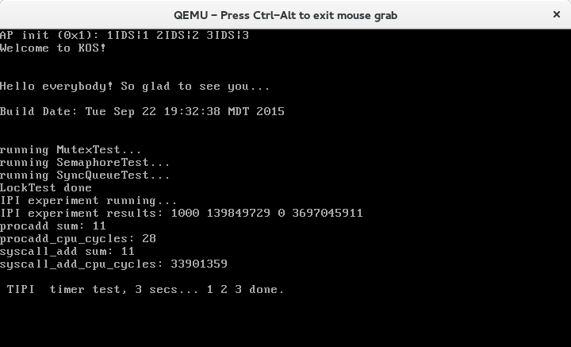
<!---Part 4---->

<!---Part 5---->

#include "syscalls.h"
#include <iostream>

//Part 2 deliverable procadd function
long procadd(long a, long b)
{
return a + b;
}

//Pentium Time Stamp Counter
// method below was obtained from:
// http://www.cs.wm.edu/~kearns/001lab.d/rdtsc.html
unsigned long long int rdtsc(void)
{
unsigned long long int x;
unsigned a, d;

__asm__ volatile("rdtsc" : "=a" (a), "=d" (d));

return ((unsigned long long)a) | (((unsigned long long)d) << 32);;
}

int main()
{
//set variables
long a = 5;
long b = 6;
long sum1 = 0;
long sum = 0;
double cpu;

long long start;
long long end;
long long total = 0;

//part 3 deliverable
//procadd loop
for(int i = 0; i<50000; i++)
{ start = rdtsc();
sum1 = procadd(a, b);
end = rdtsc();
total += (end - start);
}

//TODO verify if the avg is avg calls/50k or (total time for the loop)/50K
long long avg = total/50000;

std::cout << "procadd sum: " << sum1 << "\n";
std::cout << "procadd_cpu_cycles: " << avg << "\n";

//TODO verify if the avg is avg calls/50k or (total time for the loop)/50K
start = rdtsc();
for(int i = 0; i<50000; i++)
{
sum = sysAdd(a,b);
}

end = rdtsc();
total = (end - start);

std::cout << "syscall_add sum: " << sum << "\n";
std::cout << "syscall_add_cpu_cycles: " << total << std::endl;

return(0);
}

<!---Part 7---→

The system call is more expensive than the process call. The reason the system call is costlier than the process call because the system call must invoke a trap inorder for the OS (Kernel) to context switch into privileged mode from unprivileged mode. The OS (kernel) must also switch back to unprivileged mode with the process loaded back into the CPU.

