How to run this app:

1. In Visual Studio 2019 create connection to any empty database

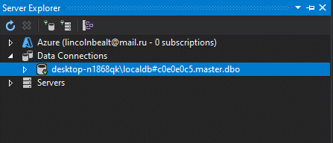

2)In this connection copy your Connection String:

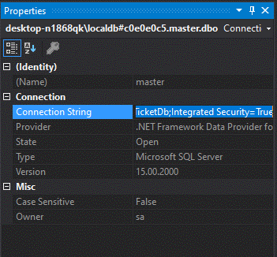

3)Paste your Connection String to appsettings.json:

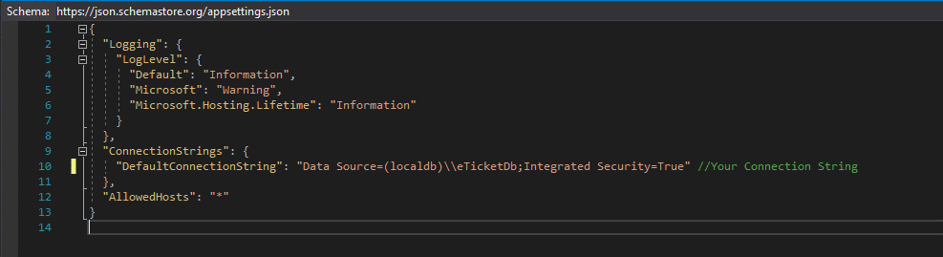

4)Run IIS Express: 