Airline Flight Delay project
Table of Contents
Files and folder 1
Processes 2
Loaded and transformed data 2
Build relational model 2
Add DAX measures 2
Visualizing data report 3

Files and folder
airlines.csv………………………………………….
airports.csv…………………………………………
cancellation_codes.csv……………………………..
flights.csv…………………………………………..
Airlines codes and full names
Airports codes and full names
Cancellation codes and full definition
All raw data of US flights in 2015

Processes
- :

Loaded and transformed data
  - airlines.csv:
    - Use top row as header
  - airports.csv:
    - Look good
  - cancellation_codes.csv:
    - Use top row as header
  - flights.csv:
    - Clean and select data columns relevant to delays
    - Created columns “Status” with Add-column > Conditional column

Build relational model

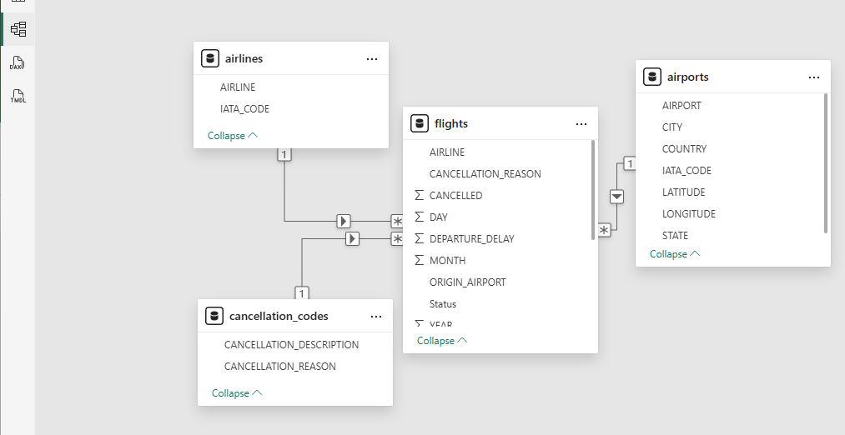
Add DAX measures
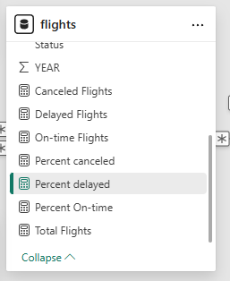
  - Add new measure of Sum and Percentage of Delayed, On-time, and Canceled flights

Visualizing data report
