Bushra dajam

Lab5

2110054

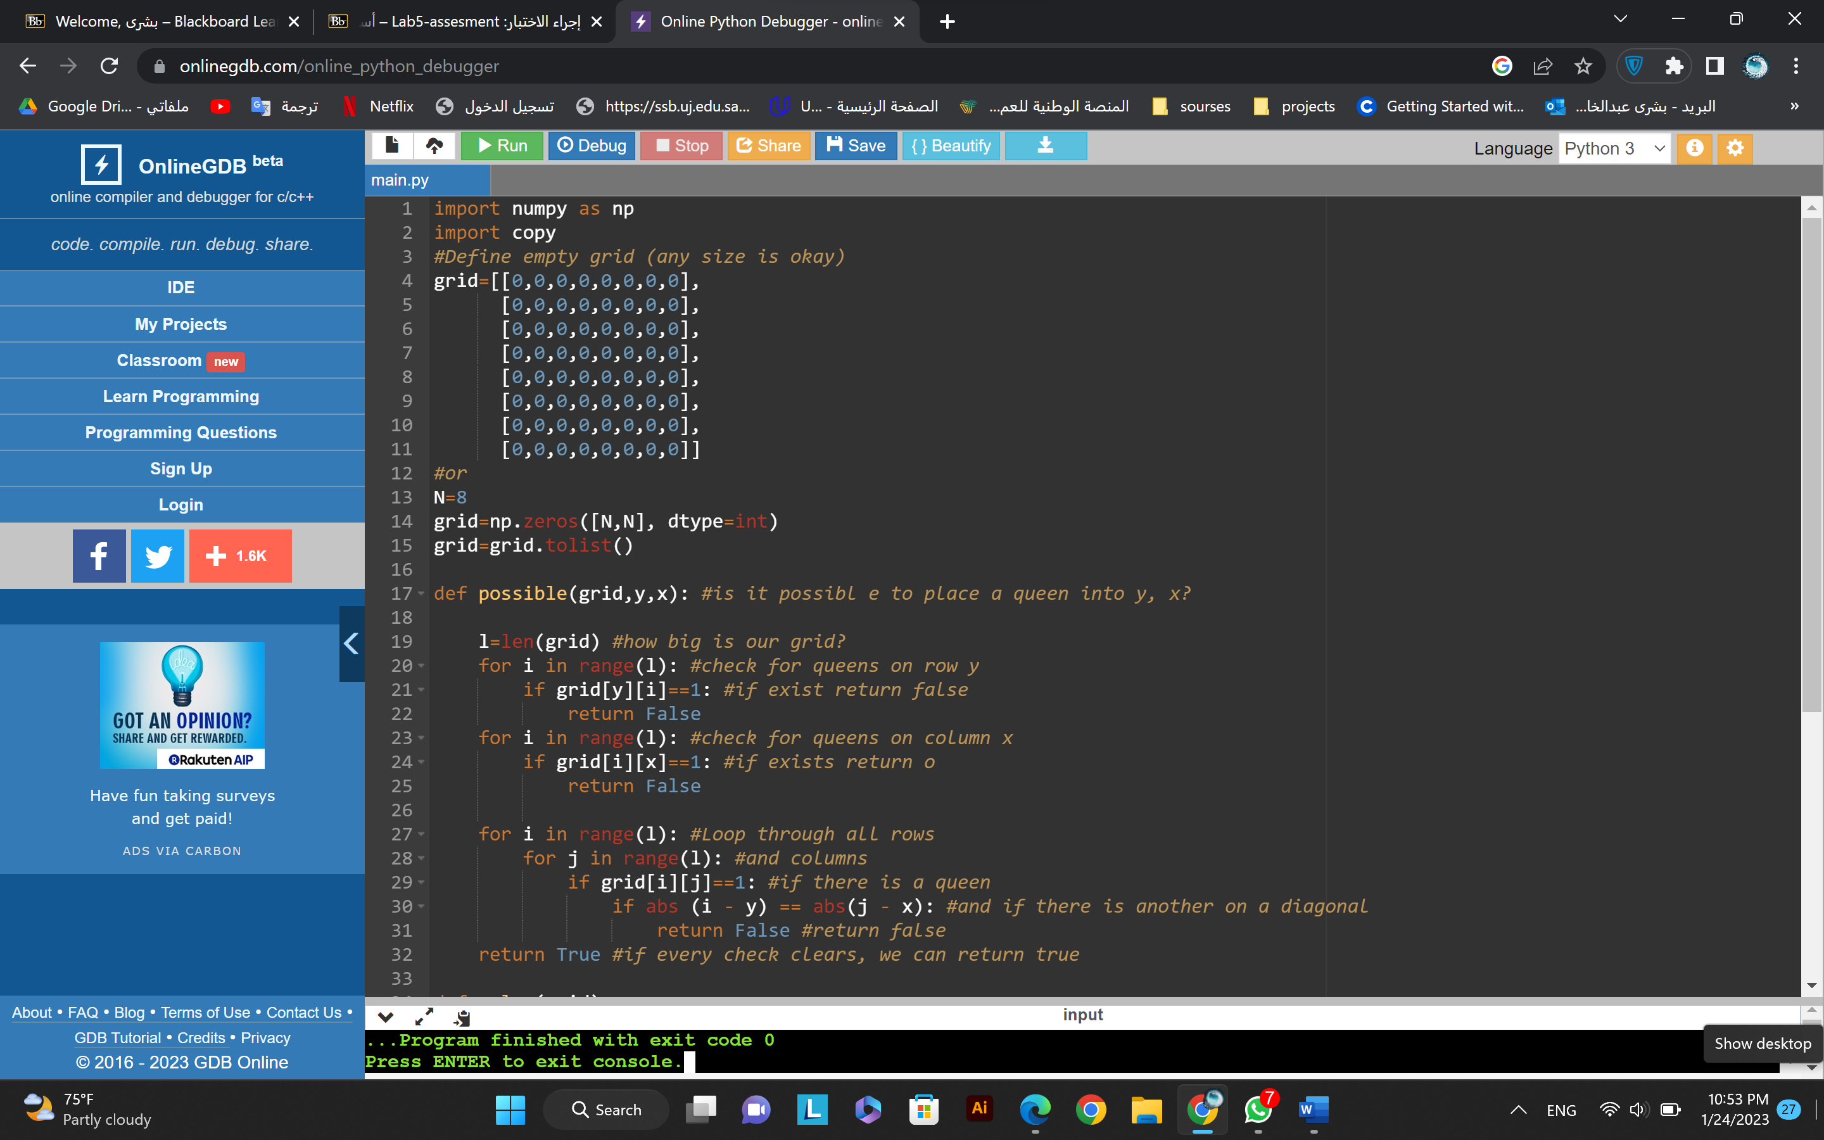

Output:

