A

Mini Project Report on

**“Enhancing Road Safety through Automated Pothole Detection”**

Submitted in partial fulfillment of the Requirements for the award of degree of **Bachelor of Technology**

in

#### Computer Science and Engineering-Data Science

By

#### N. Dyuthi Reddy

#### 21EG510103

#### J. Buvann

#### 20EG110111

#### Sree Harsha

#### 20EG110105

#### Under the Guidance of

#### Mrs. G. Swapna

#### Assistant Professor



**Department of Data Science**

**ANURAG UNIVERSITY**

**Venkatapur (V), Ghatkesar (M), Medchal(D)., T.S-500088**

**(2020-2024)**



**DEPARTMENT OF DATA SCIENCE**

**CERTIFICATE**

This is to certify that the project entitled **"Enhancing Road Safety through Automated Pothole Detection"** being submitted by **N. Dyuthi Reddy** bearing the Hall Ticket number **21EG510103, J. Buvann** bearing the Hall Ticket number **20EG110111, E. Sree Harsha** bearing the Hall Ticket number **20EG110105** in partial fulfillment of the requirements for the award of the degree of the **Bachelor of Technology** in **Computer Science and Engineering-Data Science** in **Anurag University** is a record of bonafide work carried out by them under my guidance and supervision from June 2023 to October 2023.

The results presented in this project have been verified and found to be satisfactory. The results embodied in this project report have not been submitted to any other University for the award of any other degree or diploma.

**Internal Guide**

**Mrs. G. Swapna External Examiner**

**Asst. Professor**

**Head of the Department**

**Department of Data Science**

**ACKNOWLEDGEMENT**

It is our privilege and pleasure to express profound sense of respect, gratitude and indebtedness to our guide **Mrs. G. Swapna, Asst Professor**, Dept. of Computer Science and Engineering-Data Science, Anurag University for her indefatigable inspiration, guidance, cogent discussion, constructive criticisms and encouragement throughout this dissertation work.

We express our sincere gratitude to **Dr. M. Sridevi, Associate Professor &** Head Department of Computer Science and Engineering-Data Science, Anurag University, for her suggestions, motivations, and co- operation for the successful completion of the work.

We extend our sincere thanks to **Dr. V. Vijaya Kumar**, **Professor &Dean,** School of Engineering, Anurag University, for his encouragement and constant help.

N. Dyuthi Reddy

21EG510103

J. Buvann

20EG110111

E. Sree Harsha

20EG110105

#### 

#### 

**DECLARATION**

We hereby declare that the project work entitled **"Enhancing Road Safety through Automated Pothole Detection"** submitted to the **Anurag University** in partial fulfillment of the requirements for the award of the degree of **Bachelor of Technology (B. Tech)** in Computer Science and Engineering-Data Science is a record of an original work done by us under the guidance of **Mrs. G. Swapna, Assistant Professor** and this project work have not been submitted to any other university for the award of any other degree or diploma.

N. Dyuthi Reddy

21EG510103

J. Buvann

20EG110111

E. Sree Harsha

20EG110105

**ABSTRACT**

Potholes are a major cause of accidents and injuries on road, and there is a growing need for new technologies to improve road safety. Object detection using deep learning is a promising new approach that can be used to identify potholes. In this project, we will develop a system for road safety implementation using object detection in deep learning. The system will use a camera to capture images of road, and a deep learning model will be used to detect objects such as potholes, depth and size. The system will then be able to generate alerts if it detects any of the objects and also evaluates based on data set of images from real-world environments. We will measure the accuracy of the system in detecting objects and hazards and we will also evaluate the system's ability to generate timely alerts. The results of this project will demonstrate the feasibility of using object detection in deep learning for road safety implementation. The system has the potential to significantly improve safety on roads by reducing the number of accidents and injuries.

**KEYWORDS:** Video analytics, Object Detection, deep learning, Road safety, Pothole detection, accident prevention.

|  |  |  |
| --- | --- | --- |
| **S.NO** | **CONTENTS** | **PAGE NO** |
| 1. Introduction |  | 1 |
| 1.1. Motivation |  | 2 |
| 1.2. Problem Definition |  | 3 |
| 1.3. Objective of the Project |  | 3 |
| 2. Literature Survey |  | 4 |
| 2.1. Existing System |  | 5 |
| 2.2. Proposed System |  | 6 |
| 3. Analysis |  | 7 |

3.1. Software Requirement Specification 7

3.1.1 Purpose and Scope 8

3.2.2 Overall Description 9

4.Design 13

4.1. UML Diagrams 13

4.1.1. Use Case 13

4.1.2. Activity Diagram 14

4.1.3. Class Diagram 15

5.Implementation 16

5.1. System Architecture and Methodology 16

5.2. Detecting Pothole by Yolv8 15 17

5.2.1. Object Detection 17

5.2.2. Artificial Intelligence 18

5.2.3. Machine Learning 18

5.2.4. You Only Look Once 19

5.2.5. Tensorflow 19

5.2.6. You Only Look Once v8 19

5.2.7. Sample Code 20

6. Test Cases 21

7. Screenshots 23

8. Conclusion 27

9. Future Enhancement 28

10. Bibiliography 29

|  |  |  |  |
| --- | --- | --- | --- |
|  |  | **LIST OF FIGURES** |  |
| **S.No** | **Fig.No** | **Title of figure** | **Page No** |
| 1. | 3.1.2 | Model Sub-tree | 7 |
| 2. | 4.1.1 | Use Case diagram | 13 |
| 3. | 4.1.2 | Activity diagram | 14 |
| 4. | 4.1.2.1 | Activity diagram (object scan) | 14 |
| 5. | 4.1.2.2 | Activity diagram (object Detection) | 14 |
| 6. | 4.1.2.3 | Activity diagram (object detection results) | 14 |
| 7. | 4.1.3 | Class Diagram | 15 |
| 8. | 5.1 | System Architecture | 17 |
| 9. | 6.1 | Results of epochs | 21 |
| 10. | 6.2 | Results (Train Data) | 21 |
| 11. | 6.3 | Results (validate Data) | 22 |
| 12. | 7.1 | Installing Ultralytics and import Yolv8 | 23 |
| 13. | 7.2 | Execution Image | 23 |
| 14. | 7.3 | Execution Image | 24 |
| 15. | 7.4 | Execution Image | 24 |
| 16. | 7.5 | Execution Image | 25 |
| 17. | 7.6 | Execution Image | 25 |
| 18. | 7.7 | Execution Image | 26 |

**LIST OF ABBREVIATIONS**

|  |  |  |  |
| --- | --- | --- | --- |
| **S.No** | **Abbreviation** | **FullForm** | **Page.No** |
| 1. | IOT | Internet Of Things | 5 |
| 2 | YOLV3 | You only look once V3 | 5 |
| 3. | PSO | Particle Swarm Optimization | 6 |
| 4. | SVM | Support Vector Machine | 6 |
| 5. | YOLV8 | You Only Look Once V8 | 10 |
| 6. | SHM | [Simple Harmonic Motion](https://www.bing.com/ck/a?!&&p=d745cbf63f5467f9JmltdHM9MTY5NjQ2NDAwMCZpZ3VpZD0zOTIwY2FkNy00MTA4LTYyOTEtMDEzMS1kOTQzNDA1YTYzZWImaW5zaWQ9NTIyMQ&ptn=3&hsh=3&fclid=3920cad7-4108-6291-0131-d943405a63eb&psq=shm+full+form+IN+MAChine+learning&u=a1aHR0cHM6Ly93d3cuZ2Vla3Nmb3JnZWVrcy5vcmcvc29tZS1zeXN0ZW1zLWV4ZWN1dGluZy1zaW1wbGUtaGFybW9uaWMtbW90aW9uLw&ntb=1) | 10 |
| 7. | TPU | Tensor Processing Unit | 10 |
| 8. | GPU | Graphics Processing Unit | 10 |
| 9. | UML | Unified Modeling Language | 13 |

1. **INTRODUCTION**

Potholes are a major cause of accidents and injuries on roads, and there is a growing need for new technologies to improve road safety. Object detection using deep learning is a promising new approach that can be used to identify potholes. In this project, we will develop a system for road safety implementation using object detection in deep learning. The system will use a camera to capture images of the road, and a deep learning model will be used to detect objects such as potholes, depth, and size. The system will then be able to generate alerts if it detects any of the objects. The system will be evaluated on a dataset of images from real-world environments.

Potholes are caused by a variety of factors, including weather, traffic, and poor road construction. Potholes can be a significant hazard to drivers, cyclists, and pedestrians. They can cause damage to vehicles, lead to accidents. Traditional methods of pothole detection, such as manual inspection and visual surveys, are time-consuming and labor-intensive. They can also be inaccurate, especially in large or remote areas. In recent years, however, there has been a growing interest in using technology to improve pothole detection.

Potholes are those annoying holes and bumps you find on roads. They happen because roads get old and damaged, and cars driving over them make things worse. Potholes can be small or big, but they're always a problem for drivers and walkers. Fixing potholes is essential to keep roads safe and save people from car damage. Nowadays, we use advanced technology to find and repair potholes, which helps make our roads better.

These are like little craters on the road, caused by things like rain, ice, and lots of traffic. They can make driving bumpy and even damage cars. Finding and fixing potholes is a big job for cities and towns because it keeps the roads safe for everyone. Thanks to modern technology, we now have better ways to spot and repair these pesky road holes quickly, making our journeys smoother and safer.

* 1. **MOTIVATION**

In today's world, road safety is a big concern, and potholes are a major problem causing accidents. By using advanced technology, like super-smart cameras and computers, to make roads safer. These cameras will look at the road and find potholes, measure how deep and big they are, and if they see a problem, they'll tell us right away.

What makes our idea special is that we're not just finding potholes; we're trying to stop accidents before they happen. Our system will be like a super alert system for road safety. When it sees something dangerous, it will shout out a warning to keep drivers and pedestrians safe.

We're going to test our system with real pictures of roads to make sure it works well in different situations. If it does, it could change the way we keep our roads safe. Our paper will show how this technology can make our roads much safer, preventing accidents and saving lives.

* 1. **PROBLEM DEFINATION**

Addressing the pressing issue of road accidents and injuries caused by potholes, this project seeks to develop an object detection system using deep learning for road safety. The challenge is to create a system that accurately identifies and categorizes road hazards, including potholes, utilizing image data from real-world environments, and generates timely alerts to mitigate potential dangers. The project aims to demonstrate the feasibility of employing deep learning-based object detection to significantly enhance road safety and reduce accident rates.

* 1. **OBJECTIVE OF THE PROJECT**

Create a deep learning model that accurately detects potholes in road videos and images.

Use a camera or other device that can take images of the road to implement the deep learning model. Measure the system's accuracy, recall, precision, false positive rate, and false negative rate using a dataset of images taken in real-life situations. Establish the viability of implementing object detection in deep learning for road safety.

1. **LITERATURE SURVEY**
   * 1. An Author has developed a project called An Intelligent Pothole Detection and Alert System Using IoT and Machine Learning that leverages the Internet of Things (IoT) and Machine Learning to revolutionize road safety. This system employs sensors and cameras to detect potholes in real-time, allowing for immediate alerts to authorities and drivers, thus enhancing safety and enabling timely road repairs. Advantages include proactive hazard mitigation, reduced accidents, and efficient road maintenance. However, challenges such as initial setup costs and sensor maintenance must be addressed for widespread adoption.
     2. An Author has developed a project object detection using Yolv3 The system is robust to changes in the environment, such as the appearance of objects and the lighting conditions. The system is easy to deploy. However, challenges such as

The system is not suitable for all road safety applications, such as system may not be able to detect small objects or objects that are moving quickly.

* + 1. An Author has developed a project Particle Swarm Optimization-Based SVM for Classification of Cable Surface Defects of the Cable-Stayed Bridges Utilizing PSO with SVM improves defect classification accuracy by optimizing parameters and offers automated tuning for efficiency. It enhances robustness to noisy data and efficiently explores parameters while maintaining interpretability, making it a practical solution for ensuring cable-stayed bridge safety and maintenance. It is complex implementation, computational intensity, Hyperparameter Sensitivity
  1. **EXISTING SYSTEM**

The existing system for pothole detection and maintenance typically relies on a combination of manual inspections, citizen reports, and limited technology integration. Here's a breakdown of the key components of the current system:

1. **Manual Inspections**: Municipalities and transportation agencies often conduct periodic manual inspections of roads. Trained personnel visually examine road surfaces to identify and assess the condition of potholes and other road defects. This traditional approach is time-consuming and may not be as efficient in identifying all potholes, especially in large road networks.
2. **Citizen Reporting**: Many cities and towns rely on citizens to report potholes. Residents can contact local authorities through various channels, such as phone calls, emails, or dedicated mobile apps, to report the location and size of potholes they encounter. Citizen reporting plays a crucial role in alerting authorities to the presence of potholes that may not have been detected through routine inspections.
3. **Road Maintenance Schedules**: Some regions follow predetermined road maintenance schedules. Maintenance crews are dispatched at regular intervals to inspect and repair roads, including filling potholes. However, this approach may not be responsive to newly formed potholes that can pose immediate risks to road users.
4. **Patch and Repair**: When a pothole is identified, road maintenance teams are dispatched to patch and repair it. This typically involves filling the hole with asphalt or other suitable materials. The quality and durability of repairs can vary based on the available resources and expertise.
5. **Technology Integration (Emerging)**: While technology for pothole detection was not as widespread in 2021, there were emerging initiatives. Some cities started experimenting with sensors and cameras mounted on vehicles or stationary positions to monitor road conditions. These sensors could detect anomalies in the road surface and automatically trigger alerts for pothole repair.
6. **Crowdsourcing Apps**: Crowdsourcing apps and websites allowed residents to report potholes and road defects, contributing to more timely repairs. These platforms often included features for submitting photos and geolocation data to aid maintenance crews.

It's important to note that the adoption of advanced technologies like machine learning, AI, and IoT for real-time pothole detection and automated repair scheduling.

Top of Form

* 1. **PROPOSED SYSTEM**

The proposed system is to use YOLOv8 to develop a video analytics system for road safety that is specifically designed to address the challenges of road safety. The system will be trained on a large dataset of videos that are representative of the types of environments and objects that will be encountered on roads.

The proposed solution would have a number of benefits, including:

**\* Improved accuracy**: YOLOv8 has been shown to be very accurate in a variety of applications. This means that the proposed system would be able to detect objects more accurately than current solutions.

**\* Increased safety**: A more accurate video analytics system would be able to detect potential hazards more quickly and accurately. This would help to prevent accidents and injuries.

* **Reduced costs**: A more accurate system would require less human intervention. This would reduce the costs associated with monitoring and managing road safety.

The proposed system will be implemented in three phases:

* Phase 1: Data collection and preparation: A large dataset of videos will be collected and prepared for training the YOLOv8 model. The dataset will be representative of the types of environments and objects that will be encountered in industrial settings.

* Phase 2: Model training: The YOLOv8 model will be trained on the prepared dataset. The model will be tuned to optimize accuracy and performance.

* Phase 3: System deployment: The trained YOLOv8 model will be deployed in a video analytics system for industrial safety. The system will be tested and evaluated to ensure that it meets the desired performance requirements.

1. **ANALYSIS**

In the report gives a detailed analysis and explanation of the methodologies adopted in the proposed system along with its advantages. The software requirements specification section in the report discusses both hardware and software prerequisites needed for the project. It is further followed by the overall description of the flow of activities performed.

* 1. **SOFTWARE REQUIREMENT SPECIFICATION**

The software requirements are always subject to change when it comes to the extent of the accuracy the user desires or the flexibility in which the deployment is needed. This project can be made by using the following software and hardware which are enough for students’ purposes in the industry or market.

**Hardware**: The system could be tested using variety of hardware platforms, such as IP cameras and computers.

**Software**: The system could be tested using a variety of software frameworks, such as TensorFlow, PyTorch, and OpenCV.

**Data**: The system is trained and tested on a dataset of over 10000 images and videos that are representative of the real-world conditions in which the system will be deployed. The dataset should include images and videos of potholes, as well as images and videos of different types of potholes.

* + 1. **PURPOSE AND SCOPE**

The purpose of this research project is to address the critical issue of road safety by developing and implementing an innovative system for pothole detection and hazard alerting. Specifically, the objectives of this work include:

* Utilizing deep learning techniques to enhance the accuracy of pothole identification on road surfaces.
* Expanding the system's functionality to assess pothole depth and size, providing comprehensive hazard information.
* Developing a real-time alerting mechanism that promptly notifies relevant parties, including drivers and authorities, upon pothole detection.
* Evaluating the system's performance using a dataset of real-world road images, measuring accuracy and timely alert generation.

We'll focus on creating a smart system to find potholes on roads and warn drivers about them. The project includes taking pictures of roads with cameras, teaching a computer to recognize potholes using deep learning, and making sure it can quickly alert people when it finds one. We'll test how well the system works using real road pictures and ensure it respects privacy rules. We'll also explore working with local authorities and make the system user-friendly, affordable, and ready for future improvements.

* + 1. **OVERALL DESCRIPTION**.

Our initiative is at the forefront of leveraging cutting-edge technology to tackle the pressing issue of road safety. Our primary objective is to create a smart system that can accurately identify and promptly warn individuals about the presence of potholes on road surfaces. This proactive approach aims to significantly diminish road accidents and enhance overall safety for all travelers.

To achieve this, we rely on a combination of state-of-the-art cameras and robust machine learning techniques. These cameras are strategically placed along roadways to continuously monitor the road surface. The machine learning algorithms we employ play a pivotal role in recognizing potholes, determining their depth and size, and transmitting real-time alerts to relevant authorities or road users. This holistic approach ensures that we not only identify potholes but also assess their severity, aiding in prioritizing repair efforts.

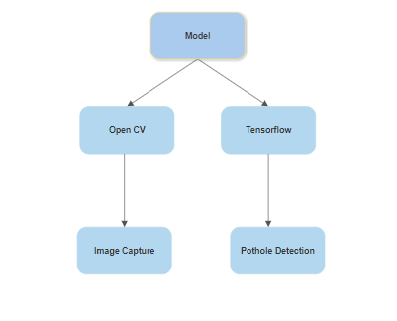

**Figure.3.1.2**  Model Sub-tree

**Parameters improved by our method:**

**1. Accuracy of Detection:**

* Improve the accuracy of Pothole detection by fine-tuning the YOLOv8 model and optimizing hyperparameters.

**2. Real-time Processing Speed:**

* Optimize the model for real-time processing to minimize latency in detecting individuals’ potholes.
* Utilize hardware acceleration (e.g., GPUs or TPUs) to speed up inference.

**3. Safety Compliance**:

Improve object detection for pothole identification can enhance road safety compliance and reduce accidents and injuries.

**5. Scalability and Camera Support:**

* Design the system to support camera, enabling monitoring of larger areas or different entry points.

**6. Deployment Flexibility:**

* Make the system adaptable for deployment in various settings, including public spaces, workplaces.

**Mathematic formulas for calculating parameter values:**

* **Bounding Box Coordinates:**

Formula: (x, y, width, height)

* **Intersection over Union (IoU):**

Formula: IoU = (Area of Intersection) / (Area of Union)

* **Mean Average Precision (mAP):**

Formula: mAP = (1 / N) * Σ Precision at Recall_i

* **Precision:**

Formula: Precision = (True Positives) / (True Positives + False Positives)

* **Recall (Sensitivity):**

Formula: Recall = (True Positives) / (True Positives + False Negatives)

* **F1-Score (Harmonic Mean of Precision and Recall):**

Formula: F1-Score = 2 * (Precision * Recall) / (Precision + Recall)

* **Training Loss (e.g., YOLO Loss):**

Formula: Loss = λ_coord * (Σ |x - x̂| + |y - ŷ|) + λ_coord * (Σ |√w - √ŵ| + |√h - √ĥ|) + (Σ |C - Ĉ|) + λ_noobj * (Σ |conf - conf̂|)

* **Learning Rate Scheduling (e.g., Step Decay):**

Formula: lr_new = lr_initial * (lr_decay_rate ^ (epoch / lr_decay_step))

1. **DESIGN**
   1. **UML DIAGRAM**

I have represented the design of the system with the help of UML diagrams. The following UML diagrams visually represent the system along with its main actors, roles, actions, and classes. They help in easily understanding the overall system.

**4.1.1. USE CASE DIAGRAM**

Use cases share different kinds of relationships. Defining the relationship between two use cases is the decision of the software analysts of the use case diagram. A relationship between two use cases is basically modeling the dependency between the two use cases. The reuse of an existing use case by using different types of relationships reduces the overall effort required in developing a system.

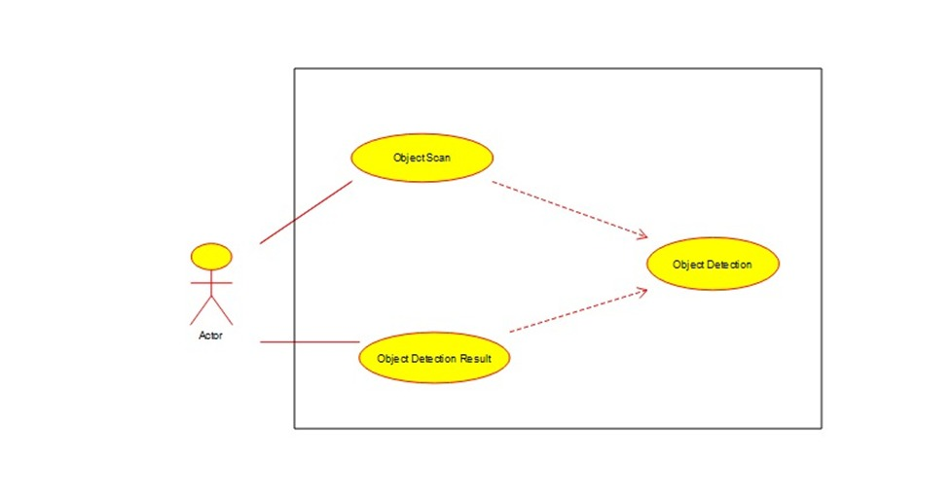

**Figure 4.1.1** Use Case diagram

**4.1.2. ACTIVITY DIAGRAM**

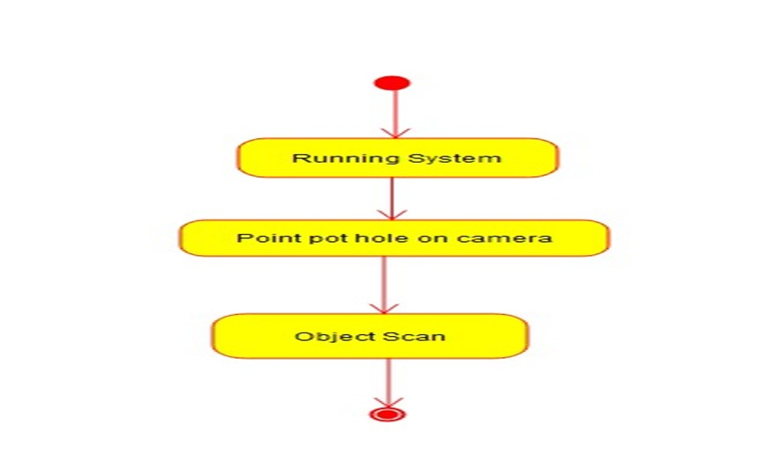Activity diagram is another important diagram in UML to describe the dynamic aspects of the system. Activity diagram is basically a flowchart to represent the flow from one activity to another activity. The activity can be described as an operation of the system. The control flow is drawn from one operation to another. This flow can be sequential, branched, or concurrent. Activity diagrams deal with all type of flow control by using different elements such as fork, join, etc.

**Figure 4.1.2.1** Activity diagram (Object scan)

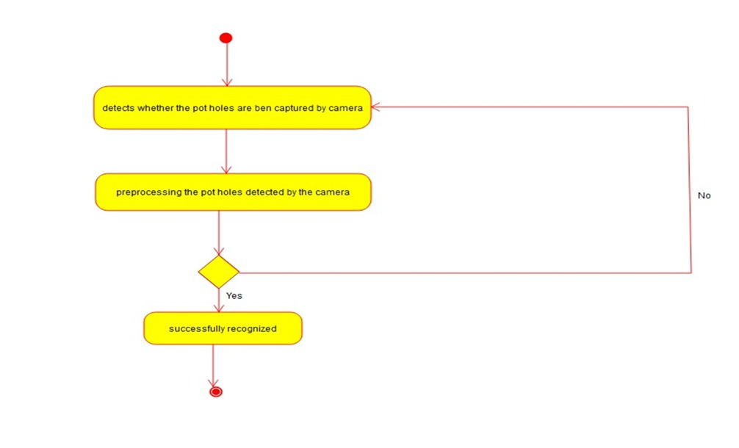

**Figure 4.1.2.2** Activity diagram (Object Detection)

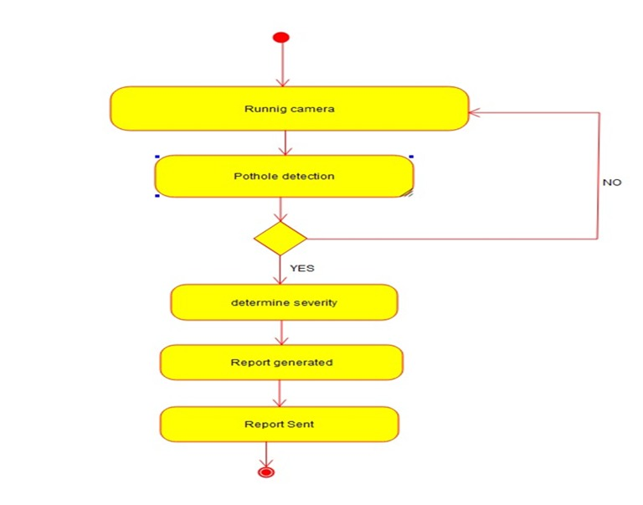

**Figure 4.1.2.3** Activity diagram (Object Detection results)

**4.1.3. CLASS DIAGRAM**

A class diagram in the Unified Modeling Language (UML) is a type of static structure diagram that describes the structure of a system by showing the system's classes, their attributes, operations (or methods), and the relationships among objects.

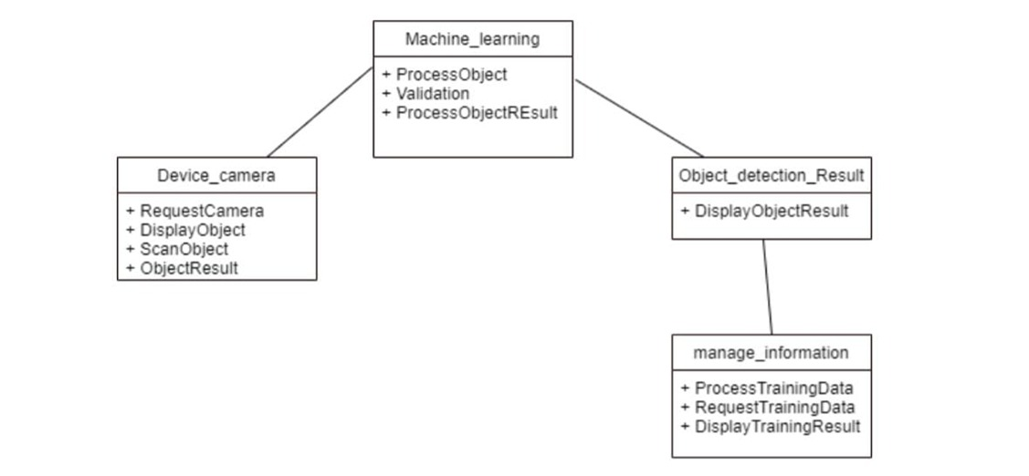

**Figure 4.4** Class Diagram

1. **IMPLEMENTATION**

The implementation of the project has been carried out in a step-by-step manner. A detailed description of each module is given below and it is followed by an introduction to the technologies used in implementing the project.

## SYSTEM ARCHITECTURE AND METHODOLOGY

The ultralytics and yolv8 modules were used to develop the project's code in Python. In this work, the modules that will be used for additional input and output operations are initially loaded. This project makes use of the libraries- OpenCV, and yolv8, which must be loaded. The primary camera provides the video inputs. Now that tensorflow is being used to identify the video as input from the camera, Next, we used a box and label to access the presentation. The input processing must then be completed by converting the input image to a predicted image. Then it's your turn to specify the pothole and yolv8 is used to modify the required output of this operation. In this process, presentation is managed by the pothole. The yolv library for the Python programming language is necessary for computing. It contains several components, including:

* An efficient array of N dimensions
* Tools for C integration and object detection

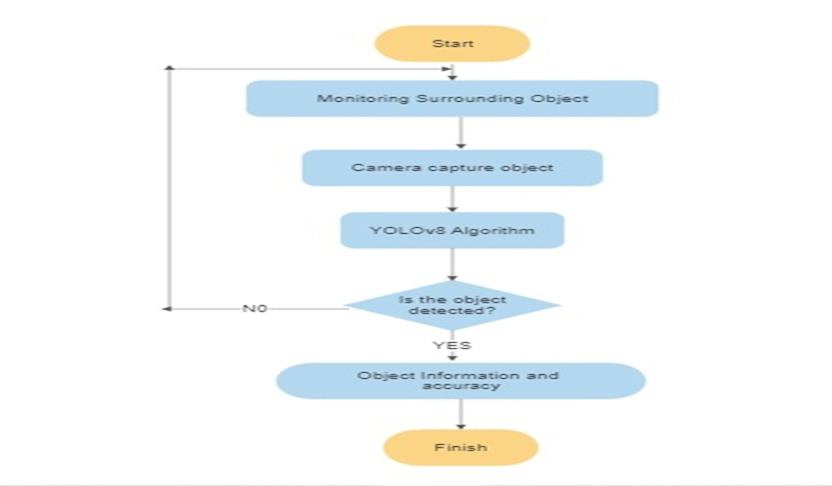

**Figure 5.1** System Architecture

## DETECTING POTHOLE BY YOLV8

## 

## Object Detection

## Object detection is an activity that aims to gain an understanding of the classification, concept estimation, and location of objects in an image. As one of the basic computer vision problems, object detection can provide valuable information for semantic understanding of images and videos, and is associated with many applications, including image classification.

## Artificial Intelligence

## Artificial Intelligence is a simulation of human intelligence that is modeled in a machine and programmed to be able to think like humans. Artificial intelligence is a technology that requires data to be used as knowledge so that the intelligence made can be even better so that it can continue to grow and learn from previous mistakes. Artificial intelligence can do self-correction is because artificial intelligence designed to learn from the mistakes that have been experienced. Artificial intelligence is one of the following four factors, namely: acting humanly, thinking humanly, thinking rationally, and acting rationally.

## Machine Learning

## Machine learning can be defined as computer applications and mathematical algorithms adopted using learning that comes from data and produces predictions in the future. The learning process in question is an attempt to acquire intelligence through two stages, including training and testing. The field of machine learning deals with the question of how to build computer programs to improve automatically based on experience.

## You Only Look Once

## You Only Look Once (YOLO) is an algorithm for object detection based on Convolutional Neural Network. In the YOLO architecture, there are 24 convolutional layers that function to get features from the image. Then followed by 2 connected layers which function to predict probability and coordinates.

## Tensorflow

## Tensorflow is a software library or library that is open source or open, and free for machine learning. Tensorflow is used for many things but focuses more on training and inference of deep neural Tensorflow library is a library based on dataflow and programming. Tensorflow is a computational framework for building machine learning models. Tensorflow provides a variety of toolkits that allow you to build models at your preferred level of abstraction and run graphics on multiple hardware platforms, including CPU, GPU, and TPU.

## You Only Look Once V8

## YOLOv8 is an innovative object detection algorithm known for its simplicity and efficiency. Unlike its predecessors, YOLOv8 combines the strengths of various YOLO versions, resulting in a robust and versatile model. Its unique feature lies in its ability to handle multi-scale object detection without extensive computational resources. YOLOv8 achieves high accuracy by employing a single-pass architecture that directly predicts bounding boxes and class probabilities, making it a preferred choice for real-time applications.

## SAMPLE CODE

## # Pip install method (recommended)

## !pip install ultralytics==8.0.20

## from IPython import display

## display.clear_output()

## import ultralytics

## ultralytics.checks()

## from ultralytics import YOLO

## from IPython.display import display, Image

## %cd /content/drive/MyDrive/Pothole.v1-raw.yolov8

## !yolo task=detect mode=train model=yolov8s.pt data= data.yaml epochs=100 imgsz=224 plots=True

## from google.colab import drive

## drive.mount('/content/drive')

## Image(filename='runs/detect/train/confusion_matrix.png', width=600)

## Image(filename='runs/detect/train/val_batch0_pred.jpg', width=600)

# TEST CASES

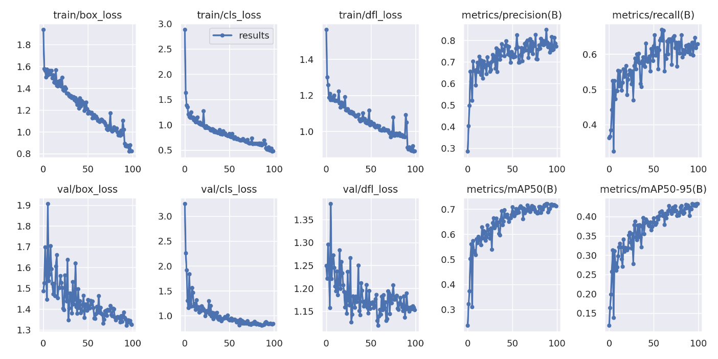

**Figure 6.1** Results of epochs (Back Propagation)

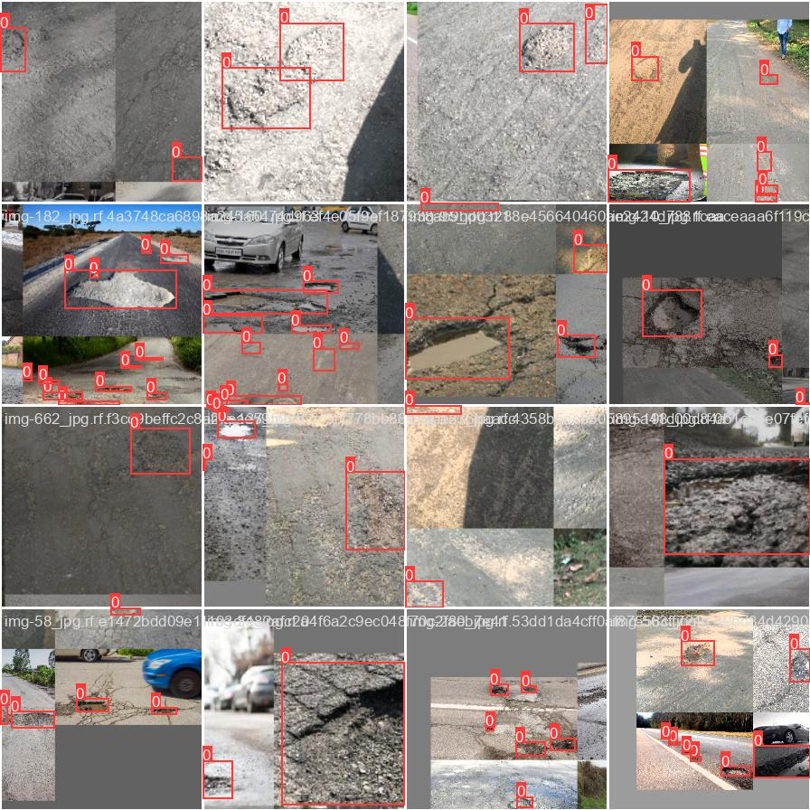

**Figure 6.2** Results (Train Data)

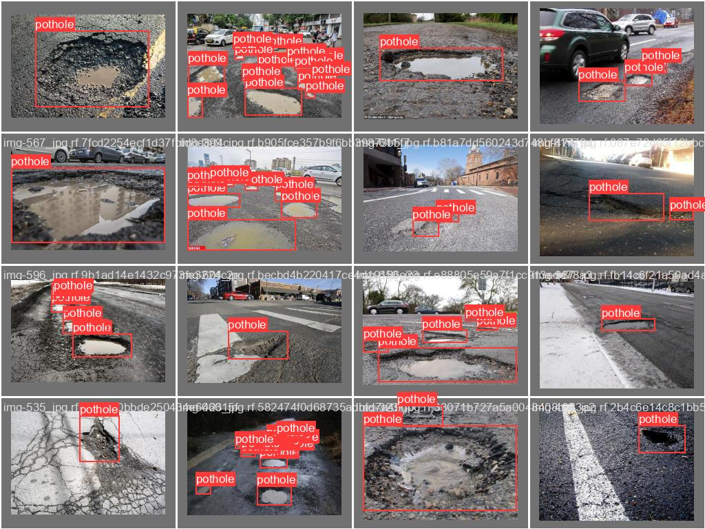

**Figure 6.3** Results (validate data)

# SCREENSHOTS

# Figure. 7.1. Installing ultralytics and import YOLV8

# Figure.7.2. Command of yolo task detection training

# 

# 

# 

# Figure.7.3. and 7.4. Each epochs one complete pass through the entire training dataset during the training of a neural network

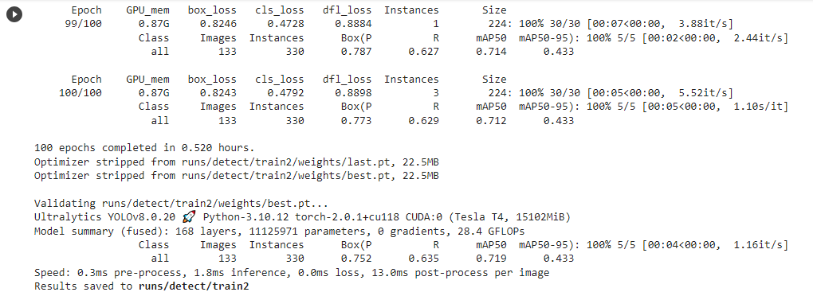

**Figure.7.5. Accuracy after the model is training**

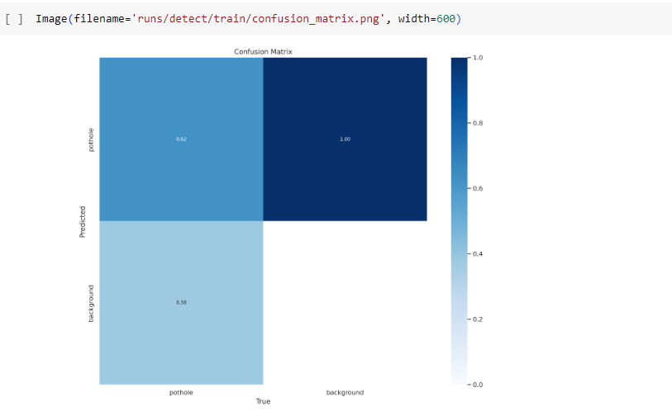

**Figure.7.6. Confusion matrix after training the dataset**

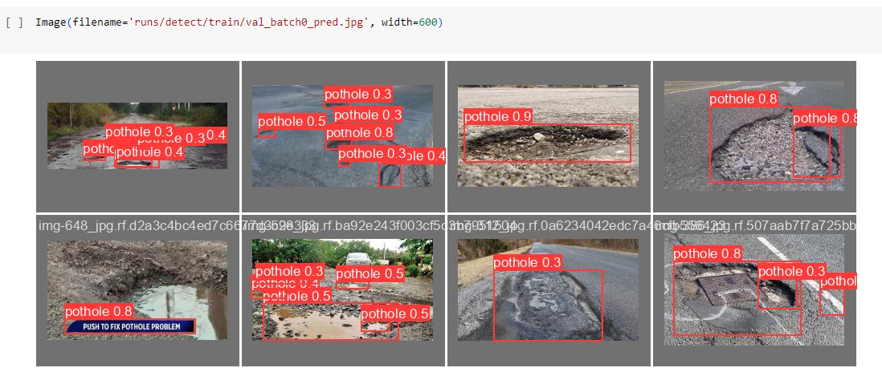

**Figure.7.7. Final result of detection the pothole and region of Interest**

# CONCLUSION

In the final analysis, our project has demonstrated how deep learning-based object identification has the potential to change the field of vehicular safety. We have developed a useful system that can significantly reduce accidents and injuries by extending detection beyond potholes, improving real-time alerts, and emphasizing affordability. Collaboration with municipalities and robust case studies underline the real-world impact of our technology. As we move forward, the path to safer roads becomes clearer, promising a future with fewer accidents and safer journeys for all.

In conclusion, utilizing the YOLO v8 algorithm for pothole detection in video analysis offers an efficient, accurate, and dynamic solution to monitor and address road surface issues. The resulting Region of Interest (ROI) within the video frames provides a clear visual representation of detected potholes, aiding in the maintenance and safety of road networks. This technology holds significant potential for enhancing road infrastructure management and ensuring smoother and safer travel for all road users.

# FUTURE ENHANCEMENT

Integrate AI-based object detection for not only potholes but also various road hazards like debris or animals. Implement real-time alerts and a user-friendly interface, offering immediate safety benefits for drivers. Explore cost-effective hardware options to ensure affordability and scalability, making it accessible in diverse regions. Collaborate with municipalities for seamless integration into existing traffic management systems. Conduct case studies to demonstrate significant reductions in accidents and injuries, emphasizing the practical impact of the technology. It should focus on making pothole detection and maintenance more efficient, proactive, and responsive to evolving road conditions. These improvements can contribute to safer and more reliable road networks.

# 10. BIBILIOGRAPHY

1. Research Gate, Google
2. Amel Ali Alhussan, Doaa Sami Khafaga, El-Sayed M. El-Kenawy, Abdelhameed Ibrahim Marwa Metwally Eid Abdelaziz A. Abdelhamid Date of Publication: 05 August 2022 INSPEC Accession Number: 21970489 DOI:10.1109/ACCESS.2022.3196660
3. Xinke Li Yongcai Guo Yongming Li Date of Publication: 23 December 2019 Electronic ISSN: 2169-3536 INSPEC Accession Number: 19442450 INSPEC Accession Number: 19442450 DOI: 10.1109/ACCESS.2019.2961755
4. Abhishek Kumar; Chakrapani; Dhruba Jyoti Kalita; Vibhav Prakash Singh 2nd International Conference on Data, Engineering and Applications (IDEA) DOI: 10.1109/IDEA49133.2020 ,28-29 Feb. 2020
5. Surekha Arjapure; D.R. Kalbande, International Conference on Communication information and Computing Technology (ICCICT) DOI: 10.1109/ICCICT50803.2021 25-27 June 2021
6. Alessio Gagliardi; V. Staderini; S. Saponara Date of Publication: 14 June 2022 Electronic ISSN: 2169-3536 INSPEC Accession Number: 21799310 DOI: 10.1109/ACCESS.2022.3183116
7. Dong Chen; Nengcheng Chen; Xiang Zhang; Yuhang Guan Date of Publication: 19 August 2022 INSPEC Accession Number: 22014136 DOI: 10.1109/JSTARS.2022.3200147
8. [Amita Dhiman](https://ieeexplore.ieee.org/author/38542229700); [Reinhard Klette](https://ieeexplore.ieee.org/author/37270732100) **INSPEC Accession Number:**19950625 **DOI:**[**1**0.1109/TITS.2019.2931297](https://doi.org/10.1109/TITS.2019.2931297)
9. Dong Chen; Nengcheng Chen; Xiang Zhang; Yuhang Guan Date of Publication: 19 August 2022 INSPEC Accession Number: 22014136 DOI: 10.1109/JSTARS.2022.3200147 Publisher: IEEE
10. Faria Kalim; Jaehoon Paul Jeong; Muhammad U. Ilyas Date of Publication: 08 September 2016 Electronic ISSN: 2169-3536 INSPEC Accession Number: 16568326 DOI: 10.1109/ACCESS.2016.2607719 Publisher: IEEE.
11. E. Salari; G. Bao Published in: 2011 IEEE INTERNATIONAL CONFERENCE ON ELECTRO/INFORMATION TECHNOLOGY Date of Conference: 15-17 May 2011 INSPEC Accession Number: 12178472 DOI: 10.1109/EIT.2011.5978575
12. [Pranjal A. Chitale](https://ieeexplore.ieee.org/author/37088749600); [Kaustubh Y. Kekre](https://ieeexplore.ieee.org/author/37088521361); [Hrishikesh R. Shenai](https://ieeexplore.ieee.org/author/37088749647); [Ruhina Karani](https://ieeexplore.ieee.org/author/37086109376); [Jay P. Gala](https://ieeexplore.ieee.org/author/37088524229) International Conference on Image and Vision Computing New Zealand, IVCNZ DOI: [10.1109/IVCNZ51579.2020](https://doi.org/10.1109/IVCNZ51579.2020) 25-27 Nov. 2020
13. [Vineet Kaushik](https://ieeexplore.ieee.org/author/37089590846); [Birinderjit Singh Kalyan](https://ieeexplore.ieee.org/author/37089588653) [2022 Second International Conference on Computer Science, Engineering and Applications (ICCSEA)](https://ieeexplore.ieee.org/xpl/conhome/9935820/proceeding)08-08 September 2022 **Date Added to IEEE *Xplore*:**07 November 2022 **ISBN Information: INSPEC Accession Number:**22239213 **DOI:**[10.1109/ICCSEA54677.2022.9936360](https://doi.org/10.1109/ICCSEA54677.2022.9936360) Publisher: IEEE
14. [A.K.M. Jobayer Al Masud](https://ieeexplore.ieee.org/author/37089218350); [Saraban Tasnim Sharin](https://ieeexplore.ieee.org/author/37089218680); [Khandokar Farhan Tanvir Shawon](https://ieeexplore.ieee.org/author/37089217459); [Zakia Zaman](https://ieeexplore.ieee.org/author/37086363762) **2021 15th International Conference on Signal Processing and Communication Systems (ICSPCS)**

DOI: [10.1109/ICSPCS53099.2021](https://doi.org/10.1109/ICSPCS53099.2021)