Lab 2

Reyna, Ricardo

Section 75C9

06/03/2015

* Prelab Questions:

None

* Problems Encountered:

In KITT2 there's a double delay at 0x18.

* Future Work/Applications:

This lab will help me interact with the input and output ports

* Schematics:

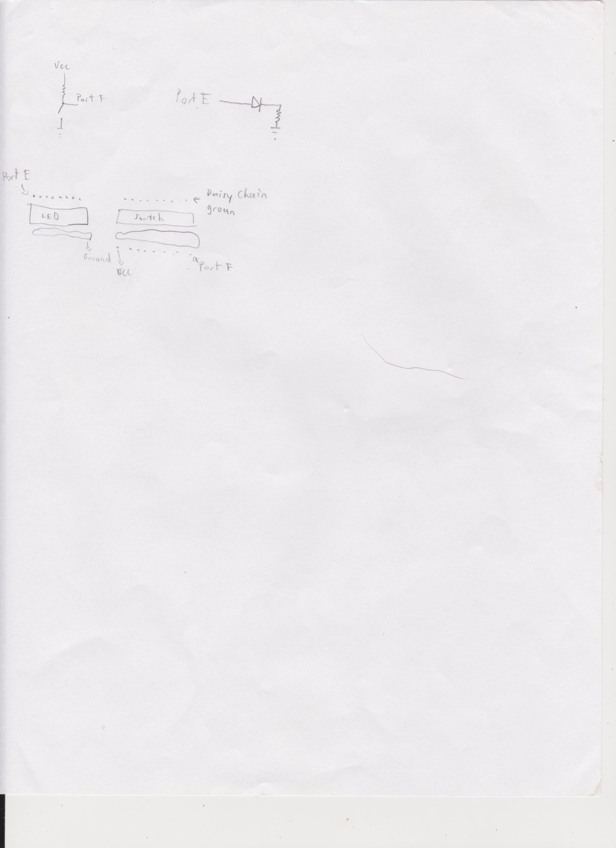

* Pseudo code:

Part a:  
Check PORT F

load value into register

load register into PORT E

Part b:  
Have an ON and OFF subroutine

LOOP with a bunch of nop and a counter

Bounce between both subroutines

Part c:

KITT1:

set carry

rotate

delay

if 0xFF restart

check for bit 3

KITT2:

load 0x81

load a register with 0x80

other register with 0x01

shift right first register

shift left other register

store the first one in a temp

or both register

delay

load temp into first regster

check for kitt1

* Program Code:

PartA:  
/*

* Lab2_A_RSR.asm

*

* Created: 5/28/2015 4:06:55 PM

* Author: stefano92

Lab 2 Part a

Name: Ricardo Stefano Reyna

Section#: 75C9

TA: Khaled Hassan

Description: This program writes to port E and reads from port F

*/

.NOLIST

.include "ATxmega128A1Udef.inc"

.LIST

.org 0x0000 ;code starts at this address

rjmp MAIN ;go to MAIN

.org 0x200

MAIN:

sts PORTF_DIR, r16 ;set port F as input

lds r16, PORTF_IN ;load value of port F into r16

sts PORTE_DIRSET, r16 ;Set port E as output

sts PORTE_OUT, r16 ;send value of r16 to port E

rjmp MAIN ;go to main

PartB:

/*

* Lab2_B_RSR.asm

*

* Created: 5/31/2015 11:33:45 PM

* Author: stefano92

Lab 2 Part b

Name: Ricardo Stefano Reyna

Section#: 75C9

TA: Khaled Hassan

Description: This program creates a delay for 200us

*/

.NOLIST

.include "ATxmega128A1Udef.inc"

.LIST

.org 0x0000 ;code starts at this address

rjmp MAIN ;go to MAIN

.org 0x200

MAIN:

ldi r16, 0x00 ;load 0 into r16

ldi r17, 0x01 ;load 1 into r17

ldi r19, 0x00 ;load 0 into r19

ON:

sts PORTE_DIRSET, r17 ;Set Port E as output

sts PORTE_OUT, r17 ;give port E the value of r17

ldi r18, 0x00 ;reset r18

inc r19 ;increase r19

LOOP:

nop ; do nothing

nop

nop

nop

nop

nop

nop

nop

nop

nop

inc r18 ;increase r18

cpi r18, 28 ;check if r18 is 28

brne LOOP ;if not loop

cpi r19, 0 ;check if r19 is 0

breq ON ;if true then go to ON

OFF:

sts PORTE_DIRSET, r16 ;Set port E as output

sts PORTE_OUT, r16 ;port E contains the value of r16

ldi r18, 0x00 ;reset r18

dec r19 ;decrease r19

rjmp LOOP ;go to LOOP

PartC:

/*

* Lab2_C_RSR.asm

*

* Created: 6/1/2015 6:53:38 PM

* Author: stefano92

Lab 2 Part c

Name: Ricardo Stefano Reyna

Section#: 75C9

TA: Khaled Hassan

Description: This program will have two settings where depending on Port F's bit 3 it will run

KITT1 or KITT2

*/

.NOLIST

.include "ATxmega128A1Udef.inc"

.LIST

.org 0x0000 ;code starts at this address

rjmp MAIN ;go to MAIN

.org 0x200

MAIN:

ldi r22, 0x00 ;load r22 with 0

ldi r21, 0x00 ;load r22 with 0

sts PORTF_DIR, r20 ;set port F as input

lds r20, PORTF_IN ;load value of port F into r20

andi r20, 0x08 ;and input with 0x08

cpi r20, 0x08 ;check for bit 3

brne KITT1 ;if false go to KITT1

jmp KITT2 ;else go to KITT2

KITT1:

ldi r16, 0xFE

sts PORTE_DIRSET, r16 ;Set port E as output

sts PORTE_OUT, r16 ;port E contains the value of r16

sec ;this is to do a rotate with no carry

LOOP1:

ROR r16

EXTRA1:

inc r21

cpi r21, 74

brne DELAY_10ms1

rjmp CONT1

DELAY_10ms1:

nop ; do nothing

nop

nop

nop

nop

nop

nop

nop

nop

nop

nop

nop

nop

nop

nop

nop

nop

nop

nop

nop

nop

nop

nop

nop

nop

nop

nop

nop

nop

nop

nop

nop

nop

nop

nop

inc r22 ;increase r18

cpi r22, 0xFF ;check if r18 is 28

brne DELAY_10ms1 ;if not loop

rjmp EXTRA1

CONT1:

ldi r22, 0x00

ldi r21, 0x00

cpi r16, 0xFF

brne NEXT1

ldi r16, 0x7F

sec

NEXT1:

sts PORTE_DIRSET, r16 ;Set port E as output

sts PORTE_OUT, r16 ;port E contains the value of r16

lds r20, PORTF_IN ;load value of port F into r16

andi r20, 0x08

cpi r20, 0x08

breq KITT2

rjmp LOOP1

/*

;

;BREAK POINT OF THE PROGRAMS

;

*/

KITT2:

ldi r16, 0x81

sts PORTE_DIRSET, r16 ;Set port E as output

sts PORTE_OUT, r16 ;port E contains the value of r16

ldi r16, 0x80

ldi r17, 0x01

ldi r19, 0x00 ;used for checking

LOOP2:

lsr r16 ;shift right

lsl r17 ;shift left

mov r18, r16 ;temp

or r16, r17

EXTRA2: ;This is used to multiply the delay_10ms

inc r21

cpi r21, 146

brne DELAY_10ms2

rjmp CONT2

DELAY_10ms2:

nop ; do nothing

nop

nop

nop

nop

nop

nop

nop

nop

nop

nop

nop

nop

nop

nop

nop

nop

nop

nop

nop

nop

nop

nop

nop

nop

nop

nop

nop

nop

nop

nop

nop

nop

nop

nop

inc r22 ;increase r18

cpi r22, 0xFF ;check if r18 is 28

brne DELAY_10ms2 ;if not loop

rjmp EXTRA2

CONT2:

sts PORTE_DIRSET, r16 ;Set port E as output

sts PORTE_OUT, r16 ;port E contains the value of r16

cpi r16, 0x81

brne NEXT2

cpi r19, 0x00

brne KITT2

NEXT2:

inc r19

mov r16, r18

ldi r22, 0x00

ldi r21, 0x00

lds r20, PORTF_IN ;load value of port F into r16

andi r20, 0x08

cpi r20, 0x00

brne LOOP2

jmp KITT1

* Appendix:

PartB:

