Lab 3

Reyna, Ricardo

Section 75C9

06/11/2015

* Prelab Questions:

1. What is the advantage of mirroring the input and output ports to $4000 - $4FFF? What would be necessary if you wanted to only place the ports at $4000 and no place else?

*Because it will be using the external memory. Set the IOPORT at address $4000.*

2. Write the address decode equation to put the input and output ports at addresses at $1000 - $7FFF.

*CSO = /A15 + A14 + A13 + A12*

3. What is the complete range of external memory on the XMEGA?

*The XMEGA is 16MB.*

4. The uPad Proto Base is configured to use the EBI in SRAM ALE1 mode, which does not give us address bits A23:16. Which mode(s) can be used to access these higher address bits? Describe the change(s) necessary to use one of these modes. What additional hardware is needed, if any?

*SRAM ALE12 or 4PORT SRAM using ALE2. We would need a 4PORT SRAM.*

* Problems Encountered:

Some of the LEDs wouldn't turn on because of poor soldering.

* Future Work/Applications:

Now I can use memory mapped IO in future labs.

* Schematics:

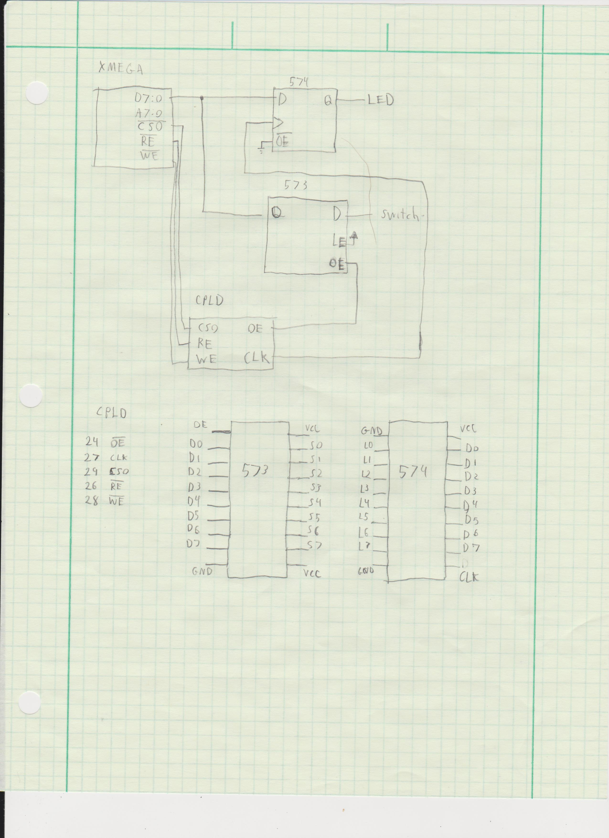

* Decoding Logic:

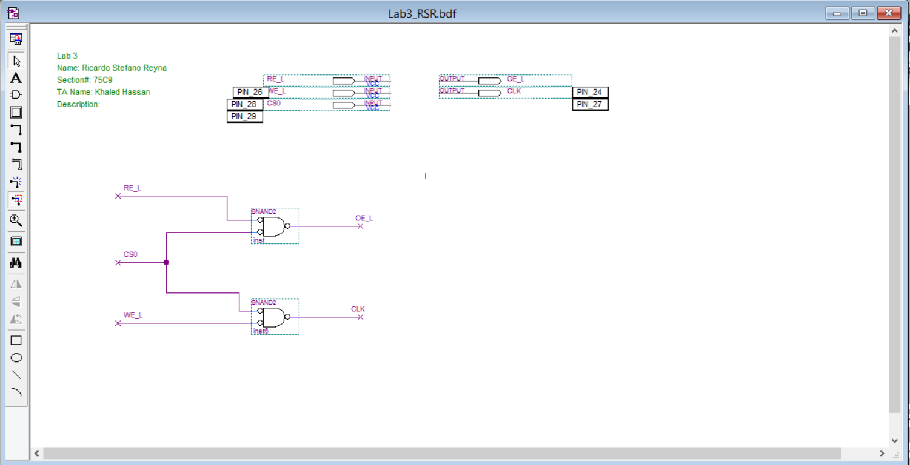

* Pseudo code:

Configure ports

have a counter

load switch

echo

shift check counter

* Program Code:

/*

* Lab3_RSR.asm

*

* Created: 6/9/2015 6:52:15 PM

* Author: stefano92

Lab 3

Name: Ricardo Stefano Reyna

Section#: 75C9

TA: Khaled Hassan

Description: This program will interact with the EBI to read from the switch and shift right every 2 seconds 8 times and then read again.

*/

.NOLIST

.include "ATxmega128A1Udef.inc"

.set IOPORT = 0x4000

.set IPORTEND = 0x4FFF

.LIST

.org 0x0000 ;code starts at this address

rjmp MAIN ;go to MAIN

.org 0x200

MAIN:

ldi R16, 0x17

sts PORTH_DIR, R16 ;configure /WE /RE and ALE

ldi R16, 0x2 ;Since /RE is an active low signal, we must set the

sts PORTH_OUT, R16 ;default output to 1.

ldi R16, 0xFF ;set all PORTJ pins (D0-D7) to be outputs. As requried

sts PORTJ_DIR, R16 ;in the data sheet.

ldi R16, 0xFF ;set all PORTK pins (A0-A15) to be outputs. As requried

sts PORTK_DIR, R16 ;in the data sheet.

ldi R16, 0x01 ;Store 0x01 in EBI_CTRL register to select 3 port EBI(H, J, K)

;mode and SRAM ALE1 mode

sts EBI_CTRL, R16

ldi ZH, HIGH(EBI_CS0_BASEADDR);reserve a chip-select zone for our input port.

ldi ZL, LOW(EBI_CS0_BASEADDR) ;the base address register is made up 12 bits

;for the address, with the lower 4 bits being reserved

;the lower 12 bits of the address are assumed to be

;zero. This limits our choice of the base addresses

;for our zone since we can only choose A23:A12

ldi R16, ((IOPORT>>8) & 0xF0) ;Store BASEADDRL. We only choose the upper 12 bits

st Z+, R16 ;of the address. It would make sense to shift

;12 bits here, but we shift right 8 times. This is

;because we have to store the lowest nibble

;of our user specified address lines (A23:A12)

;into the upper nibble of the base address reg.

;The lower 4 bits are reserved and not used. Also

;we increment the Z pointer so that we can load

;the upper byte of the base address register

ldi R16, ((IOPORT>>16)& 0xFF) ;put the upper byte (A23:16) into the upper byte

;of the base address register.

st Z, R16 ;Store BASEADDRH

ldi R16, 0x11 ;Set to 4K chip select space and turn on SRAM mode

sts EBI_CS0_CTRLA, R16 ;address space of the input port will be

;0x4000 to 0x4FFF

ldi XH, HIGH(IOPORT)

ldi XL, LOW(IOPORT)

;DEBUG:

; ld r18, X

; ldi r18, 0x55

; st X, r18

; rjmp DEBUG

LOOP:

ldi R19, 0x08 ;counter

ld R18, X ;load switches

NEXT:

st X, R18 ;Echo on leds

rcall WASTE ;delay

rcall WASTE ;delay

lsr R18 ;shift right

dec R19 ;decrement counter

cpi R19, 0 ;check if 0

BREQ LOOP ;if true check switches

rjmp NEXT ;else keep shifting

;

;DELAY LOOP

;

WASTE:

ldi r21, 0x00

ldi r22, 0x00

EXTRA:

inc r21

cpi r21, 200

brne DELAY_10ms

ret

DELAY_10ms:

nop ; do nothing

nop

nop

nop

nop

nop

nop

nop

nop

nop

nop

nop

nop

nop

nop

nop

nop

nop

nop

nop

nop

nop

nop

nop

nop

nop

nop

nop

nop

nop

nop

nop

nop

nop

nop

inc r22 ;increase r18

cpi r22, 0xFF ;check if r18 is 28

brne DELAY_10ms ;if not loop

rjmp EXTRA

* Appendix:

None