Lab 4

Reyna, Ricardo

Section 75C9

06/18/2015

* Prelab Questions:

1. What is the size CS1 used in this lab?

*The size of CS1 is 64k.*

2. Which address lines MUST be present in the SRAM chip-enable equation for **full address decoding**?

*A23:0 would need to be present for full address decoding.*

3. Draw a schematic of a 16k x 8 RAM expansion starting at address 0x7000. **You may only use address lines for decoding.**

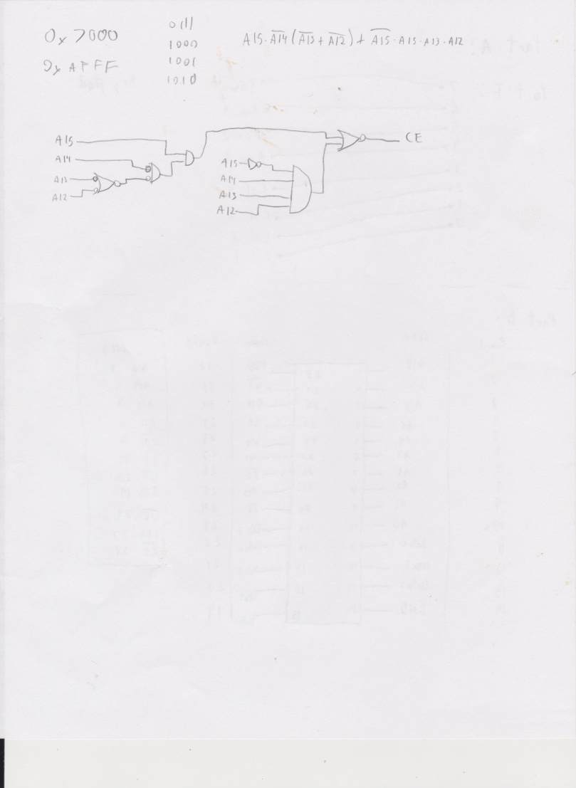

4. On the uPAD Proto Base board, is the CPLD required for interfacing with the SRAM? If not, explain.

*You don't need the CPLD to decode the SRAM, we can use the CS pins.*

5. The simple memory test program described above is not very good. It checks for neighboring data pins that are shorted or left unconnected, but we have no idea if the address bus is working. Describe a procedure for testing the address lines. Are there any limitations to your procedure (for example, does your procedure test **all** of the address lines)? Explain.

*We can input the values of the addresses inside each address line. This way we can tell which addresses are connected poorly.*

6. In this lab, we configure CS1 to be bigger than the SRAM so that we can divide it for multiple devices. If we want to connect many devices to the memory bus, this is a good way to conserve XMEGA chip select outputs. Suppose we wanted to configure CS1 to span from 0x1A0000 to 0x1BFFFF instead. Is this a valid range for an XMEGA chip select? With the hardware on your uPAD Proto Base as it is now, can we divide this new CS1 the same way do in this lab? Why or why not?

*No, because the CS has a range of 64k and this span exceeds the 64k.*

* Problems Encountered:

I had trouble setting the PINnCTRL for the Keypad

* Future Work/Applications:

I learned how to use the keypad and to setup the SRAM.

* Schematics:

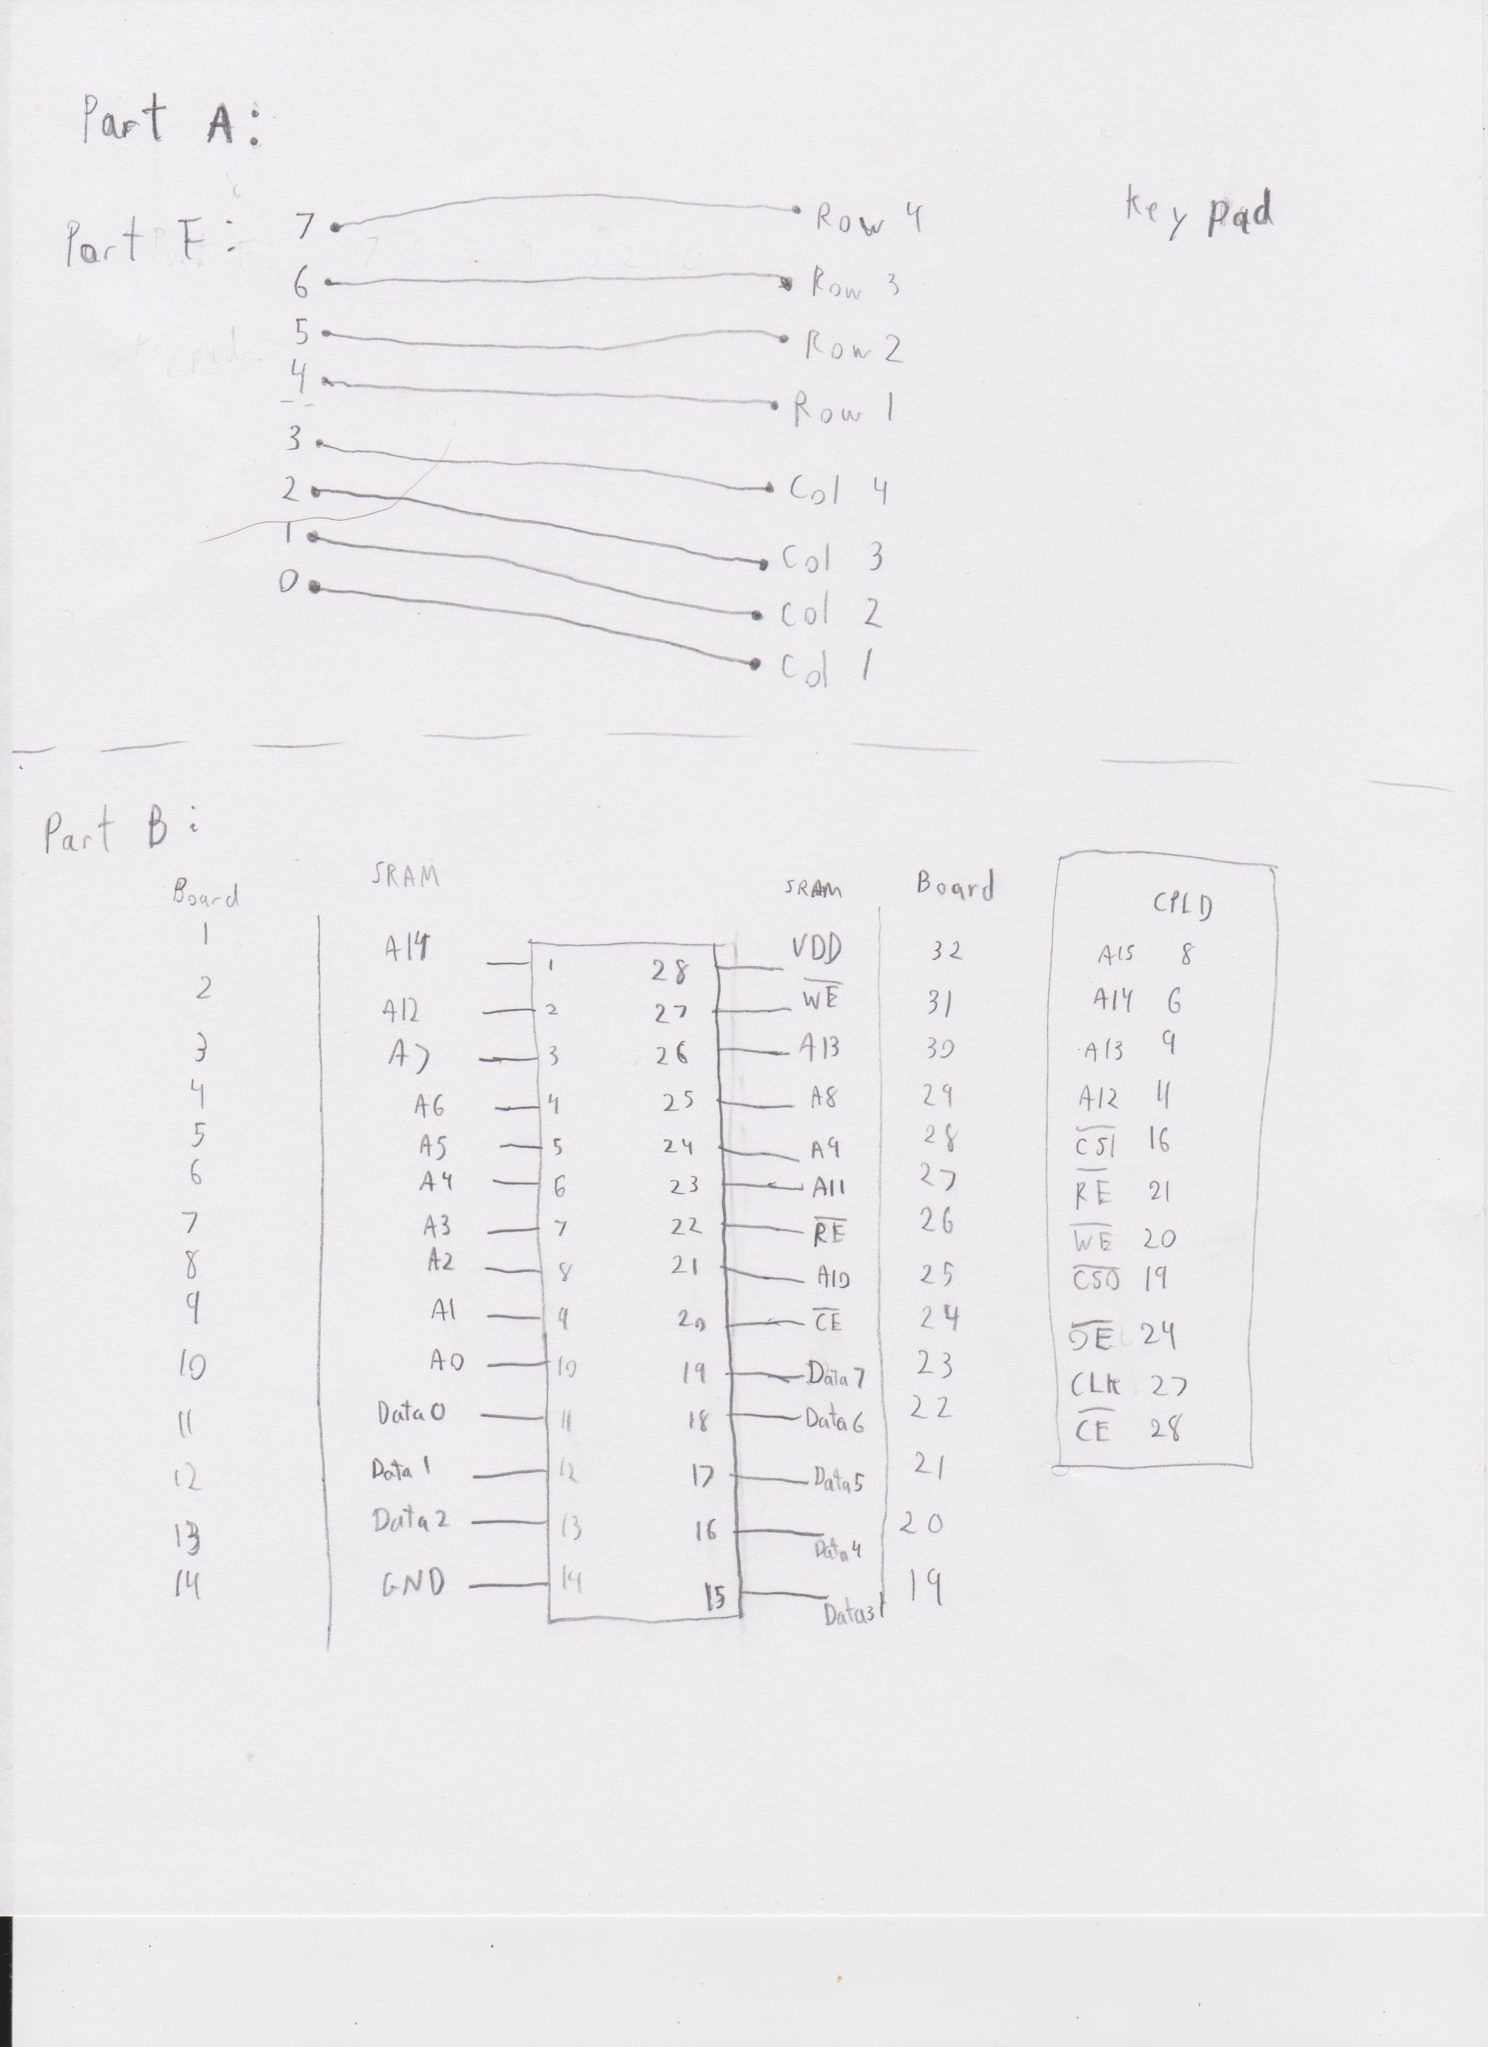

* Decoding Logic:

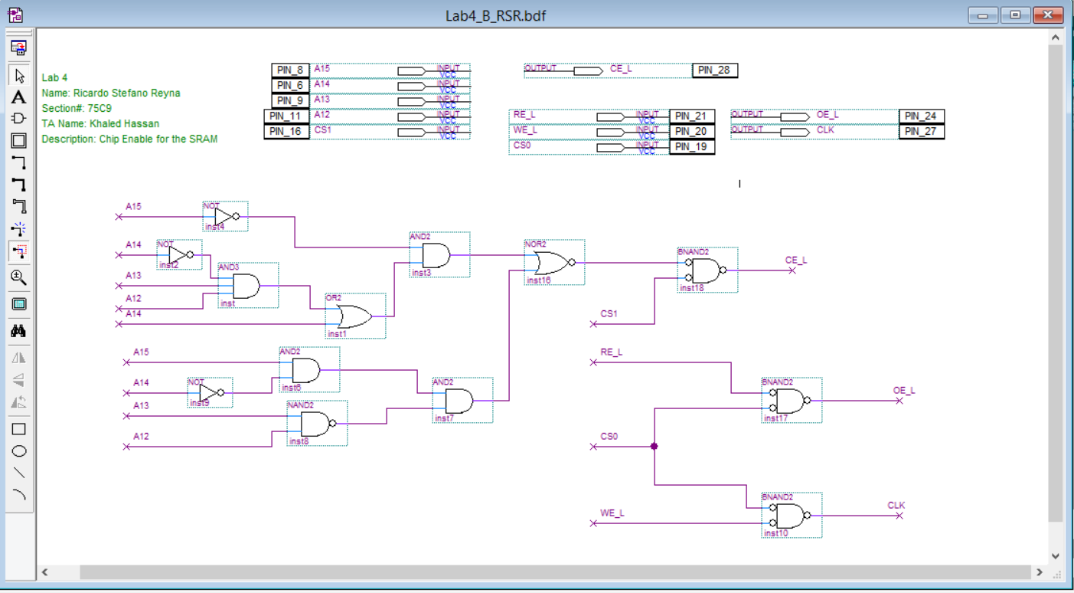

* Pseudo code:

Part A:

EBI Stuff

Set PINnCTRL

set r18 to 0xFF

check column

check each row

if it's true set r18 to that value

PartB:

EBI Stuff

Initiate Y with 0x1B3000

r16 = 0xAA or 0x55

write:

store r16 into Y

increase pointer

check if high Y is 0xB0

if no jump to write

set Y with 0x1B2FFF

set X with table

set r17 with 0

check:

increase Y

check if high Y is 0xB0

if true DONE

check r16 is 0xAA

if true jump to check

store address of Y into X

increase pointer X

check if r17 is 100 yet

* Program Code:

/*

* Lab4_A_RSR.asm

*

* Created: 6/15/2015 4:33:15 PM

* Author: stefano92

Lab 4 part A

Name: Ricardo Stefano Reyna

Section#: 75C9

TA: Khaled Hassan

Description: This program will read from the keypad and echo in the LEDs

*/

.NOLIST

.include "ATxmega128A1Udef.inc"

.set IOPORT = 0x4000

.set IPORTEND = 0x4FFF

.LIST

.org 0x0000

rjmp MAIN ;go to MAIN

.org 0x200

MAIN:

ldi r16, 0xFF

out CPU_SPL, r16

ldi r16, 0x3F

out CPU_SPH, r16 //init stack pointer

ldi r16, 0x17

sts PORTH_DIR, r16 //set port pins as outputs for RE and ALE and WE

ldi r16, 0x13

sts PORTH_OUT, r16 //WE and RE is active low so it must be set

ldi r16, 0xFF

sts PORTJ_DIR, r16 //set datalines as outputs

sts PORTK_DIR, r16 //set address lines as outputs

ldi r16, 0x01

sts EBI_CTRL, r16 //turn on 3 port SRAM ALE1 EBI

ldi ZH, HIGH(EBI_CS0_BASEADDR) //all the set up for CS0, since EBI won't work without it

ldi ZL, LOW(EBI_CS0_BASEADDR)

ldi r16, ((IOPORT>>8) & 0xF0)

st Z+, r16

ldi r16, ((IOPORT>>16) & 0xFF)

st Z, r16

ldi r16, 0x11

sts EBI_CS0_CTRLA, r16

ldi XH, HIGH(IOPORT)

ldi XL, LOW(IOPORT)

/*|~~~~~~~~~~~~~~~~~~~~~~~~~

|PROGRAM OF THE KEYBOARD

|~~~~~~~~~~~~~~~~~~~~~~~~~

*/

ldi r16, 0b011000

sts PORTF_PIN4CTRL, r16

sts PORTF_PIN5CTRL, r16

sts PORTF_PIN6CTRL, r16

sts PORTF_PIN7CTRL, r16

PARTA:

rcall KEYPAD //this will overwrite r18, will not exit until an input is recieved

st X, r18 //Hold r18

rjmp PARTA

KEYPAD:

push r16

push r17

ldi r18, 0xFF //fill 18 with a value that can't get returned. Notice it does not get pushed onto the stack!!!

ldi r16, 0x0F

sts PORTF_DIR, r16 //make sure the lower four bits are outputs and the upper are inputs

ldi r16, 0x0E //column 1

sts PORTF_OUT, r16 //make the first column low and others high

NOP

NOP

lds r17, PORTF_IN

SBRS r17, 4 //row 1

ldi r18, 0x1

SBRS r17, 5 //row 2

ldi r18, 0x4

SBRS r17, 6 //row 3

ldi r18, 0x7

SBRS r17, 7 //row 4

ldi r18, 0xE

ldi r16, 0x0D //column 2

sts PORTF_OUT, r16

NOP

NOP

lds r17, PORTF_IN

SBRS r17, 4 //row 1

ldi r18, 0x2

SBRS r17, 5 //row 2

ldi r18, 0x5

SBRS r17, 6 //row 3

ldi r18, 0x8

SBRS r17, 7 //row 4

ldi r18, 0x0

ldi r16, 0x0B //column 3

sts PORTF_OUT, r16

NOP

NOP

lds r17, PORTF_IN

SBRS r17, 4 //row 1

ldi r18, 0x3

SBRS r17, 5 //row 2

ldi r18, 0x6

SBRS r17, 6 //row 3

ldi r18, 0x9

SBRS r17, 7 //row 4

ldi r18, 0xF

ldi r16, 0x07 // column 4

sts PORTF_OUT, r16

NOP

NOP

lds r17, PORTF_IN

SBRS r17, 4 //row 1

ldi r18, 0xA

SBRS r17, 5 //row 2

ldi r18, 0xB

SBRS r17, 6 //row 3

ldi r18, 0xC

SBRS r17, 7 //row 4

ldi r18, 0xD

DONE:

pop r17

pop r16

RET

/*

* Lab4_B_RSR.asm

*

* Created: 6/16/2015 3:27:02 PM

* Author: stefano92

Lab 4 part B

Name: Ricardo Stefano Reyna

Section#: 75C9

TA: Khaled Hassan

Description: This program will read from the keypad and echo in the LEDs

*/

.include "atxmega128a1udef.inc"

.set SRAMPORT = 0x1B0000

.org 0x0000

rjmp MAIN

.dseg

.org 0x2300

Table1: .byte 200

.org 0x2700

Table2: .byte 200

.cseg

.org 0x100

MAIN:

ldi r16, 0b00110111

sts PORTH_DIR, r16 //set port pins as outputs for RE and ALE and WE CS1 and CS0

ldi r16, 0b00110011

sts PORTH_OUT, r16 //WE and RE is active low so it must be set

ldi r16, 0xFF

sts PORTJ_DIR, r16 //set datalines as outputs

sts PORTK_DIR, r16 //set address lines as outputs

ldi r16, 0x01

sts EBI_CTRL, r16 //turn on 3 port SRAM ALE1 EBI

//CS1 STUFF

ldi ZH, HIGH(EBI_CS1_BASEADDR) //set up CS1 for the SRAM

ldi ZL, LOW(EBI_CS1_BASEADDR)

ldi r16, ((SRAMPORT>>8) & 0xF0)

st Z+, r16

ldi r16, ((SRAMPORT>>16) & 0xFF)

st Z, r16

ldi r16, 0b00011101

sts EBI_CS1_CTRLA, r16

PARTB1a:

ldi r16, 0x1B //RAMP Y for the SRAM

out CPU_RAMPY, r16

ldi YH, 0x30

ldi YL, 0x00

ldi r16, 0xAA

WRITEAA:

st Y+, r16

cpi YH, 0xB0

brne WRITEAA

PARTB2a:

ldi r16, 0x1B //RAMP Y for the SRAM

out CPU_RAMPY, r16

ldi YH, 0x2F

ldi YL, 0xFF

ldi r17, 0x00

ldi XL, low(Table1) ;load low bits of the table in X

ldi XH, high(Table1) ;load high bits of the table in X

CHECKAA:

ld r16, Y+ //Pre-increment

ld r16, Y

cpi YH, 0xB0

breq PARTB1b

cpi r16, 0xAA

breq CHECKAA

st X+, YL

st X+, YH

cpi r17, 100

breq PARTB1b

inc r17

rjmp CHECKAA

PARTB1b:

ldi r16, 0x1B //RAMP Y for the SRAM

out CPU_RAMPY, r16

ldi YH, 0x00

ldi YL, 0x30

ldi r16, 0x55

WRITE55:

st Y+, r16

cpi YH, 0xB0

brne WRITE55

PARTB2b:

ldi r16, 0x1B //RAMP Y for the SRAM

out CPU_RAMPY, r16

ldi YH, 0x2F

ldi YL, 0xFF

ldi XL, low(Table2) ;load low bits of the table in X

ldi XH, high(Table2) ;load high bits of the table in X

CHECK55:

ld r16, Y+ //Pre-increment

ld r16, Y

cpi YH, 0xB0

breq DONE

cpi r16, 0x55

breq CHECK55

st X+, YL

st X+, YH

cpi r17, 100

breq DONE

inc r17

rjmp CHECK55

DONE: rjmp DONE

* Appendix:

