Lab 7

Reyna, Ricardo

Section 75C9

07/24/2015

* Prelab Questions:

1. Draw a 10kHz square wave with a 73% duty cycle. What is the period in miliseconds(ms)?

*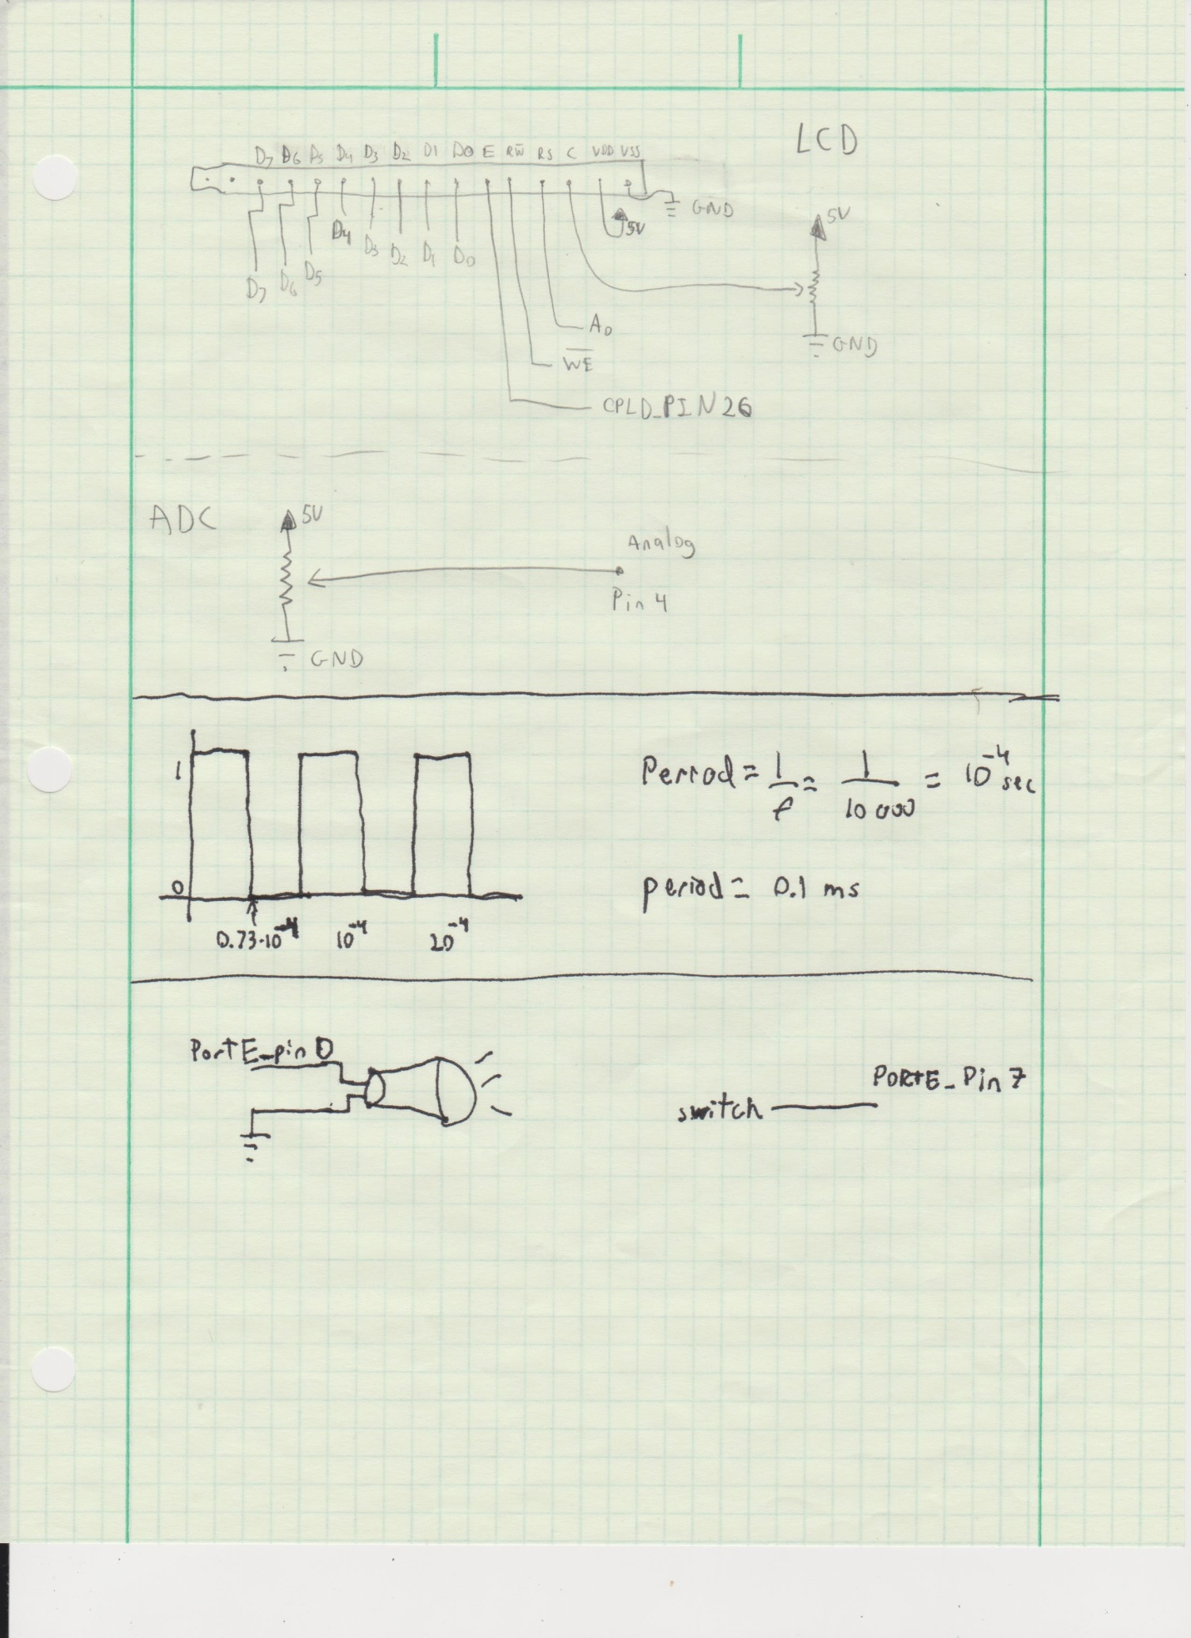*

2. For part A, what is the limiting factor for the precision of your frequency generation? Can your XMEGA generate some frequency ranges with higher precisions than other frequency ranges? Explain.

*The limiting factor is the amount of bits the CNT can contain. The XMEGA can generate lower frequencies more precise than higher ones, because higher frequencies overflow the TC faster than lower frequencies.*

3. How does the prescaler affect the way the TC system counts per clock cycle? Where are the counts stored?

*The prescaler divides the clock by a value before it's fed to the TC. The counts are stored in the CNT register.*

4. Describe the difference(s) between the TC's Frequency Generation mode and its Single/Dual Slope PWM modes. Which mode(s) can be used to emulate the other(s)? How could you make a sine wave or other waveforms using your XMEGA? Do you need to add any extra hardware?

* Problems Encountered:

The voltmeter isn't as accurate as I wanted it to be. Having the voltmeter read continuously, and going to the previous function after entering "pot mode".

* Future Work/Applications:

We can use the lcd to output characters, and we can use the ADC to connect other analog peripherals to the board.

* Schematics:

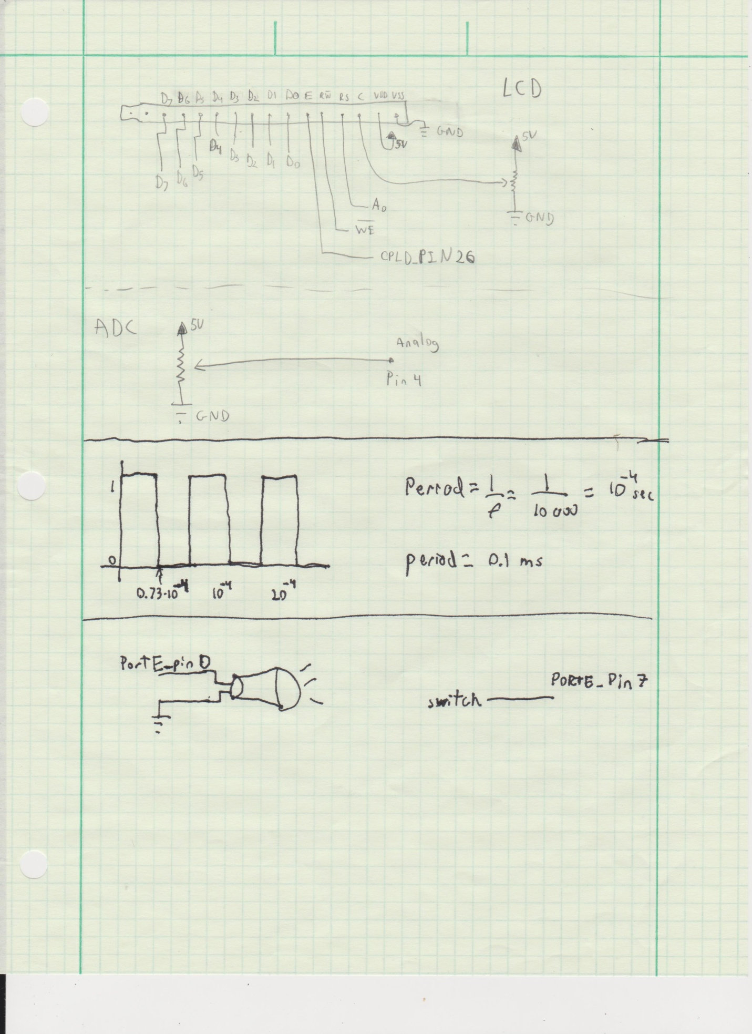

* Decoding Logic:

None in this lab

* Pseudo code:

Part A:

initialize switch

initialize speaker

check if the switch is on to play sound

PartB:

Initialize everything

Use an interrupt on the timer.

Check if \* or # to play the song, otherwise play a single note

If the note is selected also display it on the lcd

If a song is play feed the string into a function that will take each char into another function to play each note individually

Repeat infinitely

* Program Code:

Part A:

* Appendix: