Lab 7

Reyna, Ricardo

Section 75C9

07/24/2015

* Prelab Questions:

1. Draw a 10kHz square wave with a 73% duty cycle. What is the period in miliseconds(ms)?

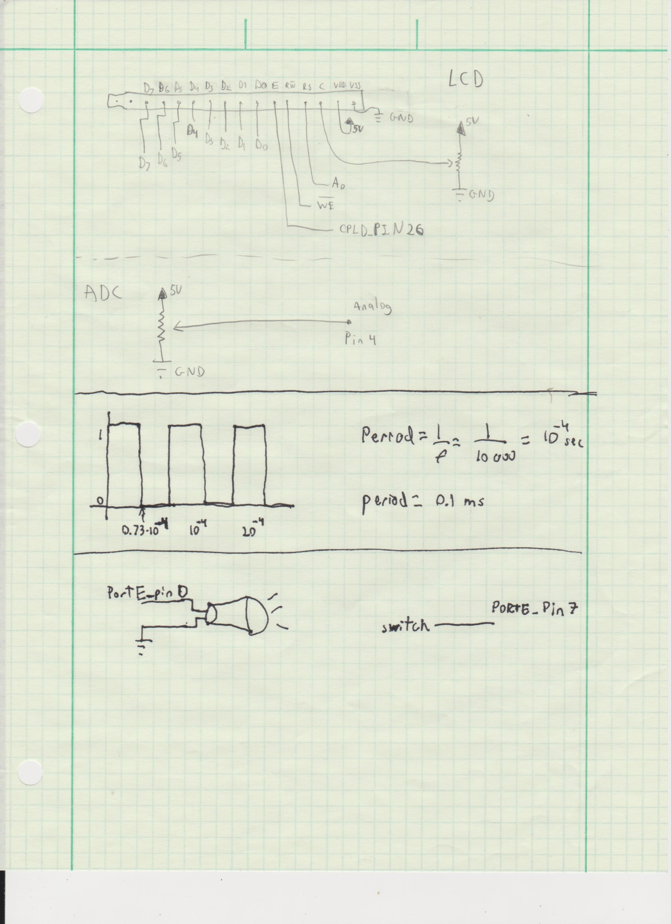

2. For part A, what is the limiting factor for the precision of your frequency generation? Can your XMEGA generate some frequency ranges with higher precisions than other frequency ranges? Explain.

*The limiting factor is the amount of bits the CNT can contain. The XMEGA can generate lower frequencies more precise than higher ones, because higher frequencies overflow the TC faster than lower frequencies.*

3. How does the prescaler affect the way the TC system counts per clock cycle? Where are the counts stored?

*The prescaler divides the clock by a value before it's fed to the TC. The counts are stored in the CNT register.*

4. Describe the difference(s) between the TC's Frequency Generation mode and its Single/Dual Slope PWM modes. Which mode(s) can be used to emulate the other(s)? How could you make a sine wave or other waveforms using your XMEGA? Do you need to add any extra hardware?

*The difference is that in frequency mode the period of the wave is controlled by the CCA register; meanwhile in the Single/Dual Slope PWM the period is controlled by the value of the PER register. The PWM mode can be used to emulate the Frequency Generation mode when the duty cycle is set to 50%. Sine waves can be generated by connecting a custom circuit that takes PWD as an input and outputs as a variable voltage. The circuit is found on the LCD specs.*

* Problems Encountered:

None in this lab.

* Future Work/Applications:

In this we used timers to generate different frequencies to produce sounds. We also combined the timers with interrupts.

* Schematics:

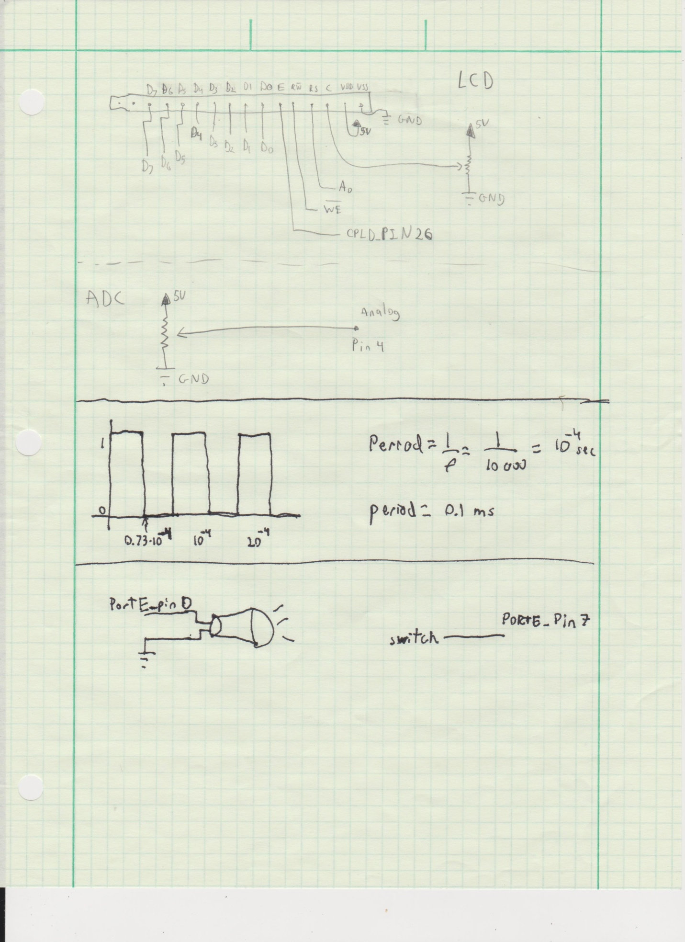

* Decoding Logic:

None in this lab

* Pseudo code:

Part A:

initialize switch

initialize speaker

check if the switch is on to play sound

PartB:

Initialize everything

Use an interrupt on the timer.

Check if * or # to play the song, otherwise play a single note

If the note is selected also display it on the lcd

If a song is play feed the string into a function that will take each char into another function to play each note individually

Repeat infinitely

* Program Code:

Part A:

/*

* Lab7_A_RSR.c

*

* Created: 7/20/2015 4:20:45 PM

* Author: stefano92

Lab 6 part A

Name: Ricardo Stefano Reyna

Section#: 75C9

TA: Khaled Hassan

Description: This program is to check the timer and check the output sound.

*/

#include <avr/io.h>

#include <avr/interrupt.h>

#include "ebi_driver.h"

#define F_CPU 2000000

#define CS0_Start 0x4000

#define CS1_Start 0x1B0000

#define LCD_COM 0x1B1000

#define LCD_DAT 0x1B1001

void init_timer();

void init_switch();

int main(void)

{

init_switch();

init_timer();

uint8_t input_check;

while(1) {

//Checks when the switch is on or off

input_check = PORTE.IN & 0x80;

if(input_check == 0x80) {

TCE0.CTRLB = 0x11;

}

else {

TCE0.CTRLB = 0x01;

}

}

return 0;

}

void init_timer() {

PORTE.DIRSET = 0x01;

TCE0.CNT = 0x00;

TCE0.CTRLA = 0x01;

TCE0.CTRLB = 0x11;

TCE0.CCA = 0x23B;

}

void init_switch() {

PORTE.DIRCLR = 0x80;

}

PartB:

/*

* Lab7_B_RSR.c

*

* Created: 7/21/2015 3:17:24 PM

* Author: stefano92

Lab 7 part B

Name: Ricardo Stefano Reyna

Section#: 75C9

TA: Khaled Hassan

Description: This program depending on the keypad will select a note to be played or a full song.

*/

#include <avr/io.h>

#include <avr/interrupt.h>

#include "ebi_driver.h"

#define F_CPU 2000000

#define CS0_Start 0x4000

#define CS1_Start 0x1B0000

#define LCD_COM 0x1B1000

#define LCD_DAT 0x1B1001

void init_EBI();

void init_lcd();

void check_BF();

void out_string(char *str);

void init_timer();

void init_SP();

void k_init();

char get_key();

void soundStop();

void delay();

void checknotes(char note, int stop);

void noise(char note);

void music(char* song, int stop);

int main(void)

{

init_SP();

init_EBI();

init_timer();

init_lcd();

k_init();

char input = '&';

char *song1 = "03603601B86803153"; //Song of time

char *song2 = "365130p365136p031"; //Lugia's song

int time1 = 20000;

int time2 = 25000;

while(1)

{

input = get_key();

//This checks if you want to play a song or just a beep

switch(input) {

case '*':

__far_mem_write(LCD_COM, 0x01);

check_BF();

out_string("Song of Time");

__far_mem_write(LCD_COM, 0xC0);

check_BF();

out_string("Ocarina of Time");

music(song1, time1);

break;

case '#':

__far_mem_write(LCD_COM, 0x01);

check_BF();

out_string("Lugia's song");

__far_mem_write(LCD_COM, 0xC0);

check_BF();

out_string("Pokemon");

music(song2, time2);

break;

default:

noise(input);

break;

}

}

}

void init_EBI() {

PORTH_DIR = 0x37;

PORTH_OUT = 0x33;

PORTK_DIR = 0xFF;

EBI.CTRL = EBI_SRMODE_ALE1_gc | EBI_IFMODE_3PORT_gc; // ALE1 multiplexing, 3 port configuration

EBI.CS0.BASEADDRH = (uint8_t) (CS0_Start>>16) & 0xFF;

EBI.CS0.BASEADDRL = (uint8_t) (CS0_Start>>8) & 0xFF; // Set CS0 range to 0x004000 - 0x004FFF

EBI.CS0.CTRLA = EBI_CS_MODE_SRAM_gc | EBI_CS_ASPACE_4KB_gc; // SRAM mode, 4k address space

// BASEADDR is 16 bit (word) register. C interface allows you to set low and high parts with 1

// instruction instead of the previous two

EBI.CS1.BASEADDR = (uint16_t) (CS1_Start>>8) & 0xFFFF; // Set CS1 range to 0x1B0000 - 0x1BFFFF

EBI.CS1.CTRLA = EBI_CS_MODE_SRAM_gc | EBI_CS_ASPACE_64KB_gc;

}

void init_lcd() {

check_BF();

__far_mem_write(LCD_COM,0x38);

check_BF();

__far_mem_write(LCD_COM,0x0F);

check_BF();

__far_mem_write(LCD_COM,0x01);

check_BF();

}

void k_init(){

PORTF_PIN4CTRL = 0x18;

PORTF_PIN5CTRL = 0x18;

PORTF_PIN6CTRL = 0x18;

PORTF_PIN7CTRL = 0x18;

PORTF_DIRSET = 0x0F; //Low bits are outputs

PORTF_DIRCLR = 0xF0; //High bits are inputs

}

void check_BF() {

volatile uint8_t temp_val = 0;

while(1) {

temp_val = __far_mem_read(LCD_COM);

if((temp_val & 0x80) == 0x00) {

break;

}

}

}

void out_string(char *str){

int cntr = 0;

//go through each char until null

while(*str!= 0) {

check_BF();

//go to the next line when ends the line

if(cntr == 16)

{

__far_mem_write(LCD_COM, 0xC0);

check_BF();

}

check_BF();

__far_mem_write(LCD_DAT,*str);

str++;

cntr++;

}

check_BF();

}

void init_timer() {

TCE1.CTRLA = 0x05;

TCE1.CTRLB = 0x10;

TCE1.INTCTRLA = 0x02;

TCE1.INTCTRLB = 0x00;

PMIC_CTRL = 0x02;

sei();

}

void init_SP() {

PORTE.DIRSET = 0x01; //making portE pin2 as an output

TCE0_CNT = 0x00; //this is where the count is stored, we are resetting it. (CNT=PER)

TCE0_CTRLA = 0x00; //setting clk to on

TCE0_CTRLB = 0x11; //enables CCA (FRQ mode, see 14.8.2), frequency mode

}

void soundStop(int num) {

TCE1.CNT = 0x00;

TCE1.PER = num;

//Setting the PER depending on the time passed in

while (TCE1.PER > TCE1.CNT)

{

TCE0.CTRLA = 0x01;

}

}

//Interrupt for the timer

ISR(TCE1_OVF_vect) {

TCE0.CTRLA = 0x00;

}

//Keypad

char get_key(){

uint8_t key;

PORTF_OUT = 0x0E;

asm("nop");

key = PORTF_IN;

if(key == 0xEE){

return '1';

}

if(key == 0xDE){

return '4';

}

if(key == 0xBE){

return '7';

}

if(key == 0x7E){

return '*';

}

PORTF_OUT = 0x0D;

asm("nop");

key = PORTF_IN;

if(key == 0xED){

return '2';

}

if(key == 0xDD){

return '5';

}

if(key == 0xBD){

return '8';

}

if(key == 0x7D){

return '0';

}

PORTF_OUT = 0x0B;

asm("nop");

key = PORTF_IN;

if(key == 0xEB){

return '3';

}

if(key == 0xDB){

return '6';

}

if(key == 0xBB){

return '9';

}

if(key == 0x7B){

return '#';

}

PORTF_OUT = 0x07;

asm("nop");

key = PORTF_IN;

if(key == 0xE7){

return 'A';

}

if(key == 0xD7){

return 'B';

}

if(key == 0xB7){

return 'C';

}

if(key == 0x77){

return 'D';

}

return '&';

}

void noise(char note) {

int timenote = 15000;

//Display on the lcd and make the noise

switch (note)

{

delay();

case '1':

TCE0.CCA = 0x3C1; //1046.50

__far_mem_write(LCD_COM, 0x01);

check_BF();

out_string("C6");

__far_mem_write(LCD_COM, 0xC0);

check_BF();

out_string("1046.50 Hz");

soundStop(timenote);

break;

case '2':

TCE0.CCA = 0x38B; //1108.73

__far_mem_write(LCD_COM, 0x01);

check_BF();

out_string("C#6/Db6");

__far_mem_write(LCD_COM, 0xC0);

check_BF();

out_string("1108.73 Hz");

soundStop(timenote);

break;

case '3':

TCE0.CCA = 0x358; //1174.66

__far_mem_write(LCD_COM, 0x01);

check_BF();

out_string("D6");

__far_mem_write(LCD_COM, 0xC0);

check_BF();

out_string("1174.66 Hz");

soundStop(timenote);

break;

case '4':

TCE0.CCA = 0x328; //1244.51

__far_mem_write(LCD_COM, 0x01);

check_BF();

out_string("D#6/Eb6");

__far_mem_write(LCD_COM, 0xC0);

check_BF();

out_string("1244.51 Hz");

soundStop(timenote);

break;

case '5':

TCE0.CCA = 0x2FA; //1318.51

__far_mem_write(LCD_COM, 0x01);

check_BF();

out_string("E6");

__far_mem_write(LCD_COM, 0xC0);

check_BF();

out_string("1318.51 Hz");

soundStop(timenote);

break;

case '6':

TCE0.CCA = 0x2D0; //1396.91

__far_mem_write(LCD_COM, 0x01);

check_BF();

out_string("F6");

__far_mem_write(LCD_COM, 0xC0);

check_BF();

out_string("1396.98 Hz");

soundStop(timenote);

break;

case '7':

TCE0.CCA = 0x2A7; //1479.98

__far_mem_write(LCD_COM, 0x01);

check_BF();

out_string("F#6/Gb6");

__far_mem_write(LCD_COM, 0xC0);

check_BF();

out_string("1479.98 Hz");

soundStop(timenote);

break;

case '8':

TCE0.CCA = 0x281; //1567.98

__far_mem_write(LCD_COM, 0x01);

check_BF();

out_string("G6");

__far_mem_write(LCD_COM, 0xC0);

check_BF();

out_string("1567.98 Hz");

soundStop(timenote);

break;

case '9':

TCE0.CCA = 0x25D; //1661.22

__far_mem_write(LCD_COM, 0x01);

check_BF();

out_string("G#6/Ab6");

__far_mem_write(LCD_COM, 0xC0);

check_BF();

out_string("1661.22 Hz");

soundStop(timenote);

break;

case '0':

TCE0.CCA = 0x23C; //1760.00

__far_mem_write(LCD_COM, 0x01);

check_BF();

out_string("A6");

__far_mem_write(LCD_COM, 0xC0);

check_BF();

out_string("1760.00 Hz");

soundStop(timenote);

break;

case 'A':

TCE0.CCA = 0x21B; //1864.66

__far_mem_write(LCD_COM, 0x01);

check_BF();

out_string("A#6/Bb6");

__far_mem_write(LCD_COM, 0xC0);

check_BF();

out_string("1864.66 Hz");

soundStop(timenote);

break;

case 'B':

TCE0.CCA = 0x1FD; //1975.53

__far_mem_write(LCD_COM, 0x01);

check_BF();

out_string("B6");

__far_mem_write(LCD_COM, 0xC0);

check_BF();

out_string("1975.53 Hz");

soundStop(timenote);

break;

case 'C':

TCE0.CCA = 0x1E0; //2093.00

__far_mem_write(LCD_COM, 0x01);

check_BF();

out_string("C7");

__far_mem_write(LCD_COM, 0xC0);

check_BF();

out_string("2093.00 Hz");

soundStop(timenote);

break;

case 'D':

TCE0.CCA = 0x1C5; //2217.46

__far_mem_write(LCD_COM, 0x01);

check_BF();

out_string("C#7/Db7");

__far_mem_write(LCD_COM, 0xC0);

check_BF();

out_string("2217.46 Hz");

soundStop(timenote);

break;

default:

break;

}

}

void music (char* song, int stop) {

//Grabs each char individually to pass each note

while (*song != 0x00) {

checknotes(*song, stop);

song++;

}

}

void checknotes(char note, int stop) {

//I use this for the songs and get each note individually, I algo include a pause

switch (note)

{

delay();

case '1':

TCE0.CCA = 0x3C1; //1046.50

soundStop(stop);

break;

case '2':

TCE0.CCA = 0x38B; //1108.73

soundStop(stop);

break;

case '3':

TCE0.CCA = 0x358; //1174.66

soundStop(stop);

break;

case '4':

TCE0.CCA = 0x328; //1244.51

soundStop(stop);

break;

case '5':

TCE0.CCA = 0x2FA; //1318.51

soundStop(stop);

break;

case '6':

TCE0.CCA = 0x2D0; //1396.91

soundStop(stop);

break;

case '7':

TCE0.CCA = 0x2A7; //1479.98

soundStop(stop);

break;

case '8':

TCE0.CCA = 0x281; //1567.98

soundStop(stop);

break;

case '9':

TCE0.CCA = 0x25D; //1661.22

soundStop(stop);

break;

case '0':

TCE0.CCA = 0x23C; //1760.00

soundStop(stop);

break;

case 'A':

TCE0.CCA = 0x21B; //1864.66

soundStop(stop);

break;

case 'B':

TCE0.CCA = 0x1FD; //1975.53

soundStop(stop);

break;

case 'C':

TCE0.CCA = 0x1E0; //2093.00

soundStop(stop);

break;

case 'D':

TCE0.CCA = 0x1C5; //2217.46

soundStop(stop);

break;

case 'p':

TCE0.CCA = 0x01; //pause

soundStop(10000);

break;

default:

break;

}

}

void delay () {

volatile uint32_t ticks; // Volatile prevents compiler optimization

for(ticks=0;ticks<=10000;ticks++); // Convinient delay

}

* Appendix:

