Lab 7

Reyna, Ricardo

Section 75C9

07/24/2015

* Prelab Questions:

1. Draw a 10kHz square wave with a 73% duty cycle. What is the period in milliseconds(ms)?

*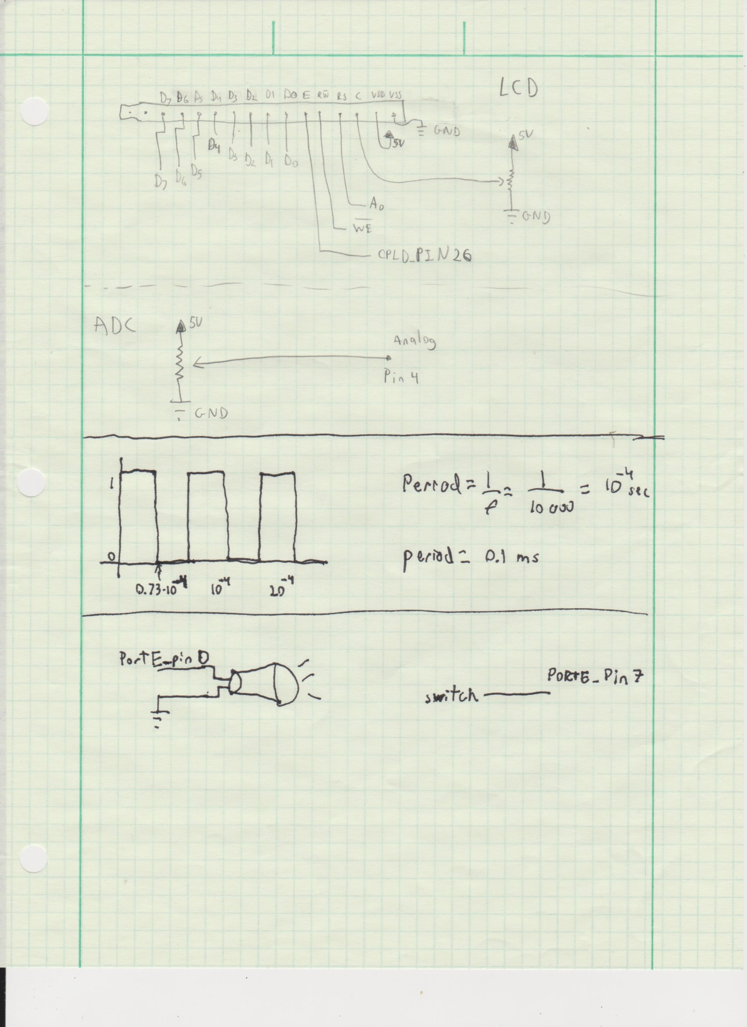*

2. For part A, what is the limiting factor for the precision of your frequency generation? Can your XMEGA generate some frequency ranges with higher precisions than other frequency ranges? Explain.

*The limiting factor is the amount of bits the CNT can contain. The XMEGA can generate lower frequencies more precise than higher ones, because higher frequencies overflow the TC faster than lower frequencies.*

3. How does the prescaler affect the way the TC system counts per clock cycle? Where are the counts stored?

*The prescaler divides the clock by a value before it's fed to the TC. The counts are stored in the CNT register.*

4. Describe the difference(s) between the TC's Frequency Generation mode and its Single/Dual Slope PWM modes. Which mode(s) can be used to emulate the other(s)? How could you make a sine wave or other waveforms using your XMEGA? Do you need to add any extra hardware?

*The difference is that in frequency mode the period of the wave is controlled by the CCA register; meanwhile in the Single/Dual Slope PWM the period is controlled by the value of the PER register. The PWM mode can be used to emulate the Frequency Generation mode when the duty cycle is set to 50%. Sine waves can be generated by connecting a custom circuit that takes PWD as an input and outputs as a variable voltage. The circuit is found on the LCD specs.*

* Problems Encountered:

None in this lab.

* Future Work/Applications:

In this we used timers to generate different frequencies to produce sounds. We also combined the timers with interrupts.