- Change password_encryption to md5.
File: C:\Program Files\PostgreSQL\13\data\postgresql.conf
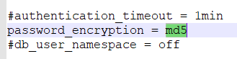
- Change scram-sha-256 to md5 in host settings.
File: C:\Program Files\PostgreSQL\13\data\pg_hba.conf.
host all all 0.0.0.0/0 md5
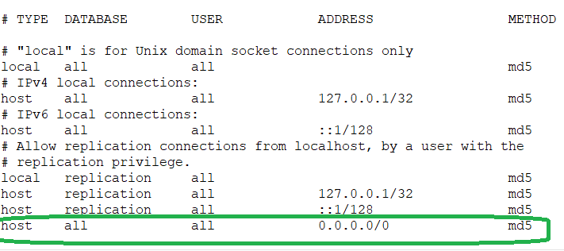
- Change Password ( this restore password in md5 format).
Example: ALTER ROLE postgres WITH PASSWORD 'root';
- Make sure you set listen_addresses = '*' if you are working non production environment.
File : C:\Program Files\PostgreSQL\13\data\postgresql.conf

