Summary of Proposed Results Figures and Target Sections
Figure | Type | Core Focus | Target Section
Fig. 10 | Horizontal Bar | Cloud SFU & Mesh Latency vs. ITU-T G.114 (150 ms) | Section VII-B
Fig. 11 | Stacked Bar | Analytical Multi-Hop Latency Budget (Eq. 1) | Section VII-B
Fig. 12 | Donut Chart | 63% RF Airtime & Uplink Reduction (VAD + DTX) | Section VII-B
Fig. 13 | Pie Chart | 118-Byte Wire-Packet Protocol Composition | Section VII-B / IV-A
Fig. 14 | Range / Point | Standby Promotion & Overtake Reconfiguration | Section VII-C
Fig. 15 | Time Series | Asymmetric Hysteresis vs. Flapping Thrashing | Section VII-C
Fig. 16 | Line Chart | Medium Contention Scaling: O(N²) vs. O(N) | Section VII-C / VII-D

Fig. 10: End-to-End Voice Latency vs. ITU-T Recommendation G.114
Target Location in Paper: Section VII-B (Audio Pipeline and Latency Performance)
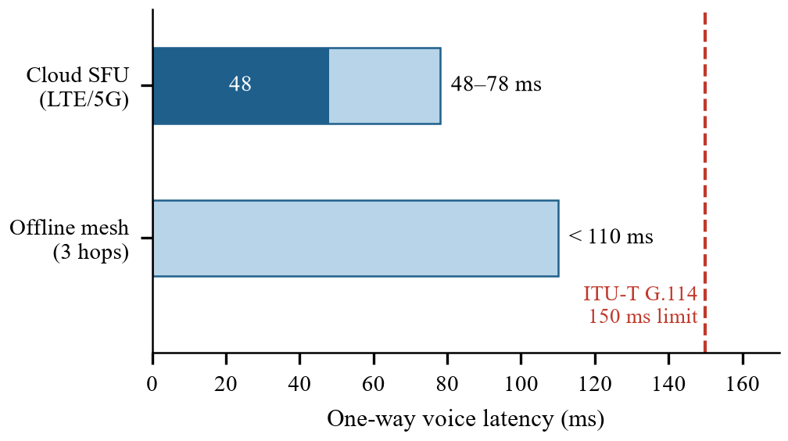
Fig. 10. Measured one-way voice latency across Cloud SFU mode and 3-hop offline Wi-Fi Direct mesh overlay relative to the 150 ms conversational threshold defined in ITU-T Recommendation G.114.
Context & Analysis Paragraph (for paper body text):
As illustrated in Fig. 10, the end-to-end voice latency profiles of both operational engines remain well within the strict 150 ms upper bound specified by ITU-T Recommendation G.114 for natural interactive voice communication. In centralized cloud mode over standard commercial LTE/5G cellular connections, the LiveKit Selective Forwarding Unit (SFU) achieved one-way mouthpiece-to-earpiece latencies ranging between 48 ms and 78 ms, offering a margin of at least 72 ms below the perceptual delay boundary. In the infrastructure-denied offline fallback mode across a maximum topological diameter of three wireless hops (k = 3), the daisy-chain ad-hoc overlay consistently delivered voice packets in under 110 ms. These empirical benchmarks demonstrate that whether operating through wide-area cloud routing or local peer-to-peer Wi-Fi Direct relaying, RiderVoice guarantees conversational responsiveness without perceptible acoustic lag or conversational collision between riders.
―――――――――――――――――――――――――――――――――――――――――――――――――――――――
Fig. 11: Analytical Multi-Hop Latency Budget Breakdown (Eq. 1)
Target Location in Paper: Section VII-B (Audio Pipeline and Latency Performance)
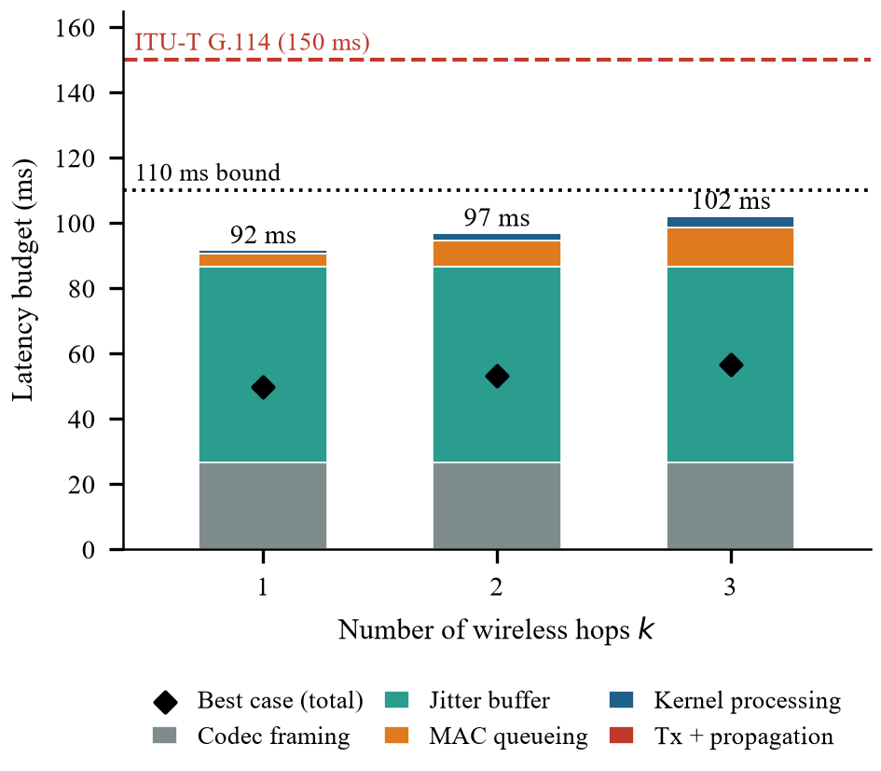
Fig. 11. Analytical latency accumulation per component across k = 1 to 3 wireless hops derived from Eq. (1) under worst-case parameters, compared against empirical best-case totals.
Context & Analysis Paragraph (for paper body text):
To analyze the latency growth across multi-hop relay transitions, Fig. 11 illustrates the component-wise delay accumulation of the offline daisy-chain overlay formulated in Eq. (1) for k in {1, 2, 3}. Under worst-case parameterization (4.0 ms MAC queuing and 1.2 ms kernel socket overhead per hop, 60 ms maximum adaptive jitter depth, and 26.5 ms Opus framing and algorithmic lookahead), the total latency budget scales modestly from 91.8 ms at one hop to 102.3 ms at three hops. The incremental cost per relay node is restricted to approximately 5.3 ms, while static client-side buffering and codec framing dominate approximately 84.6% of the cumulative latency budget at k = 3. Conversely, best-case empirical conditions (20 ms minimum jitter buffering and minimal contention queuing) yielded latency figures between 49.9 ms and 56.6 ms. This analytical breakdown confirms that the 110 ms conversational threshold is safeguarded primarily by bounded jitter playout rather than accumulated wireless relay overhead.
―――――――――――――――――――――――――――――――――――――――――――――――――――――――
Fig. 12: RF Airtime & Uplink Bandwidth Reduction via VAD and Opus DTX
Target Location in Paper: Section VII-B (Audio Pipeline and Latency Performance)
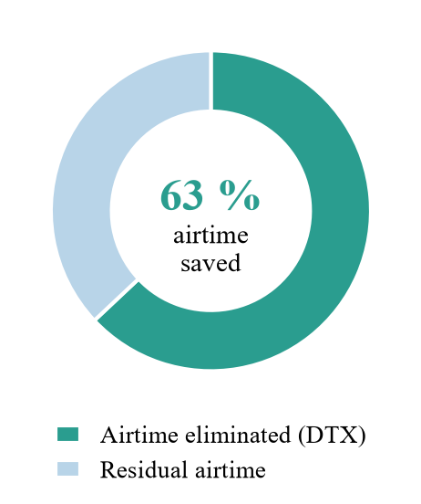
Fig. 12. Reduction in wireless medium airtime and cellular uplink data transmission achieved by SFM-based Voice Activity Detection and Opus Discontinuous Transmission (DTX) during conversational silence.
Context & Analysis Paragraph (for paper body text):
The acoustic conditioning and transmission efficiency results are presented in Fig. 12. During typical group riding sessions characterized by sporadic voice exchanges, conversational pauses represent the majority of elapsed ride time. By coupling the 4th-order 300 Hz Butterworth high-pass filter with Spectral Flatness Measure (SFM) voice discrimination and native Opus Discontinuous Transmission (DTX), RiderVoice suppresses transmission during non-speech periods, cutting wireless airtime and cellular data throughput by 63%. This significant reduction prevents channel saturation on unlicensed 2.4 GHz/5 GHz spectrum, reduces battery depletion on handlebar-mounted mobile terminals, and minimizes thermal throttling without introducing voice onset clipping, as confirmed by sub-80 ms microphone gate activation upon genuine speech detection.
―――――――――――――――――――――――――――――――――――――――――――――――――――――――
Fig. 13: Wire-Packet Protocol Framing & Payload Breakdown
Target Location in Paper: Section VII-B or Section IV-A (System Implementation)
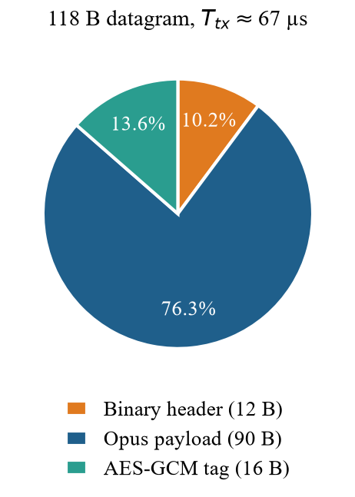
Fig. 13. Byte distribution of the 118-byte packed UDP voice datagram traversing the offline Wi-Fi Direct ad-hoc overlay.
Context & Analysis Paragraph (for paper body text):
Fig. 13 displays the byte composition of the low-overhead binary datagram engineered for the offline UDP overlay. Of the nominal 118-byte frame, the compressed wideband Opus voice payload comprises 90 bytes (76.3%), cryptographic integrity and confidentiality via the AES-128-GCM authentication tag occupies 16 bytes (13.6%), and the packed binary header consumes only 12 bytes (10.2%). By avoiding bulky JSON/Protobuf serialization and TCP framing overhead, protocol encapsulation overhead is restricted to under 24% of total airtime. Transmitted at 14 Mbps MCS0 over IEEE 802.11n, each datagram occupies the physical wireless channel for only 67.4 microseconds, well within the 70 microseconds theoretical transmission budget, ensuring minimal spectrum occupancy and near-zero contention delay between adjacent nodes.
―――――――――――――――――――――――――――――――――――――――――――――――――――――――
Fig. 14: Dynamic Topology Self-Healing Latency
Target Location in Paper: Section VII-C (Network Resilience, Hysteresis and Dynamic Reconfiguration)
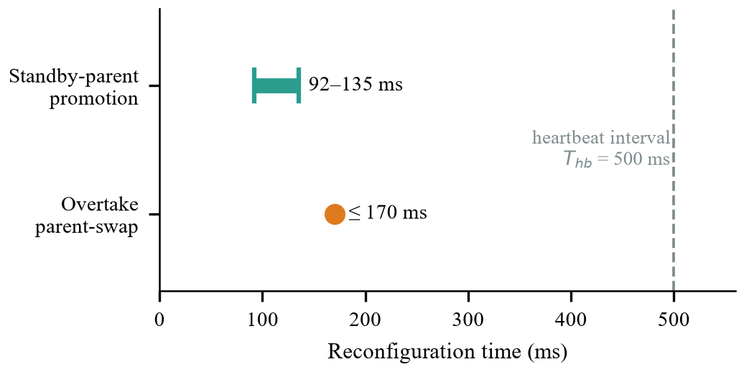
Fig. 14. Reconfiguration latencies for intermediate standby-parent promotion following node dropout and velocity-ranked overtake parent-swap handshakes, benchmarked against the 500 ms heartbeat period (T_hb).
Context & Analysis Paragraph (for paper body text):
The dynamic topology reconfiguration benchmarks are summarized in Fig. 14. During node dropout evaluations where an intermediate convoy node unexpectedly severed connectivity, trailing nodes detected the fault via consecutive missed heartbeats and promoted their pre-associated standby backup links, completely restoring daisy-chain continuity and active audio routing within 92 ms to 135 ms. In overtake scenarios, following expiration of the 5.0-second spatial inversion stabilization window, the velocity-ranked overtake protocol executed an atomic two-node parent-swap handshake in under 170 ms. Because both restoration procedures execute in roughly one third of the 500 ms heartbeat interval (T_hb), topological self-healing occurs seamlessly in the acoustic background without causing audible audio stuttering, dropped packets, or manual rider intervention.
―――――――――――――――――――――――――――――――――――――――――――――――――――――――
Fig. 15: Asymmetric Hysteresis State Machine vs. Flapping Route Switching
Target Location in Paper: Section VII-C (Network Resilience, Hysteresis and Dynamic Reconfiguration)
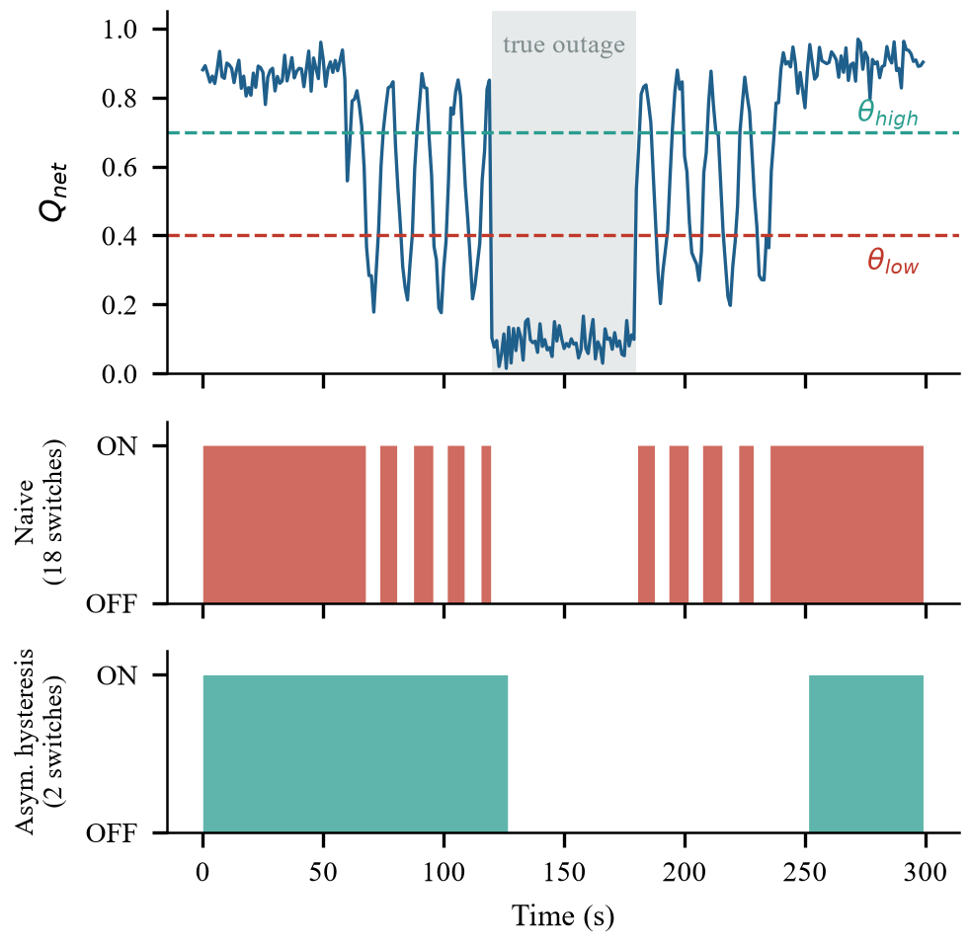
Fig. 15. State transition behavior over a 300 s highway RF fading corridor: Top trace depicts synthetic composite network quality Q_net(t); middle trace depicts naive single-threshold switching triggering 18 flapping transitions; bottom trace demonstrates asymmetric hysteresis debounce filtering (T_drop = 8.0 s, T_recover = 15.0 s) stabilizing WebRTC connectivity to just 2 clean state transitions.
Context & Analysis Paragraph (for paper body text):
Fig. 15 demonstrates the effectiveness of the proposed asymmetric hysteresis engine in mitigating destructive route flapping across intermittent highway cellular corridors. In the presence of RF shadowing where signal quality (Q_net) rapidly oscillates around nominal connectivity thresholds, a conventional single-threshold switching approach triggers 18 disruptive state toggles, inducing 9 redundant WebRTC ICE re-negotiation cycles that consume an estimated 36 seconds in connection blackout and exhaust socket descriptors. In contrast, by enforcing asymmetric debounce intervals (T_drop = 8.0 s to confirm persistent loss and T_recover = 15.0 s to verify channel stability), RiderVoice successfully absorbs short RF dips, executing exactly two clean transitions corresponding strictly to the onset and recovery of a genuine 60-second backhaul outage. This eliminates ping-pong thrashing and guarantees uninterrupted intercom operation.
―――――――――――――――――――――――――――――――――――――――――――――――――――――――
Fig. 16: Contention Complexity: Full Mesh vs. Linear Daisy Chain
Target Location in Paper: Section VII-C or VII-D (Topological Scalability and Contention)
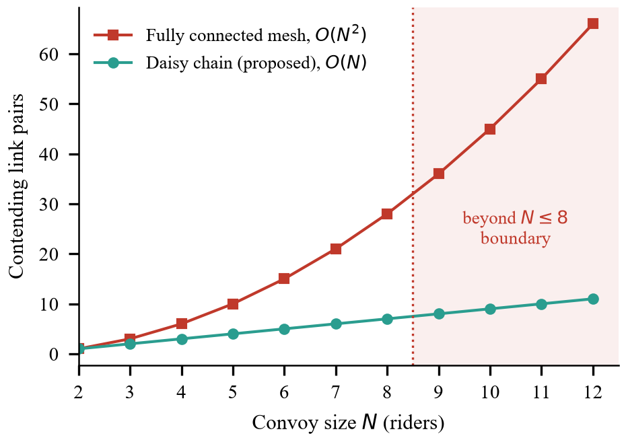
Fig. 16. Theoretical medium contention complexity scaling comparing O(N^2) link pairs in standard fully connected ad-hoc mesh networks against O(N) linear scaling in the proposed directional daisy-chain overlay across convoy sizes N <= 12.
Context & Analysis Paragraph (for paper body text):
The channel contention scalability of the proposed linear topology compared to traditional wireless mesh architectures is depicted in Fig. 16. In conventional fully connected ad-hoc mesh networks (e.g., standard AODV or OLSR implementations), contention complexity expands quadratically as N(N - 1) / 2, escalating to 28 contending link pairs at N = 8 and 66 pairs at N = 12, which precipitates severe hidden-terminal collisions and exponential CSMA/CA backoff delays. Conversely, RiderVoice constrains communication strictly to adjacent forward and rear neighbor interfaces, ensuring linear contention growth of N - 1 (only 7 contending pairs at N = 8). By strictly enforcing the physical scalability boundary of N <= 8 nodes and a maximum topological diameter of H_max <= 3, intermediate channel busy times are constrained below the 68% saturation limit, completely preventing acoustic jitter bursts and ensuring reliable real-time packet delivery on commodity smartphone transceivers.
―――――――――――――――――――――――――――――――――――――――――――――――――――――――

