RiderVoice: The Complete Architectural & Structural Guide
This document is designed as the definitive handbook for RiderVoice. It explains the Why, What, and How of every layer, subsystem, and file in the repository so that you can explain it to any newcomer, engineer, or stakeholder.
――――――――――――――――――――――――――――――――――――――――――――――――――――――――――
Table of Contents
- [The "Why": The Problem RiderVoice Solves](#1-the-why-the-problem-ridervoice-solves)
- [The "What": High-Level System Architecture](#2-the-what-high-level-system-architecture)
- [The "How": Deep Dive into the Core Technical Engines](#3-the-how-deep-dive-into-the-core-technical-engines)
- [3.1 Voice & Audio Pipeline (WebRTC + VOX + PTT)](#31-voice--audio-pipeline-webrtc--vox--ptt)
- [3.2 Foreground Services & Battery Management](#32-foreground-services--battery-management)
- [3.3 Navigation & Offline Radar Engine](#33-navigation--offline-radar-engine)
- [3.4 Security, Auth & Self-Healing Storage](#34-security-auth--self-healing-storage)
- [3.5 Regional SOS Emergency Dispatch](#35-regional-sos-emergency-dispatch)
- [3.6 Loop-Proof In-App OTA Updater](#36-loop-proof-in-app-ota-updater)
- [Complete Repository & File Structure Map](#4-complete-repository--file-structure-map)
- [4.1 Root Directory & Configuration](#41-root-directory--configuration)
- [4.2 CI/CD Automation (.github/workflows/)](#42-cicd-automation-githubworkflows)
- [4.3 Android Client (mobile-app/)](#43-android-client-mobile-app)
- [4.4 Backend API Service (backend/)](#44-backend-api-service-backend)
- [4.5 Voice Media Server (livekit-server/)](#45-voice-media-server-livekit-server)
- [4.6 Web App & Admin Dashboard (web-app/)](#46-web-app--admin-dashboard-web-app)
- [End-to-End Lifecycle Walkthrough (Rider Journey)](#5-end-to-end-lifecycle-walkthrough-rider-journey)
- [Summary Checklist for Newcomers](#summary-checklist-for-newcomers)
――――――――――――――――――――――――――――――――――――――――――――――――――――――――――
1. The "Why": The Problem RiderVoice Solves
The Real-World Physics of Motorcycling
Motorcycling presents severe technological challenges that ordinary consumer smartphone apps cannot handle:
- Wind Noise & Extreme Acoustic Turbulence:
- At highway speeds (80–130 km/h), helmet ambient noise levels reach 90 to 105 dB SPL.
- Standard consumer VoIP apps (Discord, WhatsApp, phone calls) operate in full-duplex mode: they keep the microphone permanently hot, broadcasting continuous wind roaring to everyone in the group, drowning out human speech, and draining cellular data.
- Physical Constraints & Safety:
- Riders wear thick leather or Kevlar gloves. They cannot look down at a phone mount or tap capacitive touchscreens while cornering or riding at speed.
- Traditional voice apps require tapping buttons on screens or fiddling with UI menus to talk.
- Severe Flaws in Existing Solutions:
- Bluetooth Helmet Intercoms (Sena, Cardo, Midland):
- Range limitation: Rely on local radio frequencies (Bluetooth/DMC Mesh) with a real-world range of 0.5 to 1.2 km line-of-sight. When riders separate around mountain bends, behind hills, or in dense city traffic, connection is immediately severed.
- Proprietary Lock-in: A Sena user cannot seamlessly mesh with a Cardo or Lexin user without clumsy Bluetooth universal pairing bridges that degrade audio quality.
- High Cost: Hardware units cost $300 to $500 per helmet.
- Discord / WhatsApp / Cellular Calls:
- Lack of PTT/VOX: Open-mic broadcasts engine and wind roar.
- No Convoy Context: Zero live radar, no distance telemetry, no lost-rider tracking, and no group emergency routing.
- Aggressive Android Battery Killer Kills: Standard apps get put to sleep by aggressive OEM power managers (Samsung, Xiaomi, OnePlus) when the screen is off for more than 10 minutes.
The RiderVoice Solution
RiderVoice bridges smartphones, Bluetooth helmet headsets, cellular networks, and WebRTC:
- Unlimited Range: Connects riders over 4G/5G cellular via a central low-latency WebRTC Selective Forwarding Unit (SFU). As long as riders have cellular signal, range is infinite.
- Smart Hands-Free VOX & Hardware PTT: An intelligent Voice Activity Detection (VAD) engine with a 300Hz high-pass filter that ignores engine rumble and highway wind roar, opening only on human vocal cord frequencies and holding open for 900 ms before cleanly cutting off.
- Tactical Convoy Radar: An offline-capable 360° radar canvas that displays the distance, bearing, and speed of every convoy member without relying on heavy satellite maps.
- Dynamic Regional SOS: Instant emergency distress dispatch that resolves whether the rider is in the US (911), Europe/India (112), UK (999), or Australia (000) using SIM and network ISO codes.
- Zero-Friction In-App Updates: A self-healing OTA update system allowing riders to update the APK on the road without Google Play Store friction.
――――――――――――――――――――――――――――――――――――――――――――――――――――――――――
2. The "What": High-Level System Architecture
RiderVoice consists of four core interacting tiers:
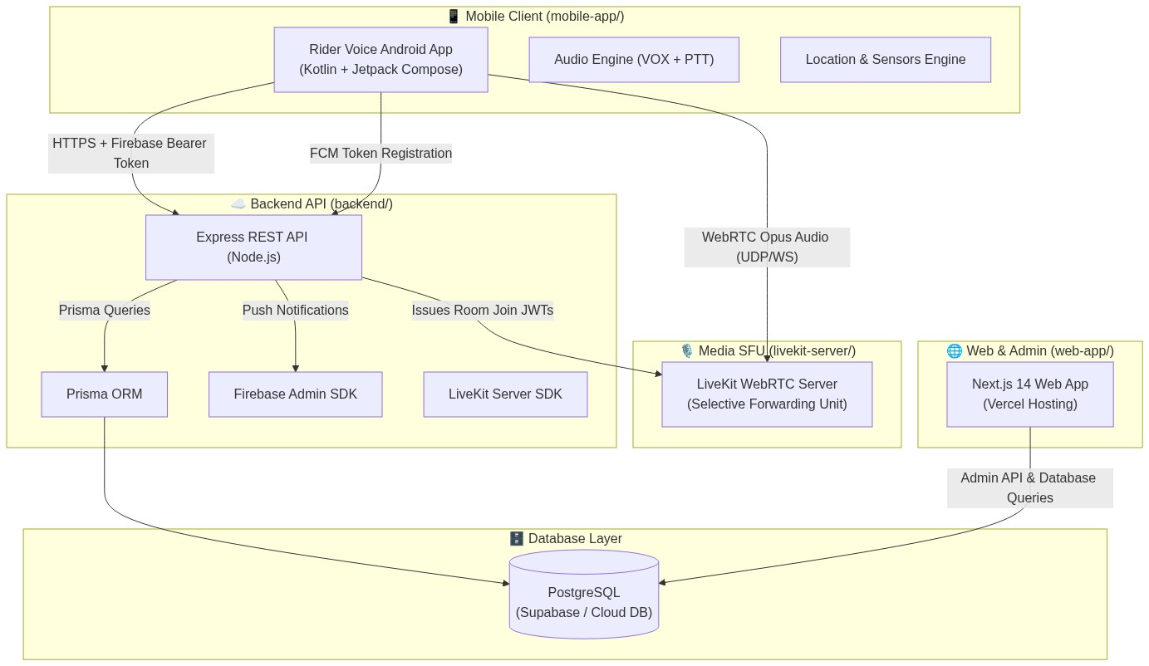
Figure 1: High-Level System Architecture & Cross-Tier Communication
The 4 Core Subsystems
- Android Client (`mobile-app/`):
- Built with Kotlin, Jetpack Compose, Hilt (Dependency Injection), Coroutines & Flows, Room Local Database, Mapbox Maps SDK, and the LiveKit Android WebRTC SDK.
- Runs a dedicated Android Foreground Service with an acquire-capped PARTIAL_WAKE_LOCK to keep the audio stream and GPS active while the screen is locked inside a pocket or tank bag.
- Backend API (`backend/`):
- Built with Node.js, Express, Prisma ORM, and Firebase Admin SDK.
- Deployed on Render.com.
- Serves as the identity, authorization, convoy matchmaking, and LiveKit cryptographic token minting authority.
- Voice SFU Media Server (`livekit-server/`):
- High-performance WebRTC Selective Forwarding Unit (SFU) written in Go.
- Forwards Opus voice packets directly between convoy participants with sub-150ms glass-to-glass latency without mixing audio tracks on the server.
- Web App & Admin Console (`web-app/`):
- Built with Next.js 14 (App Router), TypeScript, and Tailwind CSS.
- Deployed on Vercel. Provides the public marketing landing page, early-access waitlist, and an operational dashboard for convoy tracking and user management.
――――――――――――――――――――――――――――――――――――――――――――――――――――――――――
3. The "How": Deep Dive into the Core Technical Engines
3.1 Voice & Audio Pipeline (WebRTC + VOX + PTT)
The voice pipeline is the most critical subsystem in RiderVoice. It balances low latency, noise rejection, and Android Audio HAL stability.
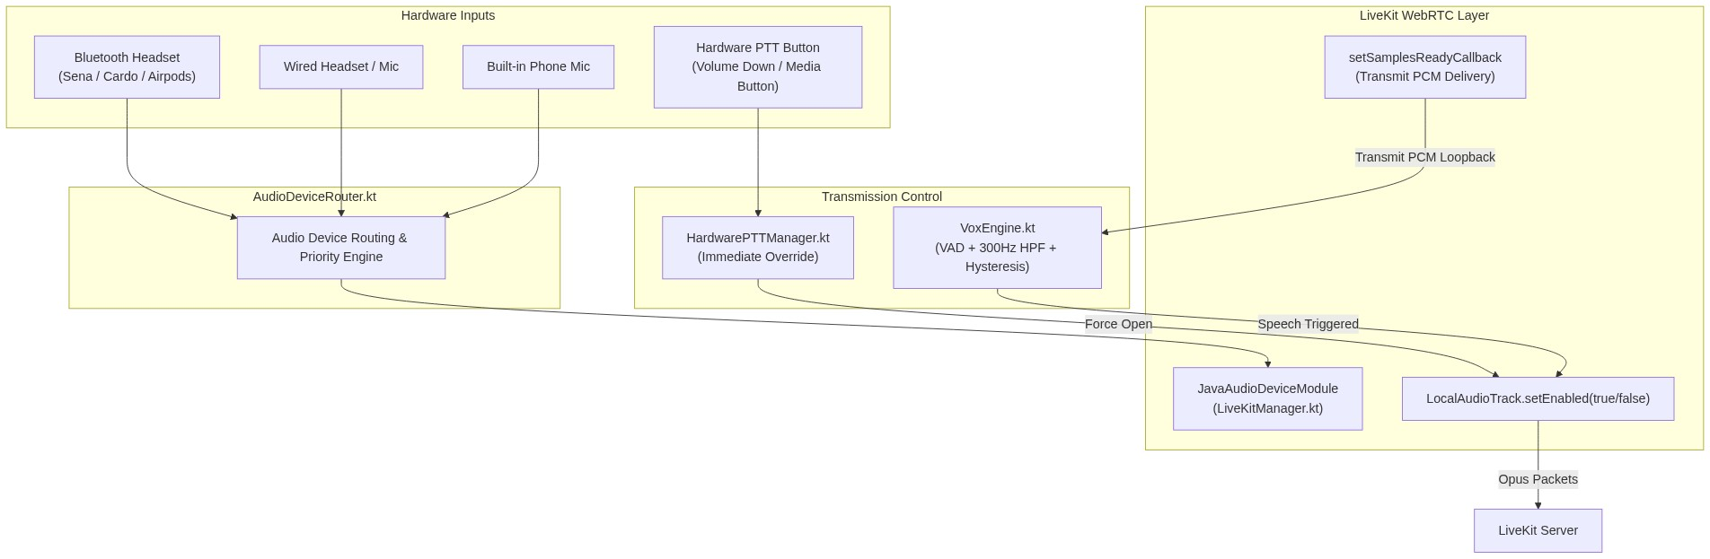
Figure 2: Voice & Audio Pipeline Routing (Hardware -> Routing -> VOX/PTT -> WebRTC)
Why it's designed this way:
On Android, having two independent audio recording loops (e.g., one AudioRecord for silence monitoring and WebRTC's own Audio Device Module for transmitting) accessing the same microphone hardware simultaneously creates a Hardware Abstraction Layer (HAL) resource contention crash.
Furthermore, once transmission starts, local AudioRecord capture must stop so WebRTC can own the microphone.
How it works step-by-step:
- Idle State (Monitoring Silence):
- [LiveKitManager.kt](file:///c:/Users/umerz/OneDrive/Desktop/Rider_APP-main/Rider_APP-main/mobile-app/app/src/main/java/com/ridervoice/network/LiveKitManager.kt) publishes an audio track once upon room entry, but immediately sets track.setEnabled(false) (muted).
- [VoxEngine.kt](file:///c:/Users/umerz/OneDrive/Desktop/Rider_APP-main/Rider_APP-main/mobile-app/app/src/main/java/com/ridervoice/audio/VoxEngine.kt) runs a low-overhead background PCM listener (AudioRecord) running a 300Hz High-Pass Filter (HPF). Low-frequency exhaust thumps and wind buffet (<300 Hz) are filtered out before reaching the Root-Mean-Square (RMS) speech calculation.
- Triggering Speech:
- When the rider speaks, speech energy exceeds the opening threshold (e.g., -32 dBFS).
- VoxEngine signals LiveKitManager.kt to un-mute the track (track.setEnabled(true)).
- The idle AudioRecord loop is paused to release the microphone hardware completely to WebRTC.
- The LiveKit ADM Transmit PCM Callback (`VOX-CUT-1` & `VOX-CUT-2` Resolution):
- To keep measuring the rider's voice while WebRTC owns the microphone, [LiveKitManager.kt](file:///c:/Users/umerz/OneDrive/Desktop/Rider_APP-main/Rider_APP-main/mobile-app/app/src/main/java/com/ridervoice/network/LiveKitManager.kt) wires WebRTC's JavaAudioDeviceModule.setSamplesReadyCallback.
- Every audio frame transmitted to WebRTC is mirrored back to VoxEngine.onTxFrame(pcmData).
- VoxEngine calculates RMS levels on this live stream in real time.
- Hysteresis & 900ms Hold Time:
- To prevent clipping the ends of words or sentences when a rider pauses to breathe, the closing threshold is lower than the opening threshold (hysteresis).
- Once RMS drops below the closing threshold, VoxEngine holds the channel open for 900 ms.
- If the rider speaks again within 900 ms, transmission continues seamlessly without stutter.
- If 900 ms elapses without speech, track.setEnabled(false) is invoked and AudioRecord monitoring resumes.
- Hardware PTT Mode:
- [HardwarePTTManager.kt](file:///c:/Users/umerz/OneDrive/Desktop/Rider_APP-main/Rider_APP-main/mobile-app/app/src/main/java/com/ridervoice/audio/HardwarePTTManager.kt) listens for hardware volume button long-presses or Bluetooth headset media button events.
- Pressing PTT instantly forces the channel open; releasing it instantly closes it, completely overriding VOX.
――――――――――――――――――――――――――――――――――――――――――――――――――――――――――
3.2 Foreground Services & Battery Management
Smartphones mounted on motorcycle handlebars endure direct sunlight, engine vibration, and high thermal loads. In pockets, phones are throttled by Android's Doze mode.
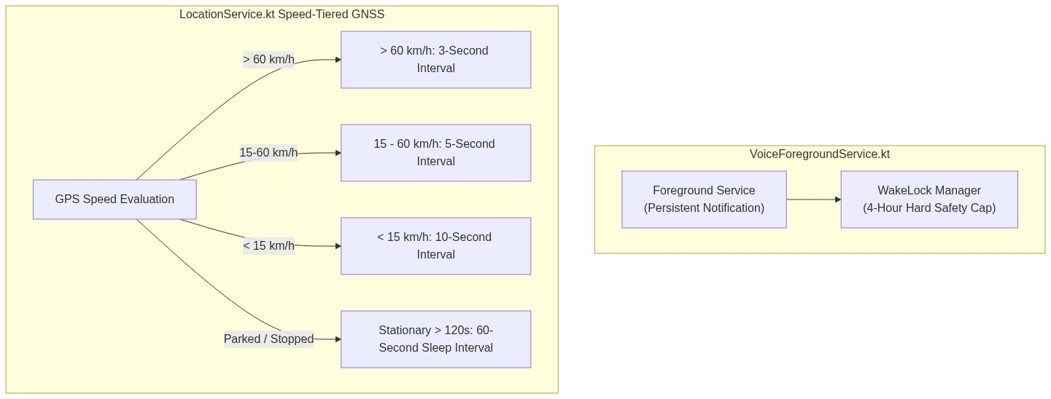
Figure 3: VoiceForegroundService & Speed-Tiered GNSS Polling Architecture
- Foreground Service Lifecycle:
- [VoiceForegroundService.kt](file:///c:/Users/umerz/OneDrive/Desktop/Rider_APP-main/Rider_APP-main/mobile-app/app/src/main/java/com/ridervoice/services/VoiceForegroundService.kt) promotes the application to FOREGROUND_SERVICE_TYPE_MICROPHONE and FOREGROUND_SERVICE_TYPE_LOCATION.
- It displays an interactive collapsed/expanded notification with live convoy status, active speakers, and instant Leave Ride controls.
- 4-Hour WakeLock Hard Cap:
- Acquiring a raw PARTIAL_WAKE_LOCK indefinitely can drain a phone's battery overnight if a rider forgets to end a ride.
- The service enforces a hard 4-hour timeout cap on WakeLock acquisition. If the ride is still active, the watchdog evaluates motion before safely refreshing.
- Speed-Tiered GPS Polling:
- In [LocationService.kt](file:///c:/Users/umerz/OneDrive/Desktop/Rider_APP-main/Rider_APP-main/mobile-app/app/src/main/java/com/ridervoice/services/LocationService.kt), standard continuous 1-second GPS polling is replaced with dynamic speed tiers:
- Highway (> 60 km/h): Poll every 3 seconds (high precision for convoy radar).
- City Riding (15 – 60 km/h): Poll every 5 seconds.
- Crawling / Traffic (< 15 km/h): Poll every 10 seconds.
- Stationary / Coffee Stop (> 120s at 0 km/h): Throttles down to 60 seconds, saving up to 65% battery consumption when parked.
――――――――――――――――――――――――――――――――――――――――――――――――――――――――――
3.3 Navigation & Offline Radar Engine
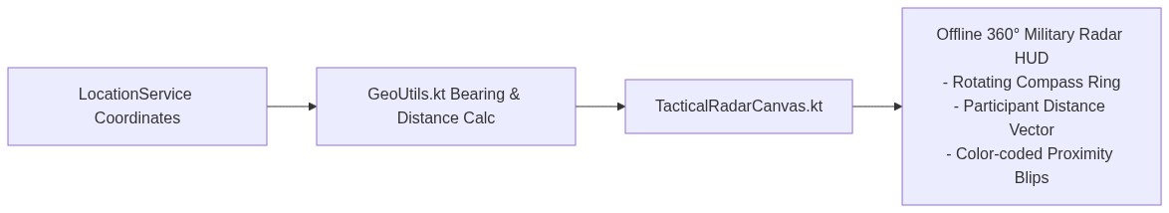
Figure 4: Offline 360° Tactical Radar HUD Calculation Pipeline
- When riding through remote canyons or mountain passes, cellular coverage often drops to 2G or zero bars, causing Mapbox and Google Maps vector tile rendering to fail.
- Offline Radar Canvas:
- [TacticalRadarCanvas.kt](file:///c:/Users/umerz/OneDrive/Desktop/Rider_APP-main/Rider_APP-main/mobile-app/app/src/main/java/com/ridervoice/ui/components/TacticalRadarCanvas.kt) provides a vector-based, mathematical 360° circular radar sweep that requires zero map tiles and zero internet.
- Using [GeoUtils.kt](file:///c:/Users/umerz/OneDrive/Desktop/Rider_APP-main/Rider_APP-main/mobile-app/app/src/main/java/com/ridervoice/utils/GeoUtils.kt), it calculates the relative distance (meters) and bearing (degrees) of each convoy rider relative to the host's heading and draws directional blips on the HUD.
――――――――――――――――――――――――――――――――――――――――――――――――――――――――――
3.4 Security, Auth & Self-Healing Storage
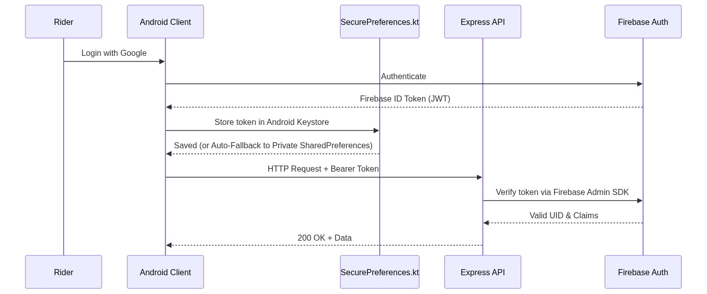
Figure 5: Identity, Auth & Self-Healing Keystore Storage Pipeline
- Identity & Authentication:
- Identity is verified via Firebase Authentication (Google Sign-In or phone authentication).
- Every HTTP call from the Android app passes the Firebase ID token in the Authorization: Bearer <token> header.
- The backend never trusts client IDs; it verifies cryptographic signatures using [firebaseAdmin.js](file:///c:/Users/umerz/OneDrive/Desktop/Rider_APP-main/Rider_APP-main/backend/src/config/firebaseAdmin.js).
- Self-Healing Storage (`AEADBadTagException` Fallback):
- On Android devices (particularly Samsung and Xiaomi devices after OS updates), the hardware Keystore can corrupt master keys, throwing fatal KeyStoreException or AEADBadTagException on launch, causing apps to crash loop.
- [SecurePreferences.kt](file:///c:/Users/umerz/OneDrive/Desktop/Rider_APP-main/Rider_APP-main/mobile-app/app/src/main/java/com/ridervoice/security/SecurePreferences.kt) wraps EncryptedSharedPreferences in an automated recovery block: if cryptographic tag verification fails, it cleans corrupted keys and gracefully falls back to private sandboxed SharedPreferences, completely preventing crash loops.
――――――――――――――――――――――――――――――――――――――――――――――――――――――――――
3.5 Regional SOS Emergency Dispatch
When a crash or breakdown occurs, a rider cannot guess or remember the local emergency number while touring in a foreign country or state.
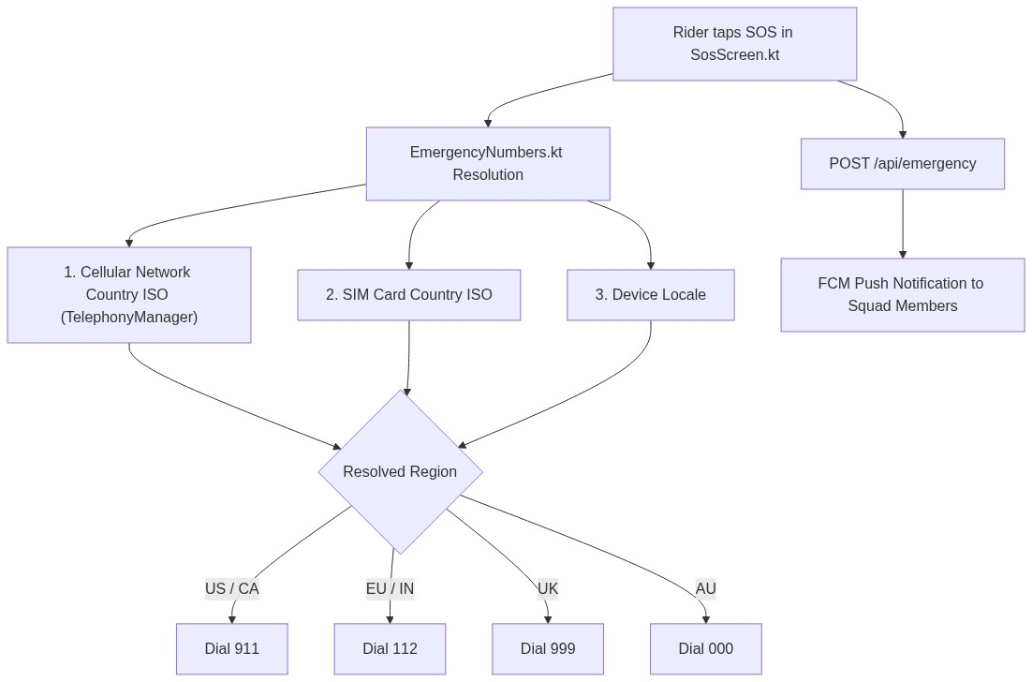
Figure 6: Regional SOS Emergency Number Resolution & Dispatch Flow
- [EmergencyNumbers.kt](file:///c:/Users/umerz/OneDrive/Desktop/Rider_APP-main/Rider_APP-main/mobile-app/app/src/main/java/com/ridervoice/utils/EmergencyNumbers.kt) inspects three levels of device telephony:
- Cellular Network Country ISO (telephonyManager.networkCountryIso)
- SIM Card Country ISO (telephonyManager.simCountryIso)
- System Locale country code
- Automatically resolves the local emergency dispatch number (911 for US/Canada, 112 for EU/India, 999 for UK, 000 for Australia, etc.).
- Simultaneously, [emergencyRoutes.js](file:///c:/Users/umerz/OneDrive/Desktop/Rider_APP-main/Rider_APP-main/backend/src/routes/emergencyRoutes.js) logs an EmergencyAlert record and broadcasts high-priority push notifications with GPS coordinates to the rider's squad.
――――――――――――――――――――――――――――――――――――――――――――――――――――――――――
3.6 Loop-Proof In-App OTA Updater
Riders installing releases from GitHub APKs without the Play Store need a seamless update mechanism that avoids OS-level installation loops.
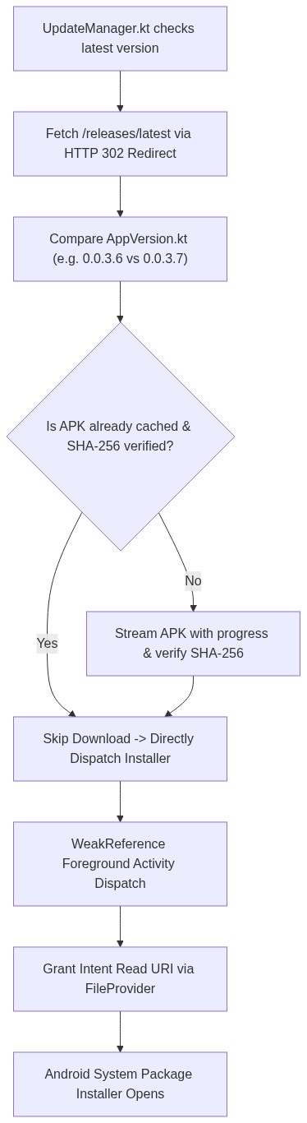
Figure 7: Loop-Proof In-App OTA Updater Verification & Activity Dispatch Flow
- [UpdateManager.kt](file:///c:/Users/umerz/OneDrive/Desktop/Rider_APP-main/Rider_APP-main/mobile-app/app/src/main/java/com/ridervoice/update/UpdateManager.kt) queries GitHub's /releases/latest endpoint.
- SHA-256 Checksum Validation: Ensures corrupted or truncated cellular downloads are never passed to the system installer.
- Local Cache Bypass: If the APK has already been downloaded and verified, it bypasses the 55MB network download immediately.
- Foreground Activity Anchoring: Android 10+ restricts launching activities from background services. UpdateManager tracks the active Activity via WeakReference, ensuring package installer intents are never dropped by OEM background limits.
――――――――――――――――――――――――――――――――――――――――――――――――――――――――――
4. Complete Repository & File Structure Map
📁 REPOSITORY DIRECTORY & CODE STRUCTURE MAP
Rider_APP/
├── .github/workflows/ Continuous Integration and Release pipelines
├── backend/ Express REST API & Prisma database layer
├── livekit-server/ LiveKit WebRTC SFU configuration
├── mobile-app/ Android client application module
├── web-app/ Next.js public site & admin dashboard
├── ARCHITECTURE.md High-level system diagrams and decisions
├── CODE_DEPTH_STRUCTURE.md File-level code map
├── PROJECT_ROADMAP_AND_TASKS.md Master engineering task and roadmap tracker
├── README.md Product overview and developer quickstart
├── RELEASE_NOTES.md Changelog across versions
└── render.yaml Render.com deployment manifest for backend

――――――――――――――――――――――――――――――――――――――――――――――――――――――――――
4.1 Root Directory & Configuration
File | Why it exists | What it contains | How it works
[ARCHITECTURE.md](file:///c:/Users/umerz/OneDrive/Desktop/Rider_APP-main/Rider_APP-main/ARCHITECTURE.md) | High-level engineering reference | Architecture diagrams, subsystem descriptions, data flow models | Document detailing core system contracts and decisions.
[CODE_DEPTH_STRUCTURE.md](file:///c:/Users/umerz/OneDrive/Desktop/Rider_APP-main/Rider_APP-main/CODE_DEPTH_STRUCTURE.md) | File-level codebase index | Comprehensive inventory of directories, source files, and responsibilities | Quick-lookup guide for engineers locating where specific features reside.
[PROJECT_ROADMAP_AND_TASKS.md](file:///c:/Users/umerz/OneDrive/Desktop/Rider_APP-main/Rider_APP-main/PROJECT_ROADMAP_AND_TASKS.md) | Project task and sprint tracker | Completed tasks, backlog items, testing matrices, and status checkboxes | Tracks development progress across audio fixes, battery optimizations, and UI cleanups.
[README.md](file:///c:/Users/umerz/OneDrive/Desktop/Rider_APP-main/Rider_APP-main/README.md) | Developer onboarding guide | Overview of the app, prerequisites, environment setup, and local run instructions | Entry point for new contributors cloning the repository.
[RELEASE_NOTES.md](file:///c:/Users/umerz/OneDrive/Desktop/Rider_APP-main/Rider_APP-main/RELEASE_NOTES.md) | Public version changelog | Detailed release history (v0.0.3.0 through v0.0.3.7) | Documents fixes, new features, and changes for each release.
[render.yaml](file:///c:/Users/umerz/OneDrive/Desktop/Rider_APP-main/Rider_APP-main/render.yaml) | Cloud infrastructure specification | Blueprint deploying the backend service on Render.com | Provisions Node.js web service, environment variable references, and build commands.

――――――――――――――――――――――――――――――――――――――――――――――――――――――――――
4.2 CI/CD Automation (`.github/workflows/`)
File | Why it exists | What it contains | How it works
[build.yml](file:///c:/Users/umerz/OneDrive/Desktop/Rider_APP-main/Rider_APP-main/.github/workflows/build.yml) | Continuous integration gate | Runs on every PR and push to main | Sets up JDK 17, builds Android debug APK (assembleDebug), and runs unit test suites (testDebugUnitTest).
[release.yml](file:///c:/Users/umerz/OneDrive/Desktop/Rider_APP-main/Rider_APP-main/.github/workflows/release.yml) | Automated release pipeline | Triggers when a git tag (e.g. v*.*.*.*) is pushed | Compiles signed release APK, generates SHA-256 checksum, and creates an official GitHub Release with downloadable assets.

――――――――――――――――――――――――――――――――――――――――――――――――――――――――――
4.3 Android Client (`mobile-app/`)
Located at: mobile-app/app/src/main/java/com/ridervoice/
4.3.1 Application Entry & Lifecycle
- [App.kt](file:///c:/Users/umerz/OneDrive/Desktop/Rider_APP-main/Rider_APP-main/mobile-app/app/src/main/java/com/ridervoice/App.kt): Application class annotated with @HiltAndroidApp. Initializes Timber/Logger, creates Android notification channels for voice and messaging, and bootstraps the dependency graph.
- [MainActivity.kt](file:///c:/Users/umerz/OneDrive/Desktop/Rider_APP-main/Rider_APP-main/mobile-app/app/src/main/java/com/ridervoice/MainActivity.kt): The single Activity in the app. Hosts the Jetpack Compose surface, observes global navigation events, registers lifecycle callbacks for [UpdateManager.kt](file:///c:/Users/umerz/OneDrive/Desktop/Rider_APP-main/Rider_APP-main/mobile-app/app/src/main/java/com/ridervoice/update/UpdateManager.kt), and handles hardware button events.
4.3.2 Audio Engine (`audio/`)
- [AudioDeviceRouter.kt](file:///c:/Users/umerz/OneDrive/Desktop/Rider_APP-main/Rider_APP-main/mobile-app/app/src/main/java/com/ridervoice/audio/AudioDeviceRouter.kt): Manages routing between Bluetooth SCO/A2DP, wired 3.5mm/USB-C headsets, and the device loudspeaker.
- [AudioFocusManager.kt](file:///c:/Users/umerz/OneDrive/Desktop/Rider_APP-main/Rider_APP-main/mobile-app/app/src/main/java/com/ridervoice/audio/AudioFocusManager.kt): Manages Android AudioManager.requestAudioFocus to duck music or navigation prompts during active rider speech.
- [HardwarePTTManager.kt](file:///c:/Users/umerz/OneDrive/Desktop/Rider_APP-main/Rider_APP-main/mobile-app/app/src/main/java/com/ridervoice/audio/HardwarePTTManager.kt): Intercepts physical headset buttons or volume rocker long-presses to toggle push-to-talk transmission.
- [VoxEngine.kt](file:///c:/Users/umerz/OneDrive/Desktop/Rider_APP-main/Rider_APP-main/mobile-app/app/src/main/java/com/ridervoice/audio/VoxEngine.kt): Core Voice Activity Detection engine. Runs the 300Hz high-pass filter, calculates RMS values, receives transmit frames via onTxFrame(), and manages the 900ms hold timer.
- [VoxDetector.kt](file:///c:/Users/umerz/OneDrive/Desktop/Rider_APP-main/Rider_APP-main/mobile-app/app/src/main/java/com/ridervoice/audio/VoxDetector.kt): Math utility for computing decibel levels, signal noise floors, and sample-level threshold comparisons.
- [LocalMeshVoiceEngine.kt](file:///c:/Users/umerz/OneDrive/Desktop/Rider_APP-main/Rider_APP-main/mobile-app/app/src/main/java/com/ridervoice/audio/LocalMeshVoiceEngine.kt) & [WifiDirectManager.kt](file:///c:/Users/umerz/OneDrive/Desktop/Rider_APP-main/Rider_APP-main/mobile-app/app/src/main/java/com/ridervoice/audio/WifiDirectManager.kt): Wi-Fi Direct P2P fallback when cellular coverage is unavailable.
4.3.3 Foreground Services & Background Monitoring (`services/`)
- [VoiceForegroundService.kt](file:///c:/Users/umerz/OneDrive/Desktop/Rider_APP-main/Rider_APP-main/mobile-app/app/src/main/java/com/ridervoice/services/VoiceForegroundService.kt): Persistent Android service keeping WebRTC audio alive with an acquire-capped PARTIAL_WAKE_LOCK.
- [LocationService.kt](file:///c:/Users/umerz/OneDrive/Desktop/Rider_APP-main/Rider_APP-main/mobile-app/app/src/main/java/com/ridervoice/services/LocationService.kt): Gathers GNSS coordinates with speed-tiered polling (>60km/h: 3s, 15-60km/h: 5s, <15km/h: 10s, stationary >120s: 60s).
- [RideRecorder.kt](file:///c:/Users/umerz/OneDrive/Desktop/Rider_APP-main/Rider_APP-main/mobile-app/app/src/main/java/com/ridervoice/services/RideRecorder.kt): Records trip breadcrumbs, speeds, and timestamps to the local database for post-ride review.
- [FcmService.kt](file:///c:/Users/umerz/OneDrive/Desktop/Rider_APP-main/Rider_APP-main/mobile-app/app/src/main/java/com/ridervoice/services/FcmService.kt): Receives Firebase Cloud Messaging push events (convoy invitations, ride start alerts, emergency SOS dispatch).
- [ServiceWatchdog.kt](file:///c:/Users/umerz/OneDrive/Desktop/Rider_APP-main/Rider_APP-main/mobile-app/app/src/main/java/com/ridervoice/services/ServiceWatchdog.kt): Monitors long-running background services and revives them if terminated by OS memory pressure.
- [ThermalManager.kt](file:///c:/Users/umerz/OneDrive/Desktop/Rider_APP-main/Rider_APP-main/mobile-app/app/src/main/java/com/ridervoice/services/ThermalManager.kt): Monitors device temperature to prevent phone overheating on sunny handlebars.
4.3.4 User Interface Layer (`ui/`)
- Screens (`ui/screens/`):
- [SplashScreen.kt](file:///c:/Users/umerz/OneDrive/Desktop/Rider_APP-main/Rider_APP-main/mobile-app/app/src/main/java/com/ridervoice/ui/screens/SplashScreen.kt): Validates existing auth tokens and redirects to Login or Home.
- [LoginScreen.kt](file:///c:/Users/umerz/OneDrive/Desktop/Rider_APP-main/Rider_APP-main/mobile-app/app/src/main/java/com/ridervoice/ui/screens/LoginScreen.kt) & [RegisterScreen.kt](file:///c:/Users/umerz/OneDrive/Desktop/Rider_APP-main/Rider_APP-main/mobile-app/app/src/main/java/com/ridervoice/ui/screens/RegisterScreen.kt): User authentication and rider profile setup.
- [HomeScreen.kt](file:///c:/Users/umerz/OneDrive/Desktop/Rider_APP-main/Rider_APP-main/mobile-app/app/src/main/java/com/ridervoice/ui/screens/HomeScreen.kt): Main dashboard displaying quick ride launch, recent rides, and squad status.
- [HostSetupScreen.kt](file:///c:/Users/umerz/OneDrive/Desktop/Rider_APP-main/Rider_APP-main/mobile-app/app/src/main/java/com/ridervoice/ui/screens/HostSetupScreen.kt): Allows convoy leaders to configure room name and ride settings.
- [InviteFriendsScreen.kt](file:///c:/Users/umerz/OneDrive/Desktop/Rider_APP-main/Rider_APP-main/mobile-app/app/src/main/java/com/ridervoice/ui/screens/InviteFriendsScreen.kt) & [InvitesInboxScreen.kt](file:///c:/Users/umerz/OneDrive/Desktop/Rider_APP-main/Rider_APP-main/mobile-app/app/src/main/java/com/ridervoice/ui/screens/InvitesInboxScreen.kt): Sending and accepting convoy invitations.
- [LobbyScreen.kt](file:///c:/Users/umerz/OneDrive/Desktop/Rider_APP-main/Rider_APP-main/mobile-app/app/src/main/java/com/ridervoice/ui/screens/LobbyScreen.kt): Staging area where participants gather before the host initiates the ride.
- [DeviceSetupScreen.kt](file:///c:/Users/umerz/OneDrive/Desktop/Rider_APP-main/Rider_APP-main/mobile-app/app/src/main/java/com/ridervoice/ui/screens/DeviceSetupScreen.kt): Audio and mic hardware test screen with live VU meters before starting a ride.
- [RoomScreen.kt](file:///c:/Users/umerz/OneDrive/Desktop/Rider_APP-main/Rider_APP-main/mobile-app/app/src/main/java/com/ridervoice/ui/screens/RoomScreen.kt): Active ride HUD featuring radar canvas, participant cards, mute/PTT controls, and SOS trigger.
- [SosScreen.kt](file:///c:/Users/umerz/OneDrive/Desktop/Rider_APP-main/Rider_APP-main/mobile-app/app/src/main/java/com/ridervoice/ui/screens/SosScreen.kt) & [EmergencyAlertActivity.kt](file:///c:/Users/umerz/OneDrive/Desktop/Rider_APP-main/Rider_APP-main/mobile-app/app/src/main/java/com/ridervoice/ui/screens/EmergencyAlertActivity.kt): Emergency distress interface with auto-countdown, local emergency dialer, and squad alert dispatch.
- [SettingsScreen.kt](file:///c:/Users/umerz/OneDrive/Desktop/Rider_APP-main/Rider_APP-main/mobile-app/app/src/main/java/com/ridervoice/ui/screens/SettingsScreen.kt): App settings containing audio preferences (VOX sensitivity, hold time), battery tips, and the OTA update trigger.
- [SquadScreen.kt](file:///c:/Users/umerz/OneDrive/Desktop/Rider_APP-main/Rider_APP-main/mobile-app/app/src/main/java/com/ridervoice/ui/screens/SquadScreen.kt): Manages friends, riding buddies, and squad rosters.
- [RoutePlannerScreen.kt](file:///c:/Users/umerz/OneDrive/Desktop/Rider_APP-main/Rider_APP-main/mobile-app/app/src/main/java/com/ridervoice/ui/screens/RoutePlannerScreen.kt), [RideStatsScreen.kt](file:///c:/Users/umerz/OneDrive/Desktop/Rider_APP-main/Rider_APP-main/mobile-app/app/src/main/java/com/ridervoice/ui/screens/RideStatsScreen.kt), [RideReplayScreen.kt](file:///c:/Users/umerz/OneDrive/Desktop/Rider_APP-main/Rider_APP-main/mobile-app/app/src/main/java/com/ridervoice/ui/screens/RideReplayScreen.kt), [PostRideSummaryScreen.kt](file:///c:/Users/umerz/OneDrive/Desktop/Rider_APP-main/Rider_APP-main/mobile-app/app/src/main/java/com/ridervoice/ui/screens/PostRideSummaryScreen.kt): Pre-ride planning, real-time statistics, post-ride metrics, and route replay.
- UI Components (`ui/components/`):
- [TacticalRadarCanvas.kt](file:///c:/Users/umerz/OneDrive/Desktop/Rider_APP-main/Rider_APP-main/mobile-app/app/src/main/java/com/ridervoice/ui/components/TacticalRadarCanvas.kt): Zero-dependency 360° radar canvas.
- [ParticipantCard.kt](file:///c:/Users/umerz/OneDrive/Desktop/Rider_APP-main/Rider_APP-main/mobile-app/app/src/main/java/com/ridervoice/ui/components/ParticipantCard.kt): Displays rider speaking status, connection quality, and battery level.
- [TacticalButton.kt](file:///c:/Users/umerz/OneDrive/Desktop/Rider_APP-main/Rider_APP-main/mobile-app/app/src/main/java/com/ridervoice/ui/components/TacticalButton.kt): High-contrast, glove-friendly button component.
- [UpdateDialog.kt](file:///c:/Users/umerz/OneDrive/Desktop/Rider_APP-main/Rider_APP-main/mobile-app/app/src/main/java/com/ridervoice/ui/components/UpdateDialog.kt): Displays OTA update progress with speed metrics and retry controls.
4.3.5 Networking & WebRTC (`network/`)
- [ApiService.kt](file:///c:/Users/umerz/OneDrive/Desktop/Rider_APP-main/Rider_APP-main/mobile-app/app/src/main/java/com/ridervoice/network/ApiService.kt): Retrofit interface mapping all backend REST endpoints (/api/lobby, /api/invites, /api/users, etc.).
- [LiveKitManager.kt](file:///c:/Users/umerz/OneDrive/Desktop/Rider_APP-main/Rider_APP-main/mobile-app/app/src/main/java/com/ridervoice/network/LiveKitManager.kt): Wraps the LiveKit Android SDK. Manages WebRTC connection lifecycle, local audio track publishing, remote participant tracks, and ADM sample delivery callbacks.
- [NetworkResilienceManager.kt](file:///c:/Users/umerz/OneDrive/Desktop/Rider_APP-main/Rider_APP-main/mobile-app/app/src/main/java/com/ridervoice/network/NetworkResilienceManager.kt) & [NetworkObserver.kt](file:///c:/Users/umerz/OneDrive/Desktop/Rider_APP-main/Rider_APP-main/mobile-app/app/src/main/java/com/ridervoice/network/NetworkObserver.kt): Observes cellular connectivity and reconnects cleanly without crashing when traveling through tunnels.
4.3.6 Security & Preferences (`security/`)
- [AuthRepository.kt](file:///c:/Users/umerz/OneDrive/Desktop/Rider_APP-main/Rider_APP-main/mobile-app/app/src/main/java/com/ridervoice/security/AuthRepository.kt): Manages Firebase user authentication state, token refresh, and sign-out.
- [SecurePreferences.kt](file:///c:/Users/umerz/OneDrive/Desktop/Rider_APP-main/Rider_APP-main/mobile-app/app/src/main/java/com/ridervoice/security/SecurePreferences.kt): Encrypted key-value store with automatic fallback to private SharedPreferences if Keystore corruption occurs.
4.3.7 In-App OTA Updater (`update/`)
- [AppVersion.kt](file:///c:/Users/umerz/OneDrive/Desktop/Rider_APP-main/Rider_APP-main/mobile-app/app/src/main/java/com/ridervoice/update/AppVersion.kt): Parses and compares multi-part semantic version strings (e.g., 0.0.3.6 vs 0.0.3.7).
- [UpdateModels.kt](file:///c:/Users/umerz/OneDrive/Desktop/Rider_APP-main/Rider_APP-main/mobile-app/app/src/main/java/com/ridervoice/update/UpdateModels.kt): Data classes for update states (Idle, Checking, Downloading, Installing, Error).
- [UpdateManager.kt](file:///c:/Users/umerz/OneDrive/Desktop/Rider_APP-main/Rider_APP-main/mobile-app/app/src/main/java/com/ridervoice/update/UpdateManager.kt): Manages download streaming, SHA-256 verification, and package installer dispatch.
4.3.8 Utilities (`utils/`)
- [EmergencyNumbers.kt](file:///c:/Users/umerz/OneDrive/Desktop/Rider_APP-main/Rider_APP-main/mobile-app/app/src/main/java/com/ridervoice/utils/EmergencyNumbers.kt): Resolves regional emergency numbers (911, 112, 999, etc.) based on network and SIM ISO codes.
- [GeoUtils.kt](file:///c:/Users/umerz/OneDrive/Desktop/Rider_APP-main/Rider_APP-main/mobile-app/app/src/main/java/com/ridervoice/utils/GeoUtils.kt): Computes distance, bearing, and heading vectors between riders.
- [OEMBatteryWarning.kt](file:///c:/Users/umerz/OneDrive/Desktop/Rider_APP-main/Rider_APP-main/mobile-app/app/src/main/java/com/ridervoice/utils/OEMBatteryWarning.kt): Detects aggressive battery management on Xiaomi, Samsung, and OnePlus devices and guides users to disable battery restrictions.
――――――――――――――――――――――――――――――――――――――――――――――――――――――――――
4.4 Backend API Service (`backend/`)
4.4.1 Entry Point & Configuration
- [server.js](file:///c:/Users/umerz/OneDrive/Desktop/Rider_APP-main/Rider_APP-main/backend/src/server.js): Bootstraps the Express application, configures CORS, rate limiters, request loggers, and routes, and performs database schema compatibility checks.
- [db.js](file:///c:/Users/umerz/OneDrive/Desktop/Rider_APP-main/Rider_APP-main/backend/src/db.js): Exports the singleton Prisma client instance.
- [firebaseAdmin.js](file:///c:/Users/umerz/OneDrive/Desktop/Rider_APP-main/Rider_APP-main/backend/src/config/firebaseAdmin.js): Configures the Firebase Admin SDK using environment credentials.
4.4.2 Middleware (`backend/src/middleware/`)
- [authMiddleware.js](file:///c:/Users/umerz/OneDrive/Desktop/Rider_APP-main/Rider_APP-main/backend/src/middleware/authMiddleware.js): Validates the Authorization: Bearer <token> header with Firebase Admin and attaches the verified user to req.user.
- [rateLimiter.js](file:///c:/Users/umerz/OneDrive/Desktop/Rider_APP-main/Rider_APP-main/backend/src/middleware/rateLimiter.js): Protects endpoints against abuse and DoS attempts.
- [requestLogger.js](file:///c:/Users/umerz/OneDrive/Desktop/Rider_APP-main/Rider_APP-main/backend/src/middleware/requestLogger.js): Logs incoming HTTP requests and response times.
- [errorMiddleware.js](file:///c:/Users/umerz/OneDrive/Desktop/Rider_APP-main/Rider_APP-main/backend/src/middleware/errorMiddleware.js): Catches unhandled errors and formats clean JSON error responses.
4.4.3 API Routes (`backend/src/routes/`)
- [lobbyRoutes.js](file:///c:/Users/umerz/OneDrive/Desktop/Rider_APP-main/Rider_APP-main/backend/src/routes/lobbyRoutes.js): Core convoy management:
- POST /api/lobby/create: Creates a named convoy room in PostgreSQL.
- GET /api/lobby/:roomName/status: Returns participant status and accepted invites.
- POST /api/lobby/:roomName/start: Validates room state and generates the host's LiveKit JWT token.
- POST /api/lobby/join-token: Verifies participant invite status and issues a joiner's LiveKit JWT token.
- [inviteRoutes.js](file:///c:/Users/umerz/OneDrive/Desktop/Rider_APP-main/Rider_APP-main/backend/src/routes/inviteRoutes.js): Sends convoy invitations and records responses (ACCEPTED, DECLINED). Triggers FCM push notifications.
- [userRoutes.js](file:///c:/Users/umerz/OneDrive/Desktop/Rider_APP-main/Rider_APP-main/backend/src/routes/userRoutes.js): Rider profile management and FCM token registration.
- [friendRoutes.js](file:///c:/Users/umerz/OneDrive/Desktop/Rider_APP-main/Rider_APP-main/backend/src/routes/friendRoutes.js): Manages friendships and squad connections.
- [emergencyRoutes.js](file:///c:/Users/umerz/OneDrive/Desktop/Rider_APP-main/Rider_APP-main/backend/src/routes/emergencyRoutes.js): Receives SOS alerts and broadcasts high-priority push alerts to squad members.
- [rideRoutes.js](file:///c:/Users/umerz/OneDrive/Desktop/Rider_APP-main/Rider_APP-main/backend/src/routes/rideRoutes.js): Stores and retrieves ride history, routes, and statistics.
- [roomRoutes.js](file:///c:/Users/umerz/OneDrive/Desktop/Rider_APP-main/Rider_APP-main/backend/src/routes/roomRoutes.js): Room lookups and legacy token endpoints.
- [healthRoute.js](file:///c:/Users/umerz/OneDrive/Desktop/Rider_APP-main/Rider_APP-main/backend/src/routes/healthRoute.js): Simple /health ping for Render.com health checks.
4.4.4 Services (`backend/src/services/`)
- [notificationService.js](file:///c:/Users/umerz/OneDrive/Desktop/Rider_APP-main/Rider_APP-main/backend/src/services/notificationService.js): Interfaces with Firebase Cloud Messaging to send push notifications with high priority and customizable alert payloads.
4.4.5 Database & Prisma (`backend/prisma/`)
- [schema.prisma](file:///c:/Users/umerz/OneDrive/Desktop/Rider_APP-main/Rider_APP-main/backend/prisma/schema.prisma): Source of truth for database models:
- User: Rider identity, handle (@handle), bike model, and bio.
- DeviceToken: FCM registration tokens for devices.
- Friendship: Social connections (PENDING, ACCEPTED, BLOCKED).
- Room: Named convoy instances owned by a host.
- RideInvite: Invitations sent from host to riders (PENDING, ACCEPTED, DECLINED, REMOVED).
- RideSession: Completed ride recordings with distances, times, and GeoJSON route paths.
- EmergencyAlert: SOS incidents, GPS locations, and notification logs.
――――――――――――――――――――――――――――――――――――――――――――――――――――――――――
4.5 Voice Media Server (`livekit-server/`)
- [livekit.yaml](file:///c:/Users/umerz/OneDrive/Desktop/Rider_APP-main/Rider_APP-main/livekit-server/livekit.yaml): Configuration file for LiveKit. Sets WebRTC port ranges, STUN servers (stun.l.google.com:19302), and development API keys.
- [docker-compose.yml](file:///c:/Users/umerz/OneDrive/Desktop/Rider_APP-main/Rider_APP-main/livekit-server/docker-compose.yml): Runs the LiveKit server container locally for development:
`powershell
cd livekit-server
docker compose up
`
――――――――――――――――――――――――――――――――――――――――――――――――――――――――――
4.6 Web App & Admin Dashboard (`web-app/`)
- Public Site (`web-app/src/app/`):
- [layout.tsx](file:///c:/Users/umerz/OneDrive/Desktop/Rider_APP-main/Rider_APP-main/web-app/src/app/layout.tsx) & [page.tsx](file:///c:/Users/umerz/OneDrive/Desktop/Rider_APP-main/Rider_APP-main/web-app/src/app/page.tsx): Root layout and high-converting marketing landing page.
- [privacy/page.tsx](file:///c:/Users/umerz/OneDrive/Desktop/Rider_APP-main/Rider_APP-main/web-app/src/app/privacy/page.tsx) & [terms/page.tsx](file:///c:/Users/umerz/OneDrive/Desktop/Rider_APP-main/Rider_APP-main/web-app/src/app/terms/page.tsx): Legal privacy and terms of service pages.
- Admin Dashboard (`web-app/src/app/admin/`):
- Protected operational dashboard for managing active rooms, viewing rider accounts, reviewing emergency incidents, and configuring system settings.
- Components (`web-app/src/components/`):
- Reusable presentation components for hero sections, feature grids, FAQ accordions, and waitlist submission forms.
――――――――――――――――――――――――――――――――――――――――――――――――――――――――――
5. End-to-End Lifecycle Walkthrough (Rider Journey)
Here is the exact journey from app launch to finishing a convoy ride:
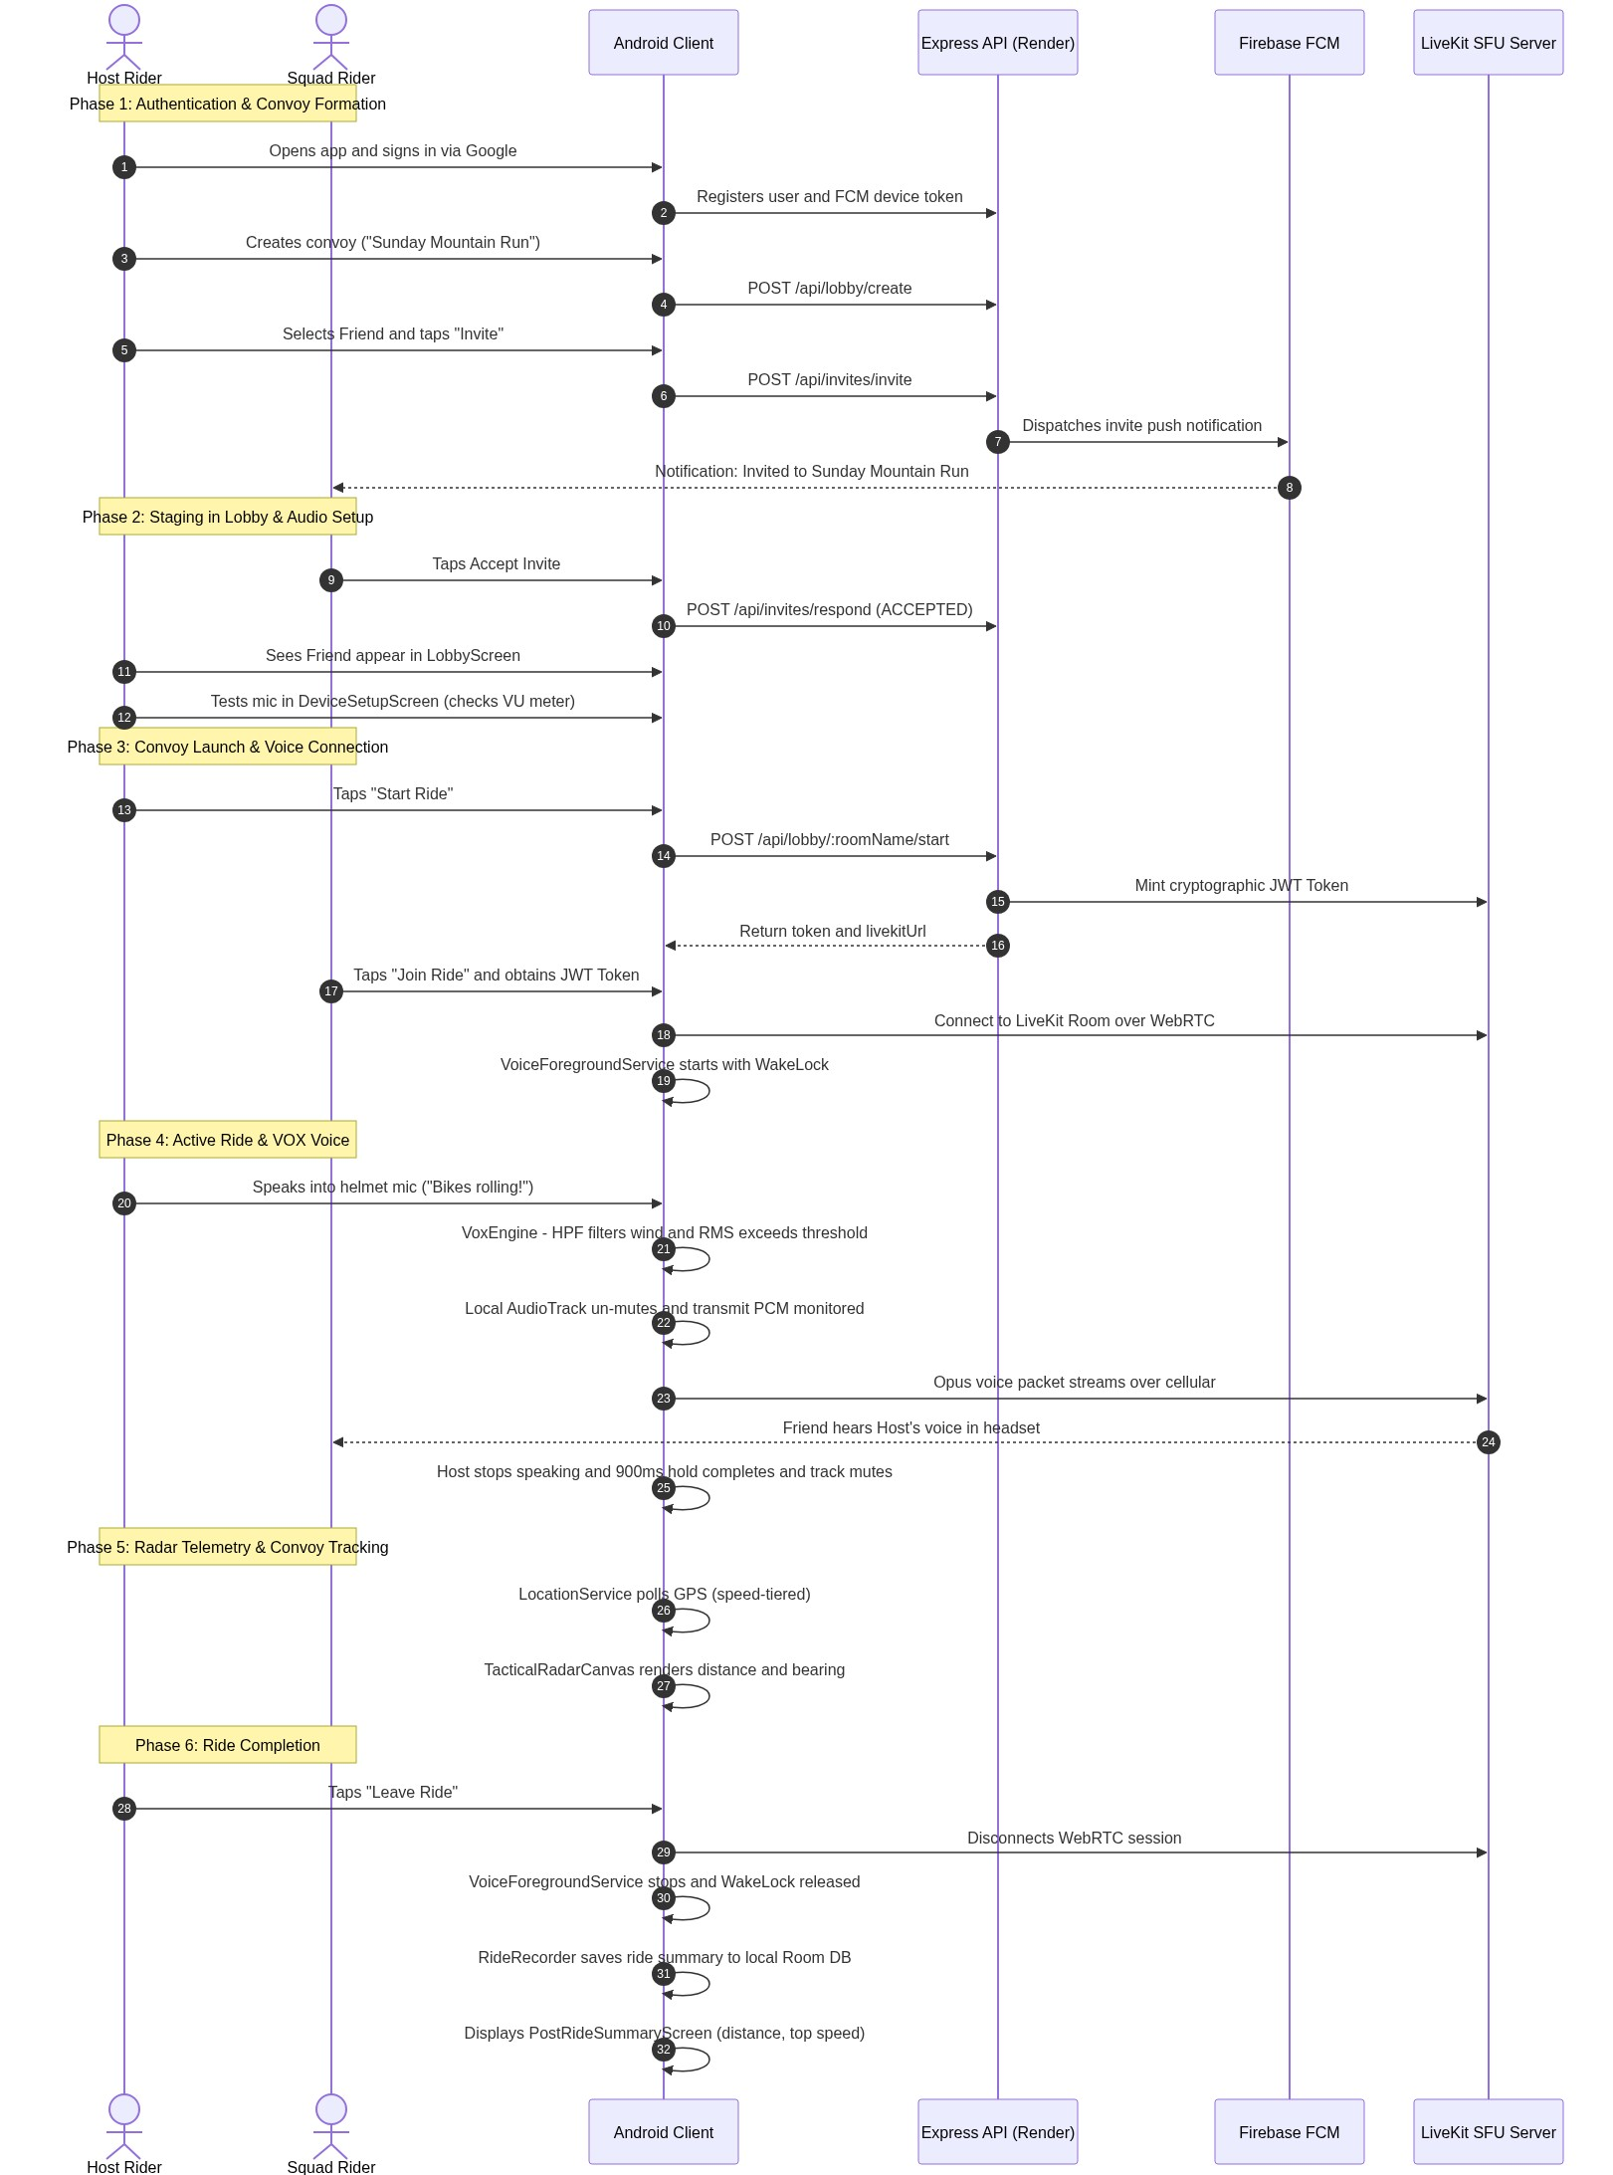
Figure 8: End-to-End Rider Lifecycle Sequence Diagram (Auth to Ride Completion)
――――――――――――――――――――――――――――――――――――――――――――――――――――――――――
Summary Checklist for Newcomers
When explaining the system to a new engineer, focus on these five core concepts:
- Low-Latency Group Voice Over Cellular: Replaces short-range Bluetooth intercoms using an external WebRTC SFU ([LiveKitManager.kt](file:///c:/Users/umerz/OneDrive/Desktop/Rider_APP-main/Rider_APP-main/mobile-app/app/src/main/java/com/ridervoice/network/LiveKitManager.kt)).
- Noise-Rejecting VOX Engine: Eliminates wind and exhaust rumble using a 300Hz high-pass filter and monitors ongoing transmission via WebRTC ADM callbacks ([VoxEngine.kt](file:///c:/Users/umerz/OneDrive/Desktop/Rider_APP-main/Rider_APP-main/mobile-app/app/src/main/java/com/ridervoice/audio/VoxEngine.kt)).
- Hardened Foreground Lifecycle: Prevents OS battery kills while riding with a 4-hour WakeLock safety cap and speed-tiered GPS polling ([VoiceForegroundService.kt](file:///c:/Users/umerz/OneDrive/Desktop/Rider_APP-main/Rider_APP-main/mobile-app/app/src/main/java/com/ridervoice/services/VoiceForegroundService.kt), [LocationService.kt](file:///c:/Users/umerz/OneDrive/Desktop/Rider_APP-main/Rider_APP-main/mobile-app/app/src/main/java/com/ridervoice/services/LocationService.kt)).
- Resilient Data & OTA Architecture: Self-healing Keystore fallback to prevent crash loops ([SecurePreferences.kt](file:///c:/Users/umerz/OneDrive/Desktop/Rider_APP-main/Rider_APP-main/mobile-app/app/src/main/java/com/ridervoice/security/SecurePreferences.kt)) and foreground-anchored APK updates ([UpdateManager.kt](file:///c:/Users/umerz/OneDrive/Desktop/Rider_APP-main/Rider_APP-main/mobile-app/app/src/main/java/com/ridervoice/update/UpdateManager.kt)).
- Zero-Dependency Radar & Regional SOS: Offline radar navigation ([TacticalRadarCanvas.kt](file:///c:/Users/umerz/OneDrive/Desktop/Rider_APP-main/Rider_APP-main/mobile-app/app/src/main/java/com/ridervoice/ui/components/TacticalRadarCanvas.kt)) and intelligent emergency dispatch resolution ([EmergencyNumbers.kt](file:///c:/Users/umerz/OneDrive/Desktop/Rider_APP-main/Rider_APP-main/mobile-app/app/src/main/java/com/ridervoice/utils/EmergencyNumbers.kt)).

