**Industrial Internship Report on**

**”Java Project”**

**Prepared by**

**Karimulla Shaik**

|  |
| --- |
| *Executive Summary* |
| This report provides details of the Industrial Internship provided by upskill Campus and The IoT Academy in collaboration with Industrial Partner UniConverge Technologies Pvt Ltd (UCT).  This internship was focused on a project/problem statement provided by UCT. We had to finish the project including the report in 6 weeks’ time.  My project was (Tell about ur Project)  This internship gave me a very good opportunity to get exposure to Industrial problems and design/implement solution for that. It was an overall great experience to have this internship. |

**TABLE OF CONTENTS**

1 Preface 3

2 Introduction 4

2.1 About UniConverge Technologies Pvt Ltd 4

2.2 About upskill Campus 8

2.3 Objective 9

2.4 Reference 9

2.5 Glossary 10

3 Problem Statement 11

3.1 Code submission (Github link): [UpSkill-Campus/MusicPlayer_ShaikKarimulla_USC_UCT/src/MusicPlayer.java at master · Buzz-DO7/UpSkill-Campus (github.com)](https://github.com/Buzz-DO7/UpSkill-Campus/blob/master/MusicPlayer_ShaikKarimulla_USC_UCT/src/MusicPlayer.java)

3.2 Report submission (Github link) : https://github.com/Buzz-DO7/UpSkill-Campus.git...........................12

4 Proposed Design/ Model 13

5 Performance Test 14

5.1 Performance Outcome 16

6 My learnings 15

7 Future work scope 17

# Preface

Summary of the whole 6 weeks’ work.

About need of relevant Internship in career development.

Brief about Your project/problem statement.

Opportunity given by USC/UCT.

How Program was planned

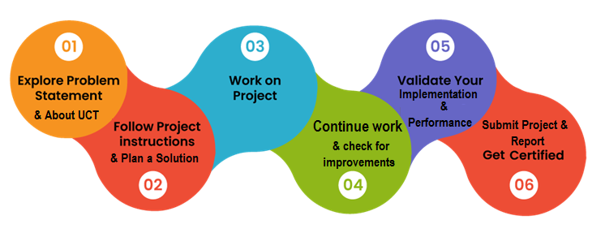

Your Learnings and overall experience.

Thank to all (with names), who have helped you directly or indirectly.

Your message to your juniors and peers.

# Introduction

## About UniConverge Technologies Pvt Ltd

A company established in 2013 and working in Digital Transformation domain and providing Industrial solutions with prime focus on sustainability and RoI.

For developing its products and solutions it is leveraging various**Cutting Edge Technologies e.g. Internet of Things (IoT), Cyber Security, Cloud computing (AWS, Azure), Machine Learning, Communication Technologies (4G/5G/LoRaWAN), Java Full Stack, Python, Front end**etc.

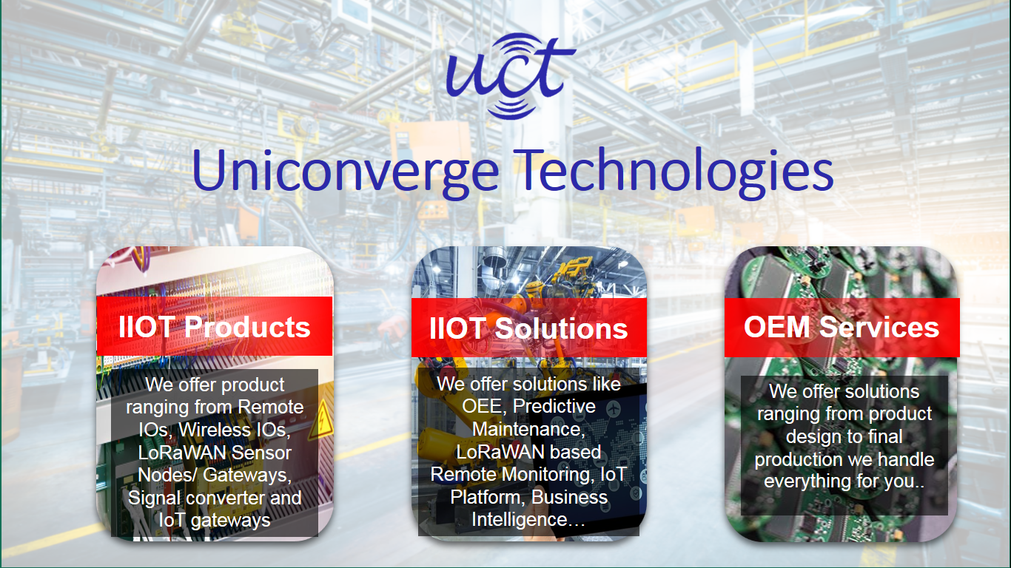

1. UCT IoT Platform **(****)**

**UCT Insight** is an IOT platform designed for quick deployment of IOT applications on the same time providing valuable “insight” for your process/business. It has been built in Java for backend and ReactJS for Front end. It has support for MySQL and various NoSql Databases.

* It enables device connectivity via industry standard IoT protocols - MQTT, CoAP, HTTP, Modbus TCP, OPC UA
* It supports both cloud and on-premises deployments.

It has features to  
• Build Your own dashboard  
• Analytics and Reporting  
• Alert and Notification  
• Integration with third party application(Power BI, SAP, ERP)  
• Rule Engine

 

1. **Smart Factory Platform (****)**

Factory watch is a platform for smart factory needs.

It provides Users/ Factory

* with a scalable solution for their Production and asset monitoring
* OEE and predictive maintenance solution scaling up to digital twin for your assets.
* to unleased the true potential of the data that their machines are generating and helps to identify the KPIs and also improve them.
* A modular architecture that allows users to choose the service that they what to start and then can scale to more complex solutions as per their demands.

Its unique SaaS model helps users to save time, cost and money.

 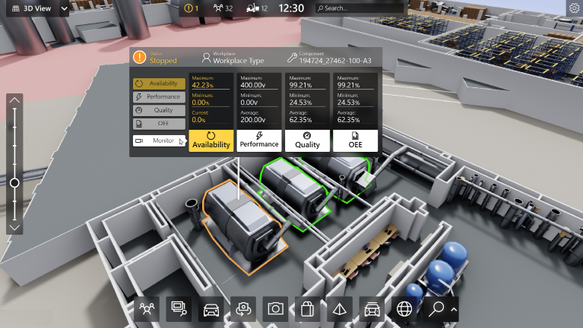

1. 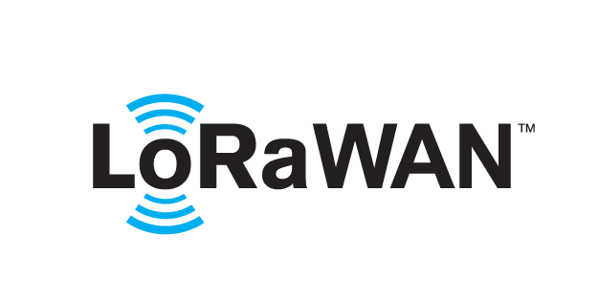 based Solution

UCT is one of the early adopters of LoRAWAN teschnology and providing solution in Agritech, Smart cities, Industrial Monitoring, Smart Street Light, Smart Water/ Gas/ Electricity metering solutions etc.

1. Predictive Maintenance

UCT is providing Industrial Machine health monitoring and Predictive maintenance solution leveraging Embedded system, Industrial IoT and Machine Learning Technologies by finding Remaining useful life time of various Machines used in production process.



## About upskill Campus (USC)

upskill Campus along with The IoT Academy and in association with Uniconverge technologies has facilitated the smooth execution of the complete internship process.

USC is a career development platform that delivers **personalized executive coaching** in a more affordable, scalable and measurable way.



Seeing need of upskilling in self paced manner along-with additional support services e.g. Internship, projects, interaction with Industry experts, Career growth Services

<https://www.upskillcampus.com/>

upSkill Campus aiming to upskill 1 million learners in next 5 year

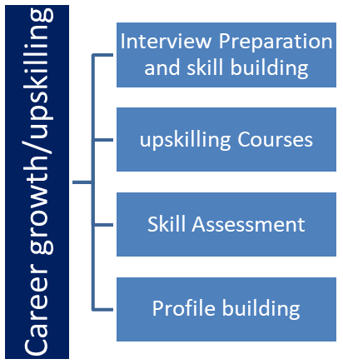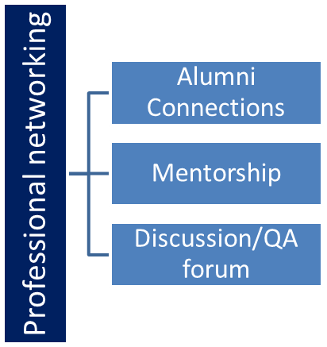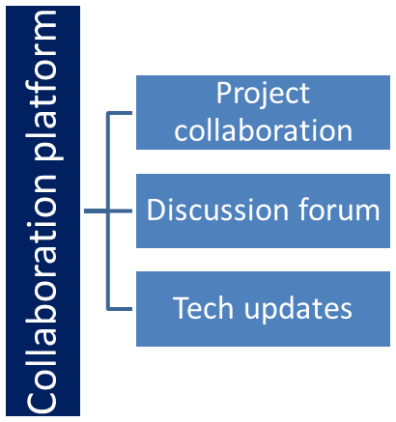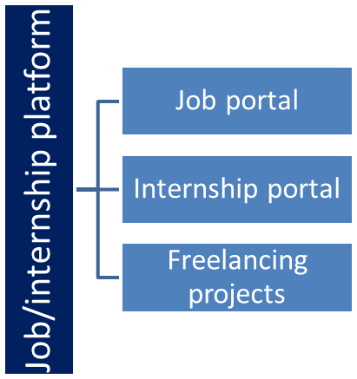

## The IoT Academy

The IoT academy is EdTech Division of UCT that is running long executive certification programs in collaboration with EICT Academy, IITK, IITR and IITG in multiple domains.

## Objectives of this Internship program

The objective for this internship program was to

 ☛ get practical experience of working in the industry.

 ☛ to solve real world problems.

 ☛ to have improved job prospects.

 ☛ to have Improved understanding of our field and its applications.

 ☛ to have Personal growth like better communication and problem solving.

## Glossary

|  |  |
| --- | --- |
| Terms | Acronym |
| Data Science | A multidisciplinary field that uses scientific methods, processes, algorithms, and systems to extract insights and knowledge from structured and unstructured data. |
| Machine Learning | A subset of artificial intelligence that enables systems to learn and make predictions or take actions without being explicitly programmed. It focuses on the development of algorithms and models that allow computers to learn and improve from experience. |
| Data Visualization | The graphical representation of data and information using visual elements such as charts, graphs, and maps |
| Natural language processing (NLP) | A field of study that focuses on the interaction between computers and human language. It involves the analysis and understanding of human language, enabling machines to process and interpret text or speech data |
|  |  |

# Problem Statement

The problem statement for this project is to develop a Music Player using java that allows users to play and manage their music collection. The application should provide a user-friendly interface for interacting with the music player’s functionalities. The goal of the project is to create a reliable and efficient music player that enables users to enjoy their favorite songs seamlessly.

## Code submission (Github link) : [UpSkill-Campus/MusicPlayer_ShaikKarimulla_USC_UCT at master · Buzz-DO7/UpSkill-Campus (github.com)](https://github.com/Buzz-DO7/UpSkill-Campus/tree/master/MusicPlayer_ShaikKarimulla_USC_UCT)

## Report submission (Github link) : https://github.com/Buzz-DO7/UpSkill-Campus.git

# Proposed Design/ Model

The provided code implements javazoom.j1 is a Java library for decoding audio files in the MPEG-1 Audio Layer lll(MP3) format. It provides functionality to read and decode the compressed MP3 audio data allowing developers to work with MP3 audio streams and extract raw audio samples for playback or further processing. This library is commonly used in Java applications that require MP3 audio playback or analysis.

# Performance Test

In terms of performance, the code provided seems to be straightforward and efficient. By increasing the number of concurrent users and analyzing response times, throughput, and resource utilization, the system's scalability and stability can be evaluated.

Different MP3 file sizes should be used to observe how the player handles larger or higher-quality audio files. This test will help determine the player's efficiency in reading and processing MP3 files and ensure that users experience minimal delays when starting to play a song.

Furthermore, the responsiveness of the scrubber (the seek bar) and the accuracy of the time displayed during song playback should be tested. This evaluation ensures that users can accurately skip to specific parts of a song and see the correct playback time while listening.

For smooth operation, ensure the hardware meets requirements and the code is efficient. Implement threading and handle errors gracefully. Optimize memory, use buffering, and profile for bottlenecks to maintain responsiveness and stability

## Performance Outcome

The performance outcome of the provided code depends on various factors such as Multithreading for Smooth Playback, Memory Optimization and Error Handling, Efficient Audio Decoding.

Multithreading for Smooth Playback: The performance outcome of the music player application is quite promising due to the effective use of multithreading for audio playback. By employing separate threads for UI interactions and audio decoding/playback, the application can provide a responsive user interface even during music playback. This ensures that the user can easily control the player while the music continues playing seamlessly in the background.

Memory Optimization and Error Handling: The music player demonstrates good memory optimization, effectively clearing and updating arrays to store song information and managing resources like the bitstream and audio device. Moreover, the code includes appropriate error handling for potential exceptions during file loading, decoding, or playback

Efficient Audio Decoding: The music player leverages the javazoom.jl.decoder library for audio decoding, which is known for its efficiency in decoding MP3 audio files. The code properly manages the bitstream and decoder, efficiently decoding audio frames, and writing audio samples to the audio device. This efficient decoding process contributes to smooth and uninterrupted playback without significant delays or lags.

# My learnings

Throughout this project, I have gained valuable learnings that have contributed to my personal and professional growth. Here are some of the key learnings I have acquired:

**Technical Skills**: Working on this project has allowed me to deepen my technical skills in Java programming, file management, error handling, memory optimization, and performance tuning. This has expanded my knowledge and proficiency in coding and software development.

**Problem-Solving and Critical Thinking**: This project has presented me with various challenges that required problem-solving and critical thinking skills. I have learned to approach problems systematically, break them down into smaller parts, and analyze potential solutions. Through trial and error, I have developed the ability to think creatively and find innovative solutions to complex problems.

**Attention to Detail**: The project has emphasized the importance of paying attention to detail in coding and project implementation. I have learned to carefully review my code, identify potential errors or bugs, and ensure the accuracy and efficiency of my solutions. This attention to detail has enhanced the overall quality of my work.

# Future work scope

The music player project already provides a solid foundation for a functional and user-friendly application. However, there are several potential areas for future work and improvements to enhance its capabilities and user experience:

**User Authentication and Playlist Management**: Implement user authentication and user-specific playlists to allow users to create and save their playlists. This will enable personalized music experiences and encourage users to return to the app.

**Audio Equalizer**: Integrate an audio equalizer to allow users to adjust the audio output according to their preferences. Adding preset equalizer settings or a customizable equalizer will give users more control over the sound output.

**Search and Music Recommendations**: Implement a search feature that enables users to search for specific songs, artists, or albums within the application. Additionally, consider integrating music recommendation algorithms based on user listening history to suggest relevant songs or artists.