

S7 Software Portfolio

redouan sammour

2024

# Introduction:

My name is Redouan Sammour, and as I embark on the journey of semester 7 in my academic pursuit, I find myself reflecting on the winding path that has brought me here. Having completed a minor, this semester holds particular significance as it serves as a pivotal point in my educational journey, bridging the gap between past experiences and the anticipation of forthcoming challenges and opportunities. It marks the transition towards my impending graduation internship, symbolizing the culmination of years of hard work and dedication to my studies. As I stand at this juncture, I am filled with excitement and anticipation for the adventures and discoveries that lie ahead, eager to continue growing and learning in pursuit of my academic and professional goals.

**Strengths**:

1. Research-oriented approach: I possess a fervent dedication to delving into complex concepts until I attain a comprehensive understanding. This propensity for thorough research equips me with the knowledge and insight necessary to adeptly implement various tools and solutions.
2. Quick learner: My innate ability to swiftly grasp new concepts and technologies enables me to adapt seamlessly to evolving environments and tasks, facilitating efficient learning and application.
3. Driven and motivated: I am propelled by a deep-seated motivation to expand my knowledge and skills, consistently seeking avenues for professional growth and development.
4. Creative, professional, and pragmatic: I approach challenges with a blend of creativity, professionalism, and pragmatism, striving to deliver innovative yet practical solutions that meet both technical requirements and real-world needs.

**Weaknesses**:

1. Commencing each semester from a blank slate can sometimes be daunting, as I navigate the initial learning curve and strive to establish a solid foundation. However, I offset this challenge through meticulous planning, diligent effort, and a proactive approach to learning.
2. This semester presents an opportunity for me to confront and overcome my lack of experience with cloud services, API gateways, and tools like Kubernetes and RabbitMQ. While I acknowledge the learning curve associated with mastering these technologies, I am committed to investing significant effort and dedication to acquire the necessary skills and expertise.

# Projects

This semester, I will be focusing my efforts on BuzzLoop, a dynamic project aimed at creating a social media platform inspired by the core functionalities of Twitter. BuzzLoop aims to provide users with a seamless experience for sharing thoughts, engaging with content, and connecting with others in real-time conversations.

BuzzLoop offers a range of features, including:

1. Posting Buzzes: Users can share their thoughts, opinions, and updates with their followers by posting Buzzes.
2. Engaging with Buzzes: Users can like, comment on, and share Buzzes to interact with content and express their opinions.
3. Discovering Trends: BuzzLoop allows users to explore trending topics and discover popular Buzzes from across the platform.
4. Connecting with Others: Users can follow other users, create connections, and engage in conversations to build meaningful relationships within the BuzzLoop community.

By working on BuzzLoop this semester, I aim to contribute to the development of a vibrant and engaging social media platform that empowers users to express themselves, connect with others, and stay informed about the latest trends and discussions.

# Self-assessment

## Sprint delivery 1

**LO1 - Professional Standard:** I've progressed in deploying my code to Docker Hub, preparing for Kubernetes integration. My next step is to deploy to an Azure Portal web server, which is pending. Until this is achieved, I rate myself at a "**Beginning**" level for LO1. Successfully deploying to Azure will mark a transition towards proficiency.

**LO2 - Personal Leadership:** I have outlined the research questions and planned the research but have not yet conducted it. My current exploration of tools like Kubernetes, and Docker, while not formally documented, sets the groundwork. Presently, I am "**Orienting**". Starting the formal research will move me to "**Beginning**," and completing it will reflect proficiency or advanced knowledge.

**LO3 - Scalable Architectures:** This semester is a learning curve, introducing me to various new tools pertinent to my future role as a project manager with in-depth software development knowledge. With more to learn, I am at a "**Beginning**" level for LO3, but I am confident in my ability to grow and achieve proficiency with further portfolio deliveries.

**LO4 - Development and Operations (DevOps):** My initial software architecture concept revealed some misplacements, and I've started setting up a Kubernetes environment. Although it's not fully operational, my acknowledgment of these early-stage challenges places me at a "**Beginning**" level for LO4. My objective is to refine the architecture and ensure it's scalable.

**LO5 - Cloud Native:** I plan to integrate GitHub Actions for CI/CD in future sprints. While I've prepared the repositories, the pipelines are not yet in place. My current status is "**Orienting**," with implementation expected in sprint 2 or 3.

**LO6 - Security by Design:** The decision to use Azure Portal as a cloud web server service has been made, but further exploration into the specific services I will utilize is pending. At this stage, for sprint 1, I am "**Orienting**" for LO6.

**LO7 - Distributed Data:** I am contemplating the use of token-based authentication to secure the API and service access, which is a critical step towards safeguarding my services. As of now, I am in the "**Orienting**" phase for LO7 as these security measures are yet to be implemented.

## Sprint Delivery 2

**LO1 - Professional Standard:** I have been consistently involved in solving ICT issues and making strides in my applied research. My engagement with complex contexts has been substantial, though there's more to be done. By integrating feedback and refining my work, I've shown responsibility in my role. Recognizing there's room for growth, I rate myself as "**Beginning**" for LO1.

**LO2 - Personal Leadership:** I've taken initiative in my professional development, setting personal goals and seeking feedback through weekly discussions with my teacher. This reflective practice and the actions stemming from it showcase my dedication to personal leadership. However, as I am still in the process of refining these skills, I give myself a "**Beginning**" rating for LO2.

**LO3 - Scalable Architectures:** I've laid the groundwork for scalable architectures by manually deploying my project on Minikube, which is essential for understanding the deployment aspects of the system architecture. While I have initiated the process, I acknowledge that I need to further develop my skills to automate and scale this process. Hence, I rate myself as "**Beginning**" for LO3.

**LO4 - Development and Operations (DevOps):** With the successful implementation of CI/CD pipelines via GitHub Actions that automatically build and push to Docker Hub, I've made a leap in optimizing my development and operations workflow. This milestone demonstrates a higher level of mastery in DevOps practices. Therefore, I consider myself "**Proficient**" in LO4.

**LO5 - Cloud Native:** During this sprint, my focus has been on other areas, and I have not yet fully engaged with cloud-native development practices. Due to this, I must rate myself as "**Beginning**" for LO5, with plans to prioritize this in the next sprint.

**LO6 - Security by Design:** With the implementation of Keycloak, I've taken the initial steps toward securing my application. However, since this is just the start and more comprehensive security measures need to be integrated, I am still orienting myself in this domain. Thus, my self-assessment for LO6 is "**Orienting**."

**LO7 - Distributed Data:** The integration of a database to store "buzzes" marks the beginning of my journey in handling and storing a large amount of various data types. As I continue to refine and enhance data management practices, I acknowledge my current status as "**Beginning**" for LO7.

# Reflection

**Delivery 1:** I'm really proud of the progress I've made in these first few weeks. Terms like orchestrators, Kubernetes, event bus handlers, and the idea of building a microservice-level application were completely new to me. At the start of the semester, I felt a bit overwhelmed and unsure of where to even begin. But as time goes on, I'm slowly starting to understand how everything fits together and what needs to be done at each step. Even though we're only a few weeks in, I've already learned a lot. There's still plenty more to learn, but it's great to see the progress I've made so far.

**Delivery 2:** Since my initial delivery, I've made substantial progress. My understanding of containerization has grown with the successful update of 'buzzloop-frontend' and 'buzzloop-backend' Docker Hub repositories. In security, I've started with Keycloak implementation, positioning myself at the 'Orienting' stage in LO6. I've achieved a 'Proficient' rating in LO4 after automating my CI/CD pipelines on GitHub Actions, demonstrating a significant improvement in my DevOps skills. I've also engaged in hands-on deployment using Minikube, enhancing my grasp of scalable architectures, although I still consider myself at the 'Beginning' level for LO3. My weekly discussions with a teacher have sharpened my personal leadership skills, leading to a 'Beginning' rating for LO2. For LO7, I've laid the foundation of distributed data management by setting up a database for 'buzzes', marking initial progress in this area. Overall, my journey continues with a clear direction for further development.

# Conclusion

**Delivery 1:** I've made significant progress with BuzzLoop, but there's still much to accomplish. The upcoming milestones on my agenda include setting up an Azure Portal service to host the application, ensuring seamless functionality of my Kubernetes cluster in the local environment, and developing additional services required for BuzzLoop.

**Delivery 2:** I recognize that my journey with BuzzLoop has advanced notably. The establishment of CI/CD pipelines and the integration of Docker and Keycloak stand as testaments to my growing capabilities. While I've reached a level of proficiency in DevOps, I acknowledge that I'm just beginning to explore other areas such as cloud services, security, and data management. The progress I've made thus far is promising, and it lays a solid foundation for the more complex tasks ahead. With key milestones on my horizon, including enhancing the Kubernetes setup and expanding BuzzLoop's functionalities.

# Screenshots

# 

1: My local docker environment with Minikube set up as well.

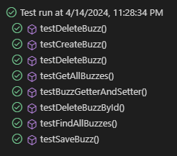

2: My test for my project

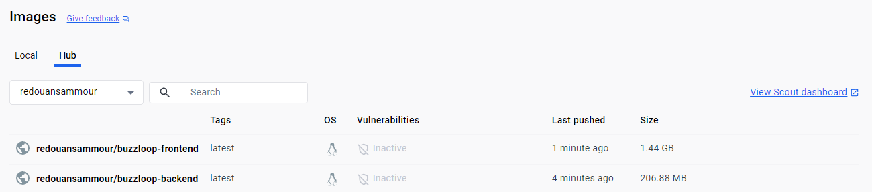

3. Two Docker Hub repositories 'buzzloop-frontend' and 'buzzloop-backend', both recently pushed.

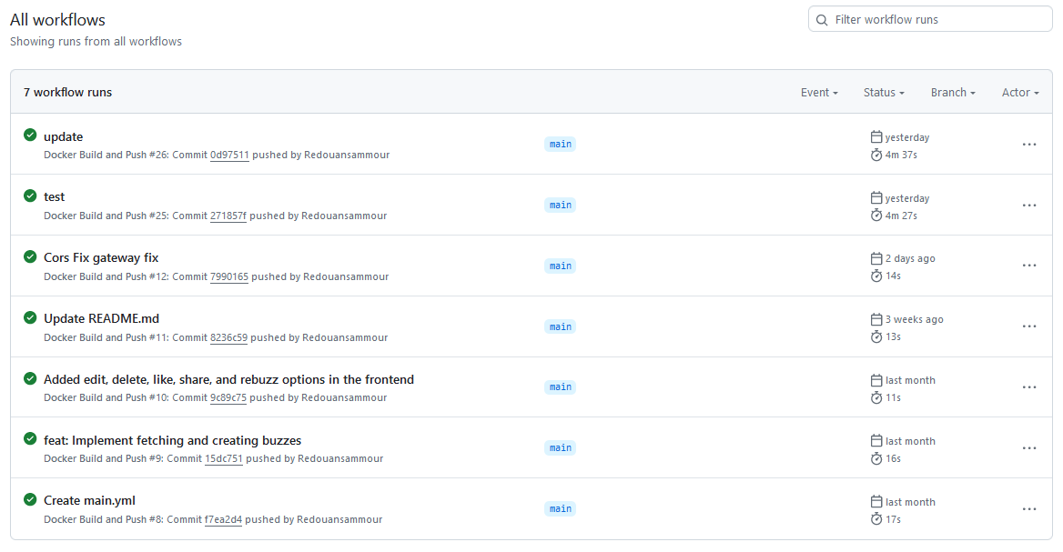

4. An overview of workflow runs for a GitHub Actions CI/CD process, with various tasks such as builds and pushes.

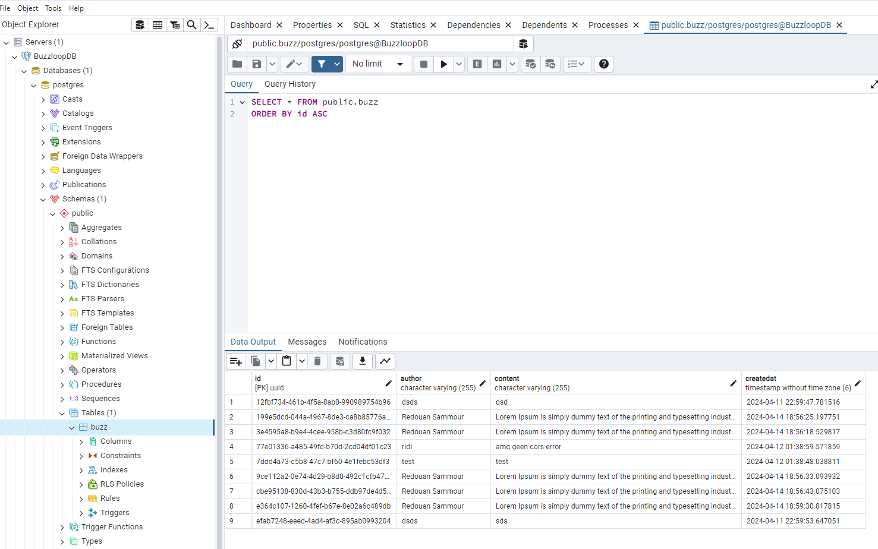

1. My database called "buzzloopdb" shows all the buzzes that were made and by who
2. 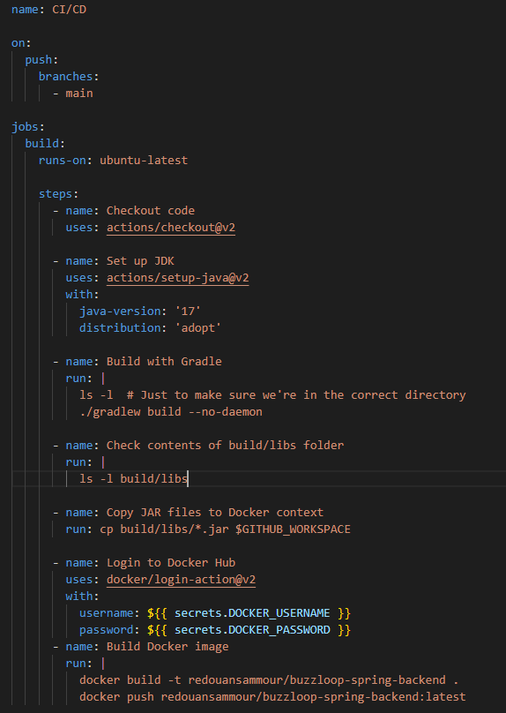My GitHub Actions workflow YAML file for a CI/CD process, triggered by pushes to the main branch, with tasks for code checkout, JDK setup, Gradle build, JAR files check, copying to Docker context, Docker login, and Docker build & push.

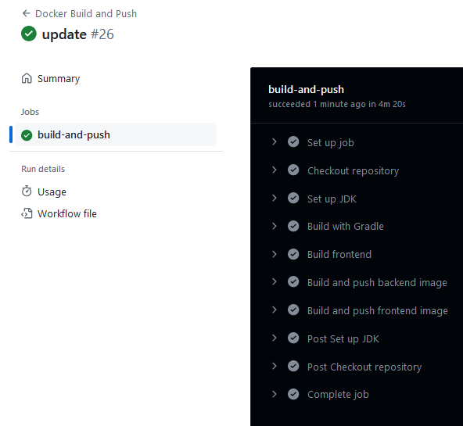

7.We see a successfully completed GitHub Actions workflow with tasks such as setup job, checkout repository, JDK setup, Gradle build, build and push for both frontend and backend images, and concluding steps like complete job.

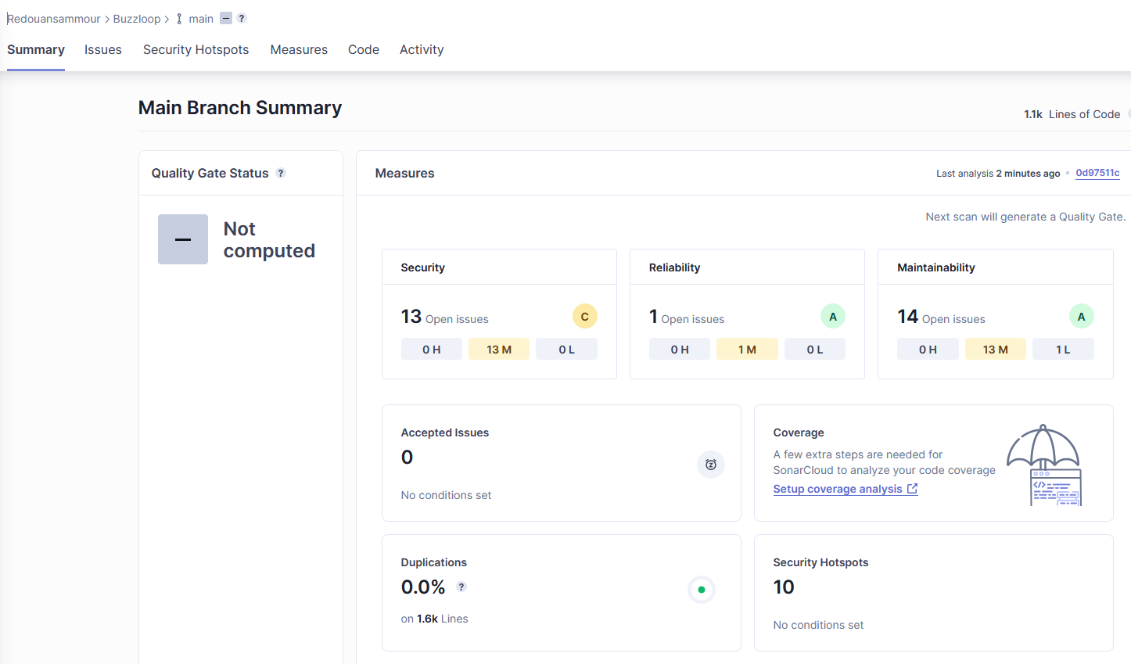

8. My sonarcloud dashboard