Crafting Effective AI Prompts for Business Insights
Bolivar Vega October 8, 2026
GLAB 928.1 Knowledge Base Report

Overview
This lab improved a broad customer-feedback request through four stages: evaluation, specificity, business context, and output formatting. The final prompt defines the feedback period and sources, focuses on a retail mobile application's interface and checkout experience, explains how leaders will use the findings, and requests an evidence-based management report. The result is a prompt that gives an AI clear boundaries while still allowing it to identify patterns, limitations, and practical actions.

Steps

Task 1 Analyzing an Existing Prompt
Original prompt
Generate a comprehensive report which analyzes customer feedback.
Specificity. The subject is identifiable, but the prompt does not define the product, feedback period, customer segment, feedback channels, business questions, or measures of importance. The word comprehensive is subjective and does not establish useful boundaries.
Context. The prompt does not explain why the analysis is needed, who will read it, or which decision it should support. Without this context, an AI may produce generic observations that are not connected to product priorities or customer-experience goals.
Desired output. The request asks for a report but does not define sections, level of detail, evidence standards, tables, visual recommendations, ranking method, or treatment of incomplete data. The AI therefore has to guess how to organize the result.
Strength. The prompt is concise and clearly names customer feedback as the subject. It offers a usable starting point for iterative refinement.
Overall assessment. The prompt is too broad to reliably produce an actionable business report. It should specify the data scope, analytical focus, intended decision, audience, output structure, and rules against unsupported conclusions.

Prompt used to obtain the Task 1 evidence
Evaluate the following business prompt based on its specificity, context, and desired output format. Identify its strengths and weaknesses, explain what important details are missing, and recommend improvements that would help an AI generate a useful and actionable business report. Original prompt: 'Generate a comprehensive report which analyzes customer feedback.'
Screenshot evidence: see Appendix A, Task 1 (all captured frames).

Task 2 Refining Specificity
The revised prompt narrows the analysis to a defined six-month period, a retail mobile application, two product areas, and three feedback channels. It also names the themes to investigate and asks the AI to separate repeated patterns from isolated comments. These constraints reduce ambiguity and make the result more useful for comparing customer problems.
Revised prompt
Generate a comprehensive report analyzing customer feedback collected from January through June 2026 about our retail mobile application's user interface and checkout process. Examine app-store reviews, post-purchase surveys, and customer-support tickets. Identify recurring usability problems, checkout failures, payment concerns, navigation issues, and positive feedback. Quantify recurring themes when the source data permits, distinguish isolated comments from repeated patterns, and identify the three issues with the greatest likely effect on conversion and customer satisfaction.
Screenshot evidence: see Appendix A, Task 2 (all captured frames).

Task 3 Adding Context
The added context explains that product and customer-experience teams will use the report for the next quarterly roadmap. It connects the analysis to checkout abandonment and customer satisfaction, identifies the decision-makers, and asks for prioritized recommendations. This helps the AI judge which findings are most relevant instead of treating every comment as equally important.
Contextualized prompt
Generate a comprehensive report analyzing customer feedback collected from January through June 2026 about our retail mobile application's user interface and checkout process. Examine app-store reviews, post-purchase surveys, and customer-support tickets. The product and customer-experience teams will use the report to prioritize the next quarterly development roadmap, reduce checkout abandonment, and improve customer satisfaction. Identify recurring usability problems, checkout failures, payment concerns, navigation issues, and positive feedback. Quantify recurring themes when the source data permits, distinguish isolated comments from repeated patterns, rank the three highest-priority issues by business impact and urgency, and recommend practical actions for product, engineering, and customer-support leaders.
Screenshot evidence: see Appendix A, Task 3 (all captured frames).

Task 4 Specifying the Desired Format
The final prompt identifies the role, audience, section order, evidence requirements, prioritization method, recommendation fields, table content, and rules for missing data. The requested structure supports senior management by placing the executive summary and key findings first while preserving detail for product and customer-experience teams. Requiring assumptions and limitations to be labeled also reduces the risk that the AI will present invented figures as facts.
Final enhanced prompt
Act as a senior customer-insights analyst. Create a management-ready report analyzing customer feedback collected from January through June 2026 about our retail mobile application's user interface and checkout process. Use app-store reviews, post-purchase surveys, and customer-support tickets as the source categories. The product and customer-experience teams will use the report to prioritize the next quarterly development roadmap, reduce checkout abandonment, and improve customer satisfaction. Structure the report with these sections: Executive Summary; Data Scope and Limitations; Key Findings; Theme Analysis; Positive Feedback; Priority Matrix; Recommendations; and Next Steps. For each major theme, state the supporting evidence, frequency or percentage when available, affected customer journey stage, likely business impact, and confidence level. Separate recurring patterns from isolated comments. Rank the three highest-priority issues by impact and urgency. Provide specific recommendations with an owner, expected benefit, suggested timeline, and measurable success indicator. Include a table summarizing the major themes and recommend appropriate bar or trend charts without inventing data. Clearly label assumptions, gaps, and any conclusion that the available feedback does not support. Use concise professional language suitable for presentation to senior management.
Screenshot evidence: see Appendix A, Task 4 (all captured frames).

Conclusion
Effective business prompts do more than name a topic. They define the boundaries of the evidence, explain the decision the analysis must support, identify the audience, and describe a usable output. The refinement process changed a one-sentence request into a controlled analytical assignment. The final prompt should produce more relevant findings, clearer priorities, and recommendations that leaders can evaluate, while also requiring the AI to disclose uncertainty and avoid inventing data.

Appendix A — ChatGPT Screenshot Evidence

Task 1 — Screenshot 1 of 3 | task1-1.png
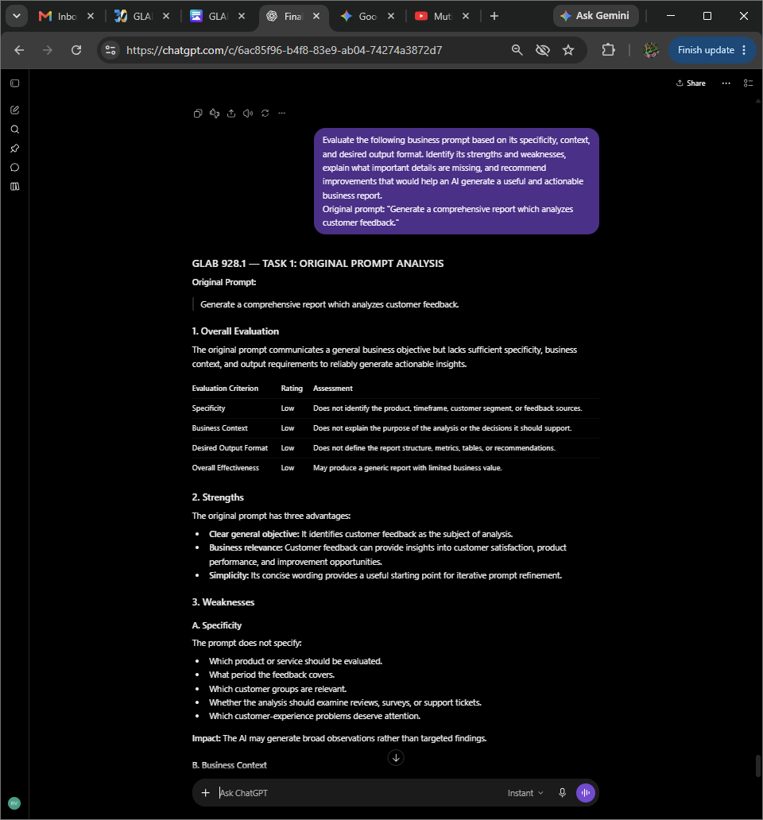
Original ChatGPT interaction captured during GLAB 928.1.

Task 1 — Screenshot 2 of 3 | task1-2.png
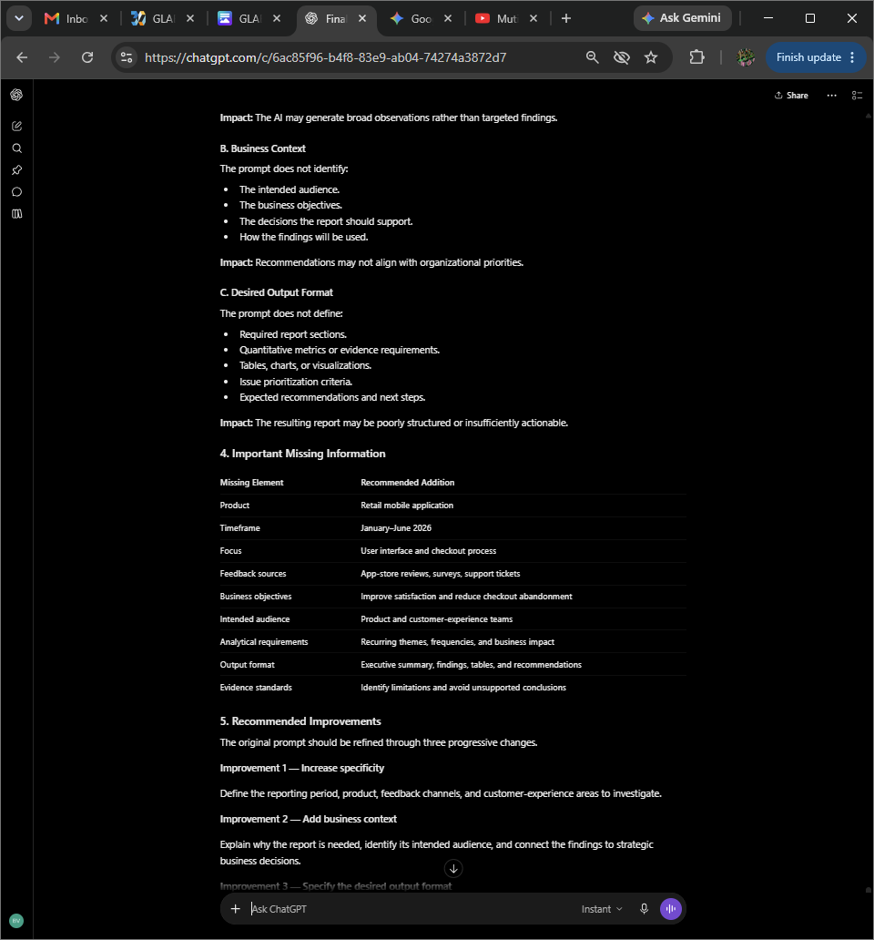
Original ChatGPT interaction captured during GLAB 928.1.

Task 1 — Screenshot 3 of 3 | task1-3.png
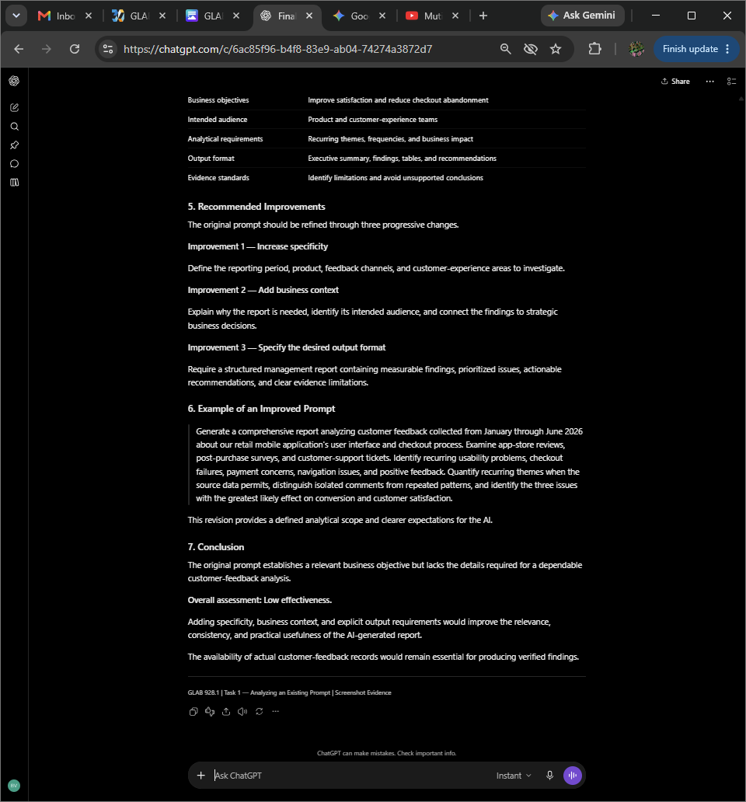
Original ChatGPT interaction captured during GLAB 928.1.

Task 2 — Screenshot 1 of 3 | task2-1.png
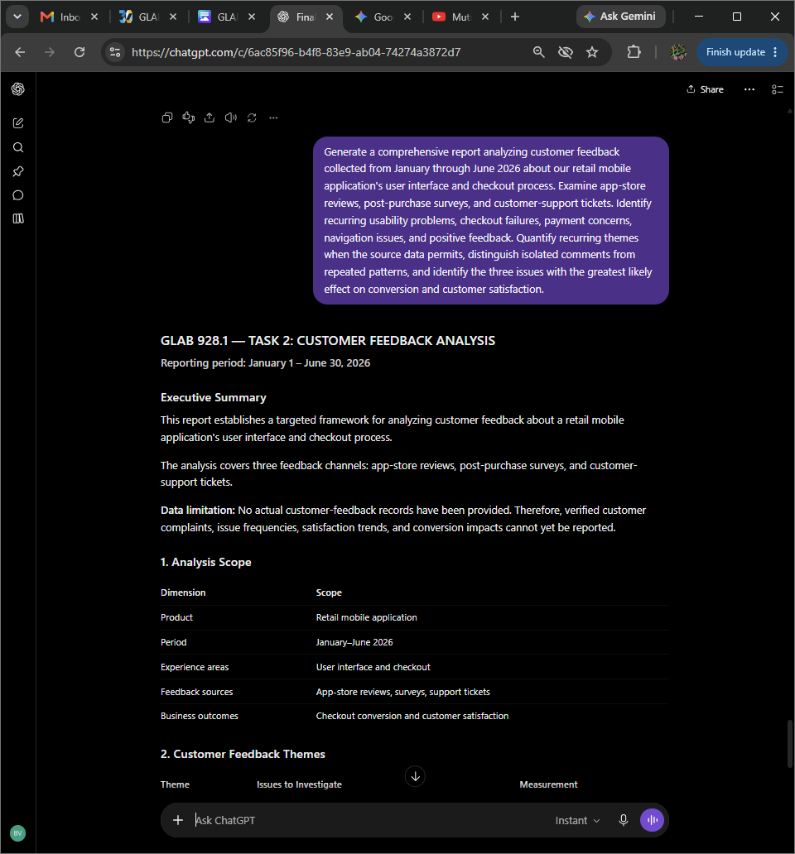
Original ChatGPT interaction captured during GLAB 928.1.

Task 2 — Screenshot 2 of 3 | task2-2.png
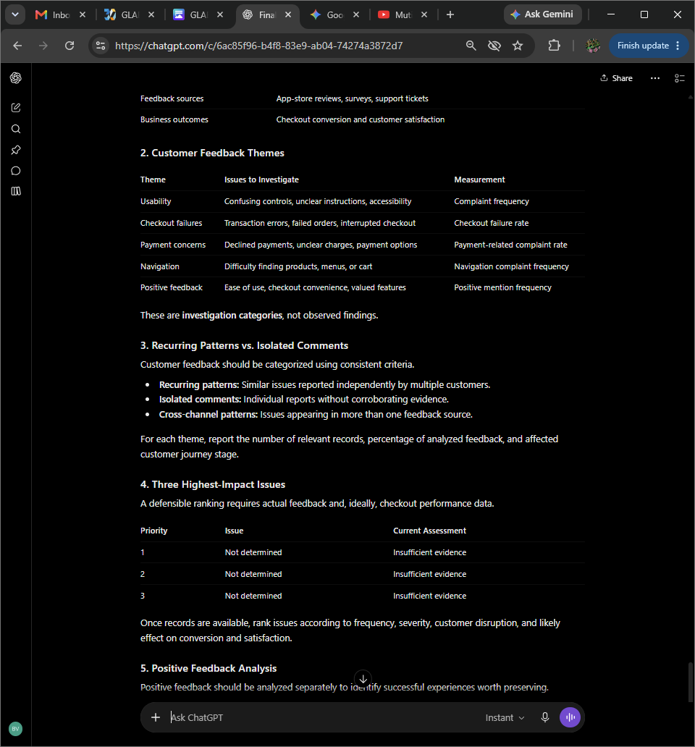
Original ChatGPT interaction captured during GLAB 928.1.

Task 2 — Screenshot 3 of 3 | task2-3.png
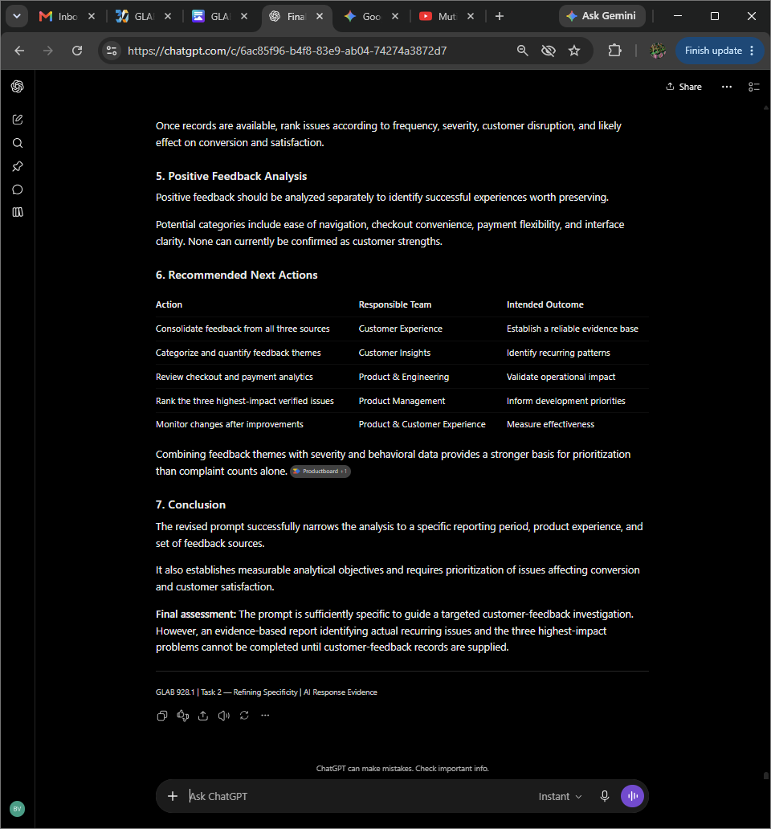
Original ChatGPT interaction captured during GLAB 928.1.

Task 3 — Screenshot 1 of 3 | task3-1.png
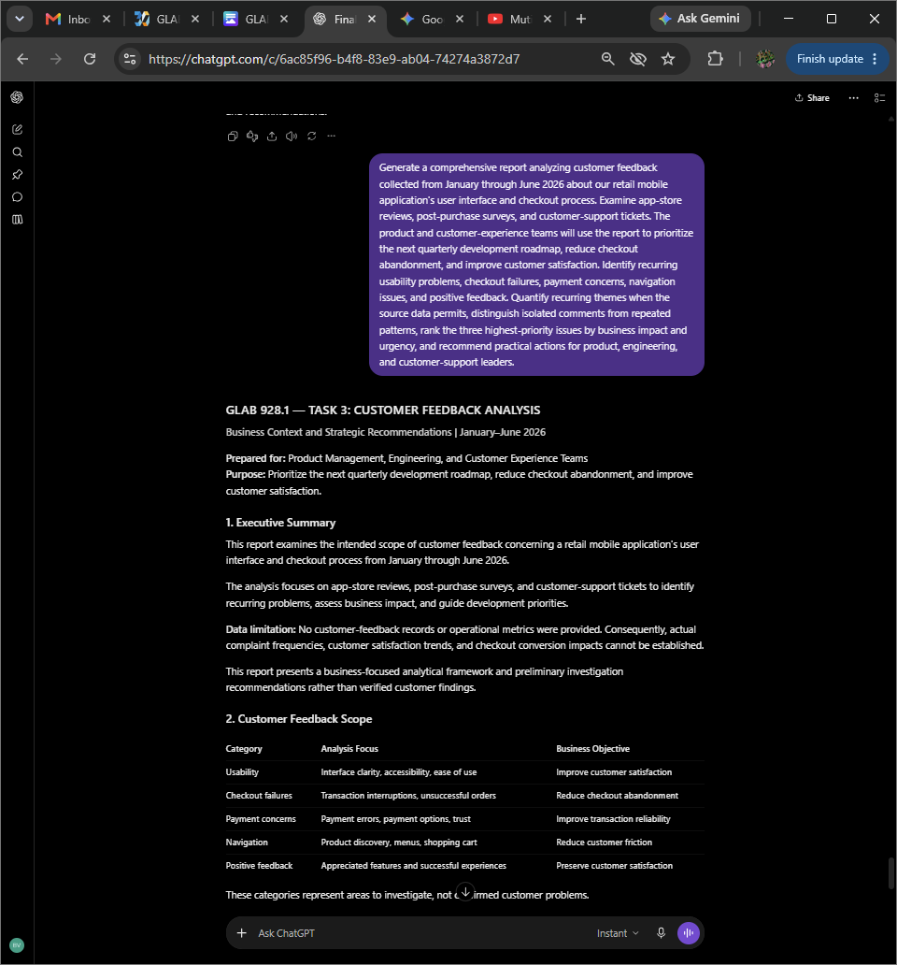
Original ChatGPT interaction captured during GLAB 928.1.

Task 3 — Screenshot 2 of 3 | task3-2.png
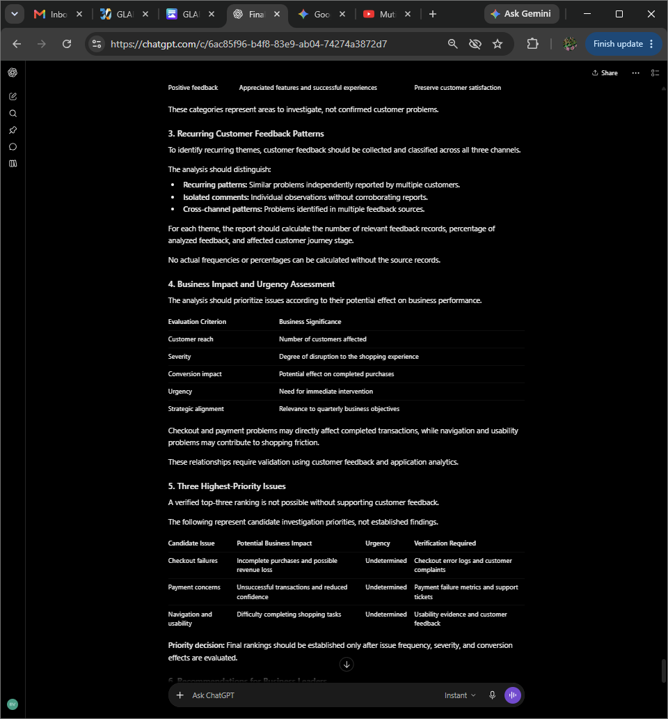
Original ChatGPT interaction captured during GLAB 928.1.

Task 3 — Screenshot 3 of 3 | task3-3.png
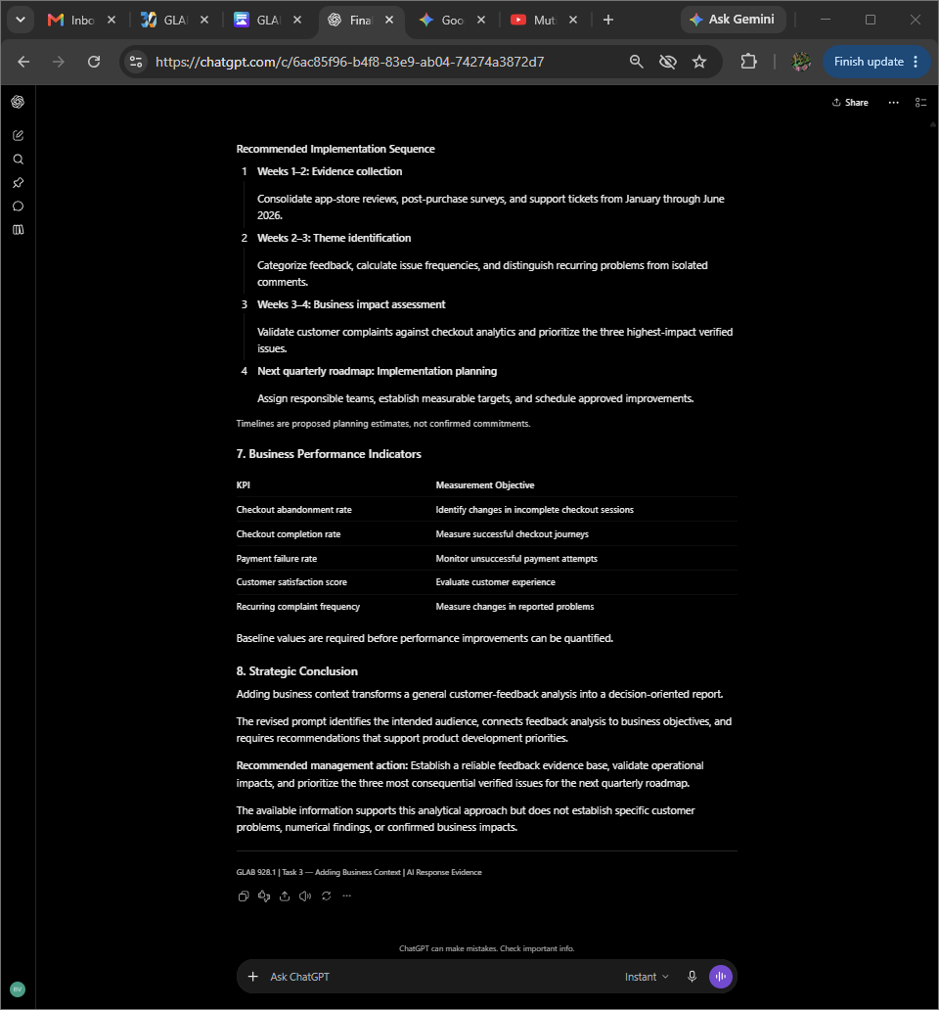
Original ChatGPT interaction captured during GLAB 928.1.

Task 4 — Screenshot 1 of 4 | task4-1.png
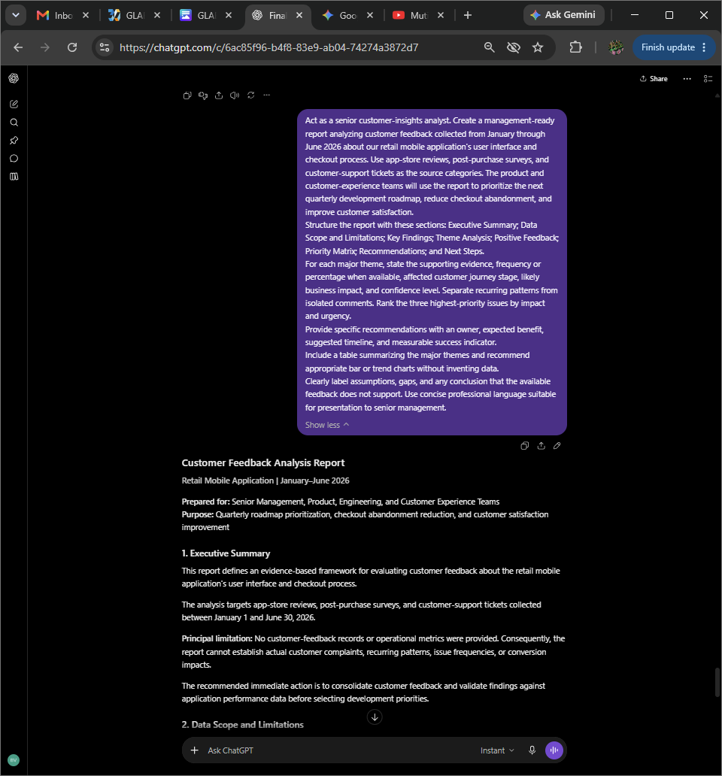
Original ChatGPT interaction captured during GLAB 928.1.

Task 4 — Screenshot 2 of 4 | task4-2.png
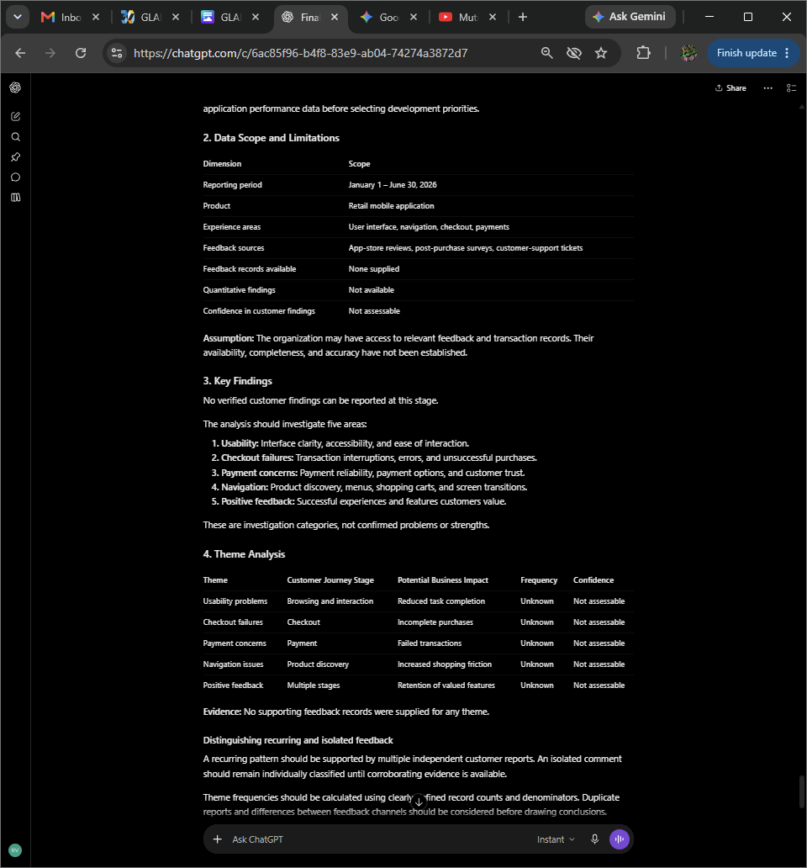
Original ChatGPT interaction captured during GLAB 928.1.

Task 4 — Screenshot 3 of 4 | task4-3.png
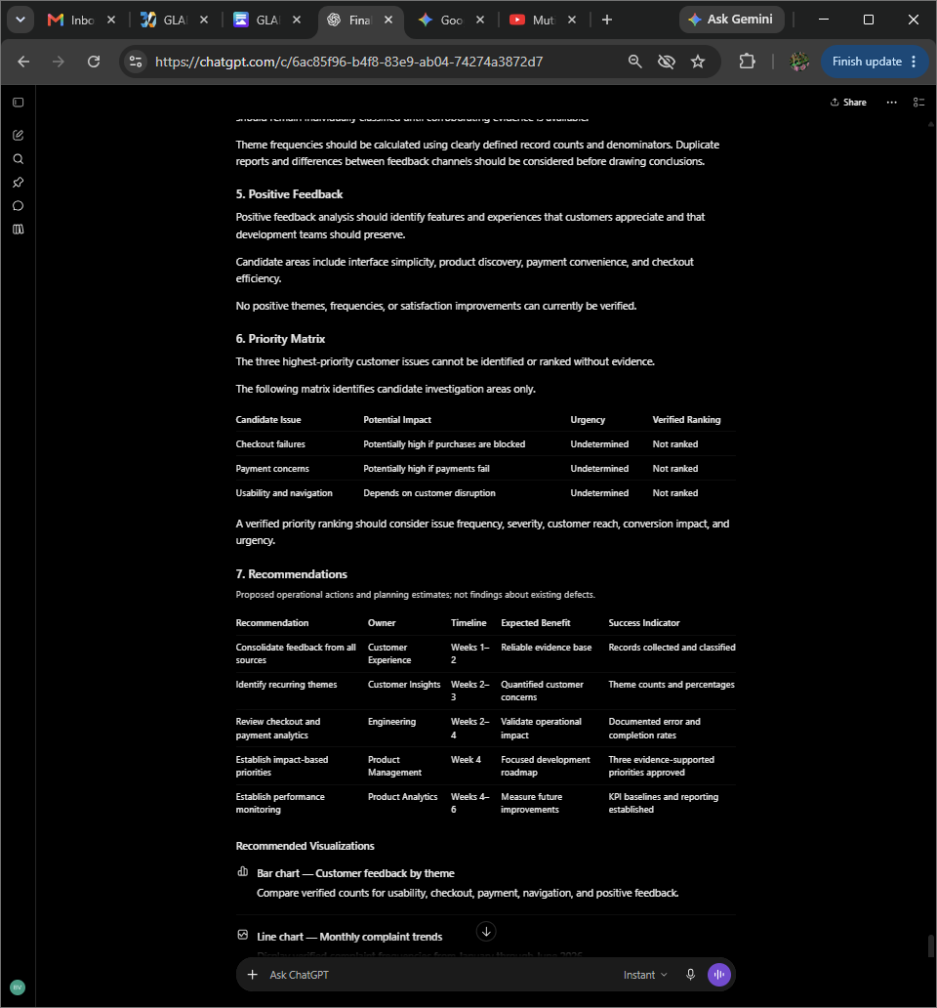
Original ChatGPT interaction captured during GLAB 928.1.

Task 4 — Screenshot 4 of 4 | task4-4.png
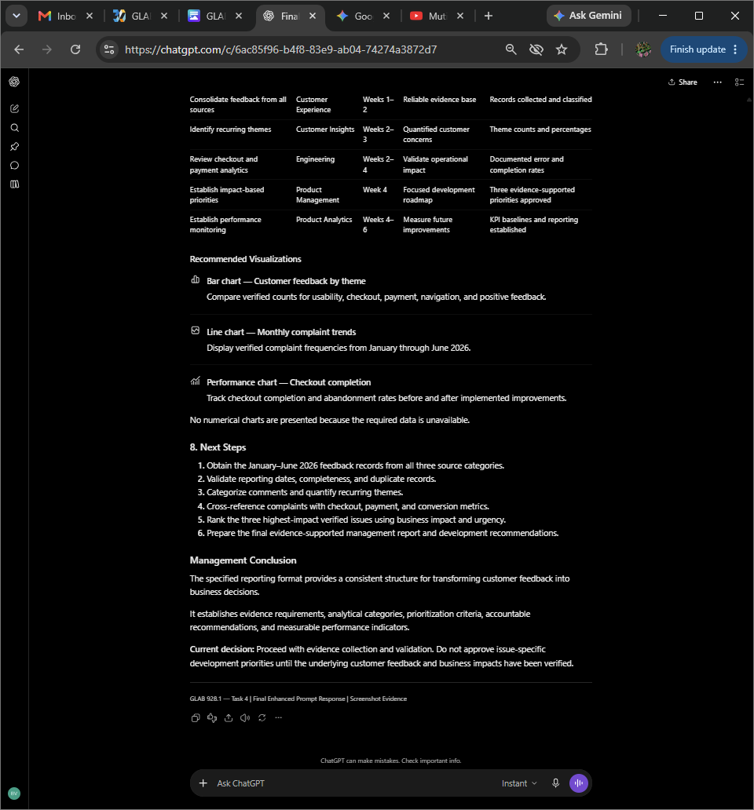
Original ChatGPT interaction captured during GLAB 928.1.

