Report
SBA 928 - Enhancing Market Research with AI Prompt Engineering
Bolivar Vega
October 2, 2026

Overview 2
Steps 3
Conclusion 4
Appendix 5

Overview
This assessment implemented an end-to-end AI prompt-engineering workflow for market research. Using the UCI Online Retail dataset as the source context, the project generated 30 deterministic market-research prompts across six categories, prepared a supervised fine-tuning dataset, completed a lightweight LoRA fine-tuning experiment on sshleifer/tiny-gpt2, compared the base and adapted model on six evaluation prompts, and performed a structured bias and fairness analysis. The implementation was intentionally small and CPU-compatible so the full workflow could be reproduced within the SBA time limit.
Key outcomes:
• 30 curated prompts covering consumer behavior, market trends, competitor analysis, pricing, customer segmentation, and regional analysis.
• 30 instruction-response records prepared for supervised fine-tuning.
• Successful LoRA training run using tiny-gpt2 with one epoch and eight CPU training steps.
• Six baseline-versus-fine-tuned model comparisons using identical deterministic decoding settings.
• Bias analysis covering demographic assumptions, regional representation, economic assumptions, product/category bias, historical-data bias, and cultural/context bias.
• Documented fairness strategies, limitations, and a reproducibility-oriented project structure.

Steps
- The following steps document the work completed for the assessment and provide screenshots as proof of completion.

1. Source dataset and generate diverse prompts
The project used the UCI Machine Learning Repository Online Retail dataset (dataset ID 352) as the market-research source. The prompt-generation script retrieved the dataset through ucimlrepo and generated a deterministic CSV containing 30 prompts. The prompts were distributed across six market-research categories and used multiple variation styles so the dataset covered different analytical and decision-support scenarios rather than repeating one prompt pattern.
Prompt categories:
• Consumer behavior
• Market trends
• Competitor analysis
• Pricing
• Customer segmentation
• Regional analysis
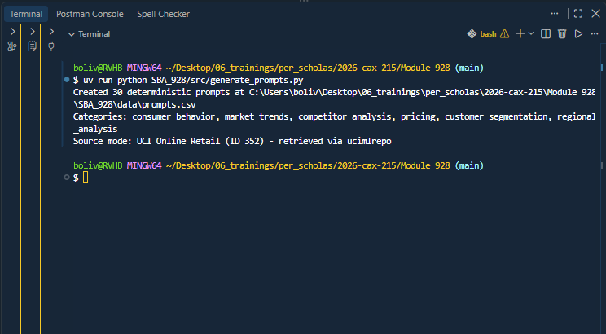
Figure 1. Prompt generation completed successfully with 30 deterministic prompts and UCI Online Retail retrieved as the source dataset.

2. Prepare the fine-tuning dataset and fine-tune a language model
The generated prompts were transformed into 30 compact instruction-response training records. Responses were designed to emphasize appropriate market-research methods, useful metrics, evidence requirements, and limitations rather than inventing unsupported business conclusions. The experiment then fine-tuned sshleifer/tiny-gpt2 with PEFT/LoRA. The run used a fixed seed, one epoch, batch size 4, maximum sequence length 128, and a learning rate of 0.0005. The adapter was saved under SBA_928/models/market-research-lora.
This was intentionally a small educational experiment. Only 64 parameters were trainable, so the objective was to demonstrate a real, reproducible fine-tuning workflow on CPU rather than to create a production-quality market-research model.
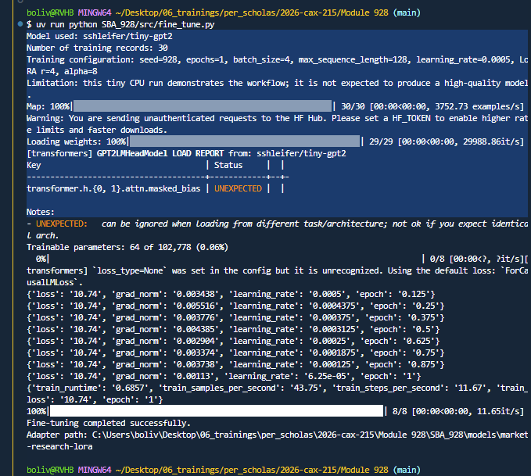
Figure 2. LoRA fine-tuning run showing model choice, 30 training records, configuration, trainable parameters, training progress, and successful completion.

3. Compare the original and fine-tuned models
The base model and fine-tuned adapter were evaluated on six prompts representing the same market-research categories. Both models used identical deterministic generation settings so that the comparison focused on observable differences in task alignment and market-research relevance.
The comparison did not show meaningful improvement in output quality. Both models frequently produced repetitive and weakly related continuations. This result was reported without modification because the tiny base model, very small dataset, and minimal training schedule substantially limit the amount of specialization that can be learned. The experiment nevertheless demonstrated the required workflow: baseline generation, fine-tuning, controlled re-evaluation, and qualitative interpretation of the results.
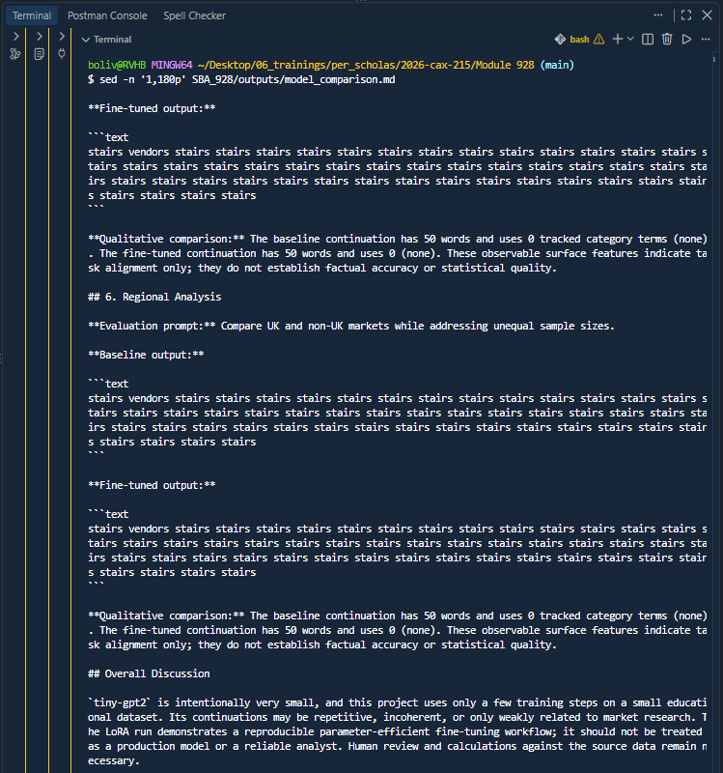
Figure 3. Example portion of the model-comparison report. The report transparently notes that the minimal tiny-gpt2 run did not produce meaningful observable improvement.

4. Assess bias and define fairness strategies
The prompt set and source dataset were reviewed for potential bias. Important limitations include the absence of direct demographic, income, attitude, or satisfaction variables; geographic concentration associated with one retailer; possible product/category bias; and the age of the 2010-2011 transaction data.
Mitigation and fairness strategies included:
• Do not infer protected traits or demographic characteristics that are not present in the data.
• Use stratified regional analysis and report sample sizes rather than ranking regions without context.
• Avoid stereotypes and describe observed transactions instead of imagined identities or motives.
• Evaluate whether the analytical sample represents the intended market by time period, region, customer coverage, and product mix.
• Report uncertainty, missingness, variability, and the distinction between correlation and causation.
• Require human review before using model suggestions for pricing, targeting, exclusion, or other consequential decisions.
• Maintain source transparency, including dataset citation, date range, retrieval status, cleaning rules, prompt version, and model version.
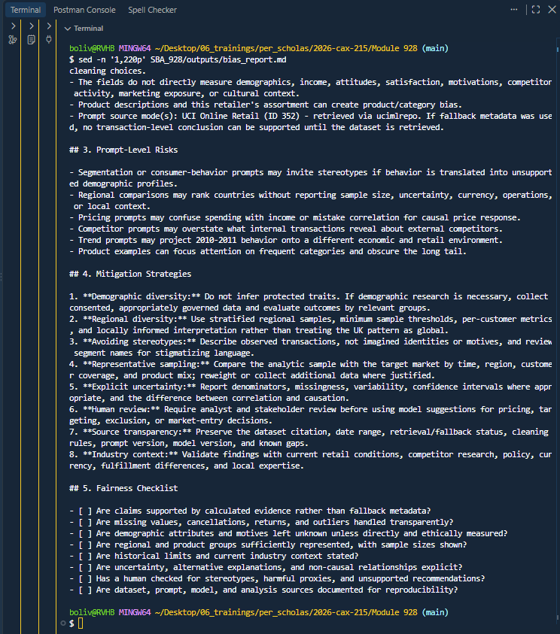
Figure 4. Bias assessment, mitigation strategies, and fairness checklist generated by the project.

5. Validate project organization and reproducibility
The project was organized as a small reproducible repository containing source code, generated datasets, analysis outputs, screenshots, and documentation. The trained LoRA model and local virtual environment were intentionally excluded from Git. The implementation was committed to the main branch after validation.
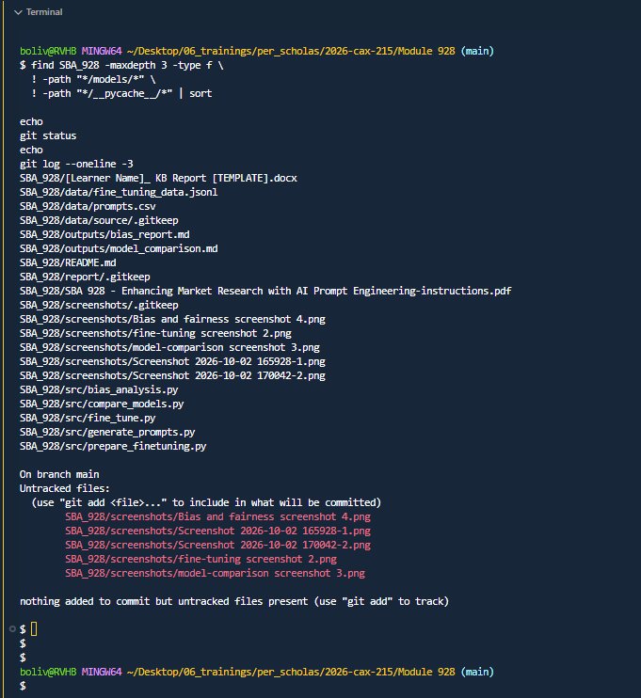
Figure 5. Final project structure, evidence files, Git state, and repository contents used to verify project completeness.

Conclusion
The SBA demonstrated how prompt engineering, lightweight model adaptation, controlled comparison, and bias analysis can be combined into a reproducible market-research workflow. The most important technical takeaway was that completing a fine-tuning process does not guarantee improved model behavior. Model capacity, dataset size, target-response quality, training duration, and evaluation design all influence the result. In this experiment, tiny-gpt2 successfully supported the mechanics of PEFT/LoRA fine-tuning, but its outputs remained low quality after the minimal training run. Reporting that limitation was preferable to overstating the result. The bias analysis also showed that market-research prompts must explicitly account for missing demographics, regional imbalance, historical context, stereotypes, uncertainty, and human oversight before AI-generated insights are used for business decisions.

Appendix

A. Project structure
• SBA_928/data/prompts.csv - 30 curated market-research prompts.
• SBA_928/data/fine_tuning_data.jsonl - 30 instruction-response fine-tuning records.
• SBA_928/src/generate_prompts.py - dataset retrieval and prompt generation.
• SBA_928/src/prepare_finetuning.py - preparation of training examples.
• SBA_928/src/fine_tune.py - PEFT/LoRA fine-tuning experiment.
• SBA_928/src/compare_models.py - base-versus-adapted evaluation.
• SBA_928/src/bias_analysis.py - bias assessment and fairness analysis.
• SBA_928/outputs/model_comparison.md - six-prompt qualitative comparison.
• SBA_928/outputs/bias_report.md - bias findings, mitigation strategies, and fairness checklist.
• SBA_928/README.md - setup, execution, outputs, dataset citation, and limitations.

B. Reproduction commands
uv sync
uv run python SBA_928/src/generate_prompts.py
uv run python SBA_928/src/prepare_finetuning.py
uv run python SBA_928/src/fine_tune.py
uv run python SBA_928/src/compare_models.py
uv run python SBA_928/src/bias_analysis.py

C. Dataset citation
Chen, D. (2015). Online Retail [Dataset]. UCI Machine Learning Repository. https://doi.org/10.24432/C5BW33
The dataset contains transactional records from a UK-based non-store online retailer and was used as the public data source for constructing market-research scenarios and prompts.

D. Experiment limitations
• The experiment used sshleifer/tiny-gpt2 to keep training feasible on CPU and within the assessment time limit.
• Only 30 training records and one training epoch were used.
• The model comparison is qualitative and does not establish statistical accuracy or business validity.
• The source data is historical and concentrated around one retailer, so findings should not be generalized to current markets without additional evidence.
• Human review and direct calculations from source data remain necessary for consequential market-research decisions.

