Report
SBA 927 - Business Text Analytics
Natural Language Processing Techniques
Learner Name: Bolivar Vega Leon
Date: September 23, 2026

Overview 2
Steps 3
Conclusion 4
Appendix 5

Overview
This assessment applied core Natural Language Processing (NLP) techniques to a 12-record text dataset. The completed workflow loaded and inspected the source data, cleaned and tokenized the text, applied stemming and lemmatization, performed Named Entity Recognition (NER) and Part-of-Speech (POS) tagging, analyzed sentiment with NLTK VADER, and compared those results with a pretrained Hugging Face RoBERTa sentiment model.
The project was developed in Visual Studio Code as a Python 3.11 uv project. Each requirement was implemented as a separate commented Python script for educational clarity, outputs were written to the outputs/ folder, screenshots were captured as evidence, and milestones were versioned with Git and pushed to GitHub.

Technology and Project Configuration
• IDE: Visual Studio Code with the Codex extension used as a guided development assistant.
• Python environment: Python 3.11.15 managed with uv.
• Core libraries: NLTK 3.10.3, NumPy, Transformers 5.17.0, and PyTorch 2.14.0 (CPU).
• Dataset: data/SBA927.txt containing 12 text records.
• Version control: Git with the repository pushed to GitHub after each major milestone.
• Validation: all seven implementation scripts passed a final end-to-end execution check.

Assessment Deliverables Completed
Completed requirements: dataset loading; tokenization and preprocessing; stemming and lemmatization; Named Entity Recognition; Part-of-Speech tagging; sentiment prompts with VADER analysis; and a pretrained Hugging Face sentiment-model experiment. All implementation scripts passed final validation.

Steps

1. Project Setup, uv Environment, and Dataset Inspection
The SBA project was organized as a dedicated uv project inside the existing Module 927 Git repository. The project uses pyproject.toml and uv.lock for dependency management, while .venv is excluded from version control. The dataset was placed in data/SBA927.txt and loaded with pathlib so the code does not depend on a hard-coded Windows path.
The initial inspection confirmed Python 3.11.15 and 12 non-empty text records. The first records include Detective Spooner, I, Robot, and Sonny, providing varied language for entity, grammar, and sentiment analysis.
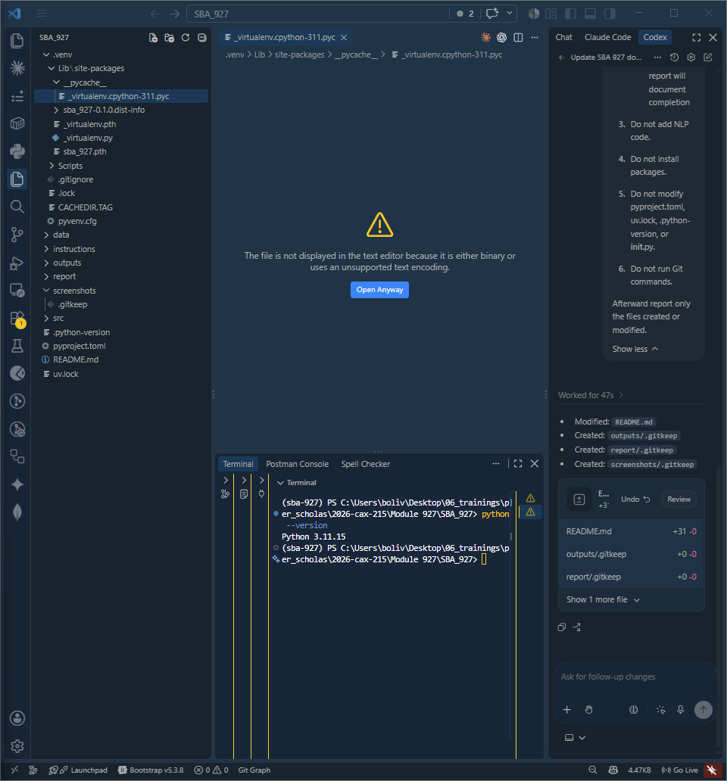
Figure 1. Project scaffold, VS Code workspace, uv configuration, and Python environment.
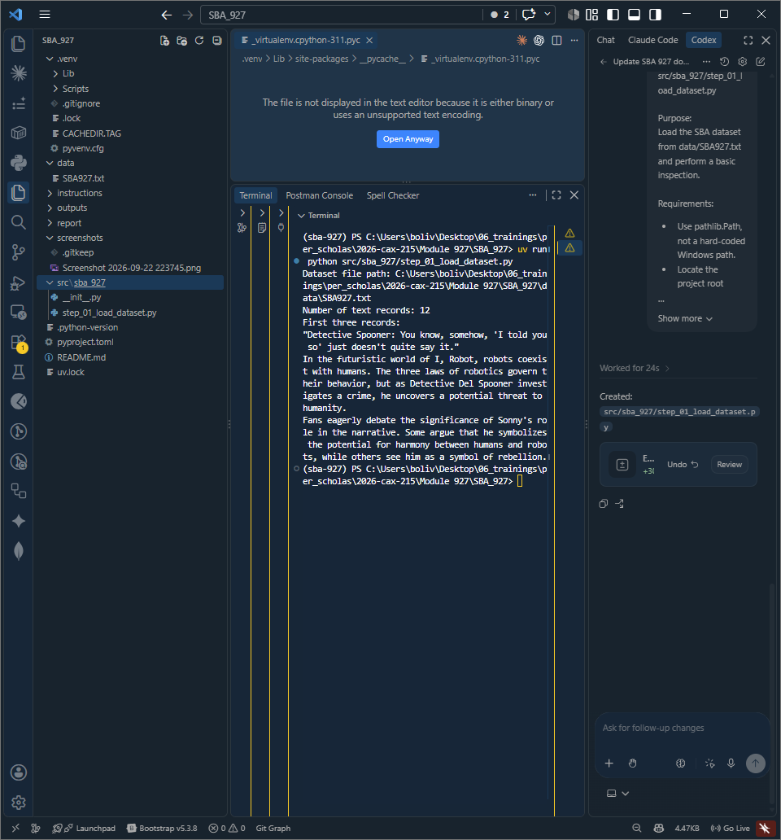
Figure 2. Dataset loading and initial inspection confirming 12 text records.

2. Tokenization and Text Preprocessing
NLTK word_tokenize() was used to split each record into tokens. The preprocessing stage normalized tokens to lowercase, removed punctuation and non-alphabetic noise, and removed common English stop words. All 12 records were processed and saved to outputs/preprocessed_text.txt.
Original text excerpt | Processed representation
In the futuristic world of I, Robot, robots coexist with humans... | futuristic world robot robots coexist humans three laws robotics govern behavior detective del spooner investigates crime uncovers potential threat humanity
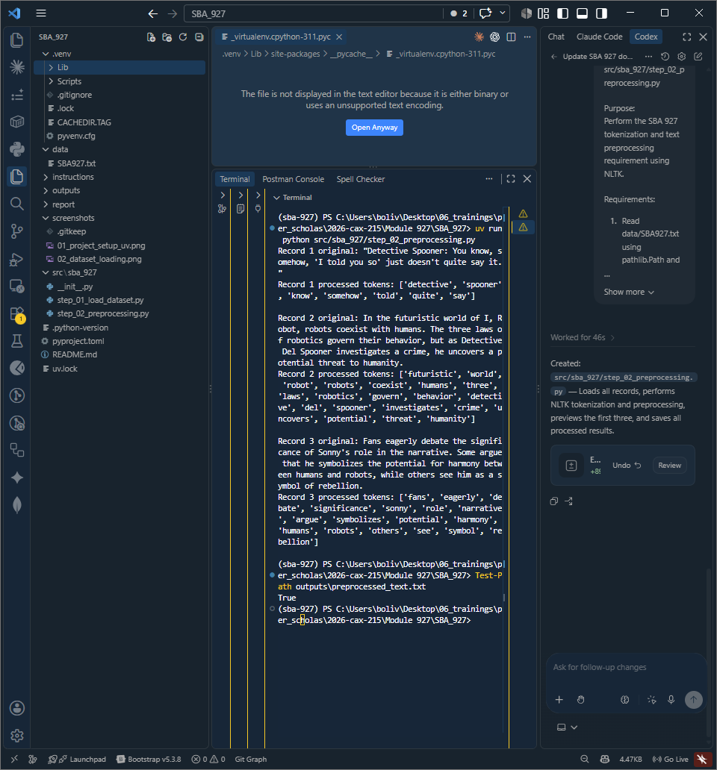
Figure 3. NLTK tokenization and preprocessing output for the first three records.

3. Stemming and Lemmatization
PorterStemmer reduced tokens to algorithmic stems, while WordNetLemmatizer attempted to return dictionary-style base forms. These methods both normalize vocabulary but behave differently: stemming is more aggressive and may create non-words, while lemmatization is usually more readable but can depend on correct grammatical context.
Processed | Stemmed | Lemmatized
detective | detect | detective
quite | quit | quite
futuristic | futurist | futuristic
humans | human | human
robots | robot | robot
A notable limitation appeared in Record 5, where the default WordNet lemmatizer converted "serves" to "serf" because no POS information was supplied to the lemmatizer. This demonstrates that lemmatization quality can improve when grammatical context is incorporated.
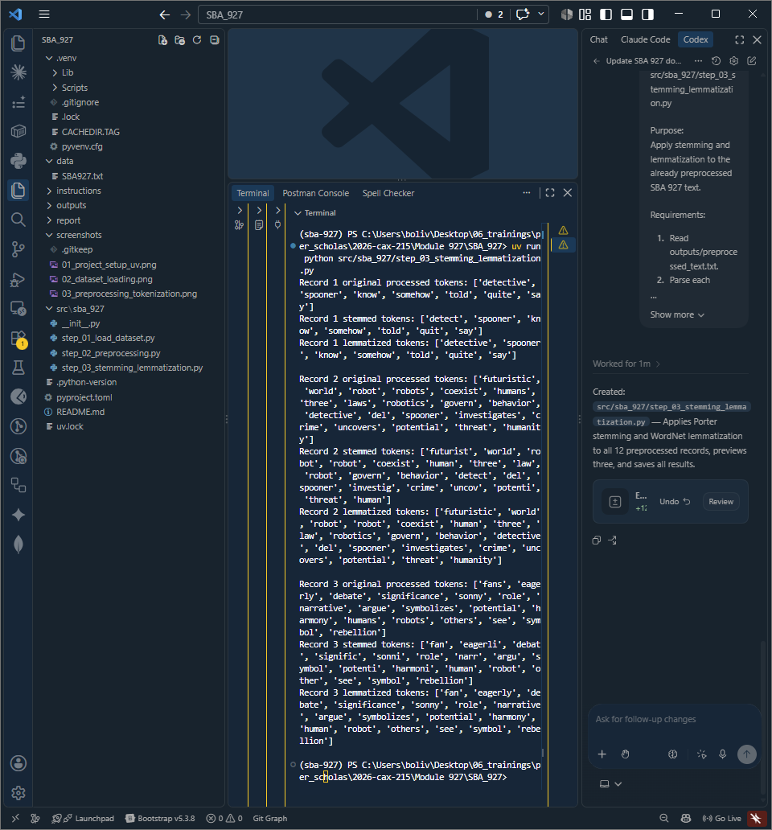
Figure 4. Porter stemming and WordNet lemmatization results.

4. Named Entity Recognition (NER)
NER was performed on the original text rather than the lowercased preprocessed tokens because capitalization and sentence context help identify names and organizations. The NLTK workflow tokenized sentences and words, assigned POS tags, and then used ne_chunk() to identify named entities.
Record | Detected entity | Category
2 | Robot | PERSON
2 | Detective Del Spooner | PERSON
3 | Sonny | PERSON
5 | Virtual Interactive Kinetic | ORGANIZATION
8 | Susan Calvin | PERSON
11 | Sonny | GPE
The results demonstrate both usefulness and limitations. NLTK correctly recognized several character names, but it also classified "Robot" as PERSON in multiple records, "Program" as PERSON in Record 7, and "Sonny" as GPE in Record 11. These errors show why entity extraction should be reviewed before it is used for business decisions.
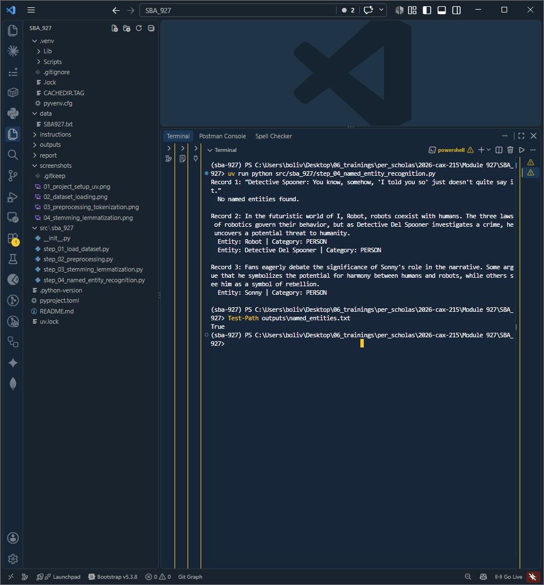
Figure 5. Named Entity Recognition results from the original text.

5. Part-of-Speech (POS) Tagging
POS tagging labeled each token according to its grammatical role. Examples from the dataset include Sonny/NNP (proper noun), eagerly/RB (adverb), symbolizes/VBZ (third-person singular verb), humans/NNS (plural noun), and futuristic/JJ (adjective). The complete results were saved to outputs/pos_tags.txt.
Tag | Meaning | Dataset example
NNP | Proper noun | Spooner, Sonny, Robot
NN/NNS | Noun / plural noun | world, humans
VB/VBP/VBZ | Verb forms | say, coexist, symbolizes
JJ | Adjective | futuristic, potential
RB | Adverb | somehow, eagerly
Some context-sensitive errors were also observed: "Detective" was tagged JJ in Record 1, "argue" was tagged NN in Record 3, and Sonny was tagged NN rather than NNP in Record 10. POS tagging is therefore useful for structure and feature extraction, but automated tags are not always perfect.
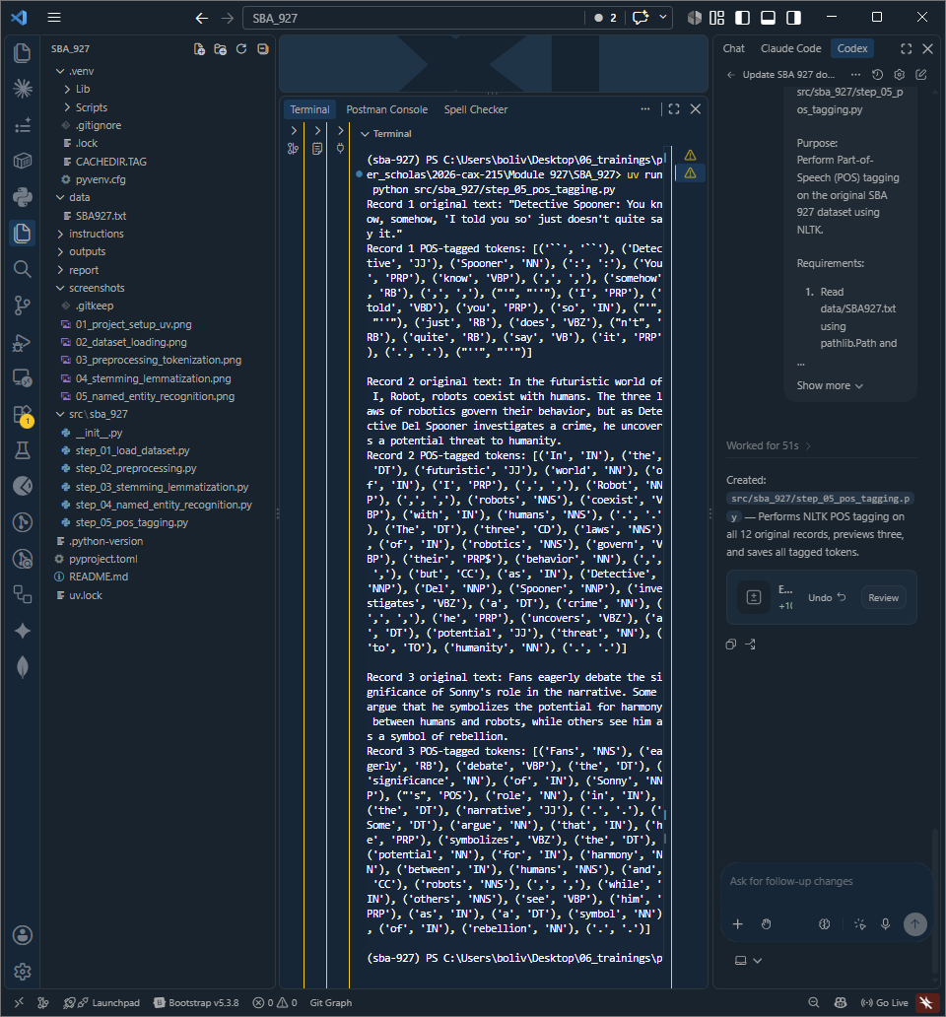
Figure 6. Part-of-Speech tagging output and common grammatical labels.

6. Sentiment Analysis with NLTK VADER
The project generated a consistent sentiment-analysis prompt for every record and used NLTK VADER as a reproducible baseline. VADER returns positive, neutral, negative, and compound scores. The compound score was mapped to Positive at >= 0.05, Negative at <= -0.05, and Neutral otherwise.
Analyze the sentiment of the following text.
Classify it as Positive, Negative, or Neutral.
Briefly explain the reason for the classification.
Text: "<record>"
Record | Compound | VADER class | Observation
1 | 0.0000 | Neutral | No strong sentiment words detected
2 | -0.8847 | Negative | Threat/crime language dominated
3 | 0.5423 | Positive | Harmony/potential language increased positivity
8 | -0.2960 | Negative | Malfunction/violation language
10 | 0.6162 | Positive | Negated phrase illustrates a lexical limitation
Across all 12 records, VADER classified 7 as Positive, 2 as Negative, and 3 as Neutral. The Record 10 result ("I did not murder him!") is a useful caution: the positive score does not necessarily match the semantic meaning of the statement, illustrating the limits of lexicon-based sentiment analysis.
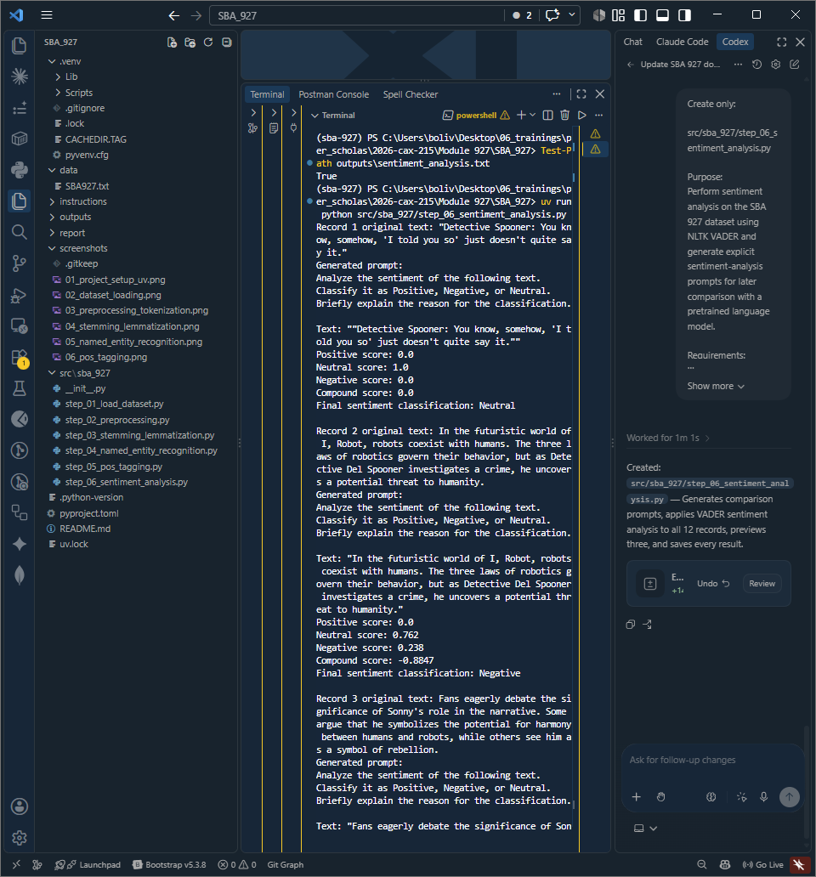
Figure 7. NLTK VADER sentiment scores and generated analysis prompt.

7. Pretrained Language Model Experiment
The final experiment used the Hugging Face pretrained model cardiffnlp/twitter-roberta-base-sentiment-latest through the Transformers pipeline. Unlike VADER, this model uses learned language patterns from pretraining/fine-tuning rather than a fixed sentiment lexicon. The model returned a sentiment label and confidence score for each of the 12 records.
Record | VADER | RoBERTa | RoBERTa confidence
1 | Neutral | Neutral | 0.6039
2 | Negative | Neutral | 0.8780
3 | Positive | Neutral | 0.8411
4 | Neutral | Positive | 0.5408
6 | Positive | Positive | 0.5833
10 | Positive | Negative | 0.4971
12 | Positive | Positive | 0.5837
The pretrained model classified 8 records as Neutral, 3 as Positive, and 1 as Negative. VADER and RoBERTa agreed on 4 of the 12 records and differed on 8. The disagreement is valuable because it shows that model selection materially affects downstream interpretation. Confidence scores also should not be treated as proof that a prediction is correct.
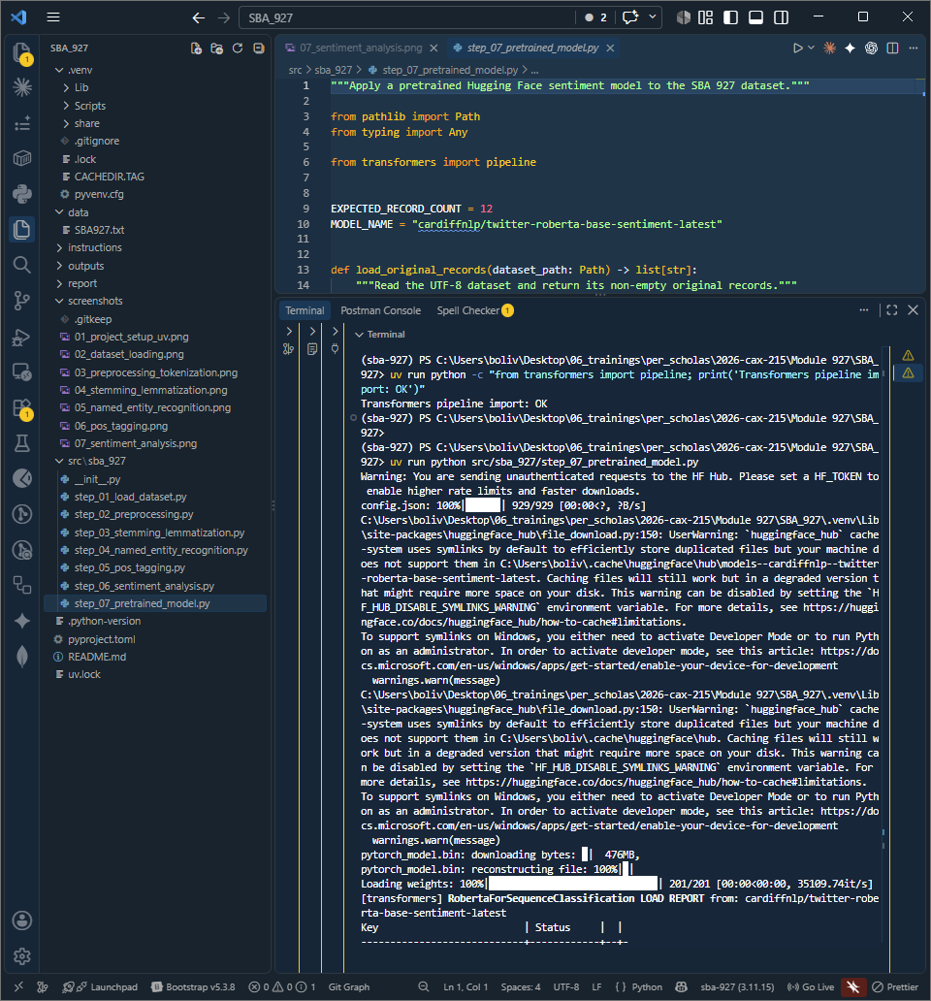
Figure 8. Hugging Face pretrained sentiment model predictions and confidence scores.

8. Final Validation and Version Control
A final end-to-end validation executed every script through uv. All seven scripts completed successfully. The implementation was committed in small milestones so each requirement can be traced independently in Git history.
PASS: step_01_load_dataset.py
PASS: step_02_preprocessing.py
PASS: step_03_stemming_lemmatization.py
PASS: step_04_named_entity_recognition.py
PASS: step_05_pos_tagging.py
PASS: step_06_sentiment_analysis.py
PASS: step_07_pretrained_model.py
===== VALIDATION COMPLETE =====
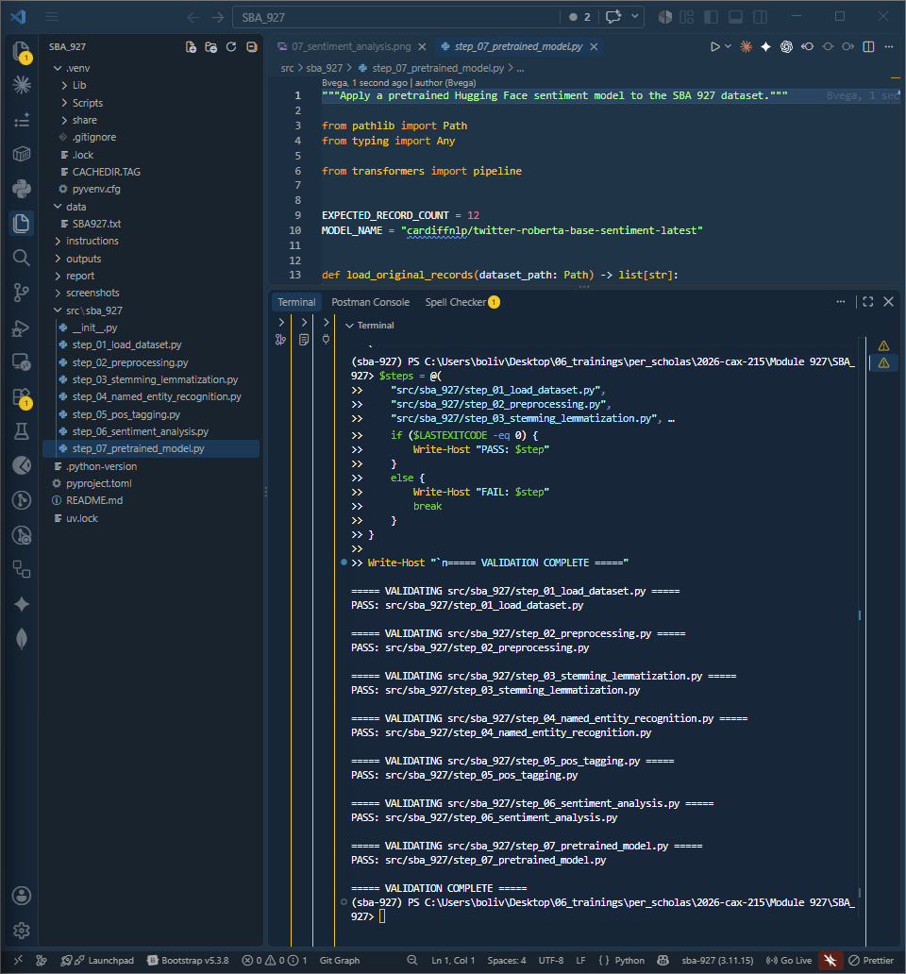
Figure 9. Final end-to-end validation with all seven scripts passing.

Differences and Advantages of Each Technique
Technique | Primary purpose | Main advantage | Important limitation
Tokenization / preprocessing | Convert raw text into cleaner analyzable units | Reduces noise and standardizes input for later NLP tasks | Can remove words or punctuation that matter for some contexts
Stemming | Reduce words to approximate stems | Fast and useful for grouping related forms | Often creates non-dictionary stems such as eagerli or investig
Lemmatization | Reduce words toward dictionary base forms | Usually more readable than stemming | Quality depends on linguistic/POS context; default settings can produce mistakes
NER | Identify people, organizations, locations, etc. | Turns unstructured text into structured entity information | Entity labels can be wrong or incomplete
POS tagging | Identify grammatical roles | Supports syntactic analysis and downstream NLP features | Ambiguous context can cause incorrect tags
VADER sentiment | Rule/lexicon-based sentiment scoring | Fast, transparent, lightweight, reproducible | Can struggle with context, negation, and domain-specific language
Pretrained RoBERTa sentiment | Contextual sentiment classification | Captures richer learned language patterns | Larger, slower, model-dependent, and still capable of errors
In a business analytics workflow, these techniques are complementary rather than interchangeable. Preprocessing prepares the text; stemming or lemmatization reduce vocabulary variation; NER and POS tagging extract structure; and sentiment models estimate attitude or tone. The most appropriate combination depends on the business question and the cost of incorrect classifications.

Conclusion
This SBA demonstrated a complete NLP workflow using Python and modern project-management practices. The dataset was transformed from raw text into structured outputs through tokenization, normalization, stemming, lemmatization, entity extraction, grammatical tagging, and sentiment classification. Each stage produced saved output that can be independently inspected and reproduced.
The strongest practical takeaway is that NLP results require evaluation rather than blind acceptance. NER and POS tagging produced several incorrect labels, the default WordNet lemmatizer produced an unexpected "serf" result for "serves," and VADER disagreed with the pretrained RoBERTa model on 8 of 12 sentiment records. These differences are not simply errors to hide; they illustrate why business text analytics should combine automated processing with validation, context, and model selection appropriate to the use case.
Using uv, Git, GitHub, separate commented scripts, saved output files, screenshots, and end-to-end validation made the project reproducible and easier to audit. All seven implementation steps passed the final validation run.

Appendix

A. Project Artifacts
Artifact | Purpose
data/SBA927.txt | 12-record source dataset
outputs/preprocessed_text.txt | Cleaned/tokenized text
outputs/stemming_lemmatization.txt | Stemmed and lemmatized results
outputs/named_entities.txt | NER results
outputs/pos_tags.txt | POS-tagging results
outputs/sentiment_analysis.txt | Generated prompts and VADER sentiment results
outputs/pretrained_model_results.txt | RoBERTa sentiment predictions and confidence scores
pyproject.toml / uv.lock | Reproducible uv dependency definition and lockfile

B. Screenshot Evidence Inventory
The project screenshots are stored under SBA_927/screenshots/ and versioned in the GitHub repository. The following evidence files were captured during execution:
• 01_project_setup_uv.png - project scaffold and uv environment
• 02_dataset_loading.png - dataset loading and 12-record verification
• 03_preprocessing_tokenization.png - tokenization/preprocessing output
• 04_stemming_lemmatization.png - stemming/lemmatization output
• 05_named_entity_recognition.png - NER output
• 06_pos_tagging.png - POS-tagging output
• 07_sentiment_analysis.png - VADER prompt and sentiment output
• 08_pretrained_model.png - Hugging Face pretrained-model output
• 09_final_validation.png - complete PASS validation run

C. Git/GitHub Milestones
Repository: https://github.com/Bvega/per-scholas-module-927
Commit | Milestone
cdceea2 | Initialize SBA 927 uv project scaffold
551813d | Add NLTK dependency with uv
1736de1 | Load and inspect SBA 927 dataset
9c0c130 | Add text preprocessing and tokenization
d9b69ba | Add stemming and lemmatization
dd65800 | Add named entity recognition
7e58988 | Add part-of-speech tagging
9e50552 | Add sentiment analysis with VADER
c437c0a | Add pretrained sentiment model experiment
fb3336b | Add final validation screenshot

D. Validation Result
All seven scripts passed the final sequential validation with uv, confirming that the project executes successfully from dataset loading through the pretrained model experiment.

