HR Attrition Analytics – Looker Studio Project Report
Dataset: IBM HR Analytics (HR_Analytics_Final_Dataset.xlsx) | 1,470 employees | 35 fields | 2-page dashboard (Basic + Advanced)

1. Executive Summary
- Overall attrition is 16.12% (237 of 1,470 employees left; 1,233 stayed).
- Highest-risk groups: Sales Representatives (39.8%), employees working OverTime (30.5%), ages 18–25 (35.8%), income under 3K (28.6%), tenure 0–2 years (29.8%), Single employees (25.5%), Job Level 1 (26.3%).
- Lowest-risk groups: Research Directors (2.5%), Managers (4.9%), Job Level 4 (4.7%), income 12K+ (5.6%), Stock Option Level 1–2 (9.4% / 7.6%).
- Leavers earn about 30% less on average (4,787 vs 6,833 monthly) and are about 4 years younger (33.6 vs 37.6).

2. Dashboard Screenshots

Page 1 – Basic Dashboard
KPI scorecards (Total Employees, Employees Left, Attrition Rate, Avg Age, Avg Monthly Income) plus breakdowns by department, gender, marital status, job role, overtime, business travel and education field.
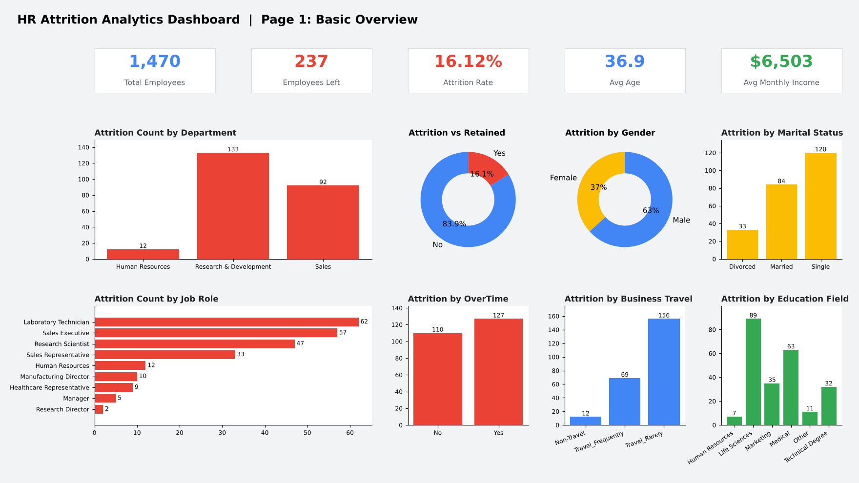

Page 2 – Advanced Dashboard (Calculated Fields)
Attrition-rate charts built on calculated fields: age group, income band, tenure band, distance band, plus satisfaction, work-life balance, job level and stock option. Dashed line = overall 16.12%.
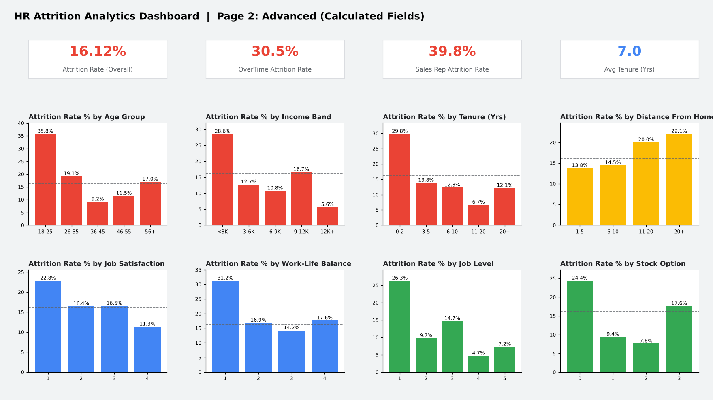

3. Page 1 Results (Basic)

KPI Scorecards
Metric | Value
Total Employees | 1,470
Employees Left (Attrition = Yes) | 237
Employees Retained | 1,233
Attrition Rate | 16.12%
Average Age | 36.9
Average Monthly Income | 6,503
Average Tenure (Years at Company) | 7.0

Attrition by Department
Department | Employees | Left | Attrition %
Human Resources | 63 | 12 | 19.0%
Research & Development | 961 | 133 | 13.8%
Sales | 446 | 92 | 20.6%
Sales (20.6%) and HR (19.0%) lose a higher share of staff than R&D (13.8%), although R&D has the highest headcount of leavers (133).

Attrition by Gender
Gender | Employees | Left | Attrition %
Female | 588 | 87 | 14.8%
Male | 882 | 150 | 17.0%

Attrition by Job Role
Job Role | Employees | Left | Attrition %
Healthcare Representative | 131 | 9 | 6.9%
Human Resources | 52 | 12 | 23.1%
Laboratory Technician | 259 | 62 | 23.9%
Manager | 102 | 5 | 4.9%
Manufacturing Director | 145 | 10 | 6.9%
Research Director | 80 | 2 | 2.5%
Research Scientist | 292 | 47 | 16.1%
Sales Executive | 326 | 57 | 17.5%
Sales Representative | 83 | 33 | 39.8%

Attrition by Marital Status
Marital Status | Employees | Left | Attrition %
Divorced | 327 | 33 | 10.1%
Married | 673 | 84 | 12.5%
Single | 470 | 120 | 25.5%

Attrition by OverTime
OverTime | Employees | Left | Attrition %
No | 1,054 | 110 | 10.4%
Yes | 416 | 127 | 30.5%
Overtime workers leave at three times the rate of others – the strongest single driver in the data.

Attrition by Business Travel
Business Travel | Employees | Left | Attrition %
Non-Travel | 150 | 12 | 8.0%
Travel_Frequently | 277 | 69 | 24.9%
Travel_Rarely | 1,043 | 156 | 15.0%

Attrition by Education Field
Education Field | Employees | Left | Attrition %
Human Resources | 27 | 7 | 25.9%
Life Sciences | 606 | 89 | 14.7%
Marketing | 159 | 35 | 22.0%
Medical | 464 | 63 | 13.6%
Other | 82 | 11 | 13.4%
Technical Degree | 132 | 32 | 24.2%

4. Page 2 Results (Advanced)

Attrition by Age Group
Age Group | Employees | Left | Attrition %
18-25 | 123 | 44 | 35.8%
26-35 | 606 | 116 | 19.1%
36-45 | 468 | 43 | 9.2%
46-55 | 226 | 26 | 11.5%
56+ | 47 | 8 | 17.0%

Attrition by Income Band (Monthly)
Income Band | Employees | Left | Attrition %
<3K | 395 | 113 | 28.6%
3-6K | 519 | 66 | 12.7%
6-9K | 223 | 24 | 10.8%
9-12K | 138 | 23 | 16.7%
12K+ | 195 | 11 | 5.6%

Attrition by Tenure Band (Years at Company)
Tenure Band | Employees | Left | Attrition %
0-2 | 342 | 102 | 29.8%
3-5 | 434 | 60 | 13.8%
6-10 | 448 | 55 | 12.3%
11-20 | 180 | 12 | 6.7%
20+ | 66 | 8 | 12.1%

Attrition by Distance From Home
Distance Band | Employees | Left | Attrition %
1-5 | 632 | 87 | 13.8%
6-10 | 394 | 57 | 14.5%
11-20 | 240 | 48 | 20.0%
20+ | 204 | 45 | 22.1%

Attrition by Job Satisfaction (1 = Low, 4 = High)
Job Satisfaction | Employees | Left | Attrition %
1 | 289 | 66 | 22.8%
2 | 280 | 46 | 16.4%
3 | 442 | 73 | 16.5%
4 | 459 | 52 | 11.3%

Attrition by Work-Life Balance (1 = Bad, 4 = Best)
Work-Life Balance | Employees | Left | Attrition %
1 | 80 | 25 | 31.2%
2 | 344 | 58 | 16.9%
3 | 893 | 127 | 14.2%
4 | 153 | 27 | 17.6%

Attrition by Job Level
Job Level | Employees | Left | Attrition %
1 | 543 | 143 | 26.3%
2 | 534 | 52 | 9.7%
3 | 218 | 32 | 14.7%
4 | 106 | 5 | 4.7%
5 | 69 | 5 | 7.2%

Attrition by Stock Option Level
Stock Option Level | Employees | Left | Attrition %
0 | 631 | 154 | 24.4%
1 | 596 | 56 | 9.4%
2 | 158 | 12 | 7.6%
3 | 85 | 15 | 17.6%

5. Looker Studio Calculated Fields
Add these under Resource > Manage added data sources > Add a field:
Field | Formula
Attrition Flag | CASE WHEN Attrition = "Yes" THEN 1 ELSE 0 END
Attrition Rate | SUM(Attrition Flag) / COUNT(EmployeeNumber)
Age Group | CASE WHEN Age <= 25 THEN "18-25" WHEN Age <= 35 THEN "26-35" WHEN Age <= 45 THEN "36-45" WHEN Age <= 55 THEN "46-55" ELSE "56+" END
Income Band | CASE WHEN MonthlyIncome < 3000 THEN "<3K" WHEN MonthlyIncome < 6000 THEN "3-6K" WHEN MonthlyIncome < 9000 THEN "6-9K" WHEN MonthlyIncome < 12000 THEN "9-12K" ELSE "12K+" END
Tenure Band | CASE WHEN YearsAtCompany <= 2 THEN "0-2" WHEN YearsAtCompany <= 5 THEN "3-5" WHEN YearsAtCompany <= 10 THEN "6-10" WHEN YearsAtCompany <= 20 THEN "11-20" ELSE "20+" END
Distance Band | CASE WHEN DistanceFromHome <= 5 THEN "1-5" WHEN DistanceFromHome <= 10 THEN "6-10" WHEN DistanceFromHome <= 20 THEN "11-20" ELSE "20+" END

6. Recommendations
- Review overtime policy and workload in Sales and Lab Technician roles.
- Strengthen onboarding and mentoring for the first two years of tenure.
- Review pay for under-3K bands and Job Level 1; extend stock options to more employees.
- Support early-career (18–25) and frequent-travel employees with flexibility.
- Track work-life balance and job satisfaction scores; both show clear links with exits.

