Appendix 1
MongoDB captured threat logs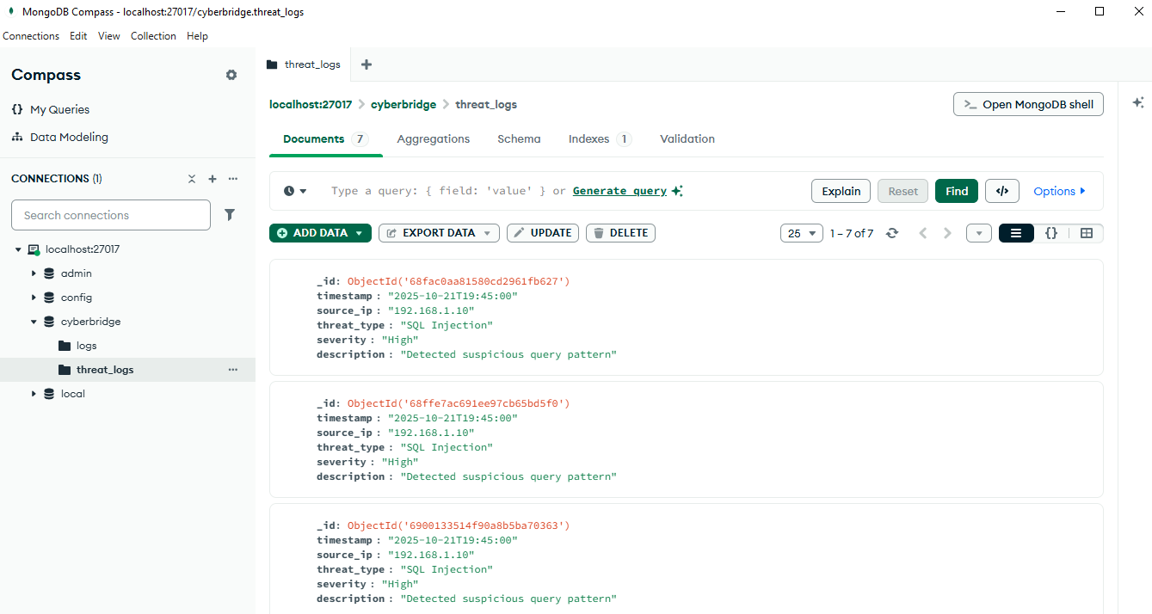

Appendix 2
Populated Threat detection Dashboard
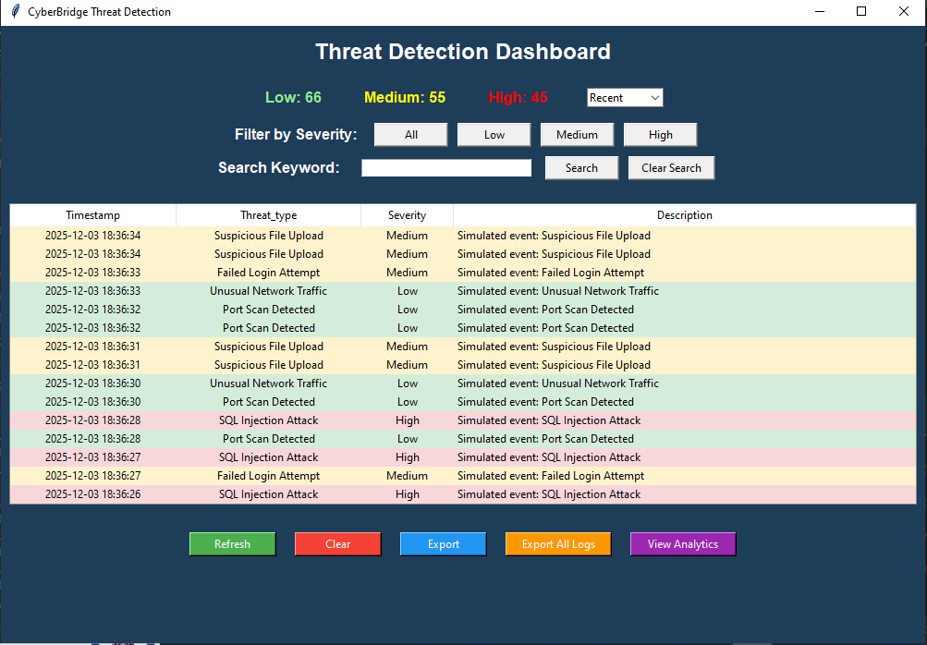

Appendix 3
Threat Analytics
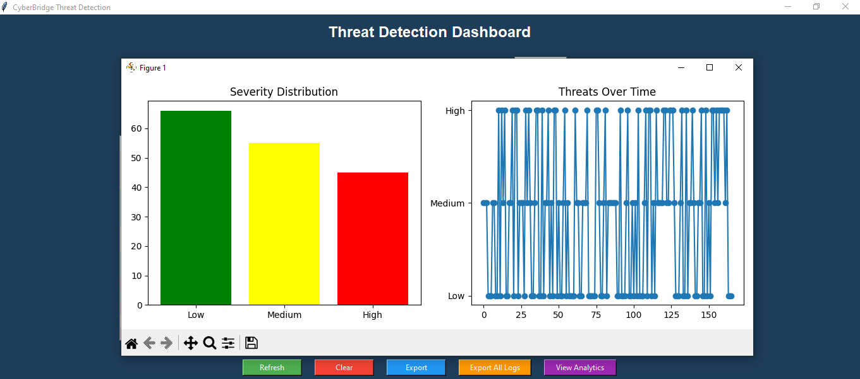

Appendix 4
Exported Threat logs
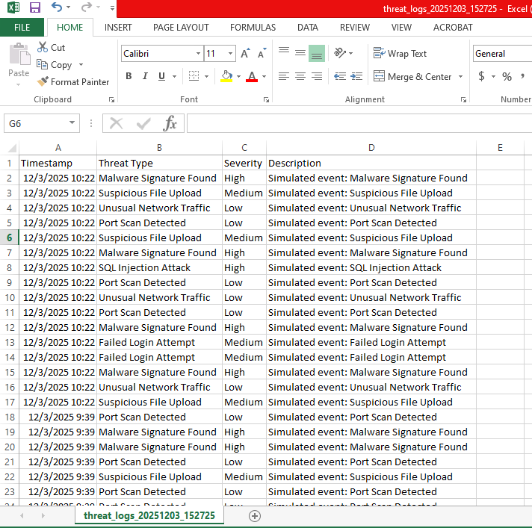

Apendix 5
otx_connector.py
Shows how CyberBridge connects to AlienVault OTX (an external server) to fetch confirmed threats, and demonstrates API integration and data ingestion.
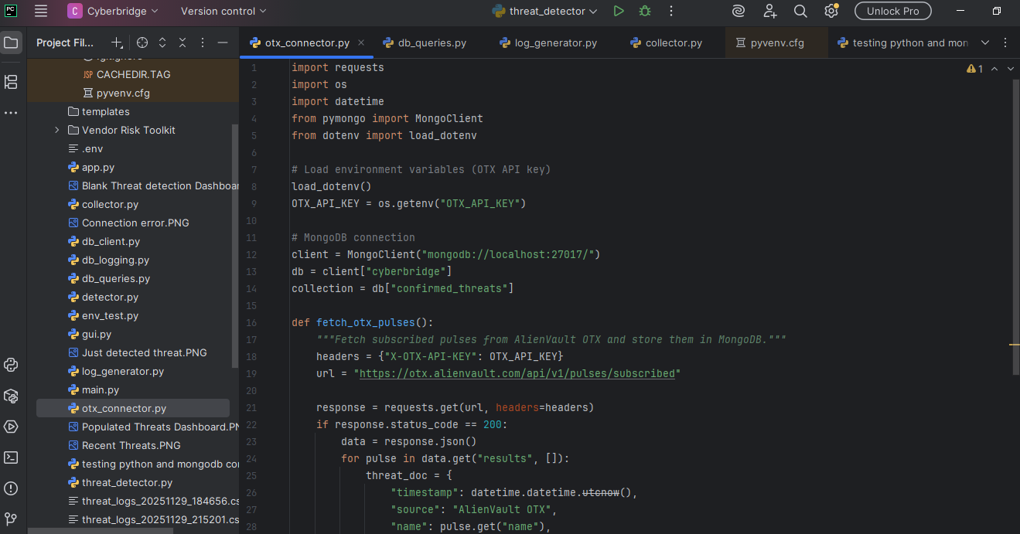

Appendix 6
db_queries.py
Handles MongoDB queries to determine whether an indicator (IP, domain, hash) exists in the confirmed threats collection, and highlights the database’s role in storing and validating logs.
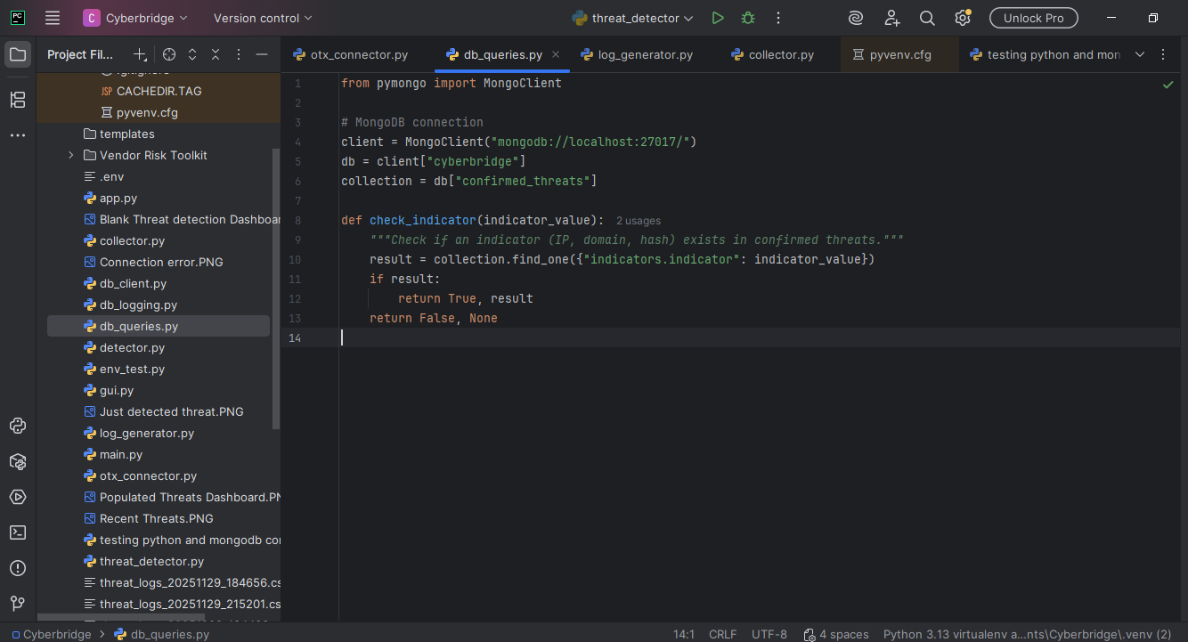
Appendix 7
detector.py
Implements CyberBridge’s detection logic, validating suspicious events against MongoDB, and shows how false positives are filtered out by cross-checking with confirmed threats.
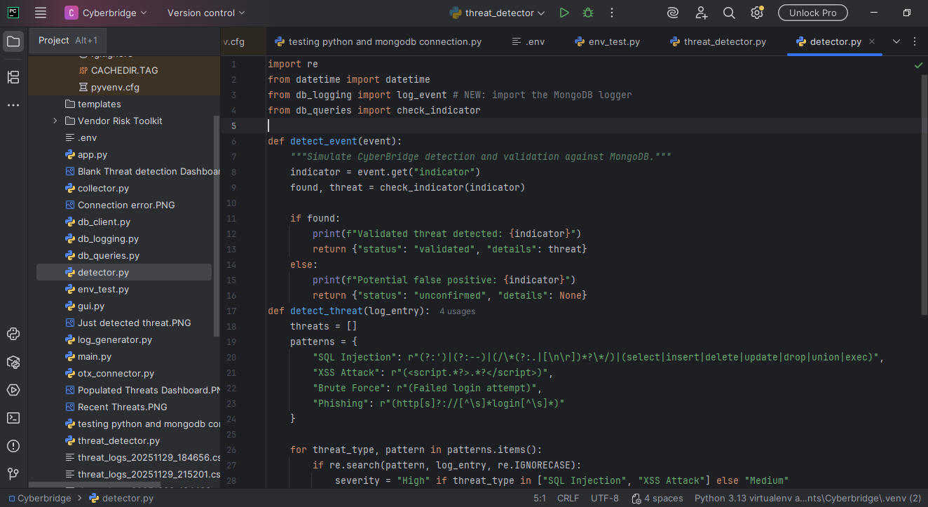

Appendix 8

app.py
Shows system orchestration and pulls together the connectors (otx_connector.py), database queries (db_queries.py), and detection logic (detector.py).
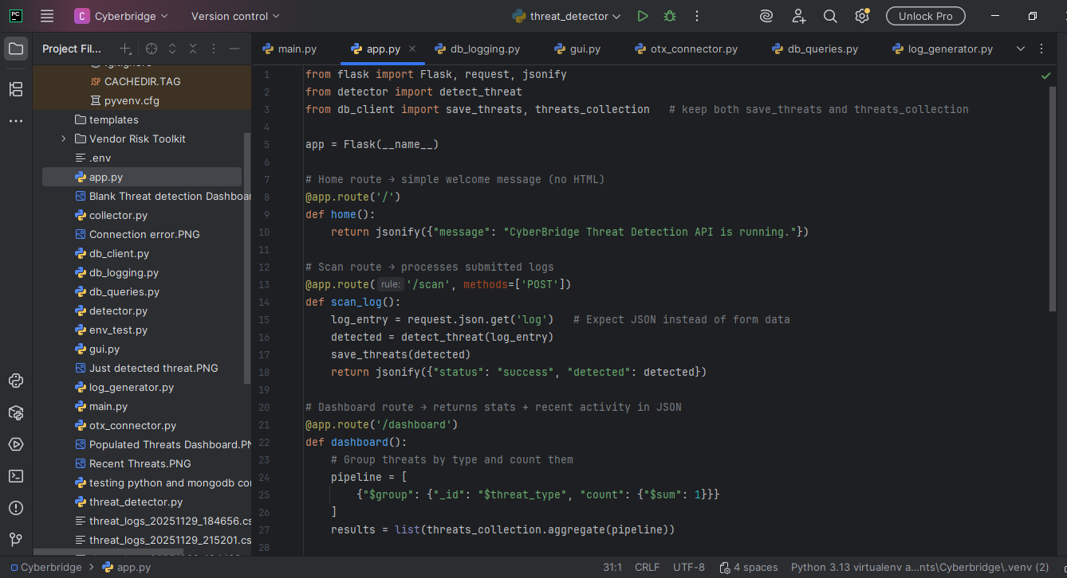
Appendix 9
gui.py
This code provides a simple interface that displays alerts and cross-checks them against confirmed threats stored in MongoDB, allowing users to quickly see whether an event is validated or a false positive.
