CSC 4630 · GROUP 20
Database Design
Conceptual, logical, ERD, schema, normalisation, security

CSC 4630 – Advanced Software Engineering
Group 20
Lecturer: [Lecturer Name]
University: [University Name]
September 2026
Unified Process (UP) — Iterative and Incremental
Analysis and design artefact. No application source code is included. Implementation starts only after the instruction START IMPLEMENTATION.

Table of Contents
Right-click and choose Update Field in Microsoft Word to refresh the table of contents.
In Word: References → Update Table, or right-click the field above.

A. Conceptual Data Model
The conceptual model is the domain model. Persistent concepts: User, Medicine, StockBatch, Sale, SalesLineItem, Payment, Customer, Prescription, Supplier, StockReceipt, StockAdjustment, AuditEntry.
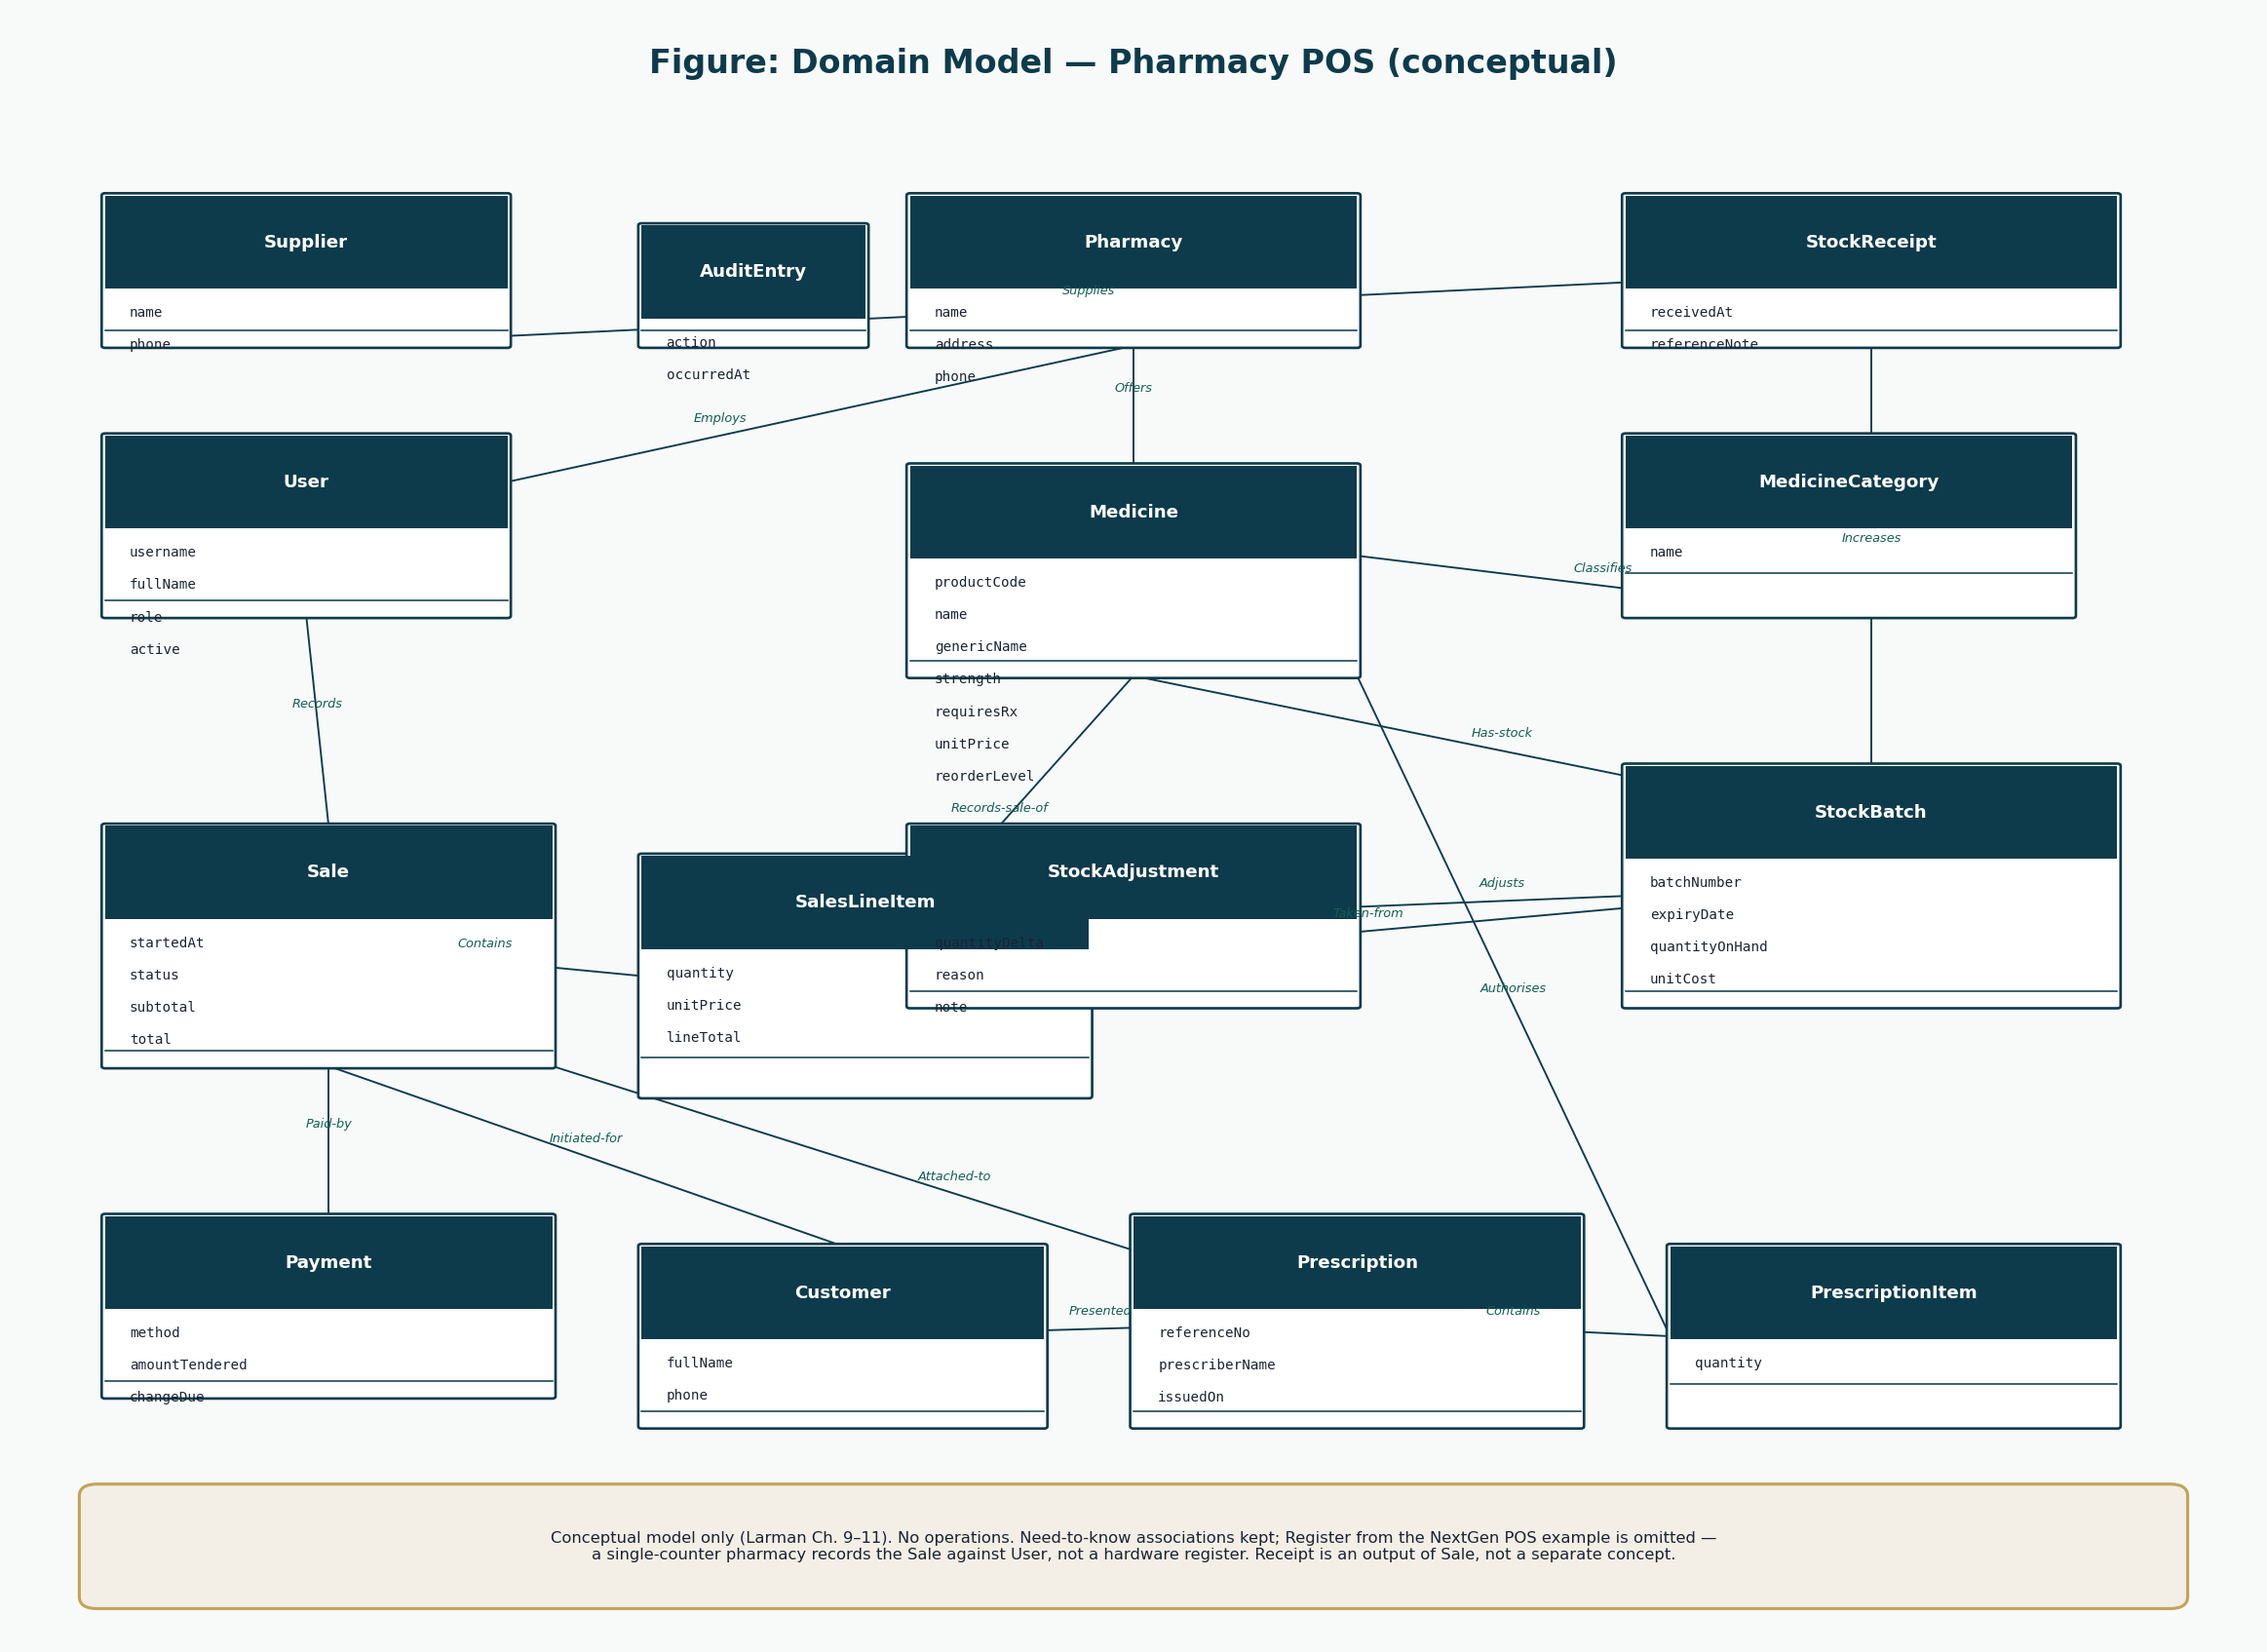
Figure 1: Conceptual data (domain model)
Receipt is not stored as its own entity.

B. Logical Database Model
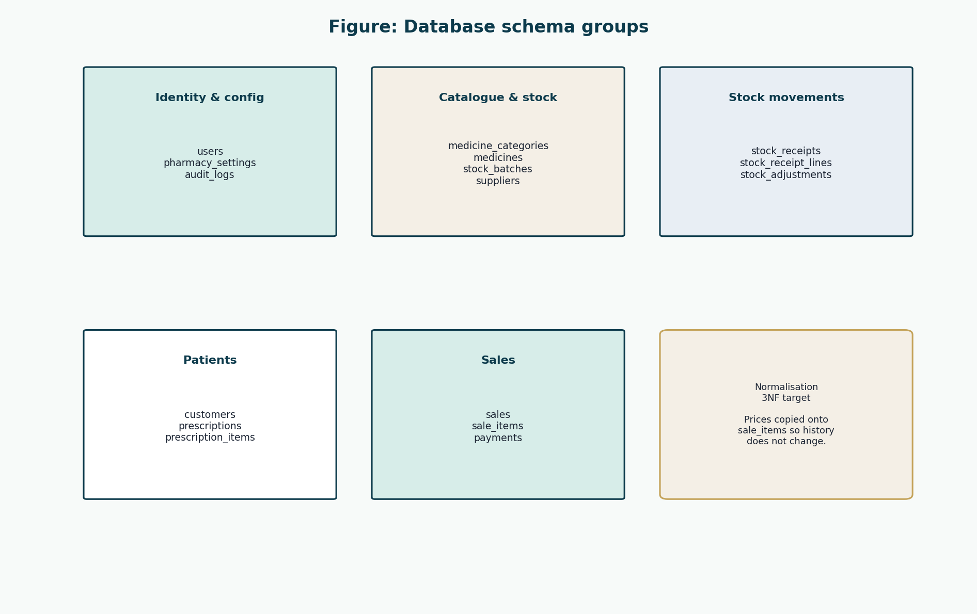
Figure 2: Logical groups
Identity, catalogue, movements, patients, sales.

C. Entity Relationship Diagram
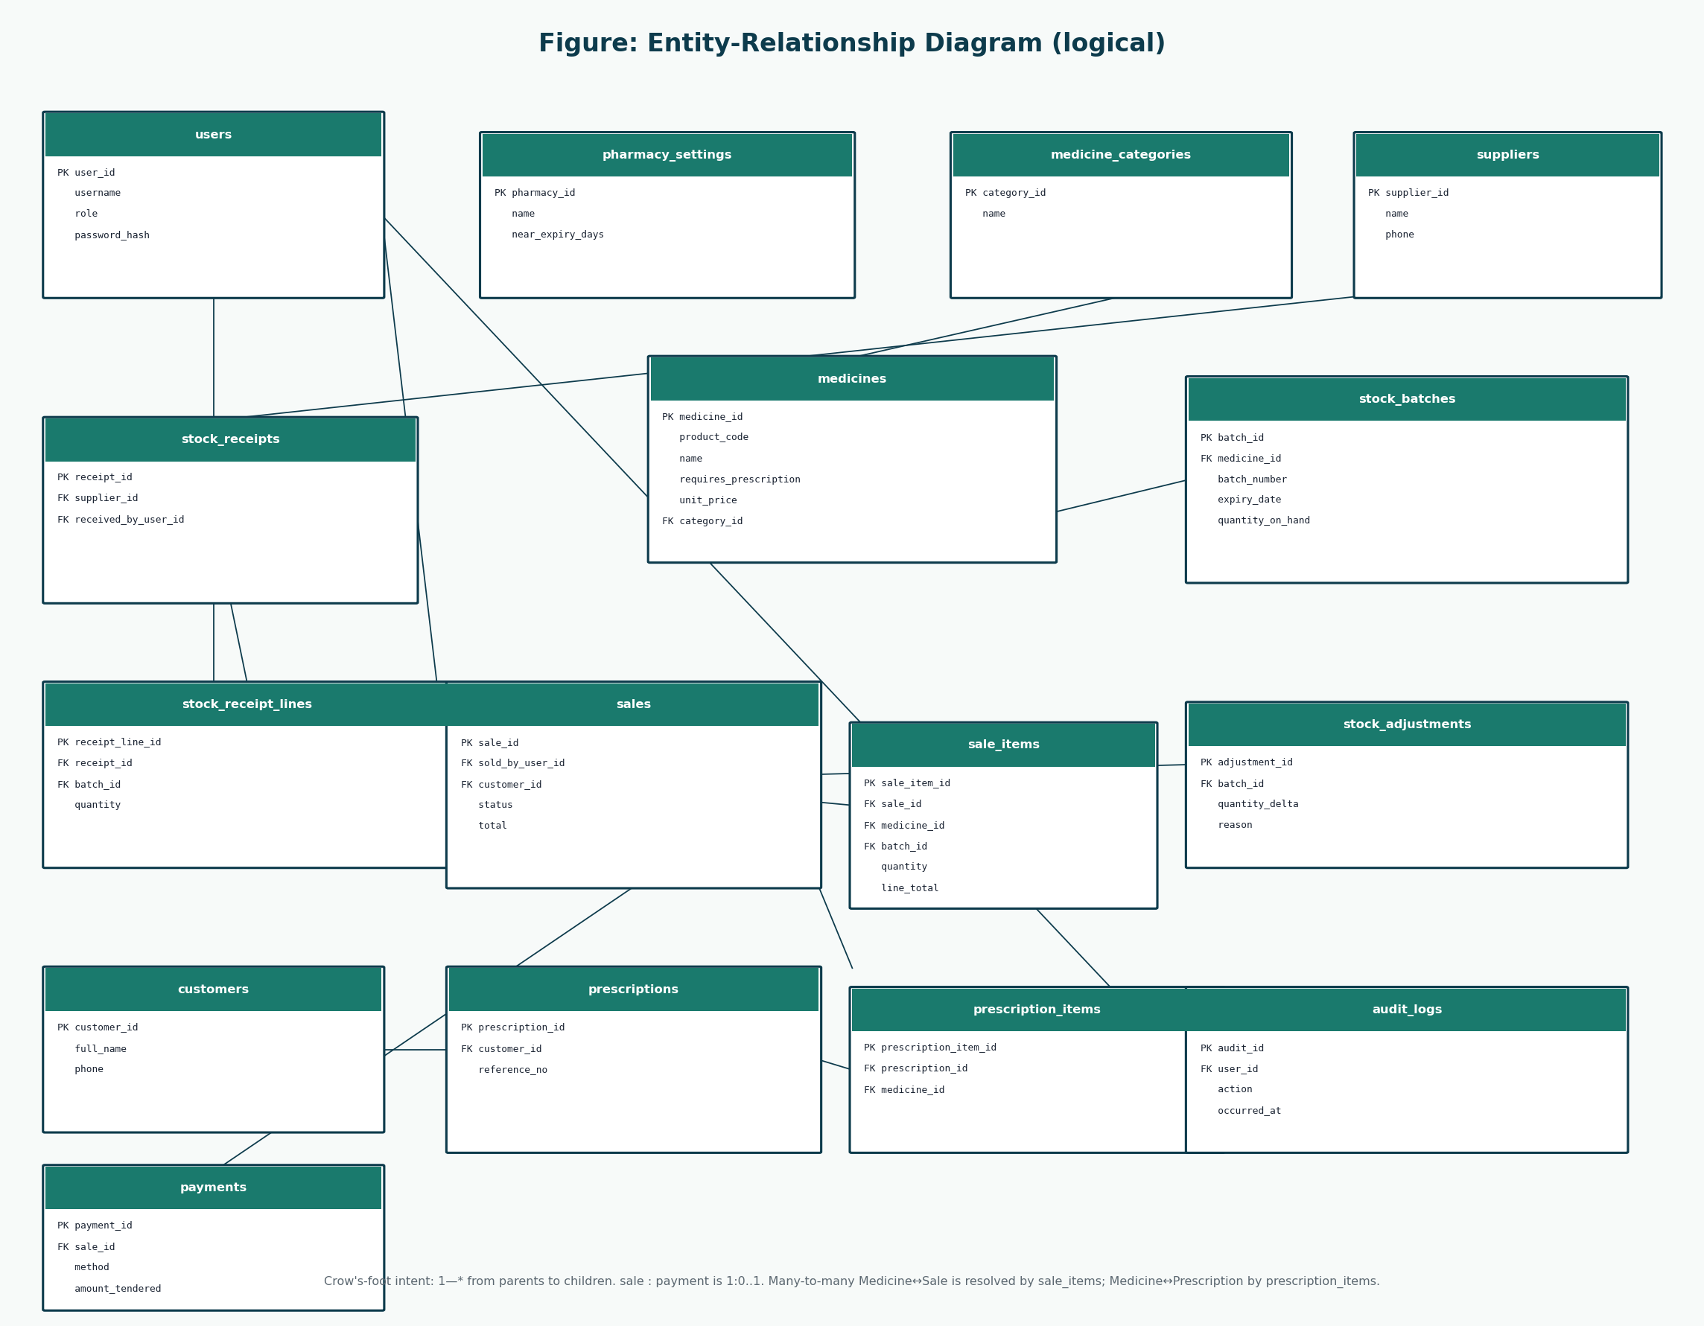
Figure 3: ERD
Must stay consistent with use cases and design classes.

D. Database Schema

users
Table | Column | Data Type | PK | FK | Nullable | Description
users | user_id | INT | Y |  | N | Surrogate primary key.
users | username | VARCHAR(50) |  |  | N | Unique login name.
users | full_name | VARCHAR(120) |  |  | N | Display name on receipts and audit.
users | role | VARCHAR(20) |  |  | N | ADMINISTRATOR or PHARMACIST.
users | password_hash | VARCHAR(255) |  |  | N | Salted hash only. Never plaintext.
users | password_salt | VARCHAR(64) |  |  | N | Per-user salt if not embedded in the hash.
users | is_active | BOOLEAN |  |  | N | Deactivated accounts cannot authenticate.
users | created_at | DATETIME |  |  | N | Account creation time.
users | last_login_at | DATETIME |  |  | Y | Last successful login.

pharmacy_settings
Table | Column | Data Type | PK | FK | Nullable | Description
pharmacy_settings | pharmacy_id | INT | Y |  | N | Single-row settings key for this deployment.
pharmacy_settings | name | VARCHAR(160) |  |  | N | Pharmacy trading name.
pharmacy_settings | address | VARCHAR(255) |  |  | Y | Printed on receipts.
pharmacy_settings | phone | VARCHAR(40) |  |  | Y | Printed on receipts.
pharmacy_settings | receipt_footer | VARCHAR(255) |  |  | Y | Thank-you or regulatory line.
pharmacy_settings | near_expiry_days | INT |  |  | N | Days used for near-expiry alerts.
pharmacy_settings | currency_code | CHAR(3) |  |  | N | ZMW for this project.

medicine_categories
Table | Column | Data Type | PK | FK | Nullable | Description
medicine_categories | category_id | INT | Y |  | N | Primary key.
medicine_categories | name | VARCHAR(80) |  |  | N | Unique category name.
medicine_categories | description | VARCHAR(255) |  |  | Y | Optional note.

medicines
Table | Column | Data Type | PK | FK | Nullable | Description
medicines | medicine_id | INT | Y |  | N | Primary key.
medicines | product_code | VARCHAR(40) |  |  | N | Unique SKU / product code.
medicines | name | VARCHAR(160) |  |  | N | Brand or dispensing name.
medicines | generic_name | VARCHAR(160) |  |  | Y | INN / generic name.
medicines | strength | VARCHAR(40) |  |  | Y | For example 500 mg.
medicines | form | VARCHAR(40) |  |  | Y | Tablet, syrup, cream.
medicines | category_id | INT |  | medicine_categories.category_id | Y | Optional category.
medicines | requires_prescription | BOOLEAN |  |  | N | True for prescription-only items.
medicines | unit_price | DECIMAL(12,2) |  |  | N | Current selling price.
medicines | reorder_level | INT |  |  | N | Low-stock threshold.
medicines | is_active | BOOLEAN |  |  | N | Inactive medicines are not sold.

suppliers
Table | Column | Data Type | PK | FK | Nullable | Description
suppliers | supplier_id | INT | Y |  | N | Primary key.
suppliers | name | VARCHAR(160) |  |  | N | Supplier trading name.
suppliers | phone | VARCHAR(40) |  |  | Y | Contact phone.
suppliers | address | VARCHAR(255) |  |  | Y | Contact address.
suppliers | is_active | BOOLEAN |  |  | N | Soft delete flag.

stock_batches
Table | Column | Data Type | PK | FK | Nullable | Description
stock_batches | batch_id | INT | Y |  | N | Primary key.
stock_batches | medicine_id | INT |  | medicines.medicine_id | N | Medicine of this batch.
stock_batches | batch_number | VARCHAR(60) |  |  | N | Manufacturer / supplier batch no.
stock_batches | expiry_date | DATE |  |  | N | Not sellable after this date.
stock_batches | quantity_on_hand | INT |  |  | N | Current sellable quantity.
stock_batches | unit_cost | DECIMAL(12,2) |  |  | Y | Optional cost for valuation.
stock_batches | received_at | DATETIME |  |  | N | First receipt time.

stock_receipts
Table | Column | Data Type | PK | FK | Nullable | Description
stock_receipts | receipt_id | INT | Y |  | N | Primary key.
stock_receipts | supplier_id | INT |  | suppliers.supplier_id | N | Source supplier.
stock_receipts | received_by_user_id | INT |  | users.user_id | N | Administrator who received.
stock_receipts | received_at | DATETIME |  |  | N | Receipt time.
stock_receipts | reference_note | VARCHAR(120) |  |  | Y | Delivery note number.

stock_receipt_lines
Table | Column | Data Type | PK | FK | Nullable | Description
stock_receipt_lines | receipt_line_id | INT | Y |  | N | Primary key.
stock_receipt_lines | receipt_id | INT |  | stock_receipts.receipt_id | N | Parent receipt.
stock_receipt_lines | batch_id | INT |  | stock_batches.batch_id | N | Batch increased.
stock_receipt_lines | quantity | INT |  |  | N | Quantity received.

stock_adjustments
Table | Column | Data Type | PK | FK | Nullable | Description
stock_adjustments | adjustment_id | INT | Y |  | N | Primary key.
stock_adjustments | batch_id | INT |  | stock_batches.batch_id | N | Adjusted batch.
stock_adjustments | adjusted_by_user_id | INT |  | users.user_id | N | Administrator.
stock_adjustments | quantity_delta | INT |  |  | N | Signed quantity change.
stock_adjustments | reason | VARCHAR(40) |  |  | N | DAMAGE, EXPIRY, RECOUNT, RECALL.
stock_adjustments | note | VARCHAR(255) |  |  | Y | Free-text explanation.
stock_adjustments | adjusted_at | DATETIME |  |  | N | When the change occurred.

customers
Table | Column | Data Type | PK | FK | Nullable | Description
customers | customer_id | INT | Y |  | N | Primary key.
customers | full_name | VARCHAR(160) |  |  | N | Patient or buyer name.
customers | phone | VARCHAR(40) |  |  | Y | Optional phone.
customers | address | VARCHAR(255) |  |  | Y | Optional address.
customers | created_at | DATETIME |  |  | N | When first recorded.

prescriptions
Table | Column | Data Type | PK | FK | Nullable | Description
prescriptions | prescription_id | INT | Y |  | N | Primary key.
prescriptions | customer_id | INT |  | customers.customer_id | N | Named patient.
prescriptions | reference_no | VARCHAR(60) |  |  | N | Paper / clinic reference.
prescriptions | prescriber_name | VARCHAR(160) |  |  | Y | Doctor or clinic if known.
prescriptions | issued_on | DATE |  |  | Y | Prescription date if known.
prescriptions | recorded_by_user_id | INT |  | users.user_id | N | Pharmacist who recorded it.
prescriptions | recorded_at | DATETIME |  |  | N | Capture time.

prescription_items
Table | Column | Data Type | PK | FK | Nullable | Description
prescription_items | prescription_item_id | INT | Y |  | N | Primary key.
prescription_items | prescription_id | INT |  | prescriptions.prescription_id | N | Parent prescription.
prescription_items | medicine_id | INT |  | medicines.medicine_id | N | Authorised medicine.
prescription_items | quantity | INT |  |  | N | Authorised quantity.

sales
Table | Column | Data Type | PK | FK | Nullable | Description
sales | sale_id | INT | Y |  | N | Primary key.
sales | sold_by_user_id | INT |  | users.user_id | N | Pharmacist/Cashier.
sales | customer_id | INT |  | customers.customer_id | Y | Optional customer.
sales | prescription_id | INT |  | prescriptions.prescription_id | Y | Optional linked prescription.
sales | status | VARCHAR(20) |  |  | N | IN_PROGRESS, COMPLETED, VOIDED.
sales | started_at | DATETIME |  |  | N | makeNewSale time.
sales | completed_at | DATETIME |  |  | Y | Completion or void time.
sales | void_reason | VARCHAR(255) |  |  | Y | Required when VOIDED.
sales | subtotal | DECIMAL(12,2) |  |  | N | Sum of line totals.
sales | total | DECIMAL(12,2) |  |  | N | Amount due.

sale_items
Table | Column | Data Type | PK | FK | Nullable | Description
sale_items | sale_item_id | INT | Y |  | N | Primary key.
sale_items | sale_id | INT |  | sales.sale_id | N | Parent sale.
sale_items | medicine_id | INT |  | medicines.medicine_id | N | Sold medicine.
sale_items | batch_id | INT |  | stock_batches.batch_id | N | Batch decremented.
sale_items | quantity | INT |  |  | N | Quantity sold.
sale_items | unit_price | DECIMAL(12,2) |  |  | N | Price at time of sale.
sale_items | line_total | DECIMAL(12,2) |  |  | N | quantity * unit_price.

payments
Table | Column | Data Type | PK | FK | Nullable | Description
payments | payment_id | INT | Y |  | N | Primary key.
payments | sale_id | INT |  | sales.sale_id | N | Paid sale (1:1 for this design).
payments | method | VARCHAR(20) |  |  | N | CASH, CARD, MOBILE_MONEY.
payments | amount_tendered | DECIMAL(12,2) |  |  | N | Amount given or confirmed.
payments | change_due | DECIMAL(12,2) |  |  | N | Cash change; zero otherwise.
payments | external_reference | VARCHAR(80) |  |  | Y | Card/mobile confirmation note.
payments | paid_at | DATETIME |  |  | N | Payment time.

audit_logs
Table | Column | Data Type | PK | FK | Nullable | Description
audit_logs | audit_id | INT | Y |  | N | Primary key.
audit_logs | user_id | INT |  | users.user_id | Y | Null only for failed unknown login.
audit_logs | action | VARCHAR(40) |  |  | N | LOGIN, LOGIN_FAIL, SALE_COMPLETE, VOID, STOCK_RECEIPT, STOCK_ADJUST, USER_ADMIN.
audit_logs | entity_name | VARCHAR(40) |  |  | Y | Affected table or concept.
audit_logs | entity_id | INT |  |  | Y | Affected key.
audit_logs | details | VARCHAR(500) |  |  | Y | Non-sensitive summary.
audit_logs | occurred_at | DATETIME |  |  | N | Event time.

E. Relationships
From | To | From | To | Notes
users | sales | 1 | 0..* | A pharmacist records many sales.
users | stock_receipts | 1 | 0..* | An administrator records many receipts.
users | stock_adjustments | 1 | 0..* | An administrator records many adjustments.
medicine_categories | medicines | 1 | 0..* | A category groups many medicines.
medicines | stock_batches | 1 | 0..* | A medicine has many batches.
suppliers | stock_receipts | 1 | 0..* | A supplier is the source of many receipts.
stock_receipts | stock_receipt_lines | 1 | 1..* | A receipt contains lines.
stock_batches | stock_receipt_lines | 1 | 0..* | A batch may be increased by receipt lines.
stock_batches | stock_adjustments | 1 | 0..* | A batch may be adjusted many times.
customers | prescriptions | 1 | 0..* | A customer may have many recorded prescriptions.
customers | sales | 1 | 0..* | A customer may appear on many sales.
prescriptions | prescription_items | 1 | 1..* | A prescription lists items.
medicines | prescription_items | 1 | 0..* | A medicine may appear on prescriptions.
prescriptions | sales | 1 | 0..1 | A prescription may be linked to a sale.
sales | sale_items | 1 | 1..* | A sale contains line items.
medicines | sale_items | 1 | 0..* | A medicine appears on many sale lines.
stock_batches | sale_items | 1 | 0..* | A batch is sold on many lines over time.
sales | payments | 1 | 0..1 | A completed sale has one payment in this design.
users | audit_logs | 1 | 0..* | A user generates many audit rows.

Many-to-many Medicine–Sale is resolved by sale_items. Medicine–Prescription is resolved by prescription_items. No unresolved M:N remains.

F. Normalisation
Target is third normal form. Each non-key attribute depends on the key, the whole key, and nothing but the key. Controlled exception: unit_price and line_total on sale_items are copied from the catalogue at sale time so that a later price change does not rewrite history. line_total is determined by quantity * unit_price and could be computed; it is stored to simplify receipts and reports. That is a documented denormalisation, not an accident.
Check | How the design answers
1NF | Atomic columns; no repeating medicine groups on sales
2NF | sale_items key is sale_item_id; no partial dependence on a composite leftover
3NF | Customer name is not stored on sales; customer_id is
Password | Only hash + salt; not a normalised “fact” about a person in plaintext

G. Data Dictionary
Entity | Attribute | Meaning
users | role | ADMINISTRATOR or PHARMACIST only
users | password_hash | Salted hash
medicines | requires_prescription | Forces UC-02 attachPrescription
stock_batches | expiry_date | Sellability rule
stock_batches | quantity_on_hand | Decremented by completed sales
sales | status | IN_PROGRESS / COMPLETED / VOIDED
payments | method | CASH / CARD / MOBILE_MONEY
audit_logs | action | Sensitive event type

H. Database Security Design
- Authentication data: username + salt + hash. Never plaintext passwords.
- Authorisation: role column; application enforces; DB account used by the app is not a human Administrator login.
- Access control: Pharmacist sessions cannot invoke catalogue writes.
- Audit: audit_logs plus immutable sale rows after void.
- Integrity: PKs, FKs, non-negative quantities, required status fields.
No CREATE TABLE script is included. That would be implementation.

References
[1] Larman, C. Applying UML and Patterns: An Introduction to Object-Oriented Analysis and Design and Iterative Development. 3rd edition. Prentice Hall. Principal methodology for UP, use cases, domain models, SSDs, design class diagrams, GRASP, and iterative development. Page numbers are not cited because the full print edition was not available as a continuous source file; chapter titles from the course extracts (System Sequence Diagrams; Domain Model associations; Design Class Diagrams) are used instead.
[2] CSC 4630 Advanced Software Engineering Course Project Marking Guide. Unified Process, 15 weeks, 100 marks. Determines milestones, deliverables, and mark weights.
[3] Larman course extracts used by the group: Chapter 9 System Sequence Diagrams; Chapter 11 Domain Model associations; Chapter 16 Design Class Diagrams.
[4] Group 20 inception briefing slides, Pharmacy POS System — Advanced Software Engineering (problem context in Zambia). Role names in those slides that implied a separate Cashier or Manager were corrected in this documentation to match the two-role rule.

