CSC 4630 · GROUP 20
Inception Report
Vision, feasibility, 10% use cases, risks, and iteration plan

CSC 4630 – Advanced Software Engineering
Group 20
Lecturer: [Lecturer Name]
University: [University Name]
September 2026
Unified Process (UP) — Iterative and Incremental
Analysis and design artefact. No application source code is included. Implementation starts only after the instruction START IMPLEMENTATION.

Table of Contents
Right-click and choose Update Field in Microsoft Word to refresh the table of contents.
In Word: References → Update Table, or right-click the field above.

1. Project Overview
This report is the Inception artefact for the Pharmacy Point-of-Sale (POS) System. Inception, in the Unified Process as taught from Larman, is not a requirements freeze and not a mini-waterfall. Its job is to decide whether the project is worth serious investigation, to name the core problem, to expose the highest risks, and to identify the small set of use cases that will drive the first real development iteration.
The group is not implementing the application in this phase. The marking guide awards 10 marks for vision, high-level use cases, risk list, feasibility, and a justified iteration plan mapped to UP phases.
Item | Value
System | Pharmacy Point-of-Sale (POS) System
Course | CSC 4630 – Advanced Software Engineering
Group | Group 20
Methodology | Unified Process (UP) — Iterative and Incremental
System user roles | Exactly two: Administrator; Pharmacist/Cashier
Implementation status | PharmaPoint built — Pharmacy-POS/apoza/ (see Construction report)

2. Problem Statement
Many small and medium pharmacies in Zambia still combine paper registers, memory, and generic retail tools that were not designed for medicines. That mix produces four recurring failures: expired packs can be sold; life-saving lines run out without a reliable warning; prices and receipts are inconsistent; and there is a weak audit trail when a regulator or owner asks who sold or adjusted a batch. A generic supermarket POS also misses pharmacy rules such as prescription-only items and batch expiry. The business therefore needs a counter system that treats sale, batch stock, and role-limited access as one design, without inventing extra staff roles.
A further problem is organisational: some generic POS products assume a cashier who is not the pharmacist. This project forbids that split. The Pharmacist performs the cashier function. Inventing a third role would misrepresent both the marking constraint and the intended workplace.

3. Business Case

3.1 Operational value
A correct sale that also updates the right batch reduces two expensive mistakes: giving out an expired pack and promising a medicine that is not on the shelf. Receipts that match the recorded sale reduce disputes at the counter.

3.2 Strategic and compliance value
Batch and expiry data turn a later inspection from a paper hunt into a query. Prescription-only items cannot silently pass as sweets. The design does not claim to submit NHIMA claims or to connect to a national e-prescription network; those are explicitly out of scope so that the business case stays honest.

3.3 Financial argument
The construction cost is student labour and ordinary hardware. The avoided cost is wasted expired stock, lost sales from false availability, and time spent reconstructing a day's takings from mixed paper and memory. No fabricated ROI percentage is offered.

3.4 Why a custom pharmacy POS rather than a supermarket till
A supermarket till has Sale, Line, and Payment — the Larman NextGen shape. A pharmacy also has StockBatch (expiry), Prescription, and a legally meaningful dispenser who is the same person taking the money. Those three facts justify a pharmacy-specific model instead of copying NextGen unchanged.

4. Vision
A pharmacy-specific point-of-sale system in which the Pharmacist runs the counter (search, sale, prescription capture, payment, receipt) and the Administrator runs the office (catalogue, stock, users, suppliers, reports). The system makes the dangerous path — selling expired or untracked medicine — hard, and the routine path — a correct paid sale — fast enough for a busy counter.

5. Scope

5.1 In scope
- Authentication and role-based authorisation for two roles only
- Medicine catalogue maintenance
- Batch-level inventory with expiry and quantity
- Over-the-counter and prescription-linked counter sales
- Payments recorded as cash, card, or mobile money
- Receipt generation
- Sale void with reason and stock restore
- Customer record when a named patient is required
- Supplier record and stock receiving
- Low-stock and near-expiry visibility
- Sales and inventory reports
- Pharmacy settings used on receipts and alerts
- Audit of sensitive actions

5.2 Out of scope
- A separate Cashier, Manager, or Inventory Clerk user role
- Online / e-commerce ordering
- NHIMA or other insurance claim submission
- Live card or mobile-money gateway settlement (manual confirmation only)
- National electronic prescription network
- Clinical diagnosis or drug-interaction decision support
- Multi-branch warehousing and inter-store transfers
- Full accounting / general ledger
- Supplier self-service portal
- Patient refill reminder campaigns
Out-of-scope items are not hidden requirements. If a later stakeholder demands NHIMA claims or a web shop, that is a new project increment, not a silent expansion of UC-02.

6. Business Objectives
ID | Objective
BO-01 | Prevent sale of expired or insufficiently stocked medicine.
BO-02 | Complete counter sales accurately with a printed or viewable receipt.
BO-03 | Keep inventory quantities consistent with sales and stock movements.
BO-04 | Support prescription-linked dispensing without creating extra user roles.
BO-05 | Give the Administrator reliable catalogue, stock, user, and report control.
BO-06 | Leave an audit trail for sales, voids, stock adjustments, and user changes.
BO-07 | Fit a 15-week UP schedule with architecture proven before construction.

7. Stakeholders
Stakeholder | Interest | System account?
Pharmacy owner / manager (person, not a role) | Profit, compliance, trustworthy stock figures | May hold the Administrator account
Administrator | Catalogue, stock, users, reports | Yes — ROLE-ADMIN
Pharmacist/Cashier | Fast correct sales; legal dispensing | Yes — ROLE-PHARM
Customer / patient | Correct medicine, fair price, receipt | No
Supplier | Deliveries recorded against their name | No
Regulator / inspector | Traceability of batches and prescription-only sales | No
Course lecturer | UP artefacts, traces, no waterfall theatre | No

8. System Users
There are exactly two system user roles. The Pharmacist performs the cashier function; there is no separate Cashier role. Customer and Supplier may appear as actors on use-case diagrams but they do not log in.
ID | Role | Kind | Summary
ROLE-ADMIN | Administrator | system user | Responsible for catalogue, inventory, users, suppliers, configuration, reports, and monitoring.
ROLE-PHARM | Pharmacist/Cashier | system user | The Pharmacist performs the cashier function. There is no separate Cashier role. The Pharmacist searches medicines, processes sales, records prescriptions where required, accepts payment, issues receipts, and triggers stock reduction through sales.

ID | Actor | Kind | Summary
ACT-CUST | Customer | external actor | Buys medicines and may present a prescription. Does not have a system login. Interacts with the Pharmacist, not with the software directly (Larman system-boundary rule).
ACT-SUP | Supplier | external actor | Provides stock to the pharmacy. Not a system user. Appears as a recorded business party when goods are received.

9. High-Level Requirements

9.1 Functional requirements
ID | Statement
FR-01 | The system shall authenticate a user with a unique username and a secret password and start a role-specific session.
FR-02 | The system shall authorise each operation according to exactly one of two roles: Administrator or Pharmacist/Cashier.
FR-03 | The Pharmacist/Cashier shall be able to start a sale, enter one or more medicine lines, and complete the sale.
FR-04 | The Pharmacist/Cashier shall be able to search medicines by name, generic name, or product code and see on-hand quantity.
FR-05 | The system shall refuse a sale line that would sell an expired batch or a quantity greater than available sellable stock.
FR-06 | When a line requires a prescription, the Pharmacist/Cashier shall record the prescription reference and essential details before the line is accepted.
FR-07 | The Pharmacist/Cashier shall record payment as cash, card, or mobile money, including amount tendered.
FR-08 | On successful payment the system shall complete the sale, reduce stock, and produce a receipt.
FR-09 | The Administrator shall create, update, deactivate, and view medicines in the catalogue (name, generic name, strength, form, category, prescription flag, selling price, reorder level).
FR-10 | The Administrator shall receive stock against a supplier, recording batch number, expiry date, quantity, and cost.
FR-11 | The Administrator shall adjust stock for damage, expiry removal, recount, or recall, with a mandatory reason.
FR-12 | The system shall present low-stock and near-expiry information to the Administrator.
FR-13 | The Administrator shall create, update, deactivate, and reset access for users assigned to one of the two roles.
FR-14 | The Administrator shall maintain supplier records used when receiving stock.
FR-15 | The Administrator shall view sales and inventory reports for selected date ranges.
FR-16 | The Pharmacist/Cashier shall look up or record a customer when a sale needs a named patient (typical for prescriptions).
FR-17 | The Pharmacist/Cashier shall void an in-progress or completed sale only with a reason; the system shall restore stock for completed voids and write an audit entry.
FR-18 | The Administrator shall configure pharmacy name, address, receipt footer, and near-expiry warning days.
FR-19 | The system shall record an audit entry for login failures, sales, voids, stock receipts, stock adjustments, and user administration.

9.2 Non-functional requirements
ID | Quality | Statement
NFR-01 | Security | Passwords shall be stored only as a salted hash. Sessions shall expire after inactivity. Role checks shall be enforced on every privileged operation.
NFR-02 | Performance | Entering a sale line and refreshing the running total should complete within about three seconds on the intended counter workstation under typical catalogue size. The figure matches busy counter expectations described in the group inception briefing, not a laboratory benchmark.
NFR-03 | Usability | A trained Pharmacist/Cashier shall complete a routine three-line OTC sale from one primary sales screen without opening an administration page.
NFR-04 | Reliability / integrity | A completed sale and its stock movements shall succeed or fail together. Partial stock reduction without a sale record is not acceptable.
NFR-05 | Availability | The system is intended for normal pharmacy opening hours. After an unexpected stop, committed sales and stock figures shall remain recoverable from the database.
NFR-06 | Maintainability | Presentation, application, domain, and persistence shall remain separable so that a UI change does not rewrite pricing or stock rules.
NFR-07 | Scalability | The first release is one pharmacy. Payment and persistence are isolated so a later gateway or second counter is not blocked by a hard-wired design.
NFR-08 | Auditability | Sensitive actions shall be attributable to a user account and a timestamp.
NFR-09 | Privacy | Customer and prescription details shall be visible only to authenticated staff and shall not appear unnecessarily on publicly displayed screens.
NFR-10 | Data integrity | Database keys, required fields, and non-negative quantities shall protect stock and money figures independently of the user interface.

9.3 Assumptions
Assumptions are not requirements. If an assumption fails, the requirement set may change.
ID | Assumption | Reason | Impact if incorrect | Status
A-01 | Single physical pharmacy (one location). | Course scope and first deployment. | Multi-branch stock and pricing would be missing. | Open
A-02 | Exactly two logged-in roles: Administrator and Pharmacist/Cashier. | Lecturer/project constraint. | Access control and use-case model would be wrong. | Confirmed
A-03 | The Customer does not operate the software. | Counter-based pharmacy practice; Larman POS boundary. | SSDs and actors would change. | Confirmed
A-04 | Card and mobile-money payment are confirmed by the Pharmacist, not by a live gateway in this release. | Avoids unverifiable third-party integration in a student construction window. | Payment design would need an external adapter earlier. | Open
A-05 | NHIMA / insurance claim submission is out of scope. | Existing project scope decision. | Prescription sale would include claim steps. | Confirmed
A-06 | No public e-commerce storefront. | POS is an in-pharmacy counter system. | Architecture and actors would expand. | Confirmed
A-07 | Prescriptions are recorded and checked in-system; there is no national e-prescription feed. | No available national interface for the project. | UC-02 extensions would change. | Open
A-08 | Currency is Zambian Kwacha (ZMW). | Deployment context is Zambia. | Money formatting and reports would change. | Confirmed
A-09 | English is the UI language for this release. | Course and team working language. | Labels and user manual would need translation. | Confirmed
A-10 | The Pharmacist is legally permitted to dispense and take payment. | Zambian pharmacy practice assumption. | A third operational role might be demanded in reality. | Open

10. Ten Percent Use Cases
Larman and the marking guide ask for about 10% of the use cases in Inception, chosen because they are architecturally significant — not because they are easy. The group identified ten user-goal use cases. Ten percent is therefore the single core goal UC-02 Process Sale, described here at a brief level. OTC and prescription-linked paths are scenarios of that one goal, not two extra Inception use cases and not button-level steps such as “click Search”.
ID | Name | Primary actor | Why this is the 10%
UC-02 | Process Sale | Pharmacist/Cashier | Touches money, stock, expiry, prescription rules, payment, and receipt — the risks that will break the architecture if ignored.

The Pharmacist records sold medicines, handles prescription data when required, takes payment, issues a receipt, and reduces stock.
Brief main success scenario (Inception level, not fully dressed):
- Pharmacist/Cashier starts a sale.
- Pharmacist/Cashier enters each medicine and quantity; the system refuses expired or insufficient batches.
- If a line is prescription-only, prescription and customer details are recorded.
- Pharmacist/Cashier ends the sale and records cash, card, or mobile-money payment.
- The system completes the sale, reduces stock, and presents a receipt.

11. Initial Use-Case Model
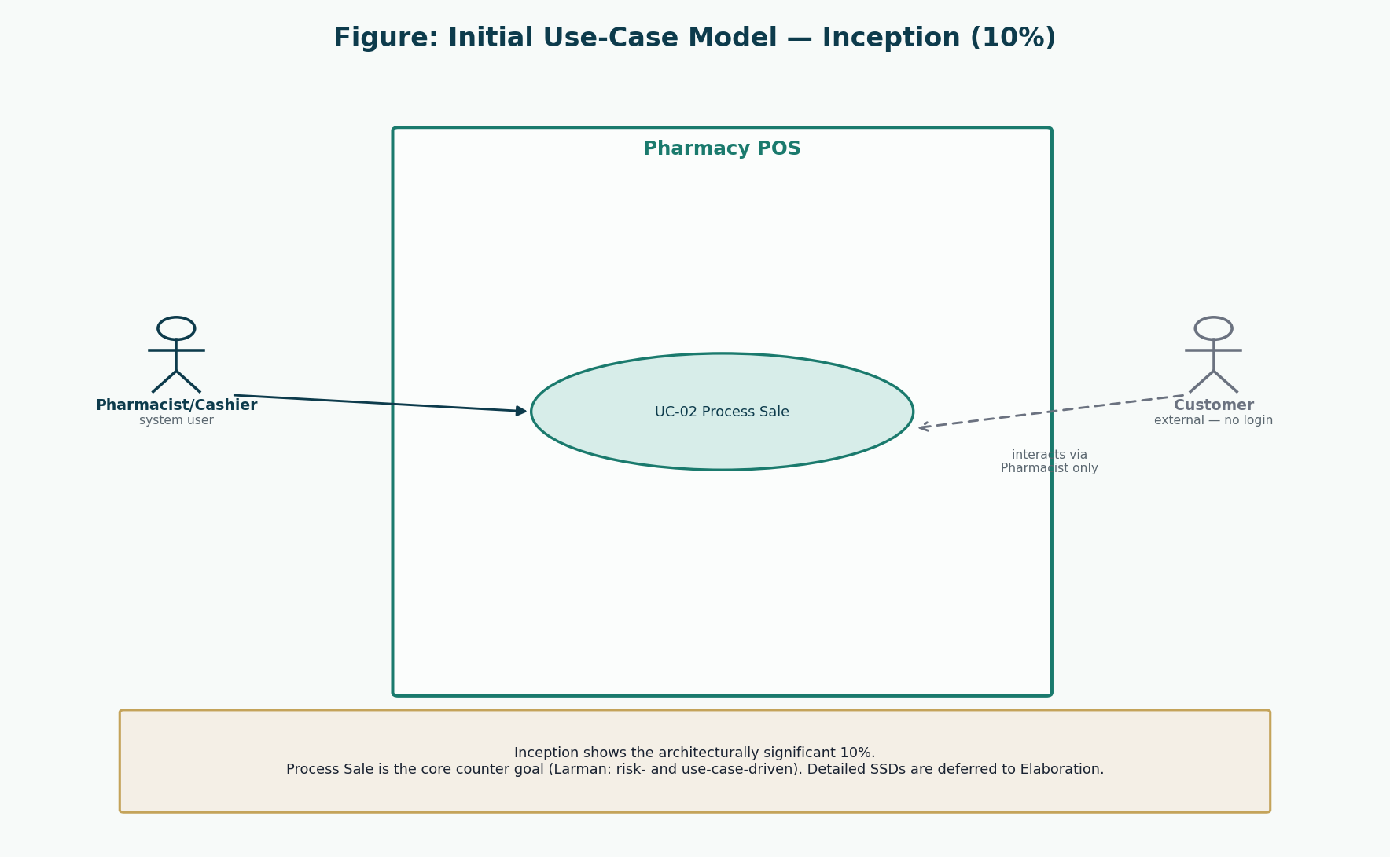
Figure 1: Initial use-case model (Inception, 10%)
Only the architecturally significant Process Sale goal is shown. The Customer does not operate the software.
The remaining nine use cases are named so that the 30% and 70% cuts are not arbitrary:
ID | Name | Primary actor | Priority | Iteration | FR
UC-01 | Authenticate User | Administrator, Pharmacist/Cashier | High | Elaboration 1 (30%) | FR-01, FR-02, FR-19
UC-02 | Process Sale | Pharmacist/Cashier | Critical | Inception 10% / Elaboration 1 detailed | FR-03, FR-04, FR-05, FR-06, FR-07, FR-08, FR-16
UC-03 | Manage Medicines | Administrator | High | Elaboration 1 (30%) | FR-09
UC-04 | Manage Inventory | Administrator | High | Elaboration 2 (remaining 70%) | FR-10, FR-11, FR-12
UC-05 | Manage Users | Administrator | High | Elaboration 2 (remaining 70%) | FR-13, FR-19
UC-06 | Manage Suppliers | Administrator | Medium | Elaboration 2 (remaining 70%) | FR-14
UC-07 | View Reports | Administrator | Medium | Elaboration 2 (remaining 70%) | FR-15
UC-08 | Record Customer | Pharmacist/Cashier | Medium | Elaboration 2 (remaining 70%) | FR-16
UC-09 | Void Sale | Pharmacist/Cashier | High | Elaboration 2 (remaining 70%) | FR-17, FR-19
UC-10 | Configure Pharmacy | Administrator | Low | Elaboration 2 (remaining 70%) | FR-18

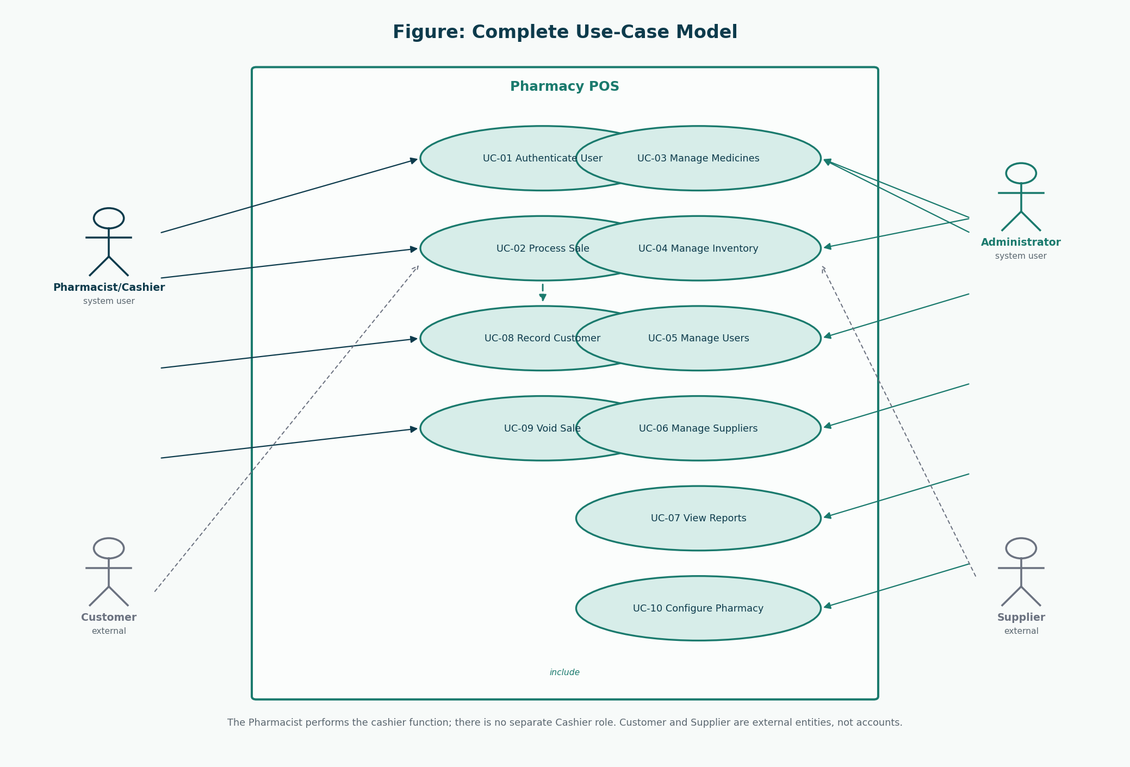
Figure 2: Full use-case outline (names only in Inception; details come later)
Showing the outline early prevents surprise actors. Detailing waits for Elaboration.

12. Initial Risk Register
ID | Risk | P | I | Priority | Mitigation | Iteration | Status
R-01 | Sale and stock update diverge (double-sell or missing decrement). | High | High | Critical | Prove one business transaction in the architectural PoC. | Inception | Open
R-02 | Expired medicine can be sold. | Medium | High | High | Batch expiry is a first-class domain rule in enterItem. | Inception | Open
R-03 | A third role creeps in and breaks the two-role rule. | Medium | High | High | Actors and authorisation designed as two roles only. | Inception | Open
R-04 | Payment recorded but sale not completed, or the reverse. | Medium | High | High | makePayment completes sale only after Payment is accepted in the same transaction. | Inception | Open
R-05 | Staff resist a new counter workflow. | Medium | Medium | Medium | Keep the sales UI on one screen; plan Transition training. | Inception | Open
R-06 | Scope grows into NHIMA claims or e-commerce. | High | High | High | Out-of-scope list is explicit; iteration plan stays POS-centred. | Inception | Open
R-07 | Fifteen-week calendar is consumed by late architecture work. | Medium | High | High | Risk-driven Elaboration 1 proves Process Sale before feature breadth. | Inception | Open
R-08 | Data loss after workstation or power failure. | Low | High | Medium | Persistence in a real database; backup plan in Transition. | Inception | Open
R-09 | Prescription recording is legally insufficient. | Medium | Medium | Medium | Record reference + patient; do not claim national e-prescription. | Inception | Open
R-10 | Layered design is too slow or too tangled for a counter sale. | Medium | High | High | Architectural PoC walks makeNewSale–enterItem–makePayment through all layers. | Inception | Open

The first elaboration iteration is aimed at R-01, R-02, R-04, and R-10: the sale must move through layers, obey expiry, and complete payment and stock together.

13. Feasibility Study

13.1 Technical feasibility
A layered desktop or web application with a relational database can represent Sale, StockBatch, User, and Payment. Password hashing, role checks, and transactional updates are ordinary techniques. Live payment gateways are treated as a later variation (A-04), which keeps technical feasibility inside the course window.

13.2 Economic feasibility
There is no licence purchase in the student project. Hardware is a normal workstation. The economic case for a real pharmacy is the reduction of waste and dispute time already stated; it is qualitative on purpose.

13.3 Operational feasibility
The two-role model matches a small pharmacy: one person on the counter, one person (or the same person at a different time) administering the catalogue. Training risk R-05 remains and is accepted into Transition rather than denied.

13.4 Schedule feasibility
The marking guide already decomposes 15 weeks. Feasibility depends on not building features during Inception and on proving Process Sale in Elaboration 1 before widening the use-case set. That is why this document forbids implementation until the group is told to start.

14. UP Methodology
The Unified Process is iterative and incremental, architecture-centric, use-case-driven, and risk-driven (Larman; marking guide “Key UP Principles”). The four phases are Inception, Elaboration, Construction, and Transition. Each phase contains iterations. This project uses Iteration 1 and 2 in Elaboration, Iterations 3–4 in Construction, and Iteration 5 in Transition.
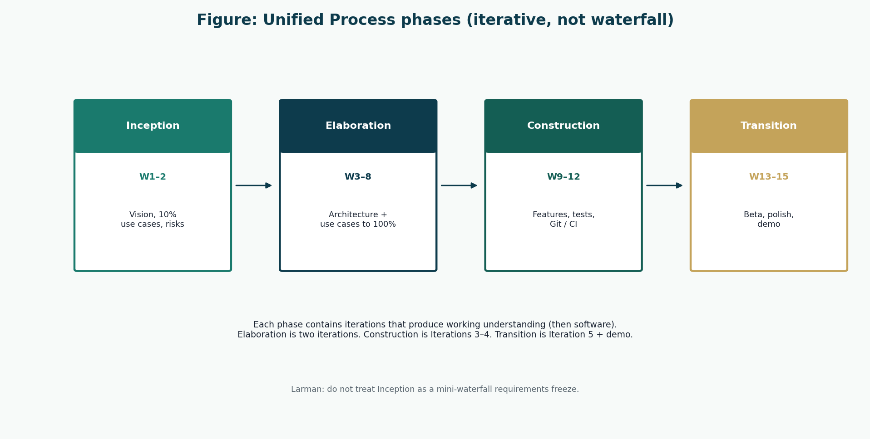
Figure 3: Unified Process phases used by this project
Arrows mean sequence of phases, not a single-pass waterfall of all requirements then all design then all code.

15. Iteration Plan
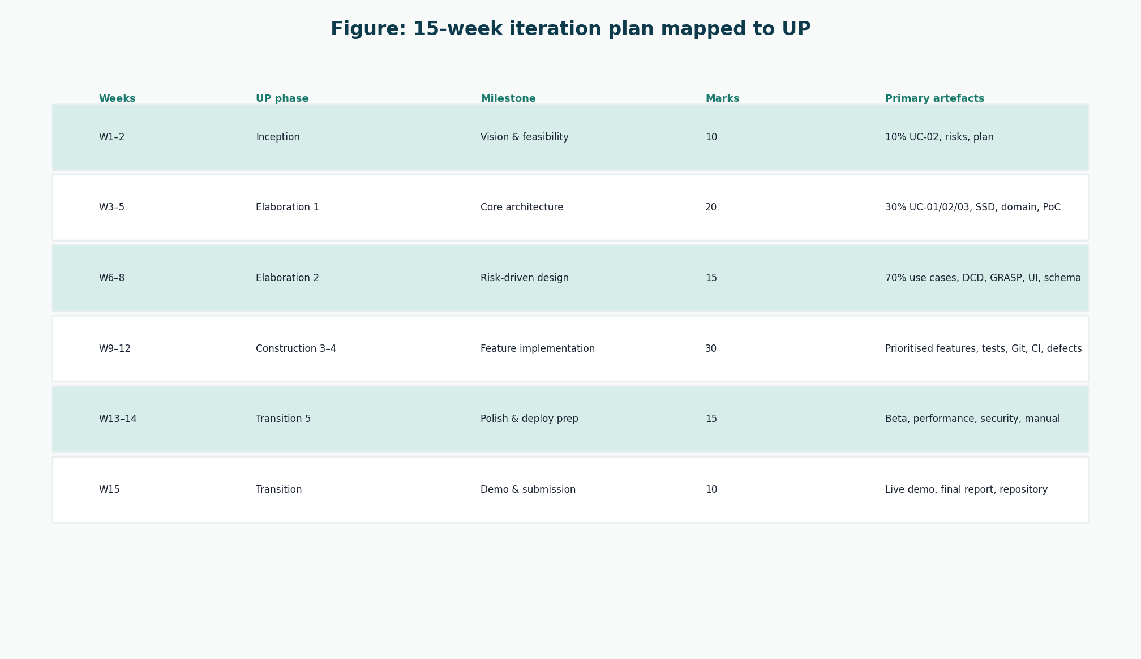
Figure 4: Fifteen-week iteration plan
Marks and weeks are taken from the lecturer’s marking guide, not invented by the group.
Weeks | Phase / iteration | Marks | Objective
1–2 | Inception | 10 | Vision, 10% use cases, risks, feasibility, plan
3–5 | Elaboration Iteration 1 | 20 | 30% detailed use cases, SSDs, domain model, architectural PoC
6–8 | Elaboration Iteration 2 | 15 | Remaining use cases, DCDs, GRASP, UI prototypes, schema
9–12 | Construction Iterations 3–4 | 30 | Prioritised features, unit + integration tests, Git, CI, defects
13–14 | Transition Iteration 5 | 15 | Beta, performance/security, final models, user manual
15 | Demo and submission | 10 | Live demo, final report, repository completeness

16. UP Phase Mapping
The mapping is justified, not decorative. Inception investigates. Elaboration attacks the risks that would make Construction a gamble. Construction grows features in priority order on a stable spine. Transition makes the system usable by real staff and submitable to the lecturer.
Marking-guide milestone | UP idea (Larman) | This project’s response
Vision & feasibility | Is it worth serious work? | Problem, business case, feasibility, 10% UC-02
Core architecture & requirements | Prove the core design | UC-01/02/03, SSDs, domain, layered PoC
Risk-driven design | Design to remaining risks | 70% use cases, DCD, GRASP, UI, database design
Feature implementation | Increment working software | Planned only — not executed in this documentation pack
Polishing & deployment prep | Make it releasable | Beta/security/performance plans; user manual draft
Demo & final submission | Show scenarios and reflect | Presentation and final report structure

17. Inception Conclusion
The project is feasible as a 15-week UP course system if the group keeps two roles, keeps insurance and e-commerce out, and treats Process Sale as the first architecture problem. Inception has named the 10% use case, the risks, and the week map. Elaboration Iteration 1 must now dress UC-01, UC-02, and UC-03, draw SSDs, build a conceptual domain model, and show a layered proof-of-concept — still without writing the application.

References
[1] Larman, C. Applying UML and Patterns: An Introduction to Object-Oriented Analysis and Design and Iterative Development. 3rd edition. Prentice Hall. Principal methodology for UP, use cases, domain models, SSDs, design class diagrams, GRASP, and iterative development. Page numbers are not cited because the full print edition was not available as a continuous source file; chapter titles from the course extracts (System Sequence Diagrams; Domain Model associations; Design Class Diagrams) are used instead.
[2] CSC 4630 Advanced Software Engineering Course Project Marking Guide. Unified Process, 15 weeks, 100 marks. Determines milestones, deliverables, and mark weights.
[3] Larman course extracts used by the group: Chapter 9 System Sequence Diagrams; Chapter 11 Domain Model associations; Chapter 16 Design Class Diagrams.
[4] Group 20 inception briefing slides, Pharmacy POS System — Advanced Software Engineering (problem context in Zambia). Role names in those slides that implied a separate Cashier or Manager were corrected in this documentation to match the two-role rule.

