CSC 4630 · GROUP 20
Elaboration Iteration 1 Report
30% use cases, SSDs, domain model, architectural proof-of-concept

CSC 4630 – Advanced Software Engineering
Group 20
Lecturer: [Lecturer Name]
University: [University Name]
September 2026
Unified Process (UP) — Iterative and Incremental
Analysis and design artefact. No application source code is included. Implementation starts only after the instruction START IMPLEMENTATION.

Table of Contents
Right-click and choose Update Field in Microsoft Word to refresh the table of contents.
In Word: References → Update Table, or right-click the field above.

1. Introduction
Elaboration Iteration 1 is the first real development iteration in Larman’s sense: not coding the whole product, but investigating the core so that Construction is not a guess. The marking guide awards 20 marks for detailed 30% use cases with SSDs, a domain model of conceptual classes, an architectural proof-of-concept, and an updated risk list.

2. Iteration Objectives
- Fully dress the 30% use cases UC-01, UC-02, and UC-03.
- Describe key scenarios of Process Sale (OTC success, prescription-linked, expiry refusal).
- Draw SSDs that treat the system as a black box.
- Build a conceptual domain model without methods.
- Propose a layered architecture and a Process Sale path as proof-of-concept.
- Sketch the persistence idea that later becomes the schema.
- Update risks now that the spine is visible.

3. Selected 30% Use Cases
Thirty percent of ten use cases is three. They are not a random third. They are the identity boundary, the money-and-stock transaction, and the catalogue the transaction depends on.
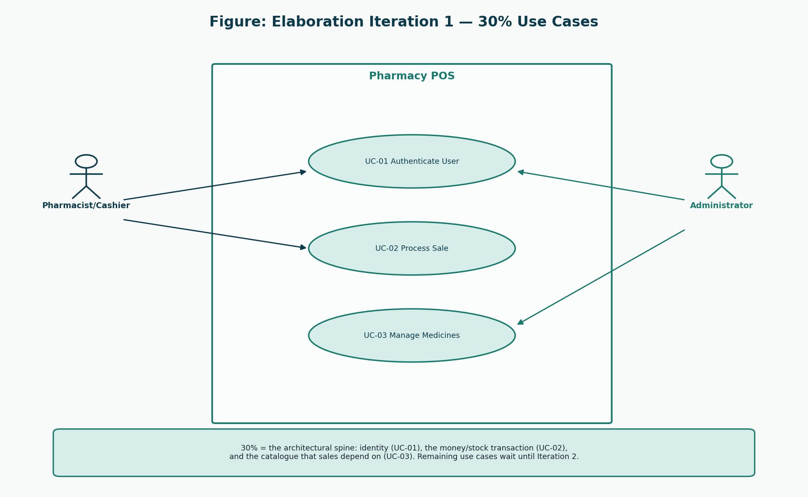
Figure 1: Elaboration 1 use-case selection
Administrator and Pharmacist/Cashier both authenticate. Only the Pharmacist processes a sale. Only the Administrator maintains medicines.
ID | Name | Actor | Priority | Iteration | FR
UC-01 | Authenticate User | Administrator, Pharmacist/Cashier | High | Elaboration 1 (30%) | FR-01, FR-02, FR-19
UC-02 | Process Sale | Pharmacist/Cashier | Critical | Inception 10% / Elaboration 1 detailed | FR-03, FR-04, FR-05, FR-06, FR-07, FR-08, FR-16
UC-03 | Manage Medicines | Administrator | High | Elaboration 1 (30%) | FR-09

4. Detailed Use Cases

UC-01 Authenticate User
Field | Description
ID | UC-01
Name | Authenticate User
Scope | Pharmacy POS application
Level | User goal
Primary actor | Staff member (Administrator or Pharmacist/Cashier)
Priority | High
Iteration | Elaboration 1 (30%)
Requirements | FR-01, FR-02, FR-19
Preconditions | The user has an active account. The application is available.
Success guarantee | A session exists, the role is known, and the correct home screen is shown.
Special requirements | Passwords are never displayed or stored in recoverable form.
Technology / data variations | Keyboard login on the counter or office workstation.
Frequency | At the start of each shift and after session timeout.

Stakeholders and interests
Stakeholder | Interest
Staff member | Gains access only to functions of their assigned role.
Pharmacy owner | Unauthorised people cannot sell or alter stock.
Auditor | Failed and successful logins can be investigated.

Main success scenario
1. The staff member starts the Pharmacy POS application.
2. The system presents the login prompt.
3. The staff member enters username and password.
4. The system verifies the credentials against the stored password hash and confirms the account is active.
5. The system creates a session containing user identity and role.
6. The system opens the Administrator dashboard or the Pharmacist sales screen according to role.
Extensions
- 4a. Credentials are wrong: the system refuses access, records a failed-login audit entry, and invites a retry.
- 4b. Account is deactivated: the system refuses access and explains that an Administrator must restore the account.
- 4c. Repeated failures in a short period: the system keeps refusing and keeps the audit trail (lockout policy may be applied in construction).

UC-02 Process Sale
Field | Description
ID | UC-02
Name | Process Sale
Scope | Pharmacy POS application
Level | User goal
Primary actor | Pharmacist/Cashier
Priority | Critical
Iteration | Inception 10% / Elaboration 1 detailed
Requirements | FR-03, FR-04, FR-05, FR-06, FR-07, FR-08, FR-16
Preconditions | The Pharmacist/Cashier is authenticated. At least one sellable medicine exists.
Success guarantee | A completed Sale, Payment, stock reduction, and Receipt exist. Prescription details exist when required.
Special requirements | Sale completion and stock reduction are one business transaction. Receipt shows pharmacy name, date, lines, total, payment method, and cashier identity (the Pharmacist user).
Technology / data variations | Product code may be typed; barcode scan is a technology variation of enterItem, not a separate use case (Larman: name events at the level of intent).
Frequency | Core daily work of the counter — typically many times per hour.

Stakeholders and interests
Stakeholder | Interest
Pharmacist/Cashier | Completes the sale quickly and correctly.
Customer | Pays the correct amount and receives the intended medicines plus a receipt.
Pharmacy owner | Money and stock stay consistent; expired stock is not sold.
Regulator | Prescription-only items are not sold without recorded prescription details.

Main success scenario
1. The Pharmacist/Cashier chooses to start a new sale (system event: makeNewSale).
2. The system creates a Sale in progress and shows an empty line list and a zero total.
3. The Pharmacist/Cashier identifies a medicine by search or product code and enters a quantity (system event: enterItem).
4. The system locates a sellable StockBatch (unexpired, sufficient quantity), adds a SalesLineItem, and returns description, unit price, line total, and running total.
5. The Pharmacist/Cashier repeats step 3–4 for each additional medicine.
6. If any accepted line is prescription-only, the Pharmacist/Cashier records the customer (or uses an existing customer) and the prescription reference (system event: attachPrescription).
7. The Pharmacist/Cashier indicates the sale content is complete (system event: endSale).
8. The system calculates tax if configured and presents the total due.
9. The Pharmacist/Cashier records the payment method and amount tendered (system event: makePayment).
10. The system records Payment, marks the Sale complete, reduces batch quantities, writes audit data, and presents the Receipt.
11. The Pharmacist/Cashier gives medicines and the receipt to the Customer.
Extensions
- 3a. Medicine is not found: the system says so; the sale remains in progress.
- 3b. Only expired batches exist: the system refuses the line (BO-01 / FR-05).
- 3c. Requested quantity exceeds sellable stock: the system refuses the line and shows the available quantity.
- 3d. Pharmacist/Cashier removes a line before payment: the system deletes that SalesLineItem and updates the total.
- 6a. Prescription-only line without prescription details: the system refuses to end the sale until details are recorded.
- 6b. Customer is new: include UC-08 Record Customer, then continue.
- 8a. Pharmacist/Cashier cancels the in-progress sale: no payment, no stock change (related to UC-09).
- 9a. Amount tendered is less than total for a cash sale: the system refuses completion and shows the shortfall.
- 9b. Card or mobile money: the Pharmacist/Cashier confirms that payment was received externally; the system records method and reference. Live gateway settlement is out of scope (A-04).
- 10a. Persistence fails after payment intent: the system does not report success; no partial stock reduction remains (NFR-04).

UC-03 Manage Medicines
Field | Description
ID | UC-03
Name | Manage Medicines
Scope | Pharmacy POS application
Level | User goal
Primary actor | Administrator
Priority | High
Iteration | Elaboration 1 (30%)
Requirements | FR-09
Preconditions | Administrator is authenticated.
Success guarantee | The medicine catalogue reflects the intended create/update/deactivate action.
Special requirements | Deactivation is preferred to physical deletion so old sales remain explainable.
Technology / data variations | Office workstation, keyboard and mouse.
Frequency | Whenever the assortment or price list changes.

Stakeholders and interests
Stakeholder | Interest
Administrator | Keeps the catalogue accurate.
Pharmacist/Cashier | Can find the correct sellable item at the counter.

Main success scenario
1. The Administrator opens medicine maintenance.
2. The Administrator searches or starts a new medicine.
3. The Administrator enters or edits name, generic name, strength, form, category, prescription-required flag, selling price, and reorder level.
4. The system validates required fields and unique product code.
5. The Administrator confirms the save.
6. The system stores the medicine and records an audit entry.
Extensions
- 4a. Duplicate product code: the system rejects the save.
- 4b. Invalid price or empty required field: the system rejects the save.
- 5a. Deactivate instead of update: the medicine remains in history but is not offered for new sale lines.

5. Key Scenarios

5.1 SC-01 Routine OTC sale
Two unexpired OTC lines, cash tendered above the total, receipt shown. This is the main success scenario of UC-02 without attachPrescription. It is the first scenario the architectural PoC must support.

5.2 SC-02 Prescription-linked sale
A prescription-only medicine is entered. The system refuses endSale until a customer and prescription reference exist (FR-06). This scenario distinguishes a pharmacy POS from NextGen’s store example.

5.3 SC-03 Expired or short stock
enterItem is refused. No SalesLineItem is created. This scenario is how BO-01 and FR-05 become visible system behaviour rather than a poster slogan.

5.4 SC-04 Administrator adds a medicine then Pharmacist sells it
UC-03 then UC-02. Proves the catalogue is not a separate toy system.

6. System Sequence Diagrams
Larman Chapter 9: an SSD shows actors and the system as a black box. Interior classes are not shown. Event names express intent (enterItem, not scan).
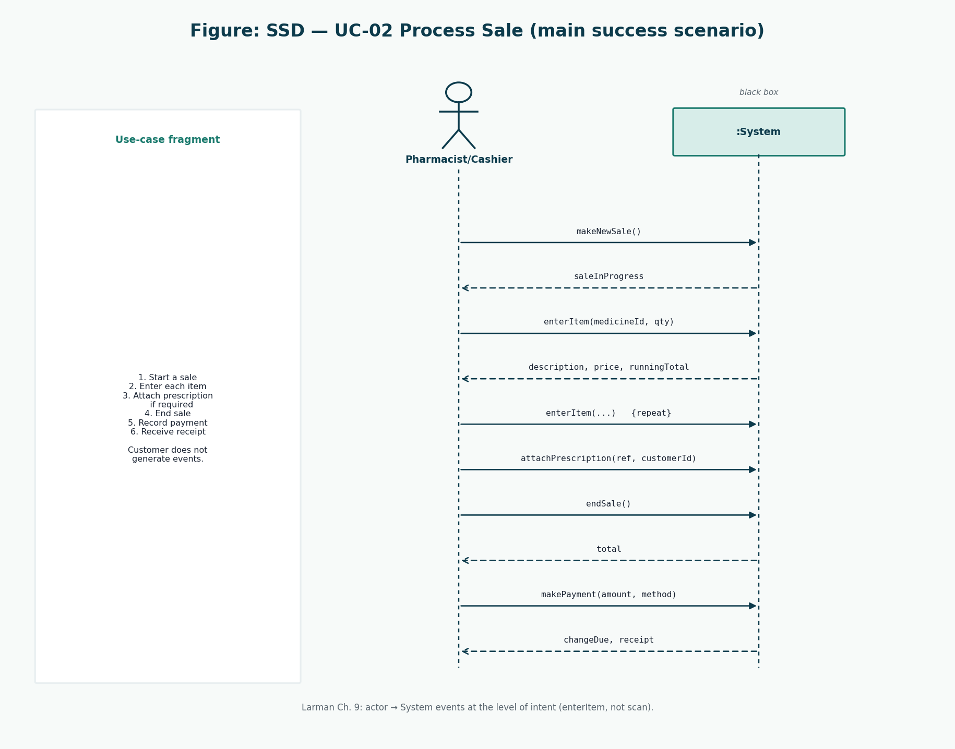
Figure 2: SSD for UC-02 Process Sale
System events: makeNewSale, enterItem, attachPrescription, endSale, makePayment. The Customer generates none of them.
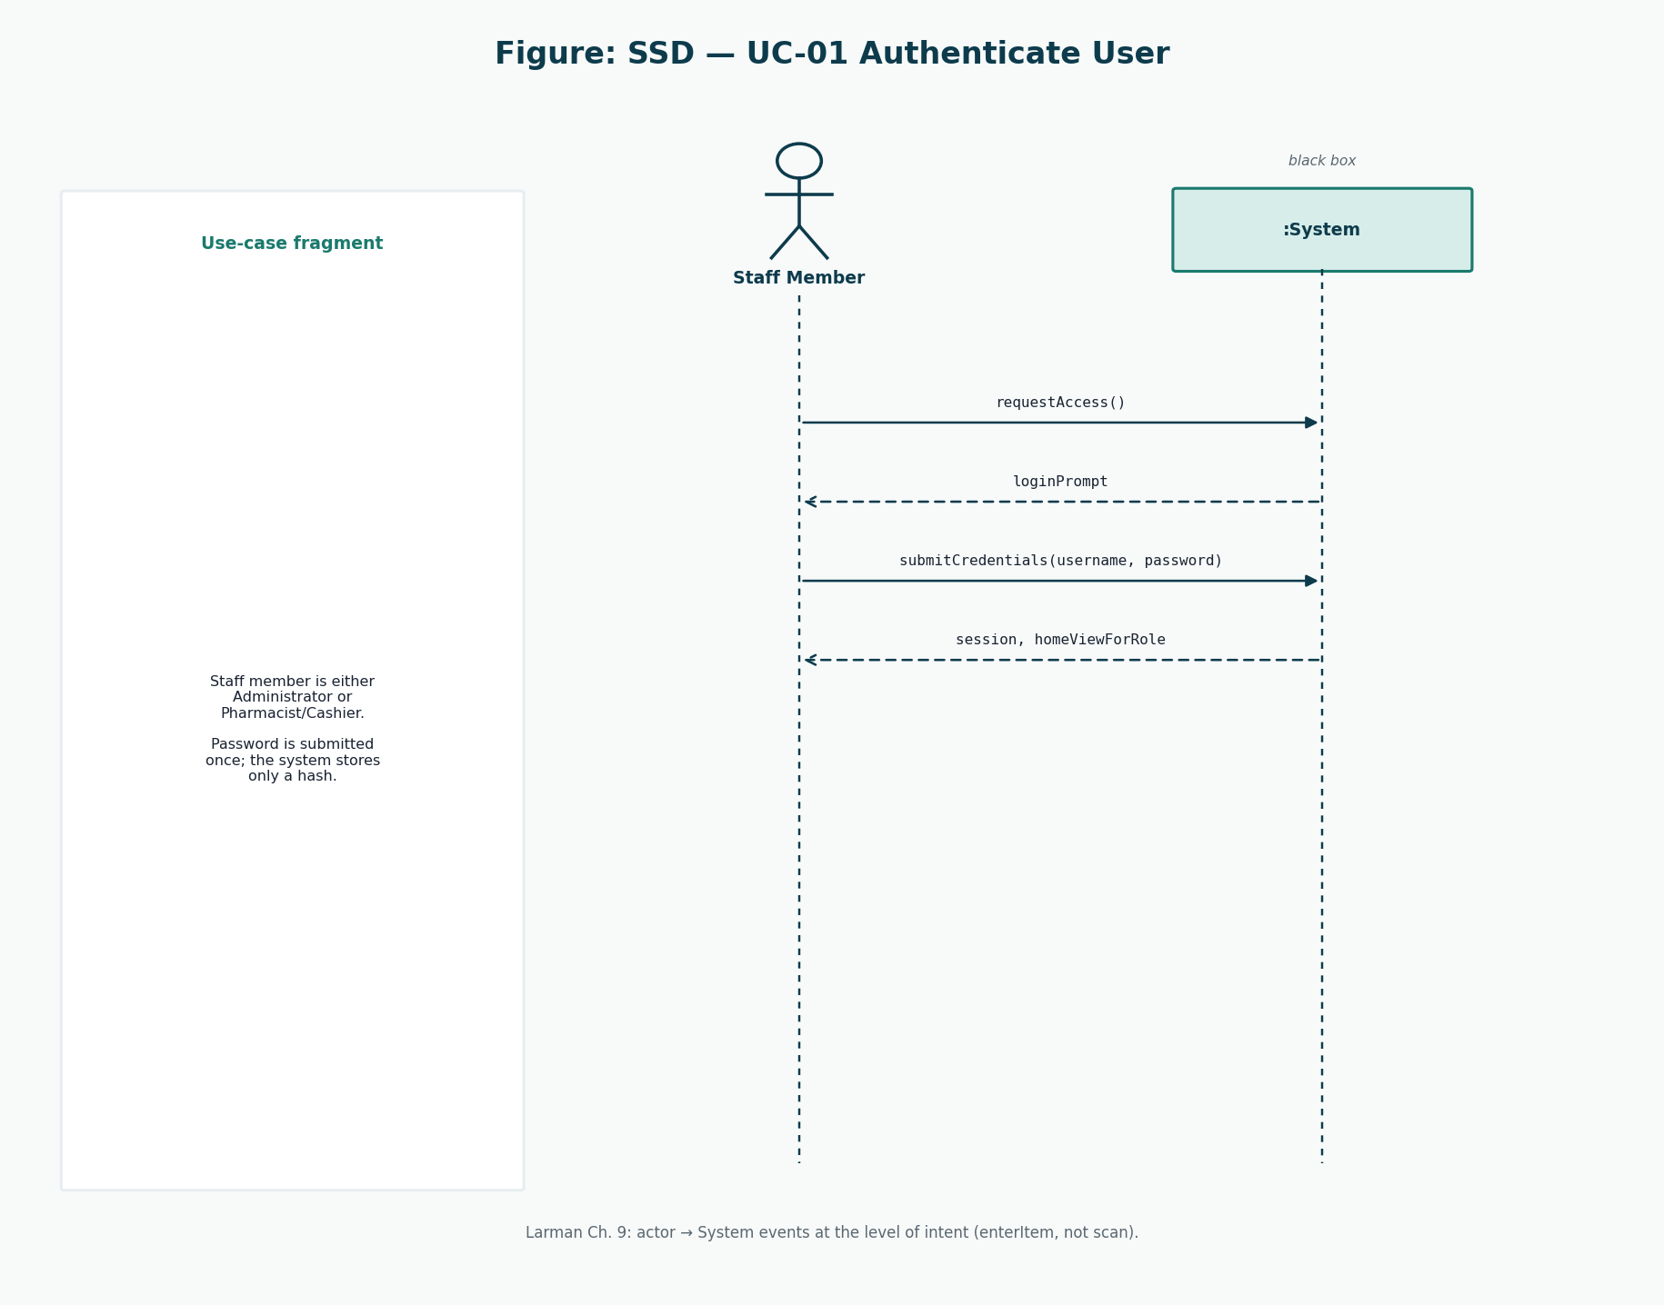
Figure 3: SSD for UC-01 Authenticate User
submitCredentials is the intent-level event. Role-specific home view is the output.
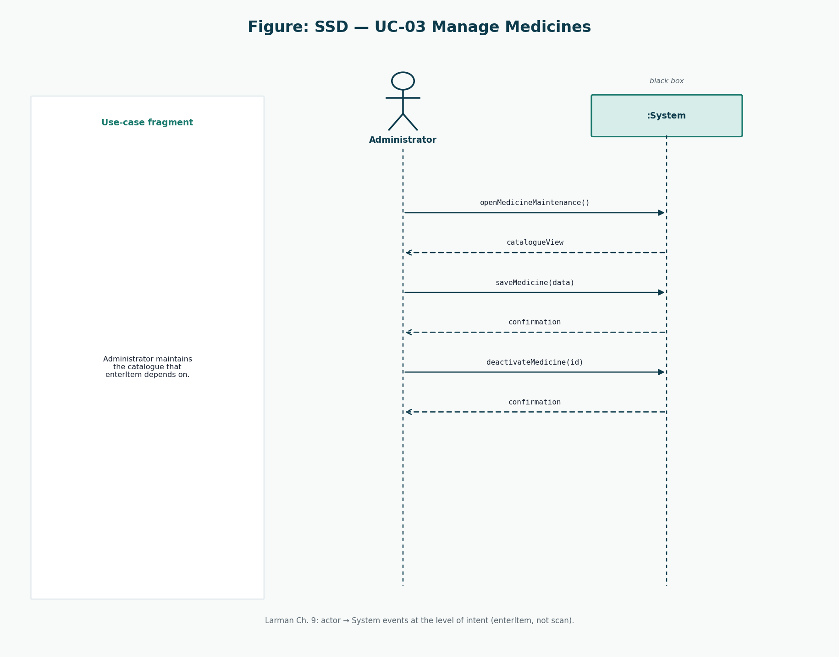
Figure 4: SSD for UC-03 Manage Medicines
saveMedicine and deactivateMedicine are Administrator system events.

7. Domain Model
The domain model is conceptual. It lists ideas the business already has, not software controllers. Methods are omitted on purpose (Larman: do not confuse the domain model with a design class diagram).
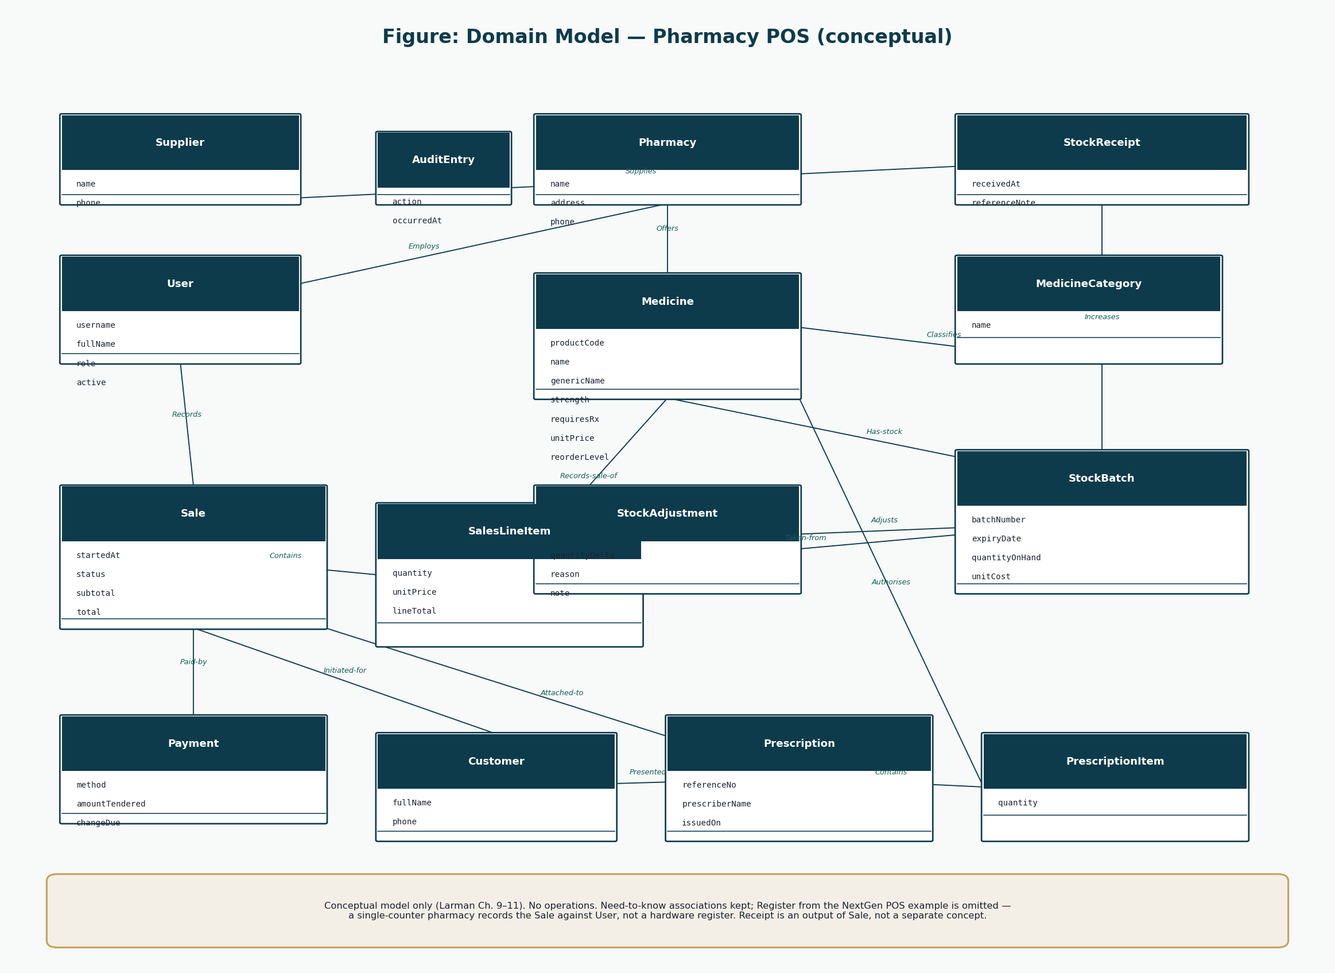
Figure 5: Conceptual domain model
Need-to-know associations are kept. NextGen’s Register is omitted: a single-counter pharmacy records Sale against User. Receipt is an output, not a concept.

8. Conceptual Classes
Conceptual class | Meaning in this pharmacy
Pharmacy | The pharmacy that owns catalogue, stock, users, and sales.
User | A person with a system account. Role is Administrator or Pharmacist/Cashier.
Medicine | A sellable pharmaceutical product definition (catalogue item).
MedicineCategory | A grouping such as antibiotic, analgesic, or OTC sundry.
StockBatch | A physical quantity of a medicine with batch number and expiry.
Sale | A sales transaction in progress or completed.
SalesLineItem | One medicine and quantity on a sale.
Payment | Money recorded against a sale (cash, card, or mobile money).
Customer | A patient or buyer recorded when a name is required.
Prescription | A recorded authority to dispense specific medicines.
PrescriptionItem | One medicine and quantity authorised on a prescription.
Supplier | An external wholesaler or manufacturer source of stock.
StockReceipt | A delivery of stock from a supplier.
StockReceiptLine | One batch line on a stock receipt.
StockAdjustment | A non-sale quantity change with a reason.
AuditEntry | A recorded security- or stock-sensitive action.

Medicine is the catalogue description. StockBatch is the physical, expiring quantity. That split is the pharmacy analogue of Larman’s ProductSpecification versus Item, adapted rather than copied: pharmacies care about batch number and expiry more than about serialized items.

9. Architectural Proof-of-Concept
The PoC question is not “can we draw four boxes?” It is: can makeNewSale, enterItem, endSale, and makePayment travel from a view through a controller into Sale and StockBatch and back out through a repository without the view knowing SQL, and without completing a sale if stock cannot move?
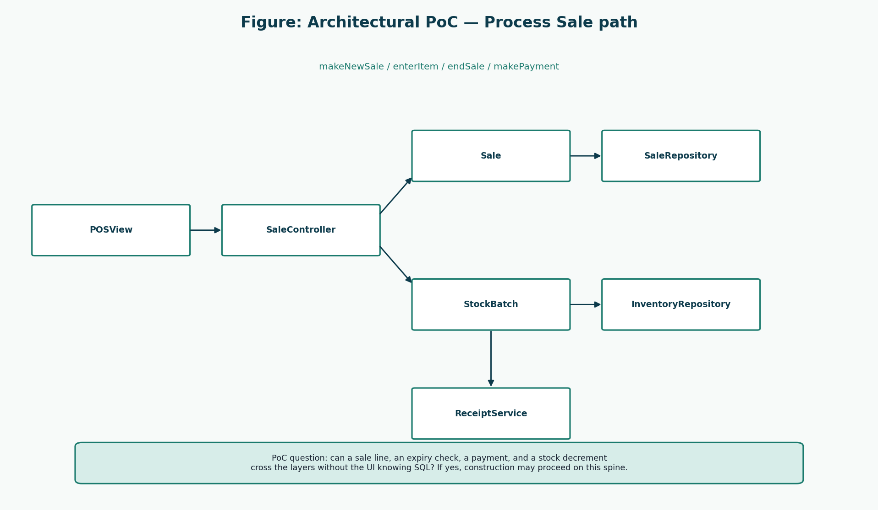
Figure 6: Process Sale path used as the proof-of-concept
If this path cannot be explained, Construction of reports or user-admin would be theatre.

10. Layered Architecture
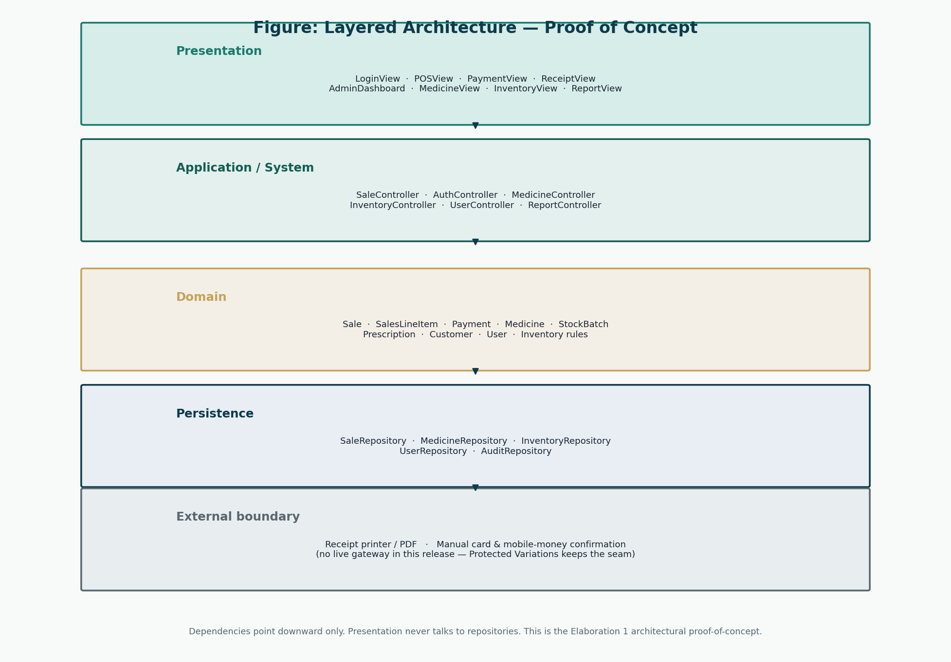
Figure 7: Layered architecture
Dependencies point down. Presentation never imports repositories. External payment gateways remain a seam, not a dependency of Sale.
Layer | Responsibility | Depends on | Major components
Presentation | Screens and user gestures | Application | LoginView, POSView, PaymentView, admin views
Application | System events (GRASP Controller) | Domain | SaleController, AuthController, MedicineController
Domain | Pharmacy rules and totals | nothing above | Sale, SalesLineItem, StockBatch, Payment, Medicine
Persistence | Store and reconstitute aggregates | database engine (later) | SaleRepository, InventoryRepository
External boundary | Printer / manual pay confirm | called via Indirection | ReceiptService, PaymentMethod implementations

11. Architectural Decisions
ID | Decision | Rationale | Alternative rejected
AD-01 | Layered architecture | Marking guide example; separates UI from rules | Smart UI with SQL in button handlers
AD-02 | Use-case controllers | Larman Controller; maps 1:1 to SSDs | One god service for the whole system
AD-03 | Two roles as an enumeration on User | Project rule; avoids a role table that invites a third role | Free-text role names
AD-04 | Batch-level stock | Expiry and recall require it | A single quantity on Medicine
AD-05 | Manual confirmation of card/mobile money | A-04; Protected Variations keeps a PaymentMethod seam | Pretending a live gateway exists
AD-06 | No Register class | Single counter; User records the sale | Copying NextGen Register without a need-to-know reason
AD-07 | Documentation before code | Group instruction and risk R-07 | Coding screens during Inception

12. Initial Database Design Concept
Persistence is still a design idea. Tables that must exist later are already implied by the domain model: users, medicines, stock_batches, sales, sale_items, payments, customers, prescriptions. Passwords will be hashes. The full schema, ERD, and normalisation argument belong to Elaboration 2 so that this iteration stays on behaviour and architecture.
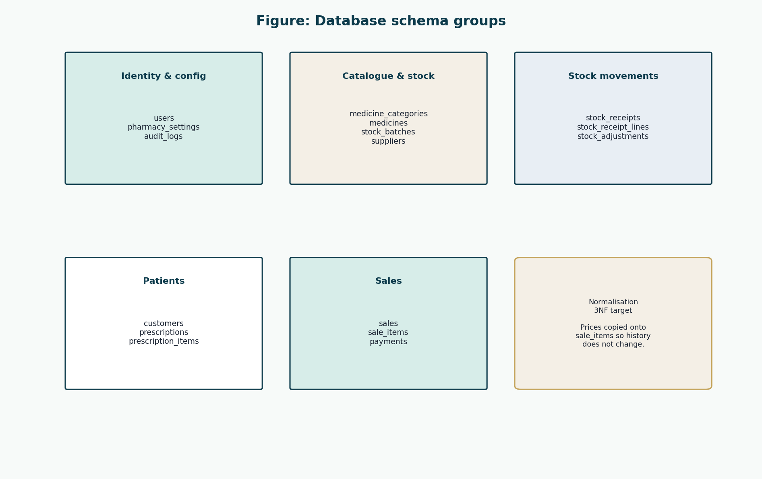
Figure 8: Intended schema groups (concept only)
Groups, not CREATE TABLE scripts. Implementation SQL is forbidden until START IMPLEMENTATION.

13. Updated Risk Register
ID | Risk | P | I | Priority | Mitigation | Iteration | Status
R-01 | Sale and stock update diverge. | Medium | High | High | PoC specifies a single application transaction around completeSale. | Elaboration 1 | Mitigating
R-02 | Expired medicine can be sold. | Low | High | Medium | Domain rule specified: only unexpired sellable batches are chosen. | Elaboration 1 | Mitigating
R-03 | Third-role creep. | Low | High | Medium | Use-case and SSD actors confirmed as two system users. | Elaboration 1 | Mitigating
R-04 | Payment / sale inconsistency. | Medium | High | High | SSD and operation contract tie makePayment to completion. | Elaboration 1 | Mitigating
R-05 | Staff resist new workflow. | Medium | Medium | Medium | Sales screen concept kept on one surface. | Elaboration 1 | Open
R-06 | Scope creep. | Medium | High | Medium | Insurance and web shop remain out of scope. | Elaboration 1 | Mitigating
R-07 | Schedule slip. | Medium | High | High | Iteration 1 limited to 30% architecturally significant use cases. | Elaboration 1 | Mitigating
R-08 | Data loss. | Low | High | Medium | Logical schema started; physical DB still construction. | Elaboration 1 | Open
R-09 | Prescription legal sufficiency. | Medium | Medium | Medium | attachPrescription is a first-class system event. | Elaboration 1 | Mitigating
R-10 | Architecture unfit for POS. | Low | High | Medium | Layered PoC documented with clear dependencies. | Elaboration 1 | Mitigating

14. Risk Analysis
R-01 and R-04 are the same family: money and stock must move together. The PoC answers them with a single completion operation. R-02 is answered by StockBatch as Information Expert. R-10 is answered by the layer diagram. R-05 (training) is not an architecture risk and is left open for Transition. No risk is marked “closed by implementation” because implementation has not started.

15. Iteration Results
Planned | Result in this documentation pack
30% detailed use cases | UC-01, UC-02, UC-03 fully dressed
Key scenarios | SC-01 to SC-04
SSDs | UC-01, UC-02, UC-03
Domain model | Conceptual classes and associations
Architectural PoC | Layered design + sale path
Updated risks | Statuses moved to Mitigating where design exists
Working application | Not produced — correctly out of this iteration’s documentation objective

16. Conclusion
Iteration 1 has a behavioural spine and an architecture that can carry it. Iteration 2 must finish the use-case set, assign methods with GRASP, prototype the UI, and lock the logical database — still without writing the product.

References
[1] Larman, C. Applying UML and Patterns: An Introduction to Object-Oriented Analysis and Design and Iterative Development. 3rd edition. Prentice Hall. Principal methodology for UP, use cases, domain models, SSDs, design class diagrams, GRASP, and iterative development. Page numbers are not cited because the full print edition was not available as a continuous source file; chapter titles from the course extracts (System Sequence Diagrams; Domain Model associations; Design Class Diagrams) are used instead.
[2] CSC 4630 Advanced Software Engineering Course Project Marking Guide. Unified Process, 15 weeks, 100 marks. Determines milestones, deliverables, and mark weights.
[3] Larman course extracts used by the group: Chapter 9 System Sequence Diagrams; Chapter 11 Domain Model associations; Chapter 16 Design Class Diagrams.
[4] Group 20 inception briefing slides, Pharmacy POS System — Advanced Software Engineering (problem context in Zambia). Role names in those slides that implied a separate Cashier or Manager were corrected in this documentation to match the two-role rule.

