CSC 4630 · GROUP 20
Elaboration Iteration 2 Report
Remaining use cases, design classes, GRASP, UI prototypes, schema

CSC 4630 – Advanced Software Engineering
Group 20
Lecturer: [Lecturer Name]
University: [University Name]
September 2026
Unified Process (UP) — Iterative and Incremental
Analysis and design artefact. No application source code is included. Implementation starts only after the instruction START IMPLEMENTATION.

Table of Contents
Right-click and choose Update Field in Microsoft Word to refresh the table of contents.
In Word: References → Update Table, or right-click the field above.

1. Introduction
Elaboration Iteration 2 is risk-driven design. The marking guide awards 15 marks for the remaining 70% of use cases, refined design class diagrams with methods, UI prototypes, and risk-mitigation progress. The group still does not implement the application.

2. Iteration Objectives
- Fully dress UC-04 through UC-10.
- Add SSDs where the system events are not obvious from Iteration 1.
- Produce design class diagrams derived from events → responsibilities → GRASP.
- Prototype Administrator and Pharmacist/Cashier screens that match the use cases.
- Publish the logical database schema and ERD.
- Show how risks moved from “open” to “mitigated in design”.

3. Remaining Use Cases
Seventy percent of ten use cases is seven. They widen administration and the exceptional sale path.
ID | Name | Actor | Priority | Iteration | FR
UC-04 | Manage Inventory | Administrator | High | Elaboration 2 (remaining 70%) | FR-10, FR-11, FR-12
UC-05 | Manage Users | Administrator | High | Elaboration 2 (remaining 70%) | FR-13, FR-19
UC-06 | Manage Suppliers | Administrator | Medium | Elaboration 2 (remaining 70%) | FR-14
UC-07 | View Reports | Administrator | Medium | Elaboration 2 (remaining 70%) | FR-15
UC-08 | Record Customer | Pharmacist/Cashier | Medium | Elaboration 2 (remaining 70%) | FR-16
UC-09 | Void Sale | Pharmacist/Cashier | High | Elaboration 2 (remaining 70%) | FR-17, FR-19
UC-10 | Configure Pharmacy | Administrator | Low | Elaboration 2 (remaining 70%) | FR-18

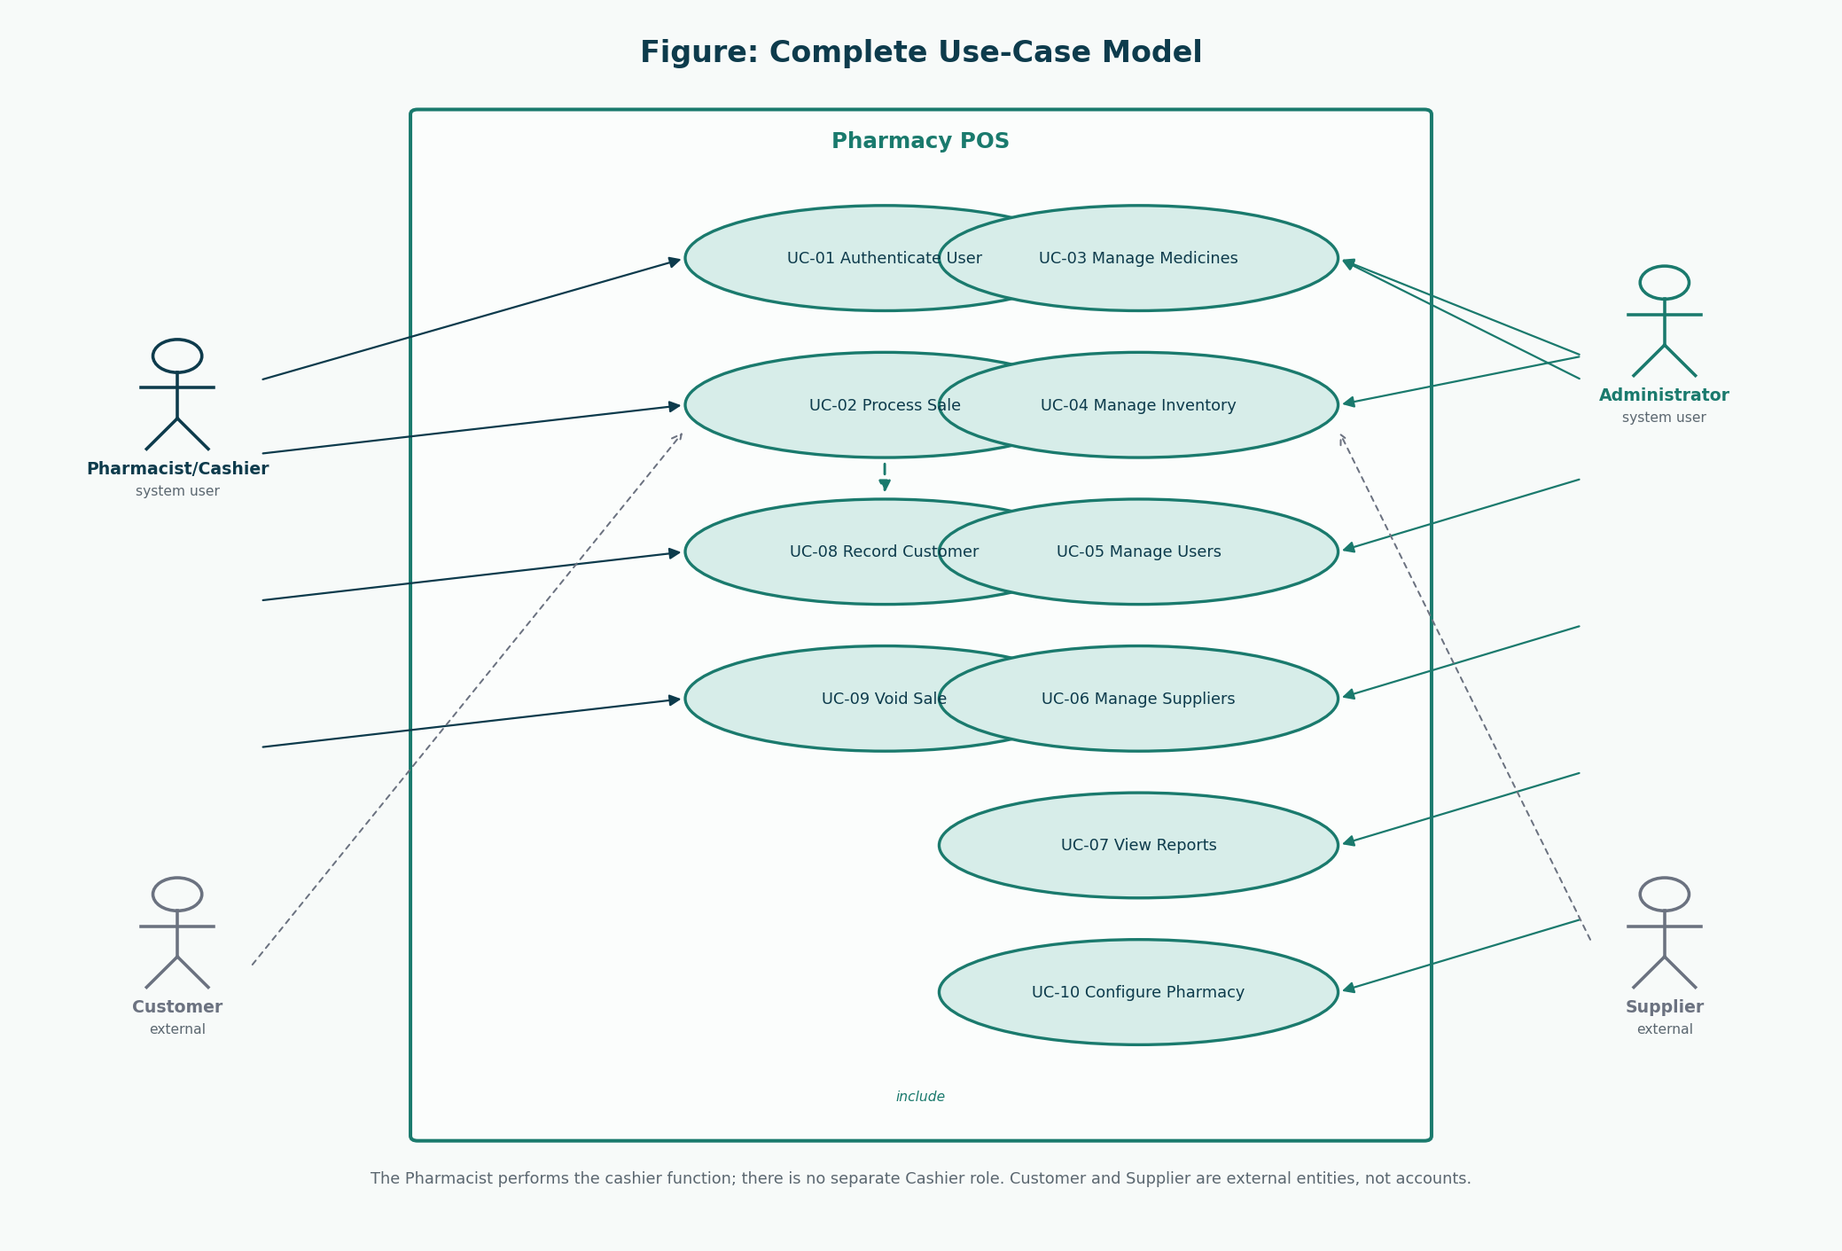
Figure 1: Complete use-case model
Same model as Inception’s outline, now with fully dressed descriptions below.

4. Detailed Use Cases

UC-04 Manage Inventory
Field | Description
ID | UC-04
Name | Manage Inventory
Scope | Pharmacy POS application
Level | User goal
Primary actor | Administrator
Priority | High
Iteration | Elaboration 2 (remaining 70%)
Requirements | FR-10, FR-11, FR-12
Preconditions | Administrator is authenticated. For receiving, the supplier and medicine already exist.
Success guarantee | A stock receipt or adjustment is stored; batch quantities change; alerts refresh.
Special requirements | Every adjustment requires a reason. Receipts of stock are not performed by the Pharmacist/Cashier role.
Technology / data variations | Keyboard entry of supplier documents.
Frequency | Deliveries and periodic stock checks.

Stakeholders and interests
Stakeholder | Interest
Administrator | Stock on the shelf matches the system.
Pharmacist/Cashier | Sellable quantities shown at the counter are trustworthy.

Main success scenario
1. The Administrator chooses Receive Stock or Adjust Stock.
2. Receive: the Administrator selects a supplier and adds lines (medicine, batch number, expiry, quantity, cost).
3. The system creates or increases a StockBatch and records a StockReceipt.
4. Adjust: the Administrator selects a batch, quantity change, and reason (damage, expiry removal, recount, recall).
5. The system applies the adjustment if the resulting quantity would not be negative.
6. The system updates low-stock and near-expiry views.
Extensions
- 2a. Expiry date is not in the future for a new receipt: the system warns; the Administrator may cancel.
- 5a. Adjustment would make quantity negative: the system refuses.
- 5b. Expiry removal of an entire batch: quantity becomes zero and the batch is not sellable.

UC-05 Manage Users
Field | Description
ID | UC-05
Name | Manage Users
Scope | Pharmacy POS application
Level | User goal
Primary actor | Administrator
Priority | High
Iteration | Elaboration 2 (remaining 70%)
Requirements | FR-13, FR-19
Preconditions | Administrator is authenticated.
Success guarantee | A user account exists or is updated with exactly one of the two roles.
Special requirements | At least one active Administrator should remain.
Technology / data variations | Office workstation.
Frequency | Staff join, leave, or forget passwords.

Stakeholders and interests
Stakeholder | Interest
Administrator | Only intended people can log in.
Staff member | Receives a working account of the correct role.

Main success scenario
1. The Administrator opens user maintenance.
2. The Administrator creates or selects a user.
3. The Administrator assigns username, full name, role (Administrator or Pharmacist/Cashier), and an initial password.
4. The system stores a password hash, not the password itself.
5. The Administrator may later deactivate the account or reset the password.
Extensions
- 3a. A third role is requested: the system does not offer one.
- 3b. Duplicate username: the system rejects the save.

UC-06 Manage Suppliers
Field | Description
ID | UC-06
Name | Manage Suppliers
Scope | Pharmacy POS application
Level | User goal
Primary actor | Administrator
Priority | Medium
Iteration | Elaboration 2 (remaining 70%)
Requirements | FR-14
Preconditions | Administrator is authenticated.
Success guarantee | Supplier name and contact details are stored or updated.
Special requirements | Suppliers are not system users and cannot log in.
Technology / data variations | Office workstation.
Frequency | When a new wholesaler is used.

Stakeholders and interests
Stakeholder | Interest
Administrator | Can identify who supplied a batch.

Main success scenario
1. The Administrator opens supplier maintenance.
2. The Administrator creates or edits name, phone, and address.
3. The system validates the name and saves the supplier.
Extensions
- 3a. Duplicate active supplier name: the system warns before save.

UC-07 View Reports
Field | Description
ID | UC-07
Name | View Reports
Scope | Pharmacy POS application
Level | User goal
Primary actor | Administrator
Priority | Medium
Iteration | Elaboration 2 (remaining 70%)
Requirements | FR-15
Preconditions | Administrator is authenticated.
Success guarantee | A report for the selected type and date range is displayed.
Special requirements | Reports are read-only.
Technology / data variations | Screen display; printing is a technology variation.
Frequency | Daily close and periodic review.

Stakeholders and interests
Stakeholder | Interest
Pharmacy owner / Administrator | Sees sales value and stock movement for a period.

Main success scenario
1. The Administrator chooses a report type (daily sales, period sales, low stock, near expiry).
2. The Administrator enters a date range where applicable.
3. The system aggregates stored sales and stock data and displays the report.
Extensions
- 3a. No data in range: the system shows an empty report, not an error.

UC-08 Record Customer
Field | Description
ID | UC-08
Name | Record Customer
Scope | Pharmacy POS application
Level | User goal
Primary actor | Pharmacist/Cashier
Priority | Medium
Iteration | Elaboration 2 (remaining 70%)
Requirements | FR-16
Preconditions | Pharmacist/Cashier is authenticated.
Success guarantee | A customer record is found or created and can be linked to the current sale.
Special requirements | Minimal data: a name is enough. Extra medical history is out of scope.
Technology / data variations | Sales screen or a small customer dialog.
Frequency | Whenever a prescription-linked sale needs a named patient.

Stakeholders and interests
Stakeholder | Interest
Pharmacist/Cashier | Can attach a patient name to a prescription sale.
Customer | Is not forced to register for a simple OTC sale.

Main success scenario
1. The Pharmacist/Cashier searches by name or phone.
2. If found, the Pharmacist/Cashier selects the customer.
3. If not found, the Pharmacist/Cashier enters name and optional phone and address.
4. The system stores the customer and returns the identifier.
Extensions
- 1a. Search is skipped for a purely OTC sale: this use case is not required.

UC-09 Void Sale
Field | Description
ID | UC-09
Name | Void Sale
Scope | Pharmacy POS application
Level | User goal
Primary actor | Pharmacist/Cashier
Priority | High
Iteration | Elaboration 2 (remaining 70%)
Requirements | FR-17, FR-19
Preconditions | Pharmacist/Cashier is authenticated. A sale in progress or a completed sale from the current business day is selected.
Success guarantee | The sale is marked void. If it had reduced stock, quantities are restored. An audit entry exists.
Special requirements | Voids are retained historically. There is no silent delete.
Technology / data variations | Sales screen.
Frequency | Occasional error correction.

Stakeholders and interests
Stakeholder | Interest
Pharmacist/Cashier | Can correct a mistake without corrupting stock.
Auditor | Sees that the original sale was voided, not silently deleted.

Main success scenario
1. The Pharmacist/Cashier selects the sale and chooses Void.
2. The system demands a reason.
3. The Pharmacist/Cashier enters the reason and confirms.
4. The system marks the sale void, reverses stock for completed sales, and writes the audit entry.
Extensions
- 1a. Sale is already void: the system refuses a second void.
- 3a. Confirmation cancelled: no change.

UC-10 Configure Pharmacy
Field | Description
ID | UC-10
Name | Configure Pharmacy
Scope | Pharmacy POS application
Level | User goal
Primary actor | Administrator
Priority | Low
Iteration | Elaboration 2 (remaining 70%)
Requirements | FR-18
Preconditions | Administrator is authenticated.
Success guarantee | Pharmacy name, address, receipt footer, and near-expiry days are stored.
Special requirements | Settings are not a third user role.
Technology / data variations | Office workstation.
Frequency | Setup and rare changes.

Stakeholders and interests
Stakeholder | Interest
Administrator | Receipts and alerts show the correct pharmacy identity.

Main success scenario
1. The Administrator opens pharmacy settings.
2. The Administrator edits the fields and saves.
3. The system applies the values to new receipts and alert calculations.
Extensions
- 2a. Near-expiry days is not a positive number: the system rejects the save.

5. Additional System Sequence Diagrams
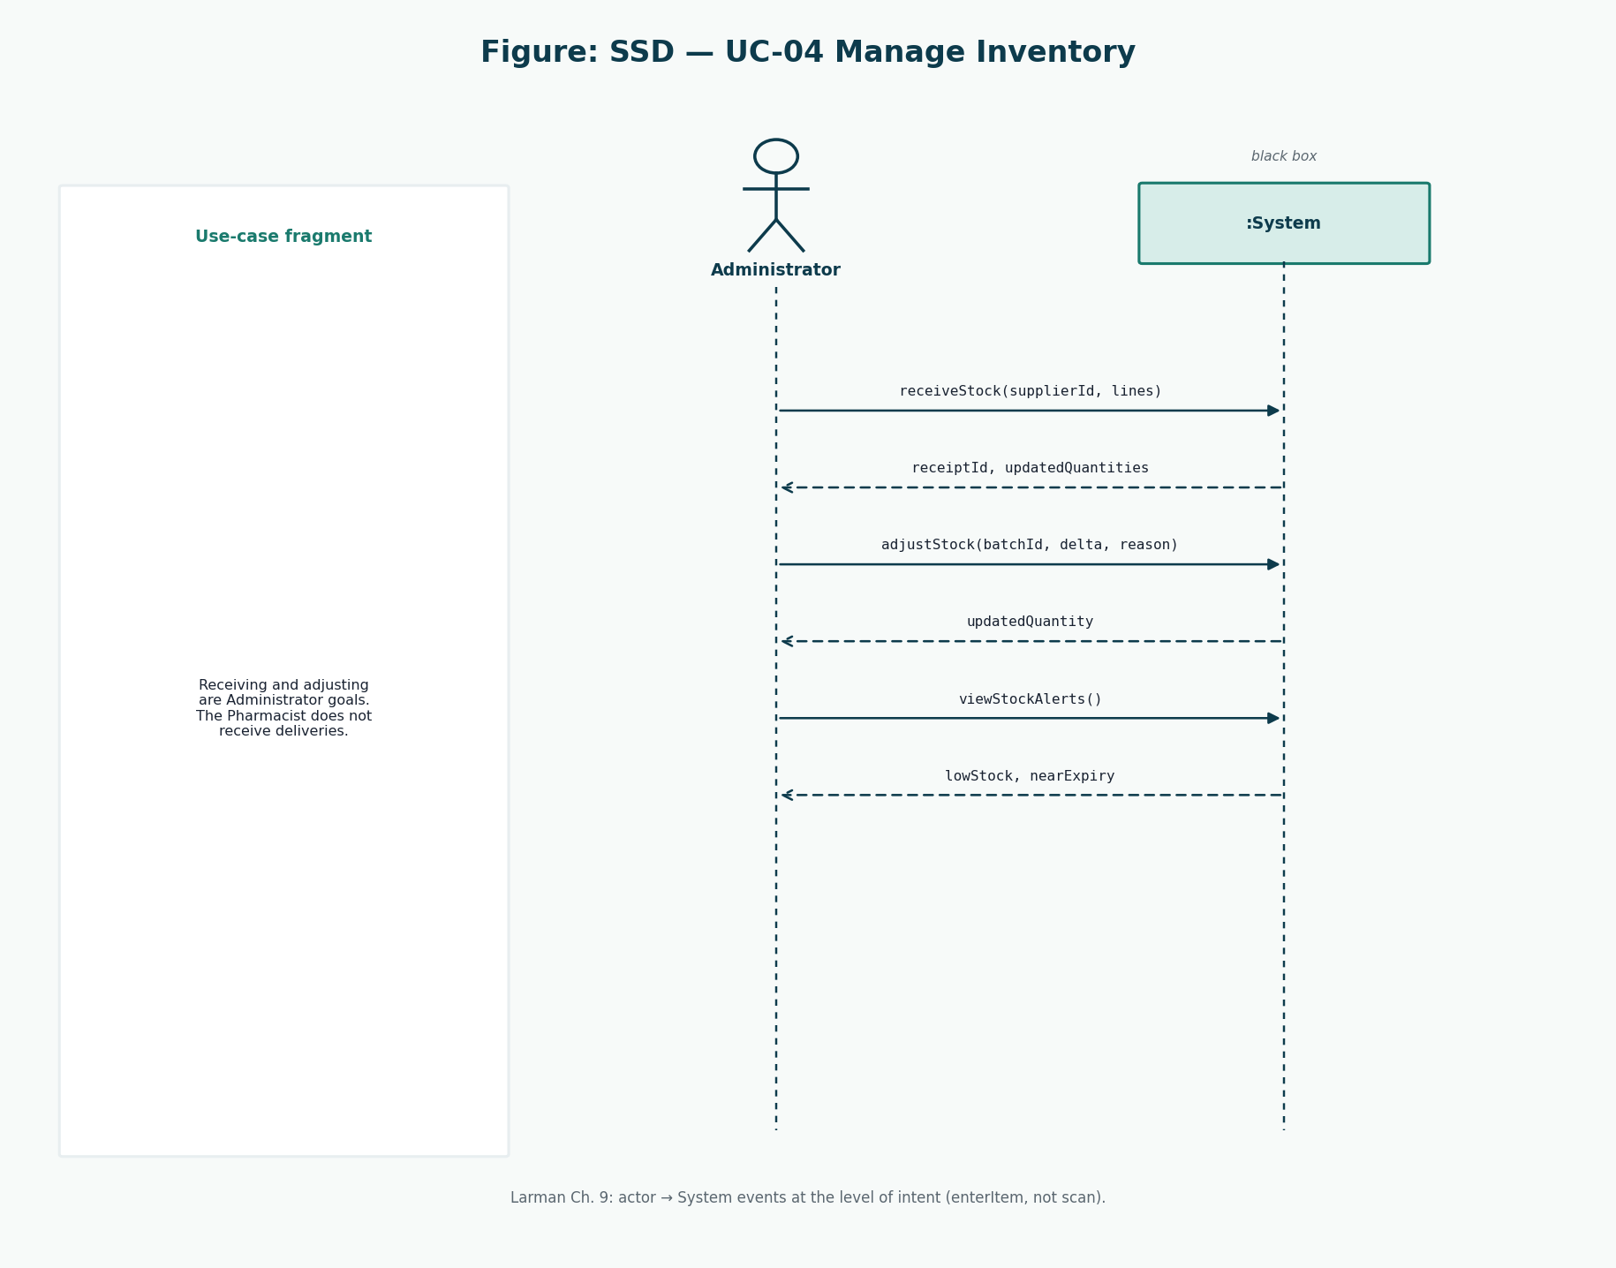
Figure 2: SSD for UC-04 Manage Inventory
receiveStock, adjustStock, and viewStockAlerts are Administrator events.
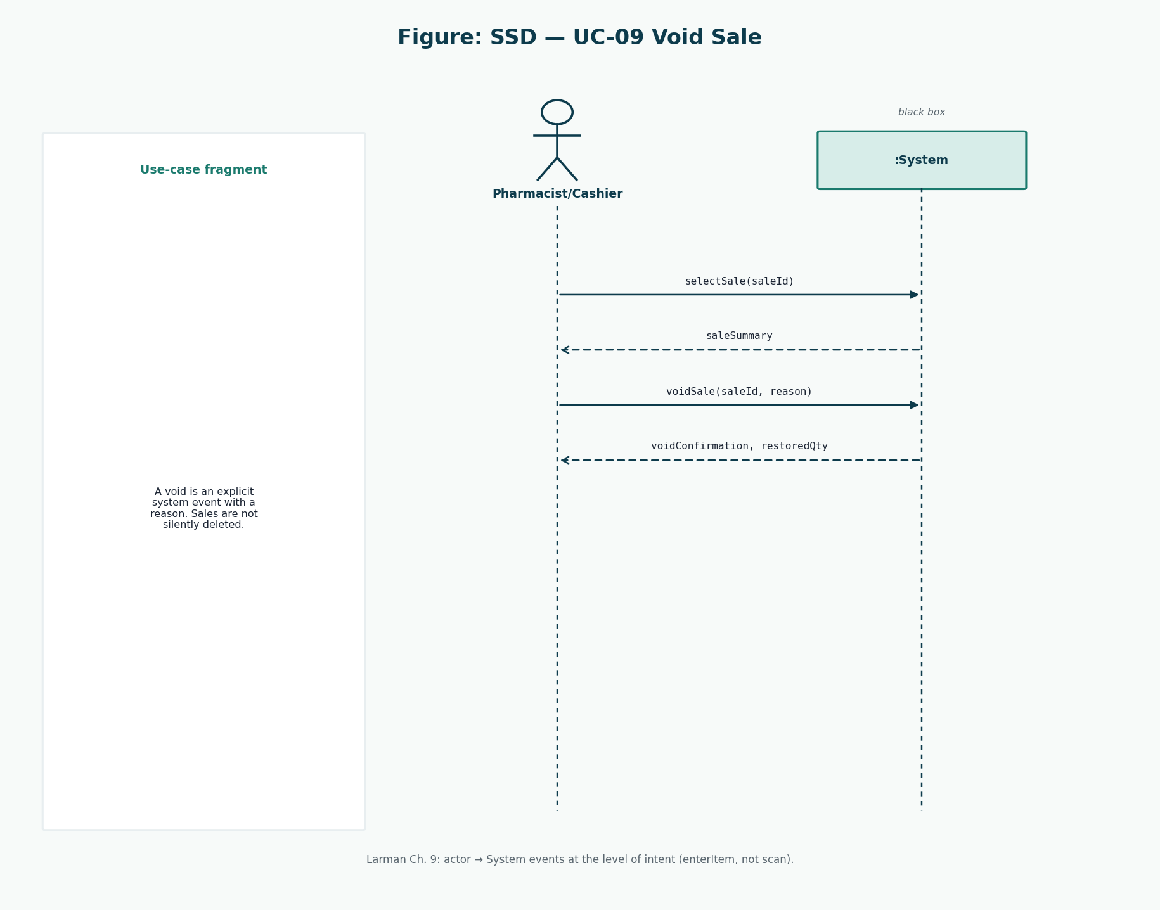
Figure 3: SSD for UC-09 Void Sale
voidSale(saleId, reason) is the intent-level event. There is no deleteSale event.

6. Refined Design
Design starts from the SSD events, not from a pile of tables. UC-02 events become SaleController methods. Those methods delegate to Sale and SaleService. Persistence objects are fabrications. Payment kinds vary behind an interface.
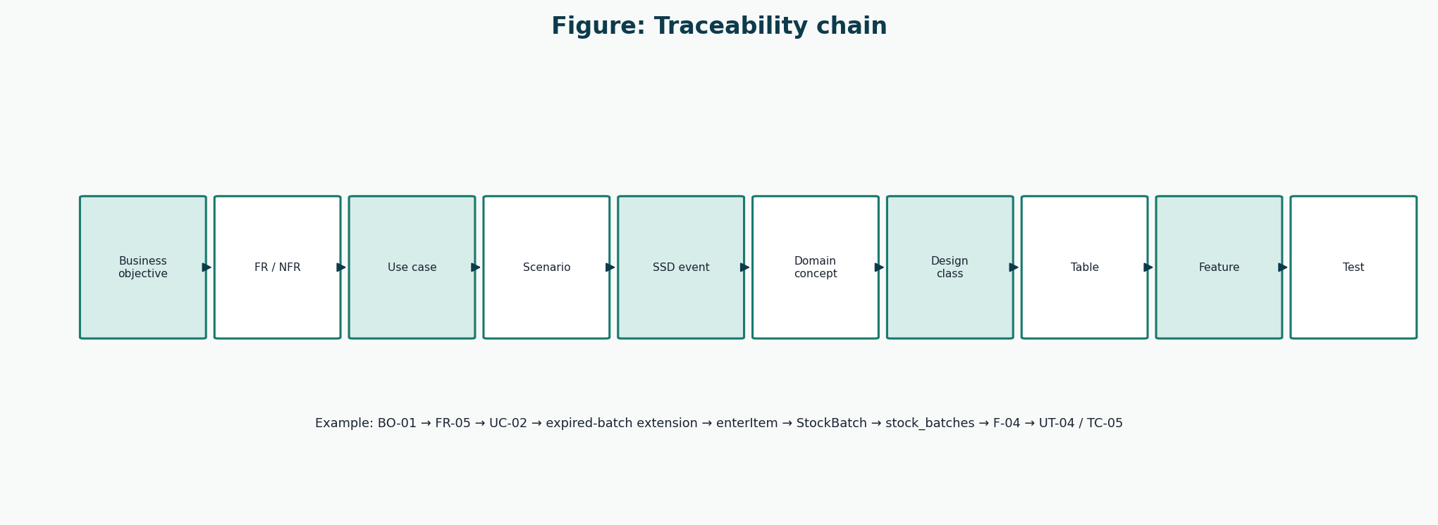
Figure 4: How a requirement becomes a class and a test
The chain is the quality rule for this project: Process Sale is one story in every artefact.

7. Design Class Diagrams
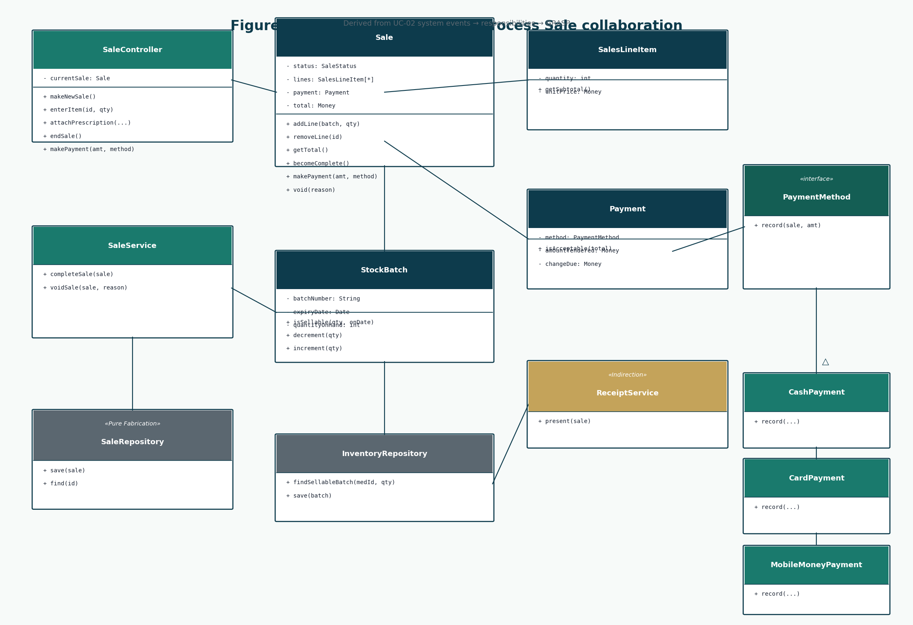
Figure 5: Design classes for Process Sale
Methods come from SSDs and GRASP, not from inventing getters for every column.
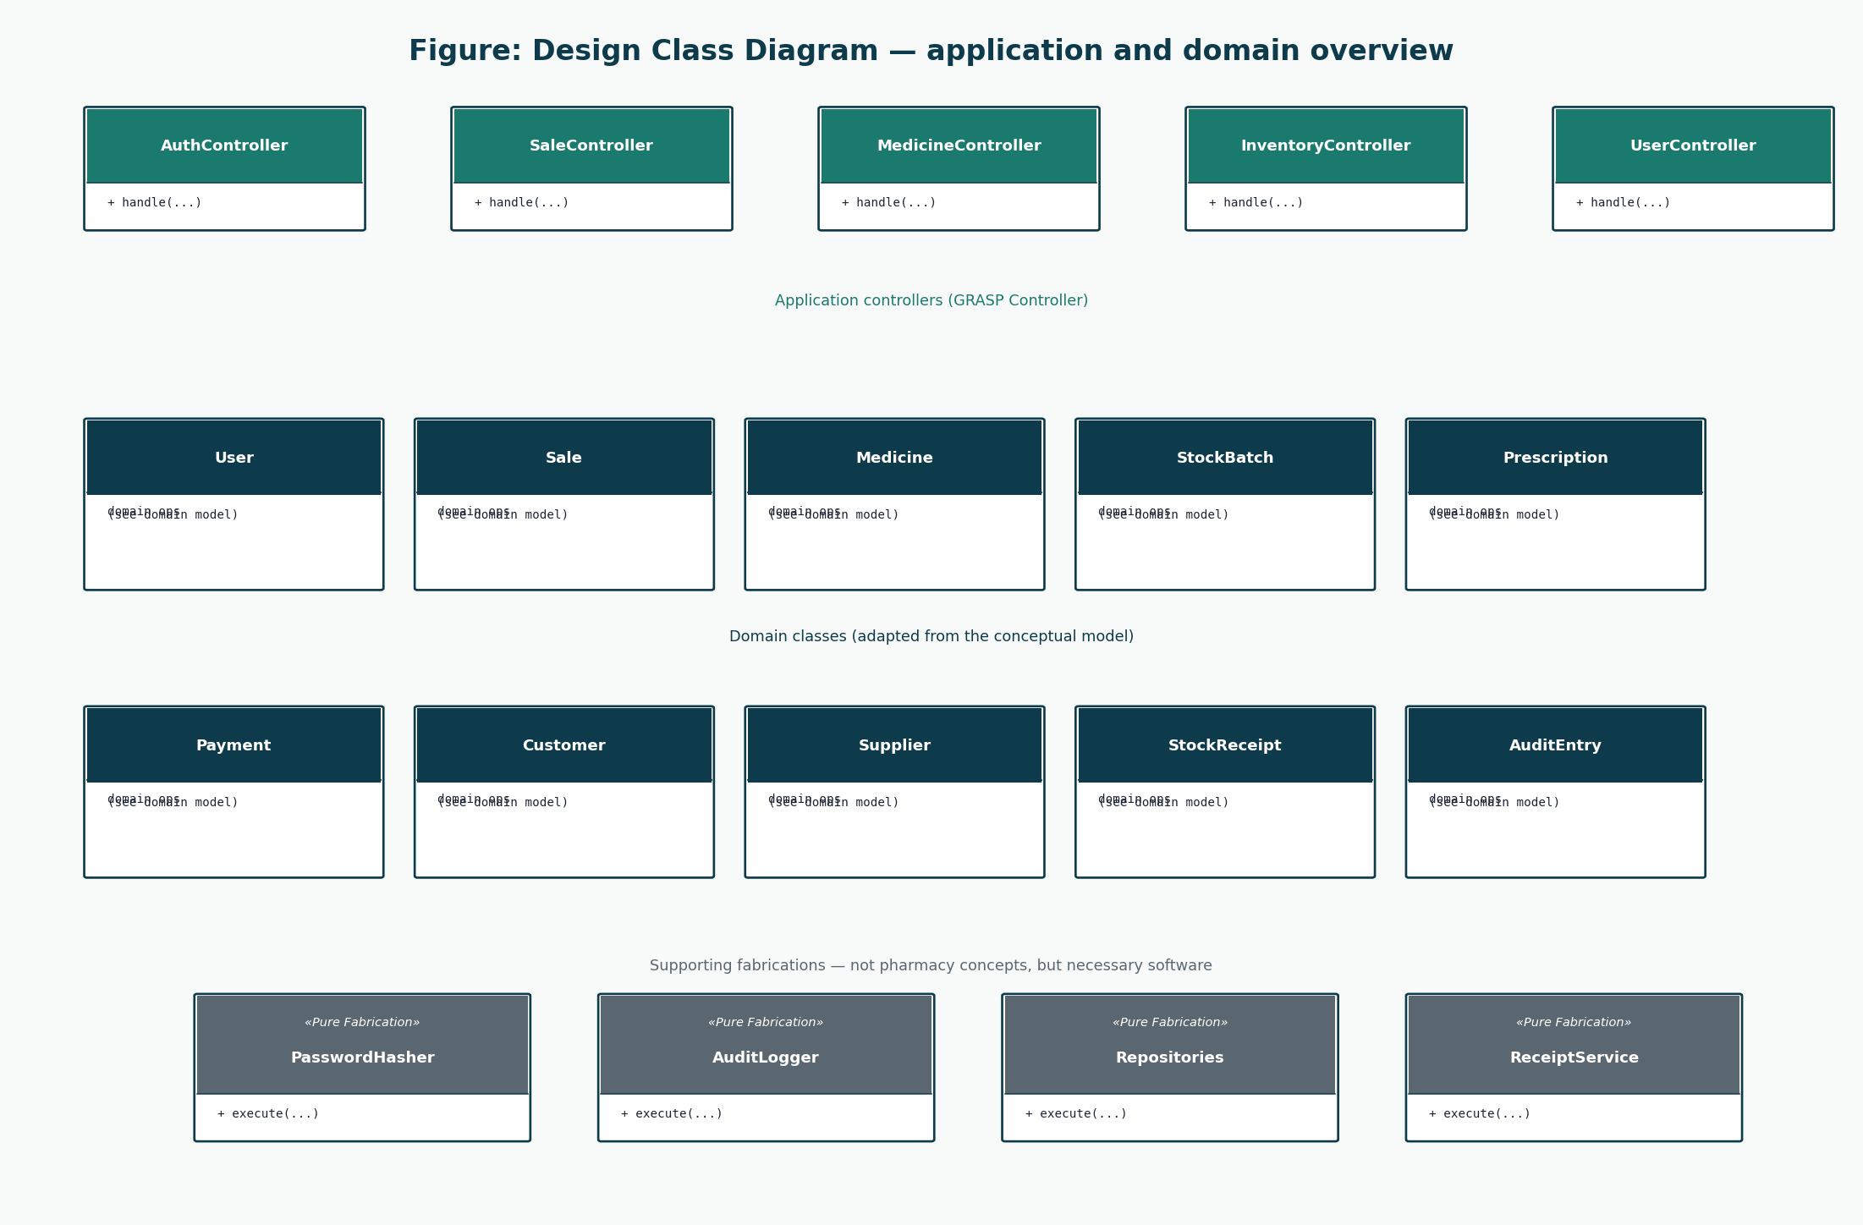
Figure 6: Application, domain, and fabrication overview
Controllers for the other use cases follow the same shape as SaleController.

8. Class Responsibilities
Class | Responsibility | Collaborators
SaleController | Accept UC-02 system events; keep a current sale | SaleService, views
Sale | Hold lines, total, status; create lines and payment | SalesLineItem, Payment
SalesLineItem | Quantity, price, line total | Medicine (price copied)
StockBatch | Expiry, quantity, sellability, increment/decrement | InventoryRepository
SaleService | Complete or void a sale as one unit of work | Sale, repositories, AuditLogger
PaymentMethod | Record a specific tender type | Payment
AuthController | UC-01 events | AuthenticationService, PasswordHasher
MedicineController | UC-03 events | Medicine, MedicineRepository
InventoryController | UC-04 events | StockReceipt, StockAdjustment, StockBatch
UserController | UC-05 events | User, PasswordHasher
ReceiptService | Present a receipt without Sale knowing the device | Sale, pharmacy settings

9. GRASP Analysis
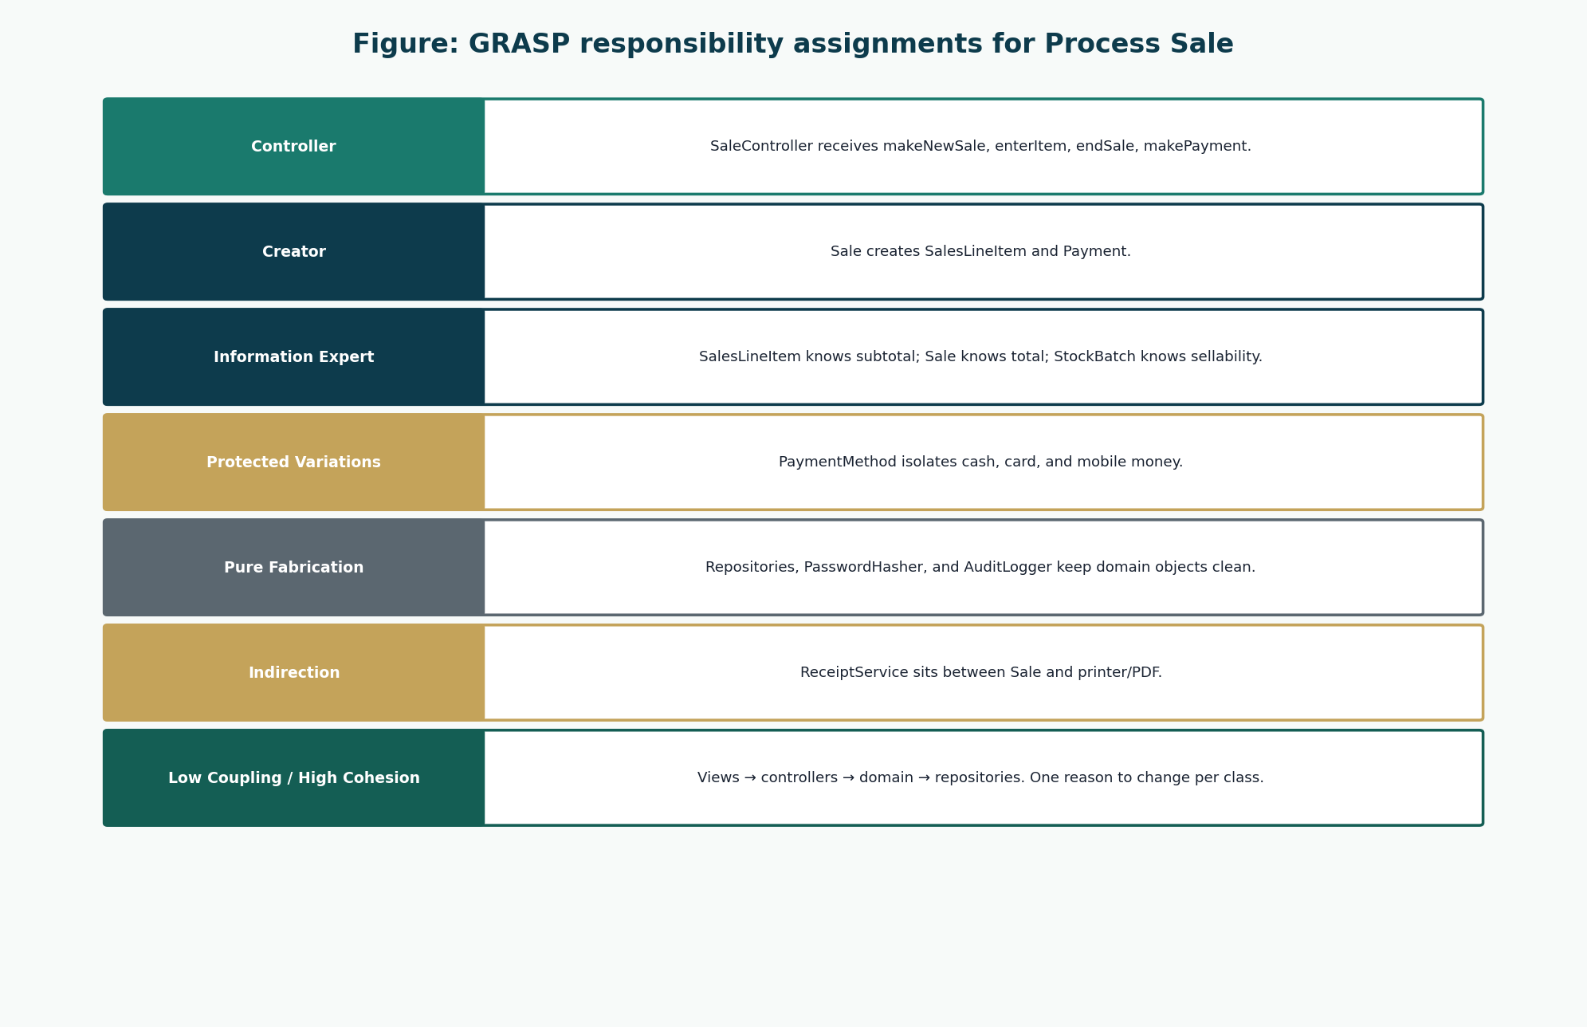
Figure 7: GRASP map for the sale collaboration
Each important operation has a principle, not just a class name.
Responsibility | Class | Collaborators | Why | GRASP
Handle system events of UC-02 | SaleController | SaleService, Sale | A use-case (facade) controller receives actor events without putting UI logic in the domain. | Controller
Create SalesLineItem | Sale | SalesLineItem, Medicine, StockBatch | Sale contains the lines and knows the moment they are added. | Creator
Create Payment | Sale | Payment | Sale records the payment that completes it. | Creator
Know line total | SalesLineItem | Medicine (price copied) | The line has quantity and unit price. | Information Expert
Know sale total | Sale | SalesLineItem | Sale has the lines. | Information Expert
Decide if a batch may be sold | StockBatch | — | The batch knows expiry date and quantity on hand. | Information Expert
Reduce stock | StockBatch / InventoryService | Sale, SalesLineItem | Quantity lives on the batch; a small domain service coordinates multi-line decrement. | Information Expert / High Cohesion
Hash passwords | PasswordHasher | User | Hashing is not a natural pharmacy concept; keep User free of crypto details. | Pure Fabrication
Write audit rows | AuditLogger | controllers / services | Cross-cutting record keeping would clutter Sale or User. | Pure Fabrication
Isolate payment kinds | PaymentMethod (cash, card, mobile money) | Payment, Sale | New methods should not explode conditionals in Sale. | Protected Variations / Polymorphism
Print or show a receipt | ReceiptService | Sale, Pharmacy settings | Output device or PDF should not sit inside Sale. | Indirection
Persist aggregates | SaleRepository and related repositories | domain objects | SQL/API details must not leak into Sale. | Pure Fabrication / Low Coupling
Keep views off repositories | Controllers + services | Views | Presentation depends inward only. | Low Coupling
One reason to change per class | Sale vs SaleController vs SaleRepository | — | Pricing rules, HTTP/UI events, and SQL stay apart. | High Cohesion

10. UI Prototypes
Prototypes are design, not a product. They exist so that UC-02 can be performed on one sales surface and so that Administrator work never appears as extra roles.
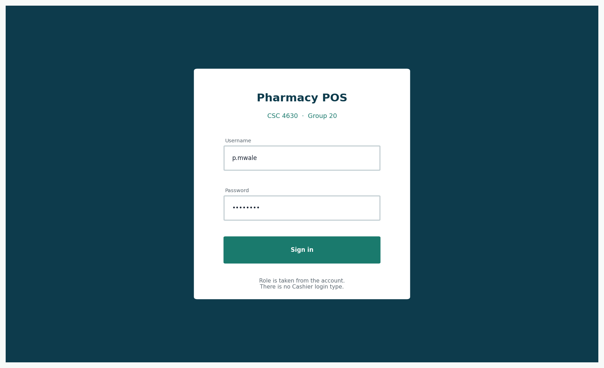
Figure 8: Login
Role is an account attribute, not a third login type.
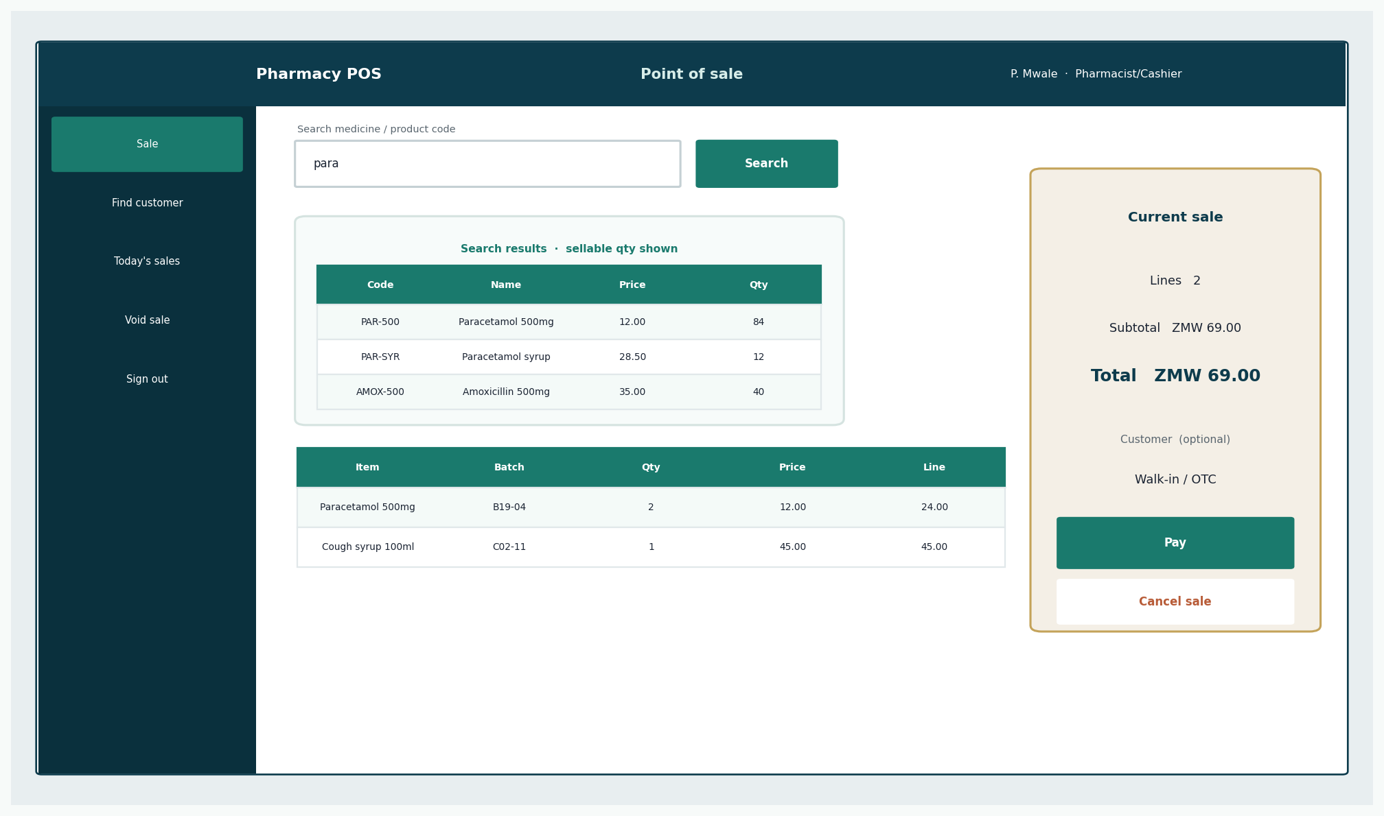
Figure 9: Pharmacist sales screen
Search, cart, batch, and total on one screen (NFR-03).
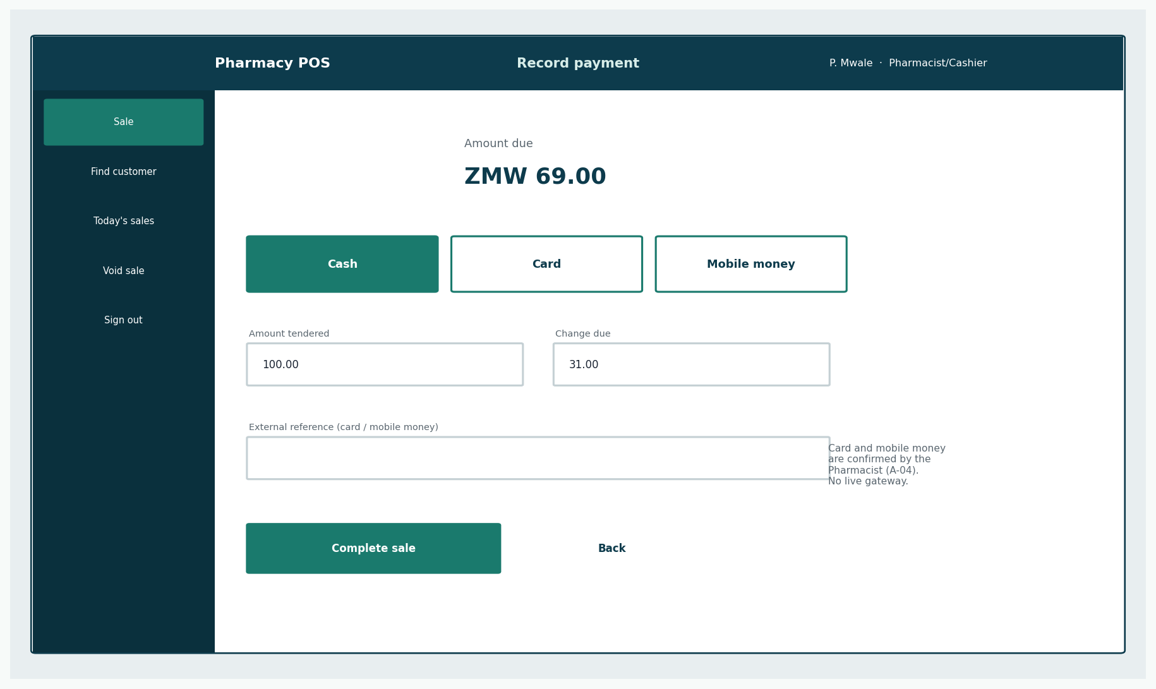
Figure 10: Payment
Cash, card, mobile money. Manual confirmation for non-cash (A-04).
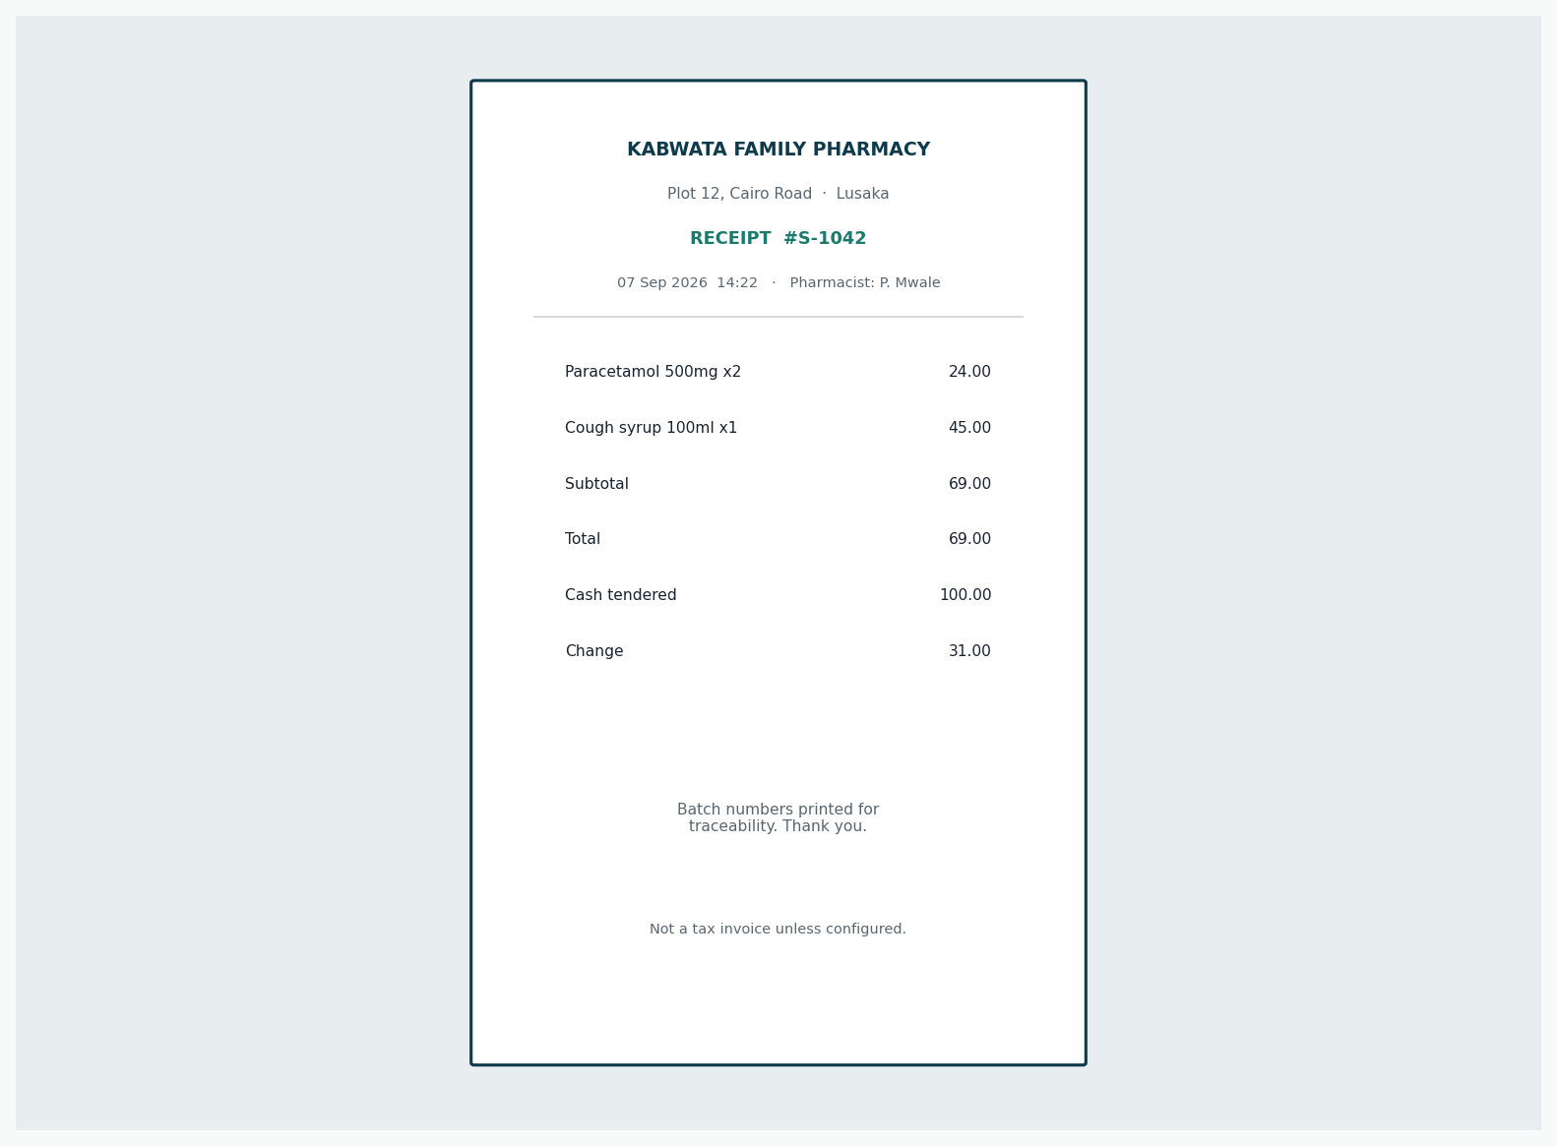
Figure 11: Receipt
Output of Sale, including pharmacist identity.
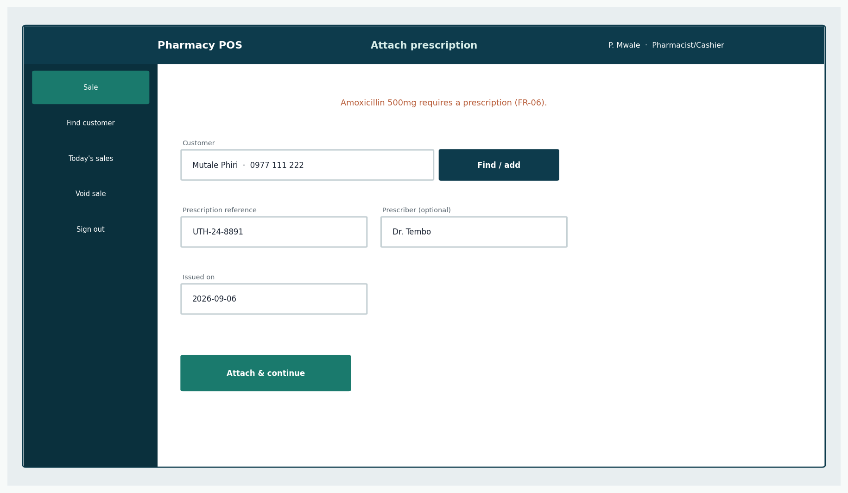
Figure 12: Attach prescription
Shown only when a line requires it.
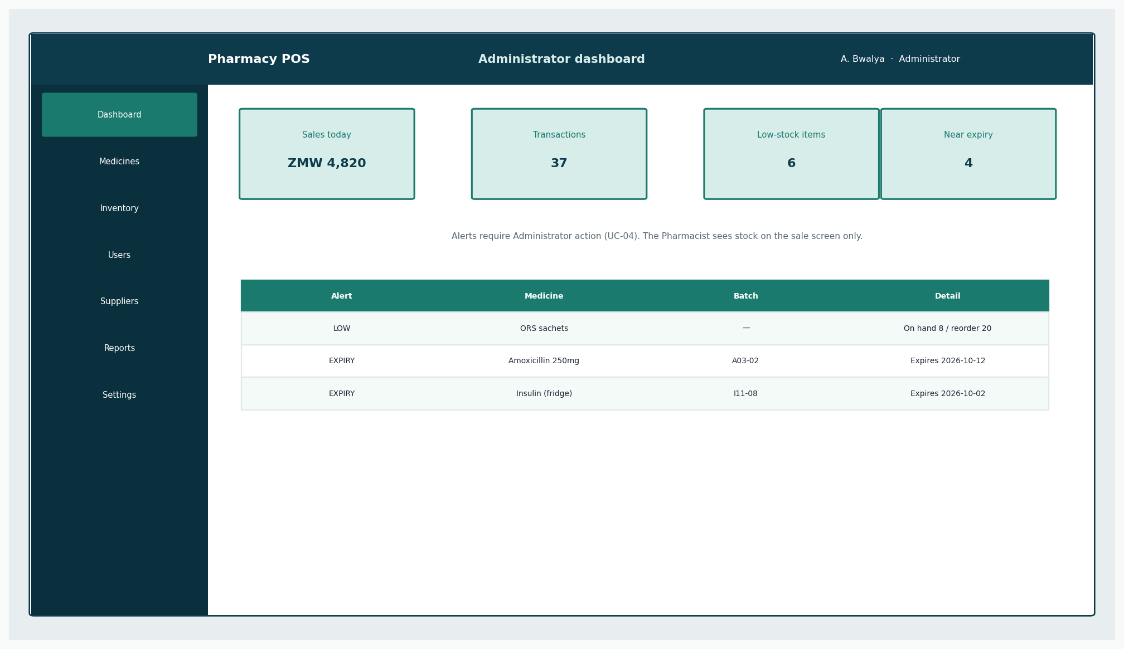
Figure 13: Administrator dashboard
Alerts for low stock and near expiry.
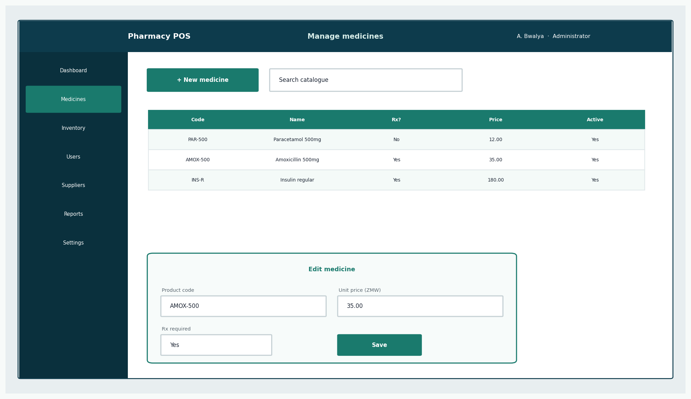
Figure 14: Medicine maintenance
Supports UC-03.
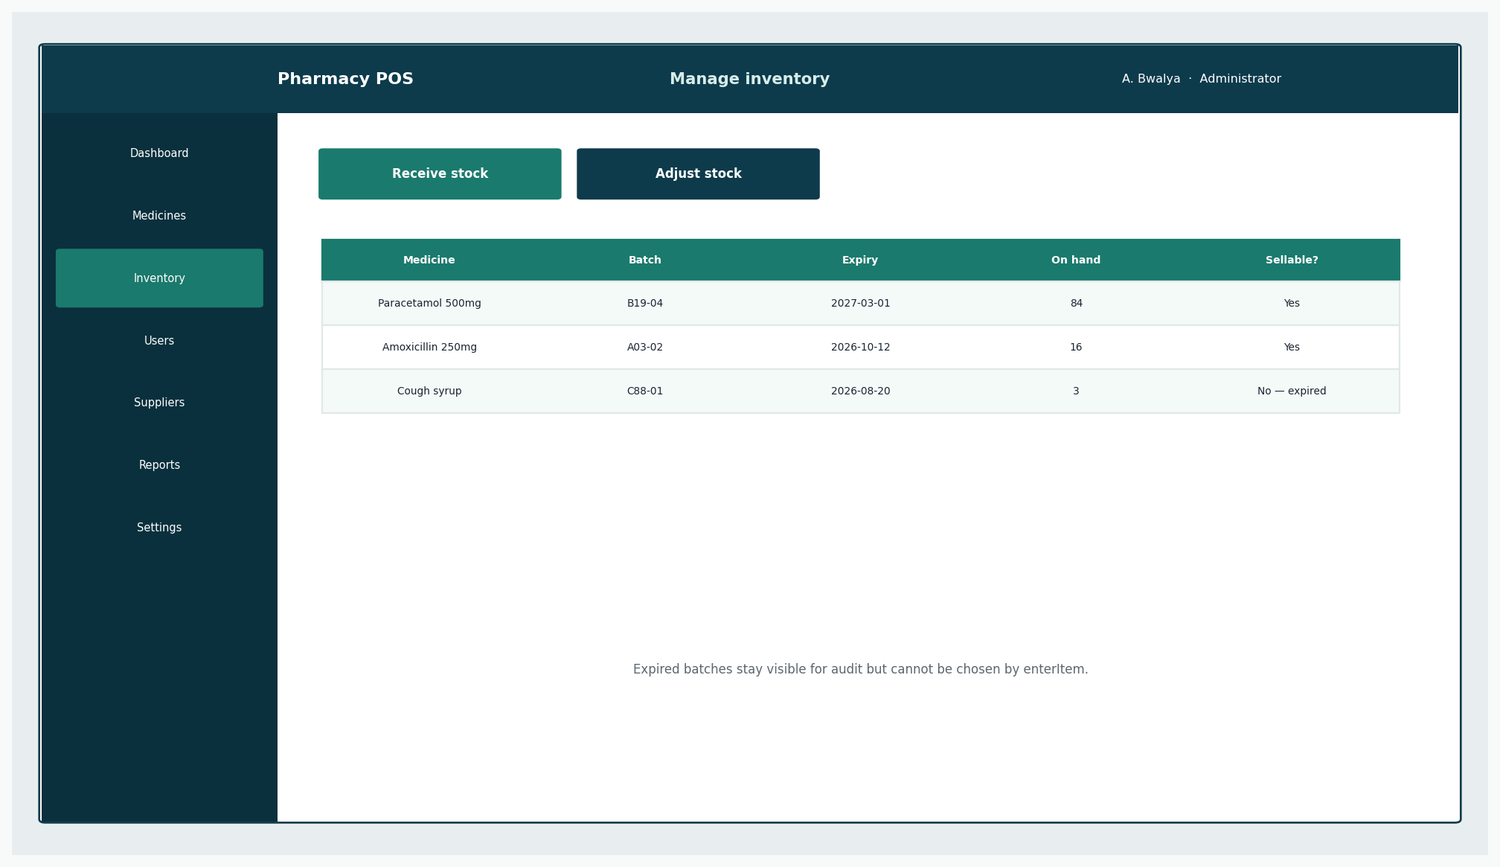
Figure 15: Inventory
Expired batches visible but not sellable.
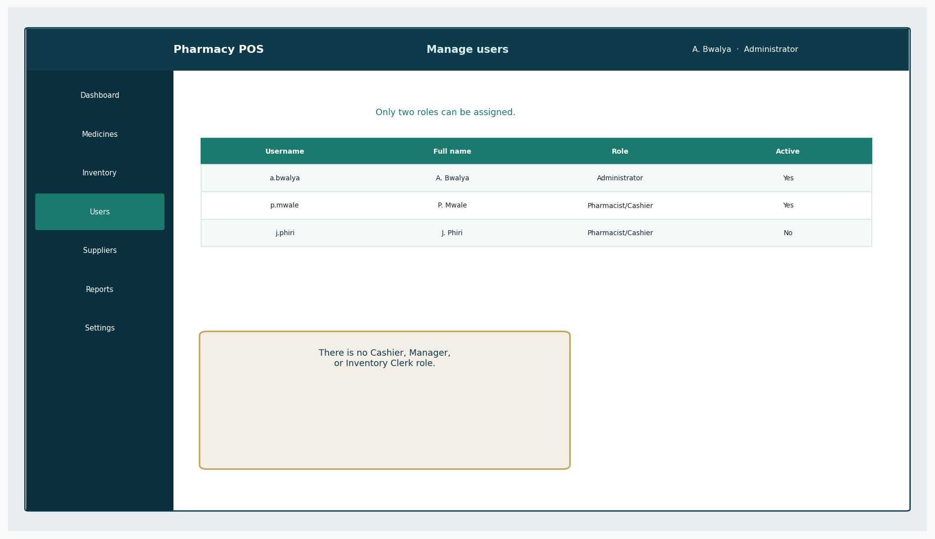
Figure 16: Users
Two roles only.
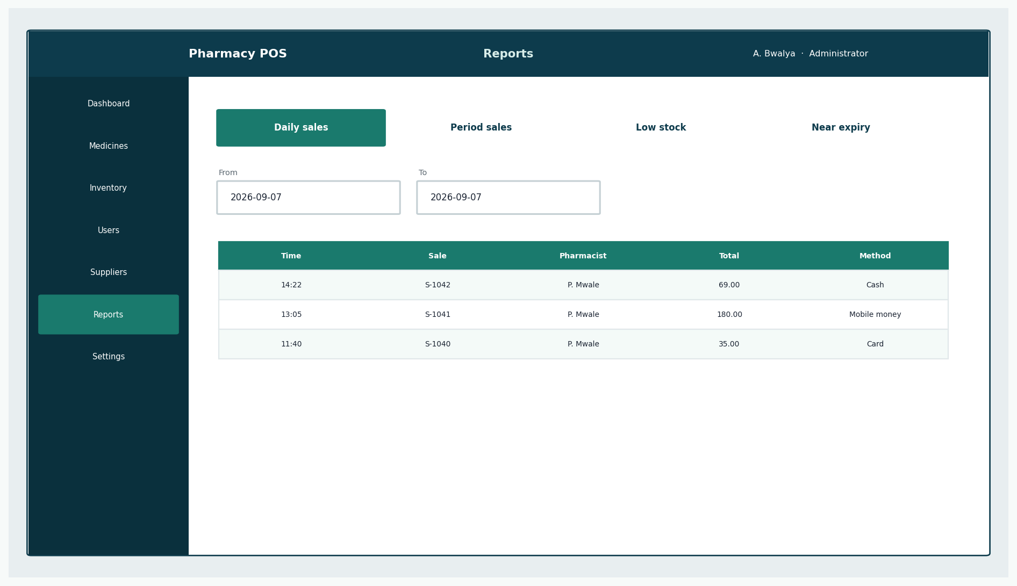
Figure 17: Reports
Read-only Administrator view.

11. Database Schema Design
The logical schema is the persistent form of the domain model. It is not an implemented database. No SQL scripts are supplied.
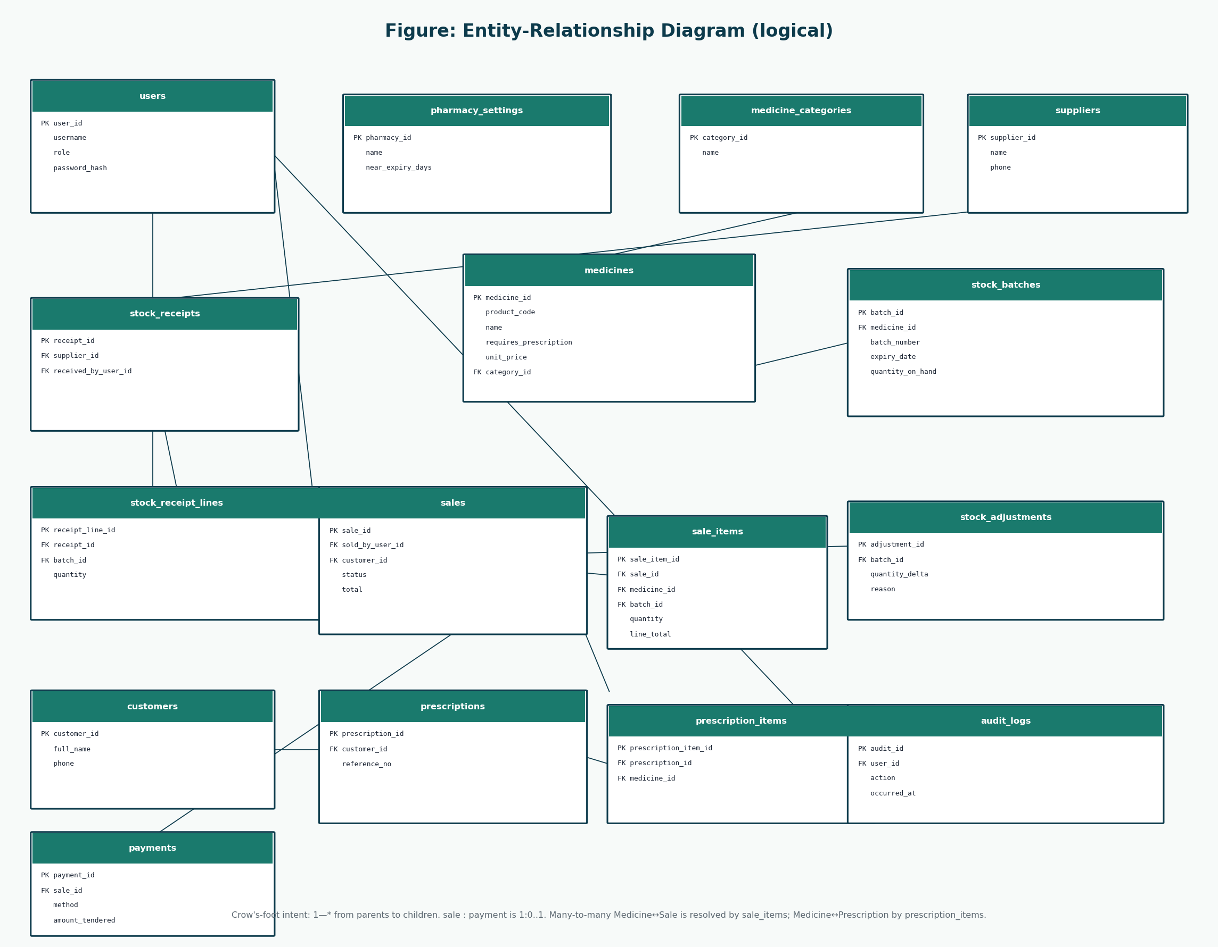
Figure 18: Logical ERD
Associative entities sale_items and prescription_items resolve many-to-many pairs.
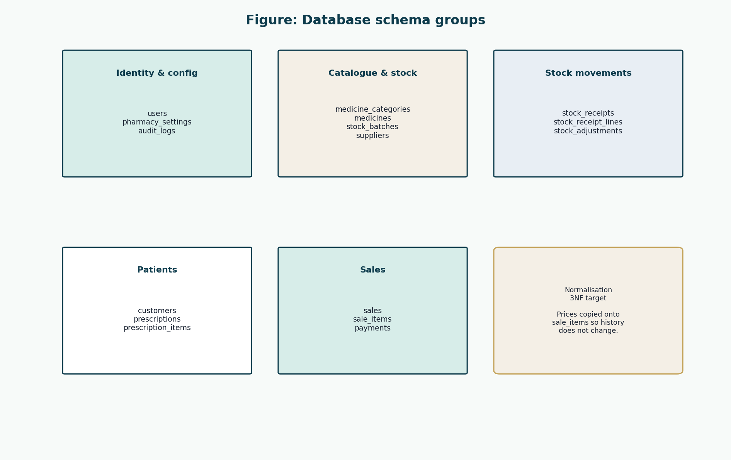
Figure 19: Schema groups
Identity, catalogue, movements, patients, sales.
Column-level specification is repeated in the Complete System Design Document and in Database-Design/.

users
Column | Type | PK | FK | Null | Description
user_id | INT | Y |  | N | Surrogate primary key.
username | VARCHAR(50) |  |  | N | Unique login name.
full_name | VARCHAR(120) |  |  | N | Display name on receipts and audit.
role | VARCHAR(20) |  |  | N | ADMINISTRATOR or PHARMACIST.
password_hash | VARCHAR(255) |  |  | N | Salted hash only. Never plaintext.
password_salt | VARCHAR(64) |  |  | N | Per-user salt if not embedded in the hash.
is_active | BOOLEAN |  |  | N | Deactivated accounts cannot authenticate.
created_at | DATETIME |  |  | N | Account creation time.
last_login_at | DATETIME |  |  | Y | Last successful login.

pharmacy_settings
Column | Type | PK | FK | Null | Description
pharmacy_id | INT | Y |  | N | Single-row settings key for this deployment.
name | VARCHAR(160) |  |  | N | Pharmacy trading name.
address | VARCHAR(255) |  |  | Y | Printed on receipts.
phone | VARCHAR(40) |  |  | Y | Printed on receipts.
receipt_footer | VARCHAR(255) |  |  | Y | Thank-you or regulatory line.
near_expiry_days | INT |  |  | N | Days used for near-expiry alerts.
currency_code | CHAR(3) |  |  | N | ZMW for this project.

medicine_categories
Column | Type | PK | FK | Null | Description
category_id | INT | Y |  | N | Primary key.
name | VARCHAR(80) |  |  | N | Unique category name.
description | VARCHAR(255) |  |  | Y | Optional note.

medicines
Column | Type | PK | FK | Null | Description
medicine_id | INT | Y |  | N | Primary key.
product_code | VARCHAR(40) |  |  | N | Unique SKU / product code.
name | VARCHAR(160) |  |  | N | Brand or dispensing name.
generic_name | VARCHAR(160) |  |  | Y | INN / generic name.
strength | VARCHAR(40) |  |  | Y | For example 500 mg.
form | VARCHAR(40) |  |  | Y | Tablet, syrup, cream.
category_id | INT |  | medicine_categories.category_id | Y | Optional category.
requires_prescription | BOOLEAN |  |  | N | True for prescription-only items.
unit_price | DECIMAL(12,2) |  |  | N | Current selling price.
reorder_level | INT |  |  | N | Low-stock threshold.
is_active | BOOLEAN |  |  | N | Inactive medicines are not sold.

suppliers
Column | Type | PK | FK | Null | Description
supplier_id | INT | Y |  | N | Primary key.
name | VARCHAR(160) |  |  | N | Supplier trading name.
phone | VARCHAR(40) |  |  | Y | Contact phone.
address | VARCHAR(255) |  |  | Y | Contact address.
is_active | BOOLEAN |  |  | N | Soft delete flag.

stock_batches
Column | Type | PK | FK | Null | Description
batch_id | INT | Y |  | N | Primary key.
medicine_id | INT |  | medicines.medicine_id | N | Medicine of this batch.
batch_number | VARCHAR(60) |  |  | N | Manufacturer / supplier batch no.
expiry_date | DATE |  |  | N | Not sellable after this date.
quantity_on_hand | INT |  |  | N | Current sellable quantity.
unit_cost | DECIMAL(12,2) |  |  | Y | Optional cost for valuation.
received_at | DATETIME |  |  | N | First receipt time.

stock_receipts
Column | Type | PK | FK | Null | Description
receipt_id | INT | Y |  | N | Primary key.
supplier_id | INT |  | suppliers.supplier_id | N | Source supplier.
received_by_user_id | INT |  | users.user_id | N | Administrator who received.
received_at | DATETIME |  |  | N | Receipt time.
reference_note | VARCHAR(120) |  |  | Y | Delivery note number.

stock_receipt_lines
Column | Type | PK | FK | Null | Description
receipt_line_id | INT | Y |  | N | Primary key.
receipt_id | INT |  | stock_receipts.receipt_id | N | Parent receipt.
batch_id | INT |  | stock_batches.batch_id | N | Batch increased.
quantity | INT |  |  | N | Quantity received.

stock_adjustments
Column | Type | PK | FK | Null | Description
adjustment_id | INT | Y |  | N | Primary key.
batch_id | INT |  | stock_batches.batch_id | N | Adjusted batch.
adjusted_by_user_id | INT |  | users.user_id | N | Administrator.
quantity_delta | INT |  |  | N | Signed quantity change.
reason | VARCHAR(40) |  |  | N | DAMAGE, EXPIRY, RECOUNT, RECALL.
note | VARCHAR(255) |  |  | Y | Free-text explanation.
adjusted_at | DATETIME |  |  | N | When the change occurred.

customers
Column | Type | PK | FK | Null | Description
customer_id | INT | Y |  | N | Primary key.
full_name | VARCHAR(160) |  |  | N | Patient or buyer name.
phone | VARCHAR(40) |  |  | Y | Optional phone.
address | VARCHAR(255) |  |  | Y | Optional address.
created_at | DATETIME |  |  | N | When first recorded.

prescriptions
Column | Type | PK | FK | Null | Description
prescription_id | INT | Y |  | N | Primary key.
customer_id | INT |  | customers.customer_id | N | Named patient.
reference_no | VARCHAR(60) |  |  | N | Paper / clinic reference.
prescriber_name | VARCHAR(160) |  |  | Y | Doctor or clinic if known.
issued_on | DATE |  |  | Y | Prescription date if known.
recorded_by_user_id | INT |  | users.user_id | N | Pharmacist who recorded it.
recorded_at | DATETIME |  |  | N | Capture time.

prescription_items
Column | Type | PK | FK | Null | Description
prescription_item_id | INT | Y |  | N | Primary key.
prescription_id | INT |  | prescriptions.prescription_id | N | Parent prescription.
medicine_id | INT |  | medicines.medicine_id | N | Authorised medicine.
quantity | INT |  |  | N | Authorised quantity.

sales
Column | Type | PK | FK | Null | Description
sale_id | INT | Y |  | N | Primary key.
sold_by_user_id | INT |  | users.user_id | N | Pharmacist/Cashier.
customer_id | INT |  | customers.customer_id | Y | Optional customer.
prescription_id | INT |  | prescriptions.prescription_id | Y | Optional linked prescription.
status | VARCHAR(20) |  |  | N | IN_PROGRESS, COMPLETED, VOIDED.
started_at | DATETIME |  |  | N | makeNewSale time.
completed_at | DATETIME |  |  | Y | Completion or void time.
void_reason | VARCHAR(255) |  |  | Y | Required when VOIDED.
subtotal | DECIMAL(12,2) |  |  | N | Sum of line totals.
total | DECIMAL(12,2) |  |  | N | Amount due.

sale_items
Column | Type | PK | FK | Null | Description
sale_item_id | INT | Y |  | N | Primary key.
sale_id | INT |  | sales.sale_id | N | Parent sale.
medicine_id | INT |  | medicines.medicine_id | N | Sold medicine.
batch_id | INT |  | stock_batches.batch_id | N | Batch decremented.
quantity | INT |  |  | N | Quantity sold.
unit_price | DECIMAL(12,2) |  |  | N | Price at time of sale.
line_total | DECIMAL(12,2) |  |  | N | quantity * unit_price.

payments
Column | Type | PK | FK | Null | Description
payment_id | INT | Y |  | N | Primary key.
sale_id | INT |  | sales.sale_id | N | Paid sale (1:1 for this design).
method | VARCHAR(20) |  |  | N | CASH, CARD, MOBILE_MONEY.
amount_tendered | DECIMAL(12,2) |  |  | N | Amount given or confirmed.
change_due | DECIMAL(12,2) |  |  | N | Cash change; zero otherwise.
external_reference | VARCHAR(80) |  |  | Y | Card/mobile confirmation note.
paid_at | DATETIME |  |  | N | Payment time.

audit_logs
Column | Type | PK | FK | Null | Description
audit_id | INT | Y |  | N | Primary key.
user_id | INT |  | users.user_id | Y | Null only for failed unknown login.
action | VARCHAR(40) |  |  | N | LOGIN, LOGIN_FAIL, SALE_COMPLETE, VOID, STOCK_RECEIPT, STOCK_ADJUST, USER_ADMIN.
entity_name | VARCHAR(40) |  |  | Y | Affected table or concept.
entity_id | INT |  |  | Y | Affected key.
details | VARCHAR(500) |  |  | Y | Non-sensitive summary.
occurred_at | DATETIME |  |  | N | Event time.

12. Architecture Refinement
Iteration 1 proposed layers. Iteration 2 names the classes inside them and the GRASP reasons they exist. The downward dependency rule is unchanged. Construction should implement by feature (a vertical slice of Process Sale) rather than finishing one layer completely before the next — that would be waterfall in disguise.

13. Updated Risk Register
ID | Risk | P | I | Priority | Mitigation | Iteration | Status
R-01 | Sale and stock update diverge. | Low | High | Medium | SaleService.completeSale collaborates with Inventory and repositories in one unit of work. | Elaboration 2 | Mitigated in design
R-02 | Expired medicine can be sold. | Low | High | Medium | StockBatch.isSellable() is Information Expert for expiry and quantity. | Elaboration 2 | Mitigated in design
R-03 | Third-role creep. | Low | High | Low | User.role is an enumeration of two values in schema and UI. | Elaboration 2 | Mitigated in design
R-04 | Payment / sale inconsistency. | Low | High | Medium | Payment created by Sale; completion only after accepted payment. | Elaboration 2 | Mitigated in design
R-05 | Staff resist new workflow. | Medium | Medium | Medium | UI prototypes issued for counter and admin paths. | Elaboration 2 | Mitigating
R-06 | Scope creep. | Low | High | Low | Remaining 70% use cases do not add insurance or web shop. | Elaboration 2 | Mitigated in design
R-07 | Schedule slip. | Medium | Medium | Medium | Construction will implement by feature priority, not by layer-in-isolation. | Elaboration 2 | Open
R-08 | Data loss. | Low | High | Medium | Schema includes keys, required fields, audit table; backup remains Transition. | Elaboration 2 | Mitigating
R-09 | Prescription legal sufficiency. | Medium | Medium | Medium | Prescription and Customer tables designed; national feed still out of scope. | Elaboration 2 | Mitigated in design
R-10 | Architecture unfit for POS. | Low | Medium | Low | DCD and GRASP keep controllers thin and domain cohesive. | Elaboration 2 | Mitigated in design
R-11 | UI prototypes misunderstood as finished product. | Medium | Low | Low | Prototypes labelled as design only. | Elaboration 2 | Open

14. Risk Mitigation Progress
Risk | Inception | Elaboration 1 | Elaboration 2
R-01 stock/sale split | Named | PoC transaction | SaleService unit of work in DCD
R-02 expired sale | Named | Domain rule | StockBatch.isSellable in DCD
R-03 third role | Named | Actor model | role enumeration + UI
R-04 payment split | Named | SSD makePayment | Payment + PaymentMethod
R-05 user resistance | Named | Still open | UI prototypes ready for beta
R-06 scope creep | Named | Scope held | 70% use cases stay inside POS
R-10 architecture | Named | Layers drawn | Responsibilities assigned

No row claims that code has been measured. Mitigation here means design mitigation.

15. Iteration Results
Marking item | Artefact
Remaining 70% use cases | UC-04–UC-10 fully dressed
Design class diagrams with methods | DCD-Process-Sale, DCD-Overview
UI prototypes | Ten screens covering both roles
Risk mitigation progress | Register + progress table

16. Conclusion
Design is now rich enough to construct from. The next documents record how Construction and Transition will be run, and the Complete System Design Document binds every identifier together. Coding still waits for START IMPLEMENTATION.

References
[1] Larman, C. Applying UML and Patterns: An Introduction to Object-Oriented Analysis and Design and Iterative Development. 3rd edition. Prentice Hall. Principal methodology for UP, use cases, domain models, SSDs, design class diagrams, GRASP, and iterative development. Page numbers are not cited because the full print edition was not available as a continuous source file; chapter titles from the course extracts (System Sequence Diagrams; Domain Model associations; Design Class Diagrams) are used instead.
[2] CSC 4630 Advanced Software Engineering Course Project Marking Guide. Unified Process, 15 weeks, 100 marks. Determines milestones, deliverables, and mark weights.
[3] Larman course extracts used by the group: Chapter 9 System Sequence Diagrams; Chapter 11 Domain Model associations; Chapter 16 Design Class Diagrams.
[4] Group 20 inception briefing slides, Pharmacy POS System — Advanced Software Engineering (problem context in Zambia). Role names in those slides that implied a separate Cashier or Manager were corrected in this documentation to match the two-role rule.

