CSC 4630 · GROUP 20
Complete System Design Document
Requirements, models, architecture, schema, UI, security, traceability

CSC 4630 – Advanced Software Engineering
Group 20
Lecturer: [Lecturer Name]
University: [University Name]
September 2026
Unified Process (UP) — Iterative and Incremental
Analysis and design artefact. No application source code is included. Implementation starts only after the instruction START IMPLEMENTATION.

Table of Contents
Right-click and choose Update Field in Microsoft Word to refresh the table of contents.
In Word: References → Update Table, or right-click the field above.

1. System Overview
The Pharmacy Point-of-Sale (POS) System is a counter application for a single Zambian pharmacy. A Pharmacist/Cashier sells medicines; an Administrator maintains catalogue, stock, users, suppliers, and reports. The design follows UP and Larman: use-case-driven, architecture-centric, iterative.

2. Scope
In scope:
- Authentication and role-based authorisation for two roles only
- Medicine catalogue maintenance
- Batch-level inventory with expiry and quantity
- Over-the-counter and prescription-linked counter sales
- Payments recorded as cash, card, or mobile money
- Receipt generation
- Sale void with reason and stock restore
- Customer record when a named patient is required
- Supplier record and stock receiving
- Low-stock and near-expiry visibility
- Sales and inventory reports
- Pharmacy settings used on receipts and alerts
- Audit of sensitive actions
Out of scope:
- A separate Cashier, Manager, or Inventory Clerk user role
- Online / e-commerce ordering
- NHIMA or other insurance claim submission
- Live card or mobile-money gateway settlement (manual confirmation only)
- National electronic prescription network
- Clinical diagnosis or drug-interaction decision support
- Multi-branch warehousing and inter-store transfers
- Full accounting / general ledger
- Supplier self-service portal
- Patient refill reminder campaigns

3. Actors
Name | Kind | Notes
Administrator | system user | Responsible for catalogue, inventory, users, suppliers, configuration, reports, and monitoring.
Pharmacist/Cashier | system user | The Pharmacist performs the cashier function. There is no separate Cashier role. The Pharmacist searches medicines, processes sales, records prescriptions where required, accepts payment, issues receipts, and triggers stock reduction through sales.
Customer | external actor | Buys medicines and may present a prescription. Does not have a system login. Interacts with the Pharmacist, not with the software directly (Larman system-boundary rule).
Supplier | external actor | Provides stock to the pharmacy. Not a system user. Appears as a recorded business party when goods are received.

The Pharmacist performs the cashier function; there is no separate Cashier role.

4. Functional Requirements
ID | Statement
FR-01 | The system shall authenticate a user with a unique username and a secret password and start a role-specific session.
FR-02 | The system shall authorise each operation according to exactly one of two roles: Administrator or Pharmacist/Cashier.
FR-03 | The Pharmacist/Cashier shall be able to start a sale, enter one or more medicine lines, and complete the sale.
FR-04 | The Pharmacist/Cashier shall be able to search medicines by name, generic name, or product code and see on-hand quantity.
FR-05 | The system shall refuse a sale line that would sell an expired batch or a quantity greater than available sellable stock.
FR-06 | When a line requires a prescription, the Pharmacist/Cashier shall record the prescription reference and essential details before the line is accepted.
FR-07 | The Pharmacist/Cashier shall record payment as cash, card, or mobile money, including amount tendered.
FR-08 | On successful payment the system shall complete the sale, reduce stock, and produce a receipt.
FR-09 | The Administrator shall create, update, deactivate, and view medicines in the catalogue (name, generic name, strength, form, category, prescription flag, selling price, reorder level).
FR-10 | The Administrator shall receive stock against a supplier, recording batch number, expiry date, quantity, and cost.
FR-11 | The Administrator shall adjust stock for damage, expiry removal, recount, or recall, with a mandatory reason.
FR-12 | The system shall present low-stock and near-expiry information to the Administrator.
FR-13 | The Administrator shall create, update, deactivate, and reset access for users assigned to one of the two roles.
FR-14 | The Administrator shall maintain supplier records used when receiving stock.
FR-15 | The Administrator shall view sales and inventory reports for selected date ranges.
FR-16 | The Pharmacist/Cashier shall look up or record a customer when a sale needs a named patient (typical for prescriptions).
FR-17 | The Pharmacist/Cashier shall void an in-progress or completed sale only with a reason; the system shall restore stock for completed voids and write an audit entry.
FR-18 | The Administrator shall configure pharmacy name, address, receipt footer, and near-expiry warning days.
FR-19 | The system shall record an audit entry for login failures, sales, voids, stock receipts, stock adjustments, and user administration.

5. Non-Functional Requirements
ID | Quality | Statement
NFR-01 | Security | Passwords shall be stored only as a salted hash. Sessions shall expire after inactivity. Role checks shall be enforced on every privileged operation.
NFR-02 | Performance | Entering a sale line and refreshing the running total should complete within about three seconds on the intended counter workstation under typical catalogue size. The figure matches busy counter expectations described in the group inception briefing, not a laboratory benchmark.
NFR-03 | Usability | A trained Pharmacist/Cashier shall complete a routine three-line OTC sale from one primary sales screen without opening an administration page.
NFR-04 | Reliability / integrity | A completed sale and its stock movements shall succeed or fail together. Partial stock reduction without a sale record is not acceptable.
NFR-05 | Availability | The system is intended for normal pharmacy opening hours. After an unexpected stop, committed sales and stock figures shall remain recoverable from the database.
NFR-06 | Maintainability | Presentation, application, domain, and persistence shall remain separable so that a UI change does not rewrite pricing or stock rules.
NFR-07 | Scalability | The first release is one pharmacy. Payment and persistence are isolated so a later gateway or second counter is not blocked by a hard-wired design.
NFR-08 | Auditability | Sensitive actions shall be attributable to a user account and a timestamp.
NFR-09 | Privacy | Customer and prescription details shall be visible only to authenticated staff and shall not appear unnecessarily on publicly displayed screens.
NFR-10 | Data integrity | Database keys, required fields, and non-negative quantities shall protect stock and money figures independently of the user interface.

6. Complete Use-Case Model
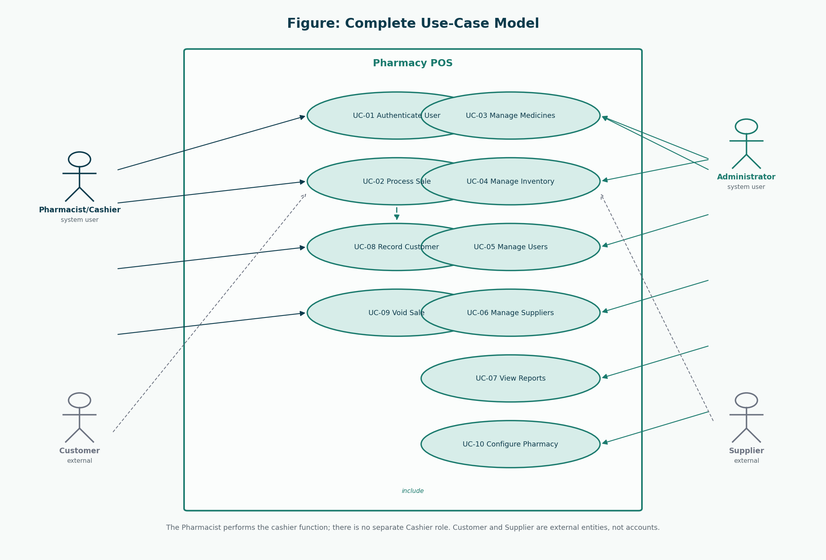
Figure 1: Complete use-case model
Ten user-goal use cases. No “click button” use cases.
ID | Name | Actor | Priority | Iteration | FR
UC-01 | Authenticate User | Administrator, Pharmacist/Cashier | High | Elaboration 1 (30%) | FR-01, FR-02, FR-19
UC-02 | Process Sale | Pharmacist/Cashier | Critical | Inception 10% / Elaboration 1 detailed | FR-03, FR-04, FR-05, FR-06, FR-07, FR-08, FR-16
UC-03 | Manage Medicines | Administrator | High | Elaboration 1 (30%) | FR-09
UC-04 | Manage Inventory | Administrator | High | Elaboration 2 (remaining 70%) | FR-10, FR-11, FR-12
UC-05 | Manage Users | Administrator | High | Elaboration 2 (remaining 70%) | FR-13, FR-19
UC-06 | Manage Suppliers | Administrator | Medium | Elaboration 2 (remaining 70%) | FR-14
UC-07 | View Reports | Administrator | Medium | Elaboration 2 (remaining 70%) | FR-15
UC-08 | Record Customer | Pharmacist/Cashier | Medium | Elaboration 2 (remaining 70%) | FR-16
UC-09 | Void Sale | Pharmacist/Cashier | High | Elaboration 2 (remaining 70%) | FR-17, FR-19
UC-10 | Configure Pharmacy | Administrator | Low | Elaboration 2 (remaining 70%) | FR-18

7. Use-Case Descriptions

UC-01 Authenticate User
Field | Description
ID | UC-01
Name | Authenticate User
Scope | Pharmacy POS application
Level | User goal
Primary actor | Staff member (Administrator or Pharmacist/Cashier)
Priority | High
Iteration | Elaboration 1 (30%)
Requirements | FR-01, FR-02, FR-19
Preconditions | The user has an active account. The application is available.
Success guarantee | A session exists, the role is known, and the correct home screen is shown.
Special requirements | Passwords are never displayed or stored in recoverable form.
Technology / data variations | Keyboard login on the counter or office workstation.
Frequency | At the start of each shift and after session timeout.

Stakeholders and interests
Stakeholder | Interest
Staff member | Gains access only to functions of their assigned role.
Pharmacy owner | Unauthorised people cannot sell or alter stock.
Auditor | Failed and successful logins can be investigated.

Main success scenario
1. The staff member starts the Pharmacy POS application.
2. The system presents the login prompt.
3. The staff member enters username and password.
4. The system verifies the credentials against the stored password hash and confirms the account is active.
5. The system creates a session containing user identity and role.
6. The system opens the Administrator dashboard or the Pharmacist sales screen according to role.
Extensions
- 4a. Credentials are wrong: the system refuses access, records a failed-login audit entry, and invites a retry.
- 4b. Account is deactivated: the system refuses access and explains that an Administrator must restore the account.
- 4c. Repeated failures in a short period: the system keeps refusing and keeps the audit trail (lockout policy may be applied in construction).

UC-02 Process Sale
Field | Description
ID | UC-02
Name | Process Sale
Scope | Pharmacy POS application
Level | User goal
Primary actor | Pharmacist/Cashier
Priority | Critical
Iteration | Inception 10% / Elaboration 1 detailed
Requirements | FR-03, FR-04, FR-05, FR-06, FR-07, FR-08, FR-16
Preconditions | The Pharmacist/Cashier is authenticated. At least one sellable medicine exists.
Success guarantee | A completed Sale, Payment, stock reduction, and Receipt exist. Prescription details exist when required.
Special requirements | Sale completion and stock reduction are one business transaction. Receipt shows pharmacy name, date, lines, total, payment method, and cashier identity (the Pharmacist user).
Technology / data variations | Product code may be typed; barcode scan is a technology variation of enterItem, not a separate use case (Larman: name events at the level of intent).
Frequency | Core daily work of the counter — typically many times per hour.

Stakeholders and interests
Stakeholder | Interest
Pharmacist/Cashier | Completes the sale quickly and correctly.
Customer | Pays the correct amount and receives the intended medicines plus a receipt.
Pharmacy owner | Money and stock stay consistent; expired stock is not sold.
Regulator | Prescription-only items are not sold without recorded prescription details.

Main success scenario
1. The Pharmacist/Cashier chooses to start a new sale (system event: makeNewSale).
2. The system creates a Sale in progress and shows an empty line list and a zero total.
3. The Pharmacist/Cashier identifies a medicine by search or product code and enters a quantity (system event: enterItem).
4. The system locates a sellable StockBatch (unexpired, sufficient quantity), adds a SalesLineItem, and returns description, unit price, line total, and running total.
5. The Pharmacist/Cashier repeats step 3–4 for each additional medicine.
6. If any accepted line is prescription-only, the Pharmacist/Cashier records the customer (or uses an existing customer) and the prescription reference (system event: attachPrescription).
7. The Pharmacist/Cashier indicates the sale content is complete (system event: endSale).
8. The system calculates tax if configured and presents the total due.
9. The Pharmacist/Cashier records the payment method and amount tendered (system event: makePayment).
10. The system records Payment, marks the Sale complete, reduces batch quantities, writes audit data, and presents the Receipt.
11. The Pharmacist/Cashier gives medicines and the receipt to the Customer.
Extensions
- 3a. Medicine is not found: the system says so; the sale remains in progress.
- 3b. Only expired batches exist: the system refuses the line (BO-01 / FR-05).
- 3c. Requested quantity exceeds sellable stock: the system refuses the line and shows the available quantity.
- 3d. Pharmacist/Cashier removes a line before payment: the system deletes that SalesLineItem and updates the total.
- 6a. Prescription-only line without prescription details: the system refuses to end the sale until details are recorded.
- 6b. Customer is new: include UC-08 Record Customer, then continue.
- 8a. Pharmacist/Cashier cancels the in-progress sale: no payment, no stock change (related to UC-09).
- 9a. Amount tendered is less than total for a cash sale: the system refuses completion and shows the shortfall.
- 9b. Card or mobile money: the Pharmacist/Cashier confirms that payment was received externally; the system records method and reference. Live gateway settlement is out of scope (A-04).
- 10a. Persistence fails after payment intent: the system does not report success; no partial stock reduction remains (NFR-04).

UC-03 Manage Medicines
Field | Description
ID | UC-03
Name | Manage Medicines
Scope | Pharmacy POS application
Level | User goal
Primary actor | Administrator
Priority | High
Iteration | Elaboration 1 (30%)
Requirements | FR-09
Preconditions | Administrator is authenticated.
Success guarantee | The medicine catalogue reflects the intended create/update/deactivate action.
Special requirements | Deactivation is preferred to physical deletion so old sales remain explainable.
Technology / data variations | Office workstation, keyboard and mouse.
Frequency | Whenever the assortment or price list changes.

Stakeholders and interests
Stakeholder | Interest
Administrator | Keeps the catalogue accurate.
Pharmacist/Cashier | Can find the correct sellable item at the counter.

Main success scenario
1. The Administrator opens medicine maintenance.
2. The Administrator searches or starts a new medicine.
3. The Administrator enters or edits name, generic name, strength, form, category, prescription-required flag, selling price, and reorder level.
4. The system validates required fields and unique product code.
5. The Administrator confirms the save.
6. The system stores the medicine and records an audit entry.
Extensions
- 4a. Duplicate product code: the system rejects the save.
- 4b. Invalid price or empty required field: the system rejects the save.
- 5a. Deactivate instead of update: the medicine remains in history but is not offered for new sale lines.

UC-04 Manage Inventory
Field | Description
ID | UC-04
Name | Manage Inventory
Scope | Pharmacy POS application
Level | User goal
Primary actor | Administrator
Priority | High
Iteration | Elaboration 2 (remaining 70%)
Requirements | FR-10, FR-11, FR-12
Preconditions | Administrator is authenticated. For receiving, the supplier and medicine already exist.
Success guarantee | A stock receipt or adjustment is stored; batch quantities change; alerts refresh.
Special requirements | Every adjustment requires a reason. Receipts of stock are not performed by the Pharmacist/Cashier role.
Technology / data variations | Keyboard entry of supplier documents.
Frequency | Deliveries and periodic stock checks.

Stakeholders and interests
Stakeholder | Interest
Administrator | Stock on the shelf matches the system.
Pharmacist/Cashier | Sellable quantities shown at the counter are trustworthy.

Main success scenario
1. The Administrator chooses Receive Stock or Adjust Stock.
2. Receive: the Administrator selects a supplier and adds lines (medicine, batch number, expiry, quantity, cost).
3. The system creates or increases a StockBatch and records a StockReceipt.
4. Adjust: the Administrator selects a batch, quantity change, and reason (damage, expiry removal, recount, recall).
5. The system applies the adjustment if the resulting quantity would not be negative.
6. The system updates low-stock and near-expiry views.
Extensions
- 2a. Expiry date is not in the future for a new receipt: the system warns; the Administrator may cancel.
- 5a. Adjustment would make quantity negative: the system refuses.
- 5b. Expiry removal of an entire batch: quantity becomes zero and the batch is not sellable.

UC-05 Manage Users
Field | Description
ID | UC-05
Name | Manage Users
Scope | Pharmacy POS application
Level | User goal
Primary actor | Administrator
Priority | High
Iteration | Elaboration 2 (remaining 70%)
Requirements | FR-13, FR-19
Preconditions | Administrator is authenticated.
Success guarantee | A user account exists or is updated with exactly one of the two roles.
Special requirements | At least one active Administrator should remain.
Technology / data variations | Office workstation.
Frequency | Staff join, leave, or forget passwords.

Stakeholders and interests
Stakeholder | Interest
Administrator | Only intended people can log in.
Staff member | Receives a working account of the correct role.

Main success scenario
1. The Administrator opens user maintenance.
2. The Administrator creates or selects a user.
3. The Administrator assigns username, full name, role (Administrator or Pharmacist/Cashier), and an initial password.
4. The system stores a password hash, not the password itself.
5. The Administrator may later deactivate the account or reset the password.
Extensions
- 3a. A third role is requested: the system does not offer one.
- 3b. Duplicate username: the system rejects the save.

UC-06 Manage Suppliers
Field | Description
ID | UC-06
Name | Manage Suppliers
Scope | Pharmacy POS application
Level | User goal
Primary actor | Administrator
Priority | Medium
Iteration | Elaboration 2 (remaining 70%)
Requirements | FR-14
Preconditions | Administrator is authenticated.
Success guarantee | Supplier name and contact details are stored or updated.
Special requirements | Suppliers are not system users and cannot log in.
Technology / data variations | Office workstation.
Frequency | When a new wholesaler is used.

Stakeholders and interests
Stakeholder | Interest
Administrator | Can identify who supplied a batch.

Main success scenario
1. The Administrator opens supplier maintenance.
2. The Administrator creates or edits name, phone, and address.
3. The system validates the name and saves the supplier.
Extensions
- 3a. Duplicate active supplier name: the system warns before save.

UC-07 View Reports
Field | Description
ID | UC-07
Name | View Reports
Scope | Pharmacy POS application
Level | User goal
Primary actor | Administrator
Priority | Medium
Iteration | Elaboration 2 (remaining 70%)
Requirements | FR-15
Preconditions | Administrator is authenticated.
Success guarantee | A report for the selected type and date range is displayed.
Special requirements | Reports are read-only.
Technology / data variations | Screen display; printing is a technology variation.
Frequency | Daily close and periodic review.

Stakeholders and interests
Stakeholder | Interest
Pharmacy owner / Administrator | Sees sales value and stock movement for a period.

Main success scenario
1. The Administrator chooses a report type (daily sales, period sales, low stock, near expiry).
2. The Administrator enters a date range where applicable.
3. The system aggregates stored sales and stock data and displays the report.
Extensions
- 3a. No data in range: the system shows an empty report, not an error.

UC-08 Record Customer
Field | Description
ID | UC-08
Name | Record Customer
Scope | Pharmacy POS application
Level | User goal
Primary actor | Pharmacist/Cashier
Priority | Medium
Iteration | Elaboration 2 (remaining 70%)
Requirements | FR-16
Preconditions | Pharmacist/Cashier is authenticated.
Success guarantee | A customer record is found or created and can be linked to the current sale.
Special requirements | Minimal data: a name is enough. Extra medical history is out of scope.
Technology / data variations | Sales screen or a small customer dialog.
Frequency | Whenever a prescription-linked sale needs a named patient.

Stakeholders and interests
Stakeholder | Interest
Pharmacist/Cashier | Can attach a patient name to a prescription sale.
Customer | Is not forced to register for a simple OTC sale.

Main success scenario
1. The Pharmacist/Cashier searches by name or phone.
2. If found, the Pharmacist/Cashier selects the customer.
3. If not found, the Pharmacist/Cashier enters name and optional phone and address.
4. The system stores the customer and returns the identifier.
Extensions
- 1a. Search is skipped for a purely OTC sale: this use case is not required.

UC-09 Void Sale
Field | Description
ID | UC-09
Name | Void Sale
Scope | Pharmacy POS application
Level | User goal
Primary actor | Pharmacist/Cashier
Priority | High
Iteration | Elaboration 2 (remaining 70%)
Requirements | FR-17, FR-19
Preconditions | Pharmacist/Cashier is authenticated. A sale in progress or a completed sale from the current business day is selected.
Success guarantee | The sale is marked void. If it had reduced stock, quantities are restored. An audit entry exists.
Special requirements | Voids are retained historically. There is no silent delete.
Technology / data variations | Sales screen.
Frequency | Occasional error correction.

Stakeholders and interests
Stakeholder | Interest
Pharmacist/Cashier | Can correct a mistake without corrupting stock.
Auditor | Sees that the original sale was voided, not silently deleted.

Main success scenario
1. The Pharmacist/Cashier selects the sale and chooses Void.
2. The system demands a reason.
3. The Pharmacist/Cashier enters the reason and confirms.
4. The system marks the sale void, reverses stock for completed sales, and writes the audit entry.
Extensions
- 1a. Sale is already void: the system refuses a second void.
- 3a. Confirmation cancelled: no change.

UC-10 Configure Pharmacy
Field | Description
ID | UC-10
Name | Configure Pharmacy
Scope | Pharmacy POS application
Level | User goal
Primary actor | Administrator
Priority | Low
Iteration | Elaboration 2 (remaining 70%)
Requirements | FR-18
Preconditions | Administrator is authenticated.
Success guarantee | Pharmacy name, address, receipt footer, and near-expiry days are stored.
Special requirements | Settings are not a third user role.
Technology / data variations | Office workstation.
Frequency | Setup and rare changes.

Stakeholders and interests
Stakeholder | Interest
Administrator | Receipts and alerts show the correct pharmacy identity.

Main success scenario
1. The Administrator opens pharmacy settings.
2. The Administrator edits the fields and saves.
3. The system applies the values to new receipts and alert calculations.
Extensions
- 2a. Near-expiry days is not a positive number: the system rejects the save.

8. Domain Model
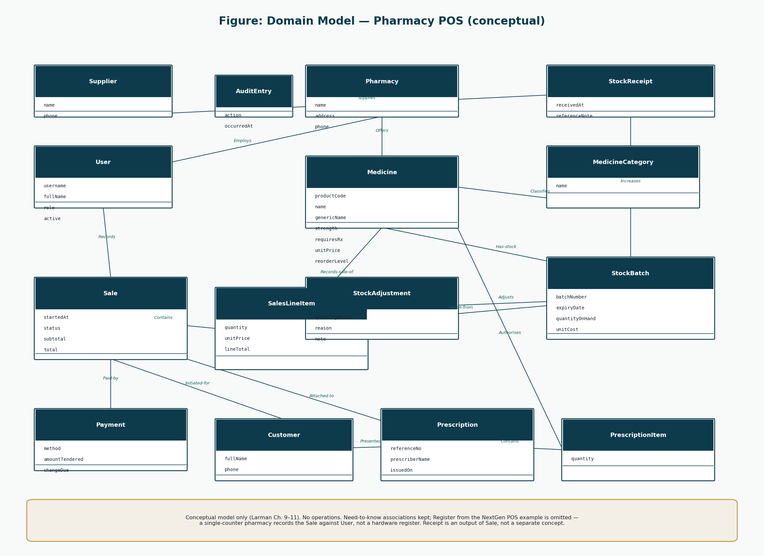
Figure 2: Domain model
Conceptual classes only.
Class | Meaning
Pharmacy | The pharmacy that owns catalogue, stock, users, and sales.
User | A person with a system account. Role is Administrator or Pharmacist/Cashier.
Medicine | A sellable pharmaceutical product definition (catalogue item).
MedicineCategory | A grouping such as antibiotic, analgesic, or OTC sundry.
StockBatch | A physical quantity of a medicine with batch number and expiry.
Sale | A sales transaction in progress or completed.
SalesLineItem | One medicine and quantity on a sale.
Payment | Money recorded against a sale (cash, card, or mobile money).
Customer | A patient or buyer recorded when a name is required.
Prescription | A recorded authority to dispense specific medicines.
PrescriptionItem | One medicine and quantity authorised on a prescription.
Supplier | An external wholesaler or manufacturer source of stock.
StockReceipt | A delivery of stock from a supplier.
StockReceiptLine | One batch line on a stock receipt.
StockAdjustment | A non-sale quantity change with a reason.
AuditEntry | A recorded security- or stock-sensitive action.

9. System Sequence Diagrams
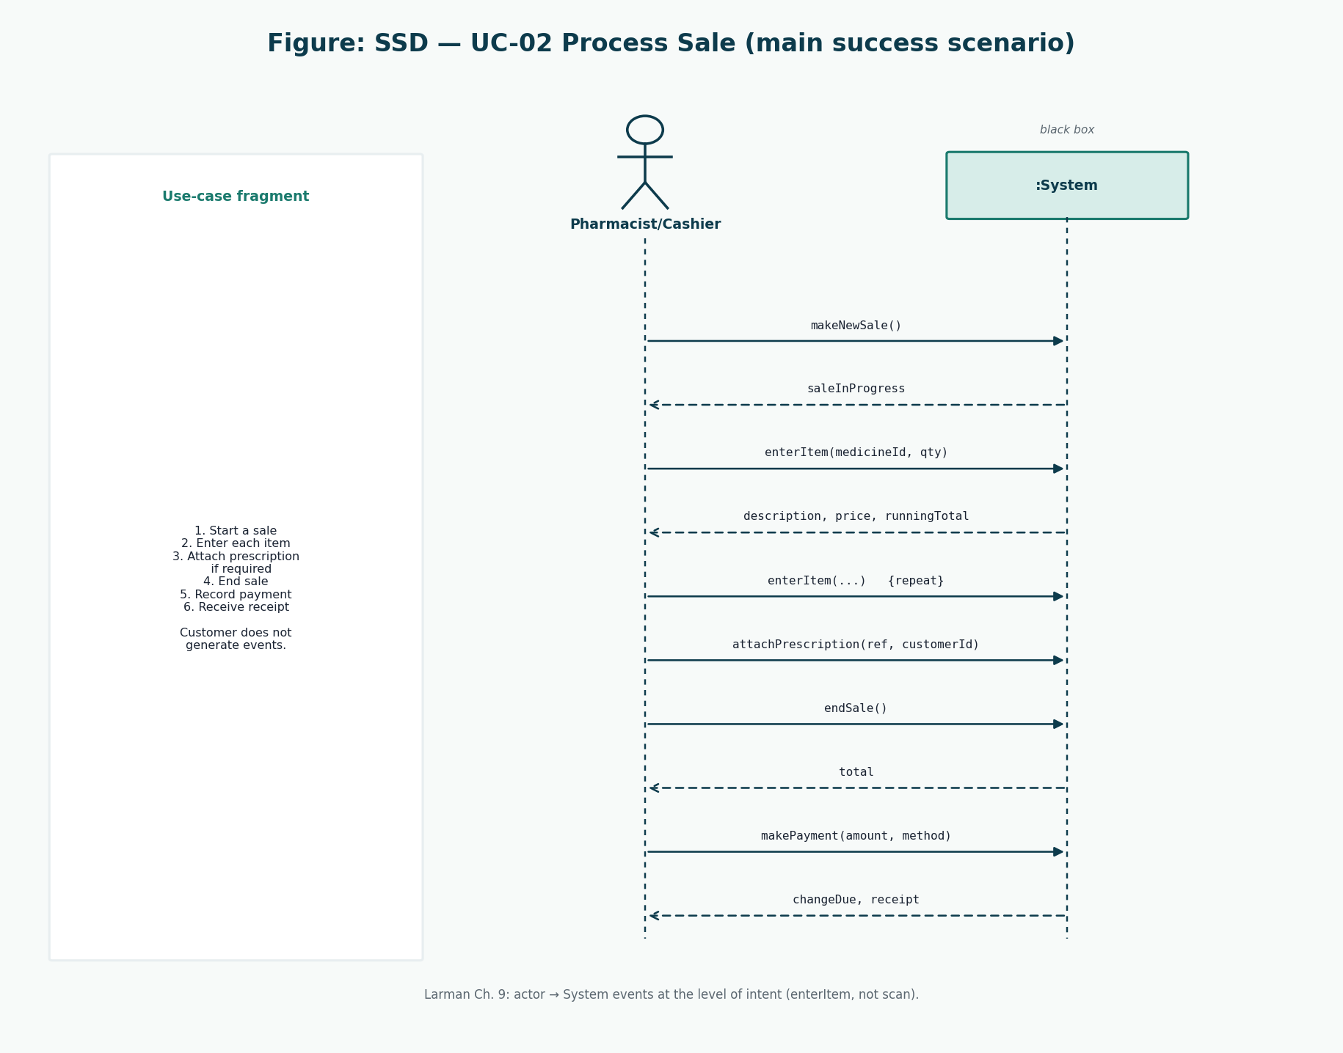
Figure 3: SSD UC-02
Core money/stock events.
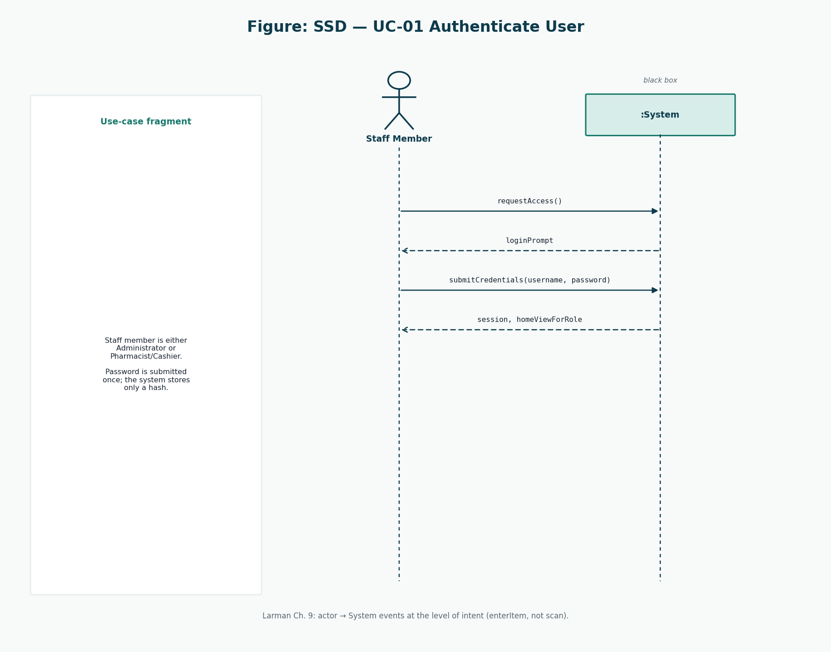
Figure 4: SSD UC-01
Session creation.
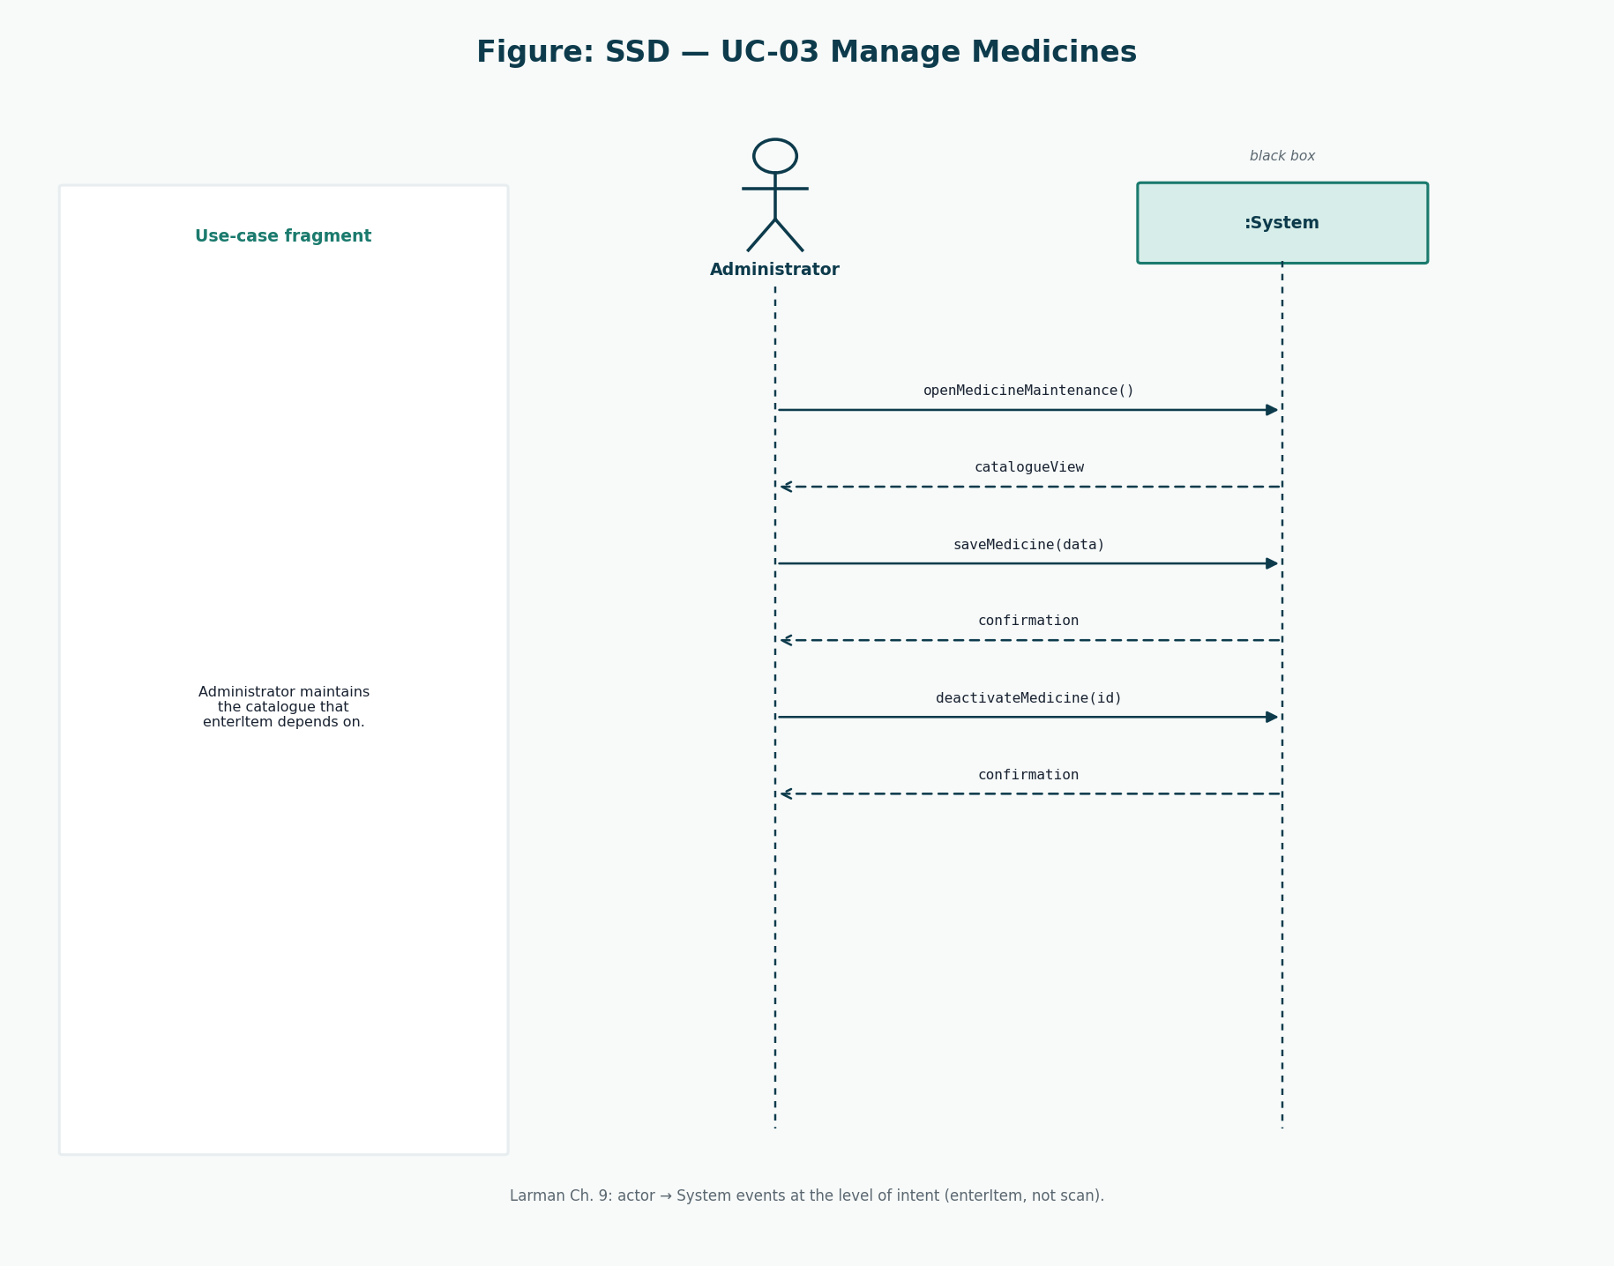
Figure 5: SSD UC-03
Catalogue events.
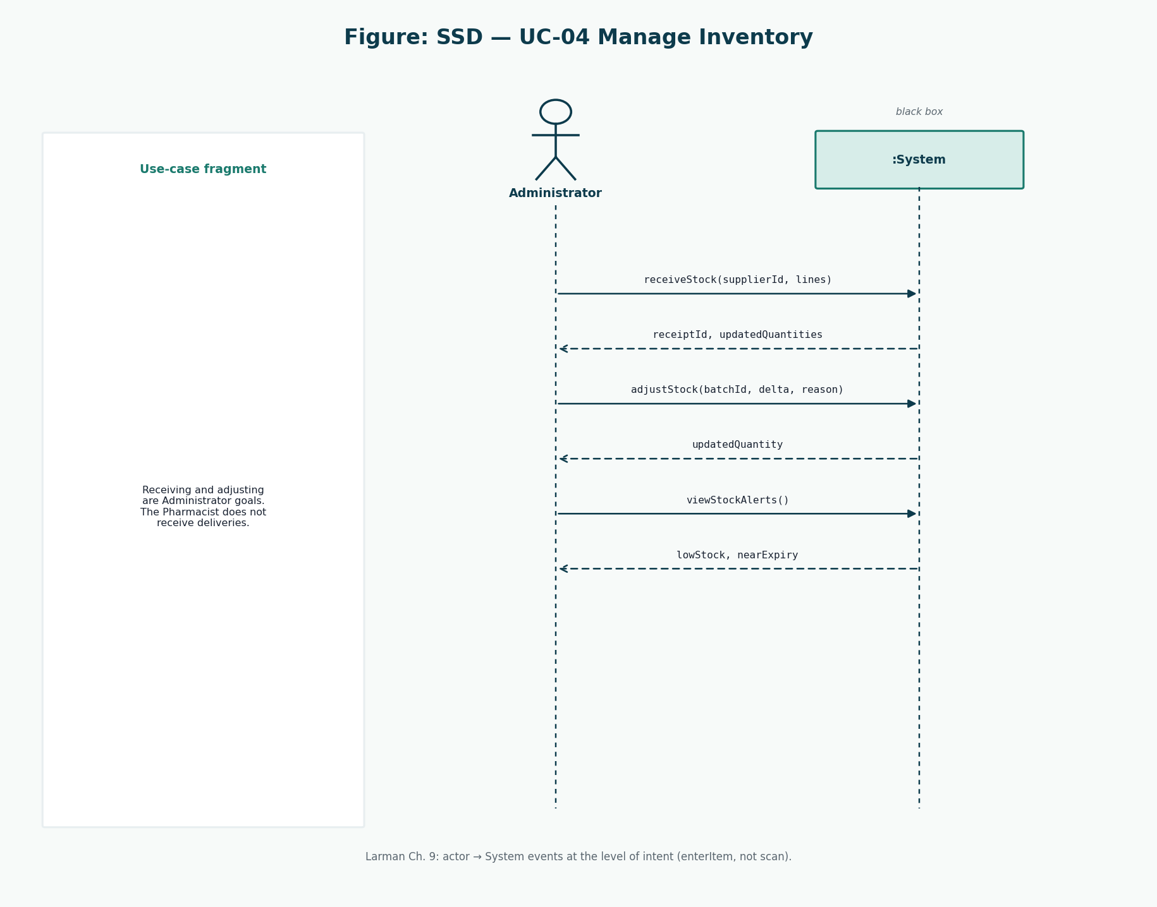
Figure 6: SSD UC-04
Stock events.
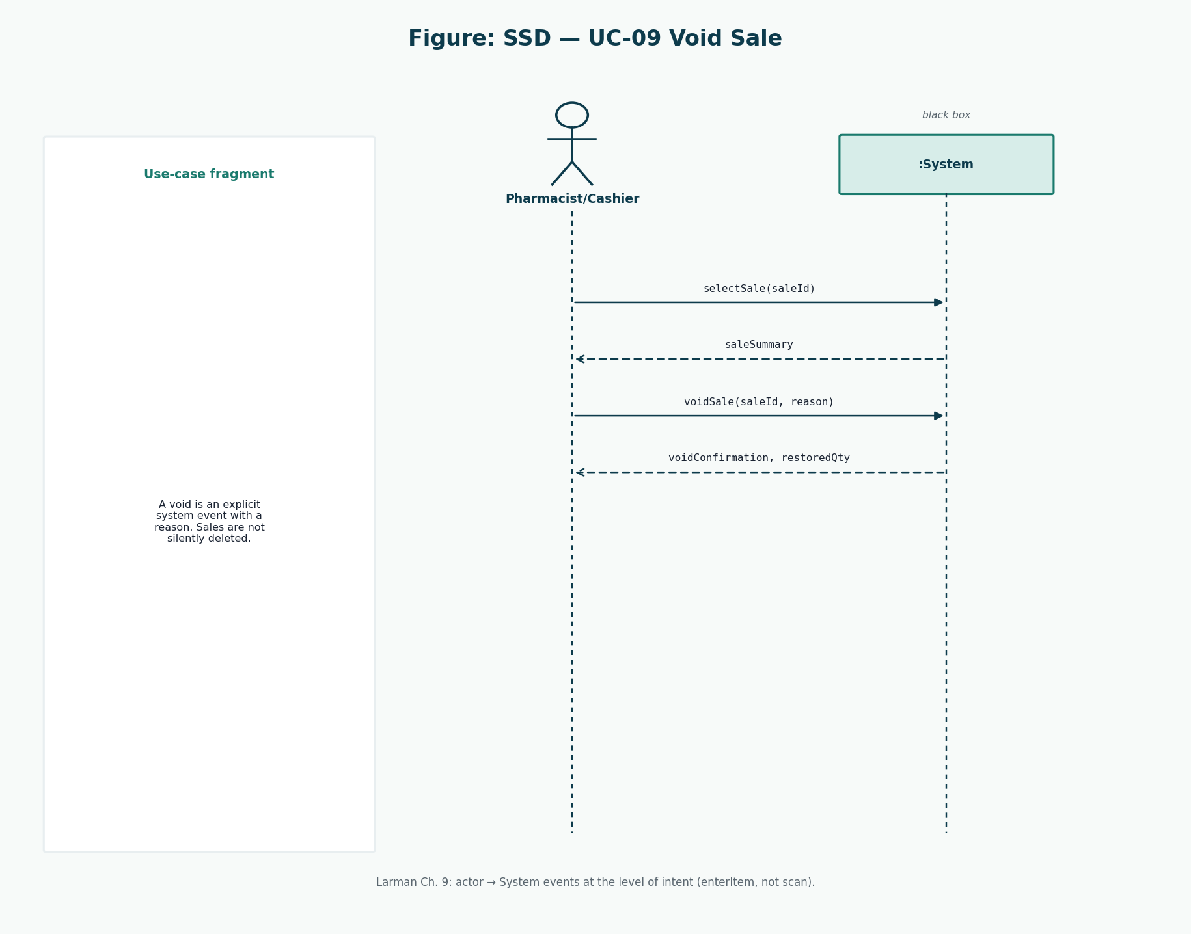
Figure 7: SSD UC-09
Compensating event.

10. Operation Contracts
Larman uses operation contracts for system operations that have non-obvious post-conditions. Two contracts are justified here: enterItem and makePayment.

Contract CO-01 enterItem
Clause | Text
Operation | enterItem(medicineId, quantity)
Cross-ref | UC-02, SSD Figure 3
Preconditions | A Sale is in progress. The Pharmacist/Cashier is authenticated.
Postconditions | If a sellable StockBatch exists: a SalesLineItem was created; it was associated with the Sale and the batch; quantity and unitPrice were set; Sale totals were updated. If none exists: no line was created and a refusal was returned.

Contract CO-02 makePayment
Clause | Text
Operation | makePayment(amount, method)
Cross-ref | UC-02
Preconditions | Sale is in progress; endSale has produced a total; prescription rules are satisfied.
Postconditions | A Payment was created and associated with the Sale; Sale.status became COMPLETED; each line’s StockBatch quantity decreased; an AuditEntry was created; a receipt presentation was requested. On failure of persistence, none of the above remain.

11. Architecture
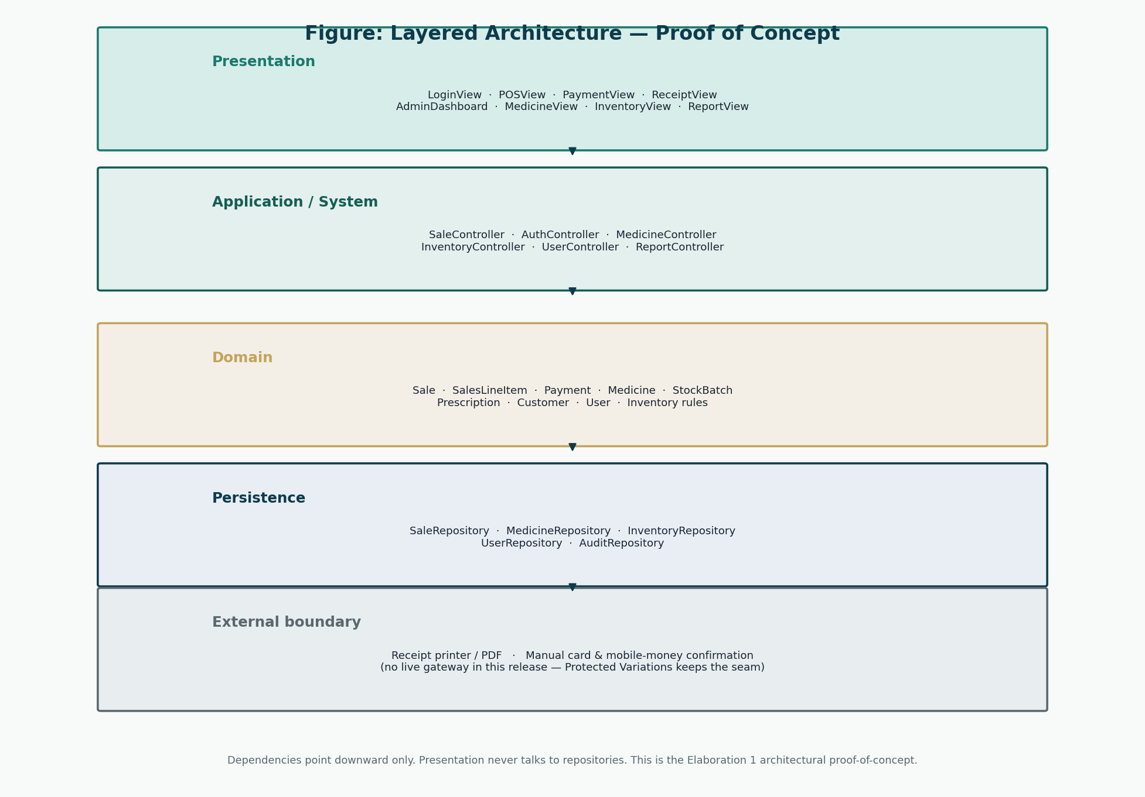
Figure 8: Layered architecture
Downward dependencies only.
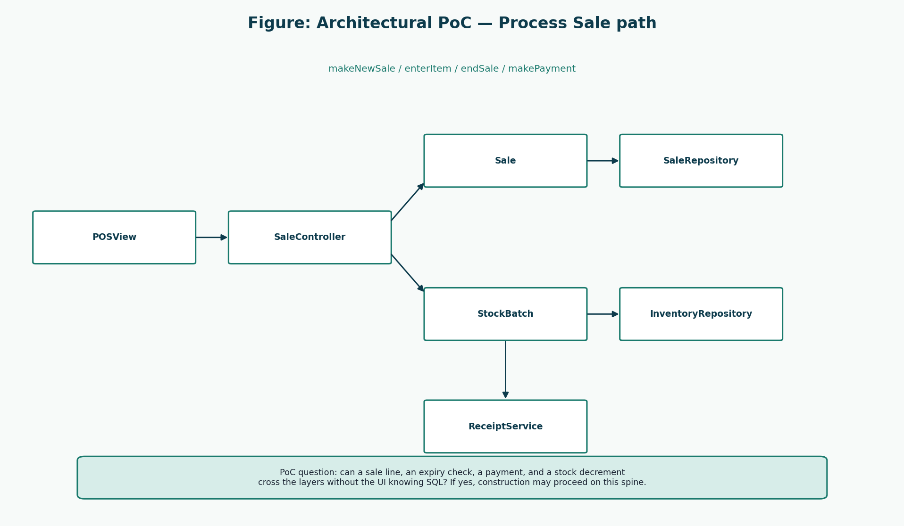
Figure 9: Sale path
PoC collaboration.

12. Design Class Diagrams
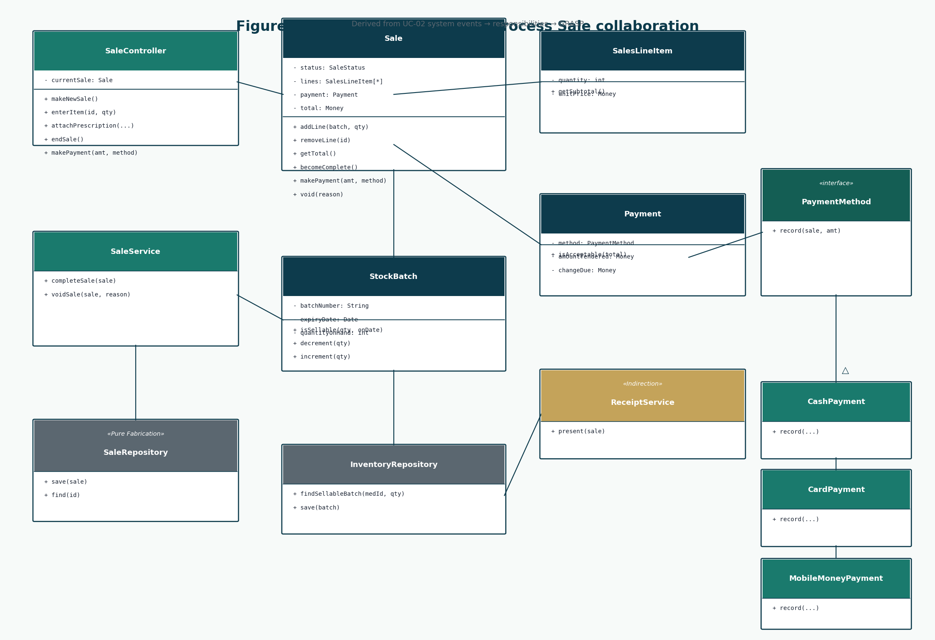
Figure 10: DCD Process Sale
Methods from SSDs.
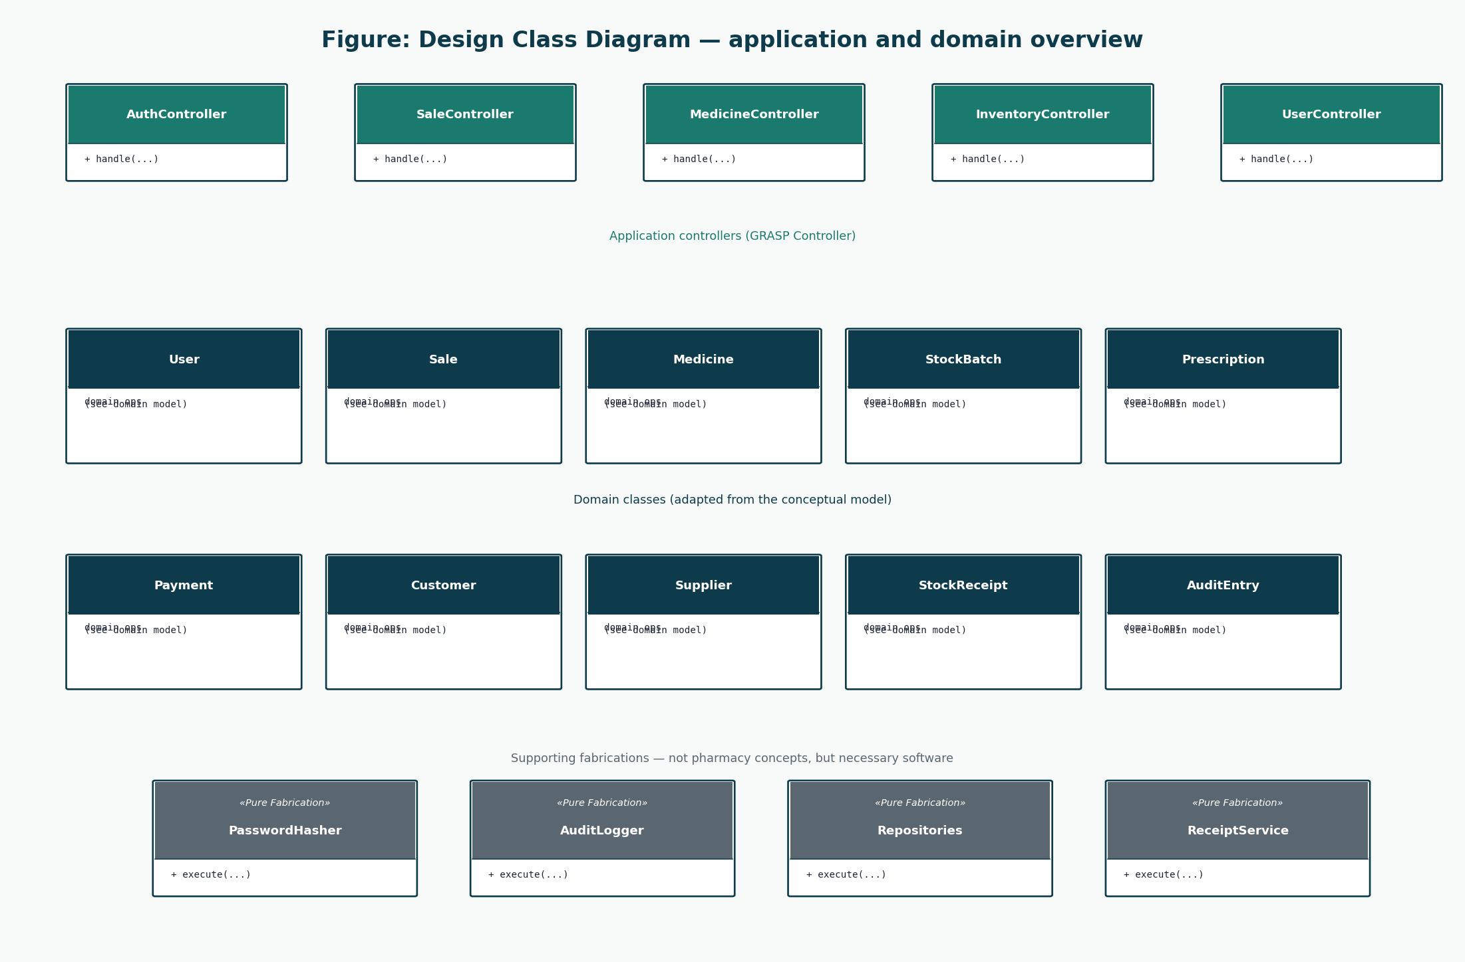
Figure 11: DCD overview
Controllers and fabrications.

13. GRASP Analysis
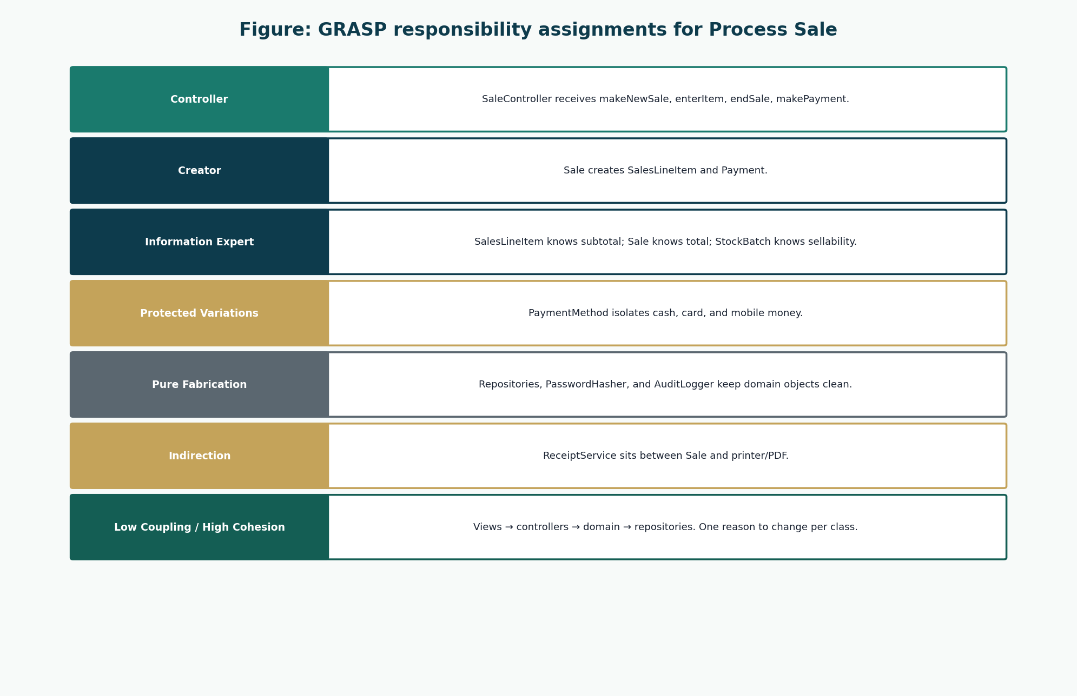
Figure 12: GRASP
Responsibility assignments.
Responsibility | Class | Collaborators | Why | GRASP
Handle system events of UC-02 | SaleController | SaleService, Sale | A use-case (facade) controller receives actor events without putting UI logic in the domain. | Controller
Create SalesLineItem | Sale | SalesLineItem, Medicine, StockBatch | Sale contains the lines and knows the moment they are added. | Creator
Create Payment | Sale | Payment | Sale records the payment that completes it. | Creator
Know line total | SalesLineItem | Medicine (price copied) | The line has quantity and unit price. | Information Expert
Know sale total | Sale | SalesLineItem | Sale has the lines. | Information Expert
Decide if a batch may be sold | StockBatch | — | The batch knows expiry date and quantity on hand. | Information Expert
Reduce stock | StockBatch / InventoryService | Sale, SalesLineItem | Quantity lives on the batch; a small domain service coordinates multi-line decrement. | Information Expert / High Cohesion
Hash passwords | PasswordHasher | User | Hashing is not a natural pharmacy concept; keep User free of crypto details. | Pure Fabrication
Write audit rows | AuditLogger | controllers / services | Cross-cutting record keeping would clutter Sale or User. | Pure Fabrication
Isolate payment kinds | PaymentMethod (cash, card, mobile money) | Payment, Sale | New methods should not explode conditionals in Sale. | Protected Variations / Polymorphism
Print or show a receipt | ReceiptService | Sale, Pharmacy settings | Output device or PDF should not sit inside Sale. | Indirection
Persist aggregates | SaleRepository and related repositories | domain objects | SQL/API details must not leak into Sale. | Pure Fabrication / Low Coupling
Keep views off repositories | Controllers + services | Views | Presentation depends inward only. | Low Coupling
One reason to change per class | Sale vs SaleController vs SaleRepository | — | Pricing rules, HTTP/UI events, and SQL stay apart. | High Cohesion

14. Database Design
Conceptual: the domain model. Logical: tables below in 3NF with controlled denormalisation of unit_price onto sale_items so historical receipts do not change when the catalogue price changes.

15. Database Schema

users
Table | Column | Data type | PK | FK | Nullable | Description
users | user_id | INT | Y |  | N | Surrogate primary key.
users | username | VARCHAR(50) |  |  | N | Unique login name.
users | full_name | VARCHAR(120) |  |  | N | Display name on receipts and audit.
users | role | VARCHAR(20) |  |  | N | ADMINISTRATOR or PHARMACIST.
users | password_hash | VARCHAR(255) |  |  | N | Salted hash only. Never plaintext.
users | password_salt | VARCHAR(64) |  |  | N | Per-user salt if not embedded in the hash.
users | is_active | BOOLEAN |  |  | N | Deactivated accounts cannot authenticate.
users | created_at | DATETIME |  |  | N | Account creation time.
users | last_login_at | DATETIME |  |  | Y | Last successful login.

pharmacy_settings
Table | Column | Data type | PK | FK | Nullable | Description
pharmacy_settings | pharmacy_id | INT | Y |  | N | Single-row settings key for this deployment.
pharmacy_settings | name | VARCHAR(160) |  |  | N | Pharmacy trading name.
pharmacy_settings | address | VARCHAR(255) |  |  | Y | Printed on receipts.
pharmacy_settings | phone | VARCHAR(40) |  |  | Y | Printed on receipts.
pharmacy_settings | receipt_footer | VARCHAR(255) |  |  | Y | Thank-you or regulatory line.
pharmacy_settings | near_expiry_days | INT |  |  | N | Days used for near-expiry alerts.
pharmacy_settings | currency_code | CHAR(3) |  |  | N | ZMW for this project.

medicine_categories
Table | Column | Data type | PK | FK | Nullable | Description
medicine_categories | category_id | INT | Y |  | N | Primary key.
medicine_categories | name | VARCHAR(80) |  |  | N | Unique category name.
medicine_categories | description | VARCHAR(255) |  |  | Y | Optional note.

medicines
Table | Column | Data type | PK | FK | Nullable | Description
medicines | medicine_id | INT | Y |  | N | Primary key.
medicines | product_code | VARCHAR(40) |  |  | N | Unique SKU / product code.
medicines | name | VARCHAR(160) |  |  | N | Brand or dispensing name.
medicines | generic_name | VARCHAR(160) |  |  | Y | INN / generic name.
medicines | strength | VARCHAR(40) |  |  | Y | For example 500 mg.
medicines | form | VARCHAR(40) |  |  | Y | Tablet, syrup, cream.
medicines | category_id | INT |  | medicine_categories.category_id | Y | Optional category.
medicines | requires_prescription | BOOLEAN |  |  | N | True for prescription-only items.
medicines | unit_price | DECIMAL(12,2) |  |  | N | Current selling price.
medicines | reorder_level | INT |  |  | N | Low-stock threshold.
medicines | is_active | BOOLEAN |  |  | N | Inactive medicines are not sold.

suppliers
Table | Column | Data type | PK | FK | Nullable | Description
suppliers | supplier_id | INT | Y |  | N | Primary key.
suppliers | name | VARCHAR(160) |  |  | N | Supplier trading name.
suppliers | phone | VARCHAR(40) |  |  | Y | Contact phone.
suppliers | address | VARCHAR(255) |  |  | Y | Contact address.
suppliers | is_active | BOOLEAN |  |  | N | Soft delete flag.

stock_batches
Table | Column | Data type | PK | FK | Nullable | Description
stock_batches | batch_id | INT | Y |  | N | Primary key.
stock_batches | medicine_id | INT |  | medicines.medicine_id | N | Medicine of this batch.
stock_batches | batch_number | VARCHAR(60) |  |  | N | Manufacturer / supplier batch no.
stock_batches | expiry_date | DATE |  |  | N | Not sellable after this date.
stock_batches | quantity_on_hand | INT |  |  | N | Current sellable quantity.
stock_batches | unit_cost | DECIMAL(12,2) |  |  | Y | Optional cost for valuation.
stock_batches | received_at | DATETIME |  |  | N | First receipt time.

stock_receipts
Table | Column | Data type | PK | FK | Nullable | Description
stock_receipts | receipt_id | INT | Y |  | N | Primary key.
stock_receipts | supplier_id | INT |  | suppliers.supplier_id | N | Source supplier.
stock_receipts | received_by_user_id | INT |  | users.user_id | N | Administrator who received.
stock_receipts | received_at | DATETIME |  |  | N | Receipt time.
stock_receipts | reference_note | VARCHAR(120) |  |  | Y | Delivery note number.

stock_receipt_lines
Table | Column | Data type | PK | FK | Nullable | Description
stock_receipt_lines | receipt_line_id | INT | Y |  | N | Primary key.
stock_receipt_lines | receipt_id | INT |  | stock_receipts.receipt_id | N | Parent receipt.
stock_receipt_lines | batch_id | INT |  | stock_batches.batch_id | N | Batch increased.
stock_receipt_lines | quantity | INT |  |  | N | Quantity received.

stock_adjustments
Table | Column | Data type | PK | FK | Nullable | Description
stock_adjustments | adjustment_id | INT | Y |  | N | Primary key.
stock_adjustments | batch_id | INT |  | stock_batches.batch_id | N | Adjusted batch.
stock_adjustments | adjusted_by_user_id | INT |  | users.user_id | N | Administrator.
stock_adjustments | quantity_delta | INT |  |  | N | Signed quantity change.
stock_adjustments | reason | VARCHAR(40) |  |  | N | DAMAGE, EXPIRY, RECOUNT, RECALL.
stock_adjustments | note | VARCHAR(255) |  |  | Y | Free-text explanation.
stock_adjustments | adjusted_at | DATETIME |  |  | N | When the change occurred.

customers
Table | Column | Data type | PK | FK | Nullable | Description
customers | customer_id | INT | Y |  | N | Primary key.
customers | full_name | VARCHAR(160) |  |  | N | Patient or buyer name.
customers | phone | VARCHAR(40) |  |  | Y | Optional phone.
customers | address | VARCHAR(255) |  |  | Y | Optional address.
customers | created_at | DATETIME |  |  | N | When first recorded.

prescriptions
Table | Column | Data type | PK | FK | Nullable | Description
prescriptions | prescription_id | INT | Y |  | N | Primary key.
prescriptions | customer_id | INT |  | customers.customer_id | N | Named patient.
prescriptions | reference_no | VARCHAR(60) |  |  | N | Paper / clinic reference.
prescriptions | prescriber_name | VARCHAR(160) |  |  | Y | Doctor or clinic if known.
prescriptions | issued_on | DATE |  |  | Y | Prescription date if known.
prescriptions | recorded_by_user_id | INT |  | users.user_id | N | Pharmacist who recorded it.
prescriptions | recorded_at | DATETIME |  |  | N | Capture time.

prescription_items
Table | Column | Data type | PK | FK | Nullable | Description
prescription_items | prescription_item_id | INT | Y |  | N | Primary key.
prescription_items | prescription_id | INT |  | prescriptions.prescription_id | N | Parent prescription.
prescription_items | medicine_id | INT |  | medicines.medicine_id | N | Authorised medicine.
prescription_items | quantity | INT |  |  | N | Authorised quantity.

sales
Table | Column | Data type | PK | FK | Nullable | Description
sales | sale_id | INT | Y |  | N | Primary key.
sales | sold_by_user_id | INT |  | users.user_id | N | Pharmacist/Cashier.
sales | customer_id | INT |  | customers.customer_id | Y | Optional customer.
sales | prescription_id | INT |  | prescriptions.prescription_id | Y | Optional linked prescription.
sales | status | VARCHAR(20) |  |  | N | IN_PROGRESS, COMPLETED, VOIDED.
sales | started_at | DATETIME |  |  | N | makeNewSale time.
sales | completed_at | DATETIME |  |  | Y | Completion or void time.
sales | void_reason | VARCHAR(255) |  |  | Y | Required when VOIDED.
sales | subtotal | DECIMAL(12,2) |  |  | N | Sum of line totals.
sales | total | DECIMAL(12,2) |  |  | N | Amount due.

sale_items
Table | Column | Data type | PK | FK | Nullable | Description
sale_items | sale_item_id | INT | Y |  | N | Primary key.
sale_items | sale_id | INT |  | sales.sale_id | N | Parent sale.
sale_items | medicine_id | INT |  | medicines.medicine_id | N | Sold medicine.
sale_items | batch_id | INT |  | stock_batches.batch_id | N | Batch decremented.
sale_items | quantity | INT |  |  | N | Quantity sold.
sale_items | unit_price | DECIMAL(12,2) |  |  | N | Price at time of sale.
sale_items | line_total | DECIMAL(12,2) |  |  | N | quantity * unit_price.

payments
Table | Column | Data type | PK | FK | Nullable | Description
payments | payment_id | INT | Y |  | N | Primary key.
payments | sale_id | INT |  | sales.sale_id | N | Paid sale (1:1 for this design).
payments | method | VARCHAR(20) |  |  | N | CASH, CARD, MOBILE_MONEY.
payments | amount_tendered | DECIMAL(12,2) |  |  | N | Amount given or confirmed.
payments | change_due | DECIMAL(12,2) |  |  | N | Cash change; zero otherwise.
payments | external_reference | VARCHAR(80) |  |  | Y | Card/mobile confirmation note.
payments | paid_at | DATETIME |  |  | N | Payment time.

audit_logs
Table | Column | Data type | PK | FK | Nullable | Description
audit_logs | audit_id | INT | Y |  | N | Primary key.
audit_logs | user_id | INT |  | users.user_id | Y | Null only for failed unknown login.
audit_logs | action | VARCHAR(40) |  |  | N | LOGIN, LOGIN_FAIL, SALE_COMPLETE, VOID, STOCK_RECEIPT, STOCK_ADJUST, USER_ADMIN.
audit_logs | entity_name | VARCHAR(40) |  |  | Y | Affected table or concept.
audit_logs | entity_id | INT |  |  | Y | Affected key.
audit_logs | details | VARCHAR(500) |  |  | Y | Non-sensitive summary.
audit_logs | occurred_at | DATETIME |  |  | N | Event time.

16. Entity Relationships
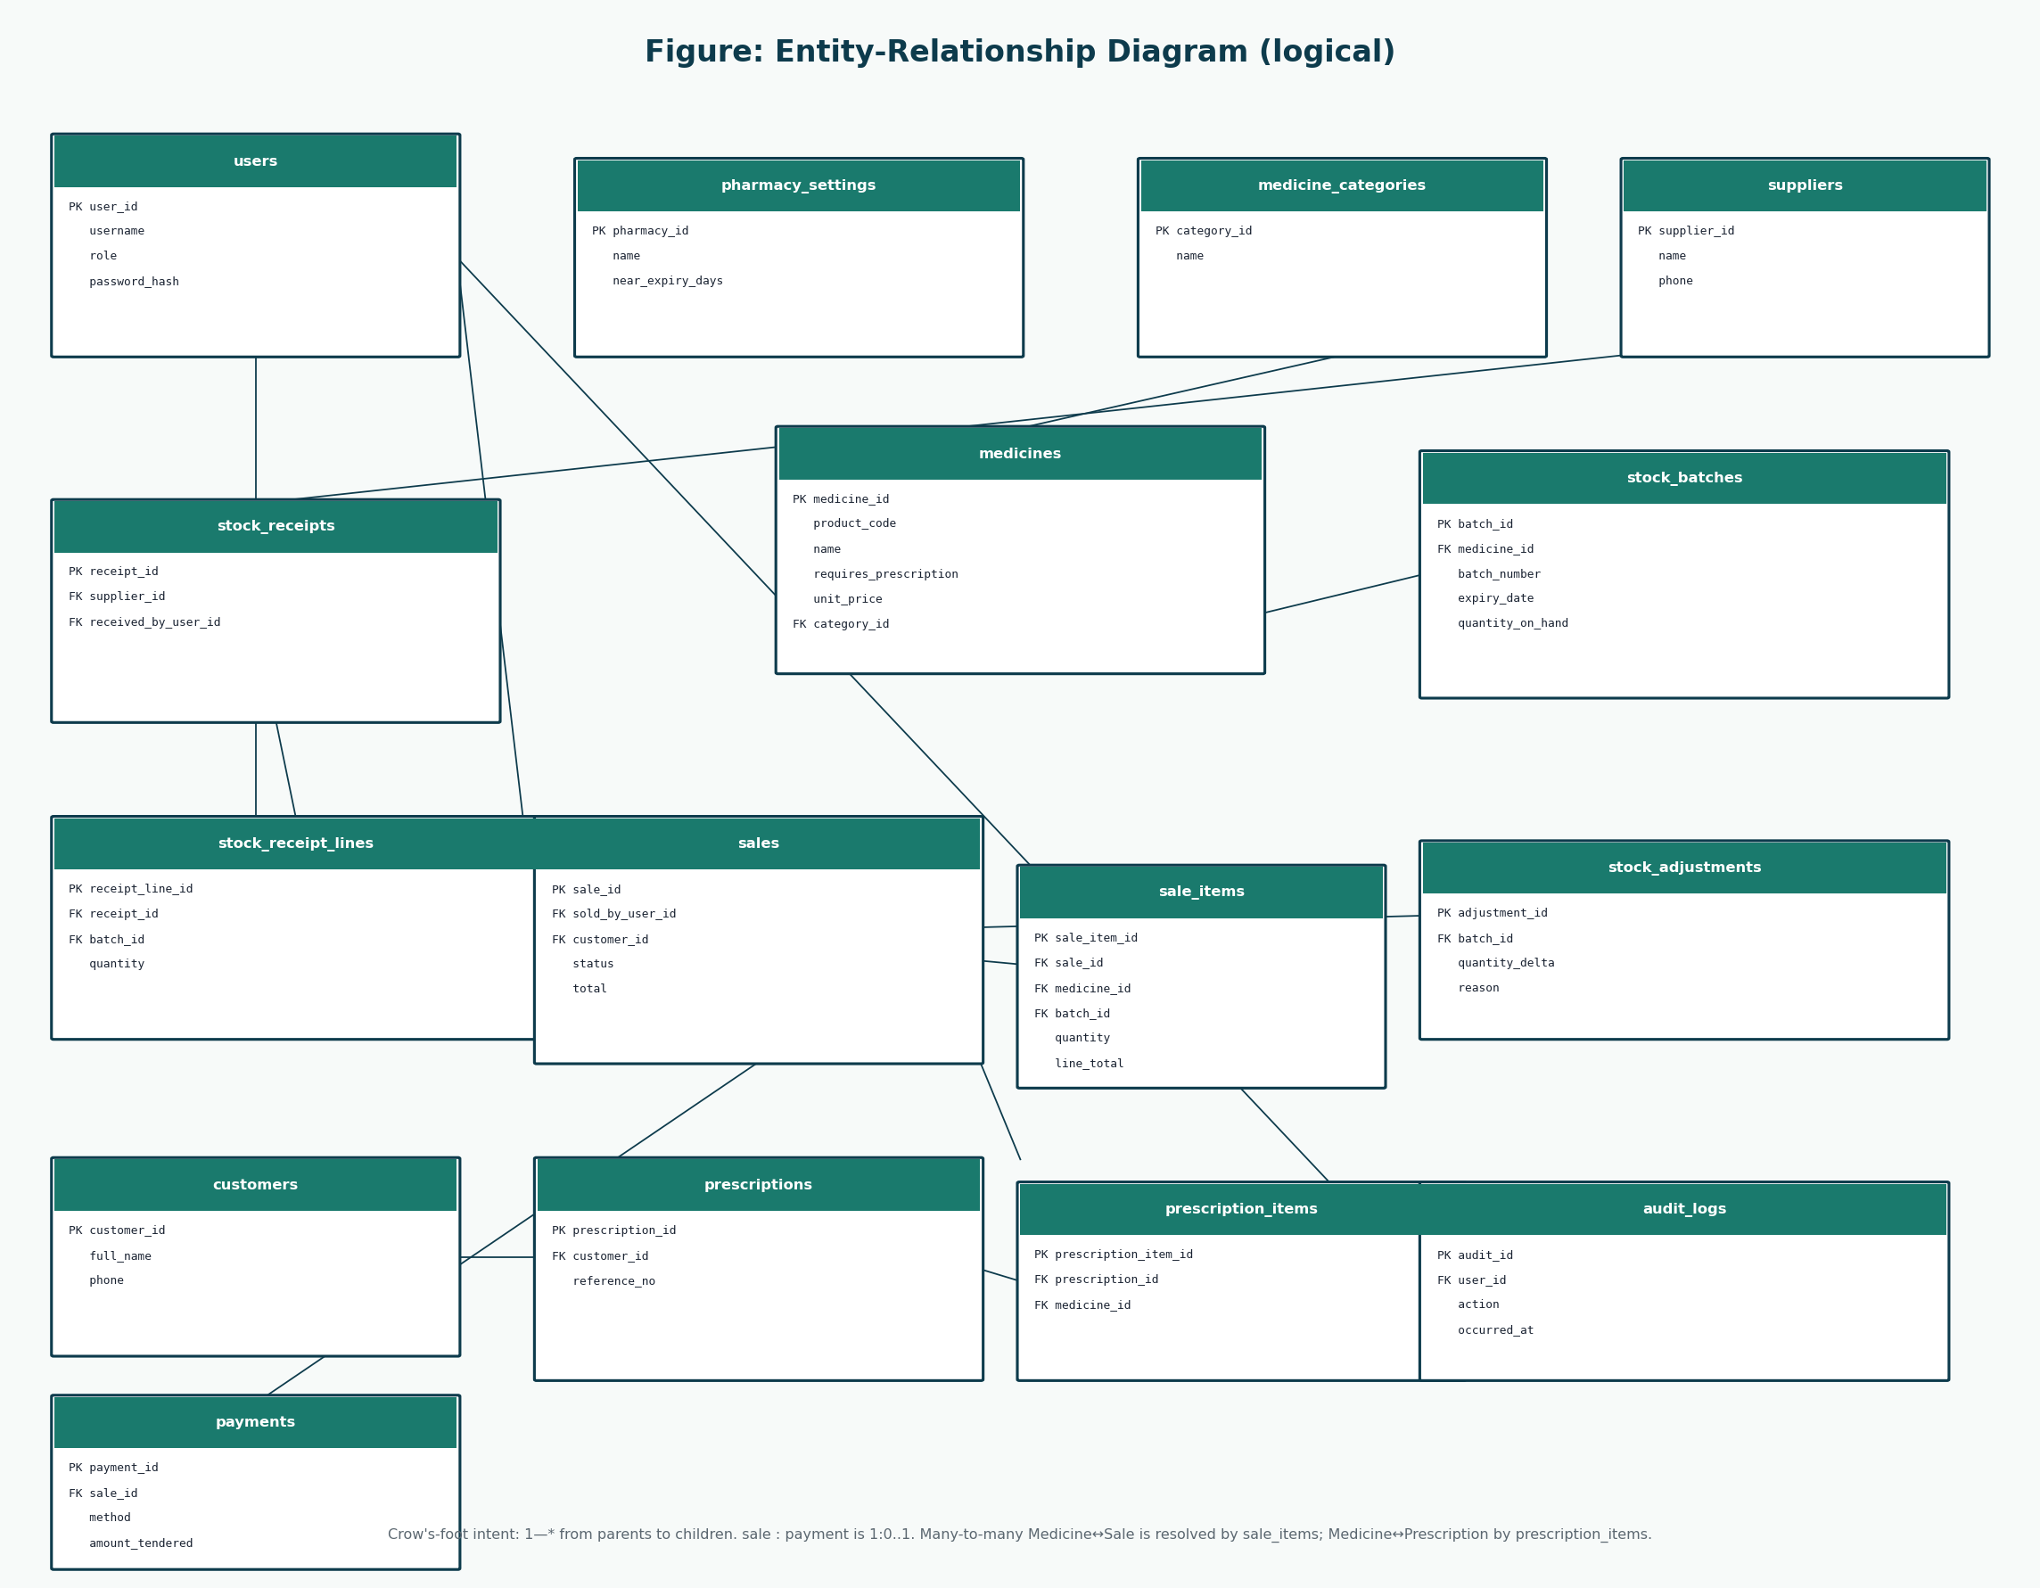
Figure 13: ERD
Logical relationships.
From | To | From card. | To card. | Meaning
users | sales | 1 | 0..* | A pharmacist records many sales.
users | stock_receipts | 1 | 0..* | An administrator records many receipts.
users | stock_adjustments | 1 | 0..* | An administrator records many adjustments.
medicine_categories | medicines | 1 | 0..* | A category groups many medicines.
medicines | stock_batches | 1 | 0..* | A medicine has many batches.
suppliers | stock_receipts | 1 | 0..* | A supplier is the source of many receipts.
stock_receipts | stock_receipt_lines | 1 | 1..* | A receipt contains lines.
stock_batches | stock_receipt_lines | 1 | 0..* | A batch may be increased by receipt lines.
stock_batches | stock_adjustments | 1 | 0..* | A batch may be adjusted many times.
customers | prescriptions | 1 | 0..* | A customer may have many recorded prescriptions.
customers | sales | 1 | 0..* | A customer may appear on many sales.
prescriptions | prescription_items | 1 | 1..* | A prescription lists items.
medicines | prescription_items | 1 | 0..* | A medicine may appear on prescriptions.
prescriptions | sales | 1 | 0..1 | A prescription may be linked to a sale.
sales | sale_items | 1 | 1..* | A sale contains line items.
medicines | sale_items | 1 | 0..* | A medicine appears on many sale lines.
stock_batches | sale_items | 1 | 0..* | A batch is sold on many lines over time.
sales | payments | 1 | 0..1 | A completed sale has one payment in this design.
users | audit_logs | 1 | 0..* | A user generates many audit rows.

17. Data Dictionary
Term | Kind | Notes
Medicine | Concept / table medicines | Catalogue description
StockBatch | Concept / table stock_batches | Expiring physical quantity
Sale | Concept / table sales | IN_PROGRESS, COMPLETED, VOIDED
SalesLineItem | Concept / table sale_items | Resolves Sale–Medicine
Payment | Concept / table payments | One per completed sale
User.role | Attribute | ADMINISTRATOR | PHARMACIST
password_hash | Attribute | Never plaintext
requires_prescription | Attribute | Drives attachPrescription
Receipt | Output | Not a stored entity
Customer | External person / table customers | No login

18. UI Design
Prototypes correspond to use cases, not to an invented third role.
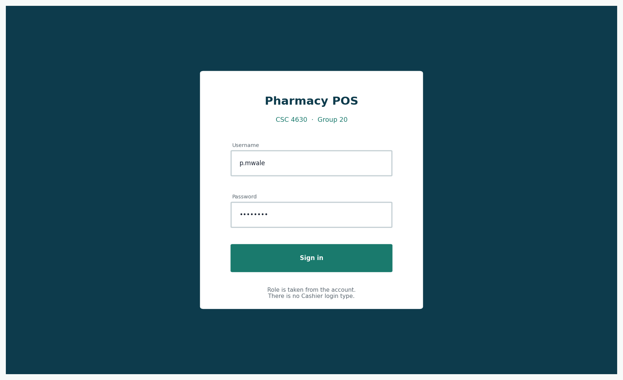
Figure: Login — UC-01
See Elaboration 2 for commentary.
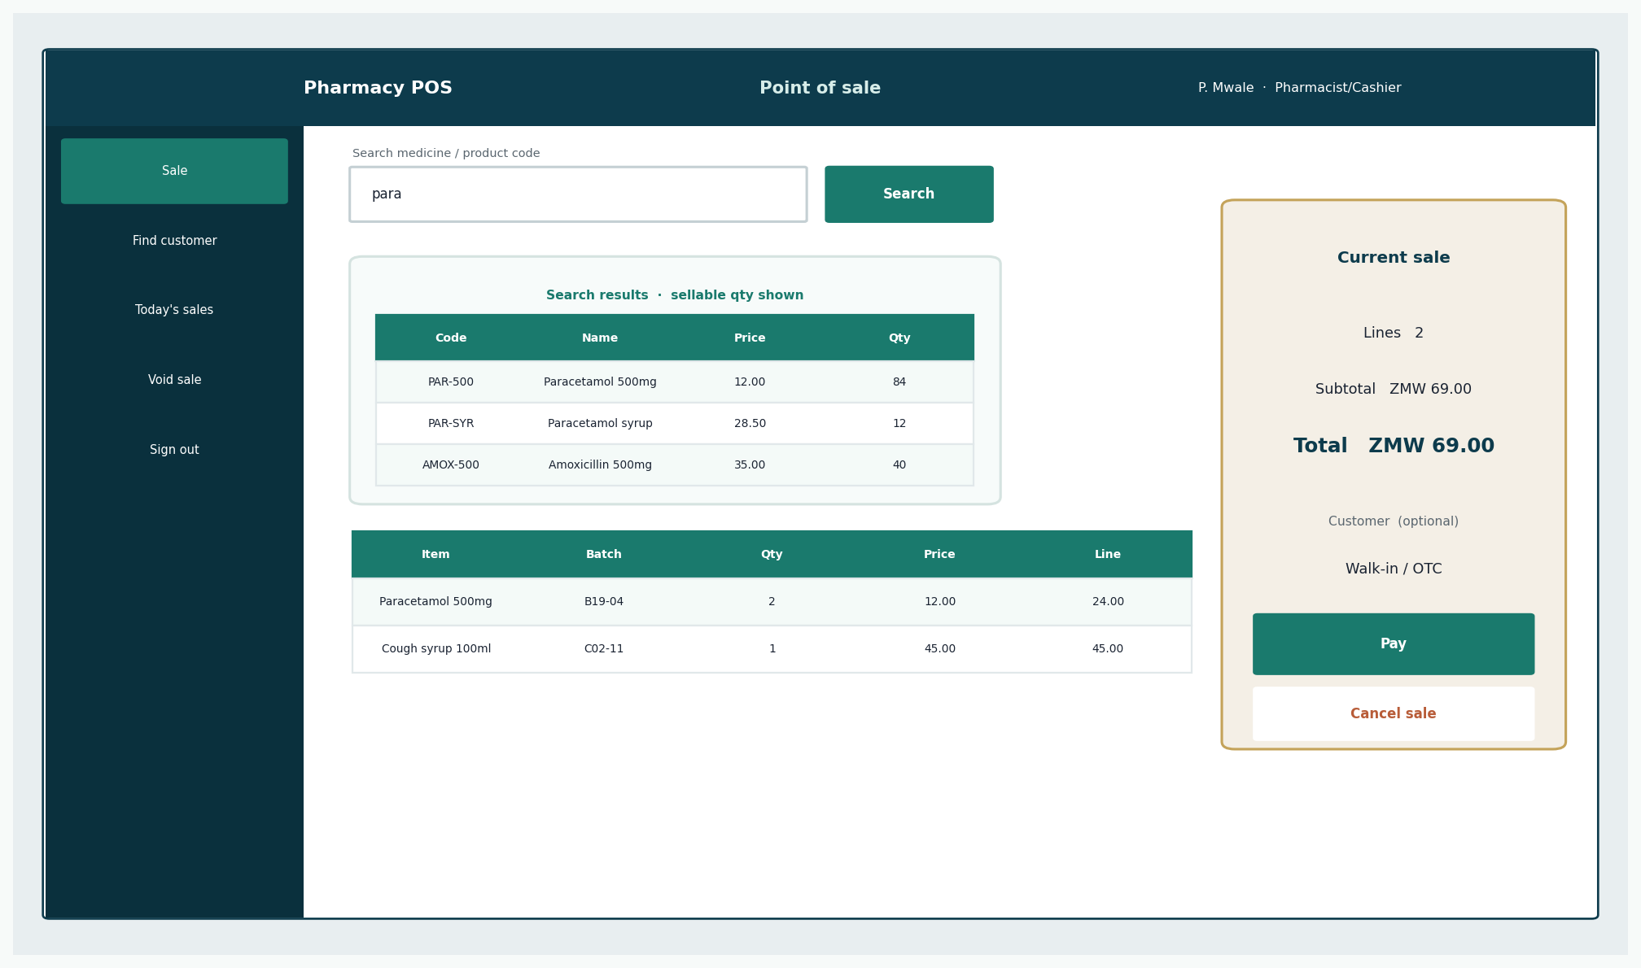
Figure: POS — UC-02
See Elaboration 2 for commentary.
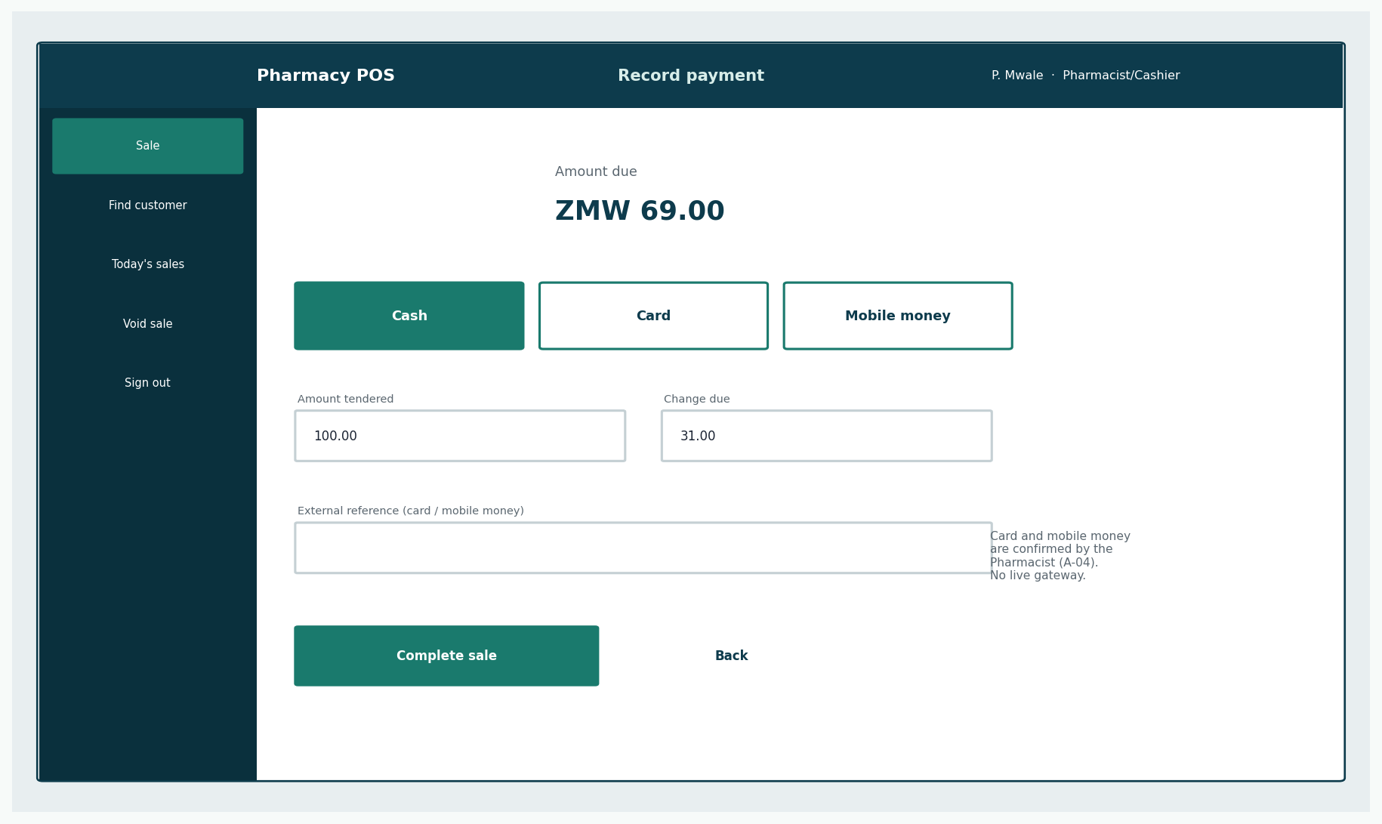
Figure: Payment — UC-02
See Elaboration 2 for commentary.
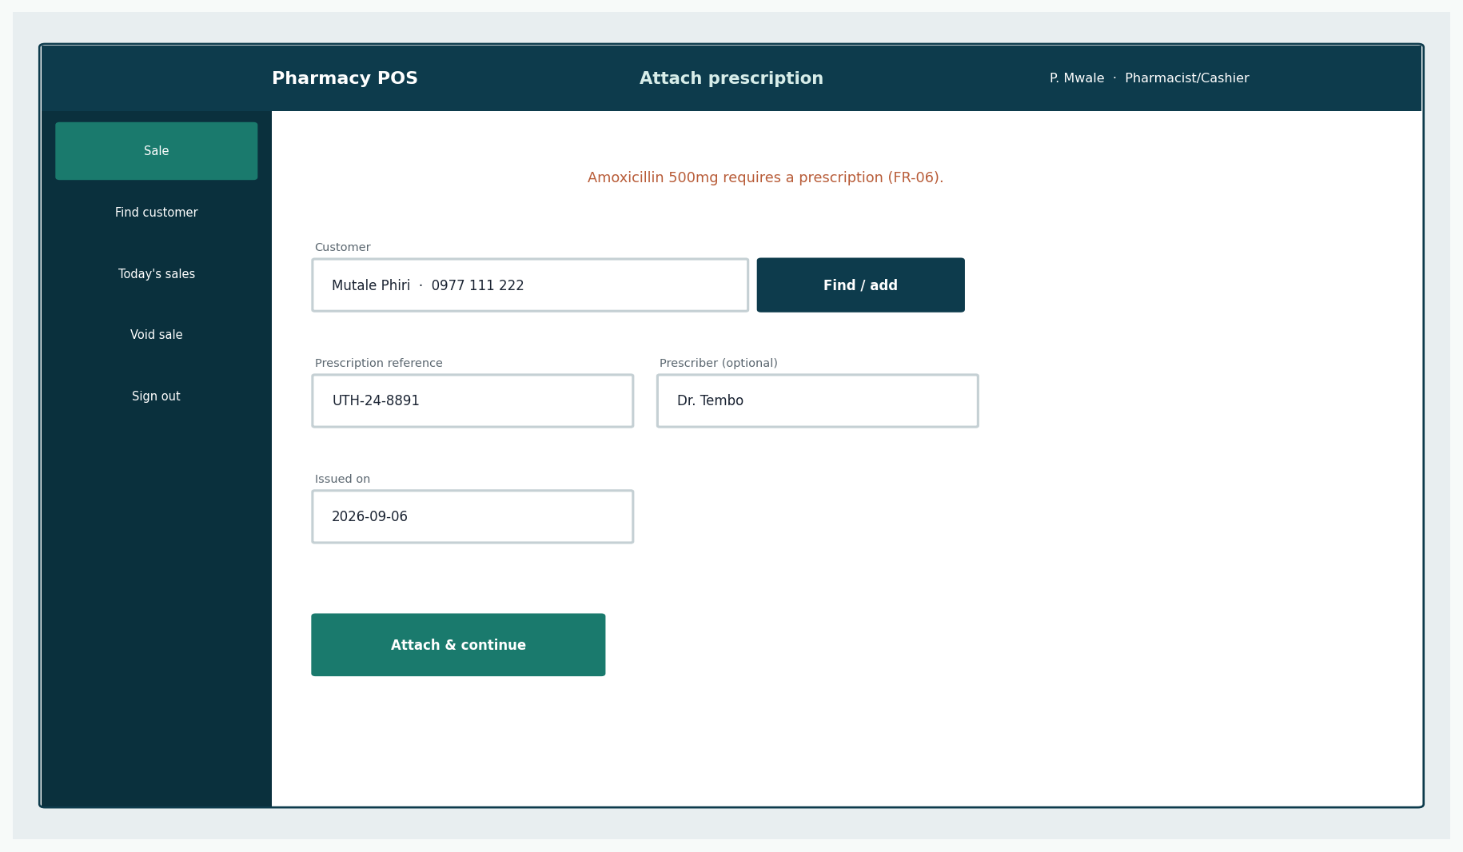
Figure: Prescription — UC-02 / UC-08
See Elaboration 2 for commentary.
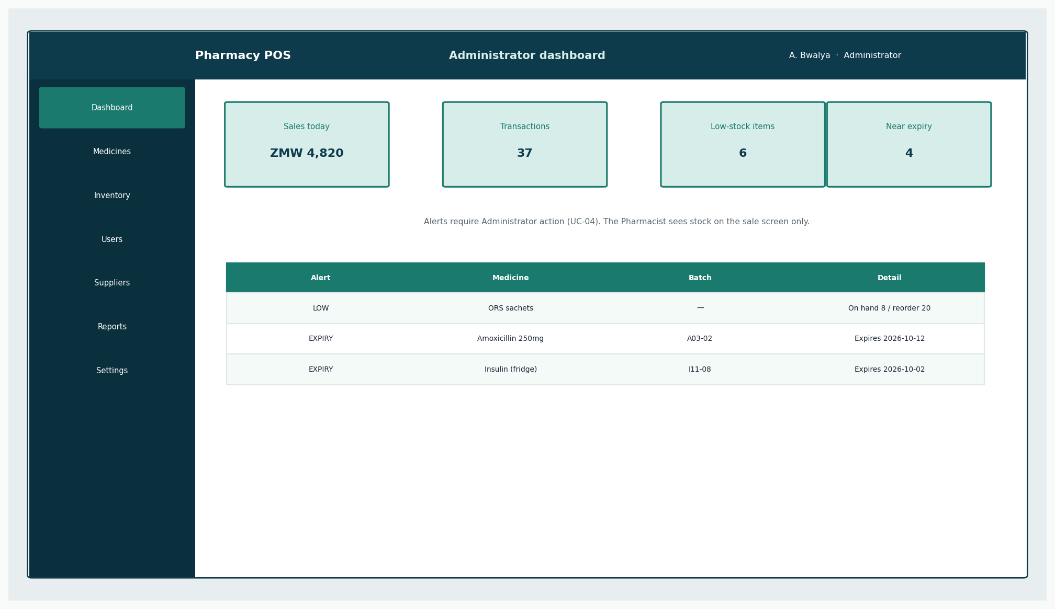
Figure: Admin home — UC-04 alerts
See Elaboration 2 for commentary.
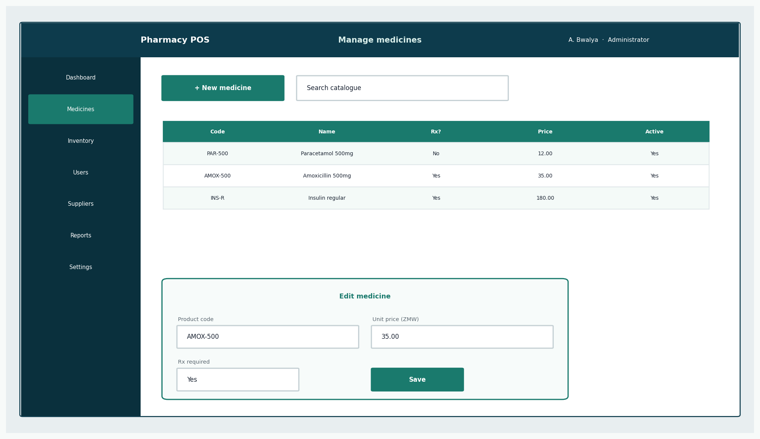
Figure: Medicines — UC-03
See Elaboration 2 for commentary.
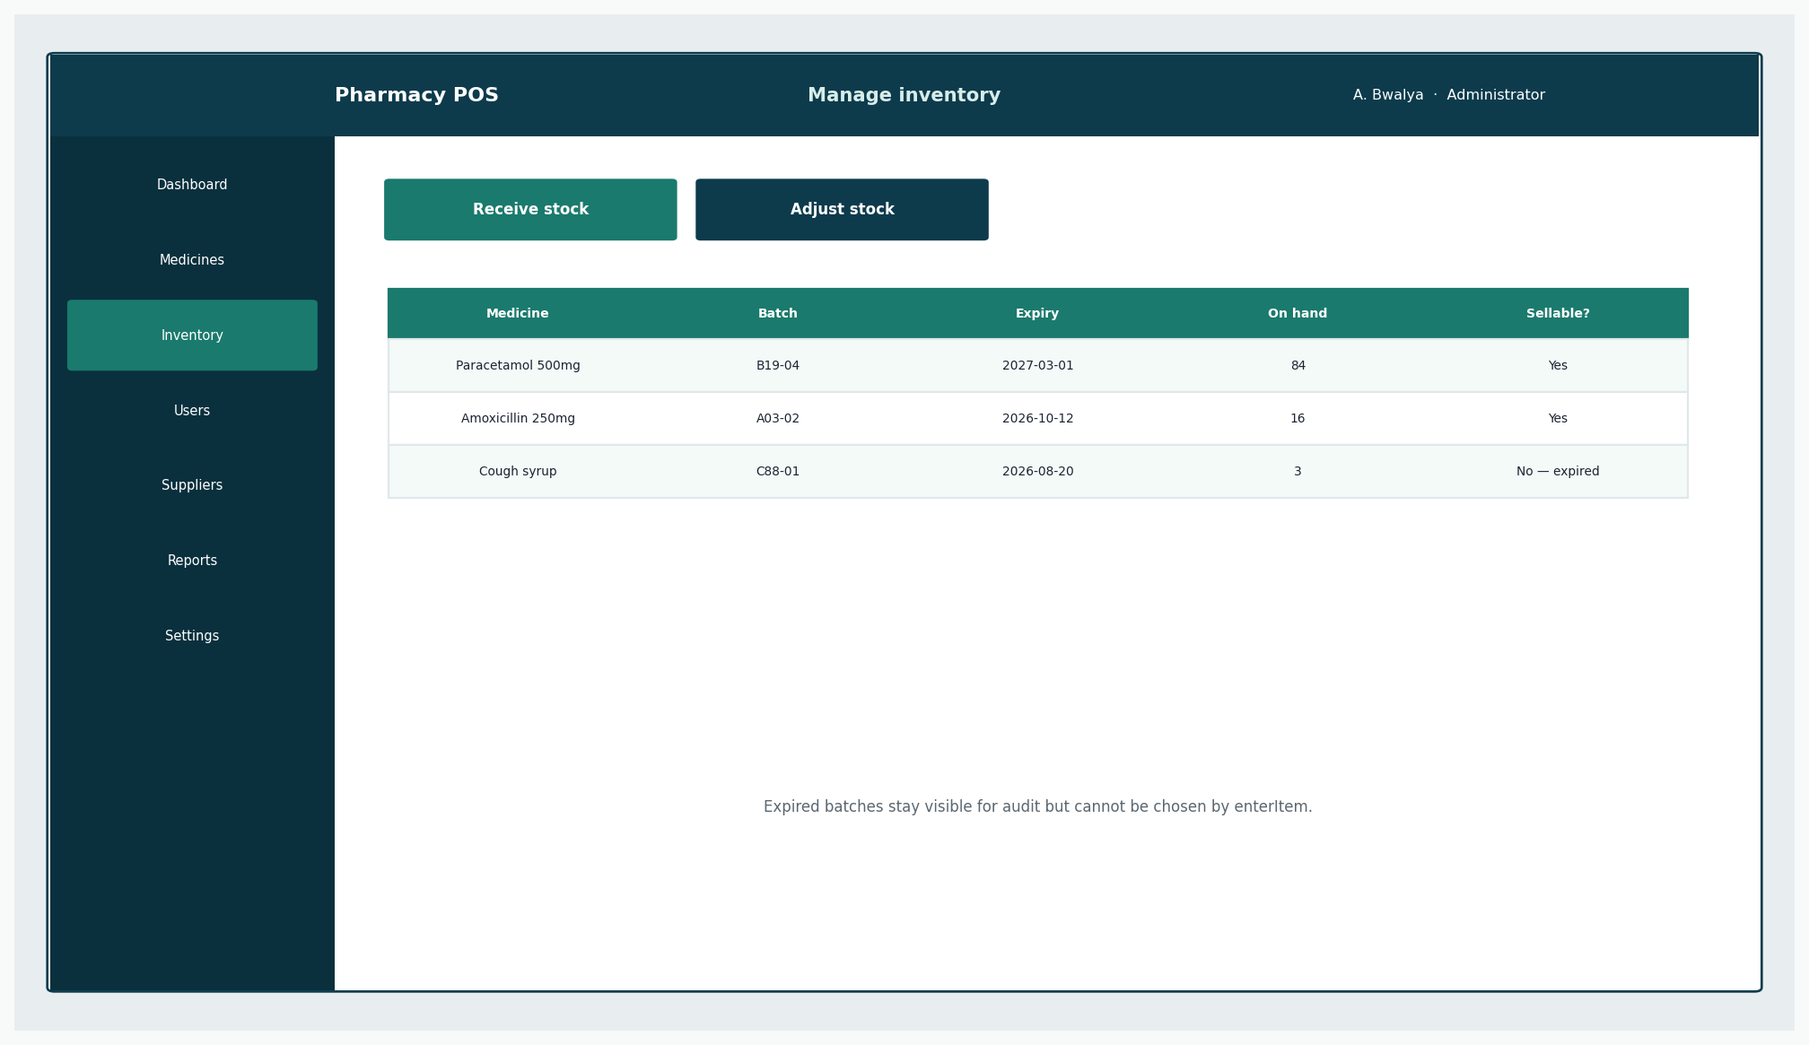
Figure: Inventory — UC-04
See Elaboration 2 for commentary.
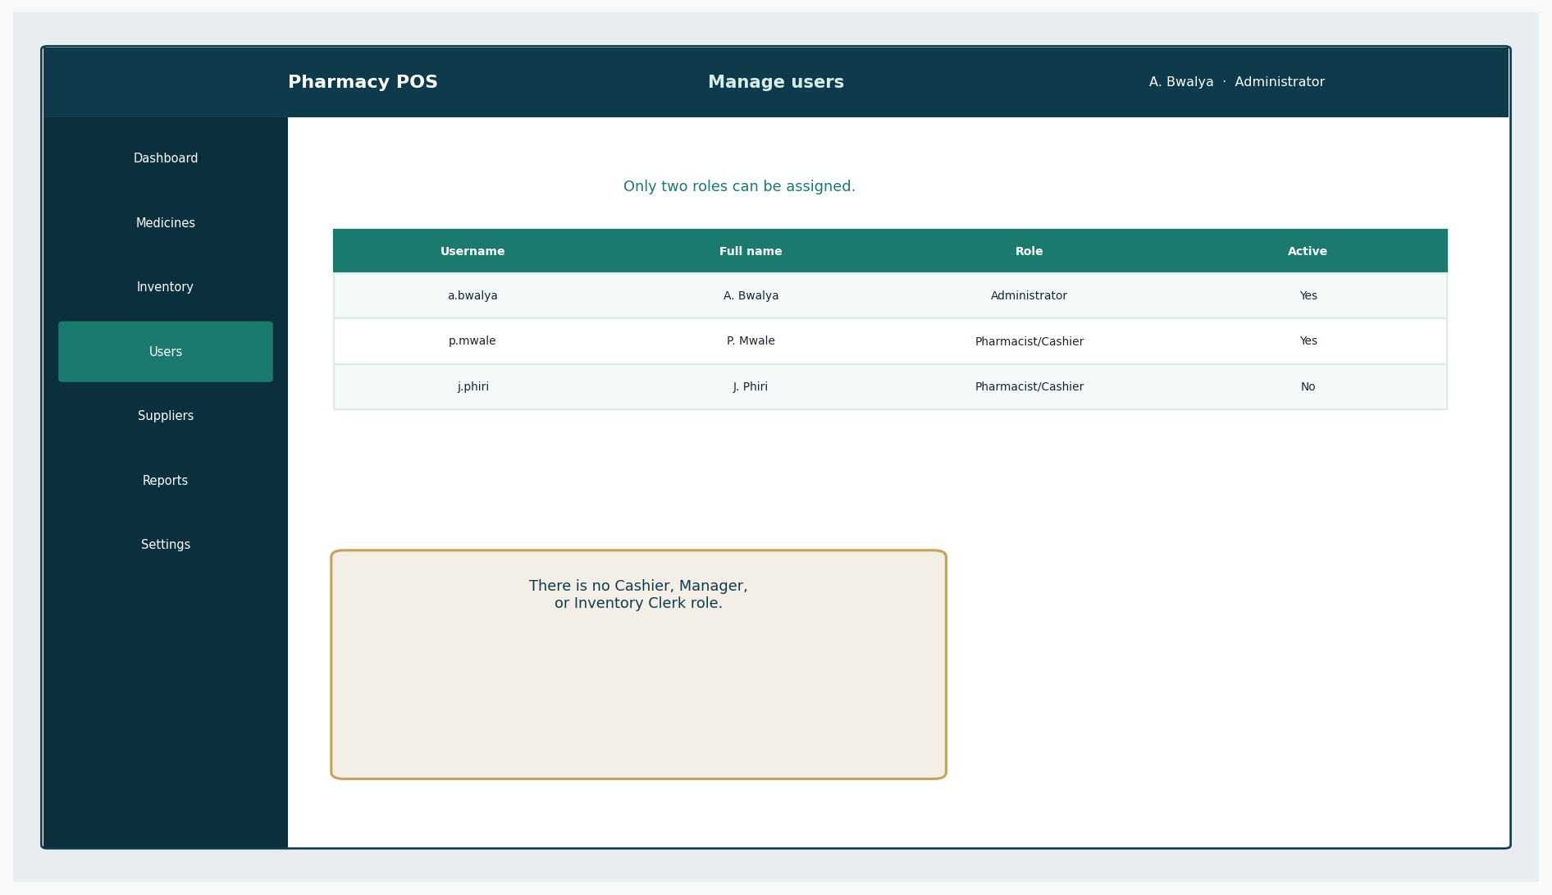
Figure: Users — UC-05
See Elaboration 2 for commentary.
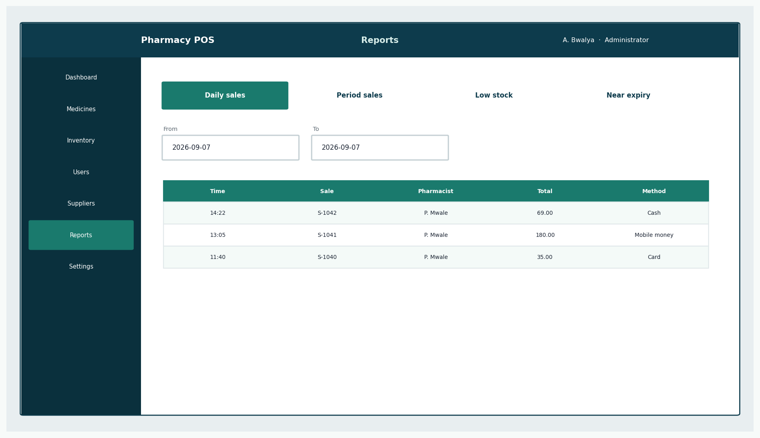
Figure: Reports — UC-07
See Elaboration 2 for commentary.

19. Security Design
Control | Design
Authentication | Username + salted password hash (NFR-01, users table)
Authorisation | Exactly two roles; checked on every privileged operation
Password handling | No plaintext, no reversible encryption
Session | Server-side or equivalent session; idle timeout
Input validation | Quantities ≥ 0; prices ≥ 0; required fields; unique codes
Audit | audit_logs for login, sale, void, stock, user admin
Sensitive data | Customer and prescription fields only on staff screens
Database | Least-privilege DB account in construction; no shared admin password in source
Transport | HTTPS if the construction choice is a web client

20. Performance Considerations
NFR-02 asks for about three seconds to accept a line and refresh the total on the intended workstation. The design supports that by: searching on indexed product_code and name; choosing one sellable batch rather than scanning history in the UI; and keeping the sale in memory until completeSale. Measurements belong to Transition — none are invented here.

21. Integration Considerations
Receipt output is isolated (ReceiptService). PaymentMethod isolates tender types. No NHIMA, no e-commerce, no live gateway. Those seams are how Protected Variations is applied without fake integrations.

22. Traceability Matrix
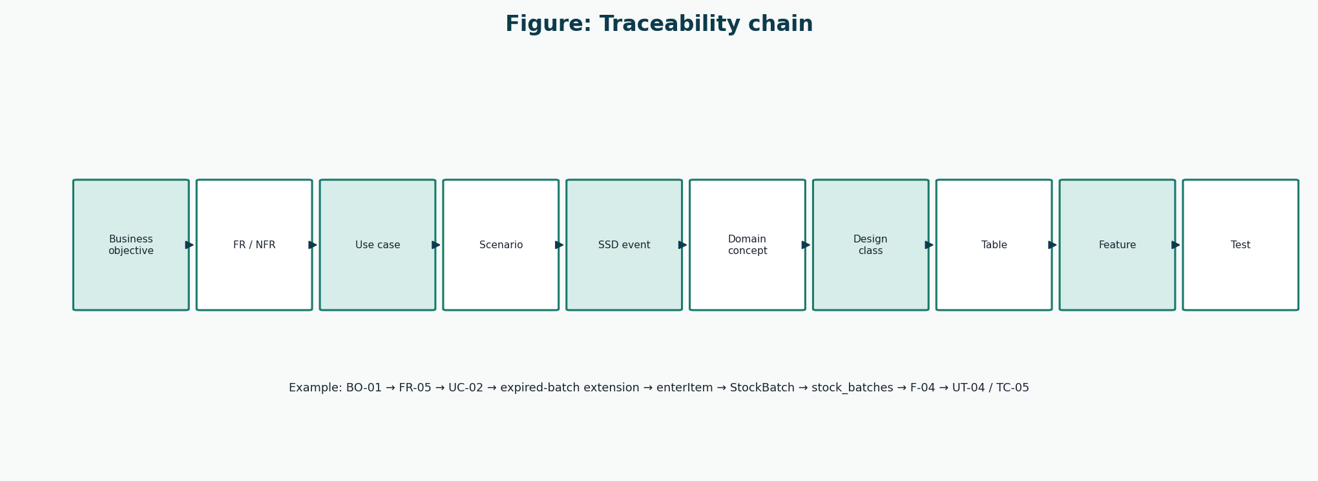
Figure 14: Traceability chain
Used to build the matrix.
FR | Use case | Scenario | SSD / events | Design / data | Feature | Test
FR-01, FR-02, FR-19 | UC-01 | Main + extensions | SSD UC-01 | See domain / DCD | F-01 | TC-01
FR-03, FR-04, FR-05, FR-06, FR-07, FR-08, FR-16 | UC-02 | Main + extensions | SSD UC-02 | See domain / DCD | F-02 | TC-04
FR-09 | UC-03 | Main + extensions | SSD UC-03 | See domain / DCD | F-08 | TC-11
FR-10, FR-11, FR-12 | UC-04 | Main + extensions | SSD UC-04 | See domain / DCD | F-09 | TC-12
FR-13, FR-19 | UC-05 | Main + extensions | Events in description | See domain / DCD | F-11 | TC-14
FR-14 | UC-06 | Main + extensions | Events in description | See domain / DCD | F-12 | —
FR-15 | UC-07 | Main + extensions | Events in description | See domain / DCD | F-13 | —
FR-16 | UC-08 | Main + extensions | Events in description | See domain / DCD | F-14 | —
FR-17, FR-19 | UC-09 | Main + extensions | SSD UC-09 | See domain / DCD | F-15 | TC-15
FR-18 | UC-10 | Main + extensions | Events in description | See domain / DCD | F-16 | —

22.1 Objectives to requirements
Objective | Requirements
BO-01 | FR-05, FR-08, FR-11
BO-02 | FR-03, FR-07, FR-08
BO-03 | FR-08, FR-10, FR-11, FR-17
BO-04 | FR-06, FR-16
BO-05 | FR-09 to FR-15, FR-18
BO-06 | FR-17, FR-19
BO-07 | Iteration plan (process requirement)

23. Design Decisions
See Elaboration 1 AD-01 to AD-07. Additional decisions:
ID | Decision | Rationale
AD-08 | Copy unit_price onto sale_items | Historical receipts stay stable
AD-09 | Soft-deactivate users and medicines | Old sales remain explainable
AD-10 | One payment per completed sale | Matches the counter workflow; splits can wait
AD-11 | Void keeps the sale row | Audit over convenience

24. Risks and Mitigations
ID | Risk | P | I | Priority | Mitigation | Iteration | Status
R-01 | Sale and stock update diverge. | Low | High | Medium | SaleService.completeSale collaborates with Inventory and repositories in one unit of work. | Elaboration 2 | Mitigated in design
R-02 | Expired medicine can be sold. | Low | High | Medium | StockBatch.isSellable() is Information Expert for expiry and quantity. | Elaboration 2 | Mitigated in design
R-03 | Third-role creep. | Low | High | Low | User.role is an enumeration of two values in schema and UI. | Elaboration 2 | Mitigated in design
R-04 | Payment / sale inconsistency. | Low | High | Medium | Payment created by Sale; completion only after accepted payment. | Elaboration 2 | Mitigated in design
R-05 | Staff resist new workflow. | Medium | Medium | Medium | UI prototypes issued for counter and admin paths. | Elaboration 2 | Mitigating
R-06 | Scope creep. | Low | High | Low | Remaining 70% use cases do not add insurance or web shop. | Elaboration 2 | Mitigated in design
R-07 | Schedule slip. | Medium | Medium | Medium | Construction will implement by feature priority, not by layer-in-isolation. | Elaboration 2 | Open
R-08 | Data loss. | Low | High | Medium | Schema includes keys, required fields, audit table; backup remains Transition. | Elaboration 2 | Mitigating
R-09 | Prescription legal sufficiency. | Medium | Medium | Medium | Prescription and Customer tables designed; national feed still out of scope. | Elaboration 2 | Mitigated in design
R-10 | Architecture unfit for POS. | Low | Medium | Low | DCD and GRASP keep controllers thin and domain cohesive. | Elaboration 2 | Mitigated in design
R-11 | UI prototypes misunderstood as finished product. | Medium | Low | Low | Prototypes labelled as design only. | Elaboration 2 | Open

25. Assumptions
ID | Assumption | Reason | Impact if incorrect | Status
A-01 | Single physical pharmacy (one location). | Course scope and first deployment. | Multi-branch stock and pricing would be missing. | Open
A-02 | Exactly two logged-in roles: Administrator and Pharmacist/Cashier. | Lecturer/project constraint. | Access control and use-case model would be wrong. | Confirmed
A-03 | The Customer does not operate the software. | Counter-based pharmacy practice; Larman POS boundary. | SSDs and actors would change. | Confirmed
A-04 | Card and mobile-money payment are confirmed by the Pharmacist, not by a live gateway in this release. | Avoids unverifiable third-party integration in a student construction window. | Payment design would need an external adapter earlier. | Open
A-05 | NHIMA / insurance claim submission is out of scope. | Existing project scope decision. | Prescription sale would include claim steps. | Confirmed
A-06 | No public e-commerce storefront. | POS is an in-pharmacy counter system. | Architecture and actors would expand. | Confirmed
A-07 | Prescriptions are recorded and checked in-system; there is no national e-prescription feed. | No available national interface for the project. | UC-02 extensions would change. | Open
A-08 | Currency is Zambian Kwacha (ZMW). | Deployment context is Zambia. | Money formatting and reports would change. | Confirmed
A-09 | English is the UI language for this release. | Course and team working language. | Labels and user manual would need translation. | Confirmed
A-10 | The Pharmacist is legally permitted to dispense and take payment. | Zambian pharmacy practice assumption. | A third operational role might be demanded in reality. | Open

References
[1] Larman, C. Applying UML and Patterns: An Introduction to Object-Oriented Analysis and Design and Iterative Development. 3rd edition. Prentice Hall. Principal methodology for UP, use cases, domain models, SSDs, design class diagrams, GRASP, and iterative development. Page numbers are not cited because the full print edition was not available as a continuous source file; chapter titles from the course extracts (System Sequence Diagrams; Domain Model associations; Design Class Diagrams) are used instead.
[2] CSC 4630 Advanced Software Engineering Course Project Marking Guide. Unified Process, 15 weeks, 100 marks. Determines milestones, deliverables, and mark weights.
[3] Larman course extracts used by the group: Chapter 9 System Sequence Diagrams; Chapter 11 Domain Model associations; Chapter 16 Design Class Diagrams.
[4] Group 20 inception briefing slides, Pharmacy POS System — Advanced Software Engineering (problem context in Zambia). Role names in those slides that implied a separate Cashier or Manager were corrected in this documentation to match the two-role rule.

