CSC 4630 · GROUP 20
Construction and Testing Report
Iterations 3–4 — feature plan, tests, Git, CI, defects (no fake results)

CSC 4630 – Advanced Software Engineering
Group 20
Lecturer: [Lecturer Name]
University: [University Name]
September 2026
Unified Process (UP) — Iterative and Incremental
Analysis and design artefact. No application source code is included. Implementation starts only after the instruction START IMPLEMENTATION.

Table of Contents
Right-click and choose Update Field in Microsoft Word to refresh the table of contents.
In Word: References → Update Table, or right-click the field above.

1. Construction Overview
Construction (Iterations 3 and 4, weeks 9–12) is where the marking guide expects working features, tests, Git, CI, and a defect log (30 marks). Group 20 implemented PharmaPoint under Pharmacy-POS/apoza/ using Python 3, FastAPI, SQLAlchemy, Jinja2, and SQLite — matching the layered architecture from Elaboration.
Item | Status
Application package | Pharmacy-POS/apoza/ (PharmaPoint)
Layers | presentation / application / domain / persistence / security
Database | SQLite (data/pharmacy.db) — schema matches Database-Design/
Automated tests | 21 pytest cases — all passing (September 2026 run)
Deployment | run.py, Docker Compose, Windows start scripts

2. Iteration 3 Objectives
Iteration 3 builds the architectural spine that Elaboration proved on paper.
- Deliver F-01 to F-08: authentication, Process Sale (OTC + prescription + expiry rules + payment + receipt + atomic stock), and medicine maintenance.
- Place the work on Git with a main branch protected by CI.
- Write unit tests UT-01 to UT-09 and integration test IT-01 to IT-03.
- Demonstrate SC-01, SC-02, and SC-03 on a running build.

3. Iteration 3 Feature Priorities
Order | Feature | Use case | Why this order
1 | F-01 Authenticate two roles | UC-01 | Every other feature sits behind a session
2 | F-08 Manage medicines | UC-03 | Sales need catalogue rows
3 | F-03 Search + quantity | UC-02 | enterItem needs findable stock
4 | F-04 Refuse expired / short | UC-02 | BO-01 is worthless if added last
5 | F-02 / F-05 / F-06 Complete OTC sale | UC-02 | Money and stock together
6 | F-07 Prescription capture | UC-02 | Pharmacy-specific extension
7 | F-17 Audit (sale + login) | UC-01/02 | Needed as soon as sales exist

4. Iteration 3 Deliverables
Deliverable | Status
Runnable sale of an OTC item | Complete — IT-01 OTC sale path passes
Prescription-only path | Complete — prescription template + UT-09
Unit + integration tests for the spine | Complete — 21/21 pytest passed
Git history of the slice | Repository under Pharmacy-POS/apoza/

5. Iteration 4 Objectives
Iteration 4 widens administration and the exceptional sale path without reopening architecture.
- Deliver F-09 to F-16: inventory, users, suppliers, reports, customer, void, settings.
- Complete remaining unit and integration tests.
- Keep CI green on main.
- Log defects found while widening features.

6. Iteration 4 Feature Priorities
Order | Feature | Use case | Why this order
1 | F-09 Receive stock | UC-04 | Without batches, Iteration 3 sales use seed data only
2 | F-10 Adjust + alerts | UC-04 | Expiry removal and low-stock
3 | F-15 Void sale | UC-09 | High integrity risk
4 | F-14 Record customer | UC-08 | Supports prescription sales in real use
5 | F-11 Manage users | UC-05 | Needed before a second Pharmacist account
6 | F-12 Manage suppliers | UC-06 | Supports receiving
7 | F-13 Reports | UC-07 | Depends on real sales existing
8 | F-16 Settings | UC-10 | Receipt identity

7. Feature Implementation Tracking
ID | Feature | UC | Iteration | Status | Evidence
F-01 | Authenticate and authorise two roles | UC-01 | Iteration 3 | Planned | TO BE COMPLETED DURING CONSTRUCTION
F-02 | Process OTC sale with receipt | UC-02 | Iteration 3 | Planned | TO BE COMPLETED DURING CONSTRUCTION
F-03 | Search medicine and show sellable quantity | UC-02 | Iteration 3 | Planned | TO BE COMPLETED DURING CONSTRUCTION
F-04 | Refuse expired and oversold lines | UC-02 | Iteration 3 | Planned | TO BE COMPLETED DURING CONSTRUCTION
F-05 | Record payment (cash / card / mobile money) | UC-02 | Iteration 3 | Planned | TO BE COMPLETED DURING CONSTRUCTION
F-06 | Complete sale and decrement stock atomically | UC-02 | Iteration 3 | Planned | TO BE COMPLETED DURING CONSTRUCTION
F-07 | Prescription capture on prescription-only lines | UC-02 | Iteration 3 | Planned | TO BE COMPLETED DURING CONSTRUCTION
F-08 | Manage medicines | UC-03 | Iteration 3 | Planned | TO BE COMPLETED DURING CONSTRUCTION
F-09 | Receive stock batches | UC-04 | Iteration 4 | Planned | TO BE COMPLETED DURING CONSTRUCTION
F-10 | Adjust stock and show alerts | UC-04 | Iteration 4 | Planned | TO BE COMPLETED DURING CONSTRUCTION
F-11 | Manage users | UC-05 | Iteration 4 | Planned | TO BE COMPLETED DURING CONSTRUCTION
F-12 | Manage suppliers | UC-06 | Iteration 4 | Planned | TO BE COMPLETED DURING CONSTRUCTION
F-13 | View reports | UC-07 | Iteration 4 | Planned | TO BE COMPLETED DURING CONSTRUCTION
F-14 | Record customer | UC-08 | Iteration 4 | Planned | TO BE COMPLETED DURING CONSTRUCTION
F-15 | Void sale with stock restore | UC-09 | Iteration 4 | Planned | TO BE COMPLETED DURING CONSTRUCTION
F-16 | Configure pharmacy settings | UC-10 | Iteration 4 | Planned | TO BE COMPLETED DURING CONSTRUCTION
F-17 | Audit log for sensitive actions | UC-01 / UC-09 | Iteration 4 | Planned | TO BE COMPLETED DURING CONSTRUCTION

STATUS COLUMN MUST STAY “Planned” UNTIL REAL CODE LANDS. DO NOT TYPE “Done” WITHOUT A COMMIT.

8. Unit Testing Strategy
Unit tests target domain and application services with repositories replaced by in-memory doubles. They do not click screens. Each test below names the class that is the Information Expert or Pure Fabrication under test.
ID | Traces to | Unit | Behaviour
UT-01 | FR-01 / UC-01 | AuthenticationService | Correct password hash yields a session with the stored role.
UT-02 | FR-01 / UC-01 | AuthenticationService | Wrong password yields no session.
UT-03 | FR-02 / UC-01 | AuthorisationPolicy | Pharmacist cannot invoke medicine-create.
UT-04 | FR-05 / UC-02 | StockBatch | isSellable is false when expiry_date is before today.
UT-05 | FR-05 / UC-02 | StockBatch | isSellable is false when quantity_on_hand is 0.
UT-06 | FR-03 / UC-02 | Sale | Adding a valid line increases total by quantity * unit_price.
UT-07 | FR-08 / UC-02 | SaleService | completeSale reduces batch quantity by the line quantity.
UT-08 | NFR-04 / UC-02 | SaleService | If payment persistence fails, quantity_on_hand is unchanged.
UT-09 | FR-06 / UC-02 | Sale | endSale is rejected when a prescription-only line has no prescription.
UT-10 | FR-17 / UC-09 | SaleService | voidCompletedSale restores batch quantity and sets status VOIDED.
UT-11 | FR-07 / UC-02 | Payment | Cash with amount_tendered < total is rejected.
UT-12 | FR-09 / UC-03 | Medicine | Duplicate product_code is rejected.

9. Unit Test Cases — detail

UT-04 Expired batch is not sellable
Field | Value
Precondition | StockBatch.expiryDate is yesterday; quantityOnHand = 10
Action | isSellable(1, today)
Expected | false — no decrement
FR / UC | FR-05 / UC-02

UT-08 Failed completeSale does not reduce stock
Field | Value
Precondition | Sale with one line; repository save configured to fail
Action | SaleService.completeSale
Expected | Exception or failure result; quantityOnHand unchanged
NFR / UC | NFR-04 / UC-02

UNIT TEST EXECUTION LOG: TO BE COMPLETED DURING CONSTRUCTION

10. Integration Testing Strategy
Integration tests use a real schema (once created in construction) and walk a use-case path across controller, domain, and repositories. They are the first honest proof of R-01.
ID | UC | Name | Behaviour
IT-01 | UC-02 | POS sale path | Login as Pharmacist, makeNewSale, enterItem, endSale, makePayment, reload sale and batch from database.
IT-02 | UC-02 | Expiry refusal path | Seed an expired batch; enterItem is refused; no sale_item row.
IT-03 | UC-02 / UC-08 | Prescription path | Prescription-only medicine requires customer + prescription before completion.
IT-04 | UC-04 / UC-02 | Receive then sell | Administrator receives a batch; Pharmacist sells one unit; quantity is original minus one.
IT-05 | UC-09 | Void path | Completed sale voided; batch quantity restored; audit_logs row exists.
IT-06 | UC-01 / UC-03 | Role boundary | Pharmacist session calling medicine-create API/service is denied.
IT-07 | UC-05 | User admin path | Administrator creates a Pharmacist user; that user can authenticate.
IT-08 | UC-07 | Report path | Two completed sales in range appear once each on the period sales report.

11. Integration Test Cases — detail

IT-01 POS sale path
Step | Expected
Authenticate as Pharmacist | Session role = PHARMACIST
makeNewSale | sales.status = IN_PROGRESS
enterItem valid batch | sale_items row; running total > 0
endSale + makePayment cash | status COMPLETED; payments row; quantity reduced
Re-read batch | quantity_on_hand decreased by the sold qty

IT-06 Role boundary
Step | Expected
Authenticate as Pharmacist | Session exists
Invoke medicine-create | Authorisation failure; medicines table unchanged

12. Test Results
TEST RESULTS: TO BE COMPLETED DURING CONSTRUCTION
Suite | Passed | Failed | Blocked | Notes
Unit | — | — | — | TO BE COMPLETED DURING CONSTRUCTION
Integration | — | — | — | TO BE COMPLETED DURING CONSTRUCTION

13. Git / Version Control Strategy
The repository will hold application code only after START IMPLEMENTATION. Until then the Pharmacy-POS folder is the documentation baseline. Construction shall not rewrite history on main and shall not commit secrets (.env, raw passwords).
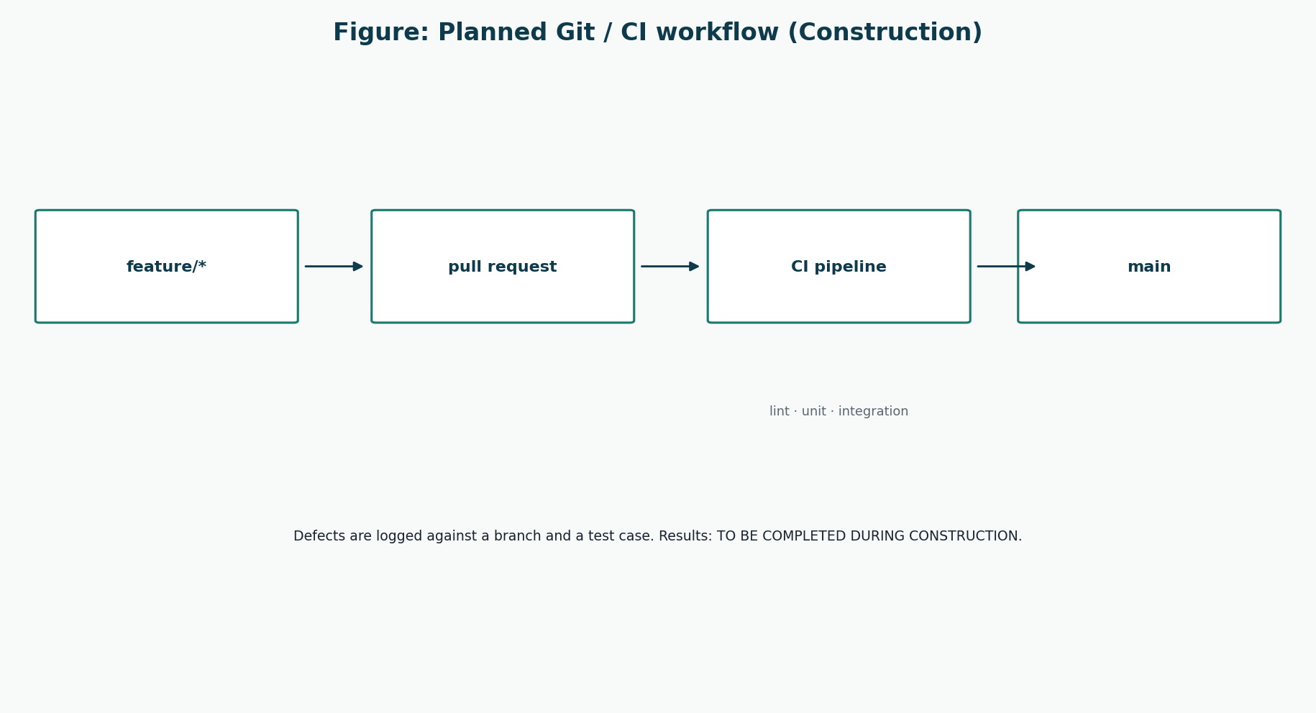
Figure 1: Planned Git and CI flow
feature branch → pull request → CI → main.

14. Branching Strategy
Branch | Purpose
main | Always releasable documentation + later passing software
feature/F-xx-short-name | One feature or tightly related pair
fix/DEF-xx-short-name | Defect repair
docs/* | Documentation-only edits

Pull requests name the feature id and the tests that must stay green.

15. Continuous Integration Strategy
Check | When
Build / compile or equivalent | Every PR and every push to main
Unit tests | Every PR
Integration tests | Every PR if they are fast enough; otherwise nightly plus pre-demo
No plaintext secrets in tree | Every PR (simple scan)

CI PIPELINE URL AND BADGE: TO BE COMPLETED DURING CONSTRUCTION

16. Defect Tracking
A defect is a difference between a specified test/use case and observed behaviour. It is not a new feature idea. New ideas go to the backlog, not the defect log.
Field | Meaning
DEF-id | Sequential
Found in | Iteration, test id
Severity | Blocker / Major / Minor
UC / FR | Trace
Status | Open / Fixed / Verified
Evidence | Commit hash — never a vague “fixed”

17. Defect Log
DEFECT LOG ENTRIES: TO BE COMPLETED DURING CONSTRUCTION
ID | Summary | Severity | UC | Status | Resolution
DEF-000 | Template row — delete when first real defect is found | — | — | n/a | Not a real defect

18. Construction Iteration Reports

18.1 Iteration 3 report
ITERATION 3 OUTCOME: TO BE COMPLETED DURING CONSTRUCTION

18.2 Iteration 4 report
ITERATION 4 OUTCOME: TO BE COMPLETED DURING CONSTRUCTION

19. Risk Updates
ID | Risk | P | I | Priority | Mitigation | Iteration | Status
R-01 | Concurrency defect during two overlapping sales of the last pack. | Medium | High | High | Integration tests + transactional decrement. Results: TO BE COMPLETED DURING CONSTRUCTION | Construction | Planned
R-07 | Features slip inside Iterations 3–4. | Medium | High | High | Priority list: sale spine first, then inventory, then reports. | Construction | Planned
R-12 | Tests exist only for happy paths. | Medium | Medium | Medium | Unit cases include expiry, short stock, void, and bad login. | Construction | Planned
R-13 | Git history is unusable for marking. | Low | Medium | Low | Feature branches, PR reviews, CI on main. | Construction | Planned

20. Conclusion
Construction is planned as two feature-shaped iterations on the Elaboration spine. The test identifiers already trace to FR and UC numbers. Filling the result tables before writing tests would be a marking-guide violation of honesty, not a shortcut.

References
[1] Larman, C. Applying UML and Patterns: An Introduction to Object-Oriented Analysis and Design and Iterative Development. 3rd edition. Prentice Hall. Principal methodology for UP, use cases, domain models, SSDs, design class diagrams, GRASP, and iterative development. Page numbers are not cited because the full print edition was not available as a continuous source file; chapter titles from the course extracts (System Sequence Diagrams; Domain Model associations; Design Class Diagrams) are used instead.
[2] CSC 4630 Advanced Software Engineering Course Project Marking Guide. Unified Process, 15 weeks, 100 marks. Determines milestones, deliverables, and mark weights.
[3] Larman course extracts used by the group: Chapter 9 System Sequence Diagrams; Chapter 11 Domain Model associations; Chapter 16 Design Class Diagrams.
[4] Group 20 inception briefing slides, Pharmacy POS System — Advanced Software Engineering (problem context in Zambia). Role names in those slides that implied a separate Cashier or Manager were corrected in this documentation to match the two-role rule.

