CSC 4630 · GROUP 20
Transition and Beta Testing Report
Iteration 5 — plans for beta, performance, security, and final models

CSC 4630 – Advanced Software Engineering
Group 20
Lecturer: [Lecturer Name]
University: [University Name]
September 2026
Unified Process (UP) — Iterative and Incremental
Analysis and design artefact. No application source code is included. Implementation starts only after the instruction START IMPLEMENTATION.

Table of Contents
Right-click and choose Update Field in Microsoft Word to refresh the table of contents.
In Word: References → Update Table, or right-click the field above.

1. Transition Overview
Transition (Iteration 5, weeks 13–14, 15 marks) prepares a constructed system for real staff and for the week-15 demo. This report specifies how that work will be done. Feedback scores, timings, and security findings are not invented.
TRANSITION MEASUREMENTS: TO BE COMPLETED DURING TRANSITION

2. Beta Testing Plan
Beta uses the constructed build against the scenarios already named in Elaboration.
Item | Plan
Build | main branch candidate after Iteration 4
Environment | A single workstation + database restore of seed data
Duration | Several short counter sessions across week 13
Facilitator | Group 20 member (not the test user)
Data rule | No real patient records from an outside pharmacy without permission

3. Test Users
Persona | Role in system | Why this person
Beta-Admin | Administrator | Must exercise UC-03 to UC-07 and UC-10
Beta-Pharmacist | Pharmacist/Cashier | Must exercise UC-02, UC-08, UC-09
Observer | None | Records pauses and errors; does not hold a third role

If the same human plays both accounts, they switch sessions. They never get a merged “manager-cashier” role.

4. Test Scenarios
Scenario | UC | Pass idea
SC-01 OTC cash sale | UC-02 | Receipt total matches lines; stock down
SC-02 Prescription-linked sale | UC-02/08 | Cannot complete without prescription
SC-03 Expired batch | UC-02 | Line refused
SC-05 Receive then sell | UC-04/02 | Quantity story holds
SC-06 Void | UC-09 | Stock restored; sale still visible
SC-07 Role boundary | UC-01/03 | Pharmacist cannot open Users or Medicines edit
SC-08 Reports | UC-07 | Completed sales appear once

5. User Feedback
USER FEEDBACK QUOTES AND RATINGS: TO BE COMPLETED DURING TRANSITION
Prompt | Response
I can complete a three-item sale without help | TO BE COMPLETED DURING TRANSITION
I understand why an expired item is blocked | TO BE COMPLETED DURING TRANSITION
I never needed a Cashier account that was not Pharmacist | TO BE COMPLETED DURING TRANSITION

6. Feedback Analysis
FEEDBACK ANALYSIS: TO BE COMPLETED DURING TRANSITION
Planned analysis method: group comments into usability, defect, and out-of-scope. Out-of-scope requests (NHIMA, web shop) are recorded as backlog, not silently built.

7. Defects Found
TRANSITION DEFECTS: TO BE COMPLETED DURING TRANSITION
ID | Summary | Severity | Status
— | No fabricated defects | — | n/a

8. Performance Testing
NFR-02 will be checked, not assumed.
Measure | Method | Target idea | Result
enterItem to new running total | Stopwatch on beta workstation, 20 lines | About 3 seconds typical | TO BE COMPLETED DURING TRANSITION
completeSale persistence | Same | Should feel immediate on local DB | TO BE COMPLETED DURING TRANSITION

9. Security Testing
Check | Expected | Result
Password column readable as plaintext | Must fail | TO BE COMPLETED DURING TRANSITION
Pharmacist opens user-create | Denied | TO BE COMPLETED DURING TRANSITION
Idle session reused | Re-authentication required | TO BE COMPLETED DURING TRANSITION
Void without reason | Refused | TO BE COMPLETED DURING TRANSITION
SQL-like input in search | No crash / no table dump | TO BE COMPLETED DURING TRANSITION

10. Performance Improvements
PERFORMANCE IMPROVEMENTS APPLIED: TO BE COMPLETED DURING TRANSITION

11. Security Improvements
SECURITY IMPROVEMENTS APPLIED: TO BE COMPLETED DURING TRANSITION

12. Updated UML Models
The models in Diagrams/ are the current approved set. Transition may update them if construction discovers a real concept (for example a second payment on one sale). Until then these figures remain the baseline.
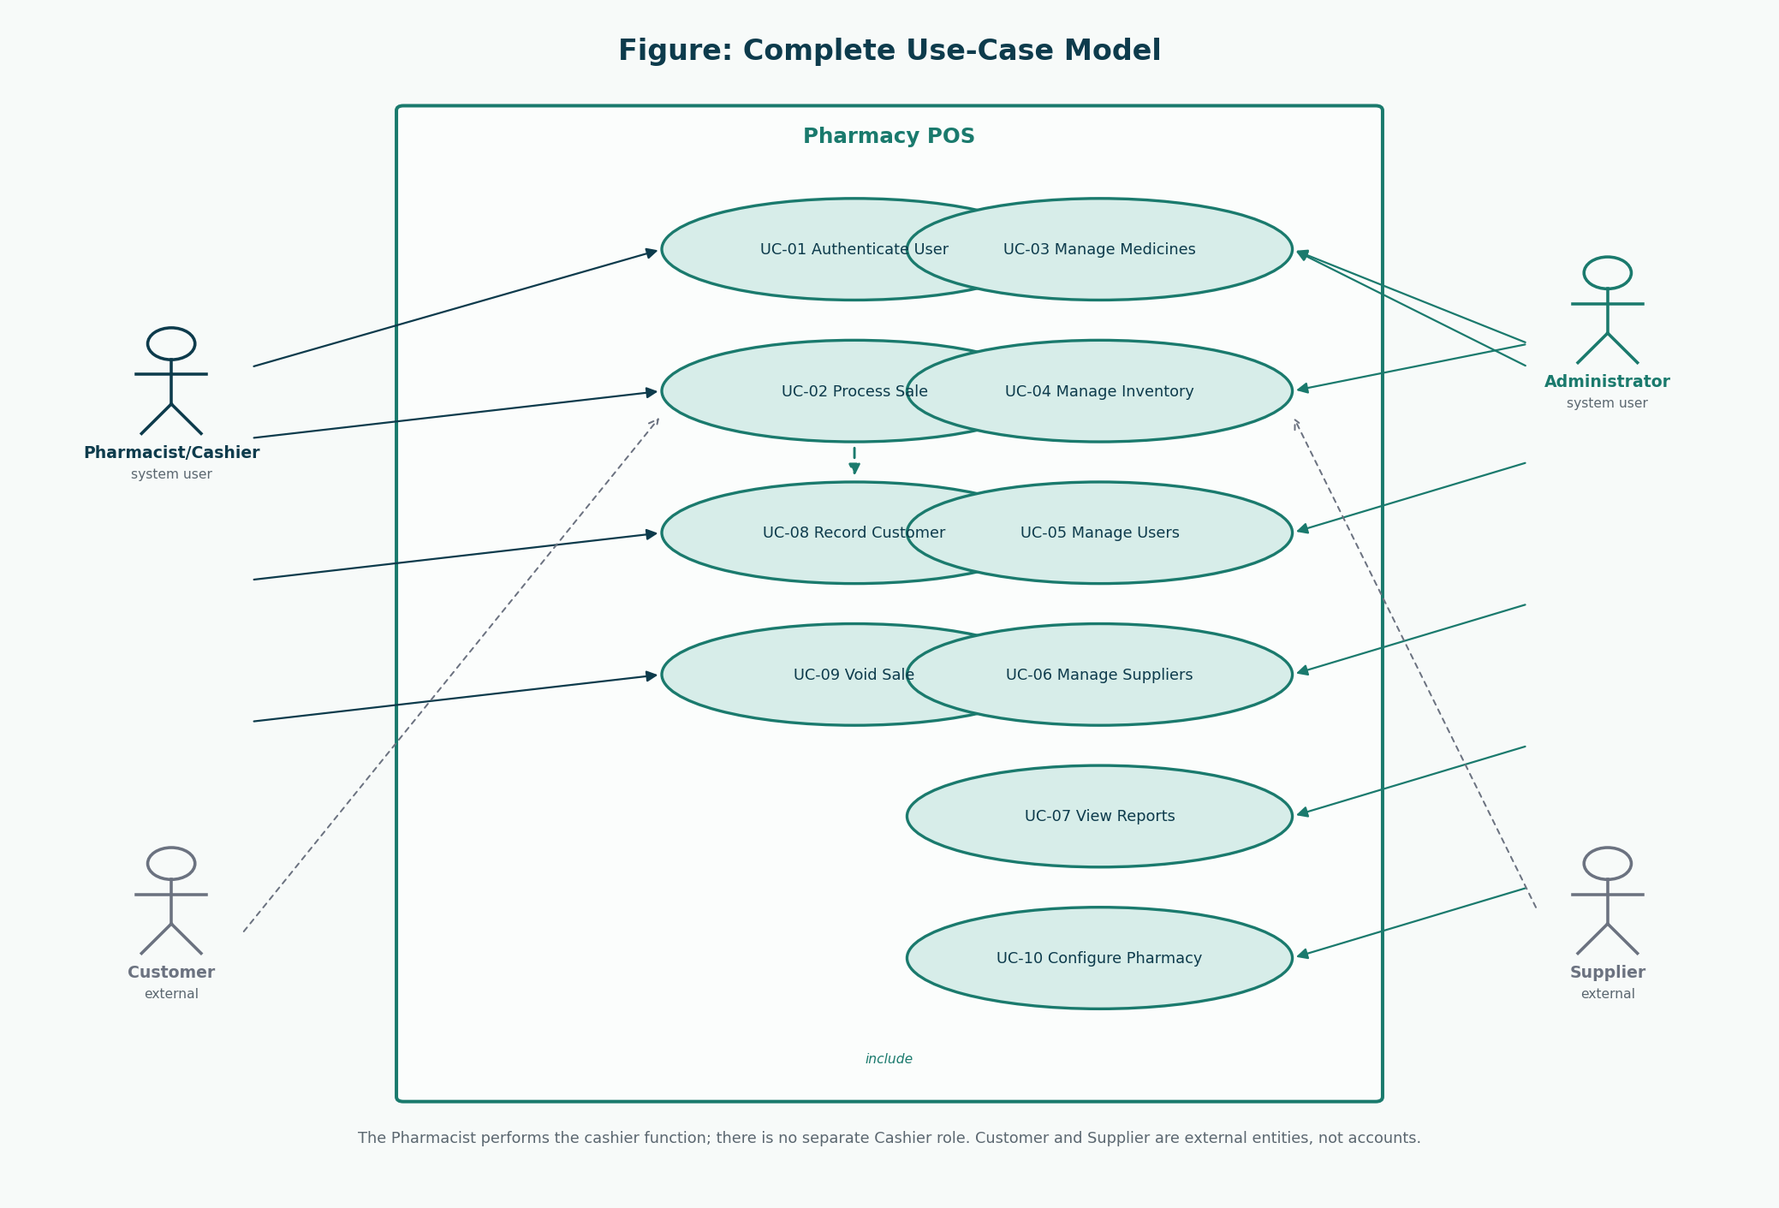
Figure 1: Use-case model (baseline)
Update only if a user goal actually changed.
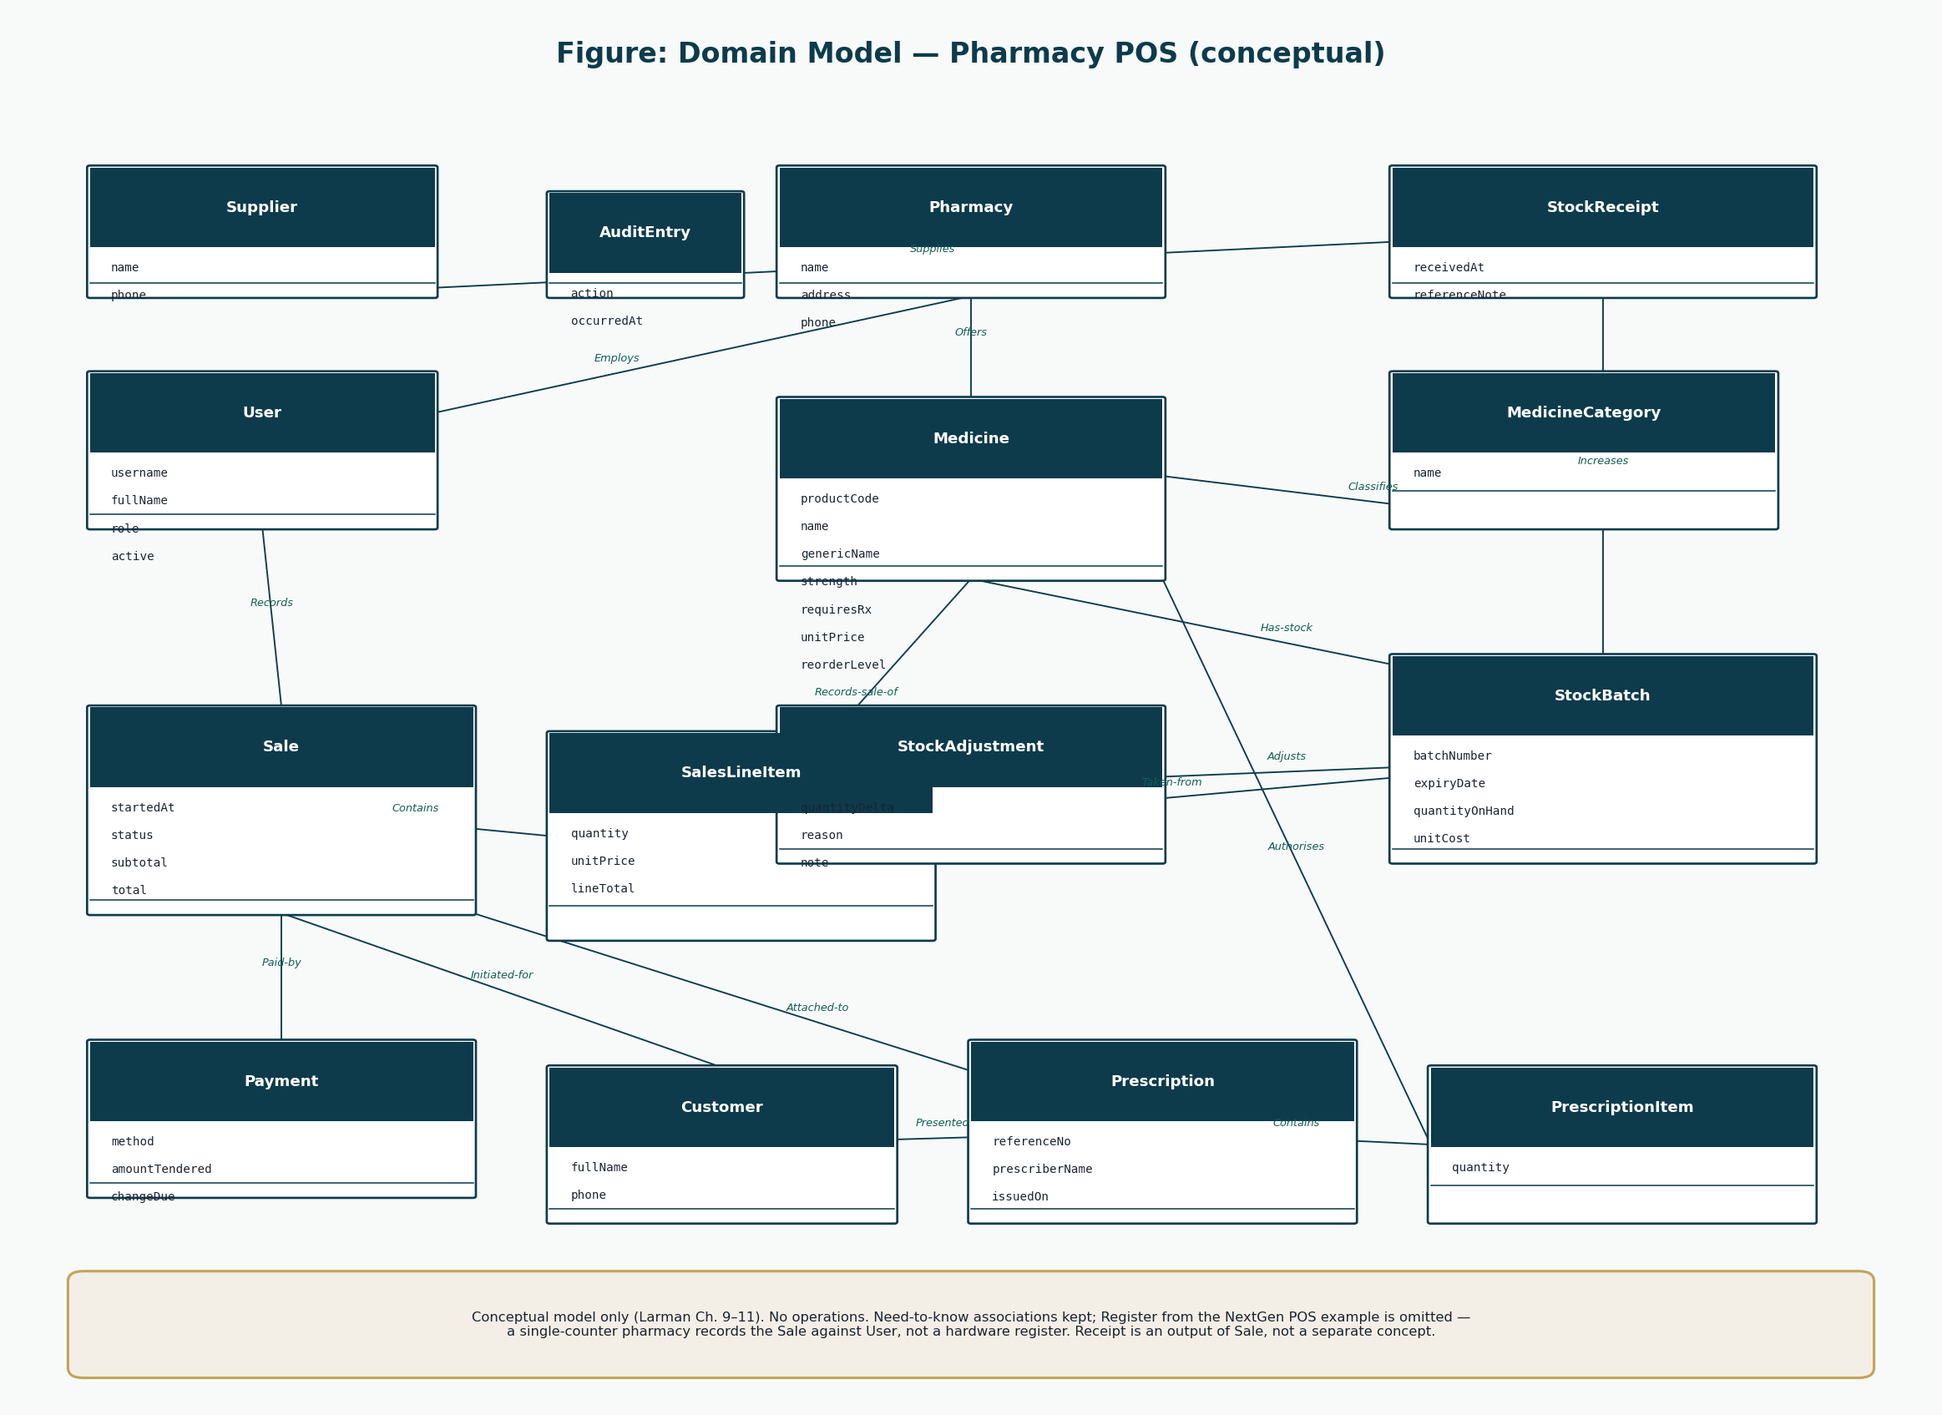
Figure 2: Domain model (baseline)
Still conceptual.
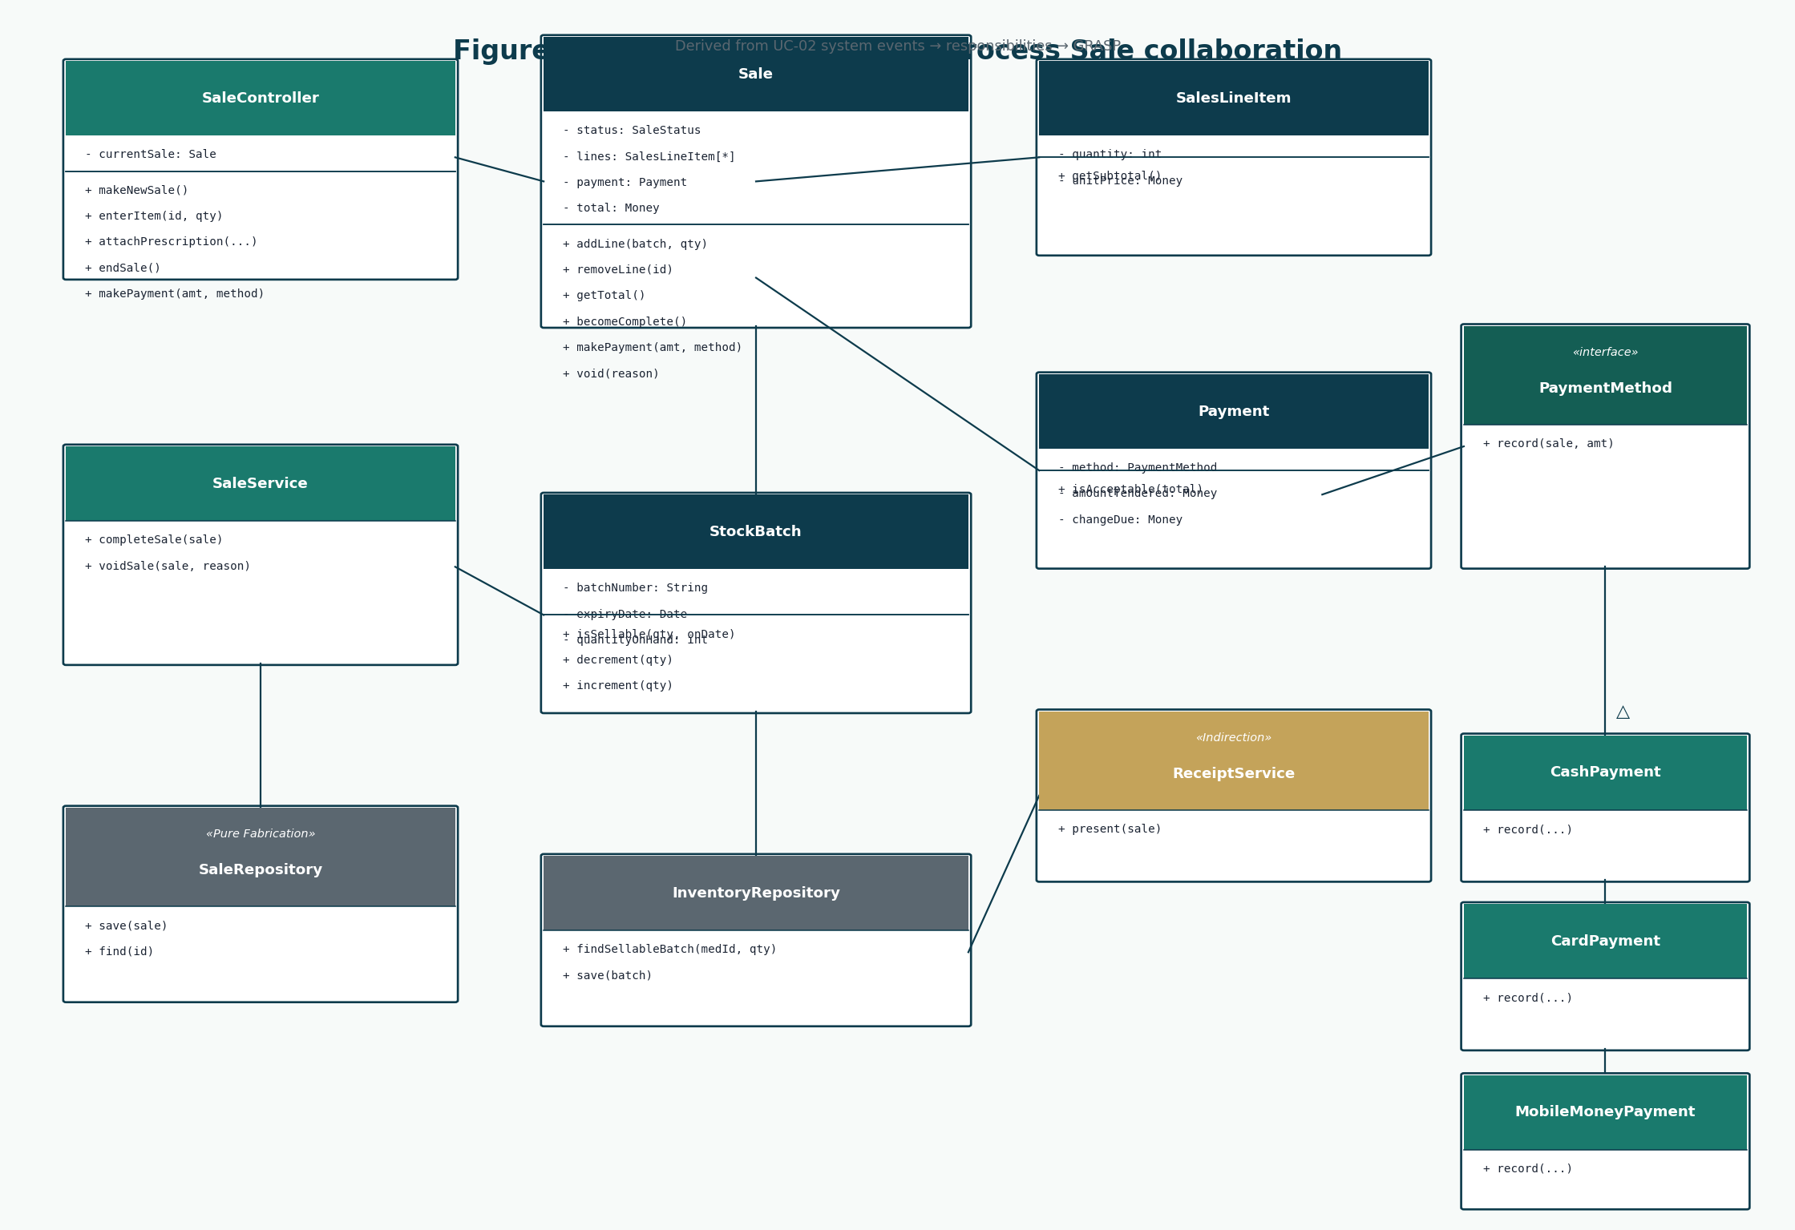
Figure 3: DCD Process Sale (baseline)
Methods should match constructed names; rename here if code names differ.

13. Final Architecture
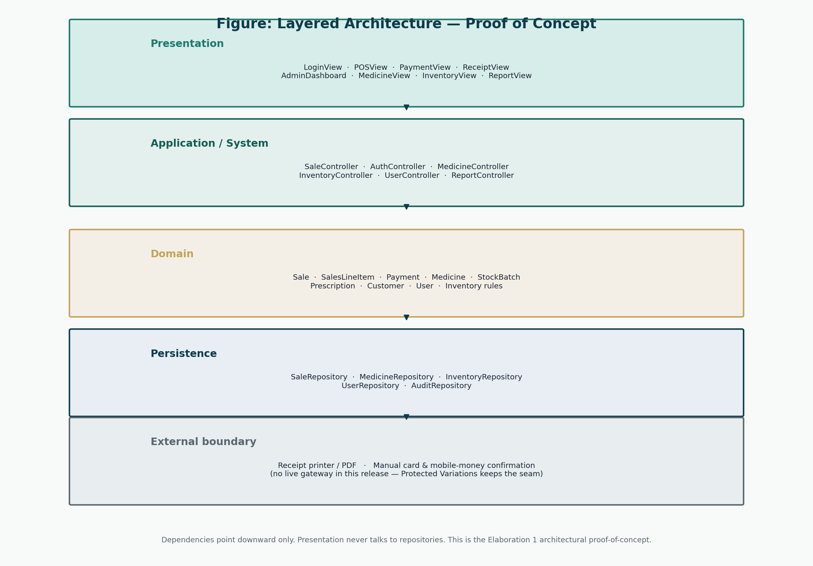
Figure 4: Architecture to be confirmed in Transition
A layer violation discovered in code is a defect, not a silent new architecture.

14. Final Database Design
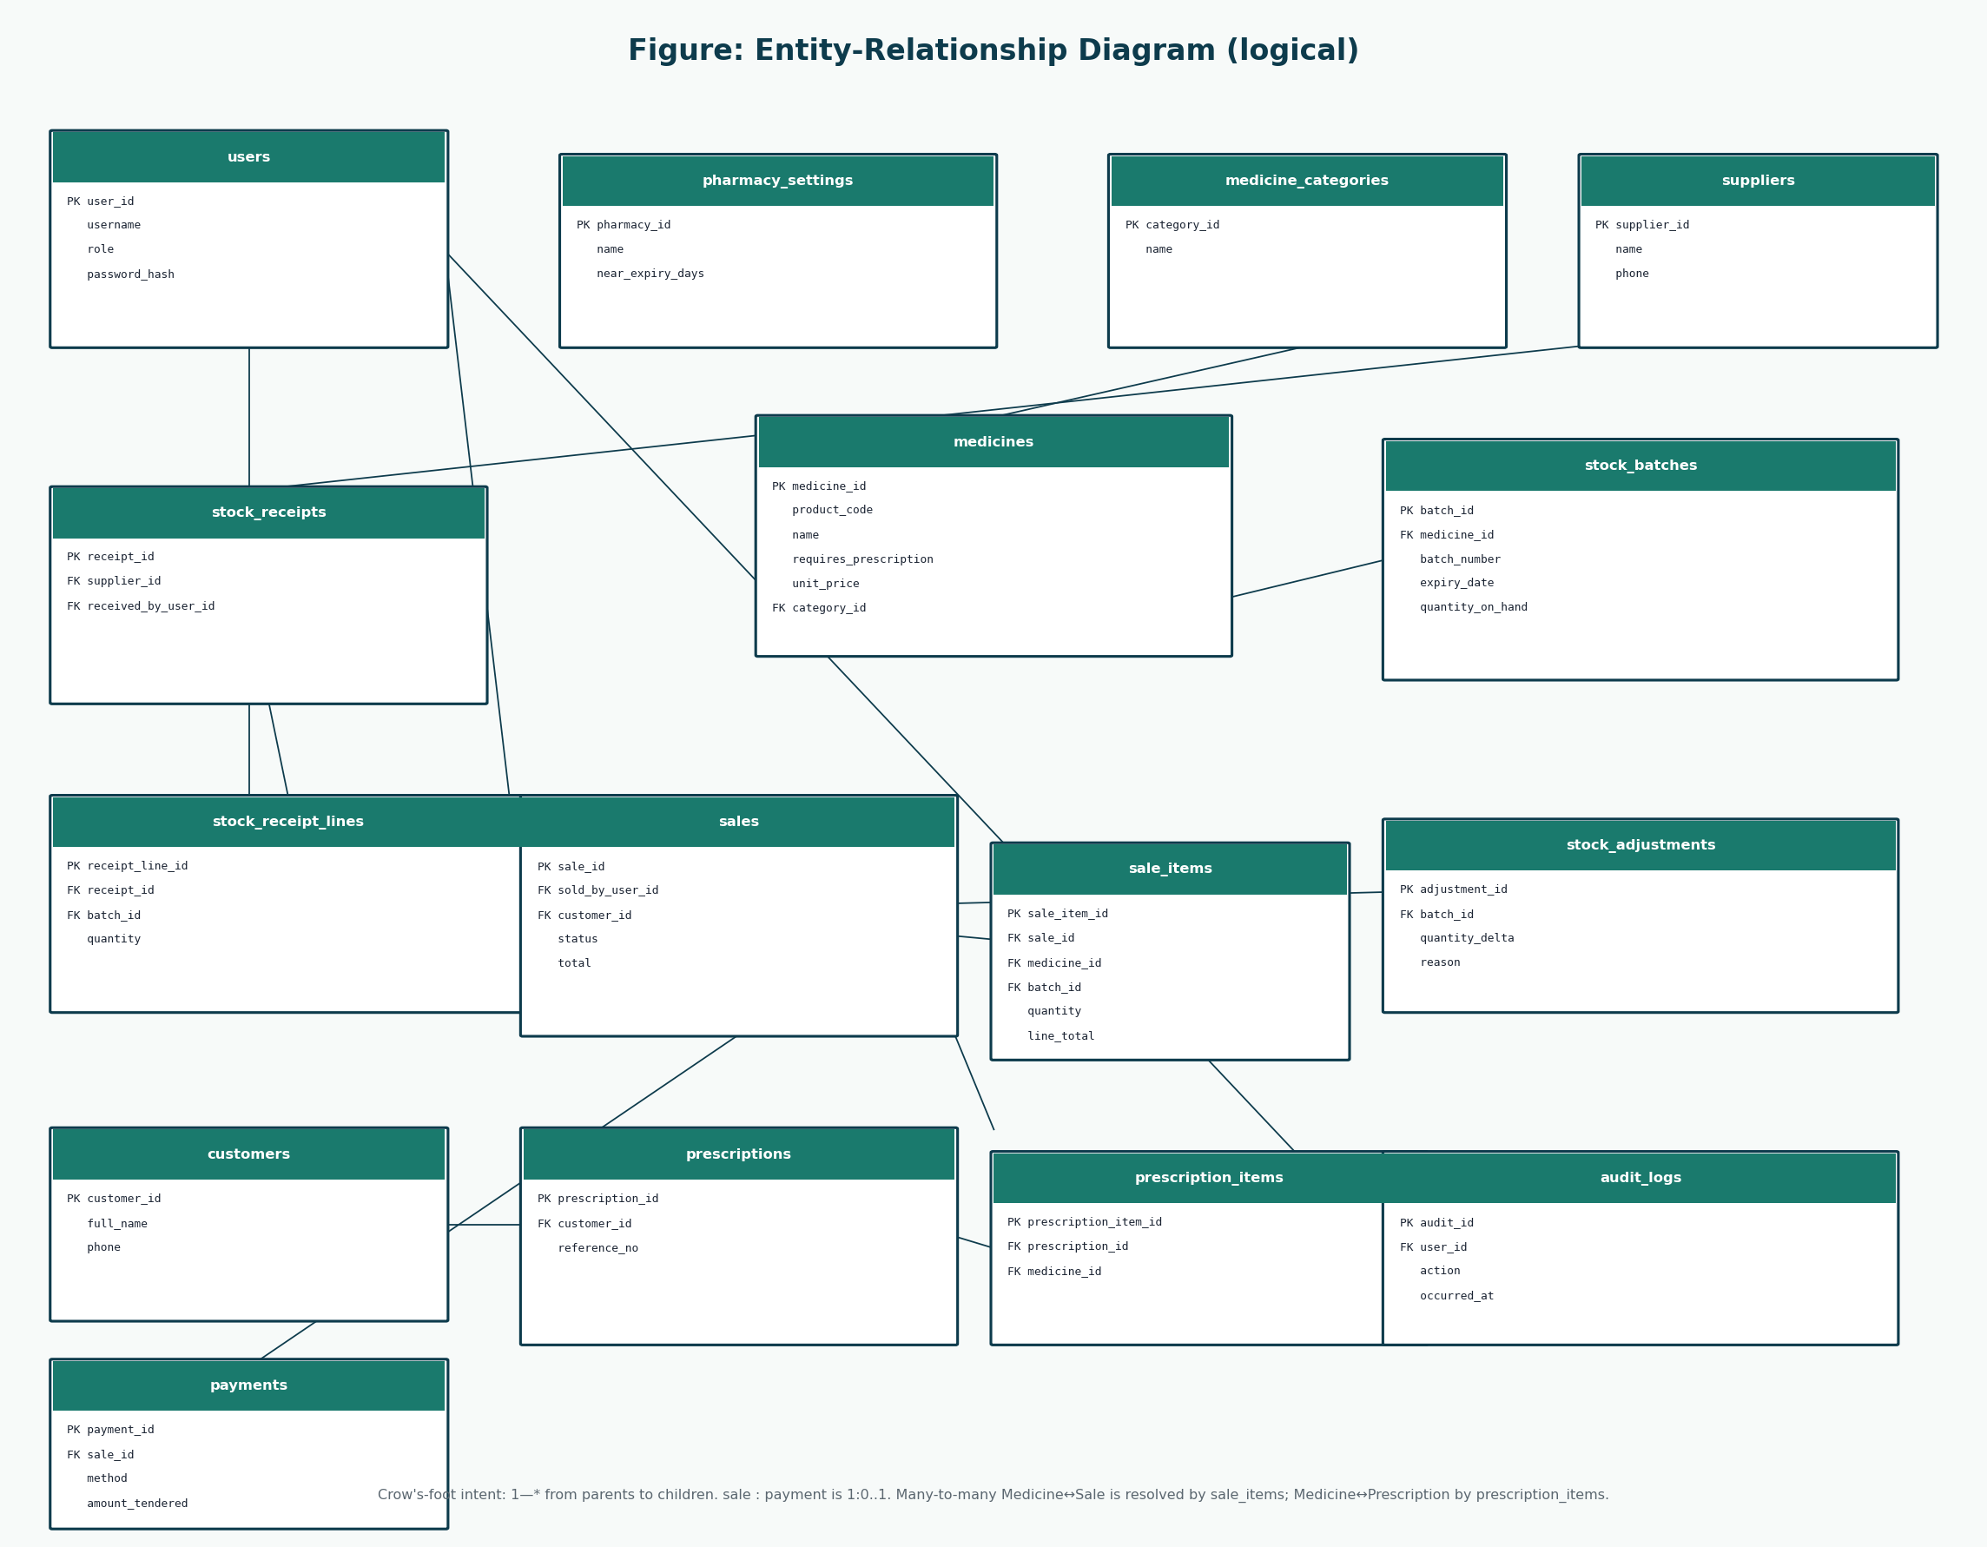
Figure 5: Logical ERD to be confirmed against the constructed schema
Drift between ERD and actual tables must be reconciled before the demo.

15. User Manual
The user manual is a separate Word document in Documentation/07-User-Manual/. It describes designed behaviour. Screenshots of a running product will replace prototypes after construction.

16. Deployment Preparation
Item | Status
Workstation with runtime | TO BE COMPLETED DURING TRANSITION
Database create from approved schema (not from this docs pack’s forbidden SQL — write it in construction) | TO BE COMPLETED DURING CONSTRUCTION / TRANSITION
Seed Administrator and one Pharmacist | TO BE COMPLETED DURING TRANSITION
Backup / restore rehearsal | TO BE COMPLETED DURING TRANSITION
Demo script (SC-01, SC-02, SC-03, SC-06, SC-07) | See Final Presentation

17. Transition Conclusion
Transition is a measured phase. This report gives the measuring instruments. Filling them with invented numbers would score nothing honest under a UP marking guide.

References
[1] Larman, C. Applying UML and Patterns: An Introduction to Object-Oriented Analysis and Design and Iterative Development. 3rd edition. Prentice Hall. Principal methodology for UP, use cases, domain models, SSDs, design class diagrams, GRASP, and iterative development. Page numbers are not cited because the full print edition was not available as a continuous source file; chapter titles from the course extracts (System Sequence Diagrams; Domain Model associations; Design Class Diagrams) are used instead.
[2] CSC 4630 Advanced Software Engineering Course Project Marking Guide. Unified Process, 15 weeks, 100 marks. Determines milestones, deliverables, and mark weights.
[3] Larman course extracts used by the group: Chapter 9 System Sequence Diagrams; Chapter 11 Domain Model associations; Chapter 16 Design Class Diagrams.
[4] Group 20 inception briefing slides, Pharmacy POS System — Advanced Software Engineering (problem context in Zambia). Role names in those slides that implied a separate Cashier or Manager were corrected in this documentation to match the two-role rule.

