CSC 4630 · GROUP 20
Pharmacy POS User Manual
Administrator and Pharmacist/Cashier — designed features only

CSC 4630 – Advanced Software Engineering
Group 20
Lecturer: [Lecturer Name]
University: [University Name]
September 2026
Unified Process (UP) — Iterative and Incremental
Analysis and design artefact. No application source code is included. Implementation starts only after the instruction START IMPLEMENTATION.

Table of Contents
Right-click and choose Update Field in Microsoft Word to refresh the table of contents.
In Word: References → Update Table, or right-click the field above.

1. Introduction
This manual explains how intended users will operate the Pharmacy POS once it is constructed. It does not describe features that are out of scope (online shop, NHIMA claims, a separate Cashier login). Figures are UI prototypes until construction screenshots replace them.

2. System Requirements
Item | Intention
Workstation | Ordinary PC used at the counter or office
Display | Large enough for the sales table and the total panel together
Printer | Optional receipt printer; a screen receipt is always available
Network | Only if the construction choice is a networked client; a local install is allowed
Accounts | At least one Administrator and one Pharmacist/Cashier

3. Getting Started
- Confirm you have been given a username and a temporary password.
- Start the Pharmacy POS application the way your installer documented in construction.
- Sign in. The home screen depends on your role.
The Pharmacist performs the cashier function. Do not ask for a third “Cashier” account.

4. Login
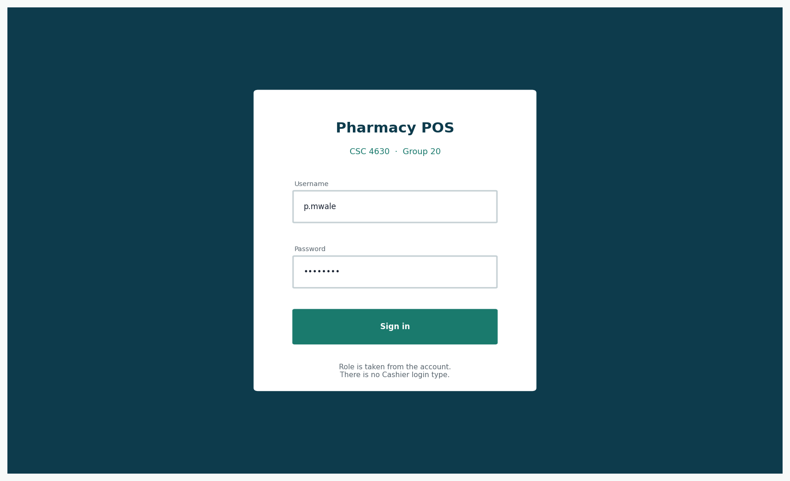
Figure 1: Login
Enter username and password. The system decides the role.
- Failed login: check caps lock; then ask an Administrator to reset the password.
- Deactivated account: only an Administrator can restore it.

5. Administrator Functions
After login the Administrator sees a dashboard with sales-today figures and stock alerts — not a sales keypad.
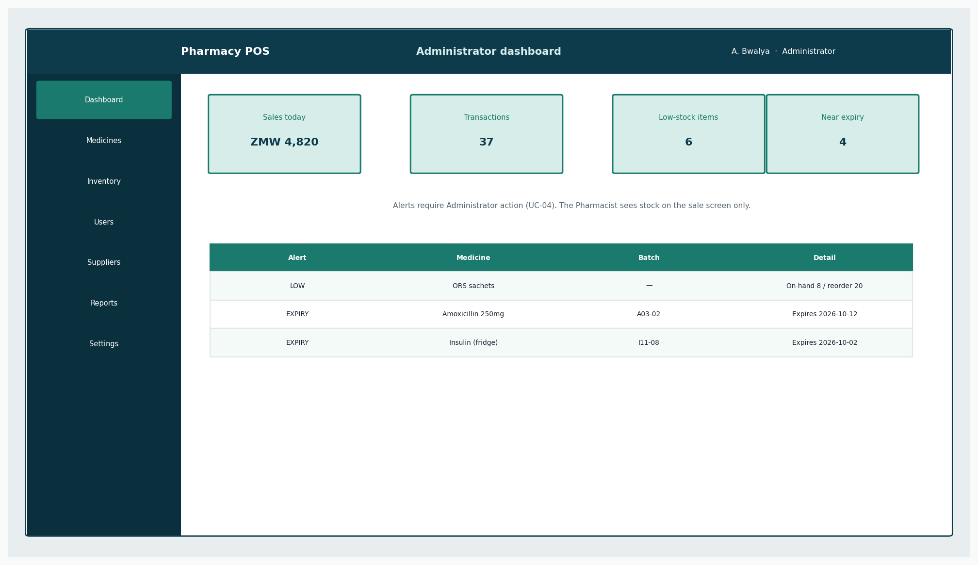
Figure 2: Administrator dashboard
Low-stock and near-expiry lists are the daily administrative starting point.
Administrator menus: Medicines, Inventory, Users, Suppliers, Reports, Settings.

6. Pharmacist/Cashier Functions
After login the Pharmacist sees the sales screen. Administration pages are not available.
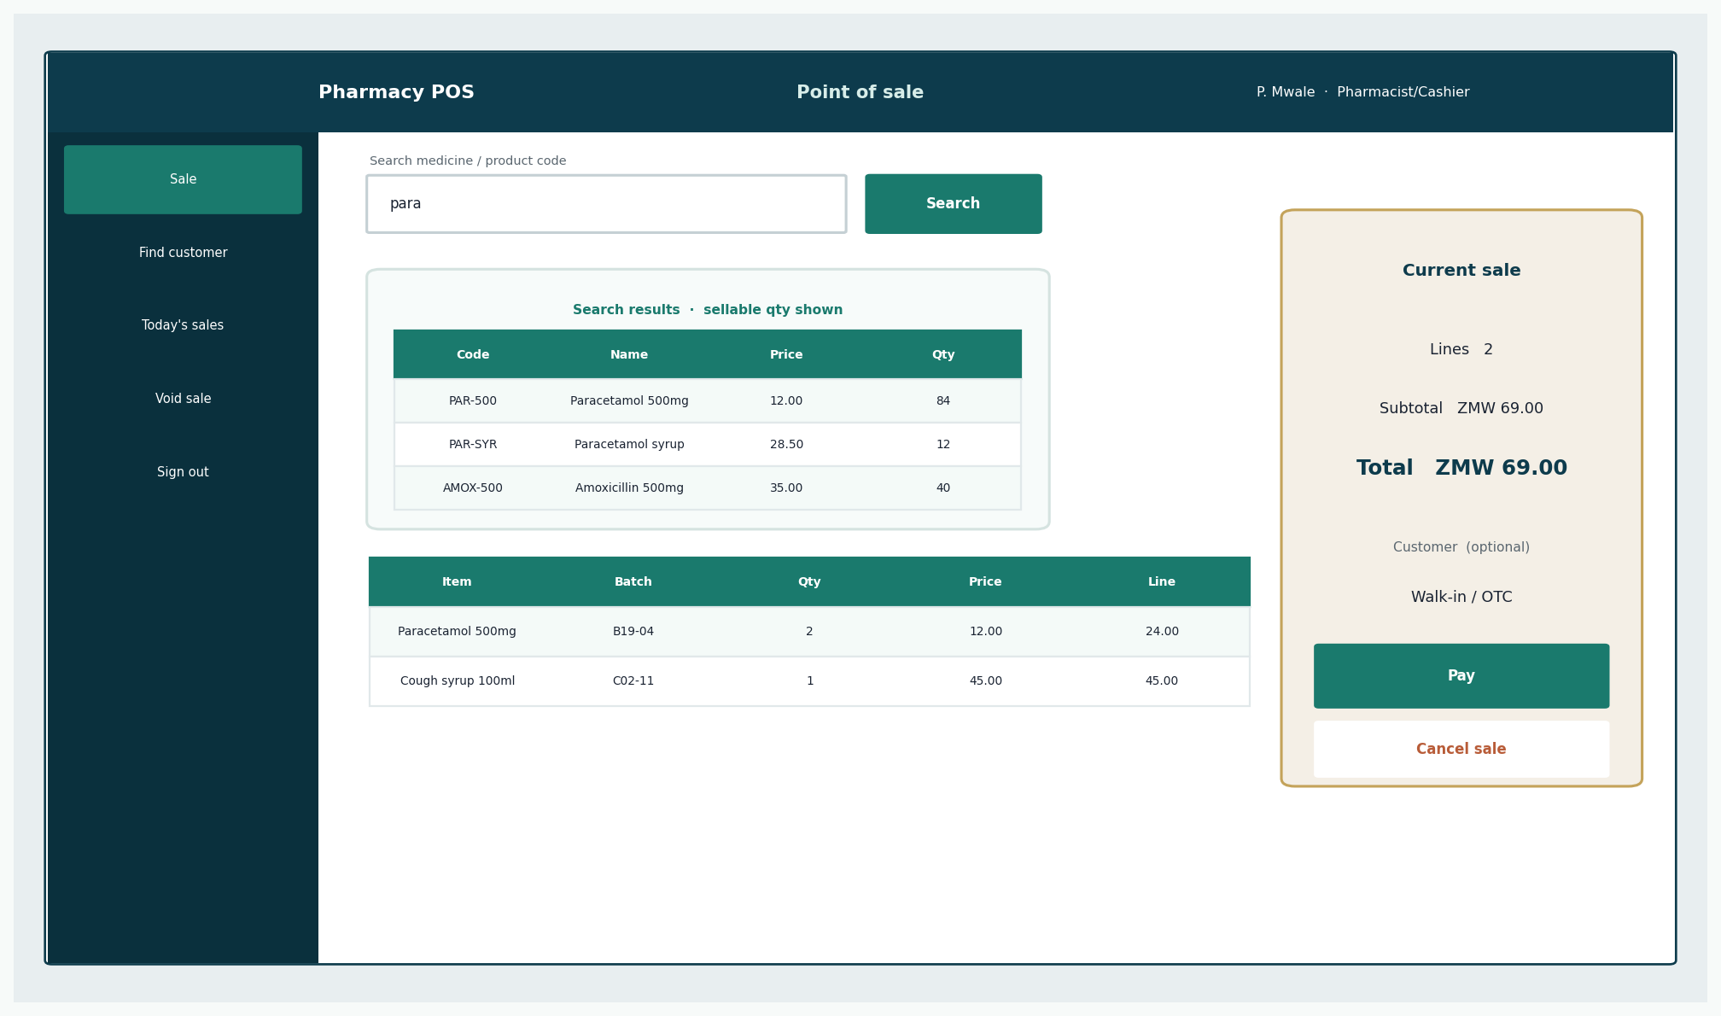
Figure 3: Sales screen
Search, results with sellable quantity, current lines, and total.

7. Managing Medicines
Role required: Administrator.
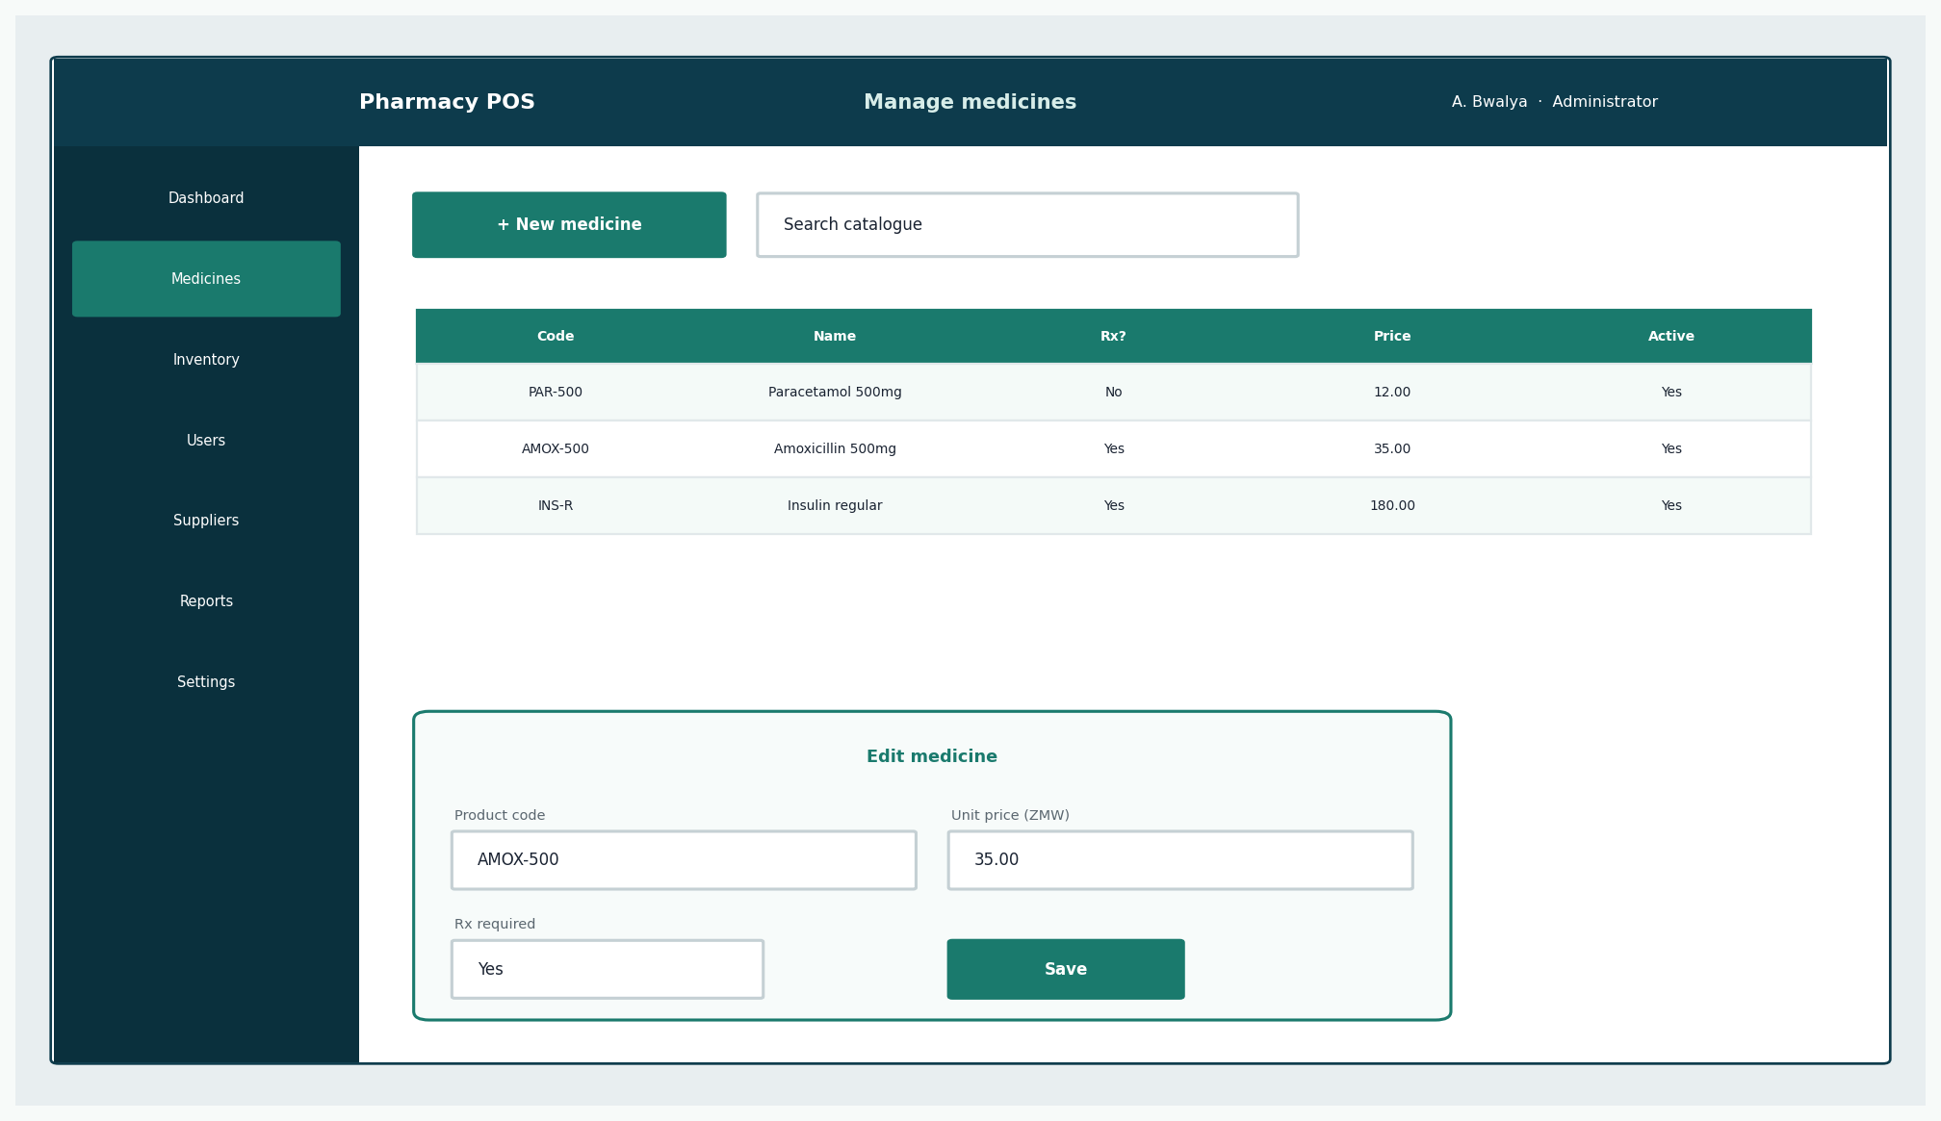
Figure 4: Medicine catalogue
Create or edit code, names, strength, prescription flag, price, reorder level.
- Deactivate a medicine instead of deleting it if it has ever been sold.
- Mark prescription-required for items that must not sell as OTC.

8. Managing Inventory
Role required: Administrator.
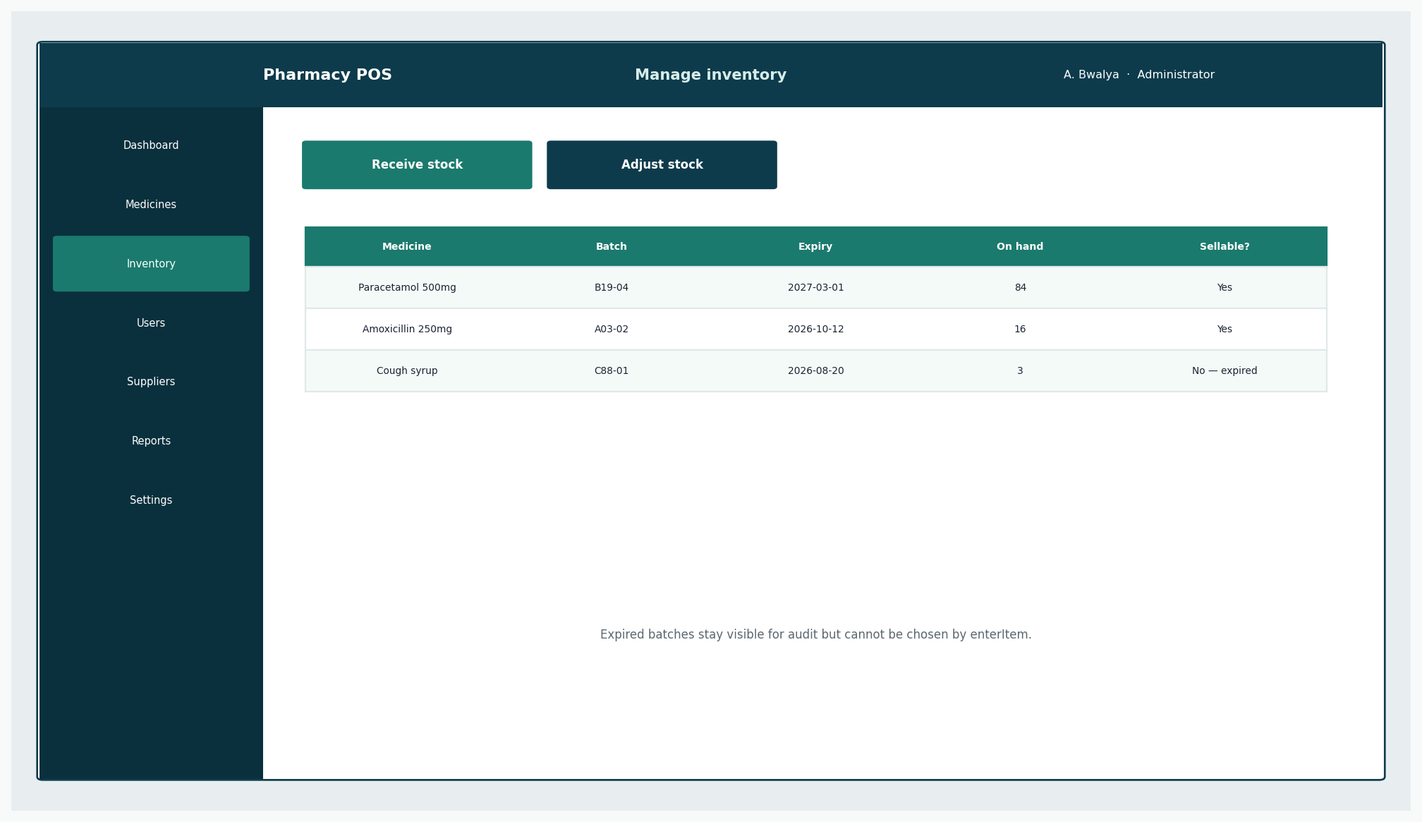
Figure 5: Batches
Each row is a batch with expiry. Expired rows are not sellable.

8.1 Receive stock
- Choose Receive stock.
- Select the supplier.
- Enter medicine, batch number, expiry, quantity, and cost.
- Save. On-hand quantity increases.

8.2 Adjust stock
- Choose Adjust stock.
- Select the batch, the quantity change, and a reason (damage, expiry, recount, recall).
- Save. A reason is mandatory.

9. Processing a Sale
Role required: Pharmacist/Cashier.
- A new sale starts automatically or via the Sale action.
- Search by name or product code.
- Enter a quantity. If the batch is expired or the quantity is too high, the line is refused.
- Repeat for each medicine.
- If any line needs a prescription, complete the prescription dialog (section 12).
- Choose Pay.

10. Processing Payment
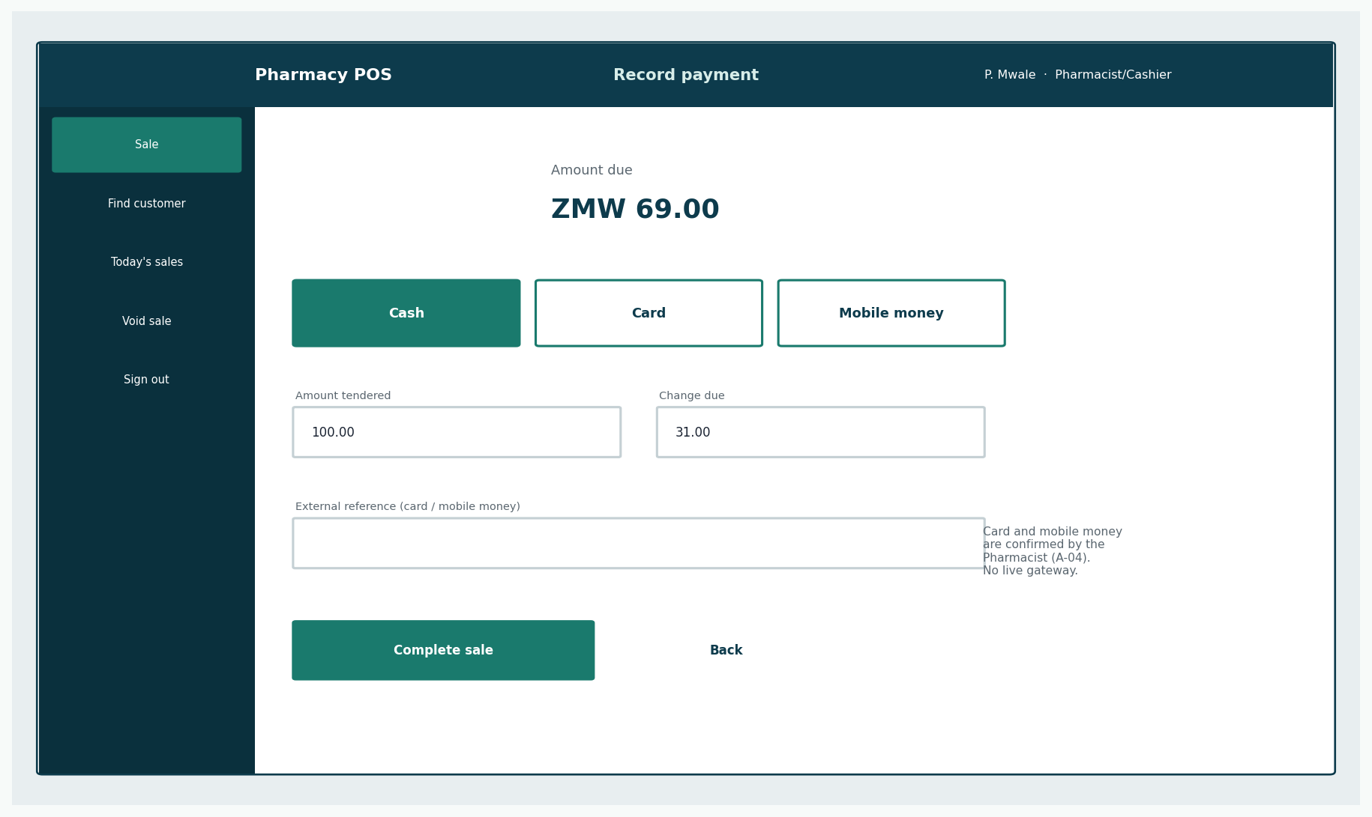
Figure 6: Payment
Choose Cash, Card, or Mobile money.
- Cash: enter amount tendered. The system shows change. Too little cash cannot complete the sale.
- Card or mobile money: confirm you have received the payment, optionally type a reference. The system does not call a bank in this release.

11. Generating Receipts
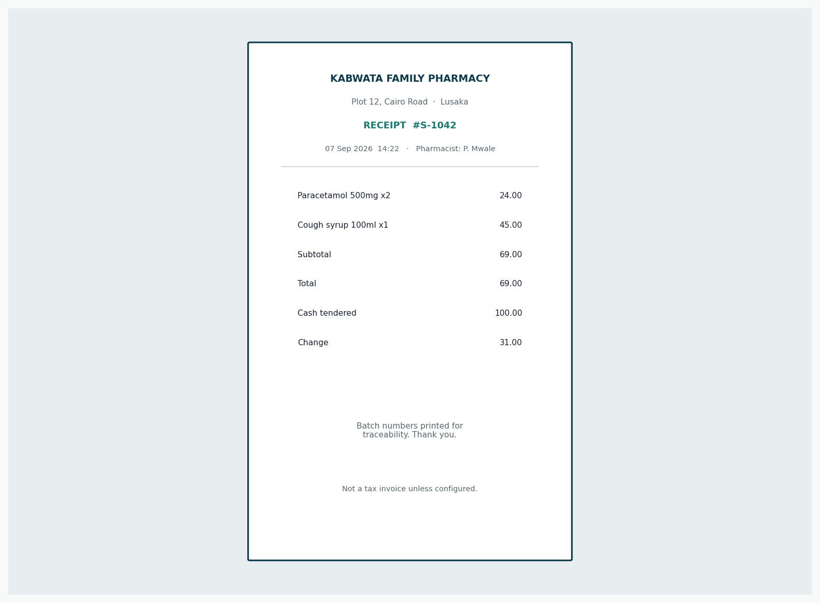
Figure 7: Receipt
Shows pharmacy name, lines, total, method, and the pharmacist’s name.
Give the receipt to the customer with the medicines. Reprint from today’s sales if the printer jams.

12. Prescription Workflow
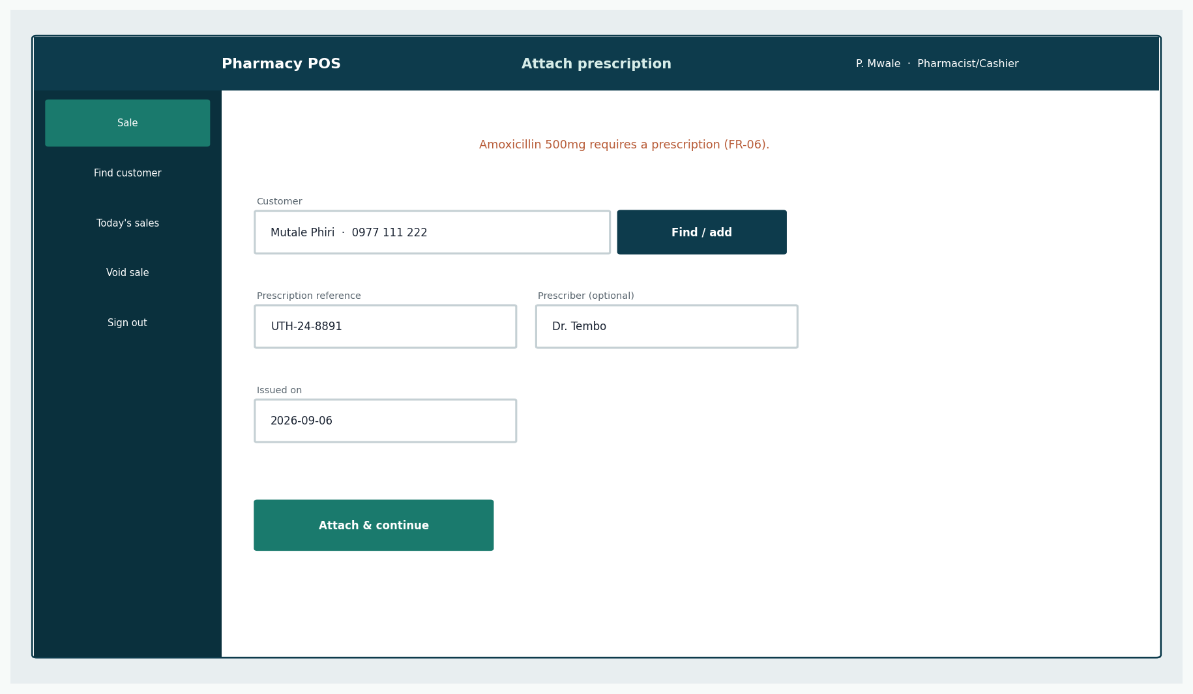
Figure 8: Prescription dialog
Required when a line is prescription-only.
- Find or add the customer (name is enough; phone helps later searches).
- Enter the prescription reference from the paper script.
- Optionally enter prescriber and date.
- Attach and continue the sale.
The system records the script. It does not contact a national e-prescription service.

13. Reports
Role required: Administrator.
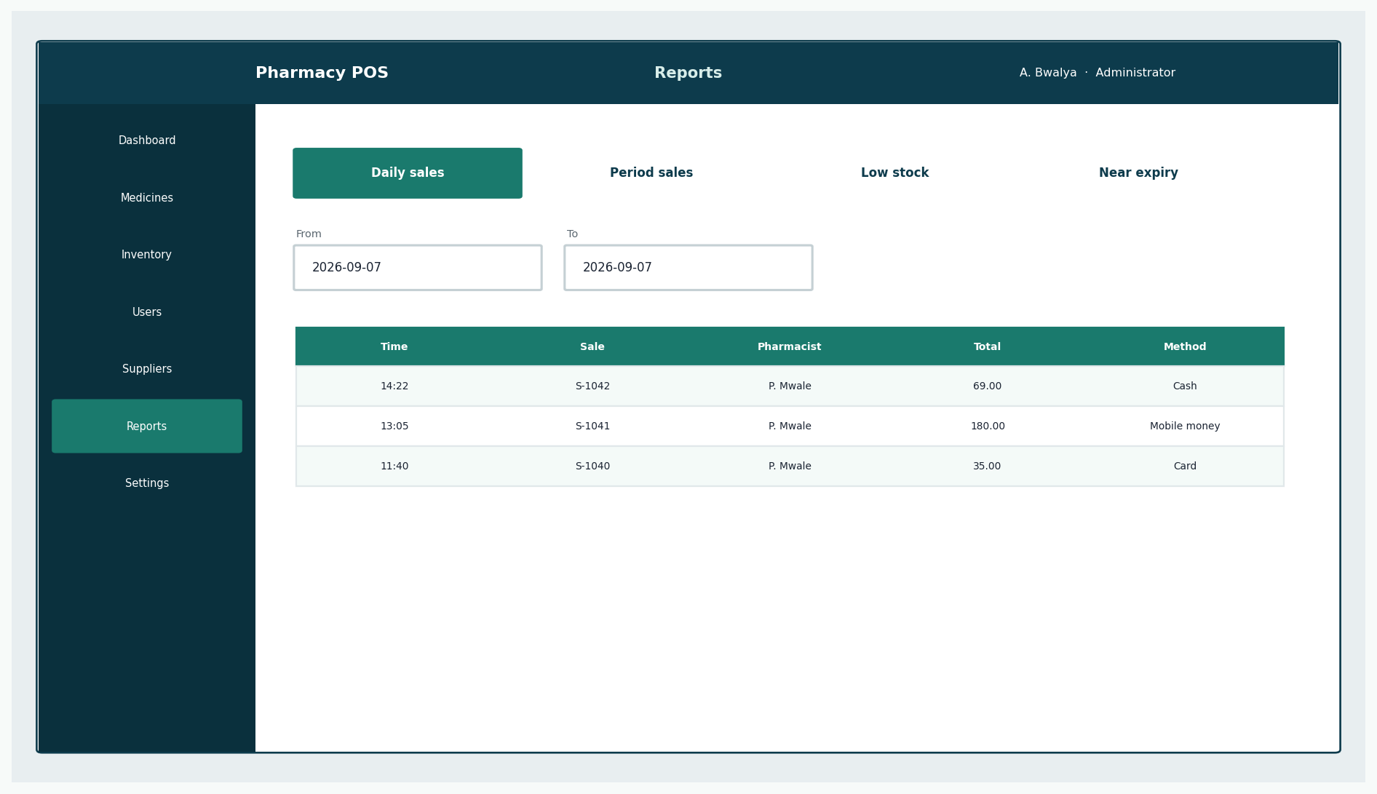
Figure 9: Reports
Daily sales, period sales, low stock, near expiry.
Reports do not change data.

14. User Management
Role required: Administrator.
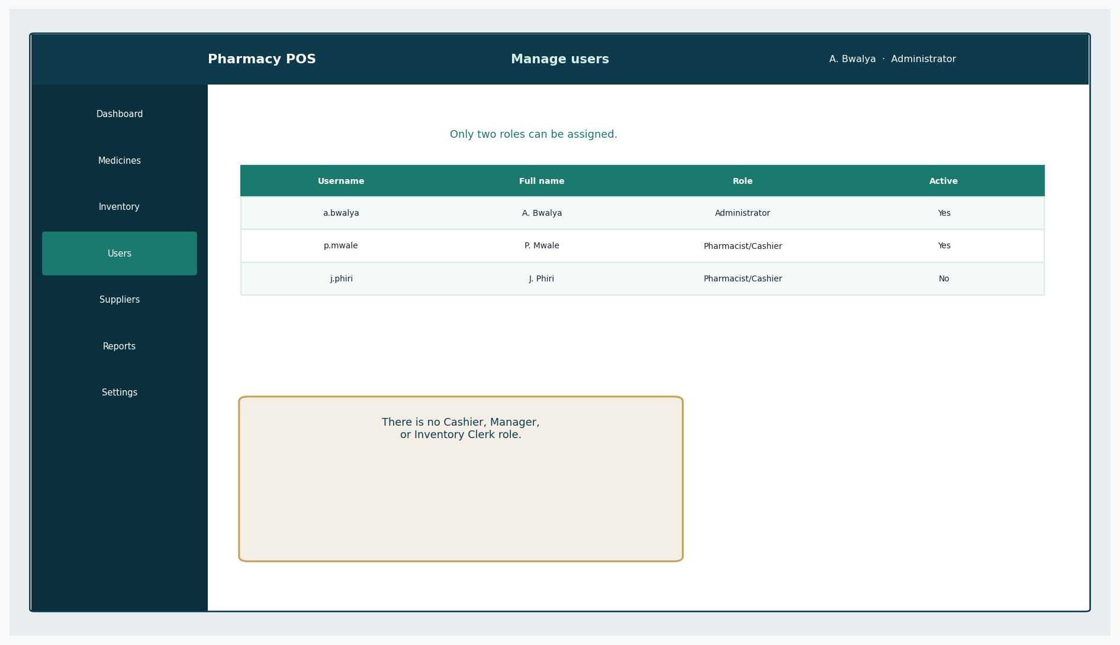
Figure 10: Users
The role list contains only Administrator and Pharmacist/Cashier.
- Create a user with exactly one role.
- Deactivate staff who leave. Do not reuse passwords on a shared slip if you can avoid it.
- Keep at least one active Administrator.

15. Logout
Use Sign out at the end of a shift or when leaving the counter. The next person must sign in as themselves so that receipts and audit rows stay honest.

16. Troubleshooting
Symptom | Likely cause | What to do
Cannot sign in | Wrong password or deactivated account | Retry; then Administrator reset
Medicine not in search | Inactive catalogue item or wrong code | Administrator checks Medicines
Line refused — expired | Batch past expiry | Do not override; Administrator removes or replaces stock
Line refused — quantity | Not enough sellable stock | Sell less or receive stock
Cannot complete sale | Missing prescription or short cash | Complete the dialog or tender enough cash
Need a Cashier account | Misunderstanding of roles | Use a Pharmacist/Cashier account
Want to delete a sale | Mistake after payment | Void sale with a reason — do not expect silent delete

References
[1] Larman, C. Applying UML and Patterns: An Introduction to Object-Oriented Analysis and Design and Iterative Development. 3rd edition. Prentice Hall. Principal methodology for UP, use cases, domain models, SSDs, design class diagrams, GRASP, and iterative development. Page numbers are not cited because the full print edition was not available as a continuous source file; chapter titles from the course extracts (System Sequence Diagrams; Domain Model associations; Design Class Diagrams) are used instead.
[2] CSC 4630 Advanced Software Engineering Course Project Marking Guide. Unified Process, 15 weeks, 100 marks. Determines milestones, deliverables, and mark weights.
[3] Larman course extracts used by the group: Chapter 9 System Sequence Diagrams; Chapter 11 Domain Model associations; Chapter 16 Design Class Diagrams.
[4] Group 20 inception briefing slides, Pharmacy POS System — Advanced Software Engineering (problem context in Zambia). Role names in those slides that implied a separate Cashier or Manager were corrected in this documentation to match the two-role rule.

