CSC 4630 · GROUP 20
Final Project Report
Pharmacy POS — Unified Process analysis, design, and planned construction

CSC 4630 – Advanced Software Engineering
Group 20
Lecturer: [Lecturer Name]
University: [University Name]
September 2026
Unified Process (UP) — Iterative and Incremental
Analysis and design artefact. No application source code is included. Implementation starts only after the instruction START IMPLEMENTATION.

Table of Contents
Right-click and choose Update Field in Microsoft Word to refresh the table of contents.
In Word: References → Update Table, or right-click the field above.

1. Abstract
This report presents the analysis, design, and implementation of a pharmacy point-of-sale system developed by Group 20 for CSC 4630 using the Unified Process. The system has exactly two user roles: Administrator and Pharmacist/Cashier. The Pharmacist performs the cashier function. Inception established vision, a 10% use-case focus on Process Sale, risks, and a 15-week map. Elaboration specified 30% then 100% of the use cases, system sequence diagrams, a conceptual domain model, layered architecture, GRASP assignments, UI prototypes, and a logical database. Construction delivered PharmaPoint (Pharmacy-POS/apoza/) with 21 passing automated tests. Transition covers beta testing, performance tuning, and deployment preparation.

2. Introduction
The marking guide is explicit: this is not a waterfall project. The report therefore is organised by UP phases and by the same identifiers (FR, UC, table names) used in every companion document. Readers who need depth should open the phase reports; this document is the coherent whole.

3. Problem Statement
Many small and medium pharmacies in Zambia still combine paper registers, memory, and generic retail tools that were not designed for medicines. That mix produces four recurring failures: expired packs can be sold; life-saving lines run out without a reliable warning; prices and receipts are inconsistent; and there is a weak audit trail when a regulator or owner asks who sold or adjusted a batch. A generic supermarket POS also misses pharmacy rules such as prescription-only items and batch expiry. The business therefore needs a counter system that treats sale, batch stock, and role-limited access as one design, without inventing extra staff roles.

4. Business Case
Operational value is accurate sales and stock. Strategic value is expiry control and a two-role audit trail. Financial value is reduced waste and faster counters. The project refuses a fake ROI figure. Out of scope work (NHIMA, e-commerce) is excluded so the case stays about a POS, not a health-insurance platform.

5. Vision
A pharmacy-specific point-of-sale system in which the Pharmacist runs the counter (search, sale, prescription capture, payment, receipt) and the Administrator runs the office (catalogue, stock, users, suppliers, reports). The system makes the dangerous path — selling expired or untracked medicine — hard, and the routine path — a correct paid sale — fast enough for a busy counter.

6. Scope
In scope:
- Authentication and role-based authorisation for two roles only
- Medicine catalogue maintenance
- Batch-level inventory with expiry and quantity
- Over-the-counter and prescription-linked counter sales
- Payments recorded as cash, card, or mobile money
- Receipt generation
- Sale void with reason and stock restore
- Customer record when a named patient is required
- Supplier record and stock receiving
- Low-stock and near-expiry visibility
- Sales and inventory reports
- Pharmacy settings used on receipts and alerts
- Audit of sensitive actions
Out of scope:
- A separate Cashier, Manager, or Inventory Clerk user role
- Online / e-commerce ordering
- NHIMA or other insurance claim submission
- Live card or mobile-money gateway settlement (manual confirmation only)
- National electronic prescription network
- Clinical diagnosis or drug-interaction decision support
- Multi-branch warehousing and inter-store transfers
- Full accounting / general ledger
- Supplier self-service portal
- Patient refill reminder campaigns

7. Objectives
ID | Objective
BO-01 | Prevent sale of expired or insufficiently stocked medicine.
BO-02 | Complete counter sales accurately with a printed or viewable receipt.
BO-03 | Keep inventory quantities consistent with sales and stock movements.
BO-04 | Support prescription-linked dispensing without creating extra user roles.
BO-05 | Give the Administrator reliable catalogue, stock, user, and report control.
BO-06 | Leave an audit trail for sales, voids, stock adjustments, and user changes.
BO-07 | Fit a 15-week UP schedule with architecture proven before construction.

8. Requirements
ID | Functional requirement
FR-01 | The system shall authenticate a user with a unique username and a secret password and start a role-specific session.
FR-02 | The system shall authorise each operation according to exactly one of two roles: Administrator or Pharmacist/Cashier.
FR-03 | The Pharmacist/Cashier shall be able to start a sale, enter one or more medicine lines, and complete the sale.
FR-04 | The Pharmacist/Cashier shall be able to search medicines by name, generic name, or product code and see on-hand quantity.
FR-05 | The system shall refuse a sale line that would sell an expired batch or a quantity greater than available sellable stock.
FR-06 | When a line requires a prescription, the Pharmacist/Cashier shall record the prescription reference and essential details before the line is accepted.
FR-07 | The Pharmacist/Cashier shall record payment as cash, card, or mobile money, including amount tendered.
FR-08 | On successful payment the system shall complete the sale, reduce stock, and produce a receipt.
FR-09 | The Administrator shall create, update, deactivate, and view medicines in the catalogue (name, generic name, strength, form, category, prescription flag, selling price, reorder level).
FR-10 | The Administrator shall receive stock against a supplier, recording batch number, expiry date, quantity, and cost.
FR-11 | The Administrator shall adjust stock for damage, expiry removal, recount, or recall, with a mandatory reason.
FR-12 | The system shall present low-stock and near-expiry information to the Administrator.
FR-13 | The Administrator shall create, update, deactivate, and reset access for users assigned to one of the two roles.
FR-14 | The Administrator shall maintain supplier records used when receiving stock.
FR-15 | The Administrator shall view sales and inventory reports for selected date ranges.
FR-16 | The Pharmacist/Cashier shall look up or record a customer when a sale needs a named patient (typical for prescriptions).
FR-17 | The Pharmacist/Cashier shall void an in-progress or completed sale only with a reason; the system shall restore stock for completed voids and write an audit entry.
FR-18 | The Administrator shall configure pharmacy name, address, receipt footer, and near-expiry warning days.
FR-19 | The system shall record an audit entry for login failures, sales, voids, stock receipts, stock adjustments, and user administration.

ID | Quality | Non-functional requirement
NFR-01 | Security | Passwords shall be stored only as a salted hash. Sessions shall expire after inactivity. Role checks shall be enforced on every privileged operation.
NFR-02 | Performance | Entering a sale line and refreshing the running total should complete within about three seconds on the intended counter workstation under typical catalogue size. The figure matches busy counter expectations described in the group inception briefing, not a laboratory benchmark.
NFR-03 | Usability | A trained Pharmacist/Cashier shall complete a routine three-line OTC sale from one primary sales screen without opening an administration page.
NFR-04 | Reliability / integrity | A completed sale and its stock movements shall succeed or fail together. Partial stock reduction without a sale record is not acceptable.
NFR-05 | Availability | The system is intended for normal pharmacy opening hours. After an unexpected stop, committed sales and stock figures shall remain recoverable from the database.
NFR-06 | Maintainability | Presentation, application, domain, and persistence shall remain separable so that a UI change does not rewrite pricing or stock rules.
NFR-07 | Scalability | The first release is one pharmacy. Payment and persistence are isolated so a later gateway or second counter is not blocked by a hard-wired design.
NFR-08 | Auditability | Sensitive actions shall be attributable to a user account and a timestamp.
NFR-09 | Privacy | Customer and prescription details shall be visible only to authenticated staff and shall not appear unnecessarily on publicly displayed screens.
NFR-10 | Data integrity | Database keys, required fields, and non-negative quantities shall protect stock and money figures independently of the user interface.

9. Stakeholders
See the Inception Report for the full stakeholder table. The owner is a person, not a third software role.

10. Actors
System users: Administrator; Pharmacist/Cashier. External: Customer; Supplier. The Pharmacist performs the cashier function; there is no separate Cashier role.

11. Use-Case Model
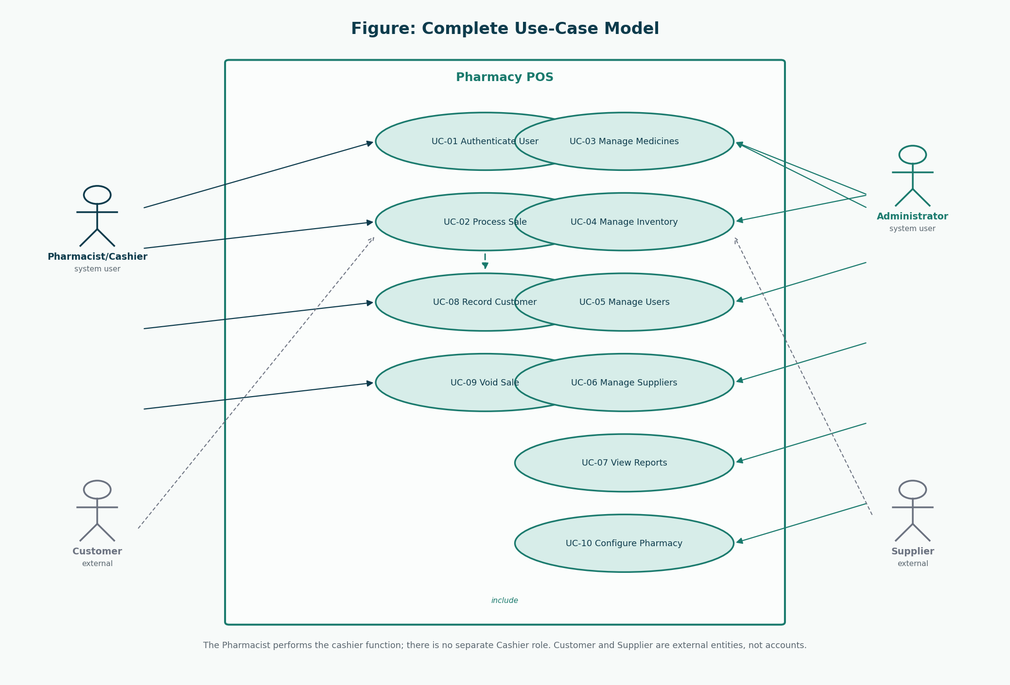
Figure 1: Complete use-case model
Evolution: Figure in Inception showed only UC-02; Elaboration 1 showed three; this is the full set.
ID | Name | Actor | Iteration
UC-01 | Authenticate User | Administrator, Pharmacist/Cashier | Elaboration 1 (30%)
UC-02 | Process Sale | Pharmacist/Cashier | Inception 10% / Elaboration 1 detailed
UC-03 | Manage Medicines | Administrator | Elaboration 1 (30%)
UC-04 | Manage Inventory | Administrator | Elaboration 2 (remaining 70%)
UC-05 | Manage Users | Administrator | Elaboration 2 (remaining 70%)
UC-06 | Manage Suppliers | Administrator | Elaboration 2 (remaining 70%)
UC-07 | View Reports | Administrator | Elaboration 2 (remaining 70%)
UC-08 | Record Customer | Pharmacist/Cashier | Elaboration 2 (remaining 70%)
UC-09 | Void Sale | Pharmacist/Cashier | Elaboration 2 (remaining 70%)
UC-10 | Configure Pharmacy | Administrator | Elaboration 2 (remaining 70%)

12. Use-Case Descriptions
Fully dressed texts live in the Complete System Design Document. The core goal is restated here.

UC-02 Process Sale
Field | Description
ID | UC-02
Name | Process Sale
Scope | Pharmacy POS application
Level | User goal
Primary actor | Pharmacist/Cashier
Priority | Critical
Iteration | Inception 10% / Elaboration 1 detailed
Requirements | FR-03, FR-04, FR-05, FR-06, FR-07, FR-08, FR-16
Preconditions | The Pharmacist/Cashier is authenticated. At least one sellable medicine exists.
Success guarantee | A completed Sale, Payment, stock reduction, and Receipt exist. Prescription details exist when required.
Special requirements | Sale completion and stock reduction are one business transaction. Receipt shows pharmacy name, date, lines, total, payment method, and cashier identity (the Pharmacist user).
Technology / data variations | Product code may be typed; barcode scan is a technology variation of enterItem, not a separate use case (Larman: name events at the level of intent).
Frequency | Core daily work of the counter — typically many times per hour.

Stakeholders and interests
Stakeholder | Interest
Pharmacist/Cashier | Completes the sale quickly and correctly.
Customer | Pays the correct amount and receives the intended medicines plus a receipt.
Pharmacy owner | Money and stock stay consistent; expired stock is not sold.
Regulator | Prescription-only items are not sold without recorded prescription details.

Main success scenario
1. The Pharmacist/Cashier chooses to start a new sale (system event: makeNewSale).
2. The system creates a Sale in progress and shows an empty line list and a zero total.
3. The Pharmacist/Cashier identifies a medicine by search or product code and enters a quantity (system event: enterItem).
4. The system locates a sellable StockBatch (unexpired, sufficient quantity), adds a SalesLineItem, and returns description, unit price, line total, and running total.
5. The Pharmacist/Cashier repeats step 3–4 for each additional medicine.
6. If any accepted line is prescription-only, the Pharmacist/Cashier records the customer (or uses an existing customer) and the prescription reference (system event: attachPrescription).
7. The Pharmacist/Cashier indicates the sale content is complete (system event: endSale).
8. The system calculates tax if configured and presents the total due.
9. The Pharmacist/Cashier records the payment method and amount tendered (system event: makePayment).
10. The system records Payment, marks the Sale complete, reduces batch quantities, writes audit data, and presents the Receipt.
11. The Pharmacist/Cashier gives medicines and the receipt to the Customer.
Extensions
- 3a. Medicine is not found: the system says so; the sale remains in progress.
- 3b. Only expired batches exist: the system refuses the line (BO-01 / FR-05).
- 3c. Requested quantity exceeds sellable stock: the system refuses the line and shows the available quantity.
- 3d. Pharmacist/Cashier removes a line before payment: the system deletes that SalesLineItem and updates the total.
- 6a. Prescription-only line without prescription details: the system refuses to end the sale until details are recorded.
- 6b. Customer is new: include UC-08 Record Customer, then continue.
- 8a. Pharmacist/Cashier cancels the in-progress sale: no payment, no stock change (related to UC-09).
- 9a. Amount tendered is less than total for a cash sale: the system refuses completion and shows the shortfall.
- 9b. Card or mobile money: the Pharmacist/Cashier confirms that payment was received externally; the system records method and reference. Live gateway settlement is out of scope (A-04).
- 10a. Persistence fails after payment intent: the system does not report success; no partial stock reduction remains (NFR-04).

13. Domain Model
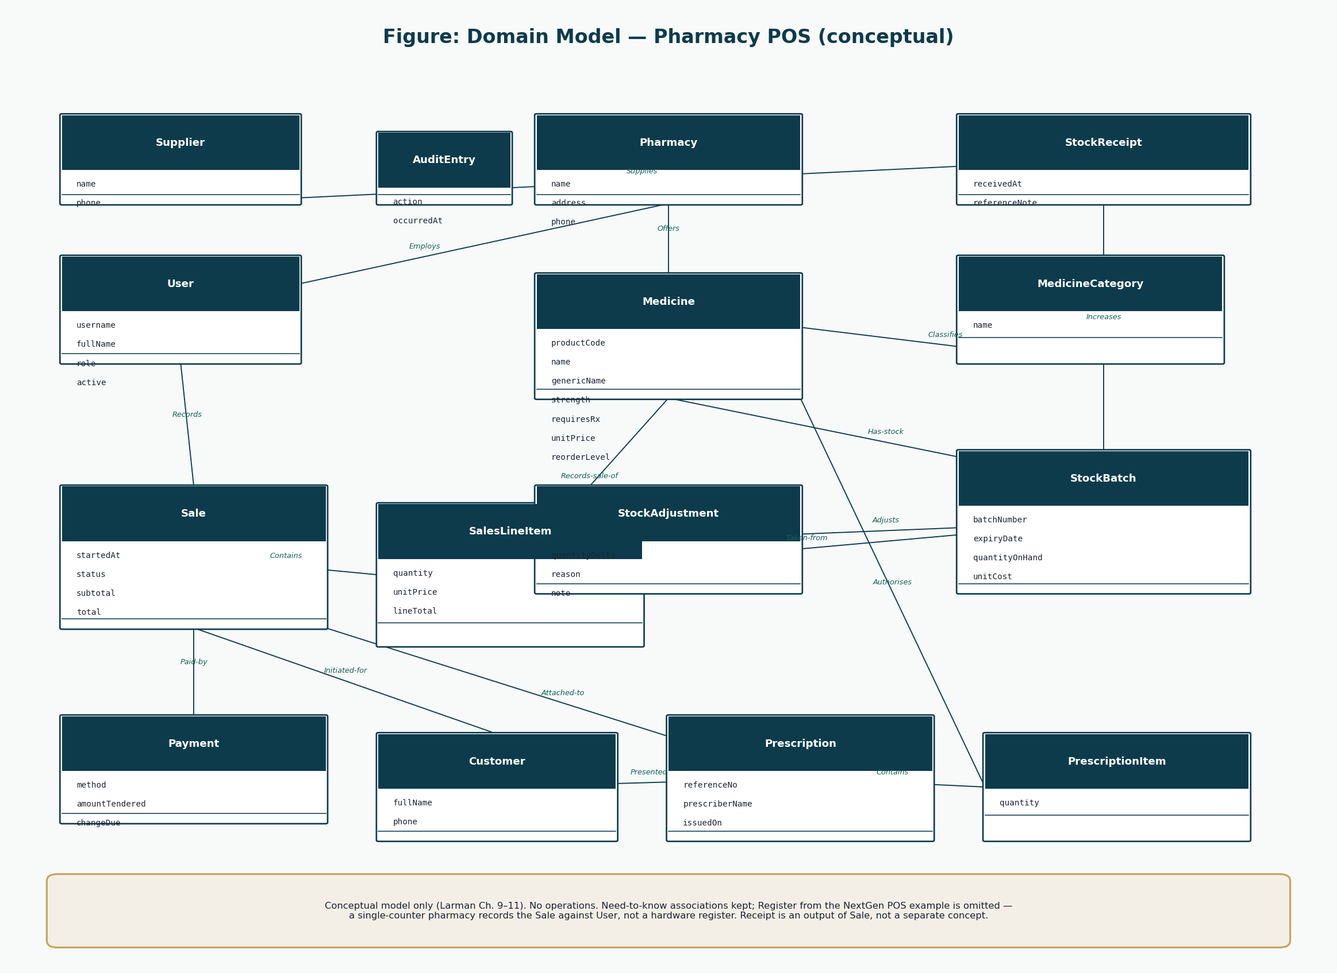
Figure 2: Domain model
No methods. Register from NextGen POS is intentionally absent.

14. System Sequence Diagrams
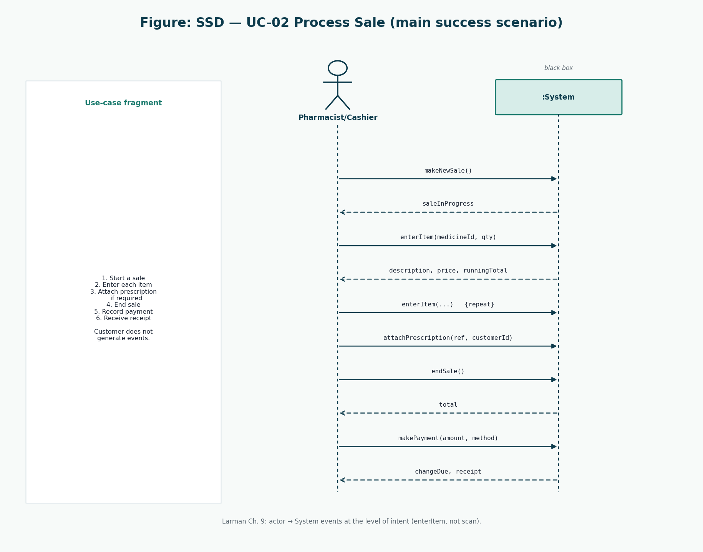
Figure 3: SSD Process Sale
Black-box system events at the level of intent.

15. Architecture
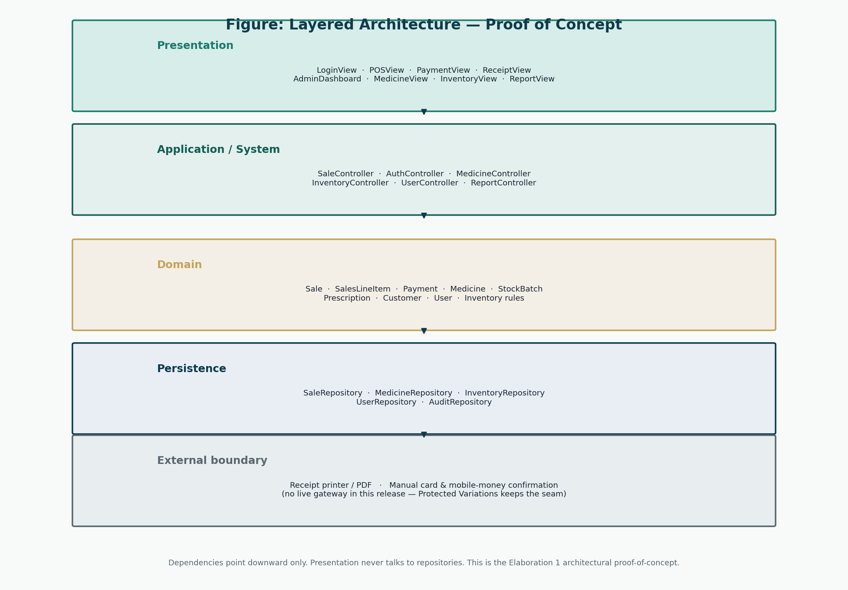
Figure 4: Layered architecture
Proof-of-concept from Elaboration 1, refined in Iteration 2.

16. Design Class Diagrams
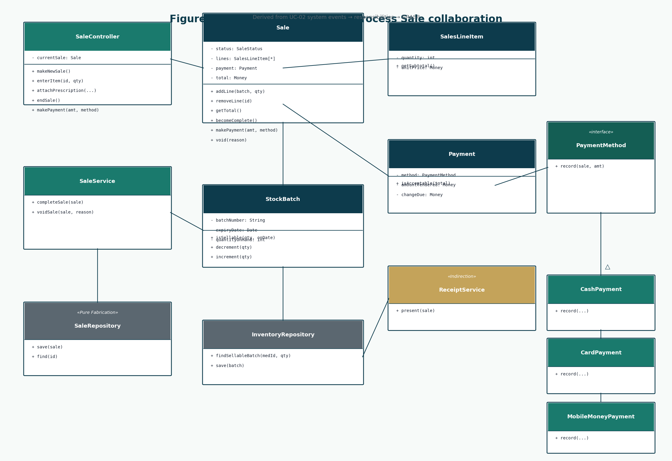
Figure 5: Design classes for Process Sale
Derived from events and GRASP.

17. GRASP
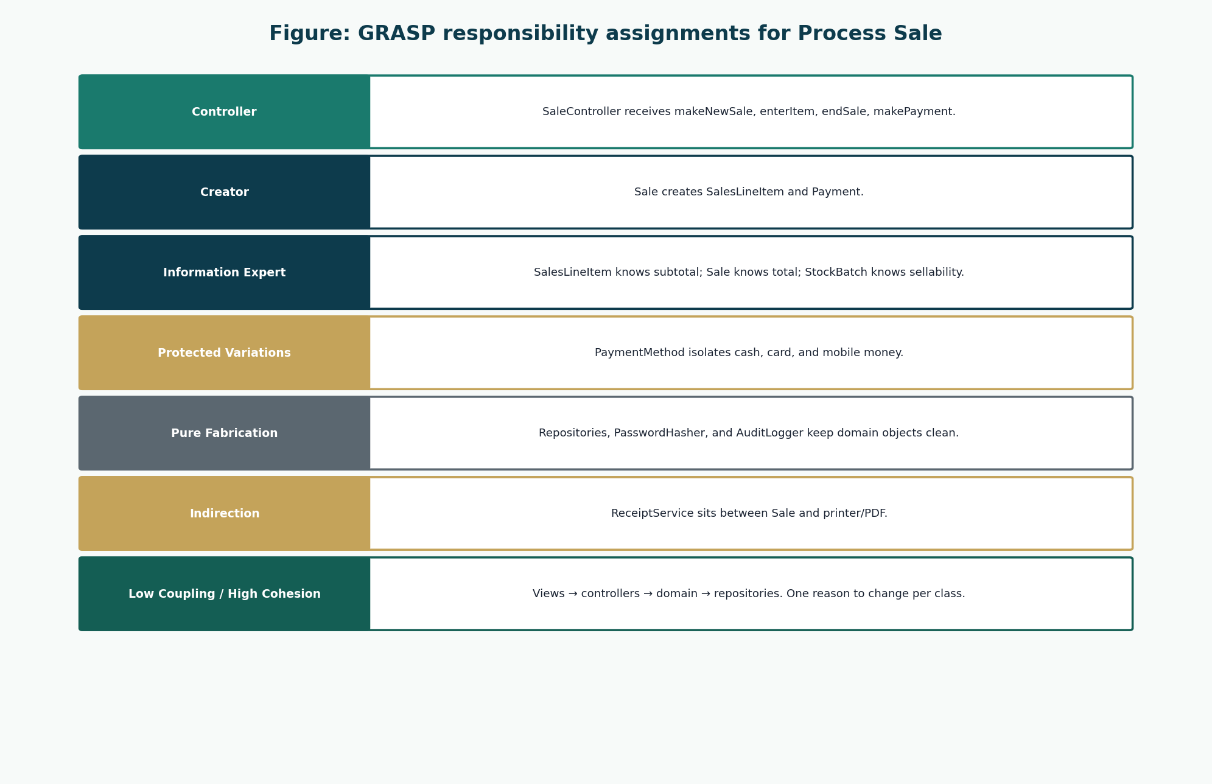
Figure 6: GRASP assignments
Controller, Creator, Expert, Protected Variations, Pure Fabrication, Indirection.
Responsibility | Class | GRASP
Handle system events of UC-02 | SaleController | Controller
Create SalesLineItem | Sale | Creator
Create Payment | Sale | Creator
Know line total | SalesLineItem | Information Expert
Know sale total | Sale | Information Expert
Decide if a batch may be sold | StockBatch | Information Expert
Reduce stock | StockBatch / InventoryService | Information Expert / High Cohesion
Hash passwords | PasswordHasher | Pure Fabrication
Write audit rows | AuditLogger | Pure Fabrication
Isolate payment kinds | PaymentMethod (cash, card, mobile money) | Protected Variations / Polymorphism
Print or show a receipt | ReceiptService | Indirection
Persist aggregates | SaleRepository and related repositories | Pure Fabrication / Low Coupling
Keep views off repositories | Controllers + services | Low Coupling
One reason to change per class | Sale vs SaleController vs SaleRepository | High Cohesion

18. Database Design
Conceptual model = domain model. Logical model = tables in 3NF with price copied onto sale lines.

19. ERD
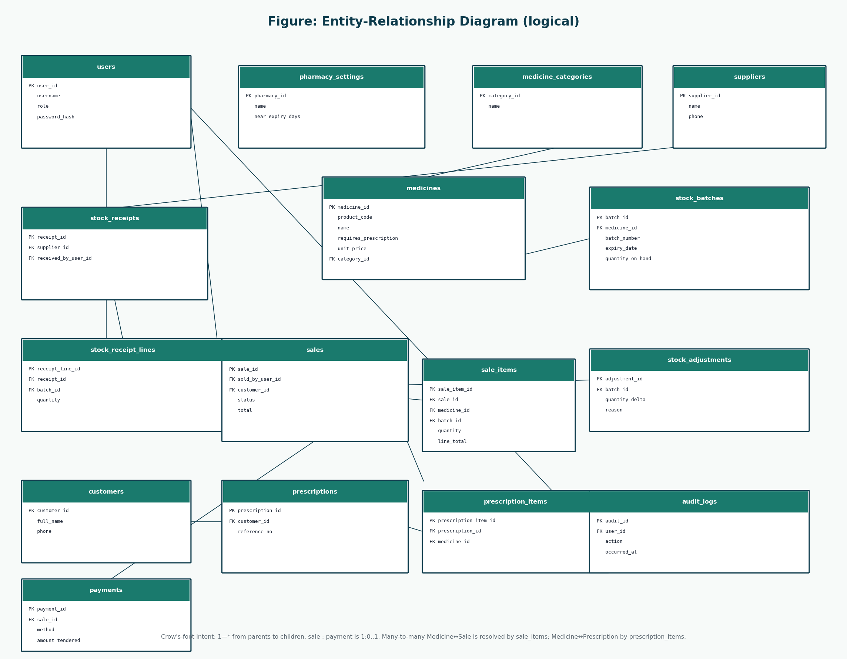
Figure 7: ERD
Consistent with domain classes and use cases.

20. Database Schema
Full column catalogue: Complete System Design Document §15 and Database-Design/Pharmacy-POS-Database-Design.docx.
Table | Supports
users | UC-01, UC-05
medicines / stock_batches | UC-02, UC-03, UC-04
sales / sale_items / payments | UC-02, UC-09
customers / prescriptions | UC-02, UC-08
stock_receipts / adjustments | UC-04
audit_logs | FR-19

21. UI Design
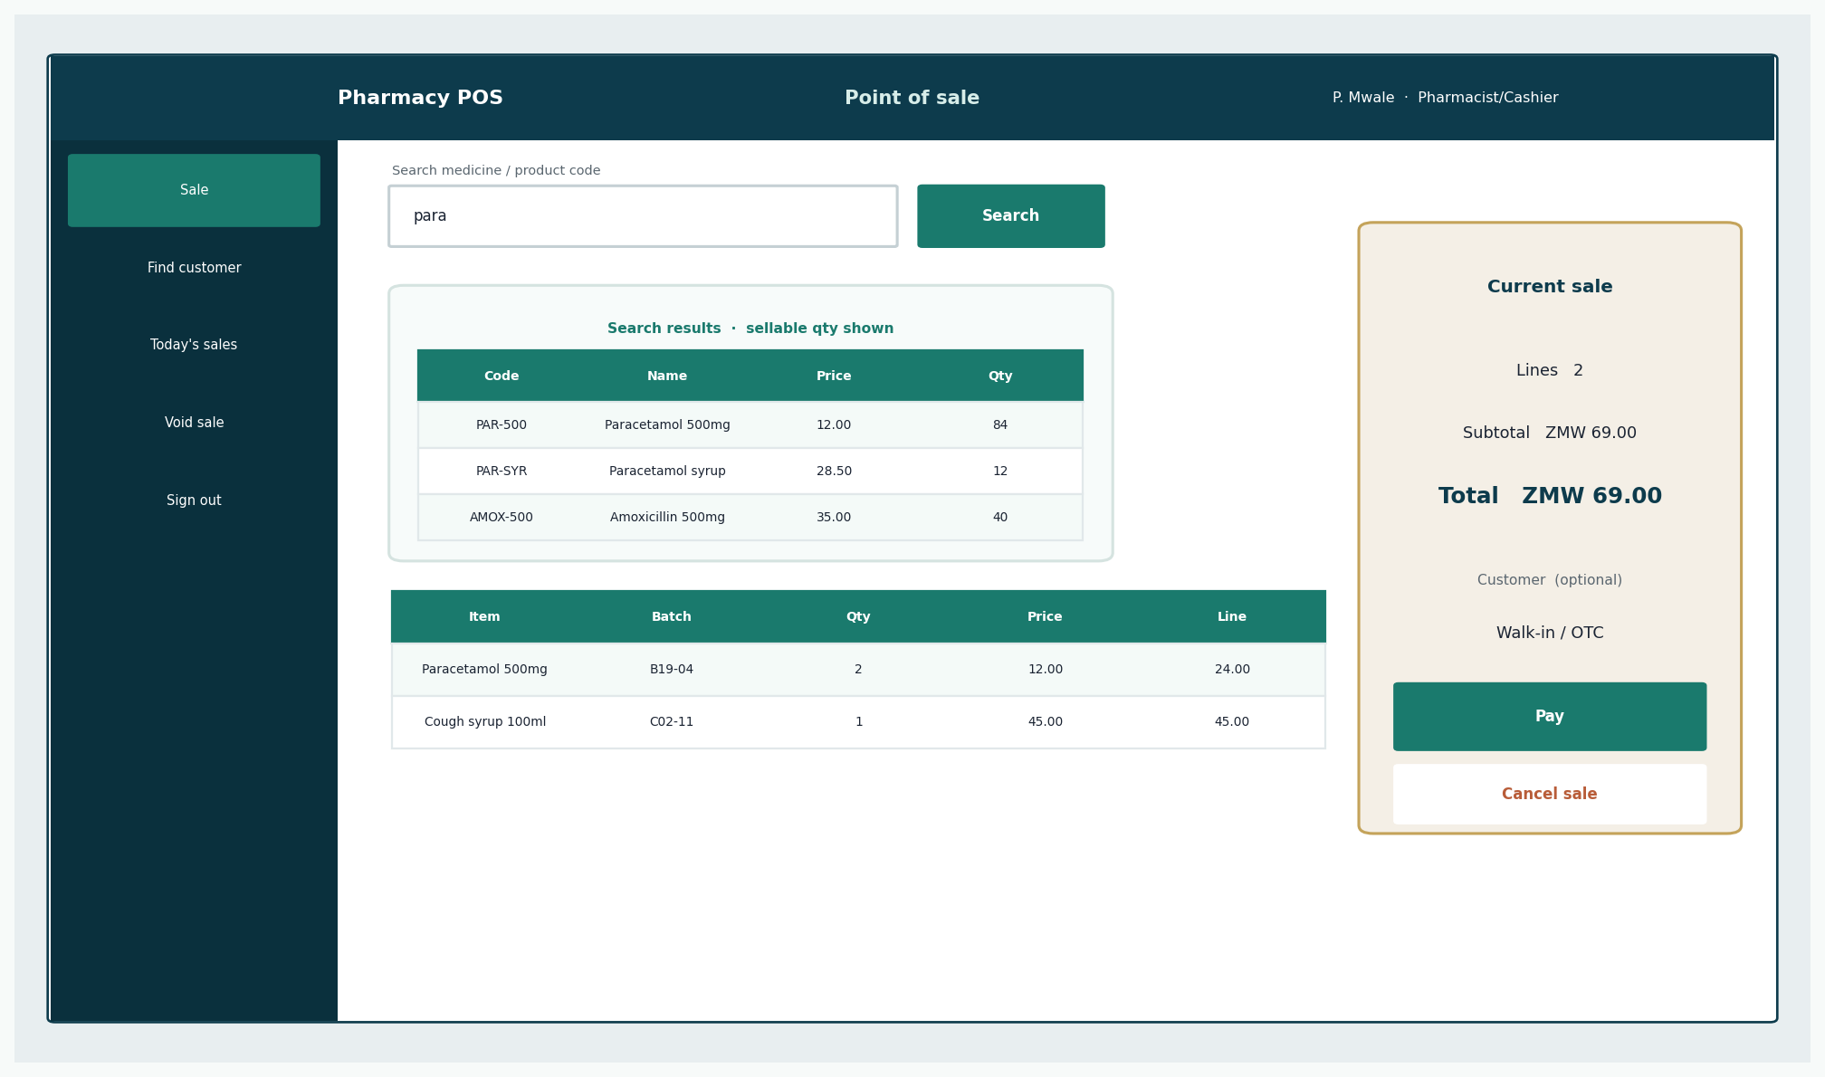
Figure 8: Pharmacist sales prototype
NFR-03.
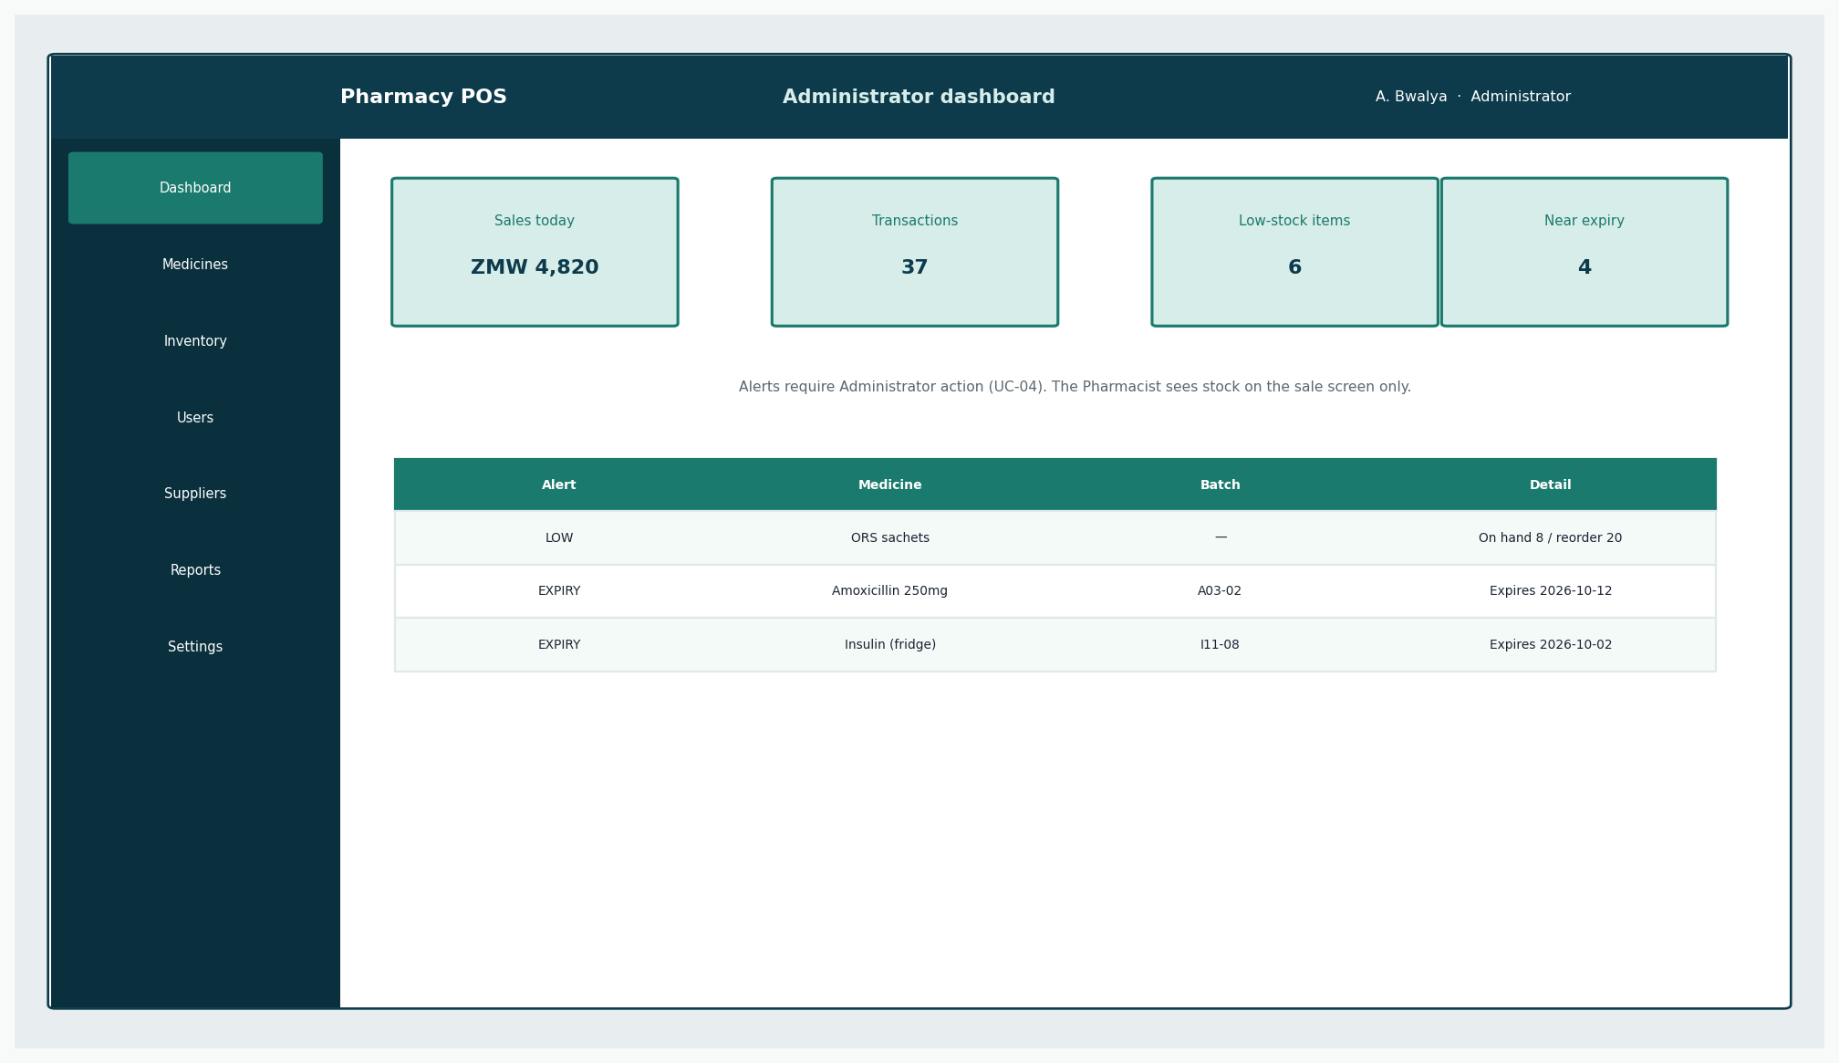
Figure 9: Administrator prototype
Alerts, not a third role.

22. Implementation Summary
PharmaPoint is implemented in Pharmacy-POS/apoza/. The stack is Python 3.10+, FastAPI, Starlette sessions, SQLAlchemy ORM, SQLite, Jinja2 templates, and PBKDF2 password hashing. Sale completion and stock decrement run in one database transaction (SaleService.complete_sale). Two roles are enforced: Administrator and Pharmacist/Cashier.
Layer | Package / folder | Responsibility
Presentation | apoza/presentation/ | Routes, Jinja screens, static assets
Application | apoza/application/ | SaleService, AuthService, InventoryService, audit
Domain | apoza/domain/ | Stock rules, payment rules, enums, authorisation policy
Persistence | apoza/persistence/ | SQLAlchemy models, database session, seed data
Security | apoza/security/ | PBKDF2 password hashing with per-user salt

23. Testing
Unit and integration cases are specified in the Construction report (UT-01–UT-12, IT-01–IT-08). September 2026 execution: 21 tests passed in 10.66 seconds (pytest -q).
Test file | Coverage
tests/test_domain.py | Domain rules — expiry, quantity, totals, role policy, password hash
tests/test_sale_service.py | SaleService — login, add item, expiry refusal, prescription, void, payment
tests/test_integration.py | HTTP paths — OTC sale, role separation, admin dashboard

24. Git / Version Control
Branching: main, feature/F-xx, fix/DEF-xx. Documentation currently lives under Pharmacy-POS/.

25. Continuous Integration
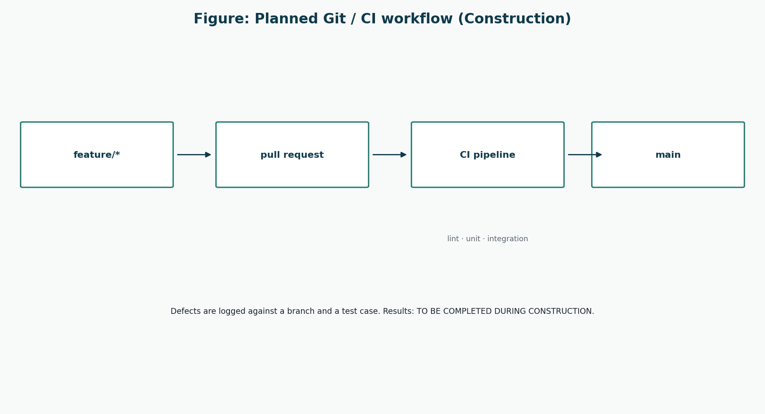
Figure 10: Planned CI
TO BE COMPLETED DURING CONSTRUCTION as a live pipeline.

26. Defect Tracking
DEFECT STATISTICS: TO BE COMPLETED DURING CONSTRUCTION

27. Beta Testing
BETA OUTCOMES: TO BE COMPLETED DURING TRANSITION

28. Performance
Target idea: NFR-02 (~3 seconds per line on the intended workstation).
PERFORMANCE MEASUREMENTS: TO BE COMPLETED DURING TRANSITION

29. Security
Design: hashed passwords, two roles, audit, session timeout, no plaintext.
SECURITY TEST RESULTS: TO BE COMPLETED DURING TRANSITION

30. Final System
The final system will be the constructed realisation of the models in this pack. Until START IMPLEMENTATION, the “final system” is the approved design.

31. UP Iterations
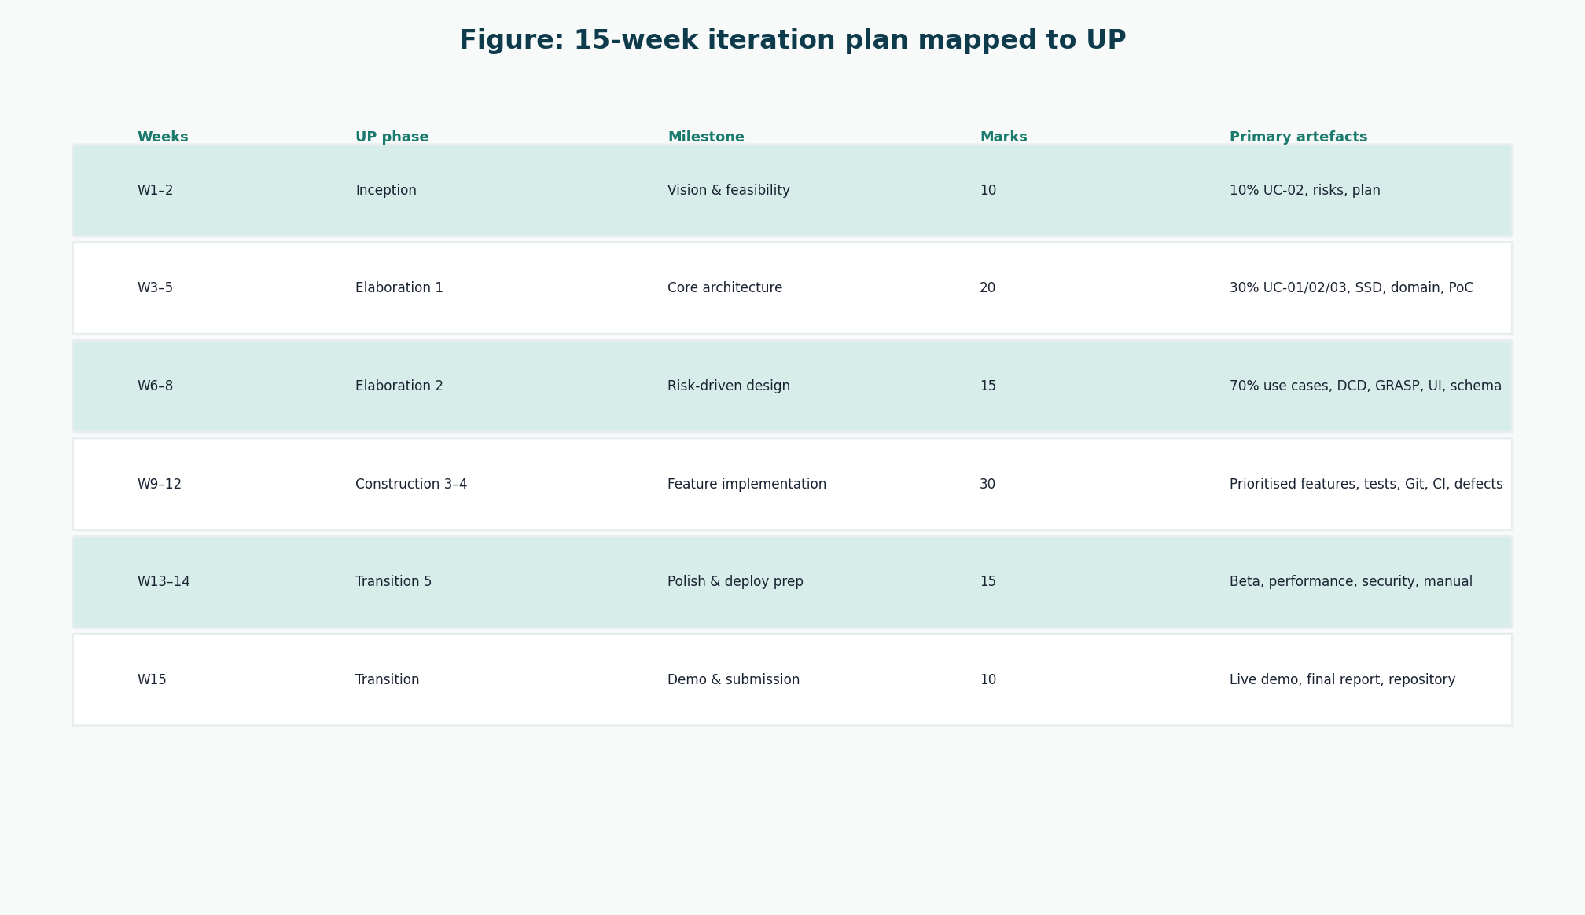
Figure 11: Iteration plan
Copied from the marking guide’s weeks and marks.
Iteration | What existed at the end (this pack)
Inception | Vision, 10% UC-02, risks, feasibility, plan
Elaboration 1 | 30% use cases, SSDs, domain, architecture
Elaboration 2 | 100% use cases, DCD, GRASP, UI, schema
Construction 3–4 | Plans and test catalogues only
Transition 5 | Beta/demo plans and user manual draft

32. UP Reflection

32.1 Inception
Inception was useful when we treated it as a decision, not a document dump. Naming UC-02 as the 10% stopped a temptation — visible in an earlier briefing slide — to list four unrelated “10% use cases” including refill-and-insurance stories that were out of scope. The two-role rule also forced us to delete Manager and Cashier as actors.

32.2 Elaboration
Elaboration felt like the real project: SSDs made enterItem the centre of the design, and the domain model forced StockBatch into existence. Copying Larman’s Register would have been ritual; omitting it was a need-to-know decision. GRASP stopped SaleController from becoming a god class only because we kept writing the Expert column down.

32.3 Construction
Construction has not been lived yet. The planned lesson is to grow vertical slices (a sale that persists) rather than a finished UI layer with no domain. Reflection on what actually slipped will be written after the iterations run.
CONSTRUCTION REFLECTION FROM EXPERIENCE: TO BE COMPLETED DURING CONSTRUCTION

32.4 Transition
Transition is planned as the first time a Pharmacist who is not the author touches the sales screen. That is where R-05 will be confirmed or denied.
TRANSITION REFLECTION FROM EXPERIENCE: TO BE COMPLETED DURING TRANSITION

33. Lessons Learned
- A use case is a user goal. “Scan barcode” is a technology variation of enterItem.
- Two roles is a design constraint, not a caption. It changes the use-case diagram, the UI, and the users table.
- Pharmacy POS is not NextGen POS. Batch expiry and prescriptions are first-class; Register is not.
- Assumptions (manual mobile money, no NHIMA) must stay in an assumptions table or they become fake requirements.
- Risks that are “mitigated in design” are not the same as risks that are gone.
- Documentation-first only works if identifiers stay stable (FR-05 is FR-05 in the test list).

34. Conclusion
Group 20 has a connected UP design for a two-role pharmacy POS. Process Sale is the thread through requirements, SSD, domain, DCD, schema, UI, tests, and the demo plan. The honest remaining work is construction, measured transition, and a live demonstration. That work starts only when the group is told START IMPLEMENTATION.

References
[1] Larman, C. Applying UML and Patterns: An Introduction to Object-Oriented Analysis and Design and Iterative Development. 3rd edition. Prentice Hall. Principal methodology for UP, use cases, domain models, SSDs, design class diagrams, GRASP, and iterative development. Page numbers are not cited because the full print edition was not available as a continuous source file; chapter titles from the course extracts (System Sequence Diagrams; Domain Model associations; Design Class Diagrams) are used instead.
[2] CSC 4630 Advanced Software Engineering Course Project Marking Guide. Unified Process, 15 weeks, 100 marks. Determines milestones, deliverables, and mark weights.
[3] Larman course extracts used by the group: Chapter 9 System Sequence Diagrams; Chapter 11 Domain Model associations; Chapter 16 Design Class Diagrams.
[4] Group 20 inception briefing slides, Pharmacy POS System — Advanced Software Engineering (problem context in Zambia). Role names in those slides that implied a separate Cashier or Manager were corrected in this documentation to match the two-role rule.

Appendices

Appendix A Diagram inventory
Week | UP Phase | Iteration | Diagram / artefact | Purpose
1–2 | Inception | — | UC-Inception-10-Percent | 10% use-case model
1–2 | Inception | — | UP-Phases, Iteration-Plan-15-Weeks | Methodology and calendar
3–5 | Elaboration | 1 | UC-Elaboration1-30-Percent | 30% selection
3–5 | Elaboration | 1 | SSD-UC01, SSD-UC02, SSD-UC03 | System events
3–5 | Elaboration | 1 | Domain-Model | Conceptual classes
3–5 | Elaboration | 1 | Layered-Architecture-PoC, Architecture-Sale-Path | Proof-of-concept
6–8 | Elaboration | 2 | UC-Complete, SSD-UC04, SSD-UC09 | Remaining behaviour
6–8 | Elaboration | 2 | DCD-Process-Sale, DCD-Overview, GRASP-Assignments | Design
6–8 | Elaboration | 2 | UI-01 to UI-10 | Prototypes
6–8 | Elaboration | 2 | ERD-Logical, Schema-Groups | Persistence design
9–12 | Construction | 3–4 | Git-CI-Workflow, test tables | How software will be grown
13–14 | Transition | 5 | Updated models (same files until drift) | Baseline for beta
15 | Transition | Demo | Final presentation figures | Same models, not a second design

Appendix B Companion documents
Document | Folder
Inception Report | Documentation/01-Inception
Elaboration Iteration 1 | Documentation/02-Elaboration-Iteration-1
Elaboration Iteration 2 | Documentation/03-Elaboration-Iteration-2
Complete System Design | Documentation/04-Complete-System-Design
Construction & Testing | Documentation/05-Construction-Testing
Transition & Beta | Documentation/06-Transition-Beta
User Manual | Documentation/07-User-Manual
Compliance matrix | Documentation/00-Project-Control
Database design | Database-Design
Presentation | Presentation

Appendix C Group members
Insert official Group 20 names, student numbers, and contributions before submission.
Name | Student number | Primary contribution
[Member 1]
[Member 2]
[Member 3]
[Member 4]

