CS 660 Final Project
Modernization Proposal for Legacy Inventory Management System
Brady Weber
The current inventory management system still supports the company’s core operations, but its technical debt, operational issues, and limited scalability make modernization necessary. Deployed in 2008 and written in ANSI C, the system was designed for single-machine performance rather than long-term adaptability, growth, and maintainability. This proposal recommends replacing the legacy system with a layered Java application using object-oriented design as its primary paradigm. This approach directly addresses the system’s documented bottlenecks while improving maintainability, security, scalability, and long-term development efficiency.
Legacy System Analysis
Abstraction and encapsulation are present in the current codebase, but only in a limited form. The system uses header and source separation and individual modules for inventory, orders, reporting, and utilities. This provides some organization, but does not create strong boundaries. Structs are visible, global state is shared, and SQL strings are embedded directly in C files. This results in a system with partial abstraction but weak encapsulation. The modules group related functions without protecting internal state or enforcing separation of concerns. Developers must still manually manage locking, memory, return-code checks, and database operations. This means even small updates can introduce unnecessary risk.
The legacy language also creates readability and maintainability concerns. The codebase has different coding styles between patches, pointer arithmetic, embedded SQL, and repeated low-level checks that make the program’s intent harder to follow. Manual memory management, global variables, and years of patch-based changes also make maintenance more difficult. These issues directly conflict with the redesign goal of reducing feature lead time and making the system easier to modify and maintain.
Performance is the strongest argument for the current C implementation, but the system’s results show that raw language speed is no longer enough. The current system has a 48 millisecond median request latency, but its 115 millisecond 95th-percentile latency and approximately 220 transactions per second fall short of the redesign goal of 500 transactions per second with 95th-percentile latency under 75 milliseconds. The main performance concern is therefore not C itself, but the architecture around it, especially the global lock that limits concurrency.
C also has a mature ecosystem, including stable compilers, POSIX support, ODBC access, and reliable Linux deployment. However, the ecosystem is less ideal for the type of backend system currently required. Modern inventory services benefit from stronger support for secure APIs, persistence layers, testing, observability, and cloud-oriented scaling.
The C99 type system is static because types are checked at compile time, but it is considered weak because implicit casts and unsafe pointer operations are still permitted. This provides some early error detection, but it does not prevent memory leaks, dangling pointers, or invalid memory access. In terms of usability, developers must manually manage memory, pointers, and low-level error handling. These limitations are major reasons why the current system has become difficult to maintain.

System Requirements and Paradigm Selection
Any redesign must first preserve the legacy system’s essential business capabilities. The retained functional requirements are stock adjustment, order fulfillment, nightly reconciliation reporting, and real-time insufficient-stock alerting. The non-functional requirements are equally important: the new design must improve performance, support horizontal scaling on commodity cloud instances, reduce feature lead time, maintain 99.9 percent uptime, and secure external traffic with TLS 1.3 and role-based access control.
Imperative programming can be valuable since inventory operations are often inherently ordered. However, the imperative system is part of the legacy design’s problem because it requires a shared mutable state and procedural flows. Functional programming could be useful due to its inherent immutability, first-class functions, and higher-order functions, especially for validation, request handling, and calculations. This paradigm isn’t a bad choice since it provides the above benefits, but it isn’t the best choice because this inventory application requires interactions with services and objects which are better represented with object-oriented design.
Object-oriented programming is the best paradigm because the system’s inner workings can be easily represented and its encapsulation, abstraction, and modularity provide better control over the individual pieces, how they interact, what they need to interact with, and the state of the data contained within. Inventory items, orders, alerts, reports, services, repositories, and security rules are all examples that can benefit from these OOP principles, especially when compared to how they were previously managed in the shared mutable state of the legacy system. Functions such as database writes, alerts, logging, and reporting can all benefit the overall system with their abstraction since the rest of the program does not need to understand how they achieve their goals as long as they provide an endpoint to conceptually achieve those goals for the rest of the program. Functional programming’s inherent immutability could fit into sections of this system’s object-oriented design by inherently protecting items heavily utilized in communications between services and concurrent operations such as request objects and transaction inputs.
Legacy Problem Solved with Object-Oriented Paradigm
A core problem in the legacy C system is that business and storage logic are not clearly separated. Inventory rules, order-processing decisions, and SQL statements are mixed together in the same files which makes the program harder to test and maintain. Object-oriented programming addresses this by providing a separation of concerns with objects: OrderService controls the order workflow and InventoryRepository handles database access.

Class OrderService
Dependency: InventoryRepository
Dependency: AlertService

Method fulfillOrder(orderRequest)
item = inventoryRepository.findBySku(orderRequest.sku)

If item does not exist
Return order-not-found error

If item.availableQuantity < orderRequest.quantity
alertService.sendInsufficientStockAlert(orderRequest)
Return insufficient-stock error

item.reserve(orderRequest.quantity)
inventoryRepository.save(item)

Return successful order result

Class InventoryRepository
Method findBySku(sku)
Run database query for matching inventory item
Return InventoryItem

Method save(item)
Run database update for changed inventory quantity

Conceptual System Outline

API Gateway
- Receives client or external system requests.
- Routes each request to the correct inventory, order, reporting, or alerting workflow.
- Abstracts client communication and entry routing from business logic.

Security Layer
- Authenticates users or systems and applies role-based access control.
- Abstracts security rules into one module instead of spreading permission checks across service code.

Validation Components
- Run after security approval and before service-layer processing.
- Check request structure, SKU format, and quantity rules.
- Abstraction/Modularity: Separation of concerns allows service layer to focus strictly on business logic rather than having to validate inside business logic

Service Layer
- Controls the main business flow for order fulfillment, stock adjustment, reporting, and alerting.
- Modular components perform business operations independently; examples: stock checks, reservation, decrementing, rollback, and alert-triggering logic.
- Abstracts complex workflows behind service methods such as fulfillOrder or adjustStock.

Repository Layer
- Modular services provide functionality to read or write inventory, order, reservation, or transaction data.
- Controls flow between repository and business logic.
- Abstracts SQL and storage details to allow business logic to operate independently.

Reporting and Alerting Components
- Run as separate workflows from the main order-processing path.
- Generate reports and send insufficient-stock alerts.
- Abstract report generation and notification delivery behind modular components.

Monitoring and Logging Components
- Observe the system throughout all workflows.
- Capture logs, metrics, health checks, audit events, and operational errors.
- Abstract monitoring logic to prevent clutter in business logic workflows.

Paradigm Comparison Table
Criterion | Legacy Imperative C | Object-Oriented
Maintainability | Business rules, SQL, and low-level resource handling remain tightly mixed. Global state and a coarse lock limit concurrency and make isolated tests harder. Imperative code becomes harder to navigate with scale. | OOP modularity supports simple iterative updates and continuous program expansion without impacting the entire system. It also provides a plug-and-play system for testing harnesses.
Team learning curve | The code in its current state and environment is familiar for existing developers. New employees, new projects, and even new functionality on existing projects may all lead to training in order to be comfortable with pointers, manual memory, and navigating existing technical debt.. | OOP is the industry standard for enterprise development and commonly learned by modern developers, but transitioning to any new language/paradigm may require retraining for some employees.
Problem-solving effectiveness | Shared state poses risks when adding any code. Memory management requires expertise to ensure alterations do not introduce bugs. Simple tasks may be easily and quickly implemented due to clear, ordered steps and minimal overhead. Complex tasks can easily become overcrowded and hard to manage. | Objects easily model common inventory/warehouse industry’s practices and tools. Modularity and polymorphism provide easy reusability of existing solutions. New problems with no existing structure may require longer to develop due to increased overhead.

Language Recommendation and Redesign
Both Java and Python can support object-oriented design, but Java is better suited for this larger enterprise system because its structure more directly supports the goals of the redesign. Python’s flexibility makes it useful across multiple paradigms, while Java’s explicit typing, stricter syntax, and object-oriented conventions help enforce data integrity, encapsulation, abstraction, and polymorphism. Java’s class-based file structure also supports the organization and readability needed for a large, layered system with many components.
The system’s performance needs also support the Java recommendation. Leadership’s redesign goal is to reach 500 transactions per second with 95th-percentile latency under 75 milliseconds, which depends heavily on effective concurrency and parallelism. Python is limited in this area by the Global Interpreter Lock, which prevents multiple threads in the same process from executing Python bytecode in parallel. Multiprocessing can work around this limitation, but each process requires separate memory, creating a tradeoff between compute capacity and memory usage.
Java avoids this specific limitation because it does not rely on a GIL. Its thread model, including JVM-managed virtual threads, allows the system to handle large numbers of concurrent tasks with less overhead than a process-based workaround. Since Java threads operate within the same process, they can also share memory more directly than separate Python processes. For a transactional inventory system with demanding throughput goals, this makes Java a stronger fit for reducing server demand, improving concurrency, and supporting long-term scalability.
Python could still be valuable as a secondary language for targeted tasks outside the main transactional workflow. It would be well suited for reporting pipelines, analytics, migration scripts, or machine learning tools that predict stock shortages or resupply needs. However, relying on third-party tools, special runtime versions, or additional dependencies to close Python’s performance gap could introduce deployment inconsistency, security concerns, version-management issues, and added maintenance overhead.
Java also provides the enterprise infrastructure needed to improve the system rather than simply recreate the legacy application in a newer language. It supports layered service architectures, structured exception handling, and built-in regular expression support through the Pattern class. These features do not guarantee that the system will automatically meet every performance or availability target, but they reduce the amount of low-level infrastructure the development team must build and maintain manually. That allows developers to focus more time on scalability, security, reliability, and new business functionality.
The object-oriented paradigm strengthens this recommendation by making the redesigned system more modular, reusable, and maintainable. Inheritance, abstraction, encapsulation, and polymorphism allow existing structures to be expanded or reused while limiting the impact of changes on the rest of the system. As a result, a Java-based object-oriented design better supports the company’s long-term goals for scalability, maintainability, and developer efficiency.
Java Control Flow and Exception Handling
Abstraction provides a simple interface to execute needed functionality while hiding inner exception handling methods and control flow specifics. Try-catch blocks support continued program execution instead of allowing the program to crash. Try-catch blocks provide space to properly revert any unwanted/unsaved changes during failed/rerouted execution to preserve system integrity from unintended behavior. Descriptive exceptions with proper handling provide robust information for monitoring and logging systems to pinpoint issues and threats.

public OrderResult fulfillOrder(OrderRequest request) {
if (request == null || request.quantity() <= 0) {
throw new IllegalArgumentException("Invalid order request.");
}

try {
transactionManager.begin();

InventoryItem item = inventoryRepository.findBySku(request.sku());

if (item == null) {
throw new ItemNotFoundException("SKU not found: " + request.sku());
}

if (item.availableQuantity() < request.quantity()) {
alertService.sendInsufficientStockAlert(request);
throw new InsufficientStockException("Insufficient stock.");
}

item.reserve(request.quantity());
inventoryRepository.save(item);

transactionManager.commit();
return OrderResult.success(item.sku(), request.quantity());

} catch (ItemNotFoundException | InsufficientStockException ex) {
transactionManager.rollback();
return OrderResult.failed(ex.getMessage());

} catch (DataAccessException ex) {
transactionManager.rollback();
throw new OrderProcessingException("Order processing failed.", ex);
}
}

Java Regular Expression Sample
The legacy SKU-recognition rule from the C implementation is preserved in this Java implementation. The original POSIX pattern accepted values with three uppercase letters, a dash, and four digits, such as ABC-1234.

import java.util.regex.Pattern;

private static final Pattern SKU_PATTERN = Pattern.compile("^[A-Z]{3}-[0-9]{4}$");

public boolean hasValidSku(String sku) {
if (sku == null) {
return false;
}
return SKU_PATTERN.matcher(sku).matches();
}

High-Level Architecture Diagram
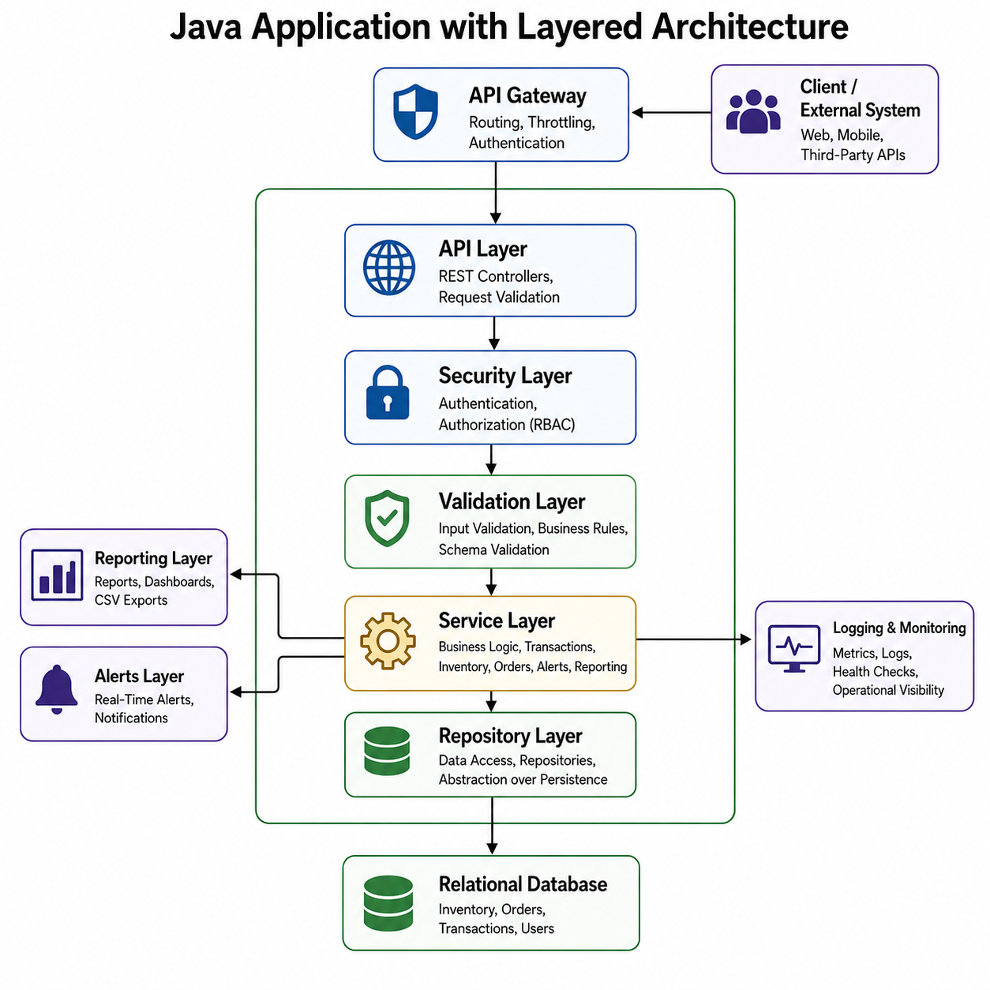
Tradeoffs
Transitioning from an imperative C design to an object-oriented Java design can have its drawbacks. Java introduces more syntax, structure, and runtime overhead compared with C, so migration will require staff training and potentially increased server costs. Furthermore, these languages interact with and utilize system processes and structures differently which may require reverse engineering or fully rebuilding certain sections; if the existing staff is not comfortable with this process, an outside firm may have to be hired. Python’s simplified design would likely provide quicker development iterations and initial time-to-market, but its architecture will likely fall short for many of the redesign’s performance goals. The Java approach favors extensibility, a mature, enterprise-level tooling ecosystem, and safer long-term maintenance over the Legacy C approach’s maximum low-level control. The core benefit of an imperative C system is its performance when running raw language business logic. But, over the lifetime of this legacy system, the evolution of modern languages, tools, and servers have narrowed this performance gap. This allows design priorities to shift to concurrency bottlenecks, quick and iterative updates, tedious debugging and maintenance, and fragile operational behavior. Ultimately, a system built in Java using object-oriented design will provide much more value and is better suited for these priorities than the outdated imperative C-based design.

References
GeeksforGeeks. (2016a, February 17). Regular Expressions in Java. GeeksforGeeks. https://www.geeksforgeeks.org/java/regular-expressions-in-java/
GeeksforGeeks. (2016b, December 23). Java Exception Handling. GeeksforGeeks. https://www.geeksforgeeks.org/java/exceptions-in-java/
GeeksforGeeks. (2020, March 30). Difference between Python and Java. GeeksforGeeks. https://www.geeksforgeeks.org/python/difference-between-python-and-java/
GeeksforGeeks. (2023, June 23). Java OOP(Object Oriented Programming) Concepts. GeeksforGeeks. https://www.geeksforgeeks.org/java/object-oriented-programming-oops-concept-in-java/
How to Throw Exceptions (The JavaTM Tutorials > Essential Classes > Exceptions). (n.d.). Docs.oracle.com. https://docs.oracle.com/javase/tutorial/essential/exceptions/throwing.html
Muhammad, S. (2024, June 30). Master Java OOP Concepts: Key Concepts Explained | Suraif Muhammad | Medium. Medium. https://medium.com/@suraif16/object-oriented-programming-9e4627abf1be
Pattern (Java Platform SE 8 ). (n.d.). Docs.oracle.com. https://docs.oracle.com/javase/8/docs/api/java/util/regex/Pattern.html
Pogrebinsky, M. (n.d.). Python Multithreading vs. Java Multithreading - Important Considerations for High Performance Programming. Top Developer Academy. https://topdeveloperacademy.com/articles/python-multithreading-vs-java-multithreading-important-considerations-for-high-performance-programming
Posa, R. (2022, August 3). Compare Functional Programming, Imperative Programming and Object Oriented Programming | DigitalOcean. Www.digitalocean.com. https://www.digitalocean.com/community/tutorials/functional-imperative-object-oriented-programming-comparison
Sherniiazov Daniiar. (2025, March 24). Mutexes in C. Medium. https://medium.com/@sherniiazov.da/mutexes-in-c-ac2b0f1a6d34
Virtual Threads. (n.d.). Oracle Help Center. https://docs.oracle.com/en/java/javase/21/core/virtual-threads.html
Vogel, L. (n.d.). Java concurrency (multi-threading) - Tutorial. Www.vogella.com. https://www.vogella.com/tutorials/JavaConcurrency/article.html

