

Installation & setup guide

AT&T Developer Program

PhoneGap Plugins for AT&T API Platform
Date: 01/30/2013
Version: 1.1

Document Versions
Version No | Release Date | Author | Description
1.0 | 12/20/12 | AT&T Developer Program
1.1 | 30/01/13 | AT&T Developer Program | Updated Call Management API

InTENDED Audience
- PhoneGap Application Developer

Legal Disclaimer

This document and the information contained herein (collectively, the "Information") is provided to you (both the individual receiving this document and any legal entity on behalf of which such individual is acting) ("You" and "Your") by AT&T, on behalf of itself and its affiliates ("AT&T") for informational purposes only. AT&T is providing the Information to You because AT&T believes the Information may be useful to You. The Information is provided to You solely on the basis that You will be responsible for making Your own assessments of the Information and are advised to verify all representations, statements and information before using or relying upon any of the Information. Although AT&T has exercised reasonable care in providing the Information to You, AT&T does not warrant the accuracy of the Information and is not responsible for any damages arising from Your use of or reliance upon the Information. You further understand and agree that AT&T in no way represents, and You in no way rely on a belief, that AT&T is providing the Information in accordance with any standard or service (routine, customary or otherwise) related to the consulting, services, hardware or software industries.

AT&T DOES NOT WARRANT THAT THE INFORMATION IS ERROR-FREE. AT&T IS PROVIDING THE INFORMATION TO YOU "AS IS" AND "WITH ALL FAULTS." AT&T DOES NOT WARRANT, BY VIRTUE OF THIS DOCUMENT, OR BY ANY COURSE OF PERFORMANCE, COURSE OF DEALING, USAGE OF TRADE OR ANY COLLATERAL DOCUMENT HEREUNDER OR OTHERWISE, AND HEREBY EXPRESSLY DISCLAIMS, ANY REPRESENTATION OR WARRANTY OF ANY KIND WITH RESPECT TO THE INFORMATION, INCLUDING, WITHOUT LIMITATION, ANY REPRESENTATION OR WARRANTY OF DESIGN, PERFORMANCE, MERCHANTABILITY, FITNESS FOR A PARTICULAR PURPOSE OR NON-INFRINGEMENT, OR ANY REPRESENTATION OR WARRANTY THAT THE INFORMATION IS APPLICABLE TO OR INTEROPERABLE WITH ANY SYSTEM, DATA, HARDWARE OR SOFTWARE OF ANY KIND. AT&T DISCLAIMS AND IN NO EVENT SHALL BE LIABLE FOR ANY LOSSES OR DAMAGES OF ANY KIND, WHETHER DIRECT, INDIRECT, INCIDENTAL, CONSEQUENTIAL, PUNITIVE, SPECIAL OR EXEMPLARY, INCLUDING, WITHOUT LIMITATION, DAMAGES FOR LOSS OF BUSINESS PROFITS, BUSINESS INTERRUPTION, LOSS OF BUSINESS INFORMATION, LOSS OF GOODWILL, COVER, TORTIOUS CONDUCT OR OTHER PECUNIARY LOSS, ARISING OUT OF OR IN ANY WAY RELATED TO THE PROVISION, NON-PROVISION, USE OR NON-USE OF THE INFORMATION, EVEN IF AT&T HAS BEEN ADVISED OF THE POSSIBILITY OF SUCH LOSSES OR DAMAGES.

Table of Contents

1 Introduction 1
2 Architectural Overview 1
3 Installation Guidelines and Notes 1
3.1 List of Component to run PhoneGap Mobile SDK modules for the AT&T API 1
3.2 Pre-requisite to use modules bundled in the package 1
3.3 Pre-requisite for sending message on AT&T network 1
4 Installation of the Components 1
4.1 Download Plugin 1
4.2 Installation of Plugin 1
4.2.1 Android 1
4.2.2 iPhone 1
4.3 Using the Components 1

Table of Figures

Figure 1: Architecture diagram of AT&T PhoneGap Mobile SDK 1
Figure 2: Structure of js folder in android 1
Figure 3: Structure of libs folder in Android 1
Figure 4: config.xml file 1
Figure 5: Structure of js folder in Xcode 1
Figure 6: Adding output_library in Plugins folder in Xcode 1
Figure 7: Structure of Plugins folder in Xcode 1
Figure 8: Cordova.plist file 1

- Introduction

The AT&T PhoneGap Mobile SDK provides a simplified access for the PhoneGap Mobile Developers to the AT&T API platform services. It helps developers to quickly bring robust PhoneGap mobile applications to market.
AT&T PhoneGap Mobile SDK significantly reduces the complexity of building applications which uses the AT&T platform services.
The AT&T PhoneGap Mobile facilitates interfaces to access APIs of the AT&T platform:

- SMS
- MMS
- SPEECH
- IN-APP MESSAGING
- NOTARY
- PAYMENT
- DEVICE LOCATION
- OAUTH

- Architectural Overview

AT&T PhoneGap Mobile SDK exposes Javascript interfaces. It complies with CommonJS specifications to access AT&T platform API. Following components provides access to AT&T platform API:
  - PhoneGap Mobile SDK Native component (iOS & Android)
  - Java Script Wrapper Library (compliant with CommonJS specification)
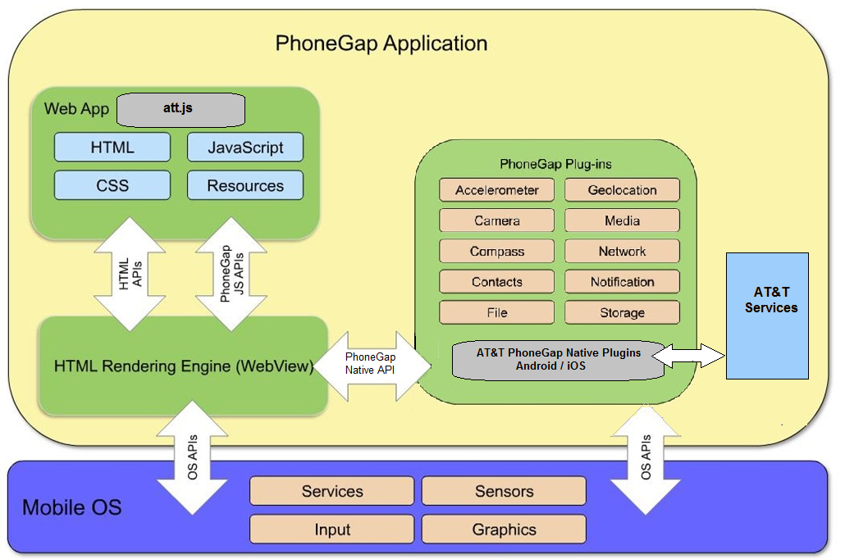
Figure 1: Architecture diagram of AT&T PhoneGap Mobile SDK

Note: To learn more about AT&T API platform, check AT&T website.

- Installation Guidelines and Notes
  - List of Components to run AT&T Plugins

- Xcode(IDE) for iPhone with minimum version of 4.5
- Eclipse (IDE) for Android with minimum version of 3.4 with ADT Plugin installed.
- Phonegap mobile SDK with version 2.2.0 Download link can be found here
- An internet connection (Required for API calls).
  - Pre-requisite to use modules bundled in the package

- These are designed to be used in the PhoneGap Mobile SDK (iOS & Android) application and might not work if an SDK of version lower than the specified minimum version is used.
- All the APIs are capable of working with AT&T network. Sending SMS, MMS and other messages to phones outside of the network, on other carriers, is not supported.

  - Pre-requisite for sending message on AT&T network

In order to use the AT&T network, it is required that your organization must abide by the AT&T API agreement. To send messages on the AT&T network, a secret key and an API key are required. These keys can be obtained by joining the AT&T developer program.
There are two types of keys for the AT&T API:
  - Sandbox Keys – These keys are available for free, and allow programmers to demonstrate proof-of-concept and perform testing on application using the AT&T APIs.
  - Production Keys – These keys provide the same capabilities as the ‘Sandbox Keys’, but are designed to handle a much larger amount of traffic.

Note: To learn more about ‘how to obtain these keys by creating an account and signing,, visit http://developer.att.com .

- Installation of the Components
  - Download Plugin
Following are the ATT PhoneGap plugin that are available at <placeholder for the link pointing to the AT&T PhoneGap Plugin> for developers to download and use in their applications:
- ATT PhoneGap plugin for Android (att-phonegap-android-1.0.zip)
  - It contains all the necessary files needed to use the ATT plugin in the applications targeting android platform.
- ATT PhoneGap plugin for iOS (att-phonegap-iphone-1.0.zip)
  - It contains all necessary files needed to use the ATT plugin in the applications targeting iOS platform.

Download the required iOS or Android module to a directory in your local computer.
  - Installation of Plugin
    - Android
- Create Phonegap Android project in Eclipse (IDE).
- Create folder structure inside ‘www’ folder as shown in fig 5 below.
- Add the following files in the below mentioned folder :

/assets/www/js/lib

    - att.js – Main file for commonJSModule wrapping AT&T Api . This file needs to be taken from the plugin for Android, i.e., att-phonegap-android-1.0.zip.
    - jquery-1.8.0.js - Required for plugin. The file needs to be downloaded from the link –
http://www.way2tutorial.com/jquery/jquery_download.php
    - jquery.json-2.3.1.js - Required for plugin. The file needs to be downloaded from the link
https://github.com/jaubourg/jquery-jsonp
    - require.js - Required for plugin. The file needs to be downloaded from the link -
http://github.com/jrburke/requirejs
    - jquery.mobile-1.0.1.min.js - Required for UI. The file needs to be downloaded from the link :
http://jquerymobile.com

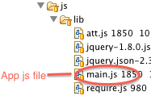
Figure 2: Structure of js folder in android

- Add the following files in the below mentioned folder:
/assets/www/css
    - jquery.mobile-1.0.1.min.css – This file needs to be downloaded from the link –
http://jquerymobile.com
    - jquery.mobile -1.1.1.css - The file needs to be downloaded from the link –
http://jquerymobile.com

- Include the native jar file to use the AT&T APIs. Add “AttAndroidPhoneGapPlugin-1.0.jar” in the “libs” folder of the project.

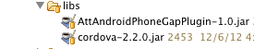
Figure 3: Structure of libs folder in Android

- Make the following changes in the config.xml that is located at :
/res/xml/config.xml

  - Add reference of native plugins for AT&T APIs under the <plugins> tag:

<plugin name="AttPlugin" value="org.att.phonegap.plugin.AttPlugin" />

  - Under the <cordova> tag, make the following changes to add domain for network calls.

<access origin=".*"/>

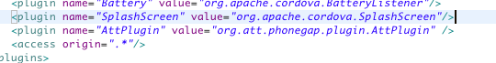 Figure 4: config.xml file

    - iPhone
- Create PhoneGap iPhone project in XCode (IDE)
- Create folder structure inside ‘www’ folder as shown in fig 5 below.
- Add the following files in the below mentioned folder :

/www/js/lib

    - att.js – Main file for commonJSModule wrapping AT&T Api . This file needs to be taken from the plugin for iPhone, i.e., att-phonegap-iphone-1.0.zip.
    - jquery-1.8.0.js - Required for plugin. The file needs to be downloaded from the link –
http://www.way2tutorial.com/jquery/jquery_download.php
    - jquery.json-2.3.1.js - Required for plugin. The file needs to be downloaded from the link
https://github.com/jaubourg/jquery-jsonp
    - require.js - Required for plugin. The file needs to be downloaded from the link -
http://github.com/jrburke/requirejs
    - jquery.mobile-1.0.1.min.js - Required for UI. The file needs to be downloaded from the link :
http://jquerymobile.com

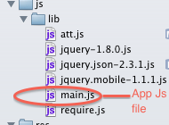
Figure 5: Structure of js folder in Xcode
- Add the following files in the below mentioned folder:
/www/css
    - jquery.mobile-1.0.1.min.css – This file needs to be downloaded from the link –
http://jquerymobile.com
    - jquery.mobile -1.1.1.css - The file needs to be downloaded from the link –
http://jquerymobile.com

- Add the following native files and folders inside Plugins folder.
    - ATTPhonegapHelper.h
    - ATTPhonegapHelper.m
    - outputLibrary/ libATTiosPhonegapPlugin.a
    - outputLibrary/include folder

*Note that for the ‘outputlibrary’, the option of ‘Create folder references for any added folders’ must be selected as shown in Figure 6.

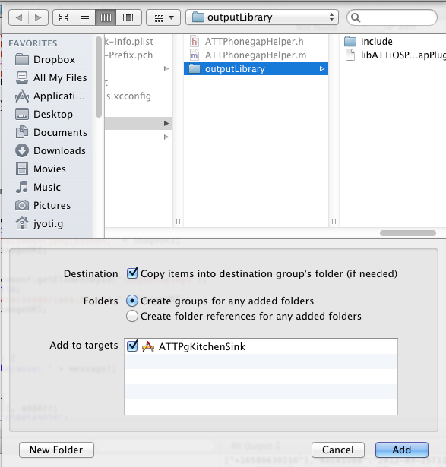
Figure 6: Adding output_library in Plugins folder in Xcode

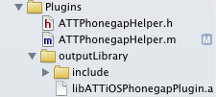
Figure 7: Structure of Plugins folder in Xcode

- Make the following changes in the Cordova.plist file that is located under ‘Resources’ folder :

  - Add reference of native plugins for AT&T APIs under the Plugins section. Add “AttPlugin” as key and “ATTPhonegapHelper” as the corresponding value
  - Set OpenAllWhitelistURLsInWebView to YES , to open Consent in a web View

  - In ExternalHosts, add domain for network calls. Set value as '*'.

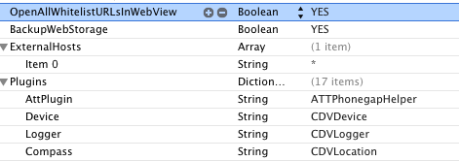
Figure 8: Cordova.plist file

  - Using the Components

- Use ‘require.js’ library to load the plugin in the application code:

Note: To learn more about on PhoneGap module installation guide, please refer http://docs.phonegap.com/en/2.2.0/guide_getting-started_index.md.html

