# DISCLAIMER

**THIS SPECIFICATION IS LICENSED AND PROVIDED BY LOGITECH "AS IS" AND ANY EXPRESS OR IMPLIED WARRANTIES, INCLUDING, BUT NOT LIMITED TO, THE IMPLIED WARRANTIES OF MERCHANTABILITY ANDFITNESS FOR A PARTICULAR PURPOSE ARE DISCLAIMED. IN NO EVENT SHALL LOGITECH OR ANY OF ITS AFFILIATED COMPANIES BE LIABLE FOR ANY DIRECT, INDIRECT, INCIDENTAL, SPECIAL, EXEMPLARY, OR CONSEQUENTIAL DAMAGES (INCLUDING, BUT NOT LIMITED TO, PROCUREMENT OF SUBSTITUTE GOODS OR SERVICES; LOSS OF USE, DATA, OR PROFITS; OR BUSINESS INTERRUPTION) HOWEVER CAUSED AND ON ANY THEORY OF LIABILITY, WHETHER IN CONTRACT, STRICT LIABILITY, OR TORT (INCLUDING NEGLIGENCE OR OTHERWISE) ARISING IN ANY WAY OUT OF THE USE OF THIS SPECIFICATION, EVEN IF ADVISED OF THE POSSIBILITY OF SUCH DAMAGE.**

# Unifying receiver (DJ) Software Interface

This section defines how the 6 paired devices are exposed to the operating system of the host computer. The example implementation is based on a software driver called “DJ Enumerator”.

## System Overview

### Without DJ Enumerator

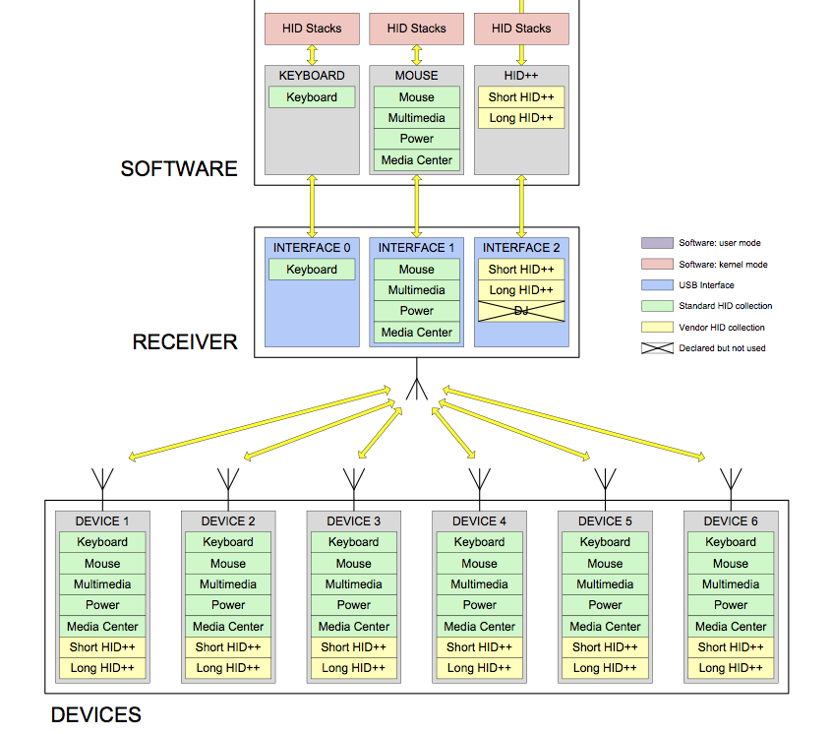When an Unifying receiver is used without the DJ enumerator driver. The system only supports the main features of the paired devices.

When a Unifying receiver is used without the DJ Enumerator, it declares the HID collections required to support one keyboard and one mouse.

Since each HID collection is declared only one time, similar reports from different devices are merged and forwarded to the software using the same collection. Therefore, similar reports from different devices cannot be differentiated by the software. There is no possibility for the software to apply different settings to different devices. For example, if two mice are connected to the same receiver, it is not possible to specify different acceleration curves for each mouse. This is especially annoying if one of the two “mice” is in reality a touchpad.

### With DJ Enumerator

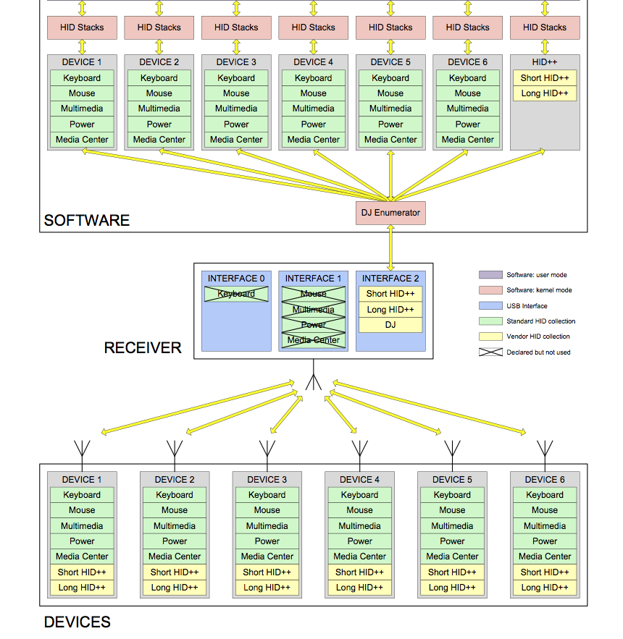

The purpose of the DJ enumerator is to let the software process reports from each device individually.

When the DJ Enumerator is launched, it queries information about all paired devices and declares up to six devices to the operating system, including only the minimum set of collections required by each device.

Once the enumeration phase is done, the DJ Enumerator sends a Switch command to the receiver. Upon receiving this command, the receiver stops posting standard HID reports on USB Interface 0 and 1. Instead, it tags all incoming raw RF reports and forwards them to the software using the DJ collection on USB Interface 2. The DJ Enumerator uses the tag information to format the reports and route them to the appropriate device driver.

## DJ Enumerator

When the DJ Enumerator is launched, it needs to get a list of all devices that are currently paired to the receiver and a sub list of all report types that are supported by each device. The DJ Enumerator needs this information to declare the right number of devices with the appropriate set of HID collections to the operating system.

Since all devices may not be active at the time the DJ Enumerator is launched, the software cannot retrieve this information directly from the devices. Therefore, a list of paired devices is maintained by the receiver and can be queried by the software at any time.

For each paired device, the table contains the Wireless PID of the device and a bitfield defining the list of report types supported by that device.

| Device Index | WPID  (2 bytes) | Report bitfield  (4 bytes) |
| --- | --- | --- |
| 1 | WPID 1 | Report bitfield 1 |
| 2 | WPID 2 | Report bitfield 2 |
| 3 | WPID 3 | Report bitfield 3 |
| 4 | WPID 4 | Report bitfield 4 |
| 5 | WPID 5 | Report bitfield 5 |
| 6 | WPID 6 | Report bitfield 6 |

The Report bitfield maintains a one-to-one relationship between the bit position within the field and the HID collection that should be exposed to the SW.

| Report bitfield | RF report name | HID collection |
| --- | --- | --- |
| bit 0 |  |  |
| bit 1 | Standard keyboard | Keyboard |
| bit 2 | Mouse | Mouse |
| bit 3 | Multimedia | Consumer Control |
| bit 4 | Power keys | System Control |
| bit 5 |  |  |
| bit 6 |  |  |
| bit 7 |  |  |
| bit 8 | Media Center | Media Center |
| bit 9 |  |  |
| bit 10 |  |  |
| bit 11 |  |  |
| bit 12 |  |  |
| bit 13 |  |  |
| bit 14 | Keyboard LED’s | Keyboard LED’s |
| bit 15 |  |  |
| bit 16 | Short HID++ | Not exposed as HID |
| bit 17 | Long HID++ | Not exposed as HID |
| bit 18 |  |  |
| bit 19 |  |  |
| bit 20 |  |  |
| bit 21 |  |  |
| bit 22 |  |  |
| bit 23 |  |  |
| bit 24 |  |  |
| bit 25 |  |  |
| bit 26 |  |  |
| bit 27 |  |  |
| bit 28 |  |  |
| bit 29 |  |  |
| bit 30 |  |  |
| bit 31 |  |  |

The keyboard LED RF reports are output reports covered by the standard HID keyboard collection.

Unassigned RF report types may be defined in the future. The receiver will not require any firmware update to support them because it simply tags and forwards all unknown reports to the DJ Enumerator. The HID report descriptor associated to future report types will be common to all Unifying devices and will be defined in a DJ enumerator update.

## USB Interfaces

The DJ functionality is managed via a separate USB Interface. This structure enables to implement the DJ Enumerator as a separate driver, independent from HID++



The DJ Interface (USB Interface 2) includes the following HID collections and reports:

* Short HID++ collection: vendor page 1: usage 1
  + Short HID++ report vendor page 1: usage 1, report id 0x10 (7 bytes)
* Long HID++ collection: vendor page 1: usage 2
  + Long HID++ report vendor page 1: usage 2, report id 0x11 (20 bytes)
* DJ collection: vendor page 1: usage 4
  + Short DJ report vendor page 1: usage 0x41, report id 0x20 (15 bytes)
  + Long DJ report vendor page 1: usage 0x42, report id 0x21 (32 bytes)

The DJ collection includes two reports with different sizes. The 15 byte report is long enough to transport all RF reports defined as of today. The 32 byte report is able to transport the longest RF report supported by the underlying transceiver.

### DJ Report Descriptor

This section defines the HID Report Descriptor of the HID++/DJ Interface (USB Interface 2).

06 00 FF USAGE_PAGE (Vendor Page 1)

09 01 USAGE (Vendor Usage 1)

A1 01 COLLECTION (Application)

85 10 REPORT_ID = 0x10 ; short HID++ packets: 7 bytes

75 08 REPORT_SIZE (8)

95 06 REPORT_COUNT (6)

15 00 LOGICAL_MIN (0)

26 FF 00 LOGICAL_MAX (255)

09 01 USAGE (Vendor Usage 1)

81 00 INPUT (Data Ary Abs)

09 01 USAGE (Vendor Usage 1)

91 00 OUTPUT (Data Ary Abs)

C0 END_COLLECTION

06 00 FF USAGE_PAGE (Vendor Page 1)

09 02 USAGE (Vendor Usage 2)

A1 01 COLLECTION (Application)

85 11 REPORT_ID = 0x11 ; long HID++ packets: 20 bytes

75 08 REPORT_SIZE (8)

95 13 REPORT_COUNT (19)

15 00 LOGICAL_MIN (0)

26 FF 00 LOGICAL_MAX (255)

09 02 USAGE (Vendor Usage 2)

81 00 INPUT (Data Ary Abs)

09 02 USAGE (Vendor Usage 2)

91 00 OUTPUT (Data Ary Abs)

C0 END_COLLECTION

06 00 FF USAGE_PAGE (Vendor Page 1)

09 04 USAGE (Vendor Usage 4)

A1 01 COLLECTION (Application)

85 20 REPORT_ID = 0x20 ; short DJ packets: 15 bytes

75 08 REPORT_SIZE (8)

95 0E REPORT_COUNT (14)

15 00 LOGICAL_MIN (0)

26 FF 00 LOGICAL_MAX (255)

09 41 USAGE (Vendor Usage 0x41)

81 00 INPUT (Data Ary Abs)

09 41 USAGE (Vendor Usage 0x41)

91 00 OUTPUT (Data Ary Abs)

85 21 REPORT_ID = 0x21 ; long DJ packets: 32 bytes

95 1F REPORT_COUNT (31)

15 00 LOGICAL_MIN (0)

26 FF 00 LOGICAL_MAX (255)

09 42 USAGE (Vendor Usage 0x42)

81 00 INPUT (Data Ary Abs)

09 42 USAGE (Vendor Usage 0x42)

91 00 OUTPUT (Data Ary Abs)

C0 End Collection

Note that two reports (report id 0x20 and 0x21) are defined within the DJ Collection (vendor page 1: usage 4).

When the DJ mode is active, the receiver adds a header to all incoming reports from paired devices and forwards them to the DJ Enumerator via the DJ Interface. The DJ header consists of a Report Id byte followed by a Device Index byte. The Report Id identifies the HID report according to the HID specification. The Device Index is the same field as already defined in the header of all HID++ packets. It defines the number (from 1 to 6) of the paired device that transmitted the packet or that must receive the packet.

When the software sends a packet to a paired device, the receiver uses the Device Index field of the DJ header to forward the corresponding RF packet to the right device.

### 0x01 - Keyboard

|  |  |  |  |  |  |  |  |  |  |  |  |  |  |  |
| --- | --- | --- | --- | --- | --- | --- | --- | --- | --- | --- | --- | --- | --- | --- |
| 1 | 2 | 3 | 4 | 5 | 6 | 7 | 8 | 9 | 10 | 11 | 12 | 13 | 14 | 15 |
| DJ Report Id | DJ Device Index | RF Report Type | RF Report Payload | | | | | | | | | | | |
| 0x20 | Index | 0x01 | HID payload | | | | | | | padding | | | | |

### 0x02 - 12-bit Mouse

|  |  |  |  |  |  |  |  |  |  |  |  |  |  |  |
| --- | --- | --- | --- | --- | --- | --- | --- | --- | --- | --- | --- | --- | --- | --- |
| 1 | 2 | 3 | 4 | 5 | 6 | 7 | 8 | 9 | 10 | 11 | 12 | 13 | 14 | 15 |
| DJ Report Id | DJ Device Index | RF Report Type | RF Report Payload | | | | | | | | | | | |
| 0x20 | Index | 0x02 | HID payload | | | | | | | padding | | | | |

### 0x03 - Consumer Control

|  |  |  |  |  |  |  |  |  |  |  |  |  |  |  |
| --- | --- | --- | --- | --- | --- | --- | --- | --- | --- | --- | --- | --- | --- | --- |
| 1 | 2 | 3 | 4 | 5 | 6 | 7 | 8 | 9 | 10 | 11 | 12 | 13 | 14 | 15 |
| DJ Report Id | DJ Device Index | RF Report Type | RF Report Payload | | | | | | | | | | | |
| 0x20 | Index | 0x03 | HID payload | | | | padding | | | | | | | |

### 0x04 - System Control

|  |  |  |  |  |  |  |  |  |  |  |  |  |  |  |
| --- | --- | --- | --- | --- | --- | --- | --- | --- | --- | --- | --- | --- | --- | --- |
| 1 | 2 | 3 | 4 | 5 | 6 | 7 | 8 | 9 | 10 | 11 | 12 | 13 | 14 | 15 |
| DJ Report Id | DJ Device Index | RF Report Type | RF Report Payload | | | | | | | | | | | |
| 0x20 | Index | 0x04 | HID | padding | | | | | | | | | | |

### 0x08 - Microsoft Media Center

|  |  |  |  |  |  |  |  |  |  |  |  |  |  |  |
| --- | --- | --- | --- | --- | --- | --- | --- | --- | --- | --- | --- | --- | --- | --- |
| 1 | 2 | 3 | 4 | 5 | 6 | 7 | 8 | 9 | 10 | 11 | 12 | 13 | 14 | 15 |
| DJ Report Id | DJ Device Index | RF Report Type | RF Report Payload | | | | | | | | | | | |
| 0x20 | Index | 0x08 | HID | padding | | | | | | | | | | |

### 0x0E – Keyboard LED’s (downstream)

|  |  |  |  |  |  |  |  |  |  |  |  |  |  |  |
| --- | --- | --- | --- | --- | --- | --- | --- | --- | --- | --- | --- | --- | --- | --- |
| 1 | 2 | 3 | 4 | 5 | 6 | 7 | 8 | 9 | 10 | 11 | 12 | 13 | 14 | 15 |
| DJ Report Id | DJ Device Index | RF Report Type | RF Report Payload | | | | | | | | | | | |
| 0x20 | Index | 0x0E | HID | padding | | | | | | | | | | |

This is the only downstream report currently defined. It is used by the DJ Enumerator to forward individual HID LED commands received from the OS to the corresponding device.

## DJ Commands & Notifications

The DJ commands and notification are exchanged by the DJ Enumerator and the receiver via the same collection as the RF reports. The difference between a DJ command, a DJ notification and an RF report is encoded in the Report Type field:

* 0x00 to 0x3f: RF reports
* 0x40 to 0x7f: DJ notifications
* 0c80 to 0xff: DJ commands

Unlike HID++ commands, DJ commands are not systematically acknowledged. DJ commands that require some type of acknowledgement may trigger the transmission of a DJ notification by the receiver.

At power-on and after a DJ Keep-Alive timeout (section 1.5.1), all DJ notifications are disabled and forbidden. The receiver activates the DJ notifications whenever it receives any DJ command.

### 0x80 - Switch and Keep-Alive

The purpose of this command is to enable and disable the DJ reporting mode for each paired device. Switching is supported “by device”, which means that the receiver may report some devices in DJ mode and some other devices in HID mode. This selective switch enables keeping a newly paired device in HID reporting mode until the enumeration is completed and all drivers are loaded.

The switch command has also a keep-alive function. The DJ Enumerator must continuously re-send the “Switch and Keep Alive” command with a repeat interval shorter than the keep-alive timeout parameter. If the keep-alive timer expires, the receiver automatically switches all devices back to HID reporting mode. This fallback mechanism is provided to avoid situations where a receiver is sending DJ reports while the DJ Enumerator is not installed or not running properly.

|  |  |  |  |  |  |  |  |  |  |  |  |  |  |  |
| --- | --- | --- | --- | --- | --- | --- | --- | --- | --- | --- | --- | --- | --- | --- |
| 1 | 2 | 3 | 4 | 5 | 6 | 7 | 8 | 9 | 10 | 11 | 12 | 13 | 14 | 15 |
| DJ Report Id | DJ Device Index | DJ Report Type | DJ Command Parameters | | | | | | | | | | | |
| 0x20 | 0xff | 0x80 | p0 | p1 | p2 | p3 | p4 | p5 | p6 | p7 | p8 | p9 | p10 | p11 |

Command parameters:

* p0: device bit field
  + bit 0: device 1 1 = DJ mode, 0 = HID mode
  + bit 1: device 2 1 = DJ mode, 0 = HID mode
  + bit 2: device 3 1 = DJ mode, 0 = HID mode
  + bit 3: device 4 1 = DJ mode, 0 = HID mode
  + bit 4: device 5 1 = DJ mode, 0 = HID mode
  + bit 5: device 6 1 = DJ mode, 0 = HID mode
  + bit 6..7: *reserved*
* p1: timeout value
  + 0x00: no keep-alive needed
  + 0x01: 1 second
  + 0x02: 2 seconds
  + …
  + 0xff: 255 seconds
* p2..p11: *reserved*

### 0x81 – Get Paired Devices

The purpose of this command is to get the list of devices paired to the receiver. Upon receiving this command, the receiver sends a “Device Paired” notification (section 1.5.3) for each paired device. The notification messages include a bit that indicates if the list is complete or if more notifications will follow. If there is no paired device, the receiver returns a notification with the “empty” bit set to 1.

|  |  |  |  |  |  |  |  |  |  |  |  |  |  |  |
| --- | --- | --- | --- | --- | --- | --- | --- | --- | --- | --- | --- | --- | --- | --- |
| 1 | 2 | 3 | 4 | 5 | 6 | 7 | 8 | 9 | 10 | 11 | 12 | 13 | 14 | 15 |
| DJ Report Id | DJ Device Index | DJ Report Type | DJ Command Parameters | | | | | | | | | | | |
| 0x20 | 0xff | 0x81 | p0 | p1 | p2 | p3 | p4 | p5 | p6 | p7 | p8 | p9 | p10 | p11 |

Command parameters:

* p0..p11: *reserved*

### 0x40 - Device Unpaired

This notification is sent by the receiver each time a device is unpaired.

|  |  |  |  |  |  |  |  |  |  |  |  |  |  |  |
| --- | --- | --- | --- | --- | --- | --- | --- | --- | --- | --- | --- | --- | --- | --- |
| 1 | 2 | 3 | 4 | 5 | 6 | 7 | 8 | 9 | 10 | 11 | 12 | 13 | 14 | 15 |
| DJ Report Id | DJ Device Index | DJ Report Type | DJ Notification Parameters | | | | | | | | | | | |
| 0x20 | index | 0x40 | p0 | p1 | p2 | p3 | p4 | p5 | p6 | p7 | p8 | p9 | p10 | p11 |

Notification parameters:

* index: device number (1 to 6)
* p0..p11: *reserved*

### 0x41 - Device Paired

This notification is sent by the receiver each time a new device is paired. Upon receiving a “Get Paired Devices” command (section 1.5.2), the receiver sends several “Device Paired” notifications back-to-back, one for each paired device. The software detects the end of the list by checking the “more” bit in each notification. If the list is empty, the receiver sends one “Device Paired” notification with the “empty” bit set to 1.

|  |  |  |  |  |  |  |  |  |  |  |  |  |  |  |
| --- | --- | --- | --- | --- | --- | --- | --- | --- | --- | --- | --- | --- | --- | --- |
| 1 | 2 | 3 | 4 | 5 | 6 | 7 | 8 | 9 | 10 | 11 | 12 | 13 | 14 | 15 |
| DJ Report Id | DJ Device Index | DJ Report Type | DJ Notification Parameters | | | | | | | | | | | |
| 0x20 | index | 0x41 | p0 | p1 | p2 | p3 | p4 | p5 | p6 | p7 | p8 | p9 | p10 | p11 |

Notification parameters:

* index: device number (1 to 6)
* p0: special functions
  + bit 0: more 1 = more notifications will follow, 0 = end of list
  + bit 1: empty 1 = other fields are not relevant (signals empty list)
  + bit 2..7: *reserved*
* p1: WPID – LSB
* p2: WPID – MSB
* p3..p6: Report Type bit field, as defined in section 1.2
  + bit 0: RF report type 0x00
  + bit 1: RF report type 0x01
  + bit 2: RF report type 0x02
  + …
  + bit 31: RF report type 0x1f
* p7..p11: *reserved*

### 0x42 – Connection Status

This notification is sent by the receiver each time a device connection or disconnection is detected. It is used by the Enumerator to release all keys that are depressed when the device disconnects and that may be repeated forever by the OS.

|  |  |  |  |  |  |  |  |  |  |  |  |  |  |  |
| --- | --- | --- | --- | --- | --- | --- | --- | --- | --- | --- | --- | --- | --- | --- |
| 1 | 2 | 3 | 4 | 5 | 6 | 7 | 8 | 9 | 10 | 11 | 12 | 13 | 14 | 15 |
| DJ Report Id | DJ Device Index | DJ Report Type | DJ Notification Parameters | | | | | | | | | | | |
| 0x20 | index | 0x42 | p0 | p1 | p2 | p3 | p4 | p5 | p6 | p7 | p8 | p9 | p10 | p11 |

Notification parameters:

* index: device number (1 to 6)
* p0: connection status
  + bit 0: 0 = connection established  
     1 = linkloss (including voluntary disconnections initiated by the device)
  + bit 1..7: *reserved*
* p1..p11: *reserved*

### 0x7F - Error

This notification is sent by the receiver when an error condition is detected.

|  |  |  |  |  |  |  |  |  |  |  |  |  |  |  |
| --- | --- | --- | --- | --- | --- | --- | --- | --- | --- | --- | --- | --- | --- | --- |
| 1 | 2 | 3 | 4 | 5 | 6 | 7 | 8 | 9 | 10 | 11 | 12 | 13 | 14 | 15 |
| DJ Report Id | DJ Device Index | DJ Report Type | DJ Notification Parameters | | | | | | | | | | | |
| 0x20 | 0xff | 0x7f | p0 | p1 | p2 | p3 | p4 | p5 | p6 | p7 | p8 | p9 | p10 | p11 |

Notification parameters:

* p0: error type
  + 0x00: *reserved*
  + 0x01: keep-alive timeout
  + 0x02 - 0xff: *reserved*
* p1..p11: *reserved*

0x01 – keep-alive timeout:

This error message is sent by the receiver in response to the first “Switch and Keep-Alive” command after a keep-alive timeout has occurred. If a “Get Paired Devices” request is received before the first “Switch and Keep-Alive” command, the “Keep-Alive Timeout” error message is discarded.

After receiving this message, the DJ Enumerator is aware that the receiver has exited DJ mode and that the DJ notifications have been disabled for a while. It needs to issue a “Get Paired Devices” request to verify and possibly update the list of enumerated devices.