There is a file reading vulnerability in the Ziguang Archives Management System
Vulnerability Description
Ziguang Software Electronic Archives Management System is a software that provides users with complete electronic archives management and network query, and can also be used with the unit's OA office automation or MIS information management system.
There is a file reading vulnerability in the Ziguang Archives Management System, which can obtain system source code and sensitive information on the server.
System development company: Tsinghua Unigroup Co., Ltd.
Company website: https://www.thunis.com/
Vulnerability version: 3.2.210802 (62532) release

Fofa： app=”紫光档案管理系统”
- Vulnerability Location
SubjectController.class.php
- Code Analysis
Get the value from the request, assign it to the session, and then check whether there is a value in the session to perform permission verification
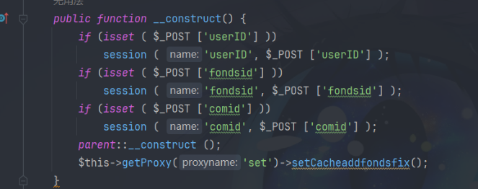
File reading:：
ClassFyController.class.php,
Get the path from the request, concatenate it with the path, and read the file to output the content
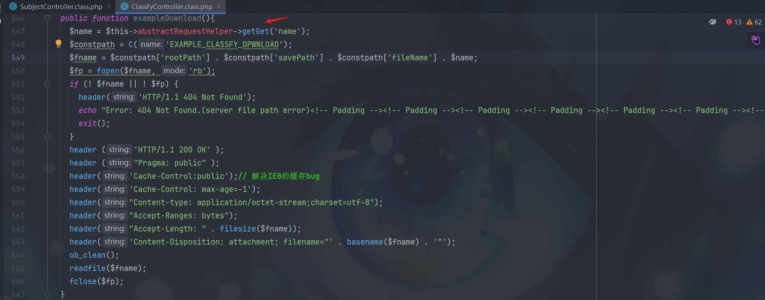

五、Vulnerability Reproduction
Assign Sessionid to the file reading poc：
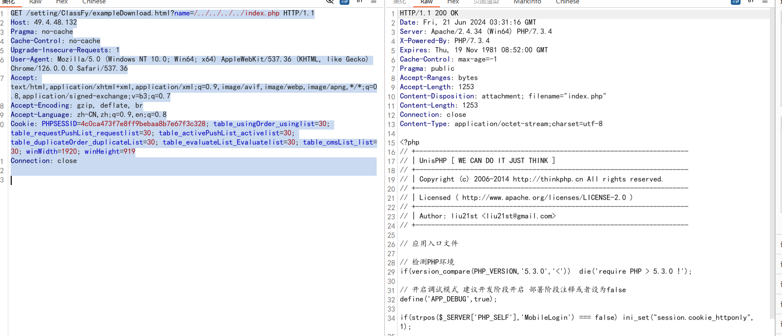
Write py script batch test：
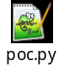
61.150.107.67:8099
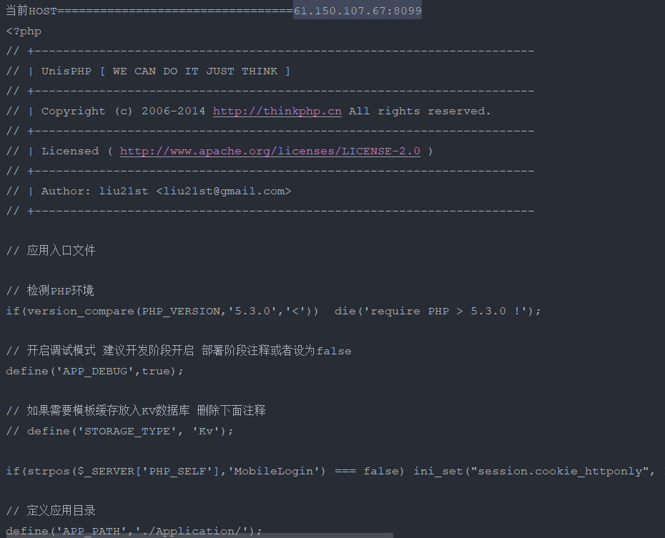
58.214.1.162:8121
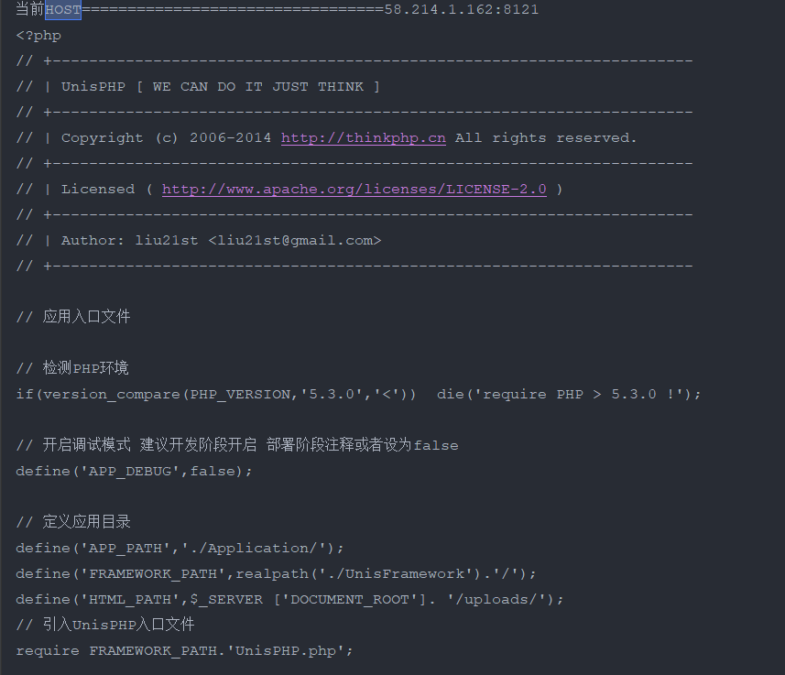
39.105.191.89:90
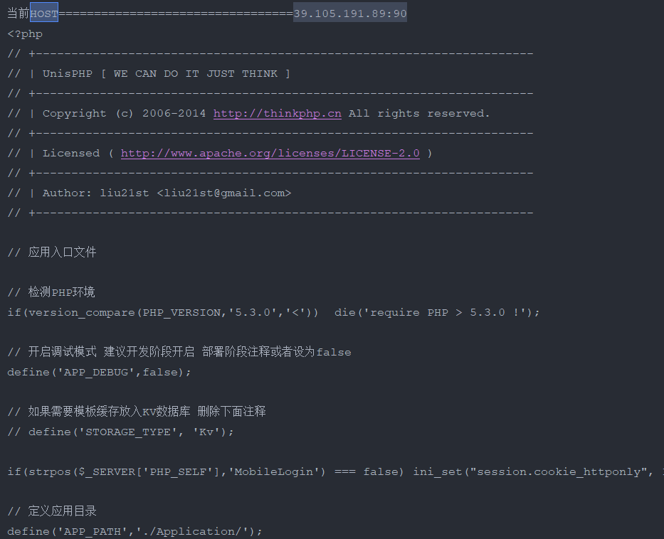
47.98.45.183
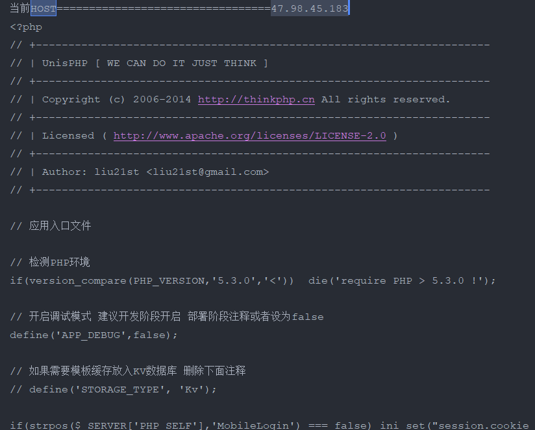
117.107.136.42:8081
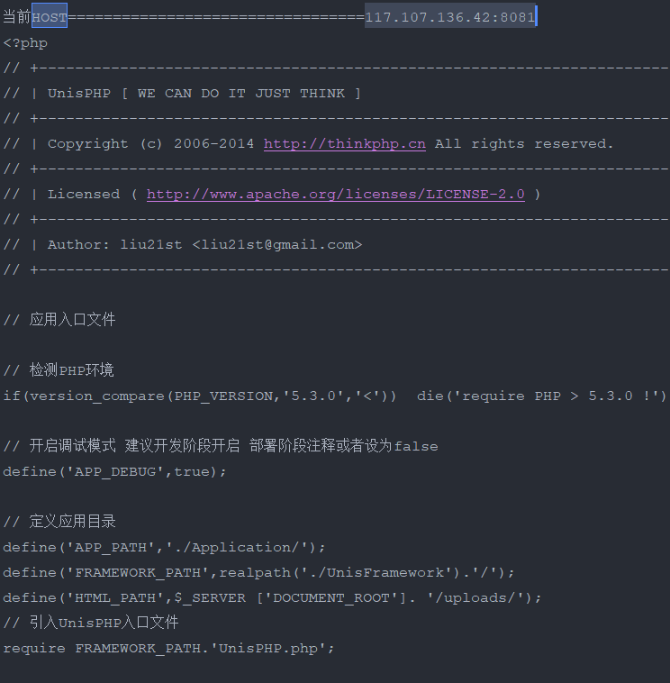
Test assets：
61.150.107.67:8099
58.214.1.162:8121
39.105.191.89:90
47.98.45.183
117.107.136.42:8081
45.119.63.167:3080
39.100.5.124:8099
1.117.64.33:8018
39.98.52.1:8001
114.255.93.226
103.10.85.70
114.255.93.226
121.15.212.174:81
121.8.124.109:9000
119.145.36.146:8081
103.10.85.70
124.232.143.6:9000
123.15.47.77:8001
47.108.20.92
153.0.148.124:8097
125.38.46.171:83
124.71.231.52:9090
123.57.205.67:7435
124.128.152.130:8066
124.221.70.74:8018
182.42.86.73:8082
111.203.173.195
125.38.46.173
175.178.90.225
211.154.138.22:2000
124.205.16.202:30080
120.133.73.75:60000
39.100.5.124
222.190.119.68:8089
39.153.246.117:7007
42.63.12.187
220.178.89.74:8084
219.159.132.142:9000
58.214.1.162:8121
47.105.138.204:81
47.108.20.92
43.138.140.91:8018
ams.jlmining.com:30080
39.100.5.124:8099
139.224.13.155:90
60.174.205.246:8097
archives-test.erp.dahuahome.com
36.7.113.162:8088
36.7.113.162:8088
111.229.202.145
ams.szmh.cn:81
ams.szwzjt.com:81
ams.zi-soft.cn
da.lnnydb.com
dorm.wuzioa.com:81
dormapi.wuzioa.com:81
dormmicro.wuzioa.com:81
dorm.szmhoa.com:81
dormapi.szmhoa.com:81
h5.szmhoa.com:81
am.weimingedu.com
dormmicro.szmhoa.com:81
h5.wuzioa.com:81
qiniuprivate.szmhoa.com:81
qiniupublic.szmhoa.com:81
sybzsy.com
da.csalc.cn
newuat.edoc.thunisdata.com
archives-test.erp.dahuahome.com
zhss.wuzioa.com:81
zhss.szmhoa.com:81

