## IT-130, A6, Fall 2020

## Part A (28 points)

Create a web page in which you have three text fields that ask the user for their first name, their favorite color, and their birth Month. Then have a button that says: “**Summarize**”: When the user clicks the button, you should output the summary of what they wrote as follows:

Hello, Lisa. Your favorite color is orange. You were born in March.

Obviously the name, color and month would be different based on what the user types.

You will obviously be using a lot of concatenation here. Also, Note that there is a comma after the word "Hello". There are also periods at the end of each sentence. These must show up in your page as well.

Output this string to a div section called **'output_string**'.

**TIP:** When creating the concatenated sections discussed above, do NOT try to do the entire statement at once. Create your output statement in very small in pieces and test each one. For example, first output "**Hello,**" and make sure it works. Then output their name and make sure that works, i.e. “**Hello, Lisa.**”. Then add “**Your favorite color is**”. And so on…

It's reeeeeaally easy for a bug to creep in to elaborate concatenated statements. So get in the habit of creating them in small pieces as shown here, and I promise you that it will make things go much easier. If you try to do too much at once, it can be a real pain!

On the same page, have an additional text field in which you ask the user to enter their age. This section should have *another* button that says: "**How old will I be in 2050?**". Then output to a div section (called '**age_2050**) their age that year.

Again, you must use concatenation when you output. For example, if the user entered 35, then their age in 2050 (30 years from now) will be 65. In this case, your output should show exactly the following:

You are currently 30. In 2050 you will be 60.

Have a line of <h1> text at the top of your page that says something like: “Age Calculator”.

In an *external* style sheet create a class called: format-main-heading. , You will be applying this class to your H1 tag. This class should change the foreground color to something other than black. Also change the background color. Change its width to something like 400 pixels (you can decide). Again, do all of this inside an external style sheet.

Apply the format-title class to your <h1> tag at the top of your page.

* As an HTML comment at the bottom of your page, indicate why it was necessary to use the parse function in the second problem of this page (the age in 2050).
* Demonstrate the use of a JavaScript comment somewhere inside your script.
* Have semantic tag sections for heading, and main.

Here is an example of that the page might look like:

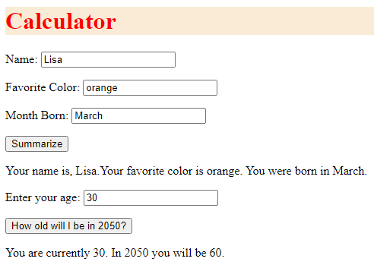

## Part B (12 points)

Upload the files (html document, and external CSS file) to the web server. Do NOT upload any zip files to the web server. Web servers don't know how to work with zip files. In this course, zip files are only for submitting assignments to D2L.

In the comments in the D2L submission page, provide a working URL to this file. For a review on how to come up with the appropriate URL, be sure to review the FTP lecture as well as the other resources (e.g. video and tip sheets) that I have made available to you on the Resources page.

*The grader must be able to paste your URL into their browser window and view your page.*

## Submission Guidelines

Upload all documents to the D2L Submissions folder (as well as to the web server as discussed in part B).