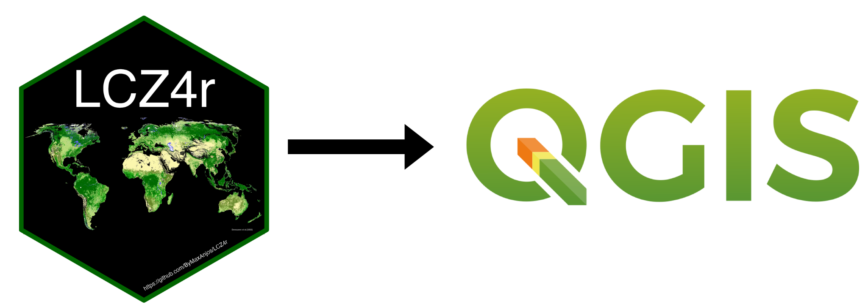

**TRANSLATION REPORT FORM**

Name:

Institution:

Contact email:

Date:

| **Select translation plugin process** |
| --- |
| Human |

You must translate where it is highlighted as green. Make sure no to use terms longer.

|  | Translate |
| --- | --- |

TRANSLATION: ENGLISH TO PORTUGUESE

From English:

##LCZ4r General functions=group

##Download LCZ map from global=display_name

##dont_load_any_packages

##pass_filenames

##QgsProcessingParameterString|City|Enter the city name |None|optional|true

##QgsProcessingParameterFeatureSource|ROI|ROI|2|None|true

##QgsProcessingParameterRasterDestination|Output|Result

To Portuguese:

##LCZ4r Funções Gerais=group

##Baixar map LCZ a partir map global=display_name

##dont_load_any_packages

##pass_filenames

##QgsProcessingParameterString|City|Escreva o nome da cidade |None|optional|true

##QgsProcessingParameterFeatureSource|ROI|Importe shp região de interesse|2|None|true

##QgsProcessingParameterRasterDestination|Output|Salve o resultado

Comments

| Text. |
| --- |