|  |
| --- |
| UTBM - Autumn 2024 semester |
| IF3E Project Report |
| Board Game Tournament Management |

|  |
| --- |
| Mathis Richard  28/10/2024 |

Table of contents

1. The goal 2

1.1. The objective 2

1.2. The scope of the project 2

2. How it is done 2

2.1. La réflexion 2

2.2. Création du diagramme entité-association 2

2.3. Création de la base de données 3

2.4. Design du site web 4

3. Conclusion 5

# The goal

## The objective

The objective of this project is to design and develop a relational database system to manage board game tournaments. This system will allow organizers to register players, schedule matches, track results, and manage scores for various board games such as chess, Settlers of Catan, Ticket to Ride, or any other popular tabletop game. The system will also support team-based games, track individual or team performance, and generate rankings.

## The scope of the project

The system will manage different types of board games, player registrations, tournament schedules, match results, and final rankings. It will support both single-player and team-based tournaments. Users can use this system to create tournaments, register participants, and follow the progress through different rounds of play.

# How it is done

## The thinking part

The first step was to analyze the subject in depth, and to understand and imagine the first ideas for the construction of the project. Some points were rather obscure, but were quickly clarified with the help of the teacher. I then created the database in the form of an entity-association diagram. This stage was rather crucial, as it determined the rest of the project, i.e. the actual creation of the database, then the queries that would be useful for the website's operation.

## Création du diagramme entité-association

After several attempts, modifications, additions and deletions, I finally came up with a diagram that spoke to me, and that seems correct for the rest of the project. Here's a picture of the diagram :

As you can see, this diagram contains many relationships 1..1, 1..N, or N..N. It's important to know that each user can become an “organizer” (i.e. create games, tournaments, matches, etc.), by having the “is_organizer” data set to 1. This will give him/her access to more features on the website.

## Création de la base de données

The next logical step after creating the diagram was to put the database into practice. The database was created using PhpMyAdmin. The .sql database file is attached to the project folder. The creation of the database also enabled us to perfect the previous diagram. Here's an image of the database's relational schema:

## Design du site web

The next logical step was to start creating the website. First, I created the user registration and login interface. But I found the interface rather sad. So I decided to start from scratch, taking the database given to me by my teacher and adapting it to my needs. This basis was used to create a graphic charter for the rest of the website.

After that, I created the “team-based” part, i.e. team creation, the fact of being able to join a team, then the creation of games and tournaments, and finally the last stage: the creation of matches and rankings.

Once players have registered, they can access their account page, where a multitude of actions are possible, such as viewing current tournaments, or managing their teams. If the player is also an “organizer”, he or she has access to two further buttons enabling him or her to manage games and tournaments, by creating, adding or modifying matches.

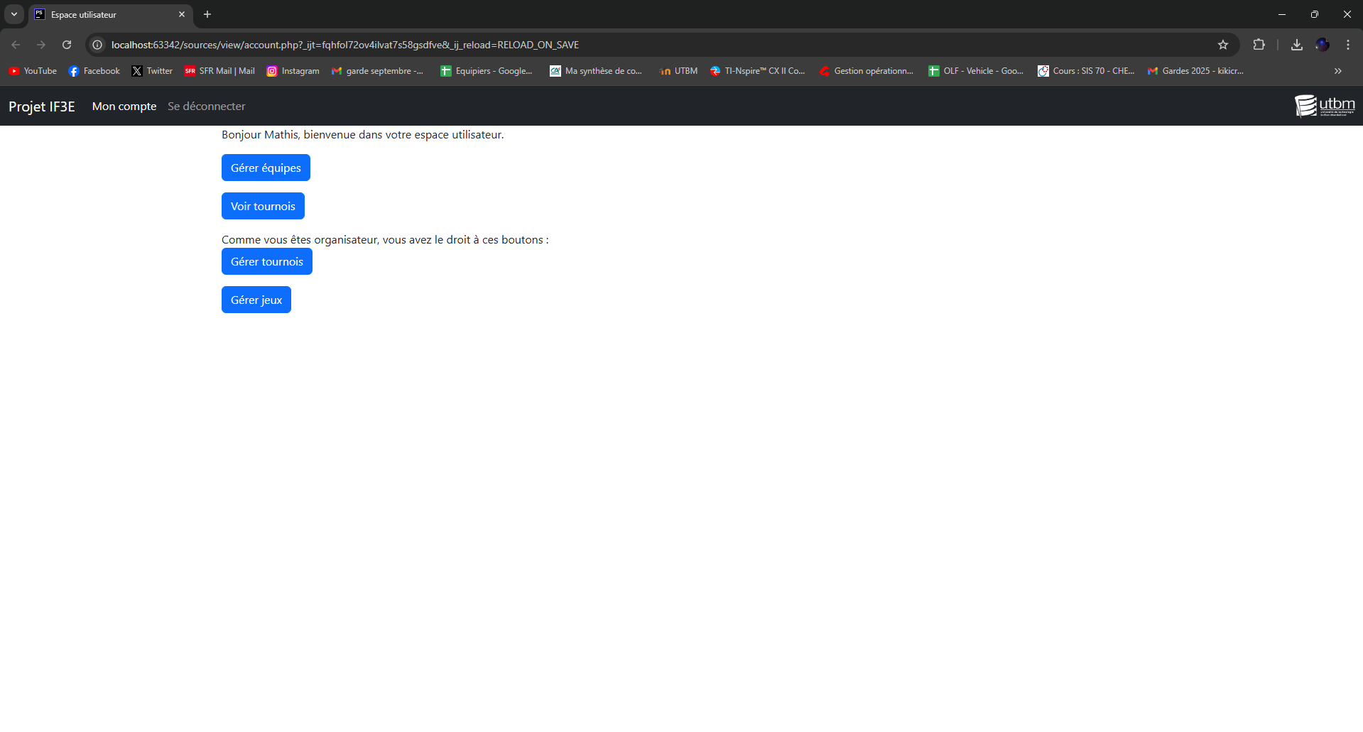 As the website developed, I was able to improve certain pages or perfect database queries. One of the queries that took me the longest was the one that calculated the ranking of a player or team in a tournament according to the number of matches won, lost or drawn.

# Conclusion