# Mehmet Enes BİTİK 22050151003

# Gürkan AĞIR 20050111073

# Mahmut Esat ÖZHÖLÇEK 20050111068

## 1-Inheritance



## 2-Exception Handling

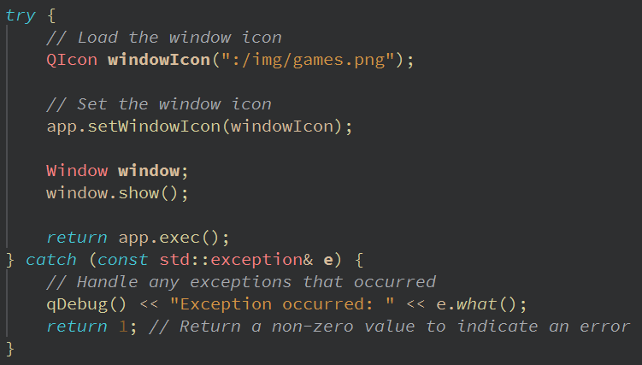

## 3-Default Parameter



## 4-Constructor

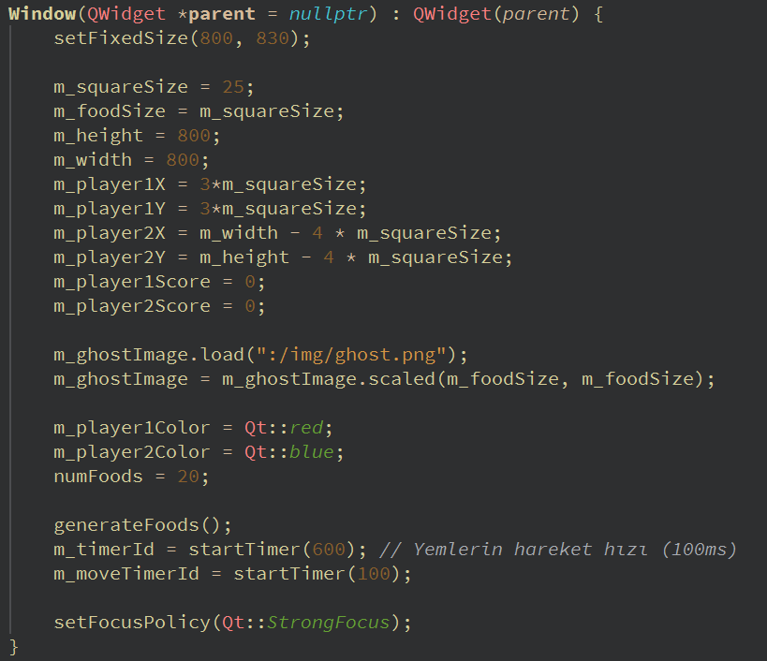

## 5-Vectors



## 6-Explicit Heap Dynamic Variable



**Photos**

