Programmer documentation

GalleryGlobe

Taras Byalyk

Table of Contents
1 Programmer documentation 3
1.1 Source code file structure 3
1.2 Code documentation 4
1.3 Project creation documentation 9
1.3.1 What I do 9

Programmer documentation

Source code file structure

1. Directory: "src"

1.1 File: "app/layout.tsx"
Main layout component with authentication and UI providers

1.2. Directory: "app/(protected)"
Protected routes requiring authentication
- collections/: User art collections management
- favorites/: User favorite artworks
- history/: Viewing history
- profile/: User profile management

1.3. Directory: "app/(public)"
Public routes accessible without authentication
- about/: About page
- artworks/: Artwork browsing and details
- artists/: Artist browsing and details

1.4. Directory: "components"
Reusable UI components
- auth/: Authentication components
- collections/: Collection management components
- common/: Shared components
- form/: Form components
- ui/: Base UI components

1.5 Directory: "server"
Server-side code
- actions/: Server actions for data operations
- db/: Database configuration and queries

2. Directory: "lib"
Utility functions and type definitions

Code documentation
1. Application Entry and Authentication Flow:

```typescript
// src/auth.ts - Main authentication configuration
// This file configures NextAuth with custom authentication settings

// src/middleware.ts - Request middleware
// Handles authentication state and route protection
```

The application starts with authentication setup and middleware that protects routes. Routes are divided into public, protected, and authentication routes.

2. Core Database Structure:

```typescript
// src/server/db/schema.ts
// Defines the database schema using Drizzle ORM
```

The schema defines core entities:
- Users and authentication tables
- Artists and Artworks
- Collections and user interactions
- History and preferences

3. Server Actions Layer:

```typescript
// src/server/actions/
// Contains server-side actions for data operations
```

Key server actions:
- fetch-artworks.ts: Handles artwork retrieval
- collections.ts: Manages user collections
- favorites.ts: Handles favoriting functionality
- history.ts: Tracks viewing history
- search.ts: Implements search functionality

4. Protected Routes Implementation:

```typescript
// src/app/(protected)/
// Protected routes requiring authentication
```

Protected sections include:
- Collections management
- Favorites
- Viewing history
- User profile

5. Public Routes:

```typescript
// src/app/(public)/
// Publicly accessible routes
```

Public areas include:
- Artwork browsing
- Artist galleries
- Public collections

6. Component Structure:

```typescript
// src/components/
// Reusable UI components
```

Components are organized into:
- Authentication components
- Collection management
- Common UI elements
- Form components

7. User Interface Utilities:

```typescript
// src/components/ui/
// Shadcn UI components
```

The UI layer uses Shadcn UI for consistent styling and interactions.

For a detailed operation example, let's look at the collections feature:

```typescript
// src/app/(protected)/collections/[id]/page.tsx

export default function CollectionPage({ params }: CollectionPageProps) {
// Collection state management
const [collection, setCollection] = useState<CollectionState | null>(null);

// Load collection data
const loadCollection = useCallback(async () => {
// Fetch collection details
const response = await getCollection(session.user.id, collectionId);
setCollection(response.data);
}, [session?.user?.id, params.id, router, status]);

// Render collection view with artwork grid
return (
<div className="container">
{/* Collection details and artwork grid */}
</div>
);
}
```

Project creation documentation

What I do
For this process, I will use Visual Studio Code.  Open the File Explorer by pressing Win button, writing in app search “File Explorer” and pressing “Enter”, double-tapping on File Explorer shortcut on the Desktop, or pressing Win+1. | 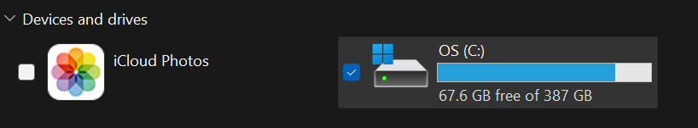
Once the File Manager is opened, you should double-tap at the disk of your choice. There is no required place for the project to be located at. In my case, I will go to Disk C.
Here, you should create a new directory. On the left-top corner of File Manager, press “New”, then press “Folder”. Name it test_1. | 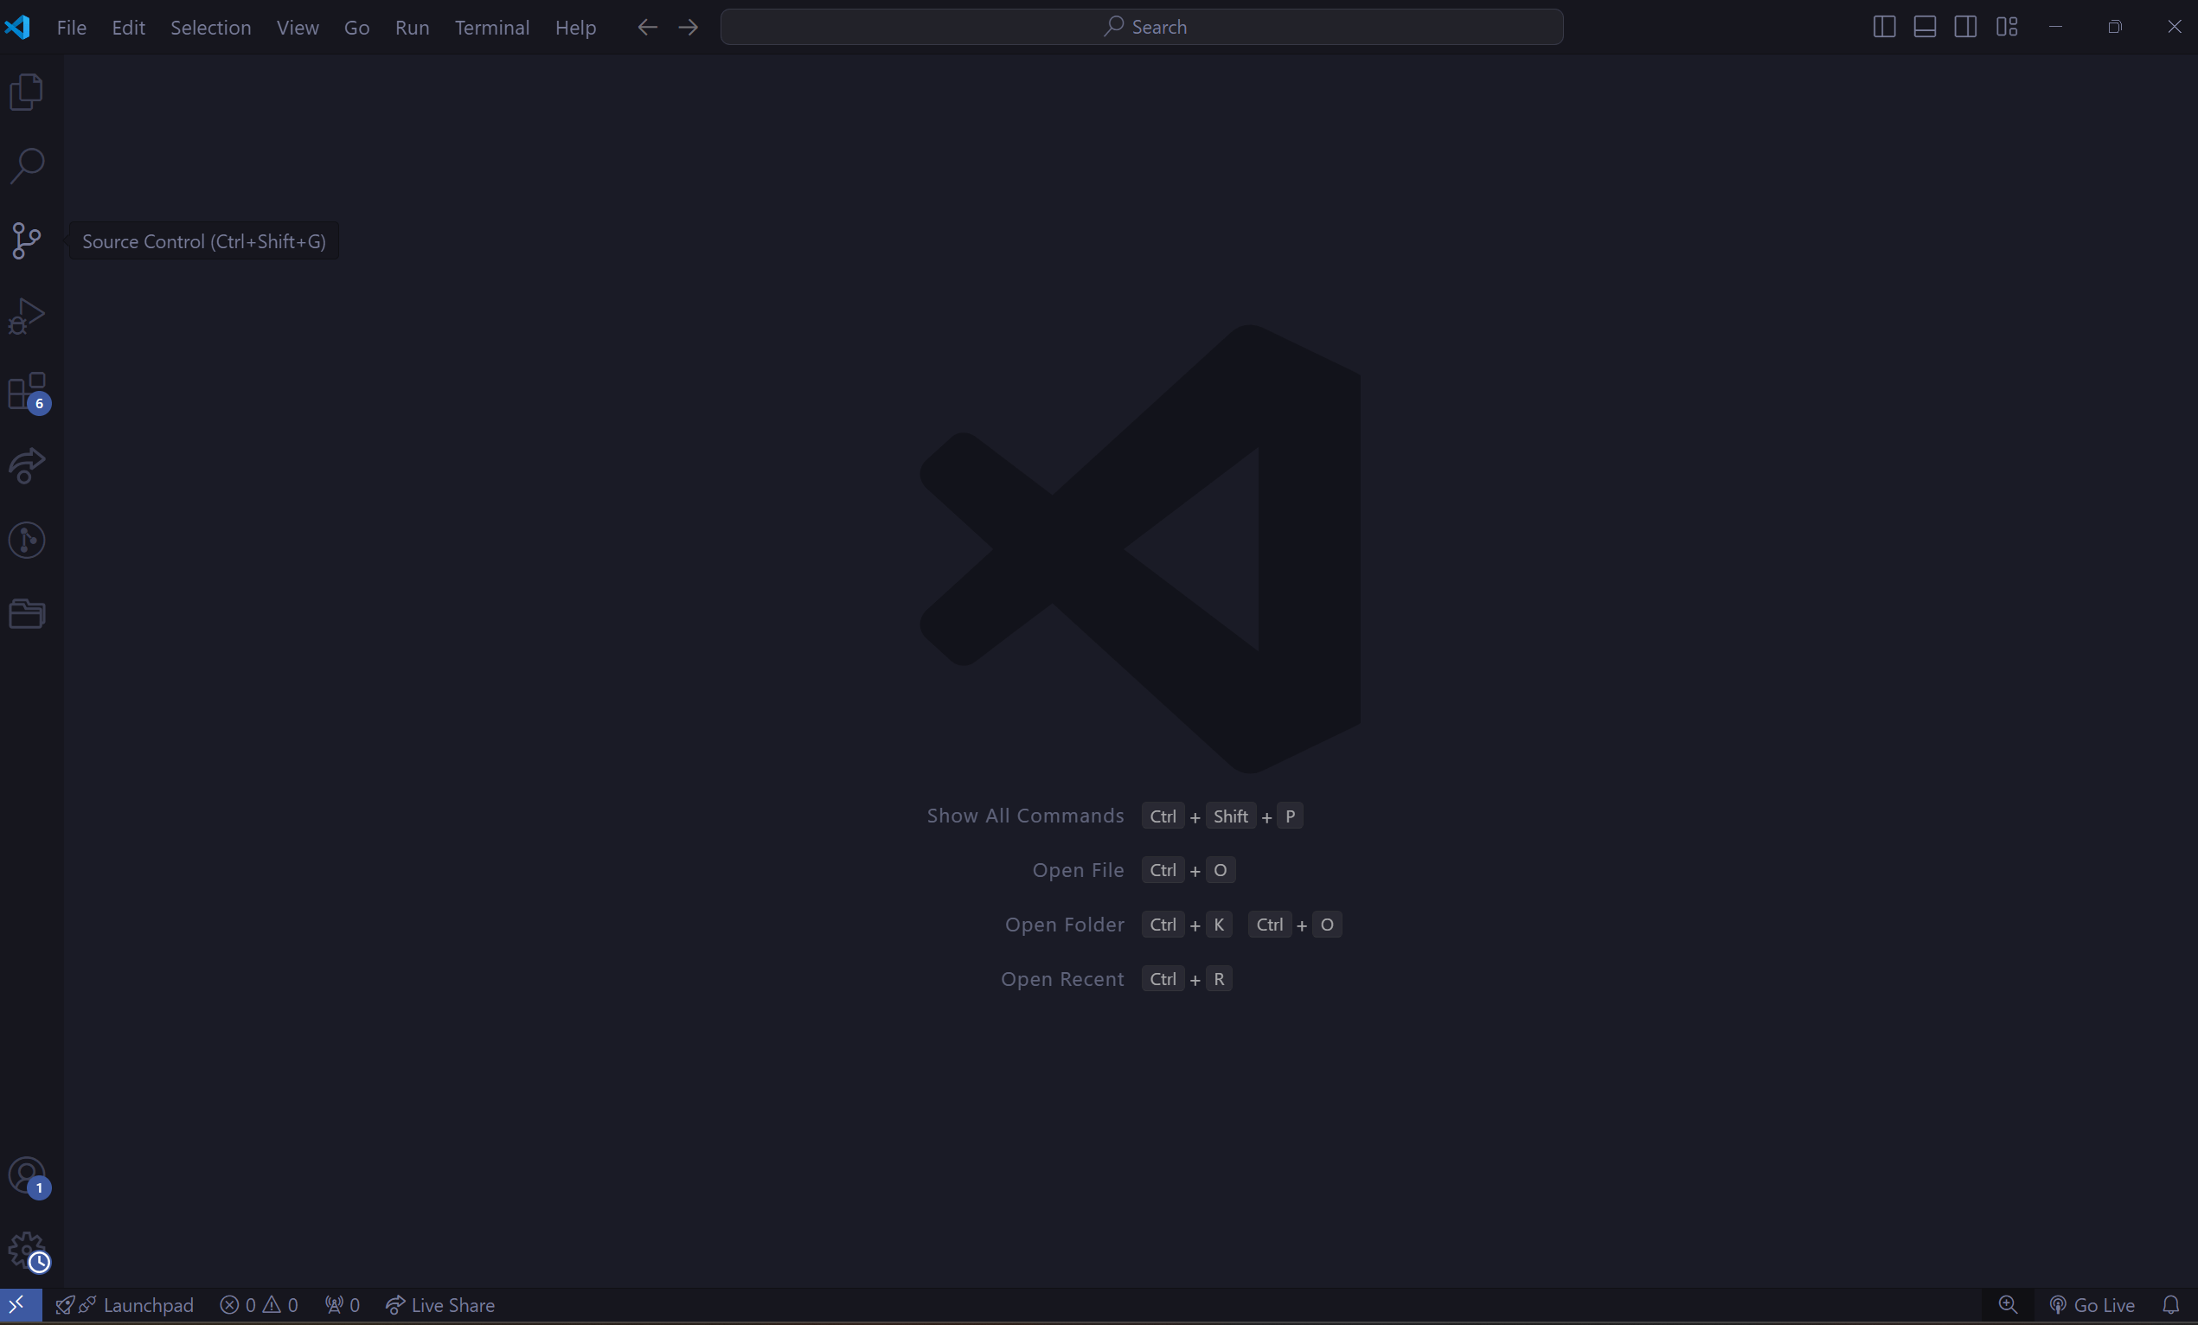
Then, open the IDE or code editor of your choice. In my case, I will use Visual Studio Code. Open the Visual Studio Code by pressing Win button, writing in app search “Visual Studio Code” and pressing “Enter”, or double-tapping on Visual Studio Code shortcut on the Desktop.
Once the Visual Studio Code is opened, on the top-left edge of the screen press “File”, then “Open Folder”, or press Ctrl+K, Ctrl+O. In the new “Open Folder” page, and pick the folder “test_1” | 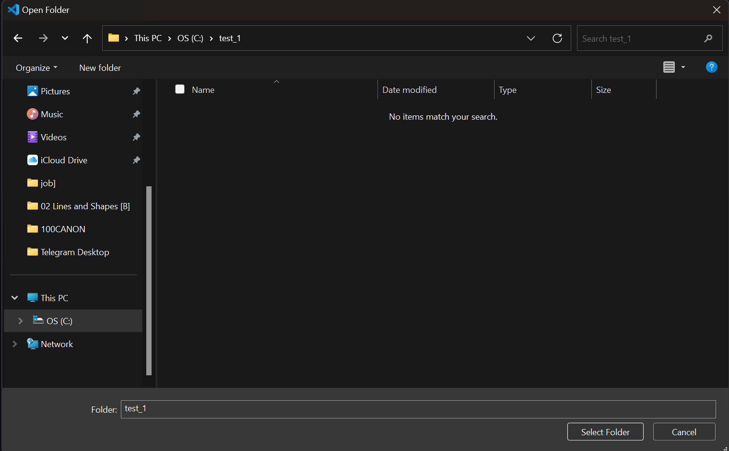
Open your browser and go to the official Node.js website https://nodejs.org/en | 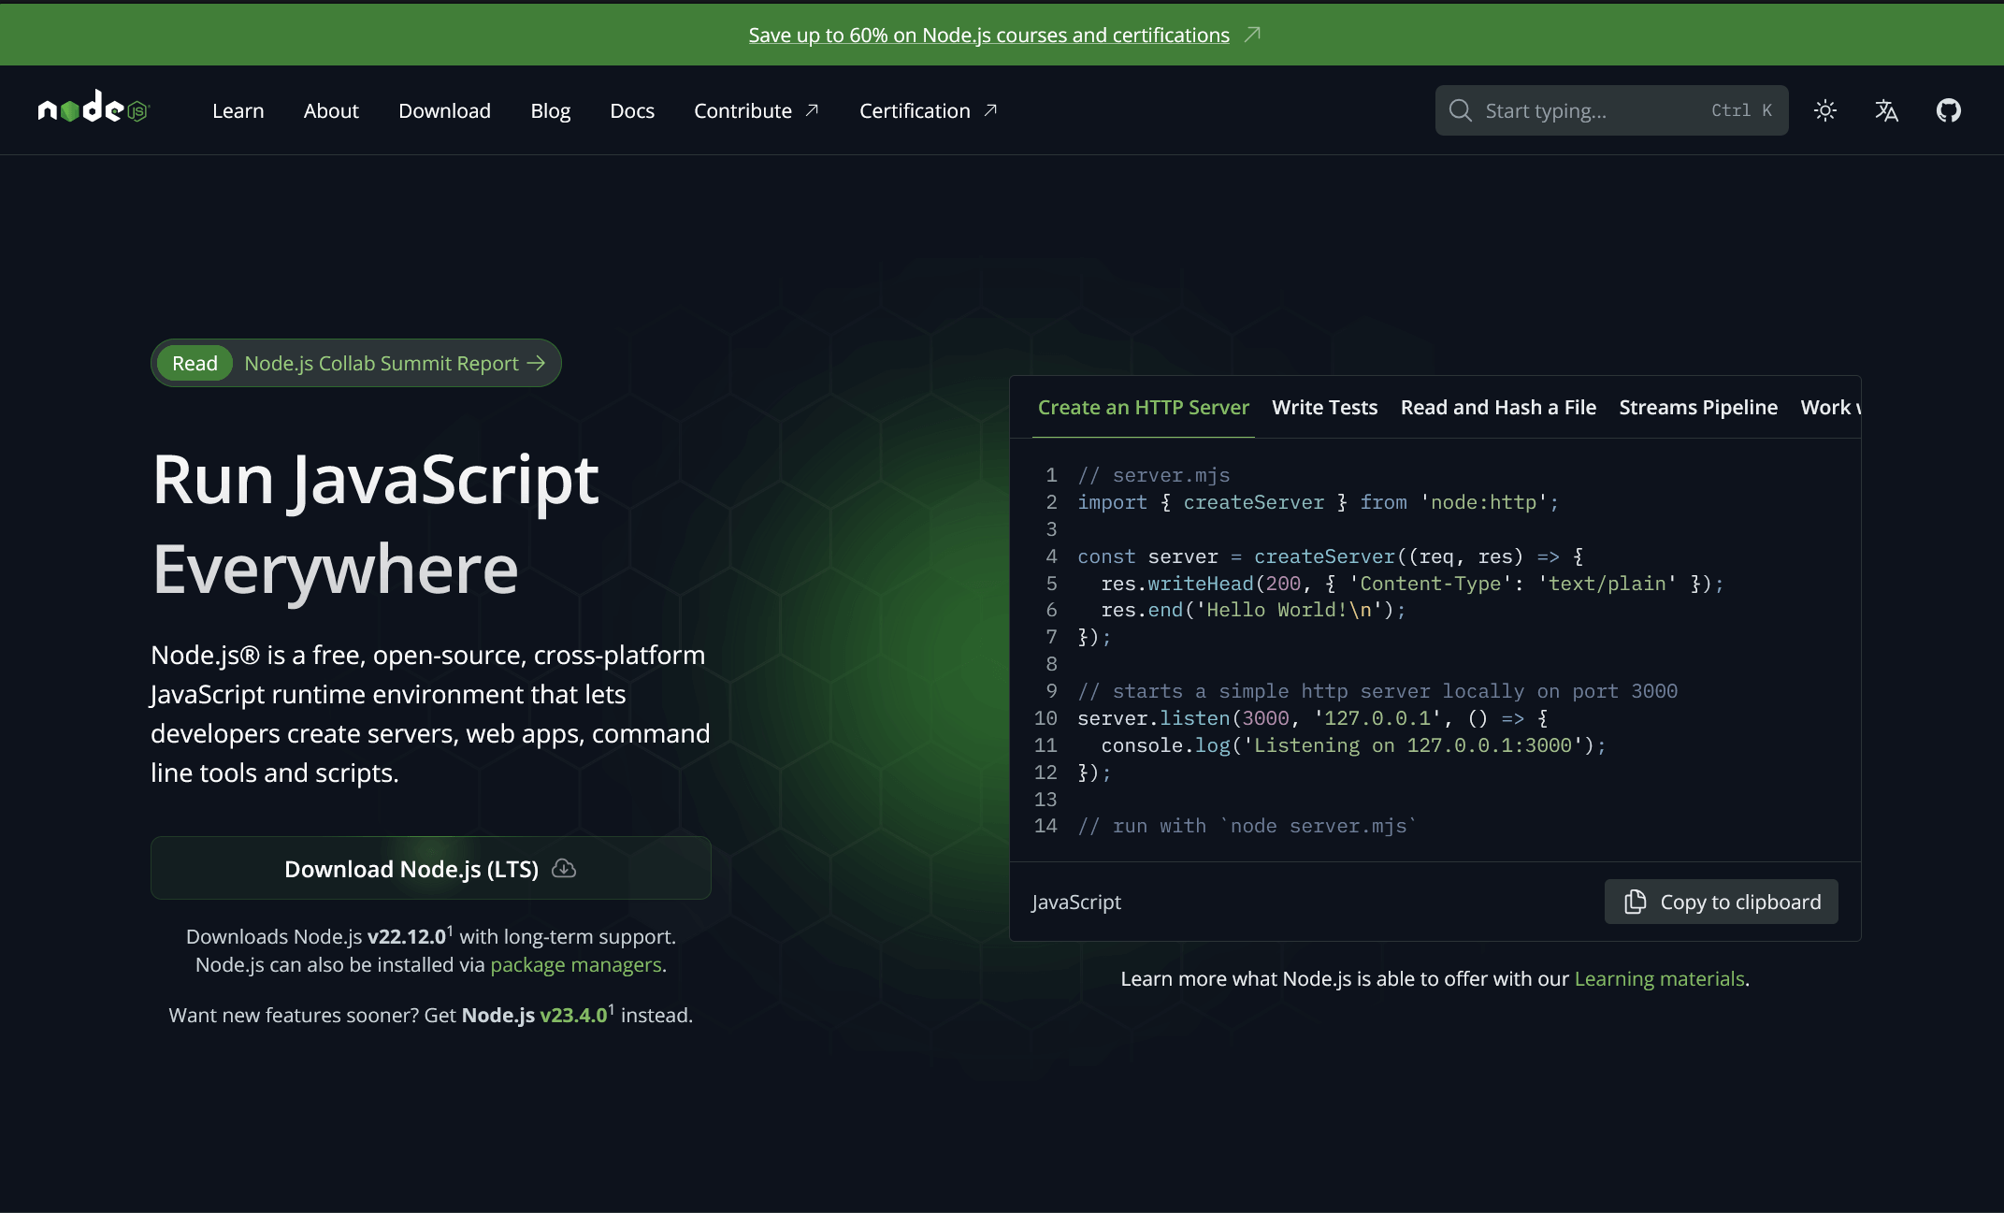
Press the button “Download Node.js (LTS)”. A file will be downloaded to your PC. In my case, it is called “node-v22.12.0-x64.msi” | 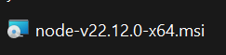
Run the installer. In there accept the license agreement, keep everything on default values. After that, Node.js and npm will be installed on your PC | 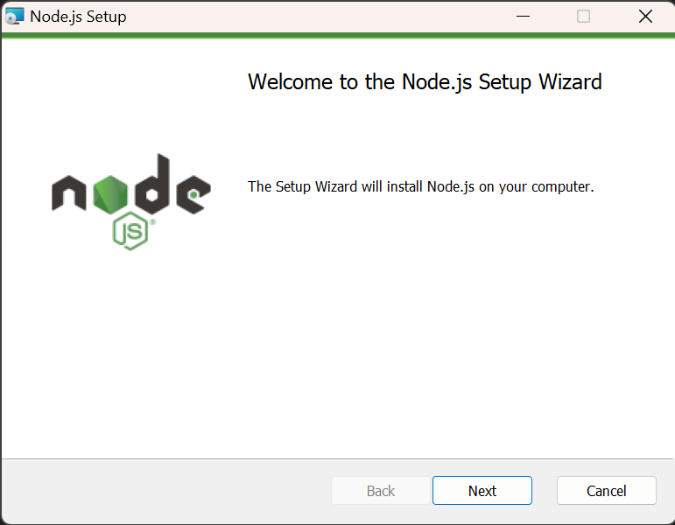
Go back to Visual Studio Code. Here, open terminal with Ctrl+Shift+`. In it, write “node -v” and “npm -v” to check if Node.js and npm were installed correctly | 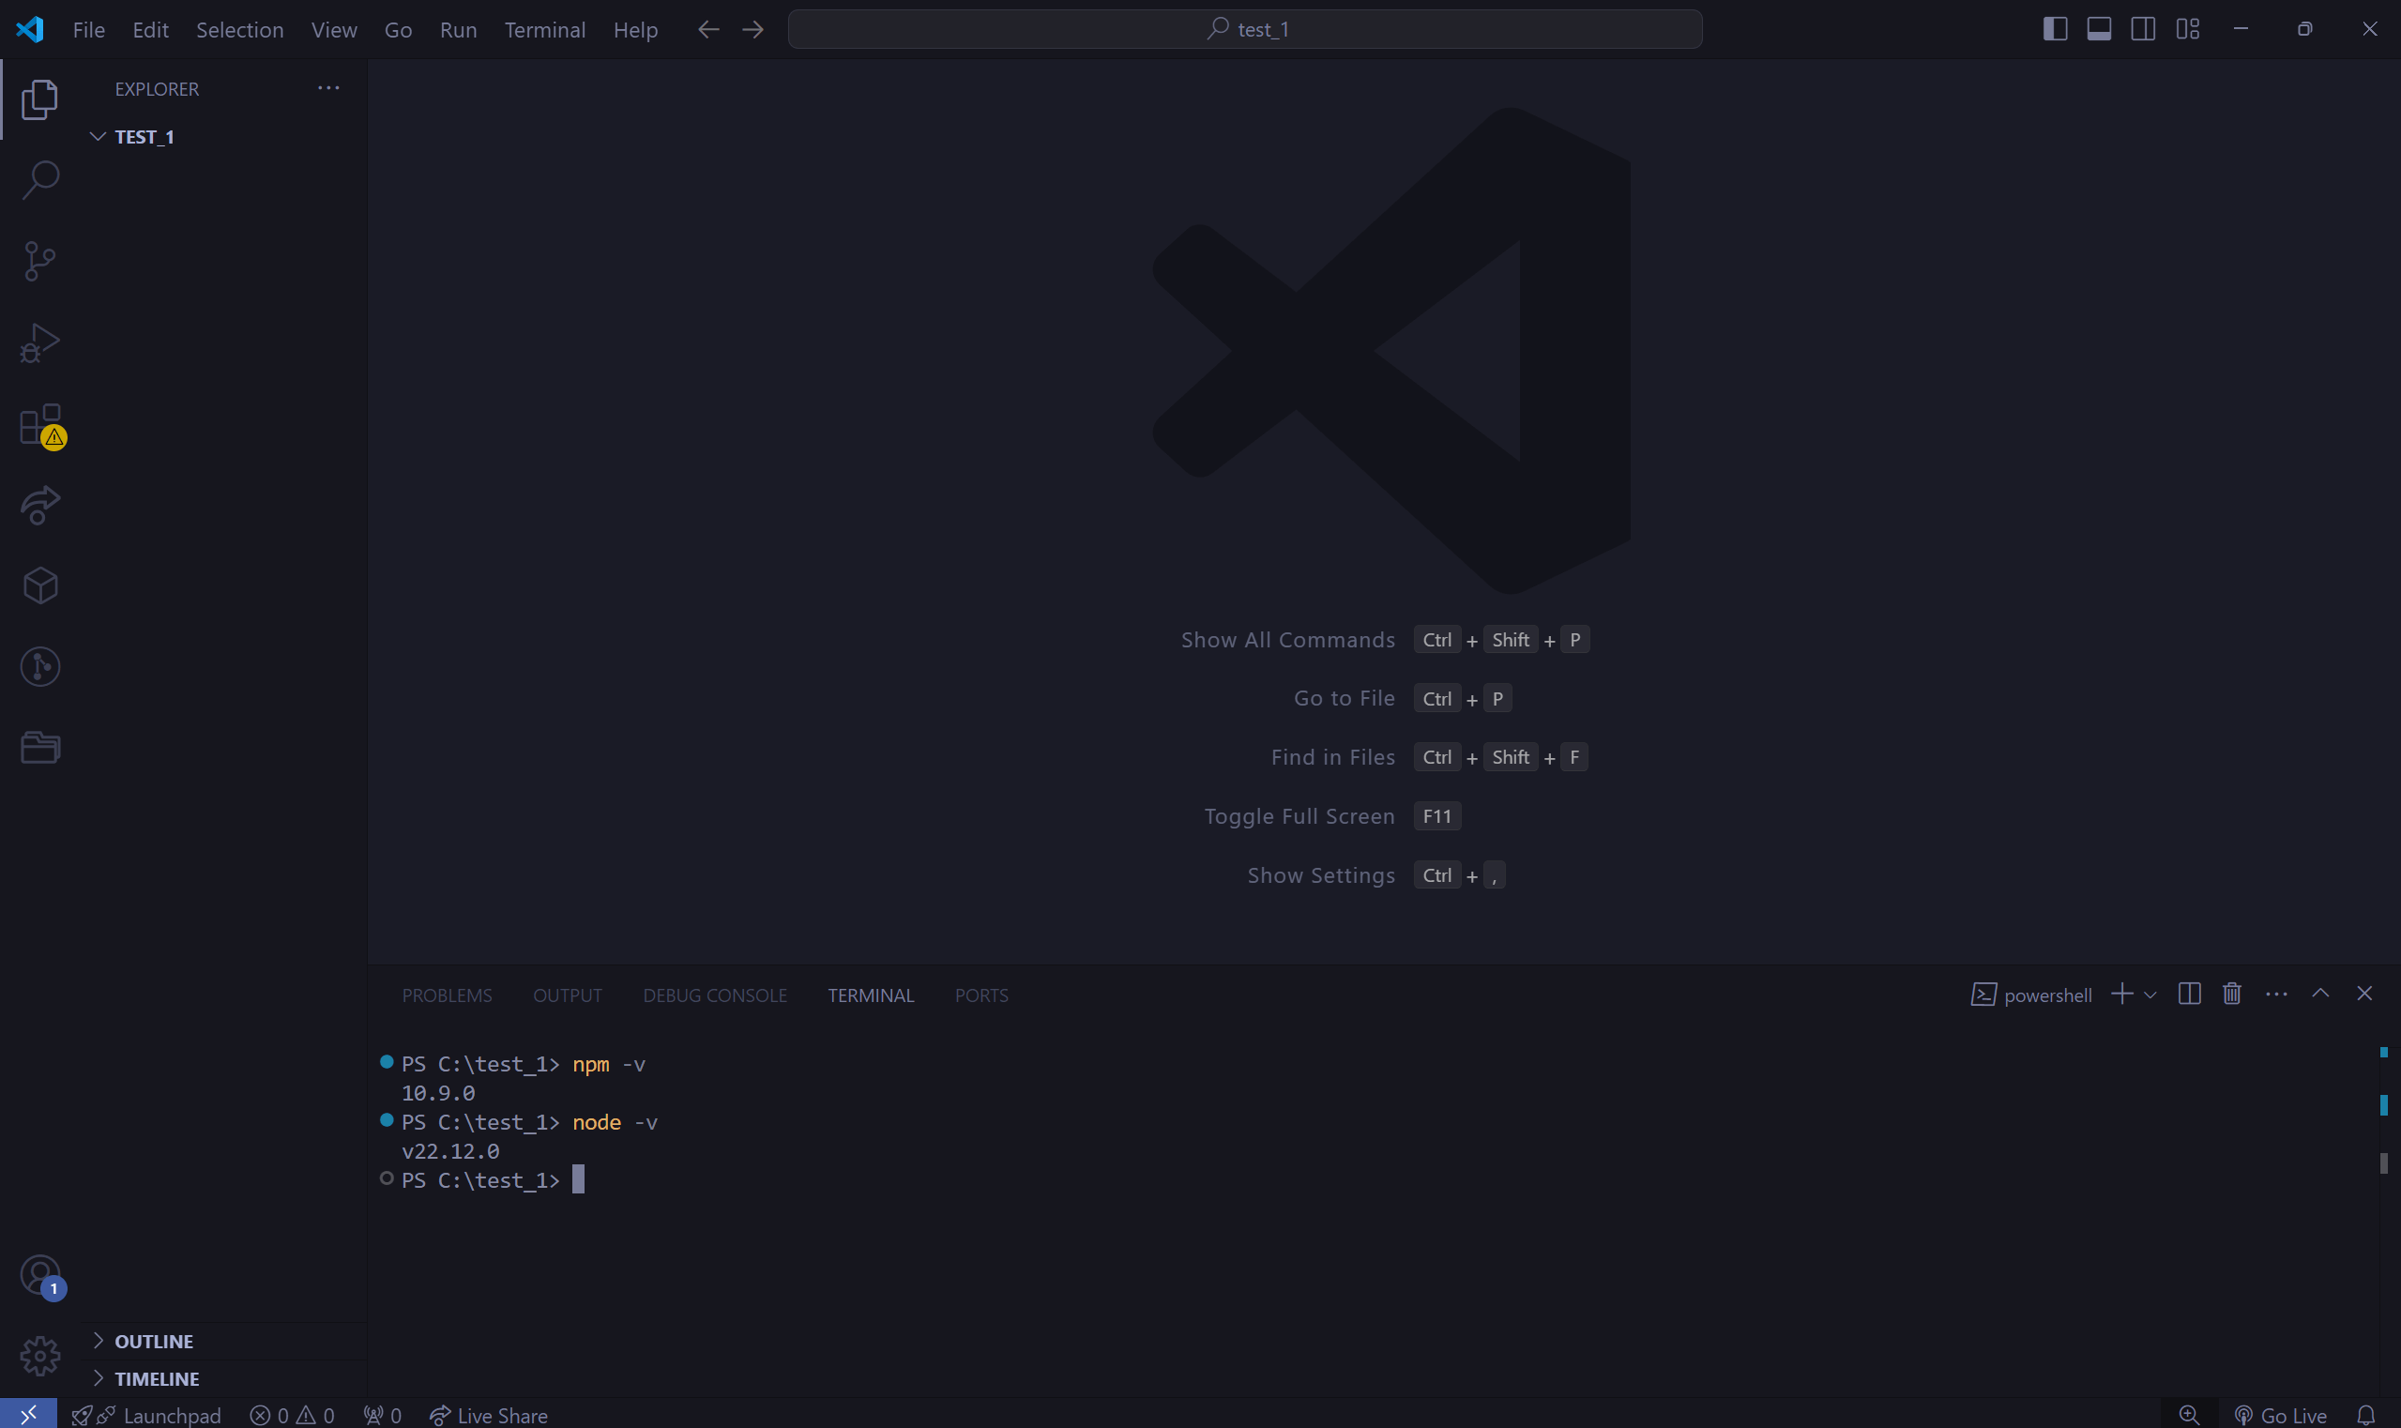
After that, run the following command to create a new Next.js app:  “npx create-next-app@latest”  You’ll be prompted to:  - Name your project: Provide a name, I will use test_1  - Choose a TypeScript setup: Select Yes if you want to use TypeScript.  - Set up ESLint: Select No.  - Use Tailwind CSS: Select No.  - Set up code inside a `src/` directory: Yes.  - Use App Route?: Yes  - Use Turbopack for `next dev`: No.  - customize the import alias: No.  - Once done, the setup will install the required dependencies. | 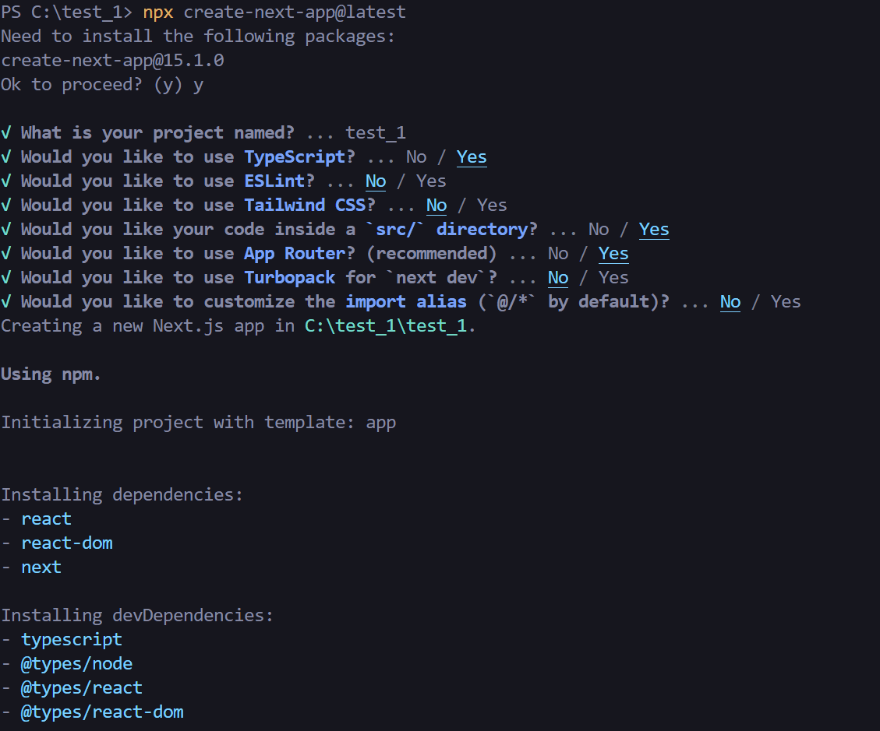
After that, write in the same terminal “cd .\test_1”, and then “npm run dev”. Your new local project should be ran on | 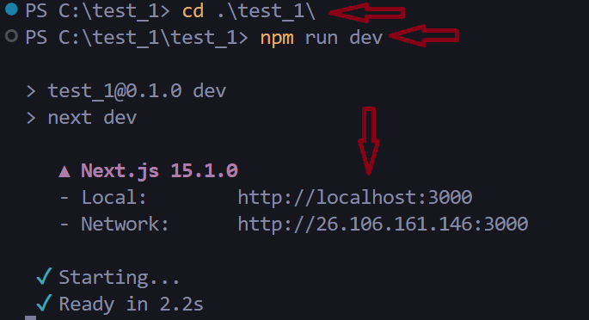
Now, you have a running Next.js project on your pc. To access it, Ctrl+Click on the local http in you cmd. In my case, it is “http://localhost:3000” After that, you will see the browser opens and shows you your starting page | 