**Introduction**

This guide walks you through the development of our project from inception to current stage.

**Architecture**

* First, we created the database design. This gave us a solid and strong understanding of how we wanted our project to operate. Next we created the business domain and data access layers. In doing this, we used Hibernate framework for data access layer and Spring framework for business domain layer. Our database management system is MySQL.
* We have 13 common objects that are as follows:
  + **Login:** Stores login information of both customer and partnerLogin
  + **Customer:** Stores customer’s detail information
  + **CustomerAddress:** Stores addresses of customer and a customer can have multiple addresses
  + **CreditCard:** Stores credit card information of customer and a customer can have multiple credit cards
  + **Partner:** Stores partner of seller detailed information
  + **Product:** Stores detailed information of products
  + **ProductCategory:** Stores categories or tags of products
  + **Order:** Stores customer’s order information
  + **OrderProduct:** Stores detailed information of products in a specific order.
  + **OrderStatus:** Stores order’s status information
  + **Cart:** Stores customer’s cart information.
  + **CartItem:** Stores items in customer’s cart.
  + **Review:** Stores customer’s review for products.

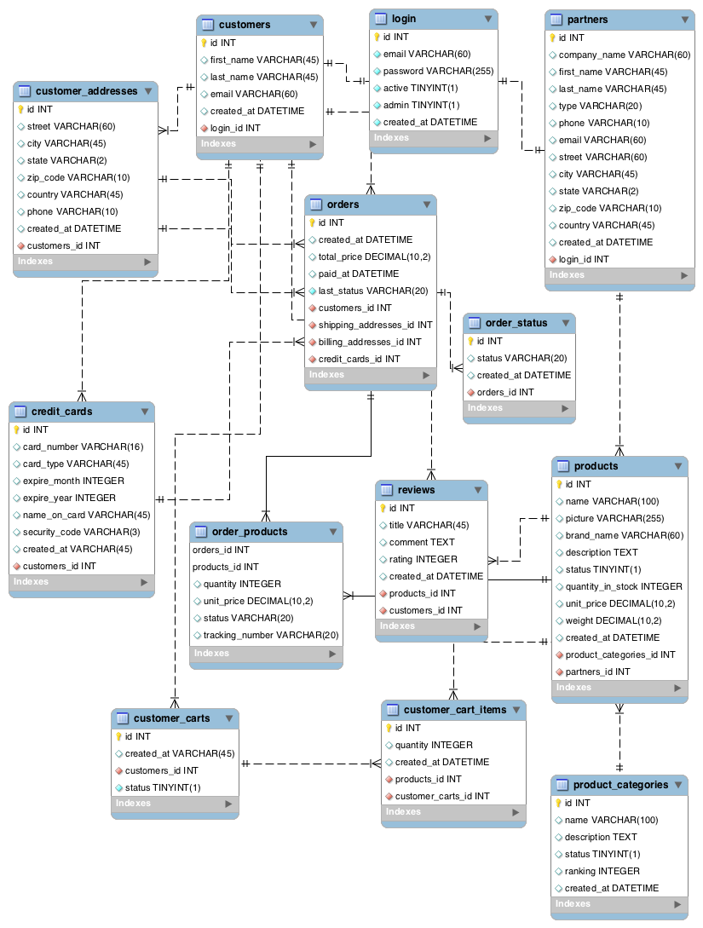

* You can access our project through the following github URL:
  + [https://github.com/Byambatsog/Comp344WS.gi](https://github.com/Byambatsog/Comp344WS.git)t
* You can find the database creation scripts in following file:
  + /src/main/resources/database.sql
* Database configuration is in the following file (need to change username and password for mysql):

/src/main/webapp/WEB-INF/classes/application.properties

* Hibernate configuration is in the following file:

/src/main/webapp/WEB-INF/classes/hibernate.properties

* Domain (Model) classes are located in:
  + com.comp344.ecommerce.domain
* Data access layer classes are located in:
  + com.comp344.ecommerce.domain
* Business layer classes are located in:
  + Com.comp344.ecommerce.business

**CustomerManager** handles detailed information of customer, addresses and credit cards.

**LoginManager** handles user profiles and authentication information.

**PartnerManager** handles detailed information.

**ProductManager** handles detailed information of product and product category information

**OrderManager** handles detailed information of order, products of order, order status, and order payment.

**ReviewManager** handles detailed information of customer review.

**CartManager** handles cart information of customers.

**Service URIs**

1. **URI:** /customerservice/customer

**Resource Class:** CustomerResource

**Http method:** GET

**Description:** Retrieve list of customers

**Parameters:**

* q = search terms
* orderBy = ordering column and direction
* page = page number
* pageSize = size of the page

1. **URI:** /customerservice/customer/{id}

**Resource Class:** CustomerResource

**Http method:** GET

**Description:** Retrieve detailed information of a customer.

1. **URI:** /customerservice/customer

**Resource Class:** CustomerResource

**Http method:** POST

**Description:** Create a new customer (consumes and produces application/json)

**Parameters:**

{

"email": "text",

"password": "text",

"firstName": "text",

"lastName": "text"

}

1. **URI:** /customerservice/customer/{id}

**Resource Class:** CustomerResource

**Http method:** PUT

**Description:** Update the specified customer (consumes application/json)

**Parameters:**

{

"email": "text",

"firstName": "text",

"lastName": "text"

}

1. **URI:** /customerservice/customer/{id}

**Resource Class:** CustomerResource

**Http method:** DELETE

**Description:** Delete the specified customer

1. **URI:** /customerservice/customer/{id}/creditcard

**Resource Class:** CustomerResource

**Http method:** GET

**Description:** Retrieve all credit cards of the customer.

1. **URI:** /customerservice/customer/{id}/creditcard/{cardId}

**Resource Class:** CustomerResource

**Http method:** GET

**Description:** Retrieve the specified credit card of the customer.

1. **URI:** /customerservice/customer/{id}/creditcard

**Resource Class:** CustomerResource

**Http method:** POST

**Description:** Add a credit card (consumes and produces application/json)

**Parameters:**

{

"cardNumber": "text",

"cardType": "text",

"expireMonth": "integer",

"expireYear": "integer",

"nameOnCard": "text",

"securityCode": "text"

}

1. **URI:** /customerservice/customer/{id}/creditcard/{cardId}

**Resource Class:** CustomerResource

**Http method:** PUT

**Description:** Update a specified credit card of the customer (consumes application/json)

**Parameters:**

{

"cardNumber": "text",

"cardType": "text",

"expireMonth": "integer",

"expireYear": "integer",

"nameOnCard": "text",

"securityCode": "text"

}

1. **URI:** /customerservice/customer/{id}/creditcard/{cardId}

**Resource Class:** CustomerResource

**Http method:** DELETE

**Description:** Delete the specified credit card of the customer.

1. **URI:** /customerservice/customer/{id}/address

**Resource Class:** CustomerResource

**Http method:** GET

**Description:** Retrieve all addresses of the customer.

1. **URI:** /customerservice/customer/{id}/address/{addressId}

**Resource Class:** CustomerResource

**Http method:** GET

**Description:** Retrieve the specified address of the customer.

1. **URI:** /customerservice/customer/{id}/address

**Resource Class:** CustomerResource

**Http method:** POST

**Description:** Add a address. (consumes and produces application/json)

**Parameters:**

{

"street": "text",

"city": "text",

"state": "text",

"zipCode": "text",

"country": "text",

"phone": "text"

}

1. **URI:** /customerservice/customer/{id}/address/{addressId}

**Resource Class:** CustomerResource

**Http method:** PUT

**Description:** Update a specified address of the customer (consumes application/json)

**Parameters:**

{

"street": "text",

"city": "text",

"state": "text",

"zipCode": "text",

"country": "text",

"phone": "text"

}

1. **URI:** /customerservice/customer/{id}/address/{addressId}

**Resource Class:** CustomerResource

**Http method:** DELETE

**Description:** Delete the specified address of the customer.

1. **URI:** /customerservice/customer/{id}/cartitem

**Resource Class:** CartItemResource

**Http method:** GET

**Description:** Retrieve all items in the customer’s cart.

1. **URI:** /customerservice/customer/{id}/cartitem/{cartItemId}

**Resource Class:** CartItemResource

**Http method:** GET

**Description:** Retrieve the specified item in the customer’s cart.

1. **URI:** /customerservice/customer/{id}/cartitem

**Resource Class:** CartItemResource

**Http method:** POST

**Description:** Add a item into the customer’s cart. (consumes and produces application/json)

**Parameters:**

{

"productId": "integer",

"quantity": "integer"

}

1. **URI:** /customerservice/customer/{id}/cartitem/{cartItemId}

**Resource Class:** CartItemResource

**Http method:** PUT

**Description:** Update the specified item in the customer’s cart (consumes application/json)

**Parameters:**

{

"productId": "integer",

"quantity": "integer"

}

1. **URI:** /customerservice/customer/{id}/cartitem/{cartItemId}

**Resource Class:** CartItemResource

**Http method:** DELETE

**Description:** Delete the specified item in the customer’s cart.

1. **URI:** /customerservice/customer/{id}/order

**Resource Class:** CustomerResource

**Http method:** GET

**Description:** Retrieve all orders of the customer.

1. **URI:** /customerservice/customer/{id}/order/{orderId}

**Resource Class:** CustomerResource

**Http method:** DELETE

**Description:** Cancel a specified order of the customer.

1. **URI:** /partnerservice/partner

**Resource Class:** PartnerResource

**Http method:** GET

**Description:** Retrieve list of partners

**Parameters:**

* q = search terms
* type = type of partner (‘COMPANY’ or ‘PERSONAL’)
* orderBy = ordering column and direction
* page = page number
* pageSize = size of the page

1. **URI:** /partnerservice/partner/{id}

**Resource Class:** PartnerResource

**Http method:** GET

**Description:** Retrieve detailed information of the partner.

1. **URI:** /partnerservice/partner

**Resource Class:** PartnerResource

**Http method:** POST

**Description:** Create a new partner (consumes and produces application/json)

**Parameters:**

{

"email": "text",

"password": "text",

"firstName": "text",

"lastName": "text",

“companyName”: “text”

}

1. **URI:** /partnerservice/partner/{id}

**Resource Class:** PartnerResource

**Http method:** PUT

**Description:** Update the specified partner (consumes application/json)

**Parameters:**

{

"companyName": "text",

"firstName": "text",

"lastName": "text",

"type": "enum" (‘COMPANY’ or ‘PERSONAL’),

"phone": "text",

"email": "text",

"street": "text",

"city": "text",

"state": "text",

"zipCode": "text",

"country": "text"

}

1. **URI:** /partnerservice/partner/{id}

**Resource Class:** PartnerResource

**Http method:** DELETE

**Description:** Delete the specified partner

1. **URI:** /partnerservice/partner/{id}/product

**Resource Class:** PartnerResource

**Http method:** GET

**Description:** Retrieve list products of the partner.

**Parameters:**

* q = search terms
* categoryId = id of the category that you want to search product in it.
* status = Boolean value (true is active, false is not active).
* orderBy = ordering column and direction
* page = page number
* pageSize = size of the page

1. **URI:** /partnerservice/partner/{id}/product/{productId}

**Resource Class:** PartnerResource

**Http method:** GET

**Description:** Retrieve the specified product of the partner.

1. **URI:** /partnerservice/partner/{id}/product

**Resource Class:** PartnerResource

**Http method:** POST

**Description:** Add a product (consumes and produces application/json)

**Parameters:**

{

"name": "text",

"picture": "text" (URL of the picture),

"brandName": "text",

"description": "text",

"status": "boolean",

"quantityInStock": "integer",

"unitPrice": "number",

"weight": "number",

"categoryId": "integer"

}

1. **URI:** /partnerservice/partner/{id}/product/{productId}

**Resource Class:** PartnerResource

**Http method:** PUT

**Description:** Update the product of the partner (consumes application/json)

**Parameters:**

{

"name": "text",

"picture": "text" (URL of the picture),

"brandName": "text",

"description": "text",

"status": "boolean",

"quantityInStock": "integer",

"unitPrice": "number",

"weight": "number",

"categoryId": "integer"

}

1. **URI:** /partnerservice/partner/{id}/product/{productId}

**Resource Class:** PartnerResource

**Http method:** DELETE

**Description:** Delete the specified product of the partner.

1. **URI:** /partnerservice/partner/{id}/order

**Resource Class:** PartnerResource

**Http method:** GET

**Description:** Retrieve list orders of the partner.

**Parameters:**

* status = status of order product (ORDERED, FULFILLED, CANCELLED, SHIPPED, DELIVERED )

1. **URI:** /partnerservice/partner/{id}/order/{orderId}/product/{product}

**Resource Class:** PartnerResource

**Http method:** POST

**Description:** Update the product’s status int the order to ‘FULFILLED’.

**Parameters:**

* trackingNumber = tracking number of the product

1. **URI:** /partnerservice/partner/{id}/order/{orderId}/product/{product}

**Resource Class:** PartnerResource

**Http method:** PUT

**Description:** Update the product’s status in the order to ‘SHIPPED’ or ‘DELIVERED’.

**Parameters:**

* status = ‘SHIPPED’ or ‘DELIVERED’

1. **URI:** /productservice/product

**Resource Class:** ProductResource

**Http method:** GET

**Description:** search products

**Parameters:**

* q = search terms
* categoryId = category of product
* partnerId = partner of product
* orderBy = ordering column and direction
* page = page number
* pageSize = size of the page

1. **URI:** /productservice/product/{id}

**Resource Class:** ProductResource

**Http method:** GET

**Description:** Retrieve detailed information of the product.

1. **URI:** /productservice/product/{id}/review

**Resource Class:** ProductResource

**Http method:** GET

**Description:** Retrieve all reviews of the product.

1. **URI:** /productservice/product/{id}/review/{reviewId}

**Resource Class:** ProductResource

**Http method:** GET

**Description:** Retrieve the specified review of the product.

1. **URI:** /productservice/product/{id}/review

**Resource Class:** ProductResource

**Http method:** POST

**Description:** Add a review on the product. (consumes and produces application/json)

**Parameters:**

{

"title": "text",

"comment": "text",

"rating": "integer",

"customerId": "integer"

}

1. **URI:** /productservice/product/{id}/review/{reviewId}

**Resource Class:** ProductResource

**Http method:** PUT

**Description:** Update the review of the product (consumes application/json)

**Parameters:**

{

"title": "text",

"comment": "text",

"rating": "integer"

}

1. **URI:** /productservice/product/{id}/review/{reviewId}

**Resource Class:** ProductResource

**Http method:** DELETE

**Description:** Delete the specified review of the product.

1. **URI:** /categoryservice/category

**Resource Class:** CategoryResource

**Http method:** GET

**Description:** Retrieve all product categories

1. **URI:** /categoryservice/category/{id}

**Resource Class:** CategoryResource

**Http method:** GET

**Description:** Retrieve detailed information of the category.

1. **URI:** /orderservce/order

**Resource Class:** OrderResource

**Http method:** POST

**Description:** Place an order (consumes application/json)

**Parameters:**

{

"customerId": "integer",

"shippingAddressId": "integer",

"billingAddressId": "integer",

"creditCardId": "integer"

}

1. **URI:** /orderservce/order/{id}

**Resource Class:** OrderResource

**Http method:** GET

**Description:** Retrieve detailed information of the specified order.

1. **URI:** /orderservce/order/{id}/status

**Resource Class:** OrderResource

**Http method:** GET

**Description:** Retrieve all status of the order.

1. **URI:** /orderservce/order/{id}/product

**Resource Class:** OrderResource

**Http method:** GET

**Description:** Retrieve all products in the order.