**I. CSS part**

1.

**<ul class=“searchResults”>**

**<li id=“results1”>**

**<a href=»http://www.nwonews.com»> New World Order News</a> -**

**News from New World Order News**

**<cite>http://www.nwonews.com/about</cite>**

**</li>**

**</ul>**

Based on the sample code above, what semantically-defined CSS rule declaration do you use to style the citation URL, but not others that may be on the page?

* a – a.cite { color: red; }
* b – ul.searchresults>Li#cite { color: red; }
* c – ul.searchResults a cite { color: red; }
* d – ul.searchResults li cite { color: red; }
* e - .cite { color: red; }

2.

What format is used for color specifications that include an alpha channel component?

* a – RGBA
* b – RGBE
* c – COLA
* d –HSL
* e – HEX

3.

To include a set of styles across a web site, you:

* a – apply styles inline to html tags.
* b – use JavaScript to apply styles.
* c – add the styles to a server-side JVA file.
* d – link a .css file.
* e – copy the same styles in the <head> tag of a document.

4.

What JavaScript statent do you use to access the inline color properly of an element using its ID to locate it?

* a – document.elements[id=”sample_id”].style.color
* b – document.style.elements[id=”sample_id”].color
* c – document.getElementById(“sample_id”).style.color
* d – document.style[id=”sample_id”].color
* e – document.getElement(“sample_id”).style.color

5.

What values of the background-repeat properly determine if the background image is repeated horizontally and vertically?

* a – repeat-h and repeat-v
* b – repeat-x and repeat-y
* c – h and v
* d – x and y
* e – vrepeat and hrepeat

6.

**.box {border-style: dashed}**

Based on the sample code above, what are the resulting border styles?

* a – Top and bottom borders: dashed  
   left and right borders: depends on the user agent
* b – Dashed borders all around
* c – Top borders: dashed  
   other borders depend on the user agent
* d – Top and bottom borders: dashed  
   left and right borders: none
* e – Top border: dashed  
   no other borders

7.

What shorthand property do you use to set the border color for all sides of an element?

* a – color-border
* b – border-color
* c – border-color-*
* d – border-color-all
* e – border-side-color

8.

What property do you use to set text to underline?

* a – style-line
* b – text-decoration
* c – font-variant
* d – text-transform
* e – font-style

9.

Which attribute of the <LINK> element specifies the location of the file?

* a – Rel
* b – Target
* c – Href
* d – Location
* e – Type

10.

Which selector is the universal selector?

* a - !important
* b – html
* c - .all
* d - *
* e - >

11.

When layering elements, which property is used to indicate the level of the element in the current stacking context?

* a – float
* b – direction
* c – z-index
* d – position
* e - top

12

**<dix id=”div1”>Employee Name</div>**

**<div id=”div2”>Employee Number</div>**

**<div id=”div3”>Years of Service</div>**

Based on the sample code above, which selector do you use to select the second div element for the styling?

* a - #div2
* b – div1>div2
* c - .div2
* d – body.div2
* e – div2

13.

What selector do you use to style all elements with the class “title”, but only if they are h1 elements?

* a - .title.h1
* b – h1.title
* c - .title
* d - .title(h1)
* e – h1>title

14.

**p {**

**font-family:Arial, Sans-serif;**

**font-size: 16pt;**

**line-height: 200%;**

**text-align: justify**

**text-indent: 20px;**

**}**

Based on the sample code above, what error is present?

* a – The line-height value cannot be a relative value.
* b – The text-align property must be followed by a semi-colon.
* c – The text-indent property must be specified in ex or em units
* d – The font-size must be measured in px or percentage
* e – The font-family property allows only one family name.

15.

What property and value do you use to prevent an element’s content from displaying its containing box?

* a – clip: visible
* b – clip: enabled
* c – overflow: no
* d - display: clipped
* e – overflow: hidden

16.

**document.getElementById(“myDiv”).style.width = 50;**

Based on the sample code above, what change do you make to correctly set width of myDiv to 50 pixels?

* a – document.getElementById(“myDiv”).styleWidth = “50px”;
* b – document.getElement(“myDiv”).style.width.px = “50”;
* c – document.getElementById(“myDiv”).style.width = “50px”;
* d – document.getElement(“myDiv”).style.width = “50px”;
* e – document.getElementById(“myDiv”).width = “50”;

17.

**<html>**

**<head>**

**<style>**

**div {**

**transition: opacity ls ease-in-out;**

**background-color: #00ee00;**

**}**

**// INSERT CODE HERE**

**</style>**

**</head>**

**<body>**

**<div>I will fade when hovered over</div>**

**</body>**

**</html>**

Based on the sample code above, what selector definition used at INSERT CODE HERE, results in the text inside the <div> fading out when the user hovers over it?

* a – div.hover { opacity-to: 0; }
* b – div:fade { opacity : 0; }
* c – hover { opacity : 0; }
* d - fade { opacity : 0; }
* e – div:hover { opacity : 0: }

18.

In what element can you place document-specific style definitions in a valid HTML document?

* a – <BODY>
* b – <FRAMESET>
* c – TABLE>
* d – <HEAD>
* e - <DIV>

19.

**<html>**

**<body>**

**<p>Paragraph one</p>**

**<div>Paragraph two</div>**

**</body>**

**</html>**

Based on the sample code above, which CSS selector affects only the element containing the text “Paragraph two”?

* a – div.2
* b – div/text ( )
* c – div[2]
* d – html body div
* e – body::child[2]

20.

Which property do you use to float text along the right margin of a containing block level element?

* a – vertical-align
* b – block-align
* c – right-align
* d – horizontal-align
* e – text-align

**II. HTML 5 Part**

1.

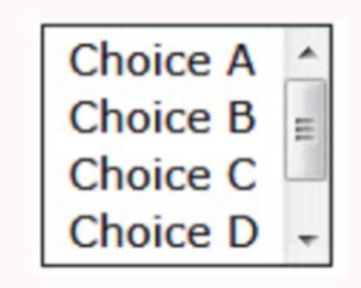

Based on the image above, what form control allows users to choose zero or more values from a list of choices?

* a – Checkbox
* b –Toggler button
* c – Hidden text
* d – Radio button
* e – Text field

2.

What type attribute value of an <input> element do you use to allow users to enter a date and time combination?

* a – calendar
* b – gregorianCalendar
* c – datetime
* d – time
* e - date

3.

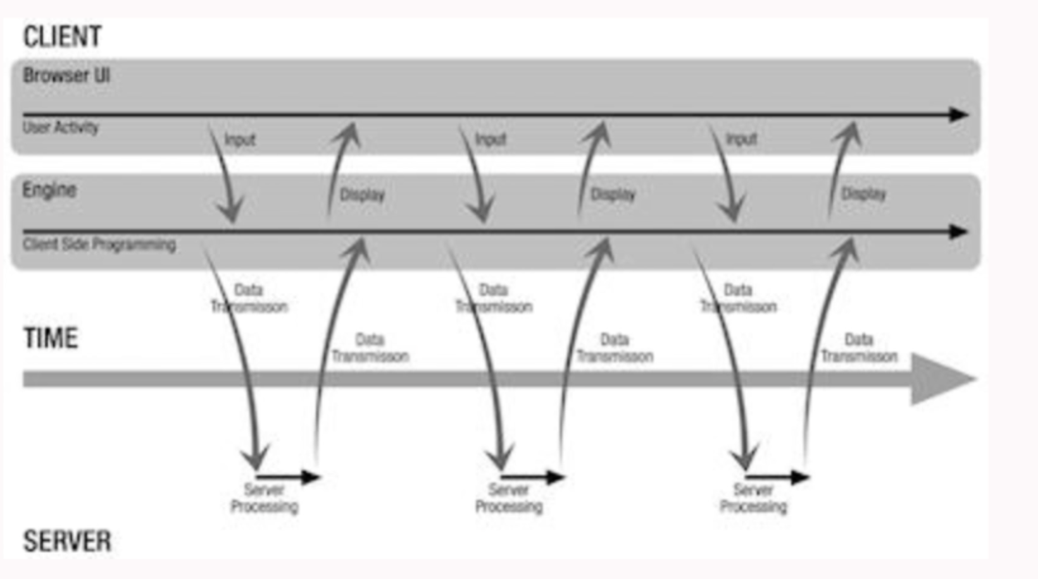

Based on the image above, what technique refreshes a portion of a page without having to refresh the entire page?

* a – HTTP
* b – AJAX
* c – JSON
* d – WS-I
* e - COMET

4.

You must highlight all of the links on a website in red when hovered over by a cursor.

Based on the scenario above, how do you achieve this?

* a – a : { color : #ff0000; }
* b – a#hover : { color : #ff0000; }
* c – a:over { color : #ff0000; }
* d – a:hover { color : #ff0000; }
* e – a.hover : { color : #ff0000; }

5.

When using the <link> element, what attribute do you use to display the relationship from the current document to the target resource?

* a –rel
* b – type
* c – media
* d – hreflang
* e - rev

6.

**<h2>Dogs & Cats</h2>**

Based on the sample code above, how do you encode the ampersand (&) character as an HTML entity?

* a – &amp:
* b – &amp
* c – /&amp:/
* d – amp:
* e - /&/

7.

What technology do you use to change the presentation of an HTML document without modifying the source document itself?

* a – BGcolor attributes
* b – Frames
* c – Framesets
* d – External style sheets
* e - <body> attributes

8.

**<table>**

**<tr>**

**<th>First Name</th>**

**<th>Last Name</th>**

**<th>Account Balance</th>**

**</tr>**

**<tr>**

**<td>Roger</td>**

**td>Miller</td>**

**<td>$-450</td>**

**</td>**

**</table>**

Based on the sample code above, how many columns are in the table?

* a – 0
* b – 1
* c – 2
* d – 3
* e - 4

9.

How many <head> elements can a valid HTML document have?

* a – 1
* b – 2
* c – 3
* d – 4
* e - Unlimited

10.

**<math mode=”display”>**

**<mrow>**

**<msqrt><mi>z</mi></msqrt><mo>=</mo>**

**<mfrac>**

**<mrow>**

**<mo form=”prefix”>&minus;</mo>**

**<mi>b</mi>**

**<mo>&PlusMinus;</mo>**

**<msqrt>**

**<msup><mi>c</mi>,mn>2</mn></msup>**

**<mo>&minus:</mo>**

**<mo>&InvisibleTimes;</mo>**

**<mi>d</mi>**

**</mrow>**

**<mrow>**

**<mn>2</mn>**

**<mo>&InvestTime;</mo>**

**<mi>a</mi>**

**<mo>&PlusMinus;</mo>**

**<mi>d</mi>**

**</mrow>**

**</mfrac>**

**</mrow>**

**</math>**

Based on the sample code above, what MathML output is generated?

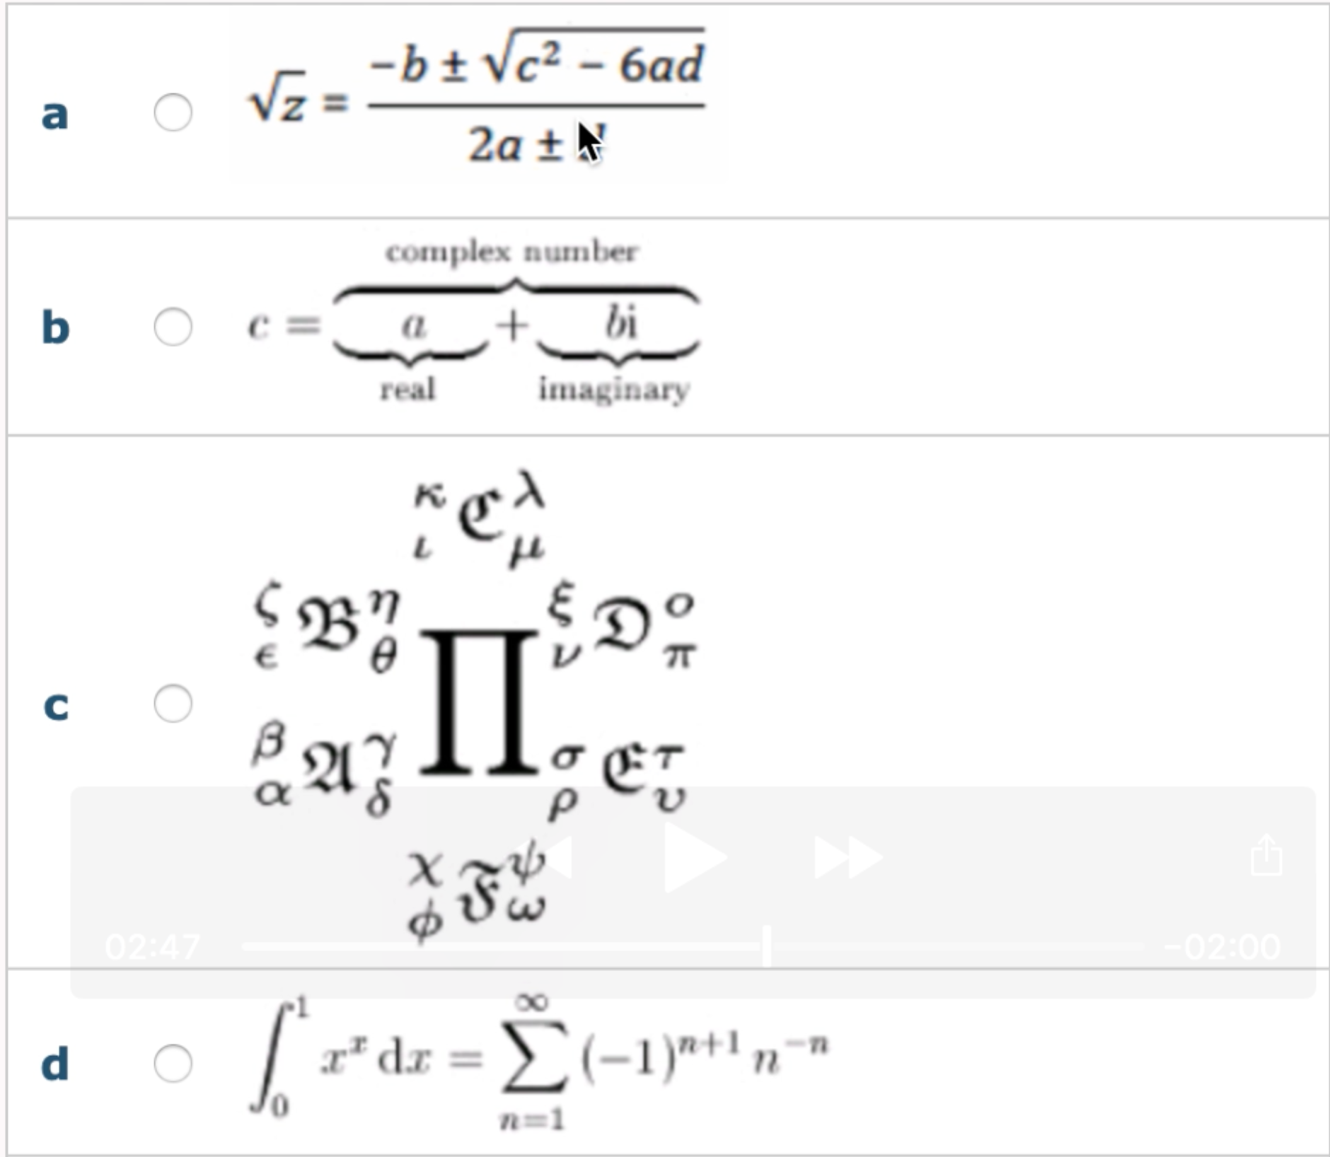

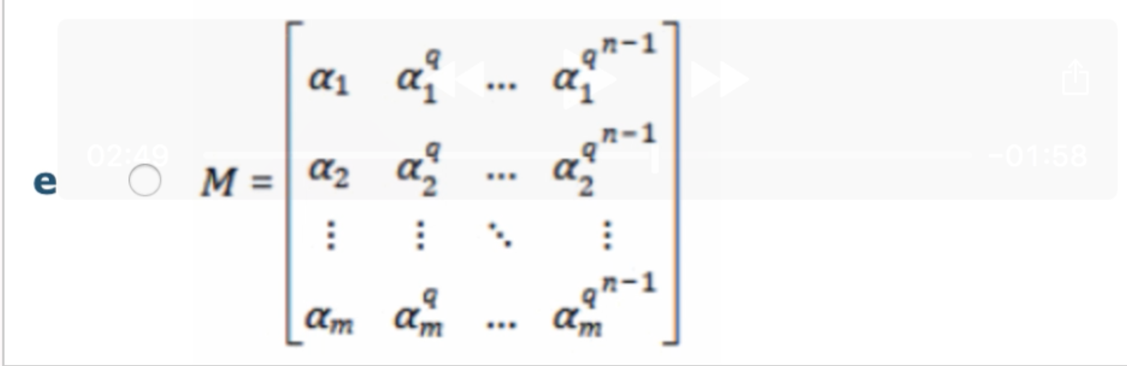

11.

What element can only be discovered in the <head> section of an HTML document?

* a – <map>
* b – <href>
* c – <linkable>
* d – <a>
* e - <link>

12.

What is an example of grouping of CSS selectors?

* a – h1, h2, p {color : green; }
* b – h1>h2>p { color : green; }
* c – h1, h2, p > color : green;
* d – h1 {color : green; } h2 {color : green; } p { color : green }
* e – h1 { h2 { p {color : green; } } }

13.

&nbsp; is rendered by the browser as:

* a – a page break.
* B – a non-breaking white space character.
* c – bold text
* d – a hard return.
* e – italic text

14.

What data structure is generated from parsing an HTML document?

* a – Node Map
* b – Node Tree Table
* c – Node Reference List
* d – Data Tree Model
* e – Document Object Model

15.

To execute JavaScript in response to mouse click events, you use the:

* a – buttonDown event.
* b – onMouseClick event.
* c – mouse.click event.
* d – mouse event.
* e – onClick event.

16.

A question mark in a URL is followed by a(an):

* a - HTML document ID.
* b - request parameter.
* c - filename marker.
* d – machine name.
* e – port number.

17.

In a webpage, the <embed> tag allows you to include:

* a – CSS definitions
* b – JavaScript source efficiently
* c – content like plugins
* d – images
* e – HTML content from other websites

18.

You implement the equivalent of the deprecated <font> tag in the HTML5 by using:

* a – semantic tags
* b – <fontStyle> tag
* c – <text> tag
* d – WebGL
* e - CSS

19.

When using https instead of http, what encryption layers must the browser and server support for the connection to succeed?

* a – SQL or TLS
* b – SSL or VLS
* c – MP3 or OGG
* d – SSL or TLS
* e – TCP or IP

**III. JavaScript1.5 Part**

1.

Which one of the following requires an event handler?

* a – The moving of an element
* b – Auto-completing a text field
* c – A hyperlink
* d – A roll-over image
* e – A scrolling background image

2.

Which property of the Event object stores the keys and mouse buttons that were pressed when the event was fired in Netscape 6.1?

* a – keyCode
* b – buttons
* c – which
* d – modifiers
* e - target

3.

**house1=new House();**

**house2=new House();**

**House prototype.buy=houseBuy;**

Referring to the above sample code, which one of the following is the correct way to delete the “buy()” method from “house1 but NOT from “house2”?

* a – delete house1.buy;
* b – delete house1.houseBuy;
* c – houseBuy=null;
* d – house1.buy=null;
* e – House.prototype.buy=null;

4.

**Array=new Array(1,2,3,5);**

**Delete array(0);**

**Array(10)=8;**

How many elements containing integers does the Array object “array” above contain?

* a – 3
* b – 4
* c – 5
* d – 10
* e - 11

5.

**num=0;**

**while (num<10) {**

**num++;**

**if (num%2==0) continue;**

**if (num%2==0) break;**

**}**

How many times does the above “while” loop iterate?

* a – 0
* b – 1
* c – 2
* d – 9
* e - 10

6.

1. **function factoria(num) {**
2. **var factorial=1;**
3. **for (var i=2; i<=num; i++) {**
4. **factorial*=i;**
5. **}**
6. **return factorial;**
7. **}**

The function factorial() returns the factorial of “num”.

Referring to the sample code above, which line contains an error?

* a – Line 1
* b – Line 2
* c – Line 3
* d – Line 4
* e – The code does not contain any errors.

7.

How long does the cookie WITHOUT an expiry date last?

* a – Until the browser is closed
* b – Until the current document is unloaded
* c – Until it is erased
* d – For 24 hours
* e – For 1 year

8.

What are the three flags that JavaScript 1.5 uses with regular expressions?

* a – a, d, t
* b – g, I, m
* c – g, n, x
* d – I, j, k
* e – m, w, z

9.

Which one of the following String methods uses regular expressions?

* a – anchor()
* b – concat()
* c – link()
* d – replace()
* e – substr()

10.

Which one of the following code segments is a String?

* a – “1”*1;
* b – “1”+1;
* c – “1”-1;
* d – 1-“1”;
* e – “1”%1;

11.

Which one of the following creates an instance of a Function object?

* a – funct == Function
* b – funct = new.Function()
* c – funct = new.Function
* d – funct = Function(new)
* e – funct = new Function()

12.

**var1=(var2==’yes’)?’okay’:’no way’;**

The ternary operator above is equivalent to which one of the following statements?

* a – if (var1==’yes’) var2=’okay’; else var2=’no way’;
* b – if (var1==’yes’) var1=’okay’; else var2=’no way’;
* c – if (var2!=’yes’) var1=’okay’; else var1=’no way’;
* d – if (var2==’yes’) var1=’okay’; else var1=’no way’;
* e – if (var1!=’yes’) var2=’okay’; else var2=’no way’;

13.

Why do you use indented nested command blacks?

* a – To prevent multi-line commands
* b – To allow objects to “fake” inheritance
* c – To ehance readability
* d – To speed execution
* e – To cause errors when loading

14.

Which one of the following “while” statements never finishes?

* a – x=0;  
   while (x++<10) {document.write(x);}
* b – x=10;  
   while (--x>0) {document.write(x);}
* c – x=-10;  
   while (x<10) {document.write(x--);}
* d – x=-10;  
   while (x<10) {document.write(++x);}
* e – x=10;  
   while (x<10) {document.write(x);x=x+1;}

15.

**x=new Array(10);**

Referring to the above sample code, what is the length of array “x”?

* a – 0
* b – 1
* c – 2
* d – 10
* e – 11

16.

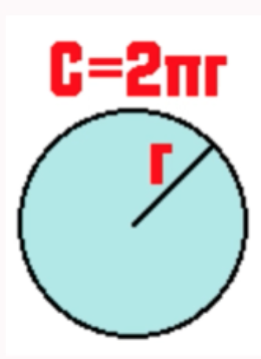

Referring to the image above, which one of the following calculates the circumference of a circle (2*pi*radius)?

* a – circumference = 2*(new Math().PI)*radius;
* b – circumference = 2*Math.PI*radius;
* c – circumference = 2*Math().PI*radius;
* d – circumference = 2*Math.getPI()*radius;
* e – circumference = 2*Math().getPI()*radius;

17.

Which one of the following returns the last element in an array?

* a – array[array.length];
* b – array[array->length];
* c – array[array.length-1];
* d – array[array.last];
* e – array[array->last];

18.

**m1=Math.max(Math.min(3,4),Math.min(2,3));**

**m2=Math.min(Math.max(5,6),Math.max(4,5));**

What is the value of Math.min(m1,m2) and Math.max(m1,m2) from the above sample code?

* a – Math.min(m1,m2) : 2  
   Math.max(m1,m2) : 6
* b – Math.min(m1,m2) : 4  
   Math.max(m1,m2) : 6
* c – Math.min(m1,m2) : 2  
   Math.max(m1,m2) : 5
* d – Math.min(m1,m2) : 3  
   Math.max(m1,m2) : 4
* e – Math.min(m1,m2) : 3  
   Math.max(m1,m2) : 5

19.

Which one of the following is a benefit of using client-side JavaScript over server-side JavaScript for Form validation?

* a – Form data is encoded for transmission to an HTTP server.
* b – It reduces network congestion, server load, and overall response time.
* c – It provides automatic decoding of encoded form data when there is an error.
* d – It reduces client workload.
* e – It provides for location specific string comparisons.

20.

Which one of the following operators is the “post-decrement operator”?

* a x--
* b --x
* c x-=y
* d x=-y
* e ~x

21.

Which one of the following techniques is used to call a form validating function?

* a – <form onsubmit=”checkForm(this);”>
* b – <form onsend=”checkForm(this);”>
* c – <form onsend=”this.checkForm();>
* d – <form onsubmit=”check.form();”>
* e - <form onsend=”checkForm();”>

22.

Which regular expression symbol is used in alternation?

* a | (pipe)
* b . (period)
* c & (ampersand)
* d _ (underscore)
* e - (hyphen)

23.

1) Validating text input

2) Aligning elements on a page

3) Accessing form data

4) Creating roll-overs

5) Auto-complete

For which one of the above actions are regular expressions best suited?

* a – Line 1
* b – Line 2
* c – Line 3
* d – Line 4
* e – Line 5

24.

How does JavaScript prevent a form from being submitted?

* a – onsubmit=”return false;”
* b – onsubmit=”return true;”
* c – onsubmit=”event.returnFalse;”
* d – onsubmit=”e.cancelEvent;”
* e – onsubmit=””

25.

Which literal is NOT a number data type?

* a – 6.3524
* b – 6E4
* c – -12
* d – ‘12’
* e – 0X5F