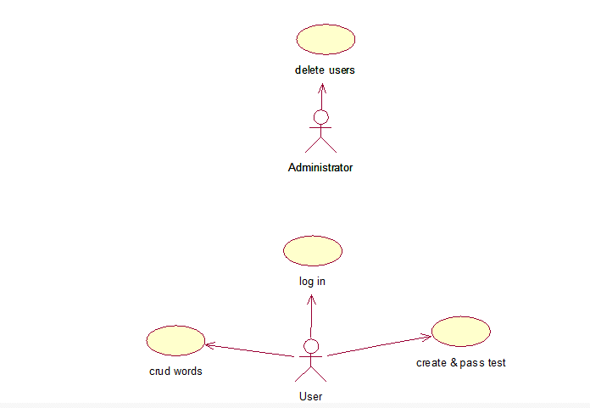

Events flow for precedent “delete users”

Short description.

This operation allows administrator to delete user’s profile.

Preconditions.

1. Non empty DB.

Main events flow:

1. Administrator enters the system, using his special secret code.
2. System checks authentication info.
3. Administrator chooses necessary user.
4. System deletes user’s information from DB and updates it.

Post conditions.

1. DB saves all changes.

Events flow for precedent “log in”

Short description.

This operation allows user to enter the system.

Preconditions.

1. Registration and getting your password key code.

Main events flow:

1. User enters password and key code.
2. System checks authentication info.
3. User gets right to enter info.

Post conditions.

1. DB saves all changes.

Events flow for precedent “CRUD word”

Short description.

This operation allows create, read, update and delete words.

Preconditions.

1. For reading, updating and delete should be non empty DB.

Main events flow:

1. User chooses necessary operation.
2. User enters info.
3. DB saves changes and updates.

Post conditions.

1. DB saves all changes.

Events flow for precedent “Create and Pass Tests”

Short description.

This operation allows create, and pas tests.

Preconditions.

1. There are should be English words in user’s database.

Main events flow:

1. User chooses necessary operation.
2. User chooses test settings.
3. User runs test.
4. User checks results.

Post conditions.

1. DB saves all changes.