Spring：

1、BeanFactory not initialized or already closed - call 'refresh' before accessing beans via the ApplicationContext

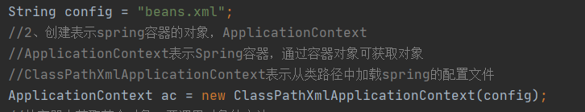

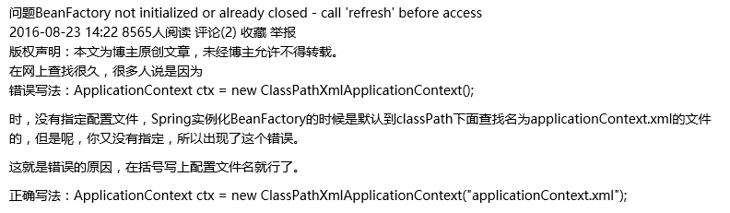

一开始没传参config