**Pattern Matching Pan and Adhar card**

>>> pattern = "[A-Z]{5}[0-9]{4}[A-Z]{1}"

>>> pattern = re.compile(pattern)

>>> pattern = "[A-Z]{5}[0-9]{4}[A-Z]{1}"

>>> pattern = re.compile(pattern)

>>> pattern1 = "[0-9]{4}[0-9]{4}[0-9]{4}"

>>> pattern1 = re.compile(pattern1)

>>> list = ["ASDFS2452G","577424682478","BNDF32452G","5772682128","BJKFS2412G","57741342478"]

>>> for x in list:

if re.match(pattern,x):

print x," is a PAN Card"

elif re.match(pattern1,x):

print x," is a ADHAR Card"

else:

print x," is nither PAN card nor ADHAR card"

**Output**

ASDFS2452G is a PAN Card

577424682478 is a ADHAR Card

BNDF32452G is nither PAN card nor ADHAR card

5772682128 is nither PAN card nor ADHAR card

BJKFS2412G is a PAN Card

57741342478 is nither PAN card nor ADHAR card

**Student Grade System**

dict1 = {'sub1':50, 'sub2':50, 'sub3':50, 'sub4':50, 'sub5':50}

dict2 = {'sub1':65, 'sub2':65, 'sub3':65, 'sub4':65, 'sub5':65}

dict3 = {'sub1':50, 'sub2':50, 'sub3':50, 'sub4':50, 'sub5':50}

dict4 = {'sub1':50, 'sub2':50, 'sub3':50, 'sub4':50, 'sub5':50}

dict5 = {'sub1':80, 'sub2':80, 'sub3':80, 'sub4':80, 'sub5':80}

list = []

list.append(dict1)

list.append(dict2)

list.append(dict3)

list.append(dict4)

list.append(dict5)

def total(list,n):

t = list[n]['sub1'] + list[n]['sub2'] + list[n]['sub3'] + list[n]['sub4'] + list[n]['sub5']

return t

n = 0

for i in list:

avg = total(list,n)

avg = avg / 5

n = n + 1

if avg>=75:

print "A"

elif avg>=60 and avg<=75:

print "B"

else:

print "C"

**Output**

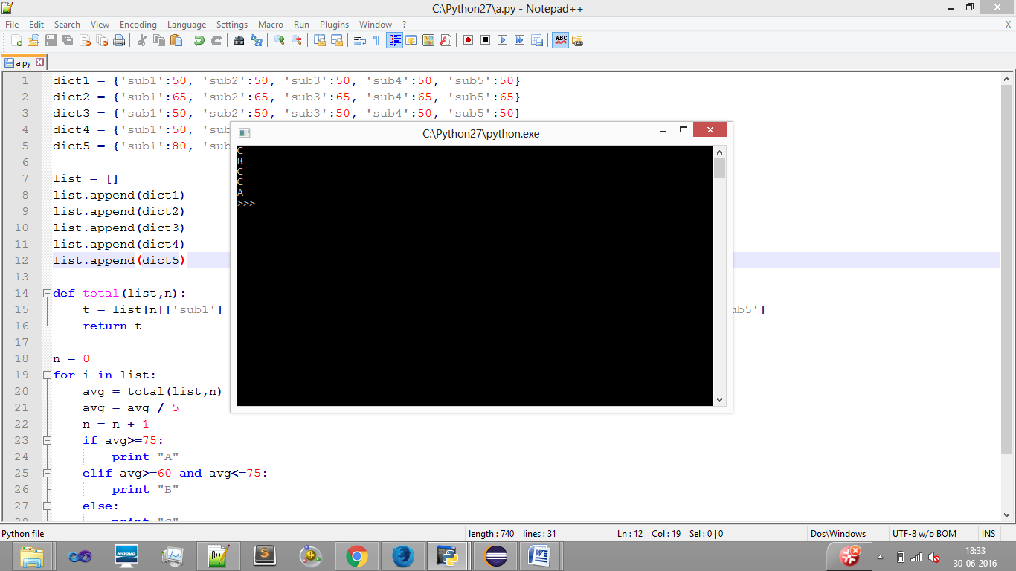

**Different Exceptions in Python**

|  |  |
| --- | --- |
| OverflowError | Raised when a calculation exceeds maximum limit for a numeric type. |
| FloatingPointError | Raised when a floating point calculation fails. |
| ZeroDivisonError | Raised when division or modulo by zero takes place for all numeric types. |
| AssertionError | Raised in case of failure of the Assert statement. |
| AttributeError | Raised in case of failure of attribute reference or assignment. |