Linux Commands Assignment

# 1. Creating and Renaming Files/Directories

Commands:  
mkdir test_dir  
cd test_dir  
touch example.txt  
mv example.txt renamed_example.txt  
  
Explanation:  
- `mkdir` creates a directory named test_dir.  
- `cd` moves into the directory.  
- `touch` creates an empty file named example.txt.  
- `mv` renames example.txt to renamed_example.txt.  
Screenshot: 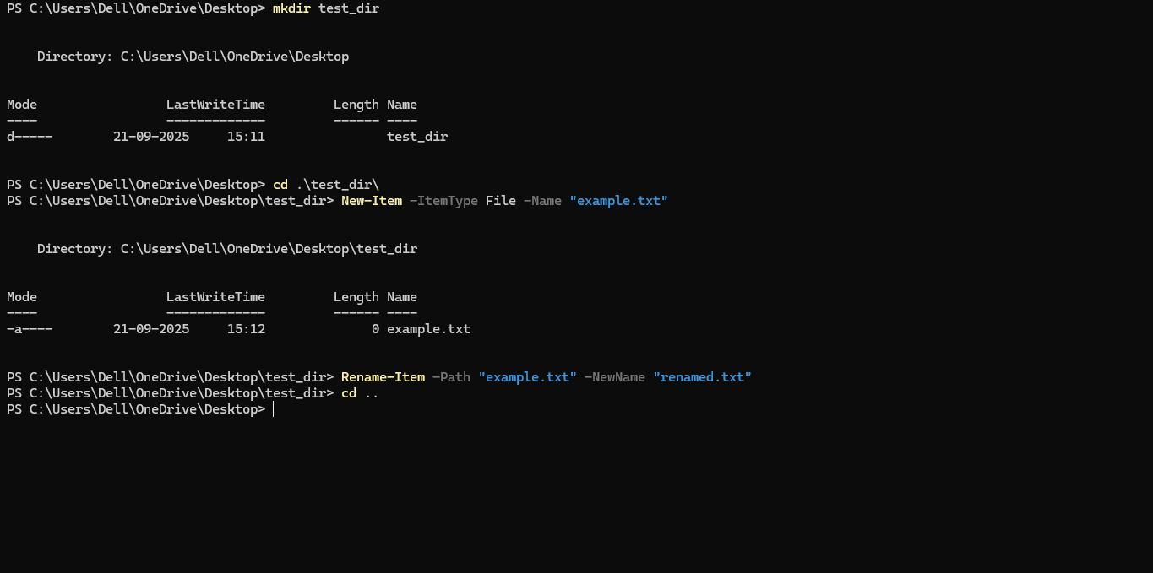

# 2. Viewing File Contents

Commands:  
cat /etc/passwd  
head -n 5 /etc/passwd  
tail -n 5 /etc/passwd  
  
Explanation:  
- `cat` displays the entire file content.  
- `head -n 5` shows the first 5 lines.  
- `tail -n 5` shows the last 5 lines.  
Screenshot: 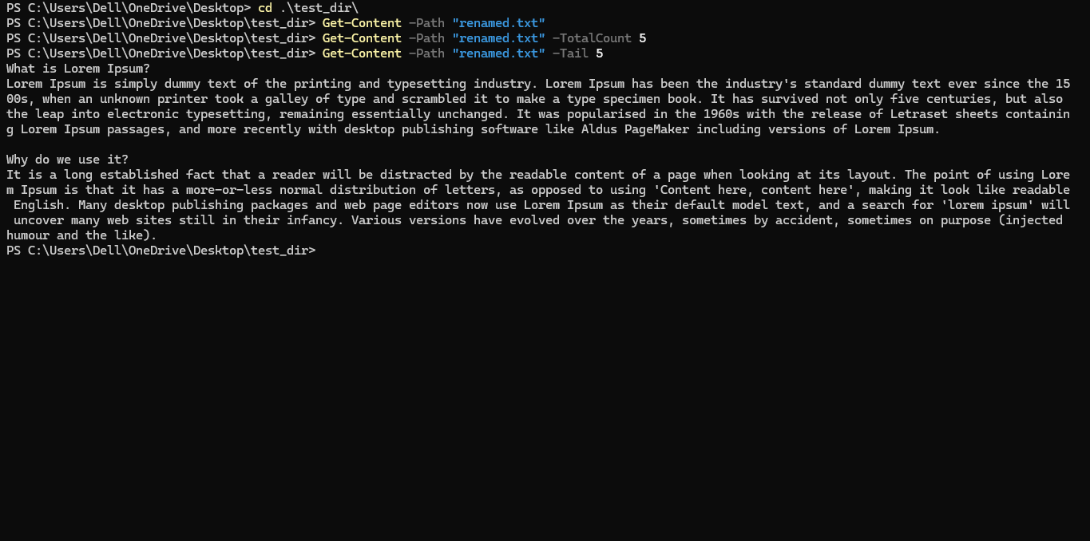

# 3. Searching for Patterns

Commands:  
grep "root" /etc/passwd  
  
Explanation:  
- `grep` searches for the word 'root' in /etc/passwd and displays matching lines.  
Screenshot: 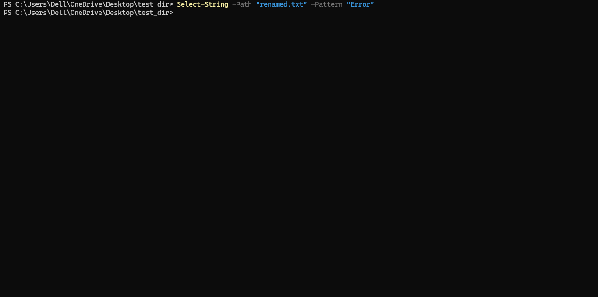

# 4. Zipping and Unzipping

Commands:  
zip -r test_dir.zip test_dir  
unzip test_dir.zip -d unzipped_dir  
  
Explanation:  
- `zip -r` compresses the folder recursively.  
- `unzip` extracts the contents to unzipped_dir.  
Screenshot: 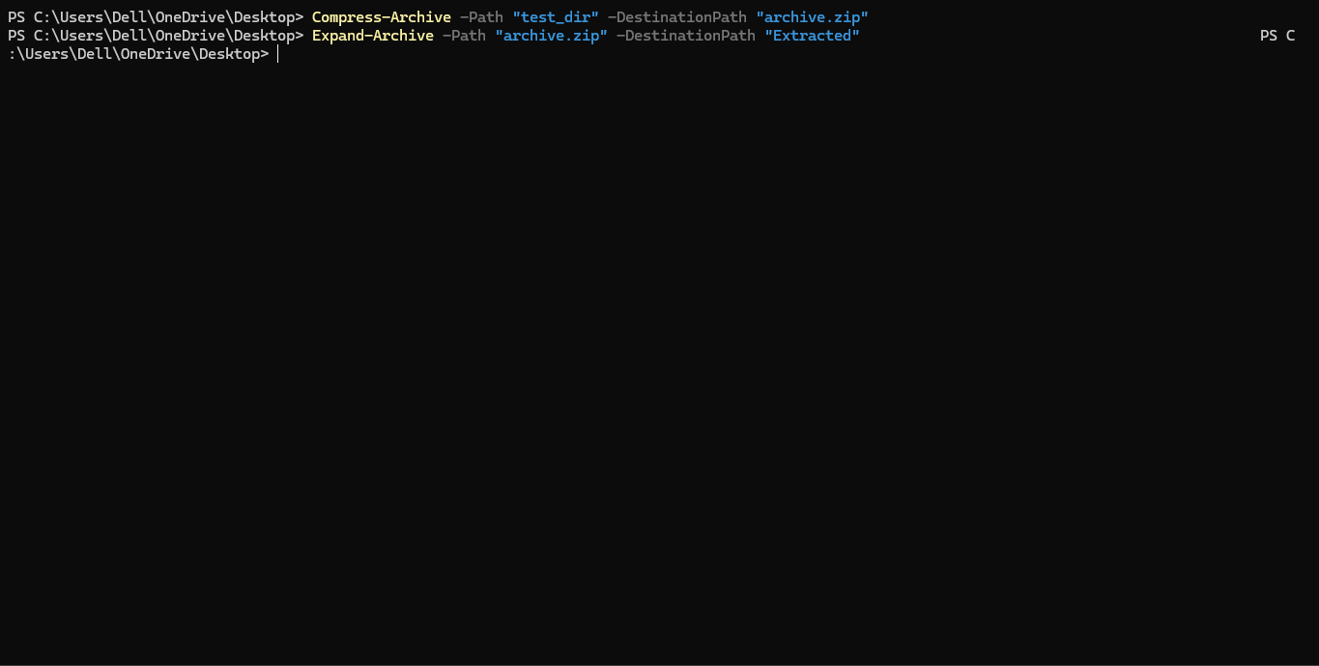

# 5. Downloading Files

Commands:  
wget https://example.com/sample.txt  
  
Explanation:  
- `wget` downloads the file from the provided URL.  
Screenshot:   
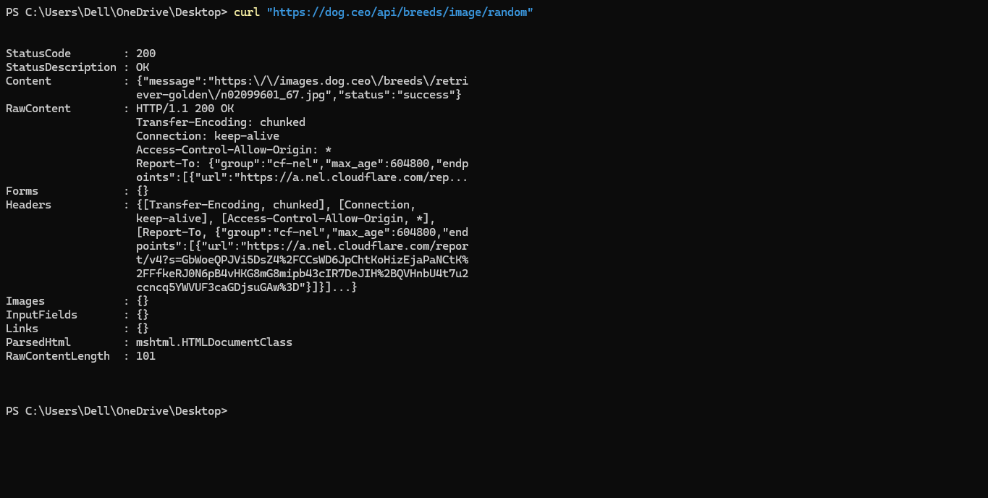

# 6. Changing Permissions

Commands:  
touch secure.txt  
chmod 444 secure.txt  
  
Explanation:  
- `touch` creates secure.txt.  
- `chmod 444` sets file to read-only for everyone.  
Screenshot:   
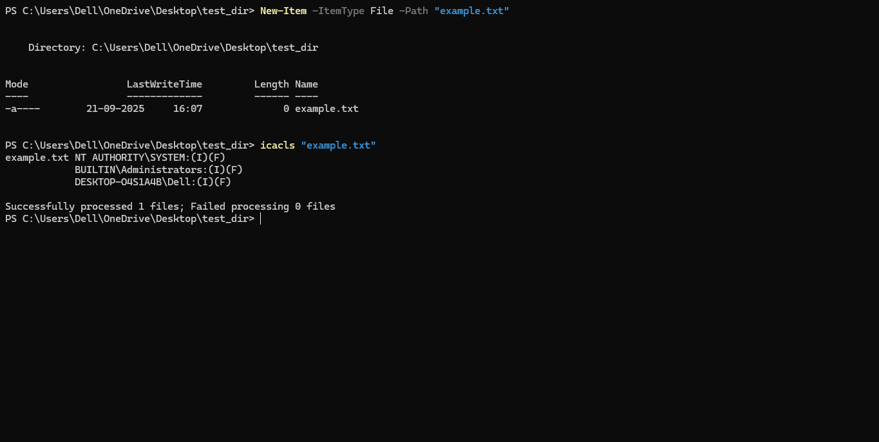

# 7. Working with Environment Variables

Commands:  
export MY_VAR="Hello, Linux!"  
echo $MY_VAR  
  
Explanation:  
- `export` sets a new environment variable.  
- `echo $MY_VAR` displays its value.  
Screenshot:   
