1. clone下来的项目在导入IJ后，如果注解都标红，有可能是没有配置JDK。
2. Npm install -g grunt -cli
3. 运行Tomcat时报错如下：

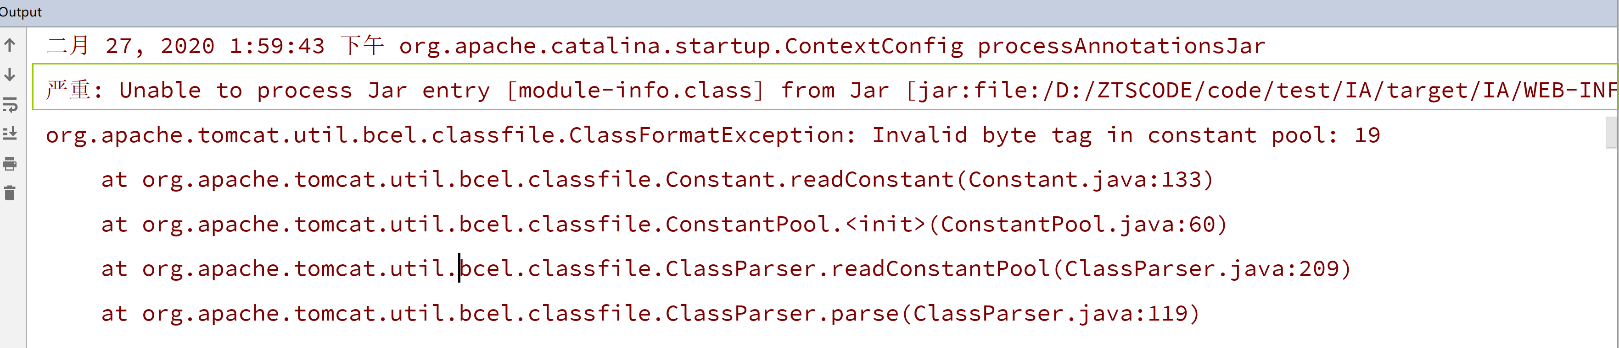

二月 27, 2020 1:59:43 下午 org.apache.catalina.startup.ContextConfig processAnnotationsJar

严重: Unable to process Jar entry [module-info.class] from Jar [jar:file:/D:/ZTSCODE/code/test/IA/target/IA/WEB-INF/lib/jackson-annotations-2.10.1.jar!/] for annotations

org.apache.tomcat.util.bcel.classfile.ClassFormatException: Invalid byte tag in constant pool: 19

at org.apache.tomcat.util.bcel.classfile.Constant.readConstant(Constant.java:133)

at org.apache.tomcat.util.bcel.classfile.ConstantPool.<init>(ConstantPool.java:60)

at org.apache.tomcat.util.bcel.classfile.ClassParser.readConstantPool(ClassParser.java:209)

at org.apache.tomcat.util.bcel.classfile.ClassParser.parse(ClassParser.java:119)

at org.apache.catalina.startup.ContextConfig.processAnnotationsStream(ContextConfig.java:2134)

解决办法：找到jackson-annotations-2.10.1.jar用好压打开，然后删除里面的module-info.class即可