Milestone2

Building first packet.(ICMP and TCP)

The function send will send a Build a packet
send(IP(dst="www.google.com")/ICMP())
p = sr1(IP(dst="www.google.com")/ICMP())

SR1() This function is for sending packets and returns the answers to those sent packets.
packet = sr1(IP(dst="www.google.com")/TCP(dport=80))
packet.summary()

SR() This function is for sending packets and returns only one packet in reply to the sent packet using TCP.
an,uans = sr(IP(dst="www.google.com")/TCP(dport=80),timeout=1)
an.summary()
uans = sr(IP(dst="www.google.com")/TCP(dport=80),timeout=1)
uans.summary()
an,uans = sr(IP(dst="www.google.com")/TCP(dport=[21,23,80,443]))
an.summary()
exit()

Creating a basic packet using the send function using the ICMP protocol.

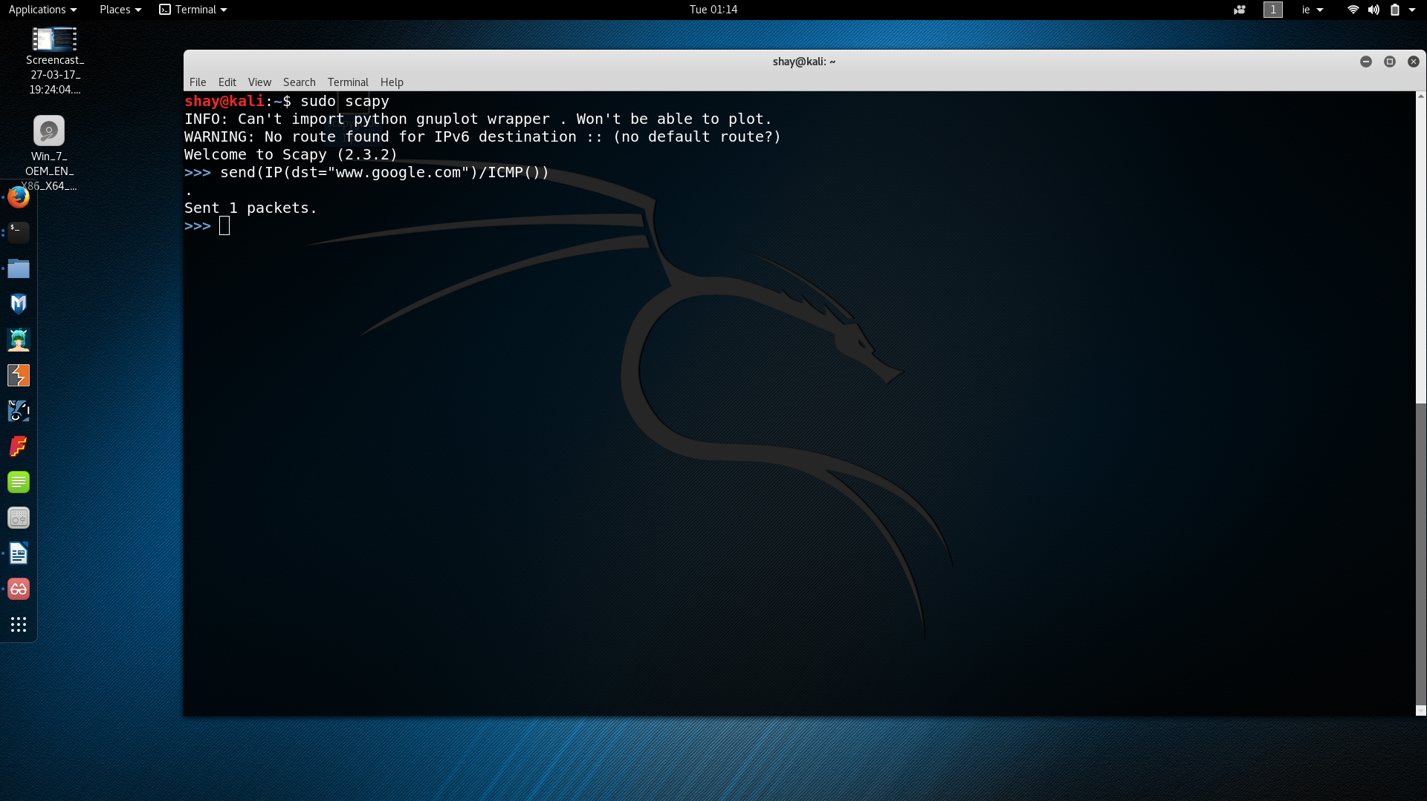

Sending a packet with ICMP and getting a response.
p.summary()

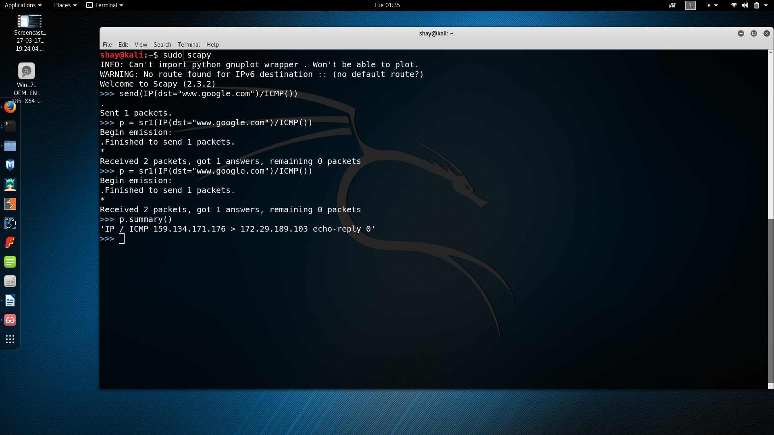
Sending a packet with TCP and getting a response to the first successful sent packet using sr1.

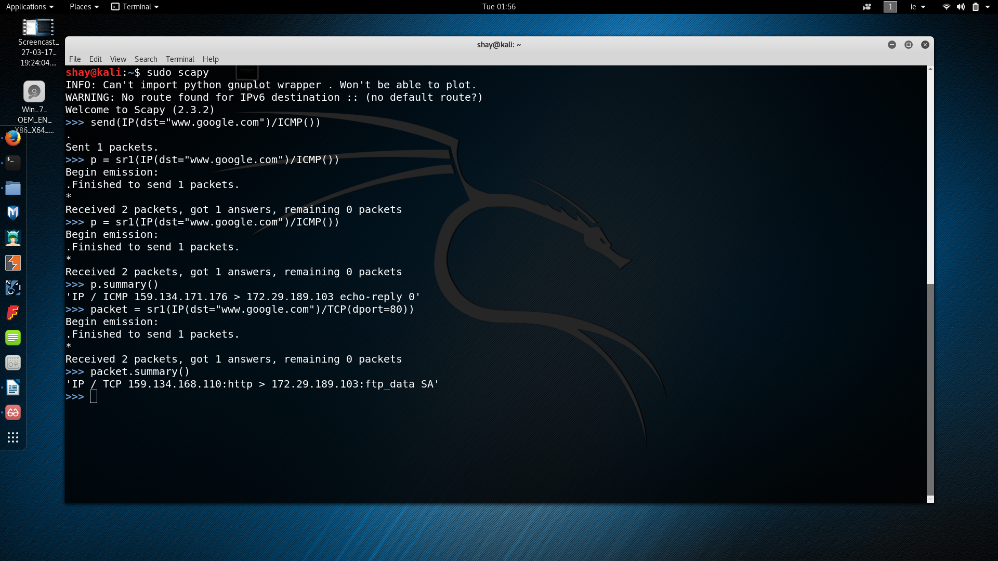

Using the sr function to get a list of answered and unanswered packets.

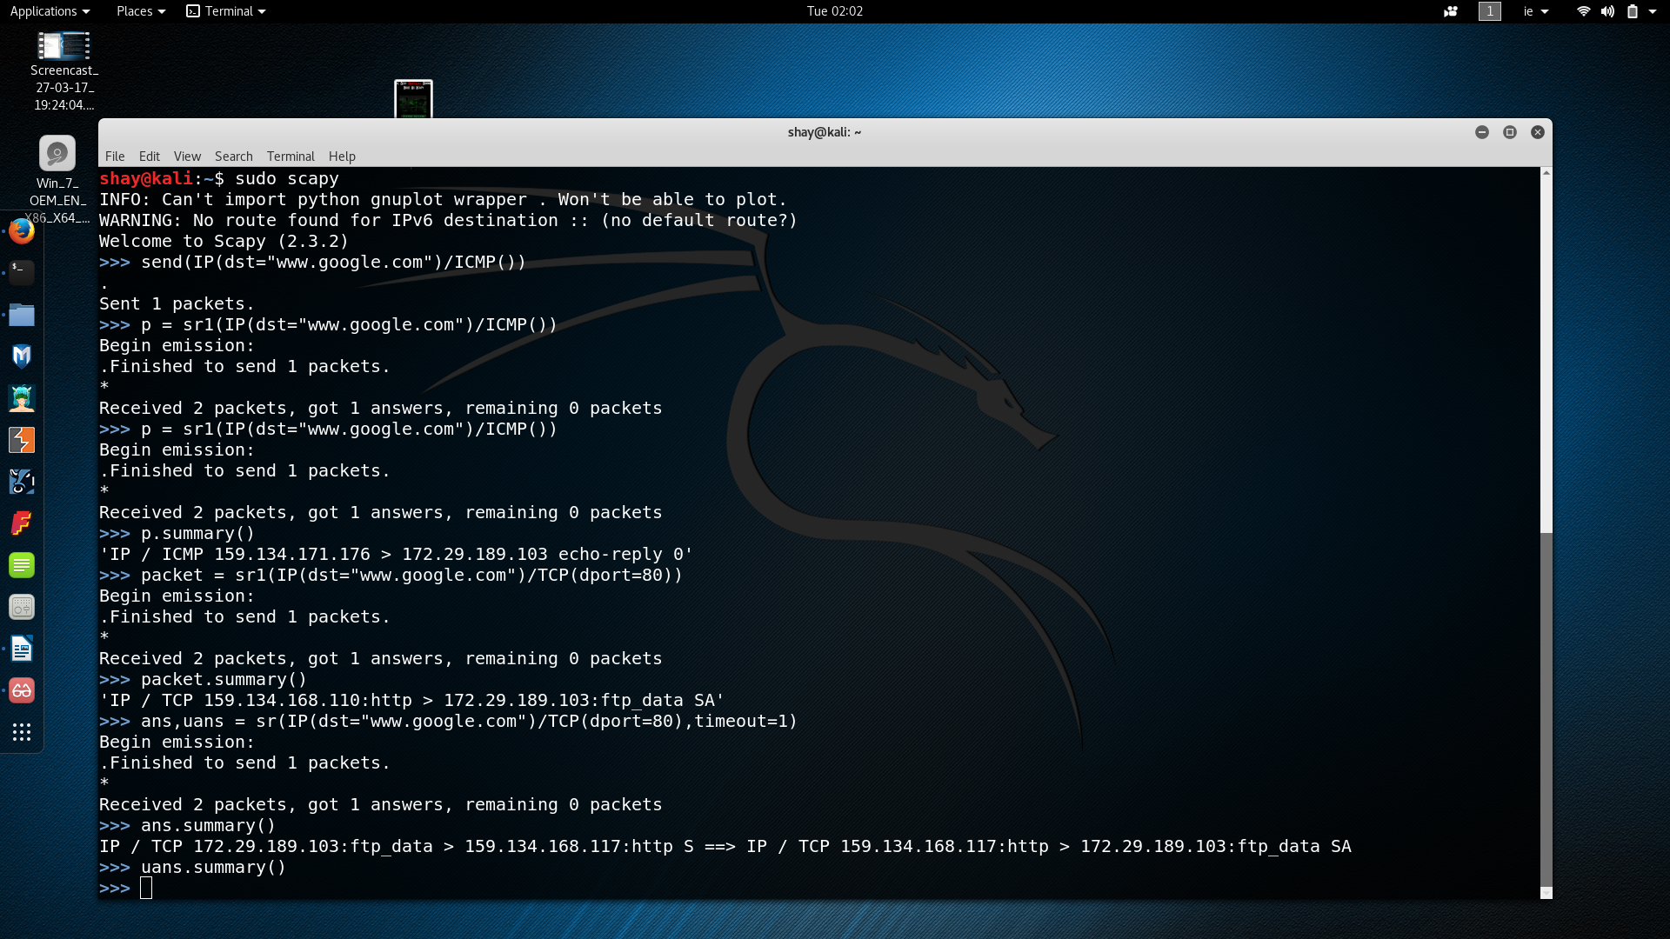
port scan
an,uans = sr(IP(dst="www.google.com")/TCP(dport=[21,23,80,443]))

Checking different ports ,SA states a sync ack meaning the ports are opened.
Telnet and ftp are not opened. This is similar to a port scan.

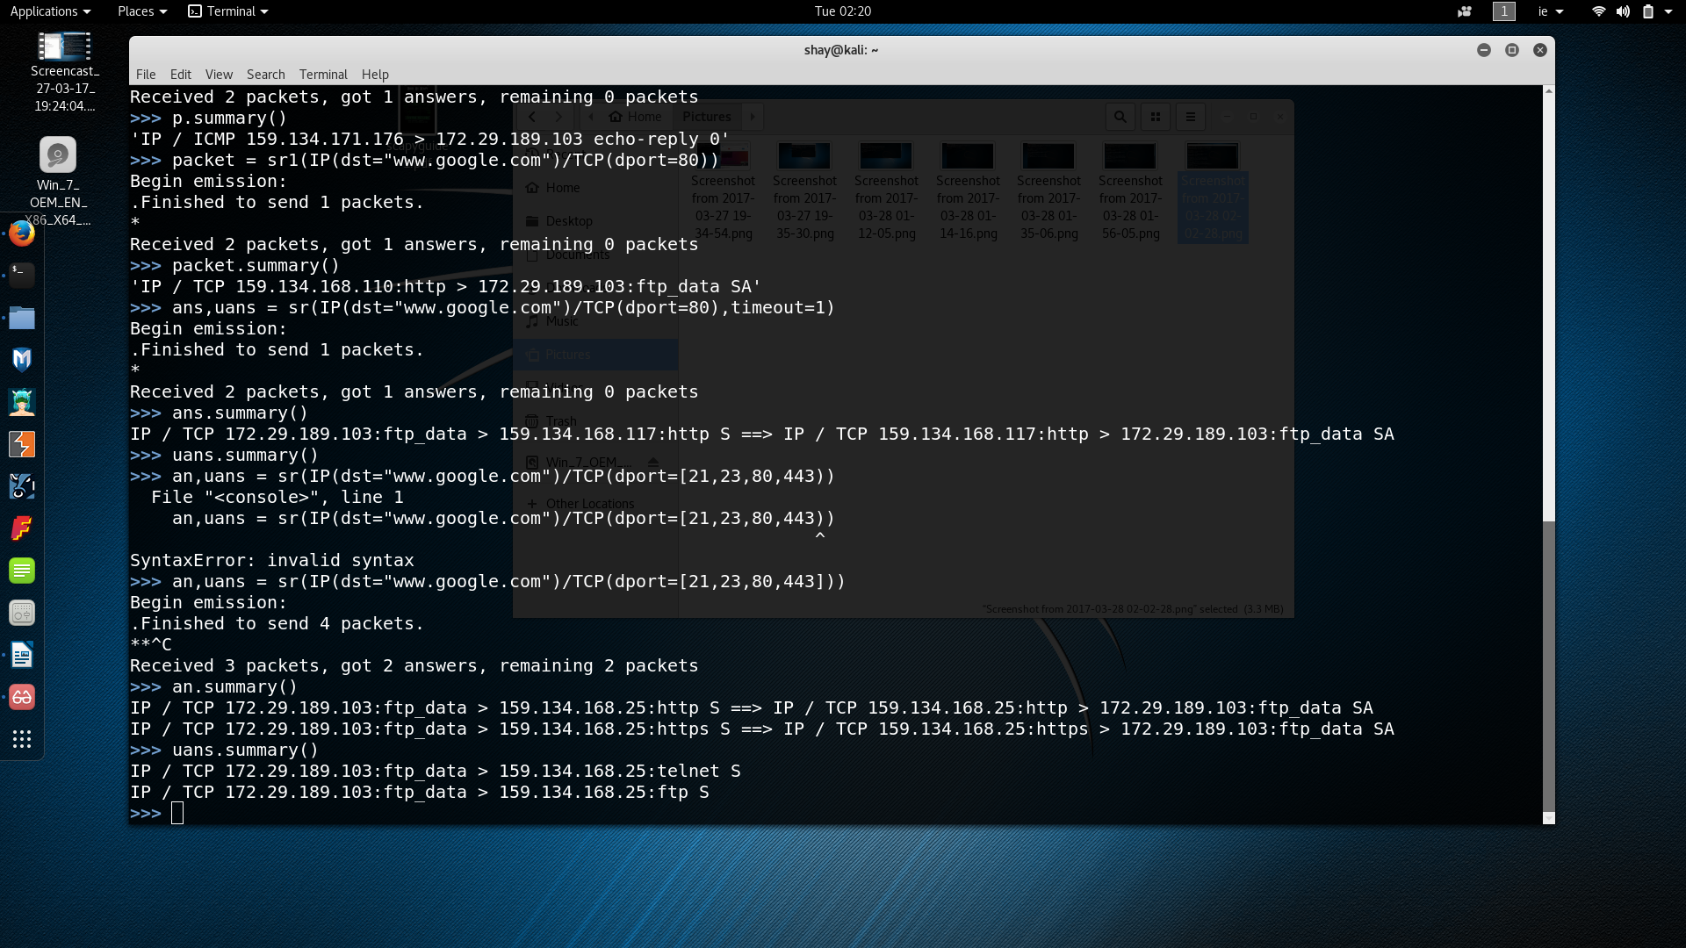

DNS Requests (to my router)

packet=sr1(IP(dst="172.29.189.185")/UDP()/DNS(rd=1,qd=DNSQR(qname="www.google.com")))

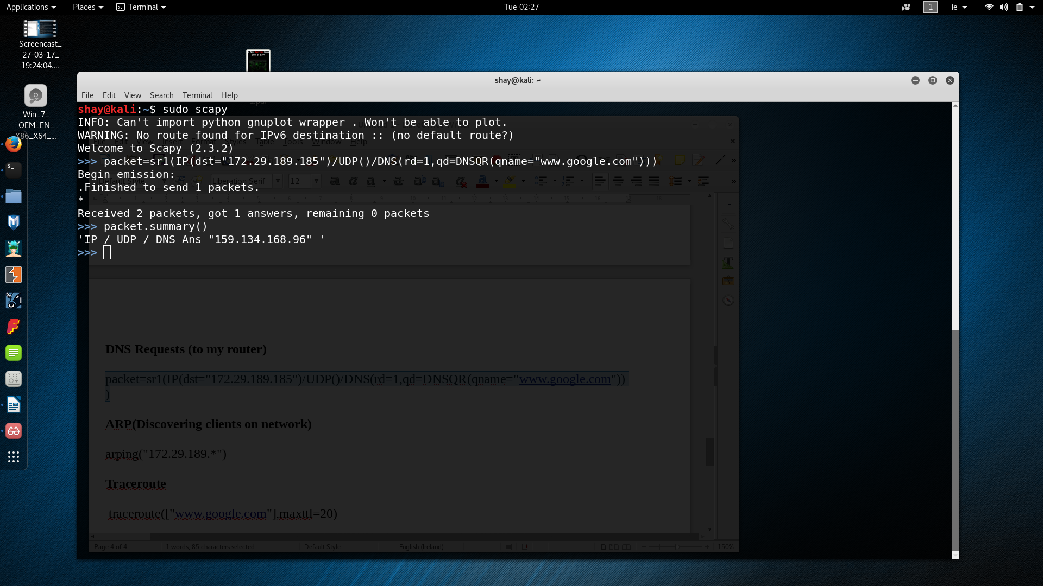

ARP(Discovering clients on network)

arping("172.29.189.*")
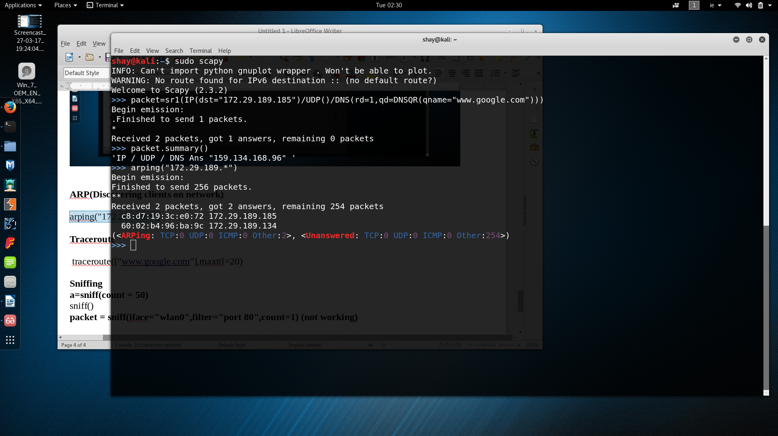

Traceroute

traceroute(["www.google.com"],maxttl=20)

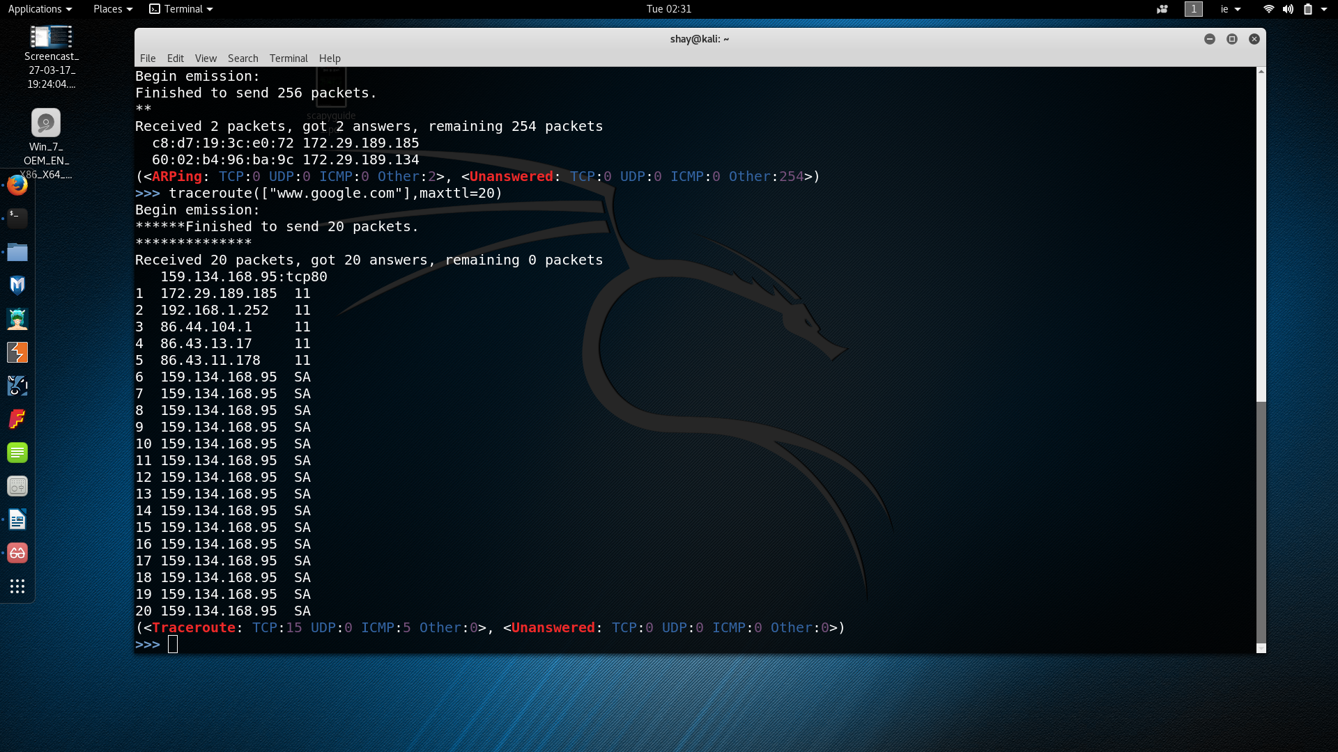

Sniffing(In progress at the moment)
a=sniff(count = 50)
sniff()
packet = sniff(iface="wlan0",filter="port 80",count=1) (not working)

packet = sniff(iface="wlan0",count=1)
packets= sniff(iface="wlan0",filter="tcp and port 80",count=1) problems

