Installation of scapy

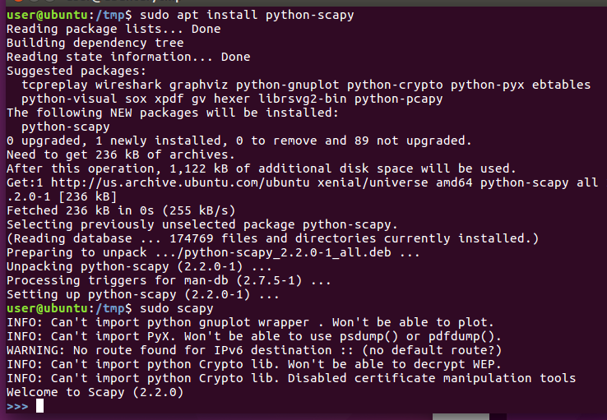

Using ICMP (INTERNET CONTROL MESSAGE PROTOCOL) I will send my first packet with scapy.
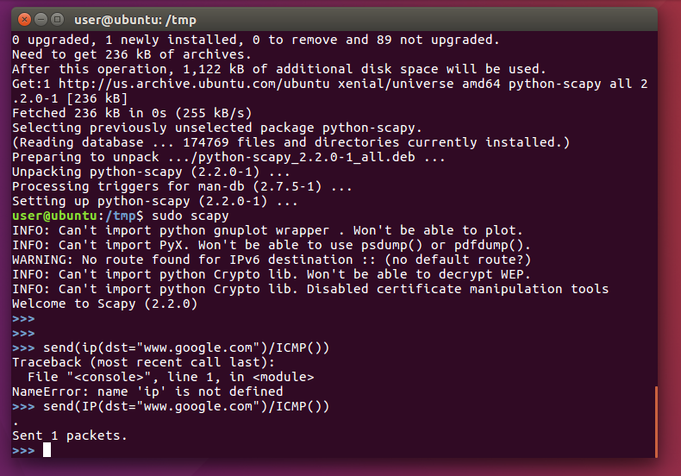
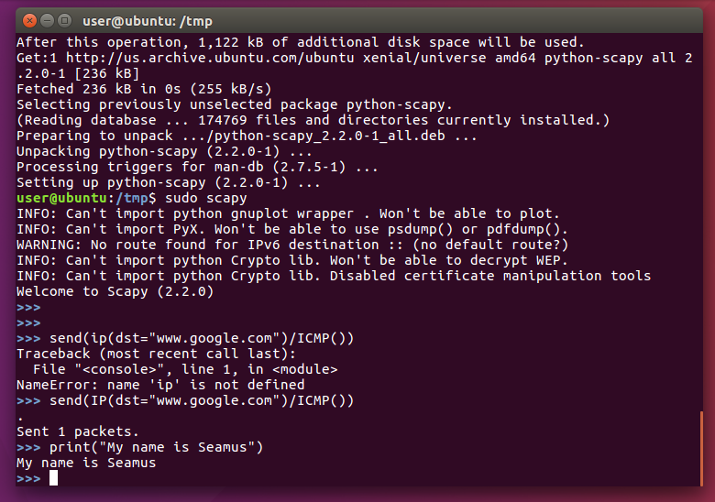

Sending and receiving packets.
SR()-This function is for sending packets and returns the answers to those send packets.
I will do this by wrapping the ICMP protocol wrapped around an IP Packet.
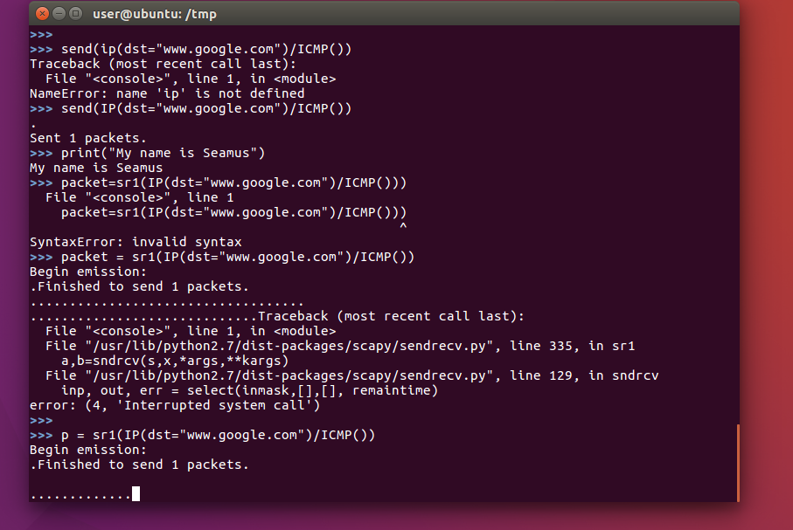
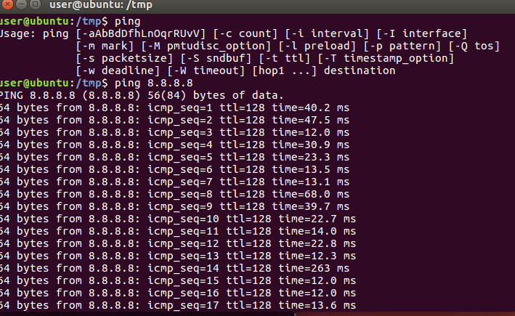

Failure
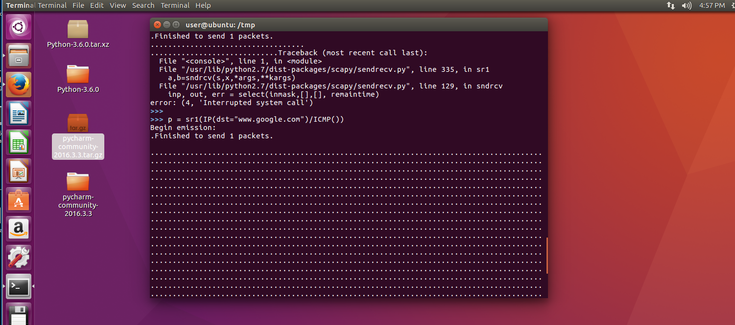

Running into trouble installing scapy. Incoming packets not getting through.

