RaceDay
Event Management Platform
Portfolio of Evidence – Part 1: System Planning and Database

1. Project Description
RaceDay is a full-stack web-based event management system designed specifically for the South African road running, walking and cycling community. It supports iconic events such as the Comrades Marathon, Soweto Marathon, Two Oceans Marathon, Cape Town Cycle Tour, and hundreds of community park runs and charity events held across the country every weekend.
The platform allows Event Organisers to create and manage events, categories and participant results, while Participants can browse upcoming events, enter events, track their personal performance history, and prepare for race day.

2. User Roles
The system supports two distinct user roles:
Role | Capabilities
Organiser | Create, edit and delete events; manage event categories; capture participant results; view all enrolments for their events.
Participant | Create an account; browse published events; enter an event by selecting a category; view own enrolments; track personal results.

3. Part 1 Deliverables
All planning documents are located in the /docs folder:
File | Description
docs/RaceDay_ERD.png | Entity Relationship Diagram (PNG image)
docs/API_Endpoint_Plan.md | Complete API endpoint specification table
docs/RaceDay_Database.sql | Full SQL Server script (schema + seed data)

4. How to Run the SQL Script
- Open SQL Server Management Studio (SSMS)
- Connect to your SQL Server instance
- Open the file docs/RaceDay_Database.sql
- Press F5 (or click Execute)
- The database RaceDayDB will be created with all tables and sample data

5. Database Entities (6 Tables)
- Roles – Organiser and Participant
- Users – All people in the system
- Events – Race / cycle / walk events
- Categories – Distance options under an event (5km, 10km, Half Marathon, etc.)
- Enrolments – When a participant enters a category
- Results – Finish times and positions

6. CI/CD
A GitHub Actions workflow is included in .github/workflows/validate-docs.yml. It checks that the required planning documents exist in the /docs folder.
Screenshot of successful green build:

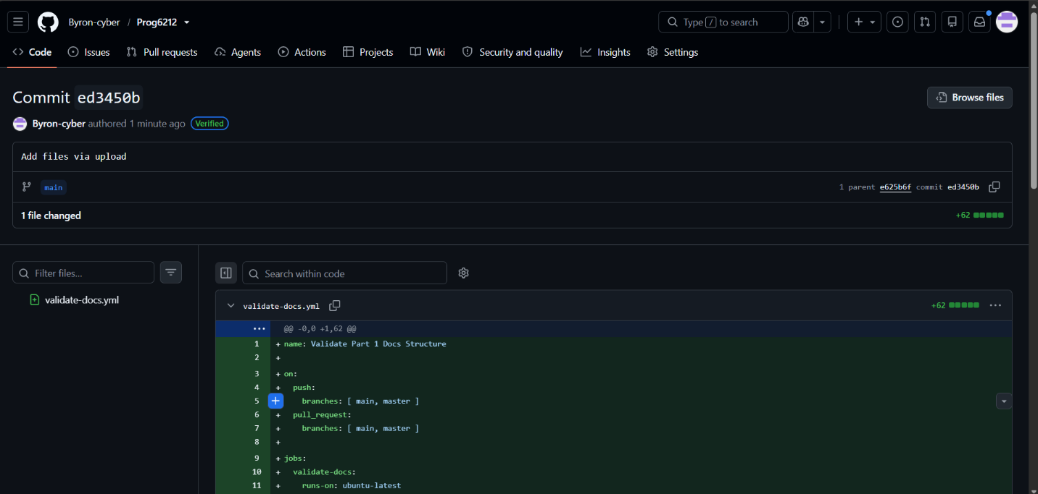7. Video Presentation
Unlisted YouTube link:
(Insert your unlisted YouTube video link here)
In the video I explain:
- The ERD design decisions and relationships
- The API endpoint plan choices
- Live execution of the SQL script in SSMS

8. Repository Structure
/
├── docs/
├── RaceDay_ERD.png
├── API_Endpoint_Plan.md
└── RaceDay_Database.sql
├── .github/workflows/
└── validate-docs.yml
└── README.md

9. AI Tool Disclosure
AI assistance was used for structuring documents and generating consistent formatting. All design decisions, entity choices, relationship cardinalities and explanations were reviewed, refined and owned by the student.

